

SAL INSTITUTE OF DIPLOMA STUDIES

**DEPARTMENT OF COMPUTER ENGINEERING**

**LAB PLANNING**

**Name :……………….**

**Enrollement No: ………**

**Branch : ………..**

**Semester: 3**

**Subject Name: RESPONSIVE WEB PAGE DESIGN**

**Subject Code: 4330705**

Term Date: / /22 To / /23

|  |  |  |  |
| --- | --- | --- | --- |
| NO. | Practical Exercises | Planned  Date | Actual  Date |
| 1 | Intro to HTML/CSS/JAVASCRIPT | 31/0/8/2023 | 31/08/2023 |
| 2 | Install Bootstrap framework and understand various tags,  attributes of HTML and other necessary files to make responsive  web page. | 15/9/2023 | 15/09/2023 |
| 3 | Design web page that shows department name, college name at  center of web page by using bootstrap framework and without  using bootstrap framework. | 15/09/2023 | 15/09/2023 |
| 4 | Display student information content on responsive web page by  using container and container-fluid classes. | 22/09/23 | 22/09/23 |
| 5 | Use offset column, reordering column and Nesting column to  create responsive web page for given format. | 22/09/23 | 22/09/23 |
| 6 | Create responsive web page of your class time table by using  bootstrap grid system | 22/09/23 | 22/09/23 |
| 7 | Shows at least five to six co-curricular/Extra activities of student  that includes multiple images and short description of each  activity on responsive web page using responsive images with  different styles and responsive tables with 3 to 4 different styles  such as hover state when mouse over, different color of each  row, table with striped row etc. | 22/09/23 | 22/09/23 |
| 8 | Use bootstrap typography to create responsive web page on  given blog topic. | 29/9/23 | 29/9/23 |
| 9 | Design responsive web page for student registration form using  bootstrap form layout, form control, bootstrap buttons. | 29/9/23 | 29/9/23 |
| 10 | Create various types of menus using bootstrap menu  components such as right aligned dropdown menu, drop up  menu, adding headers of each item etc. and glyphicons  components | 29/9/23 | 29/9/23 |
| 11 | Design responsive web page that shows odd (sem1, sem3, sem5) and even (sem2, sem4, sem6) semester consider as menu, courses of each semester as submenu using button groups and button toolbar component. | 6/10/2023 | 6/10/2023 |
| 12 | Use different bootstrap input groups components to create  responsive webpage for job application or any other kind of  application. | 6/10/2023 | 6/10/2023 |
| 13 | Use Navigation tabs/Pills to create responsive web page for  summarize of all individual units of any one course. | 19/10/23 | 19/10/23 |
| 14 | Use Nav bar component to create responsive fixed to top menu  design includes logo, menu, drop down menu, form input  elements such as sign-up button, search mechanism etc. And  fixed to bottom menu design contains footer information. | 19/10/23 | 19/10/23 |
| 15 | Create responsive web page of education website using  bootstrap breadcrumb, pagination, labels/badge,  Jumbotron/page header, thumbnail components. |  |  |
| 16 | Following tasks to be performed using bootstrap progress bars  component.  A) Creating progress bars  B) Adding label to progress bars  C) Creating multi-color, stripped and animated progress bars  D) Changing value of progress bar dynamically using JavaScript |  |  |
| 17 | Use media, rounded media, Nested media object to create  responsive web page for all family members in hierarchical  order |  |  |
| 18 | Create responsive webpage of various service provider  information using bootstrap panel component, List group  component, various alert messages and show message after  bootstrap alert has been closed. |  |  |
| 19 | Design a smooth page transition between homepage, about and  contact us page using bootstrap transition plugin. |  |  |
| 20 | Design a webpage with different modal dialog for “Save record  confirmation”, “Delete record confirmation” using model dialog  plugin of bootstrap. |  |  |
| 21 | Design news story page to demonstrate usage of Scrollspy for  multiple section, Tooltip for different photos, Collapsible and  popover plugins of bootstrap |  |  |
| 22 | Design animated photo gallery page using Carousel bootstrap  plugin with minimum seven photos. |  |  |
| 23 | Develop advanced responsive website with minimum Five to  seven pages on any of following domains (Tourism, Hospitality,  Airline reservation, Medical, E commerce etc.) |  |  |
| 24 | REVISION |  |  |
| 25 | PROJECT |  |  |

Name of Faculty:

Sign. Of Faculty: Sign. Of H.O.D:

Practical

Bootstrap 5

Practical-1) Containers-Containers-Fluid

<!DOCTYPE html>

<html lang="en">

  <head>

    <meta charset="utf-8" />

    <meta name="viewport" content="width=device-width, initial-scale=1" />

     <link rel="stylesheet" href="bootstrap-5.0.2/dist/css/bootstrap.min.css">

    <title>Bootstrap 5</title>

  </head>

  <body>

    <div class="container box">

      <h1>Hello, world 1</h1>

      <div>Container 1</div>

    </div>

    <div class="container-fluid box">

      <h1>Hello, world 2</h1>

      <div>Container 2</div>

    </div>

    <script src="bootstrap-5.0.2/dist/js/bootstrap.min.js"></script>

  </body>

</html>

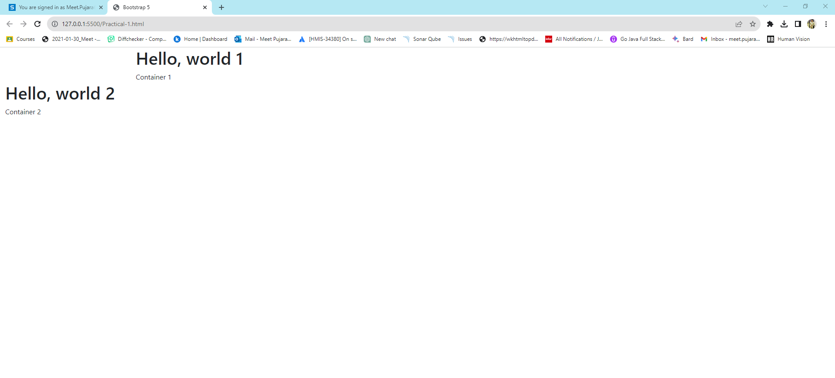

# Practical-2).Grid Rows and Columns

<!doctype html>

<html lang="en">

<head>

    <meta charset="utf-8">

    <meta name="viewport" content="width=device-width, initial-scale=1">

    <link href="bootstrap-5.0.2/dist/css/bootstrap.min.css" rel="stylesheet">

    <link href="style.css" rel="stylesheet">

    <title>Bootstrap 5</title>

</head>

<body>

    <div style="height:50px"> </div>

    <div class="container box">

        <h1>Hello, world 1</h1>

        <div class="row">

            <div class="col border">One</div>

            <div class="col border">Two</div>

            <div class="col border">Three</div>

        </div>

        <div class="row">

            <div class="col border">One</div>

            <div class="col border">Two</div>

            <div class="col border">Three</div>

            <div class="col border">Four</div>

        </div>

        <div>Container 1</div>

        <div class="row">

            <div class="col-sm-2 border">One</div>

            <div class="col-sm-4 border">Two</div>

            <div class="col-sm-2 border">Three</div>

            <div class="col-sm-4 border">Four</div>

        </div>

        <div class="row">

            <div class="col-xl-2 border">One</div>

            <div class="col-xl-4 border">Two</div>

            <div class="col-xl-2 border">Three</div>

        </div>

    </div>

            <div class="container-fluid box">

                <h1>Hello, world 2</h1>

                <div class="row">

                    <div class="col border">One</div>

                    <div class="col border">Two</div>

                    <div class="col border">Three</div>

                </div>

                <div>Container 2</div>

                <div class="row">

                    <div class="col-sm-2 border">One</div>

                    <div class="col-sm-4 border">Two</div>

                    <div class="col-sm-2 border">Three</div>

                    <div class="col-sm-4 border">Four</div>

                </div>

                <div class="row">

                    <div class="col-xl-2 border">One</div>

                    <div class="col-xl-4 border">Two</div>

                    <div class="col-xl-2 border">Three</div>

                </div>

            </div>

                <script src="bootstrap-5.0.2/dist/js/bootstrap.min.js"></script>

</body>

</html>

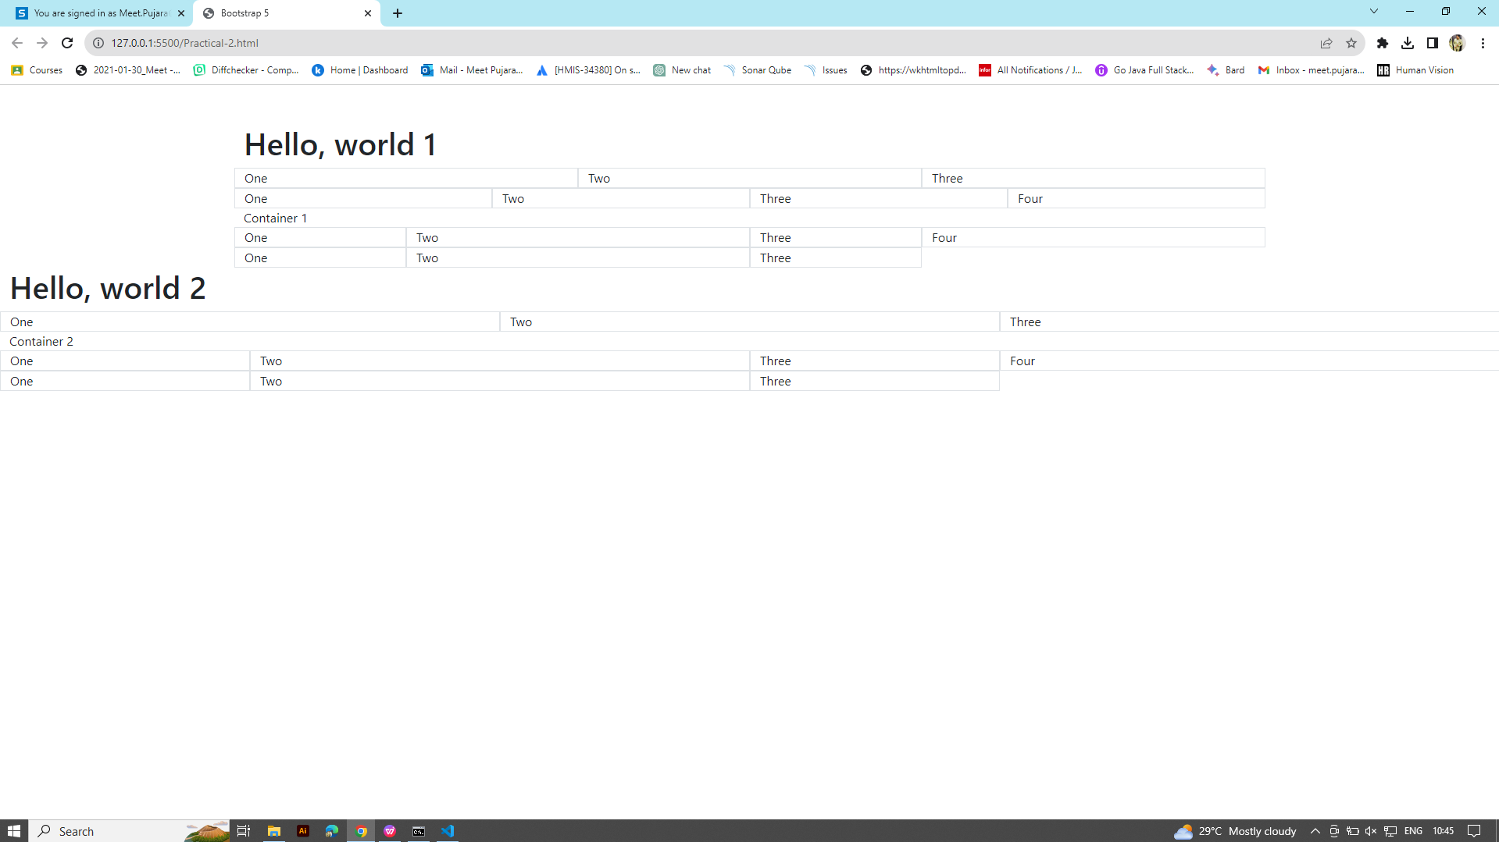

# Practical-3).Text and Typography

<!doctype html>

<html lang="en">

<head>

    <meta charset="utf-8">

    <meta name="viewport" content="width=device-width, initial-scale=1">

    <link href="bootstrap-5.0.2/dist/css/bootstrap.min.css" rel="stylesheet">

    <link href="style.css" rel="stylesheet">

    <title>Bootstrap 5</title>

</head>

<body>

    <div class="display-2">Display 2</div>

    <div class="display-3">Display 3</div>

    <div class="display-4">Display 4</div>

    <div class="display-5">Display 5</div>

    <div class="display-6">Display 6</div>

    <small>Small</small>

    <mark>Mark</mark>

    <code>Code</code>

    <br>

    <span class="small">Small</span>

    <span class="mark">Mark</span>

    <ul class="list-styled">

        <li>One</li>

        <li>Two</li>

        <li>Three</li>

        <li>Four</li>

    </ul>

    <dl>

        <dd class="col-sm-2">Ele 2</dd>

        <dd class="col-sm-2">Ele 3</dd>

        <dt class="col-sm-6">Title</dt>

        <dd class="col-sm-3">Ele 1</dd>

        <dd class="col-sm-3">Ele 2</dd>

        <dt class="col-sm-6">Title</dt>

        <dd class="col-sm-6">Ele 1</dd>

    </dl>

    <dl>

        <dt>Title</dt>

        <dd>Ele 1</dd>

        <dd>Ele 2</dd>

        <dd>Ele 3</dd>

    </dl>

    <div>Container 1 Container 1Container 1 Container

        1Container 1 Container 1Container 1 Container 1Container 1

    </div>

        <script src="bootstrap-5.0.2/dist/js/bootstrap.min.js"></script>

</body>

</html>

# 

# Practical-4).How to update Image Classes

<!doctype html>

<html lang="en">

<head>

    <meta charset="utf-8">

    <meta name="viewport" content="width=device-width, initial-scale=1">

    <link href="bootstrap-5.0.2/dist/css/bootstrap.min.css" rel="stylesheet">

    <link href="style.css" rel="stylesheet">

    <title>Bootstrap 5</title>

</head>

<body>

    <div>

        <img src="img/SAIL4921.jpg" class="rounded float-start " style="width:100px">

    </div>

    <div>

        <img src="img/SAIL4921.jpg" class="rounded float-end " style="width:100px">

    </div>

    <div>

    <div>

        <img src="img/SAIL4921.jpg" class="rounded mx-auto d-block " style="width:200px">

    </div>

    <div>

        <img src="img/SAIL4921.jpg" class="img-thumbnail img-fluid rounded-circle">

    </div>

        <img src="img/SAIL4921.jpg" class="img-fluid">

    </div>

</body>

</html>

Practical-6).Classes-Table

<!doctype html>

<html lang="en">

<head>

    <meta charset="utf-8">

    <meta name="viewport" content="width=device-width, initial-scale=1">

    <link href="bootstrap-5.0.2/dist/css/bootstrap.min.css" rel="stylesheet">

    <link href="style.css" rel="stylesheet">

    <title>Bootstrap 5</title>

</head>

<body>

    <div class="container box">

        <h1>Hello, world 1</h1>

        <div>Container 1</div>

        <table class="table-bordered collapsed bg-secondary">

            <thead class="bg-danger">

                <tr>

                    <td>Laurence</td>

                    <td>Svekis</td>

                </tr>

                <tr>

                    <td>Larry</td>

                    <td>Svekis</td>

                </tr>

                <tr>

                    <td>John</td>

                    <td>Svekis</td>

                </tr>

                <tr>

                    <td>Laurence</td>

                    <td>Doe</td>

                </tr>

            </thead>

            <tbody>

                <tr>

                    <td>Laurence</td>

                    <td>Svekis</td>

                </tr>

                <tr>

                    <td>Larry</td>

                    <td>Svekis</td>

                </tr>

                <tr>

                    <td>John</td>

                    <td>Svekis</td>

                </tr>

                <tr>

                    <td>Laurence</td>

                    <td>Doe</td>

                </tr>

                </tbody>

            </tbody>

        </table>

        </div>

    </div>

    <script src="bootstrap-5.0.2/dist/js/bootstrap.min.js"></script>

</body>

</html>

# 

Practical-7) color

<!doctype html>

<html lang="en">

<head>

    <meta charset="utf-8">

    <meta name="viewport" content="width=device-width, initial-scale=1">

    <link href="bootstrap-5.0.2/dist/css/bootstrap.min.css" rel="stylesheet">

    <link href="style.css" rel="stylesheet">

    <title>Bootstrap 5</title>

</head>

<body>

    <div class="container box">

        <h1>Hello, world 1</h1>

        <div class="text-muted">Container muted</div>

        <div class="text-primary">Container primary</div>

        <div class="text-success">Container success</div>

        <div class="text-info">Container Info</div>

        <div class="text-warning">Container Warning</div>

        <div class="text-danger">Container Danger</div>

        <div class="text-secondary">Container secondary</div>

        <div class="text-dark">Container Dark</div>

        <div class="text-light">Container Light</div>

    </div>

    <div class="container-fluid box">

        <h1>Hello, world 2</h1>

        <div class="bg-muted">Container muted</div>

        <div class="bg-primary">Container primary</div>

        <div class="bg-success">Container success</div>

        <div class="bg-info">Container Info</div>

        <div class="bg-warning">Container Warning</div>

        <div class="bg-danger">Container Danger</div>

        <div class="bg-secondary">Container secondary</div>

        <div class="bg-dark text-light">Container Dark</div>

        <div class="bg-light text-dark">Container Light</div>

        <div></div>

    </div>

    <script src="bootstrap-5.0.2/dist/js/bootstrap.min.js"></script>

</body>

</html>

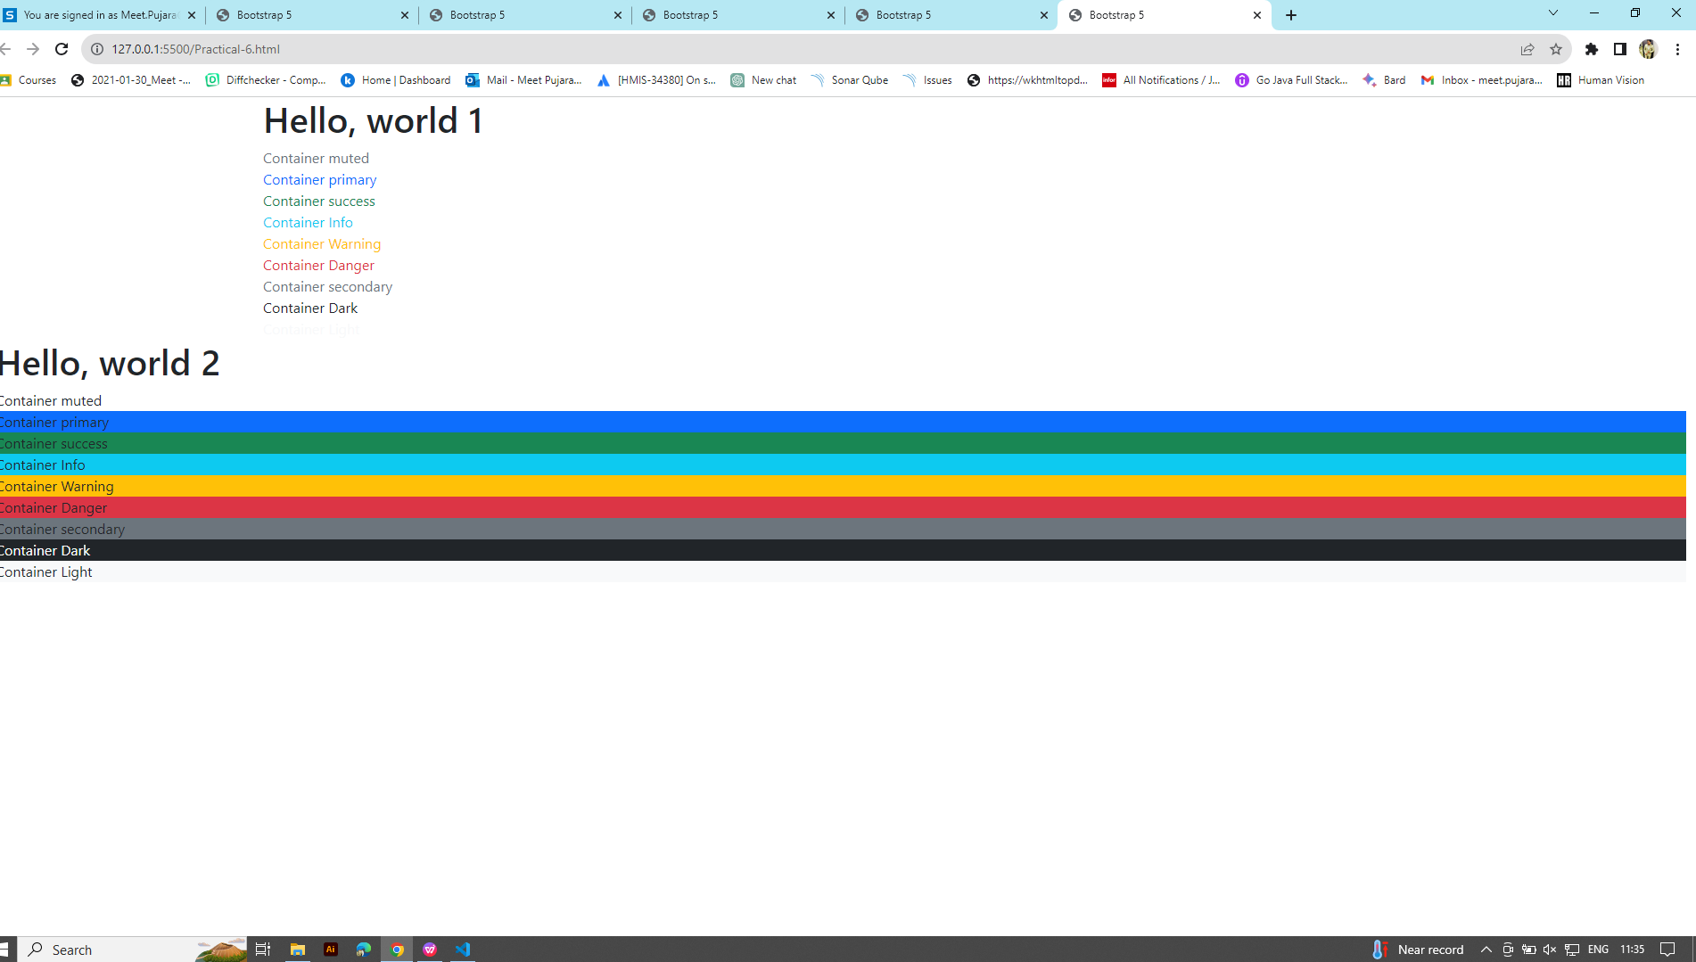

# Practical-8). Alerts Components

<!doctype html>

<html lang="en">

<head>

    <meta charset="utf-8">

    <meta name="viewport" content="width=device-width, initial-scale=1">

    <link href="bootstrap-5.0.2/dist/css/bootstrap.min.css" rel="stylesheet">

    <link href="style.css" rel="stylesheet">

    <title>Bootstrap 5</title>

</head>

<body>

    <div class="container box">

        <h1>Hello, world 1</h1>

        <div class="alert alert-success">Container Alert <a class="alert-link" href=" ">Link</a></div>

        <div class="alert alert-primary">Container Alert <a class="alert-link" href=" ">Link</a></div>

        <div class="alert alert-success alert-dismissible">Container Alert

            <a class="alert-link" href=" ">Link</a>

            <button type="button" class="btn-close" data-bs-dismiss="alert"></button>

        </div>

        <div class="alert alert-danger alert-dismissible">Container Alert

            <a class="alert-link" href=" ">Link</a>

            <button type="button" class="btn-close" data-bs-dismiss="alert"></button>

        </div>

        <div class="alert alert-info alert-dismissible fade show">Container Alert

            <a class="alert-link" href=" ">Link</a>

            <button type="button" class="btn-close" data-bs-dismiss="alert"></button>

        </div>

        <script src="bootstrap-5.0.2/dist/js/bootstrap.min.js"></script>

</body>

</html>

