|  |
| --- |
|  |
| Property Registration |
| Smart Contract Solution Document |
|  |
| **Ankit Kumar** |
| **4/20/2023** |

|  |
| --- |
| Document contains step by step guide to user who would like to understand different methods available implemented in the smart contracts and execute to understand the output. |

## Introduction

There are two smart contracts

1. for User
2. Registrar. NodeJS is used to write these smart contracts.

## Pre-requisites

These smart contracts were developed using the VM provided by UpGrad which contains necessary software for deploying and executing smart contracts.

## Users

* Seller – AnkitKumar1, ankit.kkumar@gmail.com, 1234123412341231
* Buyer – Ankit Kumar Dev, dev.ankit.kkumar@gmail.com, 1234123412341232

## Step 1: Bootstrap the network

### **Command**

1. Go to the ‘network’ folder of the project
2. Execute the command ./fabricNetwork.sh up, which will prompt for the confirmation to boot the network. Enter ‘Y’ in the terminal to bring up the network.

### Terminal Screenshot:

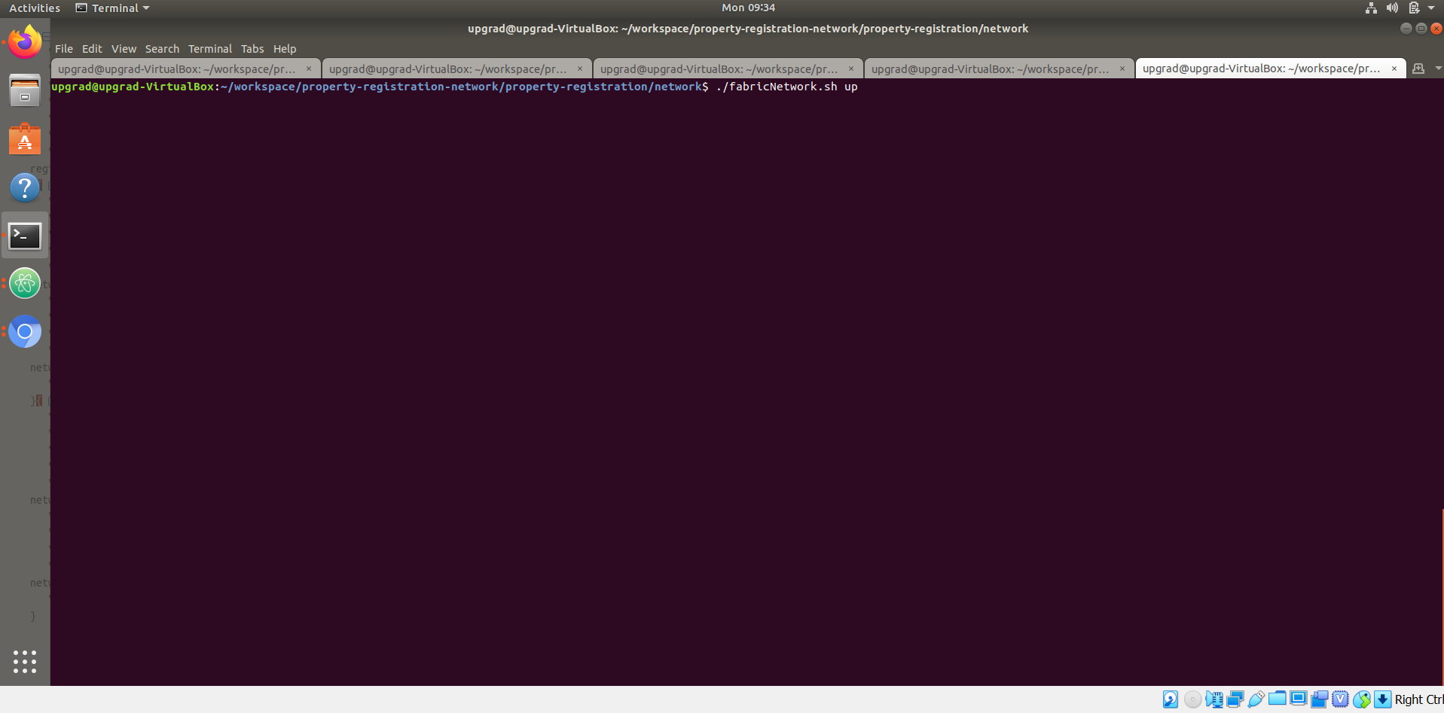

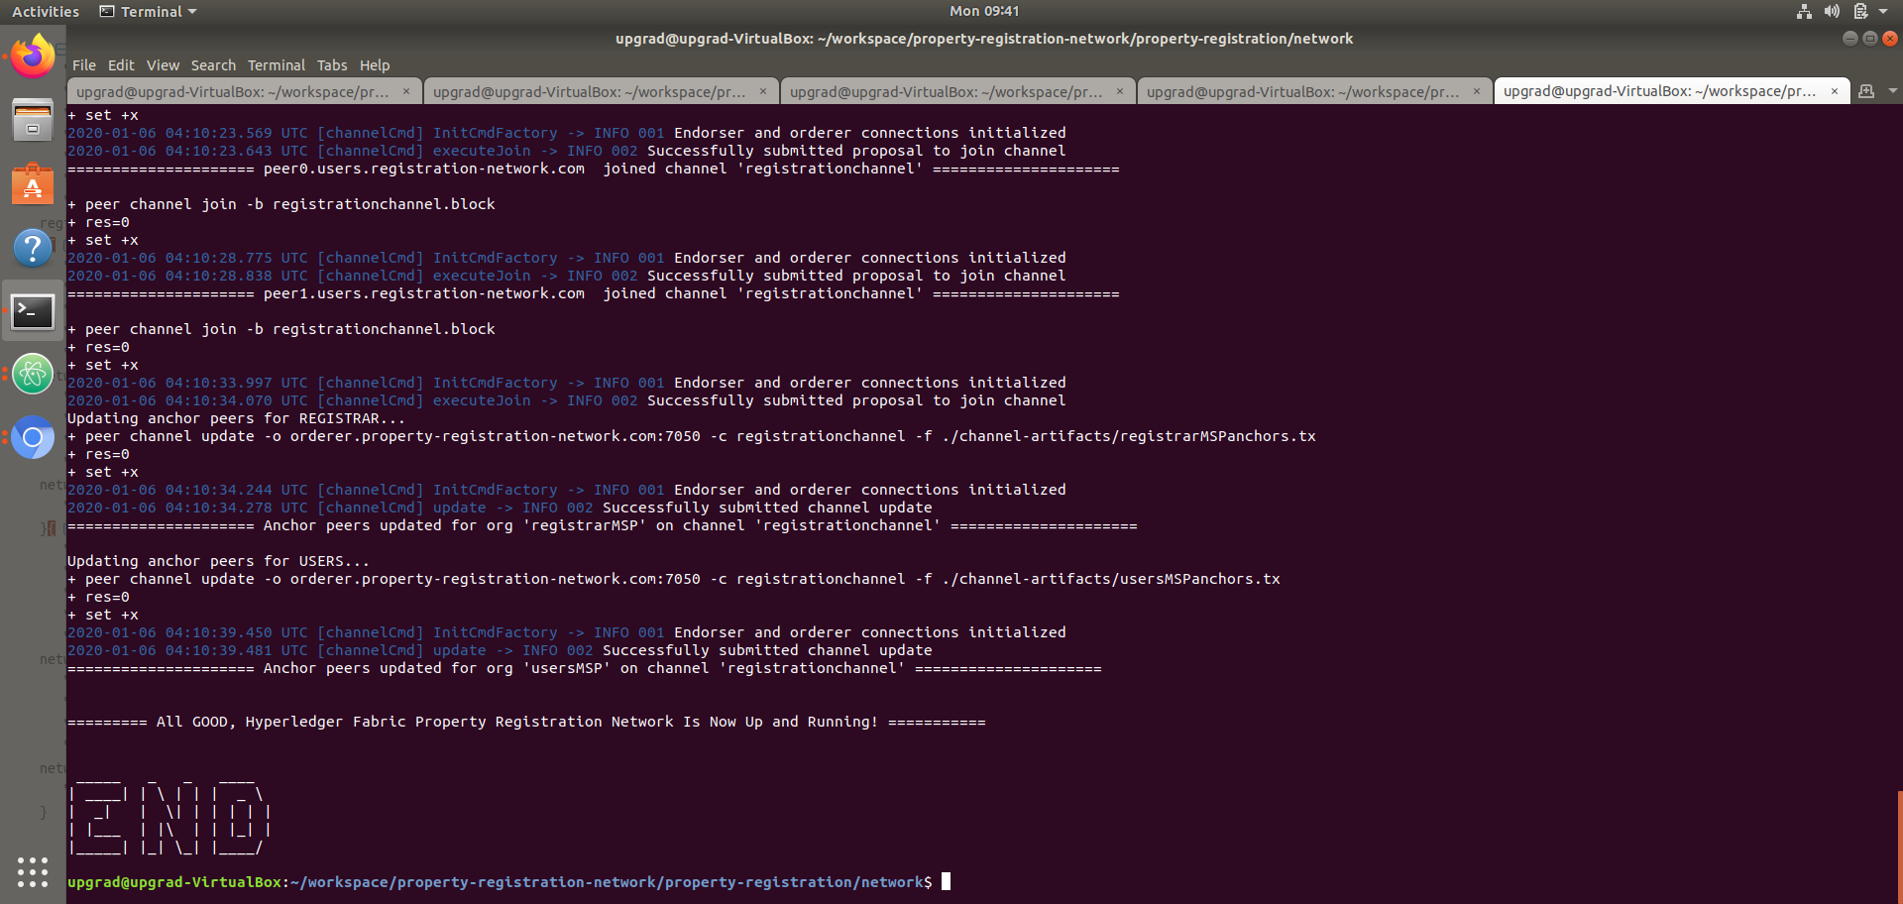

## Step 2: Chaincode Installation and Instantiation

### Command:

1. Once Step1 is complete, execute below command which will install & instantiate the smart contracts in chaincode container and allow us to invoke different methods listed below.
2. ./fabricNetwork.sh install

### Terminal

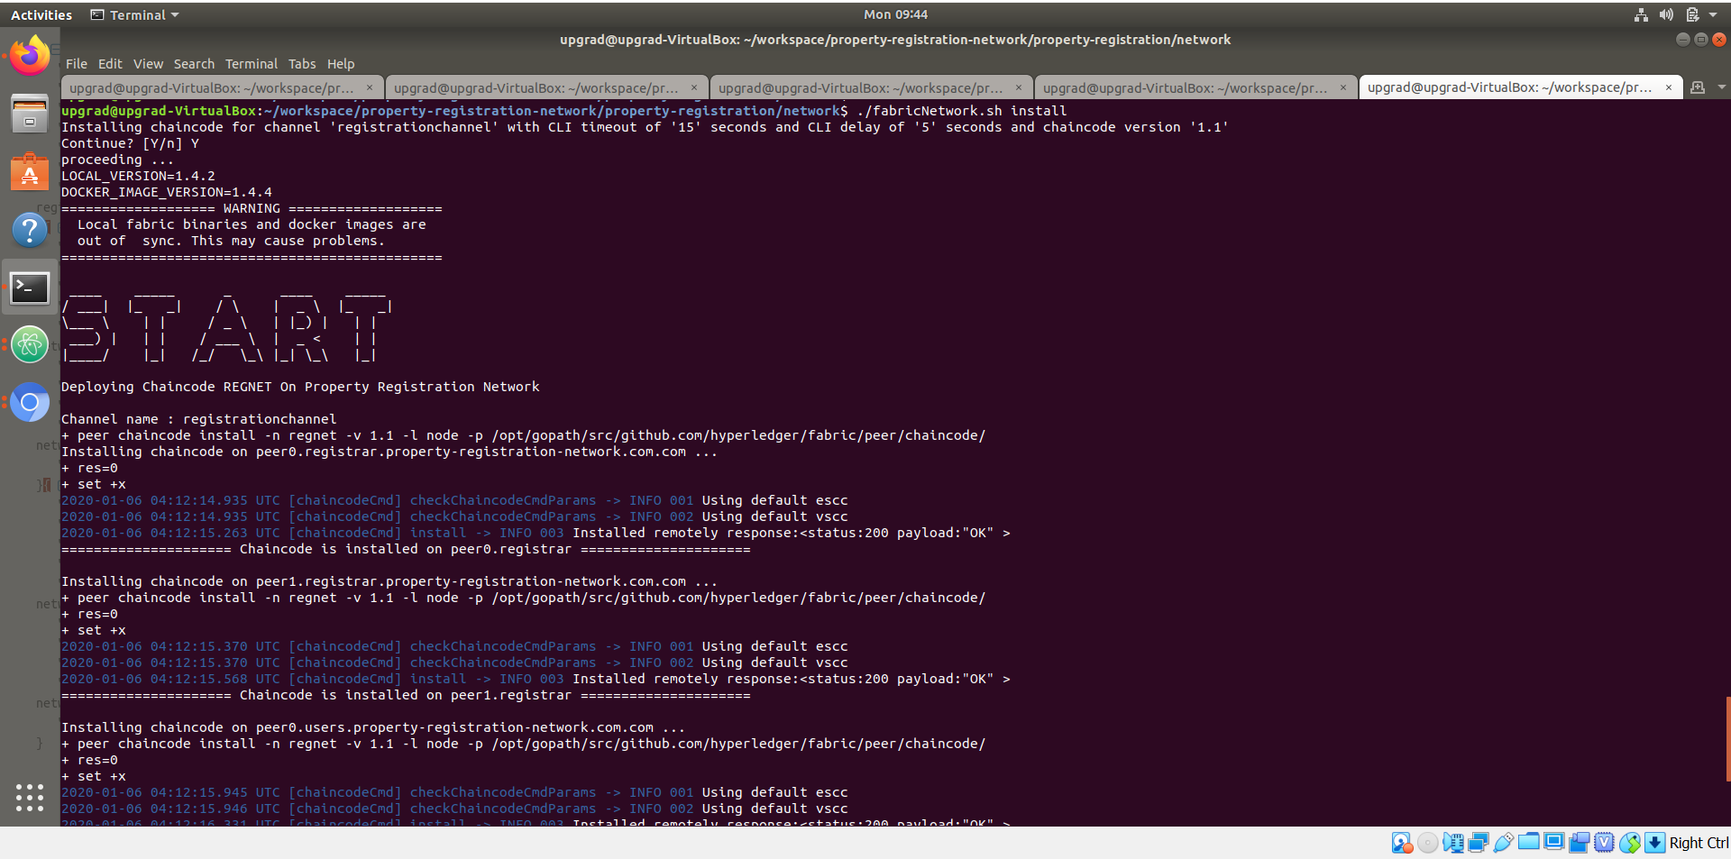

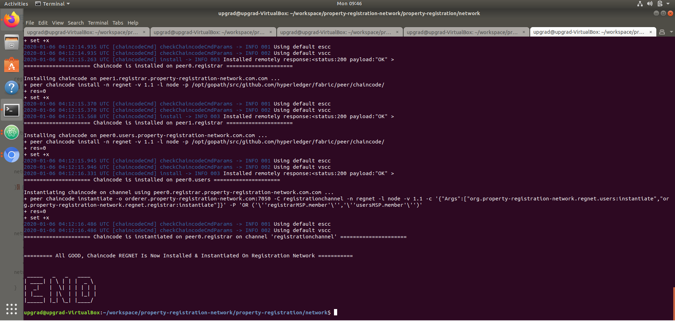

## Step 3: Start the chaincode node application

This is a must have step before proceeding to Step 4

### Command:

1. Enter into docker container for chaincode using command docker exec -it chaincode /bin/bash
2. Install node modules using ‘npm install’ command which will install all necessary Node modules inside chaincode container.
3. Start the node application: npm run start-dev

### Terminal:

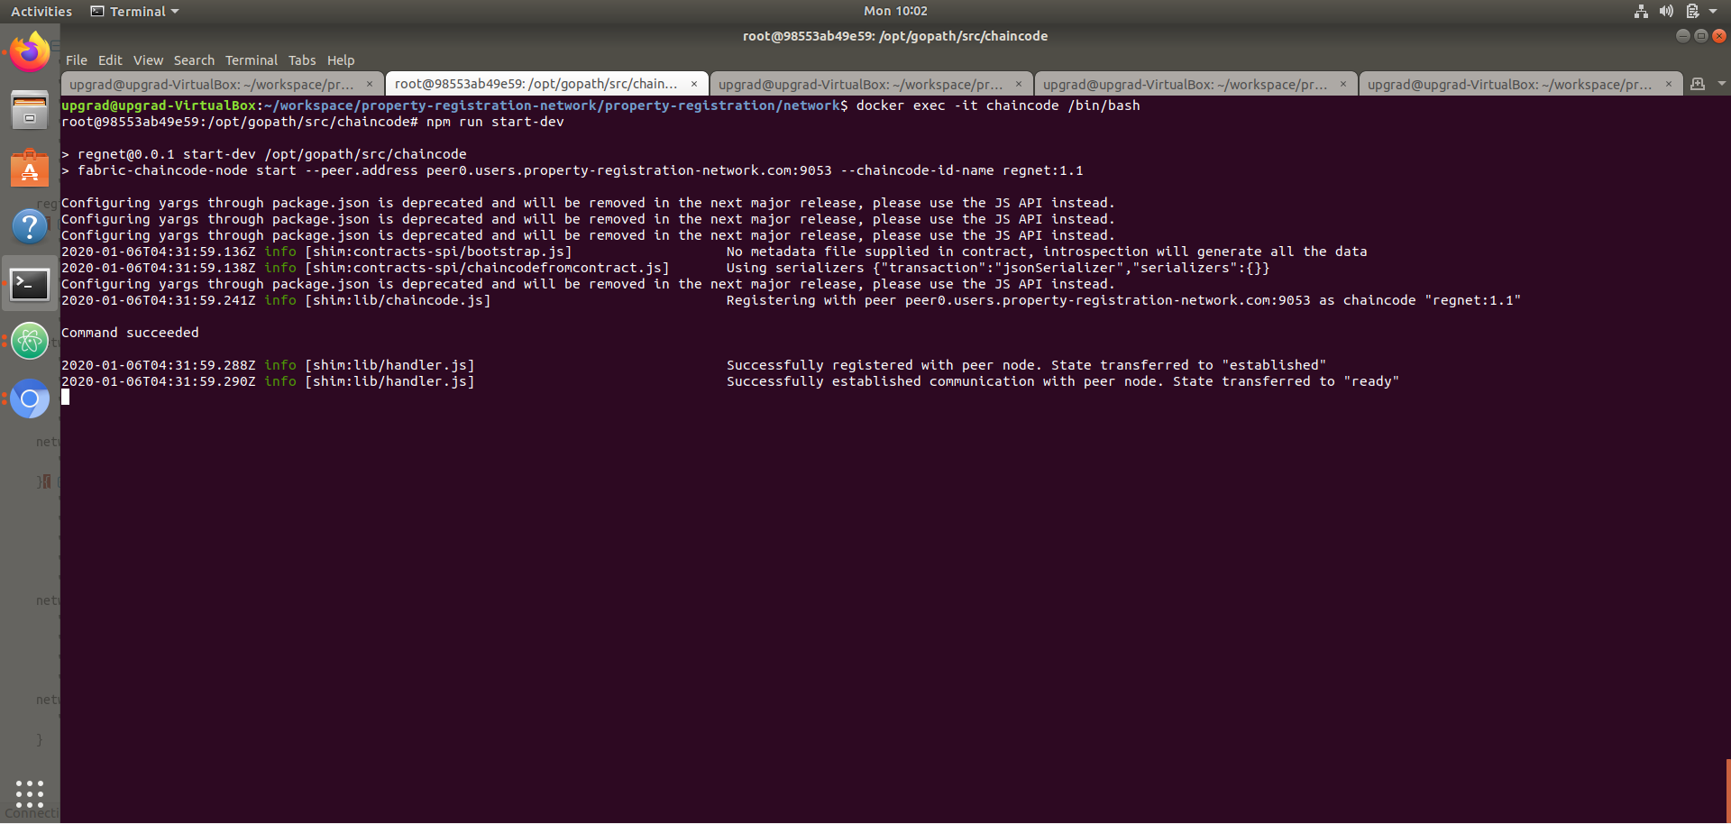

## Step 4: Invoke Smart Contract Methods

### Method 1: requestNewUser

#### Commands:

1. Enter into Peer0 of users org: docker exec -it peer0.users.property-registration-network.com /bin/bash
2. Execute command: peer chaincode invoke -o orderer.property-registration-network.com:7050 -C registrationchannel -n regnet -c'{"Args":["org.property-registration-network.regnet.users:requestNewUser","Ankit Kumar","ankit.kkumar@gmail.com","1234567890","1234123412341231"]}'

#### Terminal:

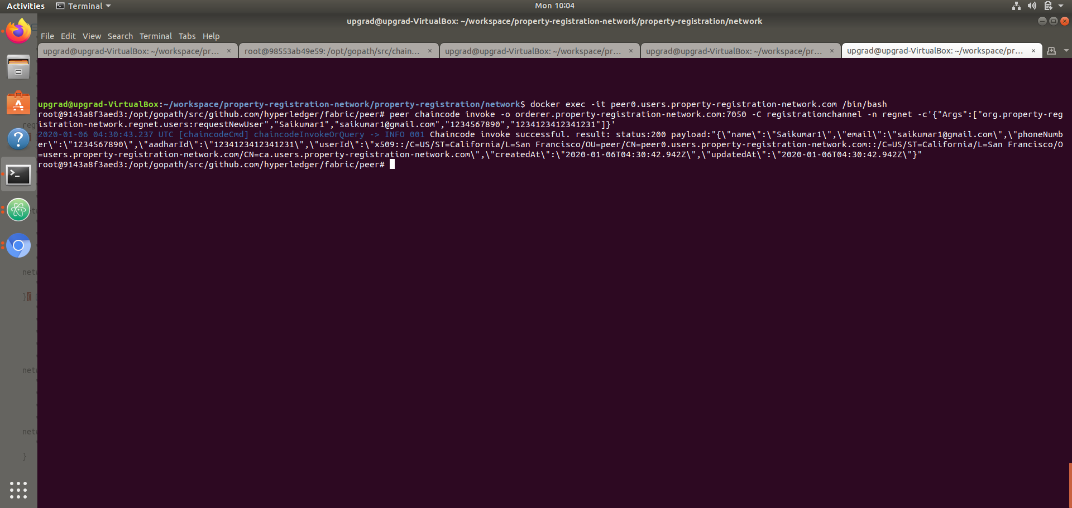

### Method 2: approveNewUser

#### Commands:

1. Enter into Peer0 of registrar org: docker exec -it peer0.registrar.property-registration-network.com /bin/bash
2. Execute command: peer chaincode invoke -o orderer.property-registration-network.com:7050 -C registrationchannel -n regnet -c'{"Args":["org.property-registration-network.regnet.registrar:approveNewUser","Ankit Kumar","1234123412341231"]}'

#### Terminal:

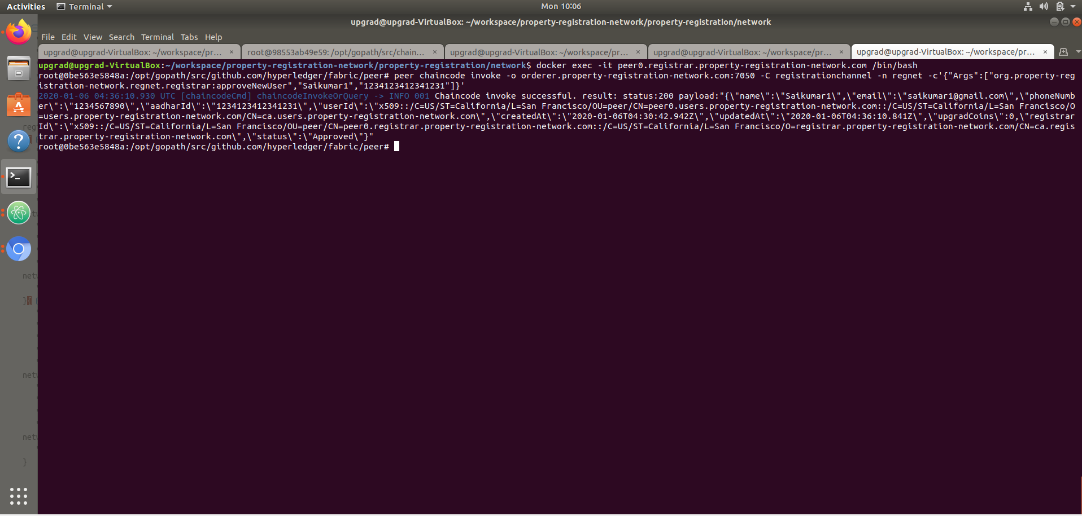

### Method 3: rechargeAccount

#### Commands:

1. Enter into Peer0 of users org: docker exec -it peer0.users.property-registration-network.com /bin/bash
2. Execute command:
   1. Success: peer chaincode invoke -o orderer.property-registration-network.com:7050 -C registrationchannel -n regnet -c'{"Args":["org.property-registration-network.regnet.users:rechargeAccount","Ankit Kumar","1234123412341231","upg500"]}'
   2. Failure: peer chaincode invoke -o orderer.property-registration-network.com:7050 -C registrationchannel -n regnet -c'{"Args":["org.property-registration-network.regnet.users:rechargeAccount","Ankit Kumar","1234123412341231","upgr500"]}'

#### Terminal for Success & Failure:

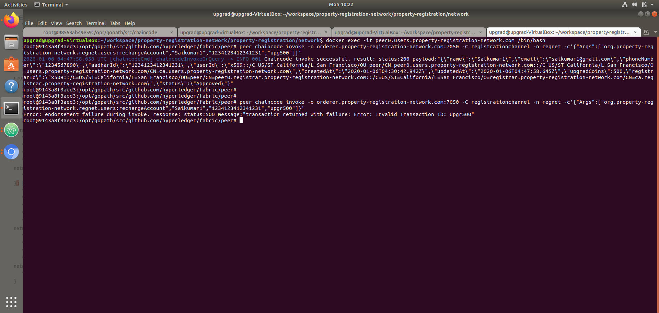

### Method 4: viewUser

#### Commands for Users Org:

1. Enter into Peer0 of users org: docker exec -it peer0.users.property-registration-network.com /bin/bash
2. Execute command: peer chaincode invoke -o orderer.property-registration-network.com:7050 -C registrationchannel -n regnet -c'{"Args":["org.property-registration-network.regnet.users:viewUser","Ankit Kumar","1234123412341231"]}'

#### Commands for Registrar Org:

1. Enter into Peer0 of registrar org: docker exec -it peer0.registrar.property-registration-network.com /bin/bash
2. Execute command: peer chaincode invoke -o orderer.property-registration-network.com:7050 -C registrationchannel -n regnet -c'{"Args":["org.property-registration-network.regnet.registrar:viewUser","Ankit Kumar","1234123412341231"]}'

#### Terminal for User:

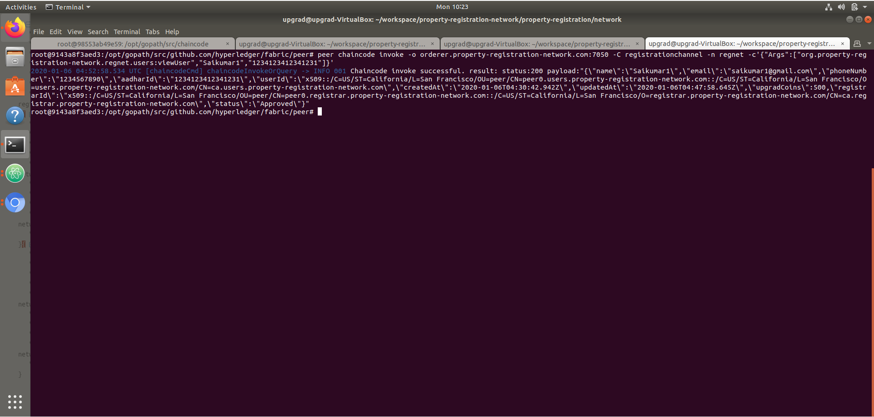

#### Terminal for Registrar:

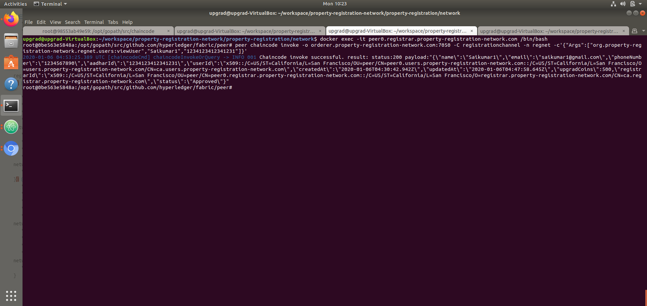

### Method 5: propertyRegistrationRequest

#### Commands:

1. Enter into Peer0 of users org: docker exec -it peer0.users.property-registration-network.com /bin/bash
2. Execute command: peer chaincode invoke -o orderer.property-registration-network.com:7050 -C registrationchannel -n regnet -c'{"Args":["org.property-registration-network.regnet.users:propertyRegistrationRequest","001","200","Ankit Kumar","1234123412341231"]}'

#### Terminal:

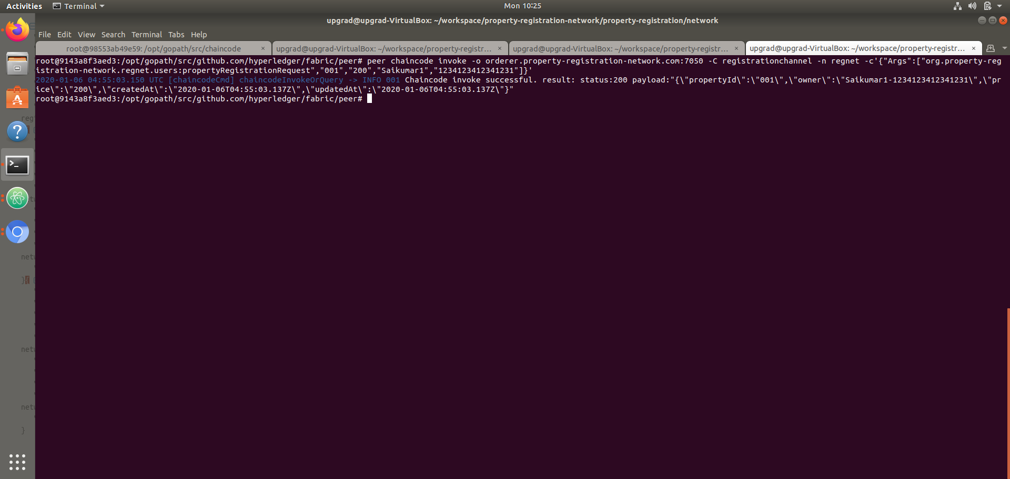

### Method 6: approvePropertyRegistration

#### Commands:

1. Enter into Peer0 of registrar org: docker exec -it peer0.registrar.property-registration-network.com /bin/bash
2. Execute command: peer chaincode invoke -o orderer.property-registration-network.com:7050 -C registrationchannel -n regnet -c'{"Args":["org.property-registration-network.regnet.registrar:approvePropertyRegistration","001"]}'

#### Terminal:

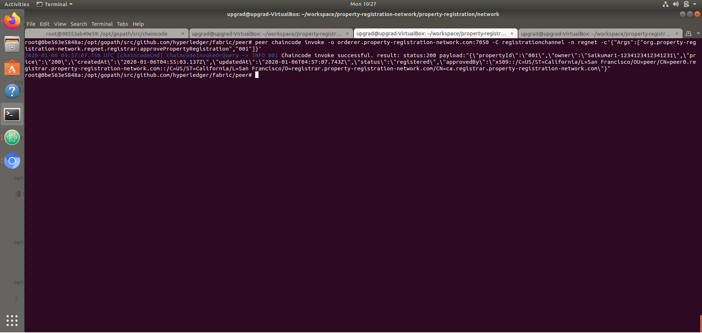

### Method 7: viewProperty

#### Commands for Users Org:

1. Enter into Peer0 of users org: docker exec -it peer0.users.property-registration-network.com /bin/bash
2. Execute command: peer chaincode invoke -o orderer.property-registration-network.com:7050 -C registrationchannel -n regnet -c'{"Args":["org.property-registration-network.regnet.users:viewProperty","001"]}'

#### Commands for Registrar Org:

1. Enter into Peer0 of registrar org: docker exec -it peer0.registrar.property-registration-network.com /bin/bash
2. Execute command: peer chaincode invoke -o orderer.property-registration-network.com:7050 -C registrationchannel -n regnet -c'{"Args":["org.property-registration-network.regnet.registrar:viewProperty","001"]}'

#### Terminal for Users:

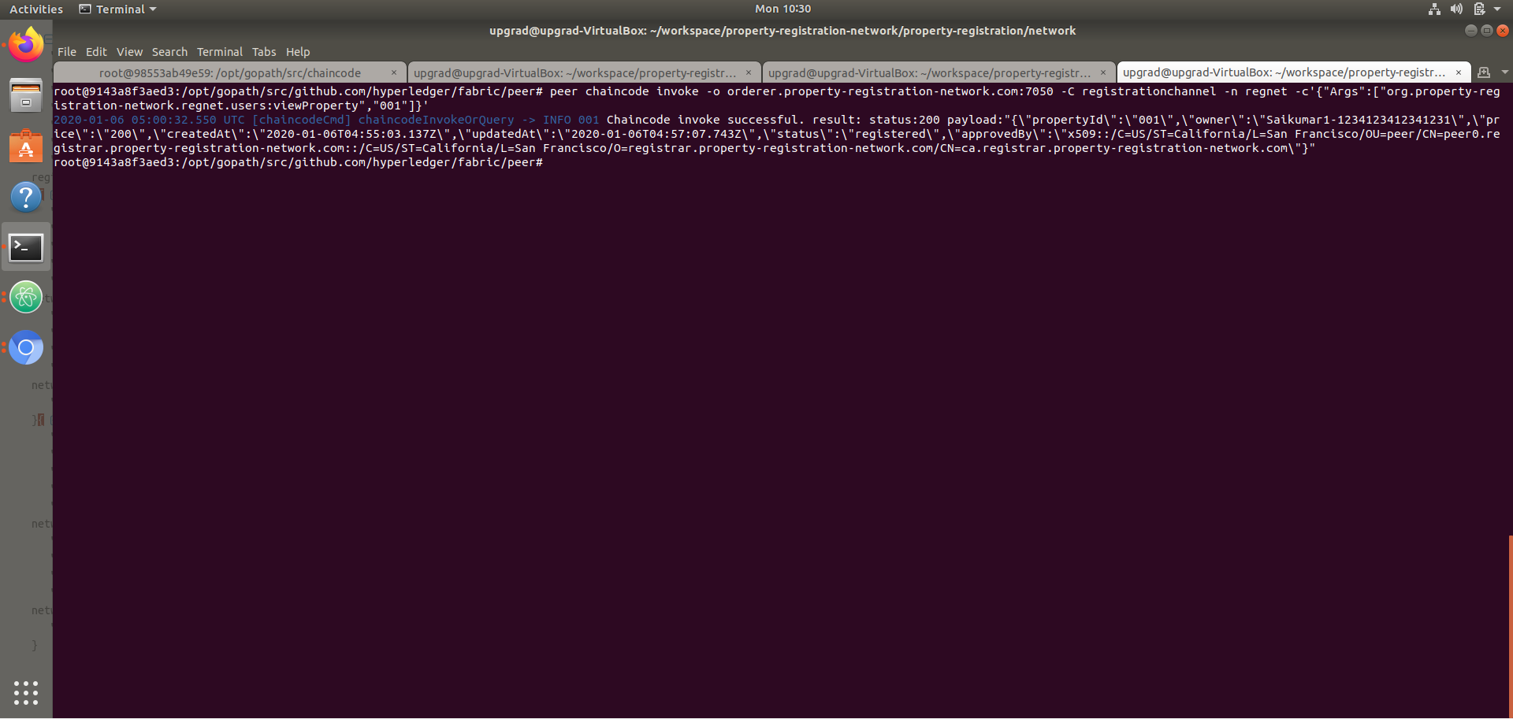

#### Terminal for Registrar:

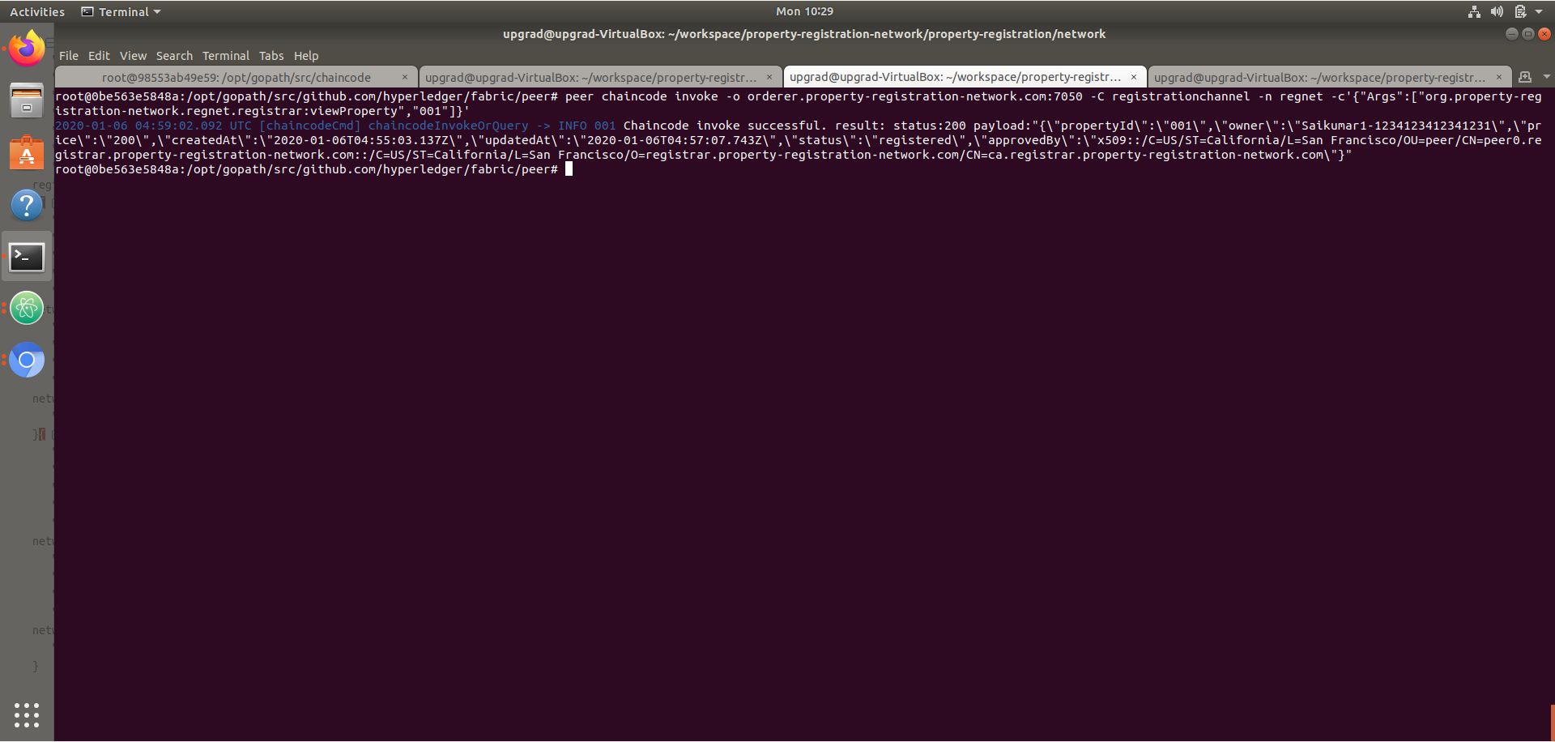

### Method 8: updateProperty

#### Commands:

1. Enter into Peer0 of users org: docker exec -it peer0.users.property-registration-network.com /bin/bash
2. Execute command: peer chaincode invoke -o orderer.property-registration-network.com:7050 -C registrationchannel -n regnet -c'{"Args":["org.property-registration-network.regnet.users:updateProperty","001","Ankit Kumar","1234123412341231","onSale"]}'

#### Terminal:

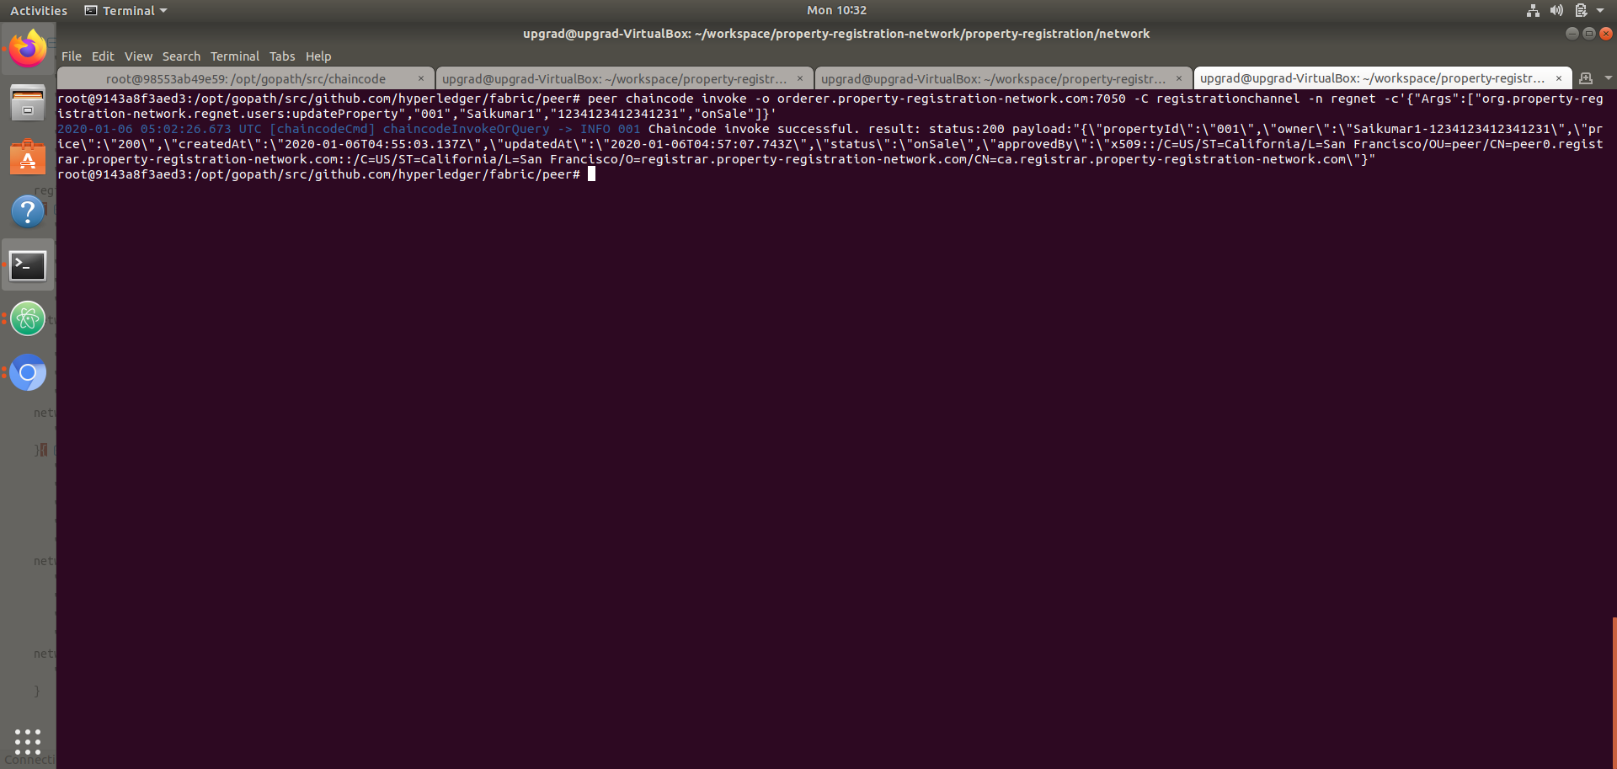

### Method 9: purchaseProperty

#### Pre-requisite:

In order to purchase property, we need to register new user as mentioned below before proceeding with purchase of the property.

#### Steps to register new user (Ankit Kumar Dev) in the network and request property purchase

1. **requestNewUser**: peer chaincode invoke -o orderer.property-registration-network.com:7050 -C registrationchannel -n regnet -c'{"Args":["org.property-registration-network.regnet.users:requestNewUser","Ankit Kumar Dev","dev.ankit.kkumar@gmail.com","1234567892","1234123412341232"]}'

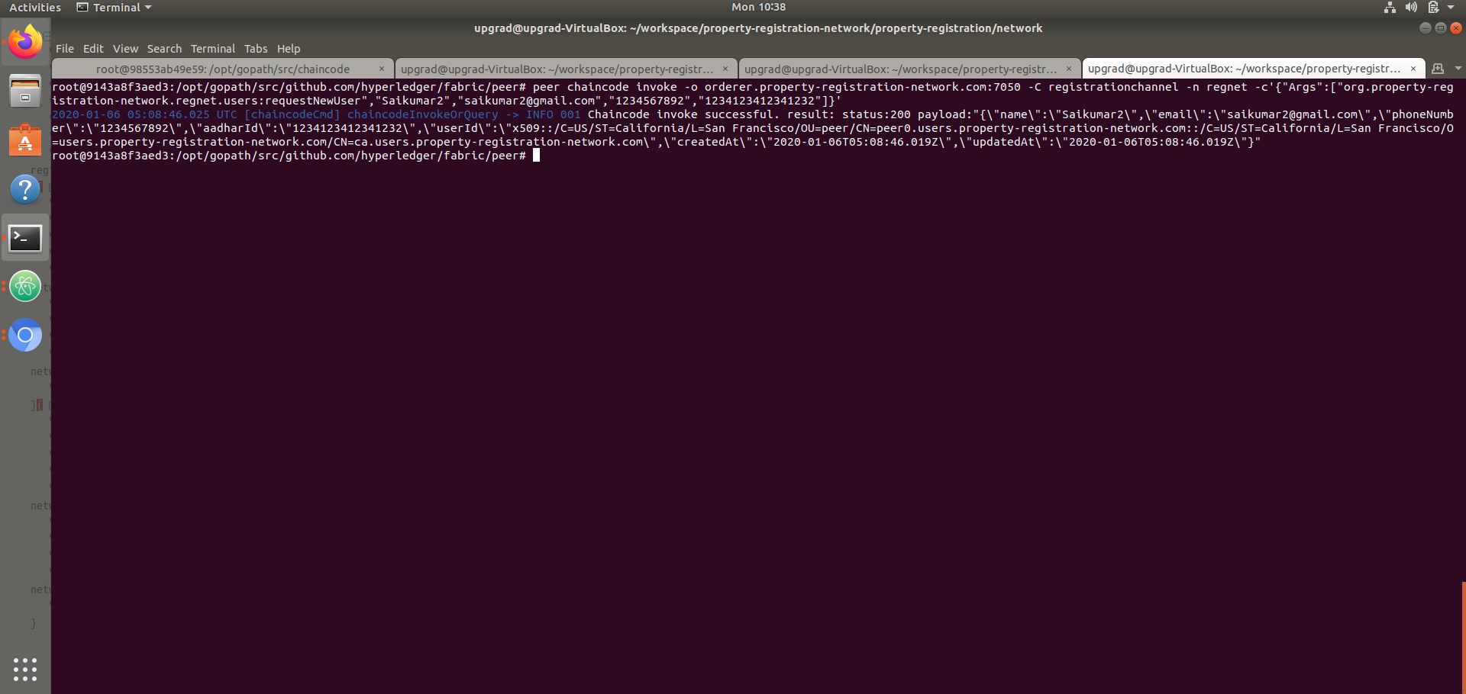

1. **approveNewUser**: peer chaincode invoke -o orderer.property-registration-network.com:7050 -C registrationchannel -n regnet -c'{"Args":["org.property-registration-network.regnet.registrar:approveNewUser","Ankit Kumar Dev","1234123412341232"]}'

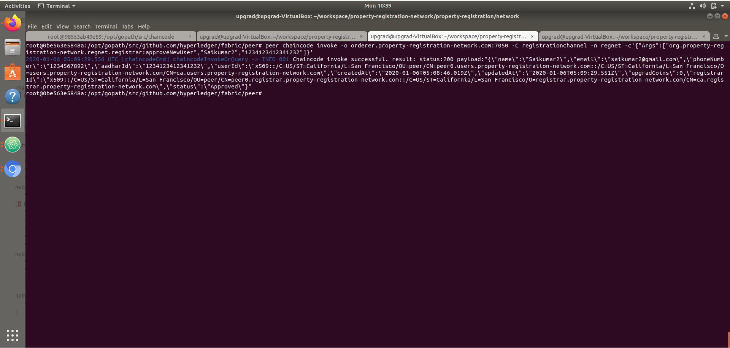

1. **rechargeAccount**: peer chaincode invoke -o orderer.property-registration-network.com:7050 -C registrationchannel -n regnet -c'{"Args":["org.property-registration-network.regnet.users:rechargeAccount","Ankit Kumar Dev","1234123412341232","upg500"]}'

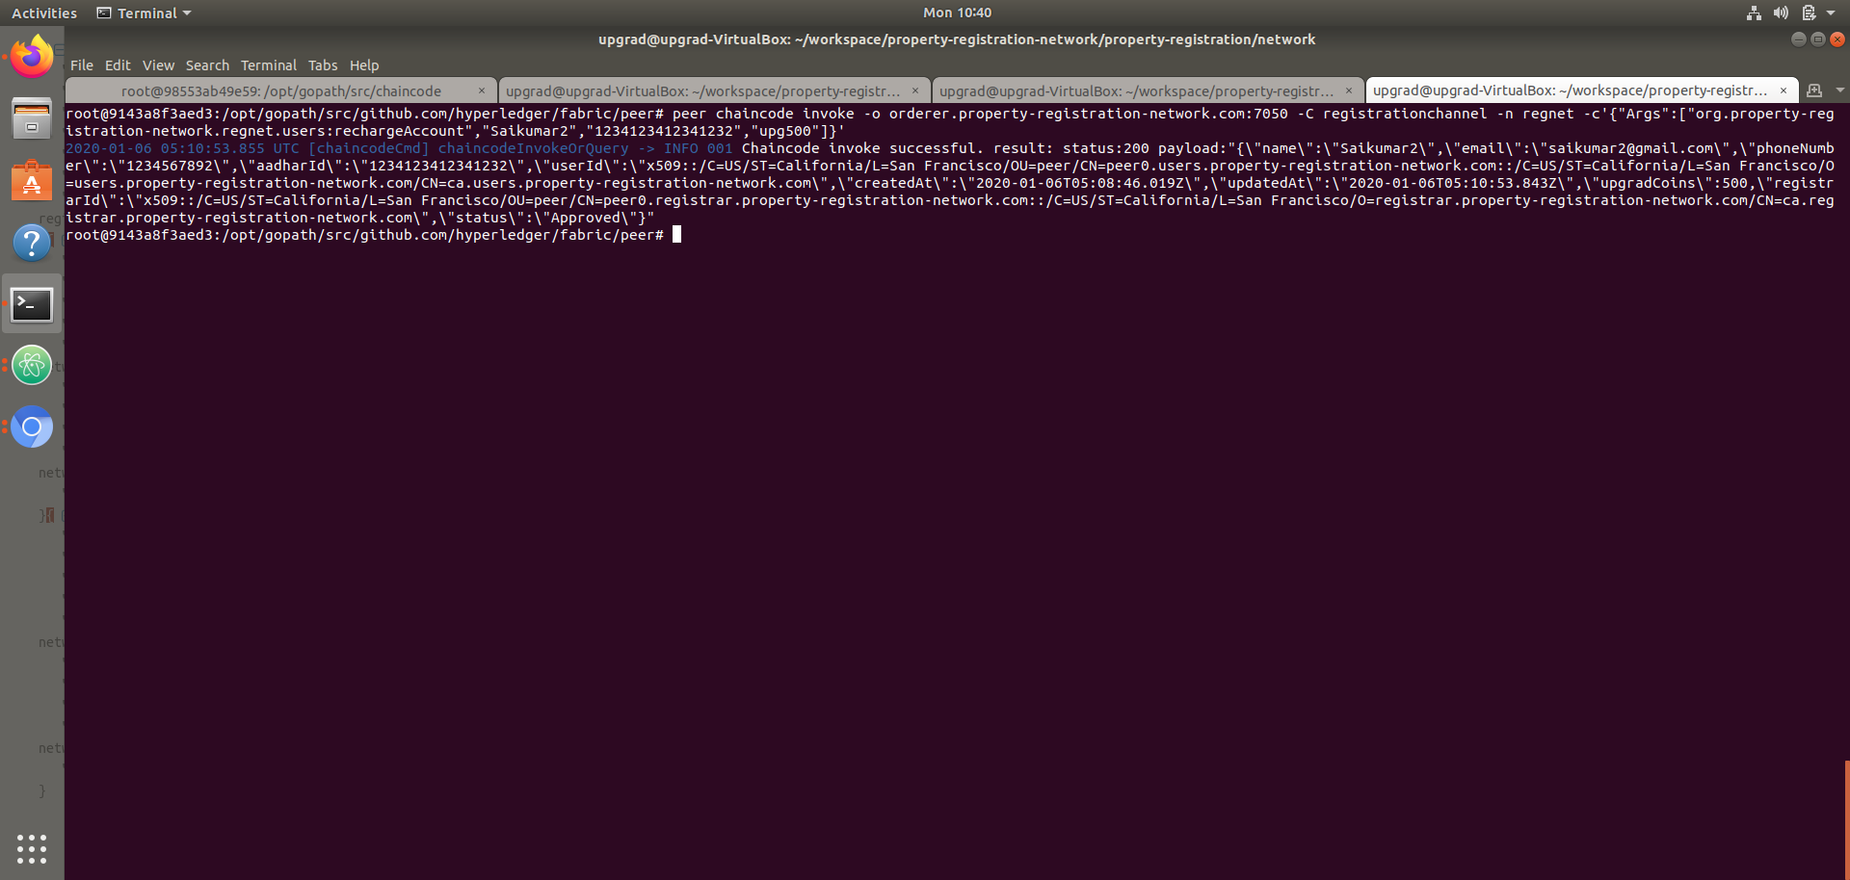

1. **purchaseProperty**: peer chaincode invoke -o orderer.property-registration-network.com:7050 -C registrationchannel -n regnet -c'{"Args":["org.property-registration-network.regnet.users:purchaseProperty","001","Ankit Kumar Dev","1234123412341232"]}'

