Instructions of the experiment

Home page
This experiment studies how individuals make decisions. We do not expect any particular behavior from you. We are not allowed to lie to you in any part of the experiment. You are completely anonymous during the game and your actions will be linked only to your username which is known only to you. The choices you make in the experiment will directly determine the amount of money you earn.

The experiment

The experiment consists of an undetermined number of rounds,
and it will take around an hour and never more than two to complete. The rules are the same for all participants.

During the game you will be paired randomly with a different participant in every round. (In the SP case). Both you and the other participant will be anonymous during the whole experiment.
Therefore you will never know who is the other person in any round and the other persons will never know who you are. They will not even know your username.
The amount of money you earn in each round depends of both your choice and the choice made by the other participants.

The gains from every round of the experiment will be summed at the end. Apart from that money, you also receive an amount of 2.5 euros for participating.

Gains per round

During the experiment you will have to choose: yellow or blue.
In the table below, you can see that the number of points you earn depends on what both you and the other player have chosen.

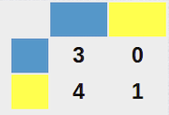

Therefore, if you choose [BLUE] and the other player chooses [BLUE] you earn 3 and the other player earns 3. If you choose [YELLOW] and the other player chooses [BLUE] you earn 4 and the other player earns 0. If you choose [BLUE] and the other player chooses [YELLOW] you earn 0 and the other player earns 4. If both choose [YELLOW], both get 1.

Each point you gain corresponds to 0.05 euros. This table will be also be visible in the top right corner during every step of the experiment. You can also find it in the written instructions.

The interface

This is the first screen you will see:

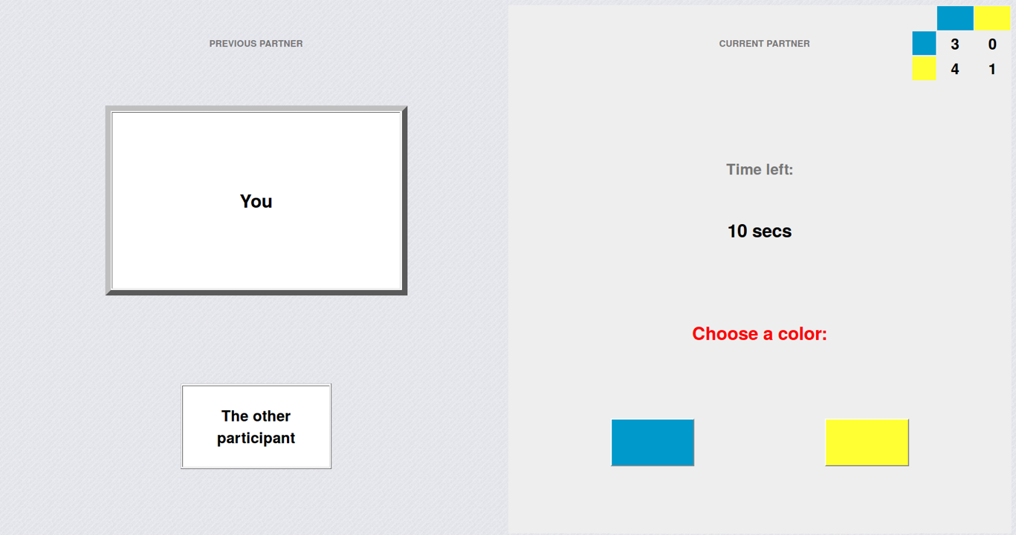

The screen is divided in two panels. In the left panel you can see what happend in the previous round with your previous partner. In the right panel you will have to choose a color.
In the first round the squares in the left panel are white because there was no previous information. In this part of the tutorial I will explain in more detail the right panel.
In the bottom of the right panel you see two buttons: a blue and a yellow button. By clicking one of these buttons you make your choice in every round of the experiment. In the middle of the panel you can see how much time is left for you to make your choice. You should be able to make your choice within the 30 seconds. Nothing happens when the time runs out. It only will result in a delay for all the other participants. Please, pay attention to the time, otherwise the experiment might take too long.

The following rounds

In the second and all following rounds, you will see a screen like this:

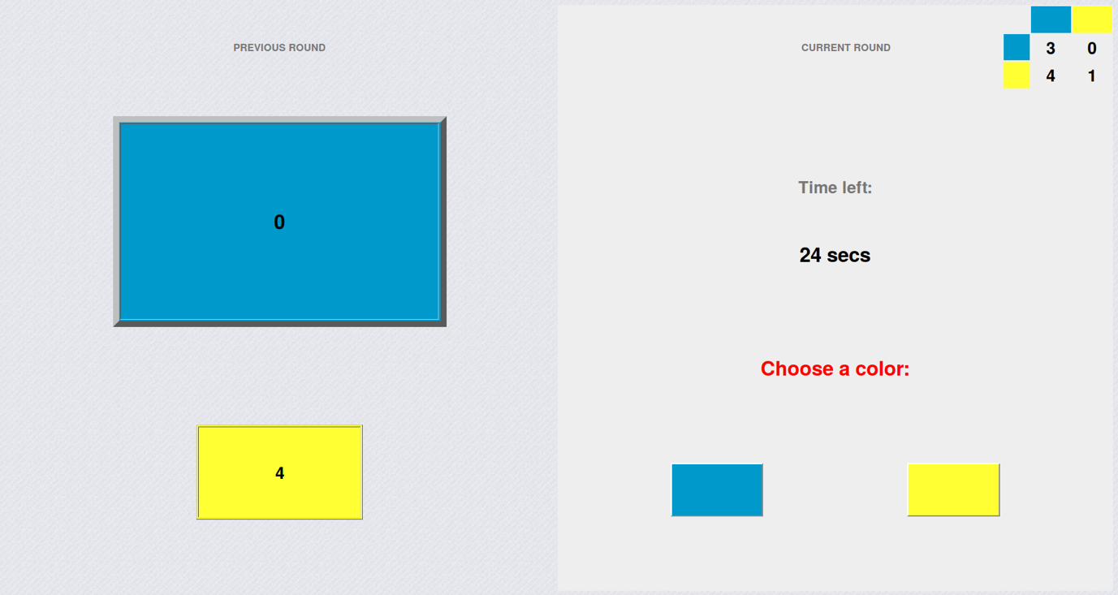

The left panel will now show the choices that both you and the previous partner made in the previous round. The color of the top big square shows your choice and the number in that square shows how many points you earned in the previous round. The color of the bottom small square shows the choice of the other player and the number shows his or her earnings. The right panel has not changed. You can proceed to make your next choice in game with a new partner.

Test your understanding

Please, answer these questions to test your understanding of the experiment. How much would YOU earn in the following situations? On the right you have the table with gains as a reminder.

Questions at the end

Please describe briefly how you decided to push the blue and yellow buttons:

Was your decision influenced by what your PREVIOUS PARTNER did in the previous round:
Yes / No

Was your decision influenced by what YOU did in the previous round?
Yes / No

Was your decision influenced by ALL the choices that were made in the rounds before the previous one? If yes, to what extent?

Is this experiment familiar to you?
Yes / No

What is the name of this game? What do you know about it?

What is your gender?
Male / Female

What is your University or School
VUB / ULB / Other

What is the level of your studies you are currently doing?
Bachelor / Master / PhD / Other

How old are you?

If you want to make another comment, please use the space below:
How did you hear about the experiment?
Flyer / Poster / Email / Facebook / Other

