SE575 Course Project – Design and Build a Blockchain Simulator

**Project Information**

Historically I have left project selection open ended, allowing students to propose their own projects based on personal interest, or helping them learn things that help with work or research. That option is still open, so you may propose your own course project if you want. If you don’t want to do this, the project that I selected is interesting which is to create a blockchain simulator. See below for details.

**Background**

Blockchain technologies are being used these days for a number of interesting applications. The first killer application for Blockchain was the Bitcoin cryptocurrency but use cases for the Blockchain have been growing over the years. Simply stated, a blockchain is a distributed, append-only, immutable distributed ledger that captures information without any centralized party controlling the blockchain. Since there is no centralized party, the novel aspect of blockchain is on how consensus of what is actually contained in the blockchain is governed given that none of the parties adding to the blockchain or querying information from the blockchain do not have any reason to trust each other. Anonymity is another aspect of the blockchain in that the owners of assets or information in the blockchain is kept secret.

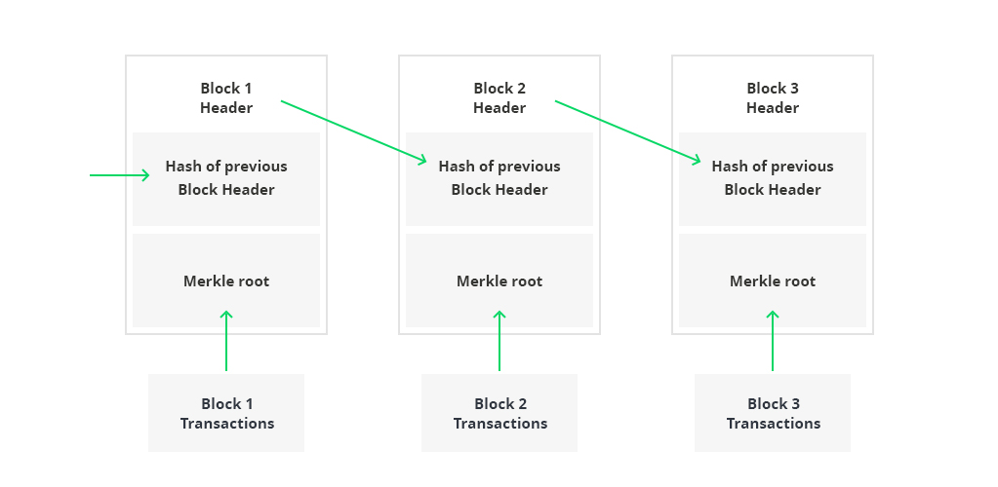

At its core the blockchain is an interesting data structure that is shown above. Individual blocks are “chained” together, and each block contains a series of “transactions”. Since everybody gets a copy of the blockchain, its possible for chains to get out of sync at the end of the chain for a small period of time so they have an additional interesting aspect in that older blocks are considered more trustworthy than blocks at the end of the chain.

**Assignment Objectives**

The following are the objectives:

1. The course will provide some fundamentals around blockchain technology, but you need to spend some time educating yourself on how blockchains work and pick an application for your blockchain – e.g., cryptocurrency, smart contracts, DLP ownership, etc.
2. You are encouraged to share useful information that you use to learn about blockchain in the #blockchainproject course slack channel
3. You must provide a way to build candidate blocks to add to the block chain
4. You must provide a way to add a block to the blockchain using a realistic consensus algorithm. There are a number of them, I would stick to proof-of-work, or proof-of-stake but you can implement any interesting algorithm that you find
5. You must provide a way to tamper with a block on the chain and show that the chain has been altered.
6. You must show how common problems like double spend are handled and mitigated
7. More advanced features to consider for larger teams (you don’t have to implement these but larger teams should have some more realistic features):
   1. Showing how block forks are managed and resolved – e.g., longest chain wins
   2. Showing how block changes are propagated to at least 2 nodes in a network.
   3. Having an API accessible via services to manage the blockchain
   4. Modernizing the packaging and deployment using things like containers and Kubernetes
   5. Using modern programming techniques that you want to learn such as Rx, functional programming, and/or use of a modern language that you might not have known in the past – e.g., Kotlin, golang, Typescript.
8. You must apply some of the design best practices we use in this class to design and implement your project solution.

**Deliverables**

1. All of your code must be placed on a public enterprise git service like github
2. You must submit a proposal about exactly what you are planning to build, and a set of high-level features of your solution. While you can do this project independently, a small team is highly encouraged. Team size must not exceed 5 people. The larger the team the more complete the solution must be – all team members will receive the same grade
3. All of your build and deploy steps must be automated
4. You must provide in your repository a link to a video (max time is 5 min) demonstrating your solution