CS575 Assignment 1 – Build and Describe an Architecture for an IoT device

**Background**

For this assignment imagine that you were just hired at an Internet of Things startup who has an idea to bring a novel product to market. The product is something that just about everybody has in their homes – its an outdoor light/wall sconce. See below:

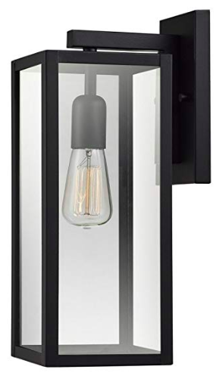

There are a number of people working on the style and colors for the outdoor light, but your job is to enhance the product to make it a “smart light”. The CEO and investors in this company believe that there is a market for such a smart light given that these lights:

* Can have a constant source of power, unlike a smart doorbell
* Are almost always located outdoors
* Tend to be located near doors
* Are not generally viewed by people as having smart capabilities.

**Assignment Objectives**

You have 2 objectives for this assignment:

1. List / devise (and be creative) 5 features that this smart outdoor light can have that you think that people would want to buy. I will give you one, so you have to come up with 4 others. Remember that customers purchasing this light might have very limited technical skills so your features should not require complex technical knowledge or setup.  
     
   **Feature 1:** The smart light will have an integrated camera, and the ability to connect to a wifi network so that customers can download a mobile application and view camera feed information realtime. The camera should be able to deal with both daylight conditions, and nighttime conditions, regardless of if the light its on or off.
2. Develop an architectural description of the smart light that shows how the architecture supports the features that you identified for the product. Your architecture description should include a high-level picture describing the architecture of the product and a writeup showing how the architecture supports the product feature requirements. You are free to pick the notation that you want to use from the ones we talk about in class (informal line and box, UML, C4) as I care more about your ability to communicate an architecture well versus using a specific notation. Don’t forget to think this through, for example, the one feature that I provided above implies that the architecture will need to support:
   1. Connecting to a wifi network securely
   2. The ability to tunnel through a home network that is behind a router
   3. A mobile application able to securely connect and stream data from the integrated camera
   4. Managing power