- Requirement: make sure your machine has openssl tool installed (either Windows or Linux version). You can just type openssl in the command prompt to check whether you have the tool or not. If you see the OpenSSL prompt, you are good to go. Just type exit to end the Openssl prompt.

In Windows command prompt

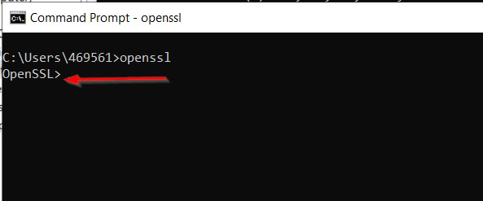

In Linux command line interface

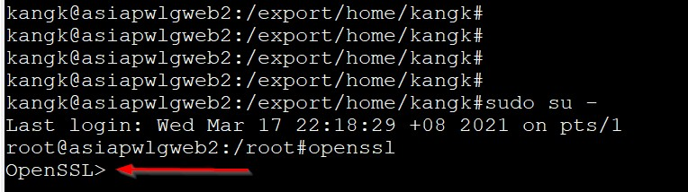
- Copy this file ( SAN.cnf ) to your machine.

e.g. D:\Certs

Edit SAN.cnf and add your SAN information.

- Add DNS.1 as your CN (common name) – compulsory
- If you have SAN, add SAN with DNS.X (X is your sequential numbers after DNS.1) - Change your information here (compulsory):
countryName = Country Name (2 letter code) stateOrProvinceName = State or Province Name (full name) localityName = Locality Name (eg, city) organizationName = SEAGATE TECHNOLOGY LLC ( follow this ) organizationalUnitName = Organizational Unit Name (eg, section)
commonName = Common Name (e.g. server FQDN or YOUR name)

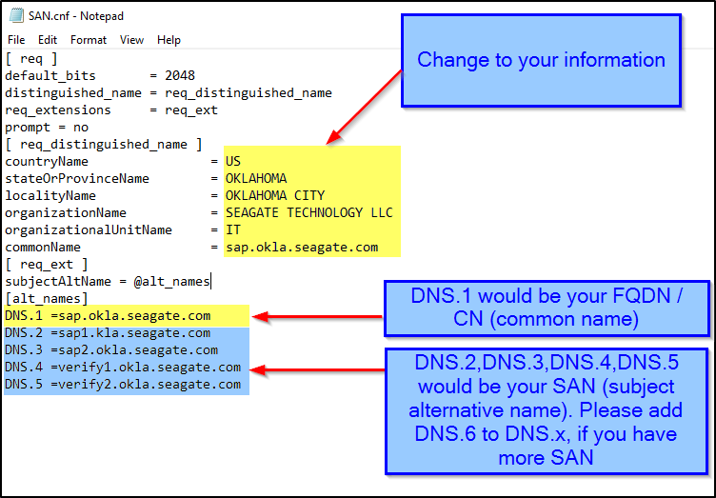

Run this openssl command and it will create below 2 files. Input the csr and key name same as your common name e.g. (sap.okla.seagate.com)

openssl req -new -out D:\Certs\sap.okla.seagate.com.csr -newkey rsa:2048 -nodes -keyout D:\Certs\sap.okla.seagate.com.key -config D:\Certs\SAN.cnf

sap.okla.seagate.com.csr sap.okla.seagate.com.key

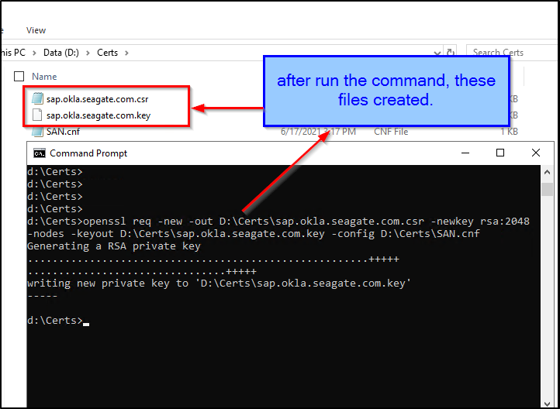

Go to the folder you have specified in step 4 eg: D:\Certs and find csr and key file you have created.

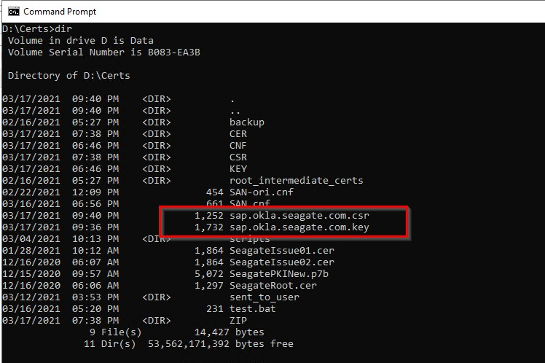
- In the command prompt, input type sap.okla.seagate.com.csr or in Linux input cat sap.okla.seagate.com.csr

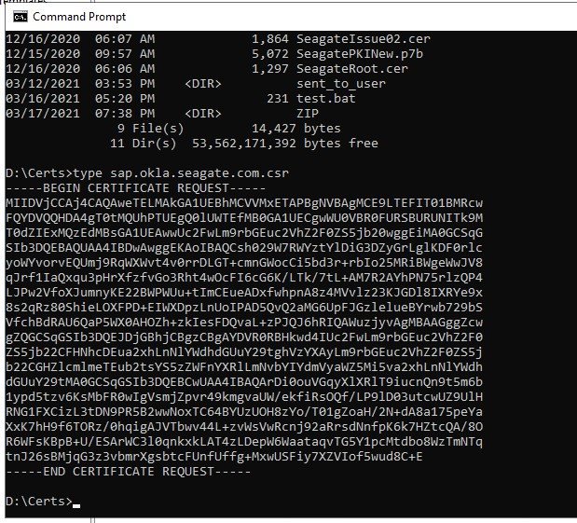

- Copy and paste the content to verify your CSR information https://www.entrust.net/ssl-technical/csr-viewer.cfm

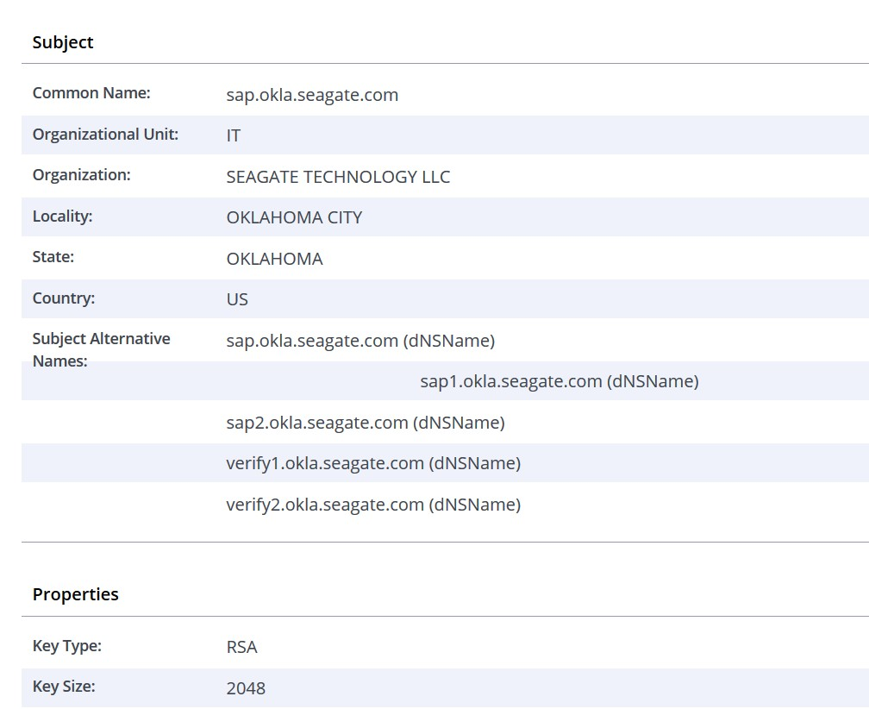

- If all information are correct, you can submit certificate request ticket and attach ONLY this CSR file. Please DO NOT attach the key file to Service Now request and store it in secure file location. This can minimize the key being exposed to public or compromised by Malware or Hacker.

