- Press Windows key + R to open Run, type mmc in the empty box and click OK

Note: you must create CSR file on the server that is going to renew the certificate.

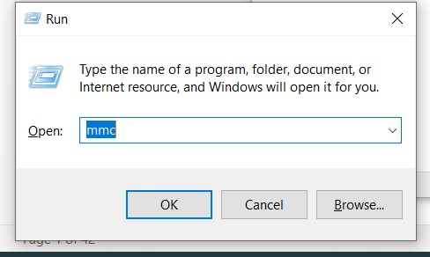
- Go to File -> Add / Remove Snap In

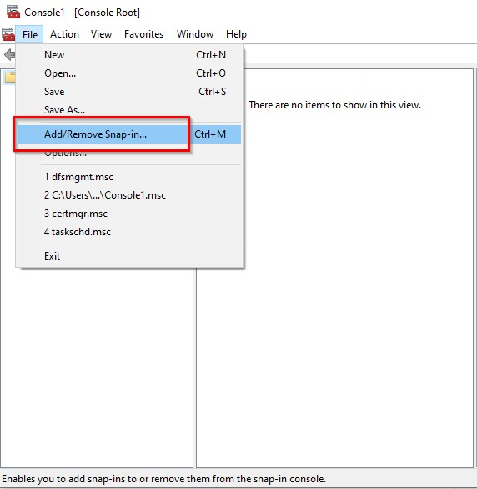
- Select Certificates -> Add -> OK

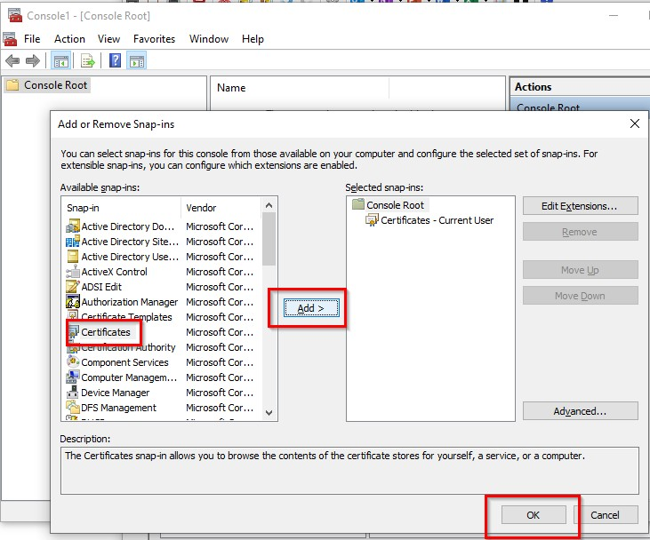
- Select Computer account -> Next

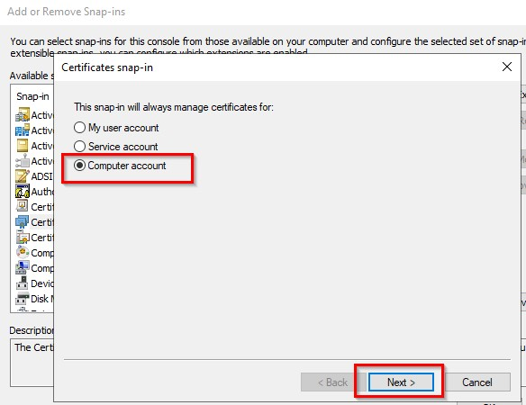
- Select Local computer -> Finish

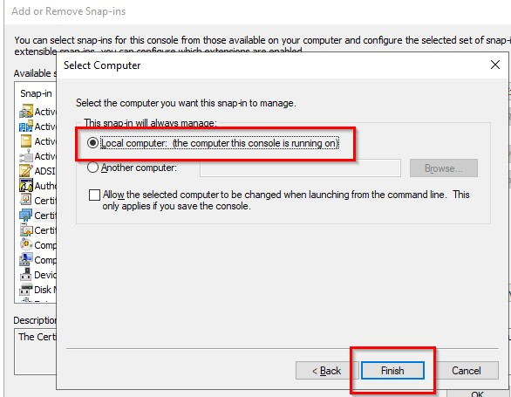

- Right click on Certificates and select All Tasks -> Advanced Operations -> Create Custom Request...

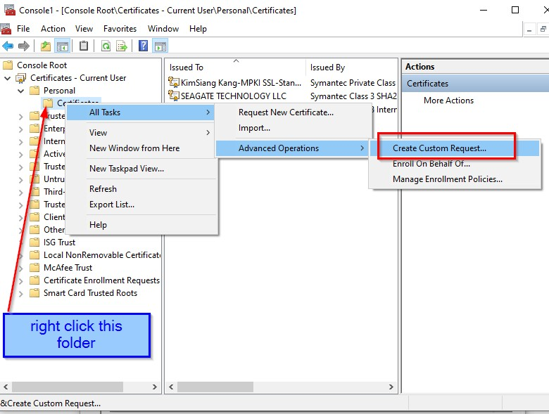
- Click Next

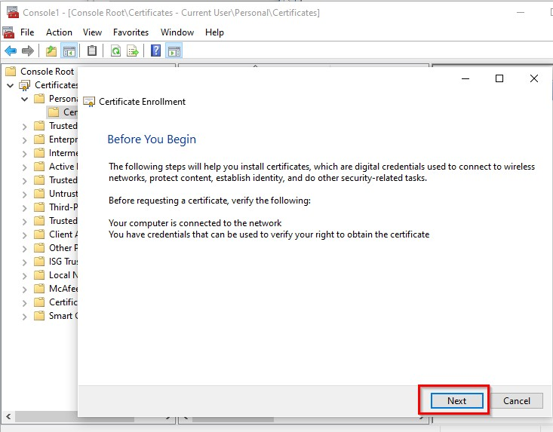
- Select Proceed without enrollment policy and click Next

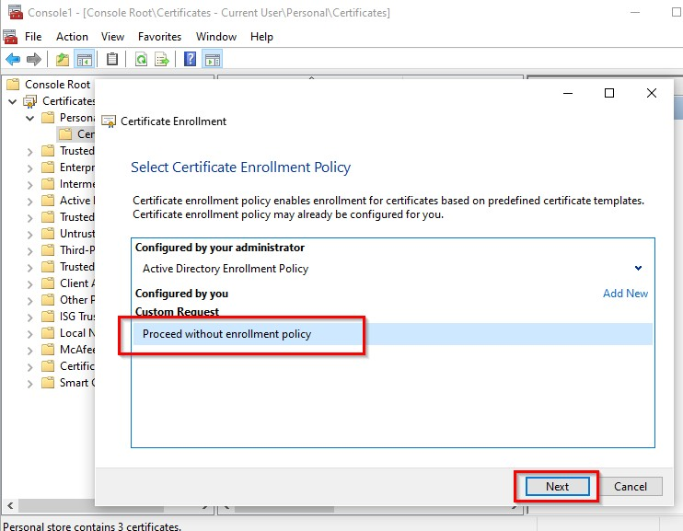
- Select (No template) Legacy key and Next

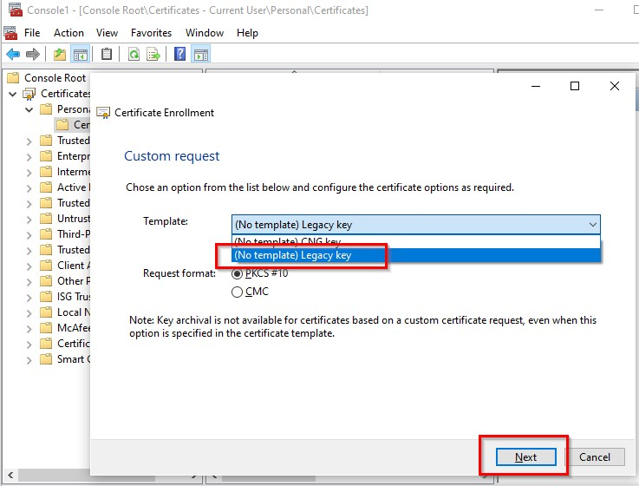

- Click Details -> Properties

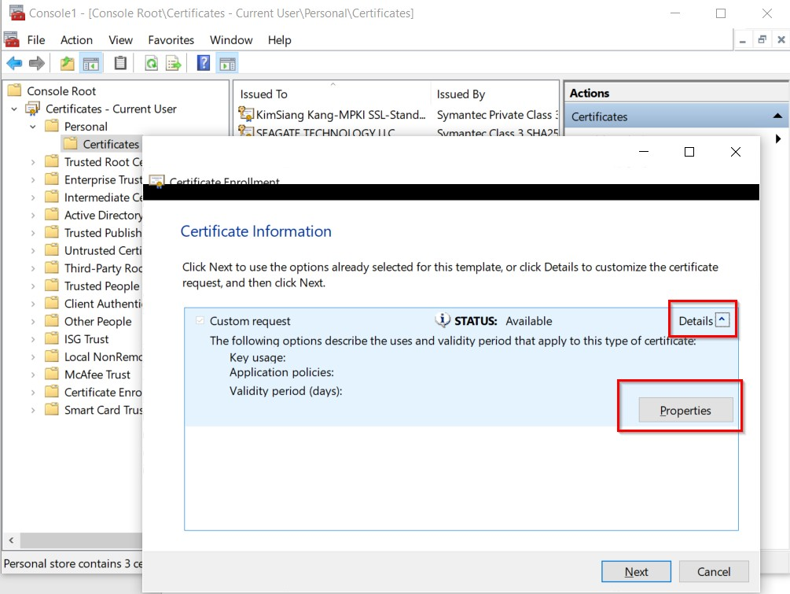

Click General tab -> input Friendly name

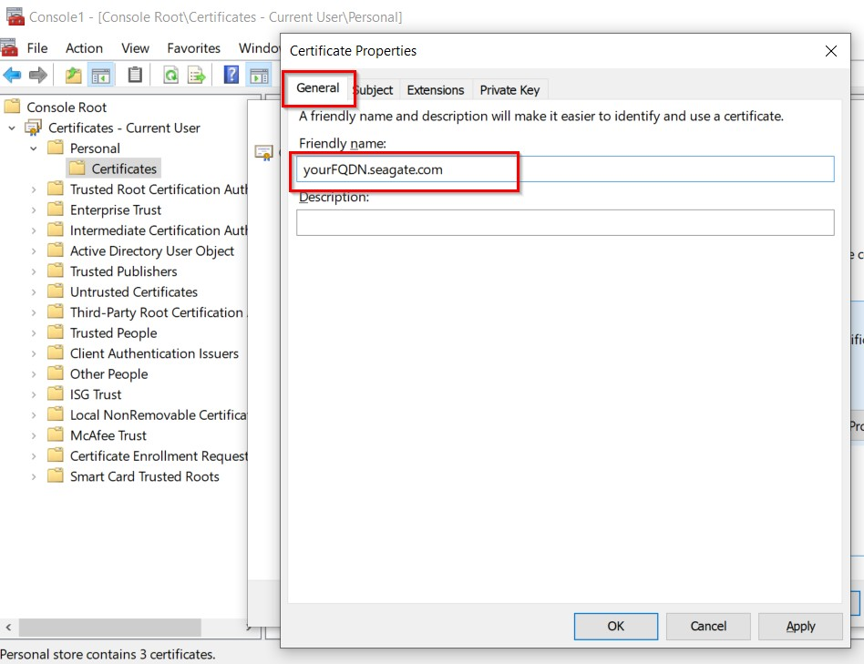

Click Subject tab -> Input Subject name -> input Alternative name

  - Subject name: choose Full DN
  - Copy and edit this red line according to your CN (common name), paste in value box and click Add
CN=thapps04.tep.thai.seagate.com,C=SG,ST=Singapore,L=Singapore,OU=IT,O=SEAGATE TECHNOLOGY LLC
If your cert request is Digicert or External cert, please use
CN=sgmxxxxxx.sing.seagate.com,C=US,ST=OKLAHOMA,L=OKLAHOMA CITY,OU=IT,O=SEAGATE TECHNOLOGY LLC c) Alternative name: choose DNS
d) Input the CN(common name) same as your CN in Subject name

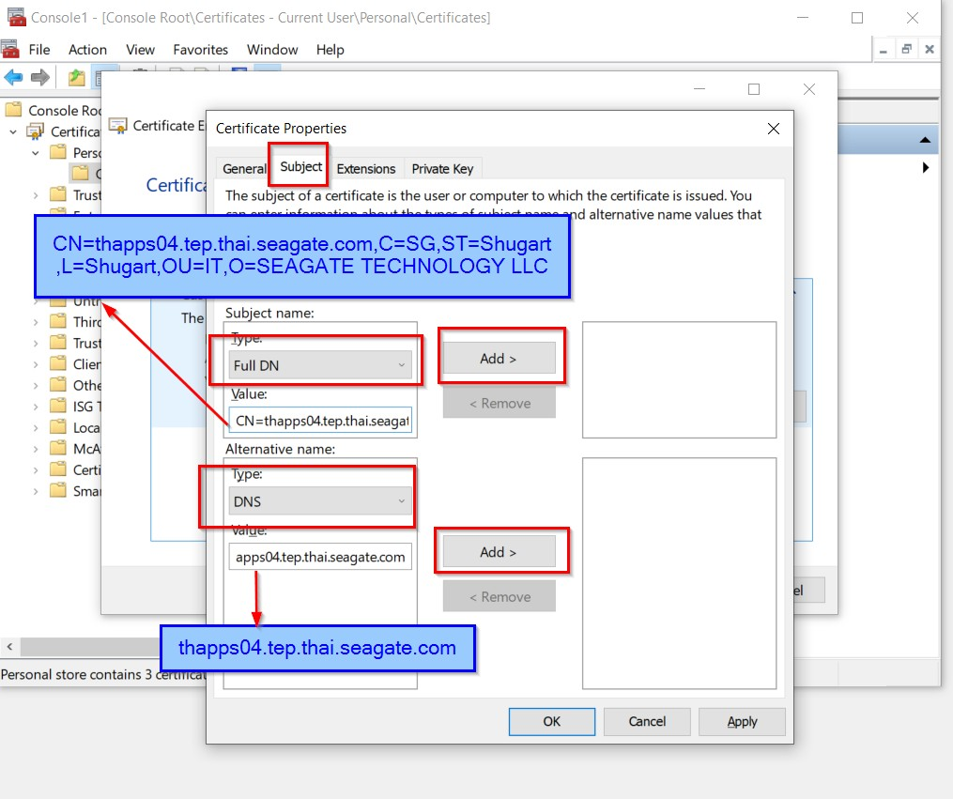

If you have more SANs (subject alternative name), you can add here.

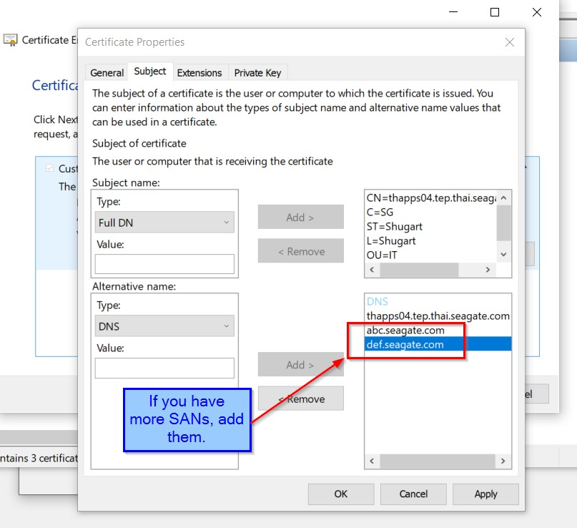

Click Extensions tab -> select Server Authentication -> click Add

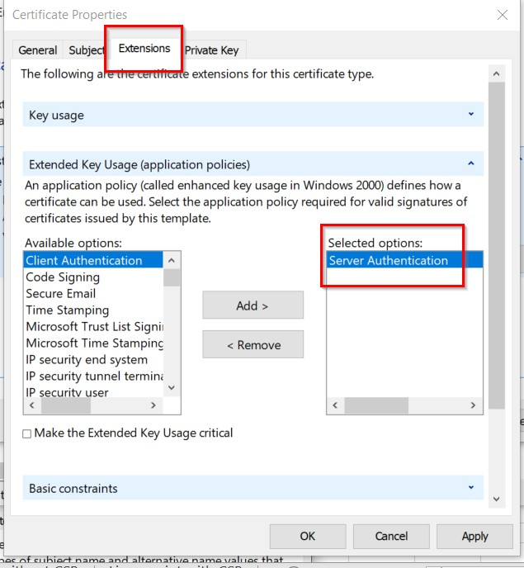

Click Private Key tab -> click Key type: select Exchange -> Cryptographic Service Provider : check
Microsoft RSA SChannel Cryptographic Provider -> uncheck Microsoft Strong Cryptographic Provider -> click Key size : select 2048 -> check Make private key exportable -> click Apply -> click OK.

Note: when you click the key type or CSP, the key size value will change. If you follow above sequence, it will not change. ( Key type -> CSP -> Key Options )

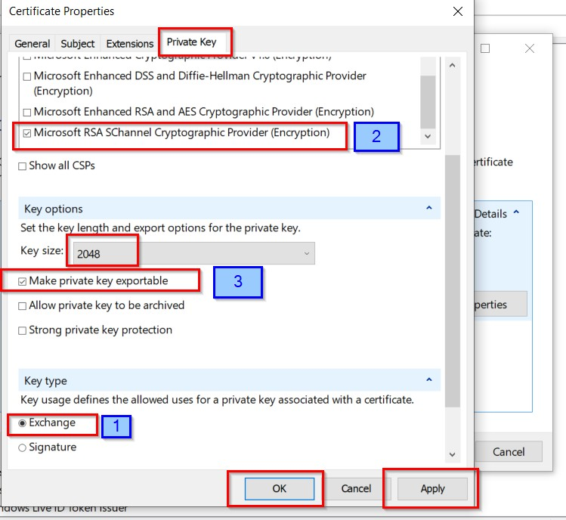

Click Next

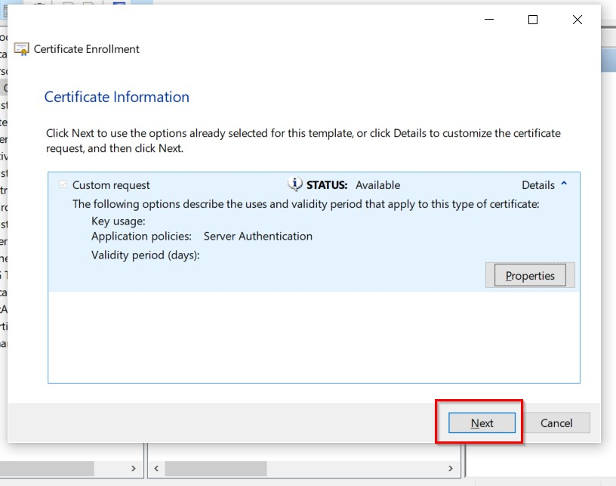
17) Click Browse and save the filename same as your CN (common name).csr
e.g. thapps04.tep.thai.seagate.com.csr

