**THE TICKET MAN**

**CHALLENGE DESCRIPTION: Usually while visiting a mall or the airport, patrons purchase an entry ticket which charges them on the basis of the hours they parked their cars in the establishment’s parking space. Taking care of the parking ticket is a nuisance and losing it leads to contention and further problems. Implement a digital alternative to this archaic system.**

**YOUR APPROACH: According to me, this archaic system can be replaced with a new digital alternative which is as follows- While entering the parking zone of a mall/airport, the person's face, who is driving the car can be captured by a face detector and the number on the car plate will also be noted. After the car number will be noted, a PIN will be generated which the driver will either memorize it or note it down on his/her phone. This way the person will not be responsible for a parking ticket and while exiting the parking lot, only if the same person's face is detected and the driver will be able to tell the PIN, and/or if someone else like his/her relative, friend etc. is driving they have to tell the PIN then only the car will be able to exit the mall/airport.**

**DETAILED DESCRIPTION: So the above archaic system can be further described as follows:**

1. In India, whenever a person travelling by car enters the mall entry he/she has to go through a security check. So we can place a CAMERA on the left top corner of the entrance so that the number plate can be captured and a PIN can be generated later. 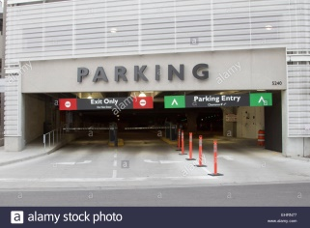
2. As soon as he/she are done with security check they get a parking ticket generated from the ticket booth. The ticket has to be submitted while exiting mall parking. So instead of this, a PIN will be generated after the number plate scanning which either they can memorize or note it down on their phone. 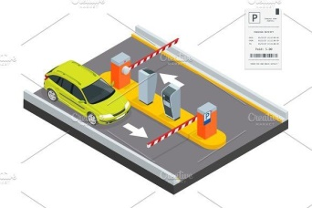
3. While exiting, the same person who was driving the car has to tell the PIN and get his face verified if he/she wants to exit the mall. If some relative is driving their car they have to tell the PIN in case they want the car to exit the mall.