**IT’S TIME TO BOUNCE**

**CHALLENGE DESCRIPTION: David runs a party club and going forward the government has imposed strict crowd control restrictions on such establishments. David wants a system that will help him easily and accurately figure out how many people are on the floor of the club at any given time so that he can let in new people wherever there is a vacancy. Can you help design such a system?**

**YOUR APPROACH:**  **Wifi or MAC Address tracking: Our phone is always looking for known Wifi Networks (home Wifi, Work Wifi. etc). It does this out of convenience so that your phone automatically gets connected to a known network manually without selecting it. This way our phone sends a probe request, which includes a unique MAC address of your phone. Even bluetooth has one too. So by David can easily calculate how many persons are dancing on the club floor (one condition: All you need is to have your Wifi turned on).**

**DETAILED DESCRIPTION: So the above archaic system can be further described as follows:**

Considering the image as a dance floor

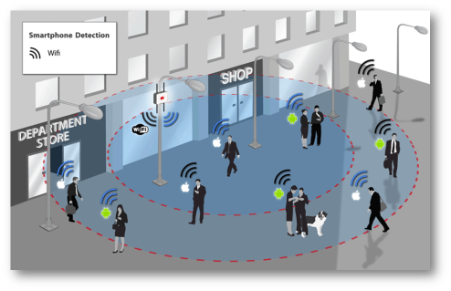The image above is a cartoonish version of how devices track your phone. Here’s how it works:

* Your phone is always looking for known WiFi networks (home WiFi, work WiFi, etc). It does this out of convenience so you can automatically connect to a known network without manually selecting it.
* The way your phone finds a WiFi network is by sending out what’s called a “probe request.” This probe request is kind of like your phone saying, “Hey my name is, Andrew.” But instead of “Andrew” it sends “40:68:AD:80:D3:A0,” which is a MAC Address unique to your phone and your phone only (it’s globally unique
* Technicalities aside, the thing to know is pretty much all WiFi routers are capable of tracking your phone. In fact, your MAC address is how a WiFi router or access point serves internet to all of your devices: your laptop, smartwatch, Fitbit, phone, Nintendo Switch, etc. They all have MAC addresses, they can all be tracked, and you do not need to be connected to the internet. All you need is to have your WiFi turned on.
* Multiple routers are listening and triangulating. They compare the relative strength of that signal to one another and can approximate where you are on the dance floor. They also know what other devices you usually carry with you (i.e. smartwatch, iPad, etc).The routers roll up this data and send it to an analytics platform that looks like this:

