A Short Technical Report towards A8027 – Technology Entrepreneurship

Microplastic Detector

Submitted in the Partial Fulfillment of the Requirements
for the Award of the Degree of BACHELOR OF TECHNOLOGY IN
Computer Science and Engineering(AI and ML)

Submitted by:
Team No.: 16
Bommera Shiva (25885A6616) Pawar Anil (25885A6618) Rampalli Architha (25885A6619) Bollela Tejasri (25885A6615)

Under the supervision of
Mr. G Krishna Teja
Assistant Professor
Ms AD Rani Sirisha
Assistant Professor



COMMUNITY INNOVATION AND TRANSFORMATION
NOV 2025

COMMUNITY INNOVATION AND TRANSFORMATION

CANDIDATE’S DECLARATION

We, Bommera Shiva (25885A6616), Pawar Anil (25885A6618), Rampalli Architha (25885A6619) & Bollela Tejasri (25885A6615) students of B.Tech (Computer Science and Engineering-AI and ML), hereby declare that the Project report titled — “Microplastic Detector” which is submitted by us to Community innovation and Transformation in fulfillment of the requirement for awarding of the Bachelor of Technology degree, is not copied from any source without proper citation.

Bommera Shiva (25885A6616)

COMMUNITY INNOVATION AND TRANSFORMATION CERTIFICATION

We, Bommera Shiva (25885A6616), Pawar Anil (25885A6618), Rampalli Architha (25885A6615) & Bollela Tejasri (25885A6619) students of B.Tech (Com- puter Science and Engineering-AI and ML), hereby declare that the Project report titled — “Microplastic Detector” which is submitted by us to Community innovation and Transformation in fulfillment of the requirement for awarding of the Bachelor of technology degree, is not copied from any source without proper citation.

Internal Examiner-1

Internal Examiner-2 External Examiner

Head, CIE Head of the Department

ABSTRACT

Keywords – Arduino, Microplastics, Light Scattering, Photodiode, Water Quality Monitoring, Environmental Sensors.

Microplastic contamination in water bodies has become a growing environmental concern due to its adverse effects on aquatic ecosystems and human health. Detecting and quantifying microplastics, however, is often challenging because traditional methods are costly, time-consuming, and require advanced laboratory equipment. This project presents the design and development of an Arduino-based Microplastic Detection System utilizing the light scattering principle to offer a simple, low-cost, and portable alternative for monitoring water quality.

The system employs a laser light source that passes through a water sample, where the presence of microplastic particles causes scattering and attenuation of the light beam. A photodiode sensor detects the transmitted light intensity, and the Arduino microcontroller processes this data to determine the percentage change in light intensity. The results are displayed on an LCD screen, indicating the level of microplastic contamination in real time.

This approach offers a cost-effective and accessible method for microplastic detection, suitable for educational, research, and field applications. The prototype demonstrates consistent performance in detecting variations in light intensity corresponding to different particle concentrations. The proposed system thus serves as a promising step toward developing compact, low-power instruments for environmental monitoring and pollution assessmen
ACKNOWLEDGEMENT

The satisfaction that accompanies the successful completion of the task would be put incomplete without the mention of the people who made it possible, whose constant guidance and encouragement crown all the efforts with success. We wish to express my deep sense of gratitude to Ms.Mavoori Pratussha, Assistant Proffesor and Mr.G.Krishna Teja , Assistant Professor for their able guidance and useful suggestions, which helped us in completing the design part of potential project in time. We particularly thankful to Dr. MA Jabbar, Professor and Head, Department of Electronics and Communication Engineering for his guidance, intense support and encouragement, which helped us to mould our project into a successful one. We show gratitude to our honorable Principal Dr.J.V.R.Ravindra, for having provided all the facilities and support.We avail this opportunity to express our deep sense of gratitude and heartful thanks to Dr Teegala Vijender Reddy, Chairman and Sri Teegala Upender Reddy, Secretary of VCE, for providing congenial atmosphere to complete this project successfully. We also thank all the staff members of Product Realization Team for their valuable support and generous advice. Finally, thanks to all our friends and family members for their continuous support and enthusiastic help.

Bommera Shiva (25885A6616) Pawar Anil (25885A6617)

Rampalli Architha (25885A6619) Bollela Tejasri (25885A6615)

Contents

Candidate’s Declaration | i
Candidate’s Declaration | ii
Abstract | iii
Acknowledgement | iv
List of Figures | vii
List of Tables | viii
CHAPTER 1: INTRODUCTION | 1
1.1 Motivation | 1
1.2 Scope | 2
1.3 Objectives | 2
1.4 Need Statement | 4
1.5 Product Realization Process | 4
CHAPTER 2: PRODUCT DESIGN AND DEVELOPMENT | 6
2.1 Flow Chart | 6
2.2 Steps involved for Product Design and Development | 6
CHAPTER 3: Community partner-Related Processes | 7
3.1 Details of Community partner | 8
3.2 Afield survey form | 8
3.3 Questioner with Community Partners responses | 9
3.4 List of Community Partner Specifications | 9

CHAPTER 4: Design and Development of Product 10
- Design of Product 10
- Purchasing information 10
- Development Process 10
- Final Product 11
CHAPTER 5: Post Product Design and Development Activities 12
- Design details(Data, Place ,means etc,.) 12
- Feedback on delivered product 12
- Redesign 12
CHAPTER 6: CONCLUSION 14
References 14

List of Tables

Figure No. | Title | Page No.
1 | Purchasing information(Hardware Components and Estimated Cost) | 13

List of Figures

Figure No. | Title | Page No.
2.1 | System Workflow: From Surplus Identification to Final Distribution | 5
2.3 | Gantt Chart of Product Development Timeline | 8

Chapter 1 INTRODUCTION

Motivation

Water pollution is one of the most pressing global issues, with microplastic contamination emerging as a particularly severe and elusive threat. Microplastics—tiny plastic particles less than 5 mm in size—originate from synthetic clothing, packaging, and industrial waste. These particles persist in aquatic environments and enter the food chain, posing significant risks to marine life and human health. Despite the growing concern, microplastic detection in water remains a complex task, often requiring advanced spectroscopic or microscopic analysis that is expensive and inaccessible for routine monitoring.

In this context, there is a strong motivation to develop an affordable, portable, and efficient system capable of detecting microplastics in water using simple physical principles. Leveraging the light scattering phenomenon provides a promising alternative. When a beam of light passes through a contaminated sample, the particles scatter and absorb part of the light, allowing detection based on the change in intensity. This principle can be effectively implemented using low-cost optical sensors and a microcontroller, such as Arduino, to achieve real-time analysis without sophisticated instruments.

Scope

The scope of this project includes the design, implementation, and testing of a compact system for detecting microplastic contamination in water using an Arduino-based light scattering setup. The system is intended for laboratory, educational, and preliminary field testing rather than industrial-scale monitoring. It aims to provide a cost-effective and accessible method for quantifying relative contamination levels, expressed as changes in light intensity percentage.

This project focuses on demonstrating the relationship between microplastic concentration and light intensity variation rather than performing precise chemical characterization. By integrating components such as a laser diode, photodiode sensor, and LCD display, the project establishes a foundation for a scalable design that can be further enhanced with data logging or IoT connectivity for real-world environmental monitoring.

Objectives

The primary objective of this project is to design and develop a microcontroller-based prototype capable of detecting microplastic particles in water samples using the light scattering principle. To achieve this, the project sets the following specific goals:

- To design a simple and cost-efficient hardware setup utilizing a laser source, photodiode sensor, and Arduino microcontroller.
- To develop software capable of processing light intensity data and displaying the percentage difference on an LCD screen.
- To establish a correlation between microplastic concentration and the observed light intensity reduction.
- To evaluate the system’s effectiveness and consistency across different sample conditions.

Through these objectives, the project aims to contribute to low-cost environmental sensing solutions suitable for educational and research applications.

Need Statement

The need for an affordable microplastic detection method arises from the growing awareness of environmental pollution and the lack of easily deployable monitoring tools. Conventional analytical techniques like Fourier-transform infrared spectroscopy (FTIR) or Raman microscopy, while accurate, are expensive, time-consuming, and impractical for field deployment. As a result, there is a gap between the scientific understanding of microplastic pollution and the availability of simple tools for on-site detection.

This project addresses that gap by developing a portable detection system using fundamental optical principles and accessible hardware components. By providing a functional and low-cost prototype, this work supports community-level water quality assessment and promotes awareness of microplastic pollution in academic and environmental sectors.

Product Design and Development Process

The product is designed around the concept of detecting microplastic presence through variations in light intensity. The core components include a laser diode that emits a narrow beam of light through the water sample and a photodiode sensor positioned opposite the light source to measure transmitted light. The Arduino Uno microcontroller serves as the processing unit, converting analog readings from the sensor into percentage intensity values. These values are displayed on a 16×2 LCD module, providing a real-time indication of contamination levels.

The product design emphasizes simplicity, portability, and energy efficiency. It operates on a 5V DC power supply and uses minimal components to ensure low manufacturing costs. The hardware is enclosed in a small casing, with transparent sample slots for easy testing. The modular design allows future upgrades such as data storage, wireless transmission, or calibration algorithms, making it adaptable for extended applications in environmental monitoring.

Chapter 2

PRODUCT DESIGN AND
DEVELOPMENT

Flow Chart
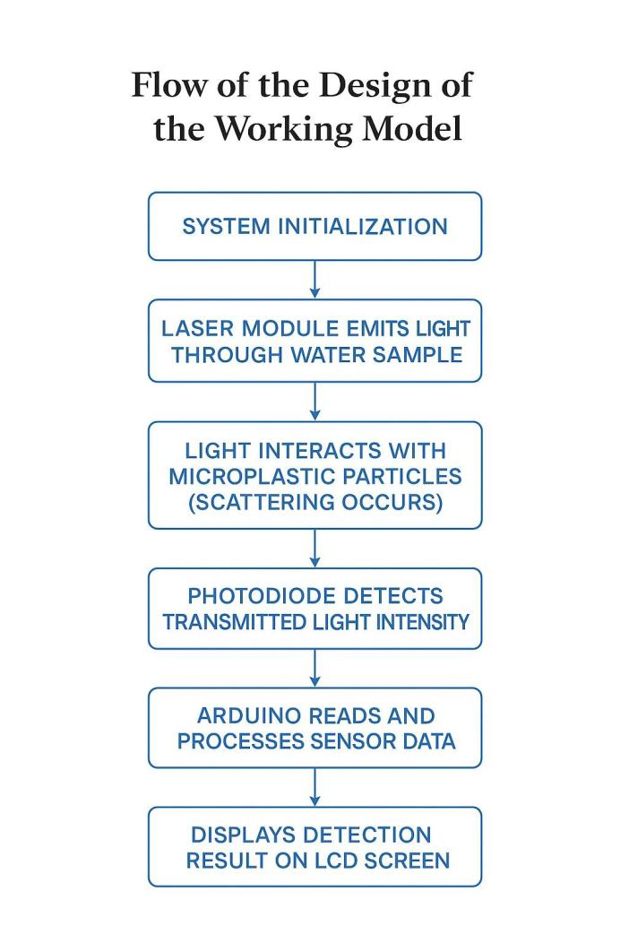
Fig 2.1-Flow of the design of working model

Steps involved for Product Design and Development
1. Problem Identification Requirement Analysis:
- Recognize the growing issue of microplastic contamination in water bodies and the need for a low-cost, portable detection system.
- Identify limitations in existing laboratory-based detection methods such as high cost, complex operation, and lack of field applicability.
- Deefine system requirements: sensitivity to light scattering, real-time display, compact hardware, and low power consumption.ease of control).
2. Concept Design Planning
- Develop the conceptual design based on the light scattering principle, where a laser beam passes through a water sample and a photodiode detects intensity variations.
- Plan the arrangement of core components — laser module, photodiode sensor, Arduino microcontroller, LCD display, and power supply.
- Design a portable and modular setup suitable for testing multiple water samples efficiently.

3. Component Selection Procurement
- Arduino Uno
- Laser diode module
- LDR/Photodiode senso
- LCD Display
- Resistors, connecting wires, and breadboard
- Power supply (9V battery or USB)

4. Mechanical and Structural Setup:
- Prepare a transparent water container for holding test samples.
- Align the laser and sensor in a straight optical path for accurate intensity measurement.
- Mount components securely on a base board to minimize vibration or misalignment during testing.
- Ensure the sensor is shielded from ambient light for precise readings.
5. Electrical Integration:
- Connect the laser module, photodiode, and LCD to the Arduino using jumper wires and resistors.
- Implement a voltage divider for the LDR/photodiode sensor to convert light intensity to measurable voltage.
- Verify all power lines (5V and GND) for proper connection and insulation.
6. Programming and Calibration:
- Write and upload Arduino code to read analog sensor values and calculate light intensity percentage changes.
- Calibrate the system using clean water as the baseline reference.
- Test with known microplastic concentrations to establish a correlation curve between light intensity and contamination level.
7. Functional Testing:
- Place samples with varying microplastic levels and record sensor readings.
- Verify the LCD displays the percentage difference in light intensity accurately.
- Test response stability, repeatability, and sensitivity under different lighting and container conditions.
8. Optimization and Validation:
- Refine sensor placement, adjust laser focus, and improve shielding to reduce noise.
- • Validate readings by comparing with standard laboratory data if available.
- • Ensure consistent operation, portability, and ease of use for field deployment.
- • Document all findings, improvements, and calibration data for final analysis.

Chapter 3

Community partner-Related Processes

Details of Community partner

Dhruvansh is an environmental non-profit organization based in Hyderabad, Telangana, dedicated to the conservation and restoration of aquatic ecosystems. Founded with the vision of protecting local lakes, rivers, and biodiversity, Dhruvansh actively engages in initiatives such as water body rejuvenation, solid waste management, awareness campaigns, and community education. Their work emphasizes reducing plastic and microplastic pollution through clean-up drives, scientific testing, and citizen participation.
With a strong environmental focus, Dhruvansh collaborates with educational institutions, research groups, and government bodies to promote sustainable practices and ecological balance. Their expertise in water quality monitoring and pollution mitigation made them an ideal community partner for this project. The collaboration allowed students to understand real-world environmental challenges and the significance of developing affordable, field-deployable tools for detecting microplastic contamination in water.
For this project, Dhruvansh provided valuable insights into water sample collection methods, typical contamination sources, and the importance of portable detection devices for environmental monitoring. Their guidance ensured that the proposed Arduino-based microplastic detection system aligns with on-ground needs, emphasizing practicality, low cost, and community relevance.

A field survey form
A field survey was conducted in collaboration with Dhruvansh to understand the extent of microplastic pollution and the challenges faced during water quality assessment. The survey aimed to gather information from field volunteers and environmental workers who routinely collect and test water samples. The form included questions such as:
- Sources of microplastic pollution observed in local water bodies.
- Frequency and methods of current water testing or analysis.
- Limitations of existing detection techniques (e.g., cost, equipment needs).
- Awareness level regarding microplastics among local communities.
- Interest in adopting low-cost portable devices for field-based detection.
The results showed that most field workers rely on visual inspection or laboratory tests for water quality analysis, which are time-consuming and expensive. Volunteers expressed interest in using portable detection tools that can quickly indicate contamination levels using simple visual outputs like percentage readings. Dhruvansh members highlighted that such innovations could significantly aid awareness campaigns and data collection efforts in rural and peri-urban areas.
.

- Questionnaire with Community Partners responses

A structured questionnaire was shared with Dhruvansh representatives to obtain their expert feedback on the proposed device. The questions and summarized responses are as follows:
• What are the major sources of microplastic pollution observed locally?
Domestic waste, single-use plastics, and synthetic fabrics discharged into lakes and drains.
• What challenges are faced in detecting or monitoring microplastics?
Lack of accessible, low-cost detection tools and dependency on laboratory analysis.
• How would a portable detection device help your organization?
It would support field-level assessment, enabling volunteers to quickly identify affected areas.
• What features would you prefer in such a device?
Compact design, battery operation, clear LCD output, and ability to calibrate with standard water samples.
• Do you foresee community-level adoption of this technology?
Yes, especially for awareness drives and basic monitoring in schools, NGOs, and environmental clubs.
Dhruvansh emphasized that integrating such devices in routine field work could bridge the gap between citizen science and professional research, fostering environmental awareness and proactive pollution control.

- List of Community Partner Specifications

Based on the feedback and discussions, Dhruvansh suggested the following specifications for the prototype:

• Portable and lightweight design suitable for on-site use.
• Battery-powered operation with USB charging option.
• Clear LCD display showing light intensity percentage or contamination indication.
• Calibration mode using clean water as a reference.
• Simple setup with minimal components for easy replication by students or volunteers.
• Durable and water-resistant housing for field conditions.
• Affordable cost (preferably under ₹1500) to ensure accessibility for NGOs and schools.
• Environmentally safe materials for construction and disposal.

These specifications guided the development of the Arduino-based microplastic detection prototype, ensuring that the system remained practical, low-cost, and directly applicable to the community’s environmental monitoring needs.

Chapter 4

Design and Development of Product

Design of Product
The product design of the Arduino-Based Microplastic Detection System is based on the light scattering principle, where the intensity of a laser beam changes as it passes through a water sample containing microplastics. The scattered light is detected by a photodiode or LDR sensor, and the change in light intensity is processed by the Arduino microcontroller to determine the presence and approximate concentration of microplastics.
The overall system consists of four major parts:
- Light Source Unit – A laser diode that emits a narrow, focused beam through the water sample.
- Detection Unit – A photodiode/LDR placed opposite the laser source to measure the transmitted light intensity.
- Processing Unit – An Arduino Uno microcontroller that reads the analog voltage signal, processes it, and calculates the percentage change in intensity.
- Display Unit – An LCD (16x2 or I2C) that shows the calculated percentage difference in light intensity, indicating the presence level of microplastics.
The system is designed to be portable, cost-effective, and easy to use. The alignment between the laser and sensor ensures accurate optical measurement. Proper shielding from ambient light helps maintain data consistency. This design provides a simplified approach to water quality testing and demonstrates the applicability of embedded systems in environmental monitoring

Purchasing information
S. No. | Component | Description | Estimated Price (INR) | Source | Purpose
1 | Arduino Uno R3 | Main microcontroller board for processing sensor input and controlling output display | ₹470 | Amazon | Acts as the brain of the system, coordinating sensor readings and output
2 | Laser Module (KY-008) | 5V laser module with PCB for light projection through water sample | ₹120 | Amazon | Emits laser beam used for microplastic scattering detection
3 | LDR Sensor Module (3-pin) | Light-dependent resistor for detecting light intensity | ₹100 | Amazon | Measures light variation caused by particles in water
4 | 9V Battery (x2) with DC Connector | Standard 9V rechargeable/alkaline batteries with clip and connector | ₹70 | Amazon | Power source for Arduino and laser setup
5 | 16x2 LCD with I2C Interface (Blue) | Character display module to show microplastic detection readings | ₹250 | Local Electronics | Displays detection data in real time
6 | Jumper Wires (Male-Female) | 30 flexible jumper wires for circuit connection | ₹100 | Local Electronics | Used for interconnecting components on the breadboard
7 | Resistors (1/4W – assorted) | 10kΩ and 1kΩ resistors for signal conditioning and voltage division | ₹20 | Local Market | Maintains safe and calibrated circuit operation
8 | Breadboard (GI12) | 400-point solderless prototyping board | ₹100 | Local Market | Base for assembling circuit connections
9 | IRF520 MOSFET Module | Power transistor module for controlling high-current devices | ₹170 | Amazon | Enables switching and power regulation if needed
10 | Miscellaneous components | Connectors, glue, insulation tape, small mounts, etc. | ₹100 | Local Market | Used for assembly and system integration

Total Cost: ₹1500

Development Process

The development of the microplastic detection system followed a structured engineering workflow, ensuring systematic progress from design to implementation.

- Conceptualization:
Initial brainstorming identified the light scattering principle as a reliable physical basis for detecting microplastics. The concept was refined through literature review and guidance from environmental experts at Dhruvansh.

- Circuit Design:
The circuit was designed to integrate the laser, photodiode, and LCD with Arduino Uno. The laser and sensor were aligned on opposite sides of a transparent container. The photodiode output was connected to an analog input pin of the Arduino via a voltage divider network.

- Coding and Calibration:
An Arduino program was written to read analog voltage values, convert them into intensity percentages, and display the results. The system was first calibrated using pure water as a reference (100% intensity). Subsequent tests with contaminated water samples provided comparative readings.

- Prototype Assembly:
All components were mounted on a small baseboard for stability. The LCD and Arduino were positioned for easy visibility, and wiring was managed using jumper cables. The sample container was placed between the laser and sensor for direct optical transmission.

- Testing and Validation:
Multiple samples were tested with varying microplastic concentrations. The device successfully displayed percentage differences correlating with contamination levels. Adjustments were made to sensor alignment and code calibration for improved accuracy.

- Optimization:
The final setup was refined for stability, Readability, and compactness. Minor improvements were implemented in code logic and display formatting for real-time updates.

Final Product

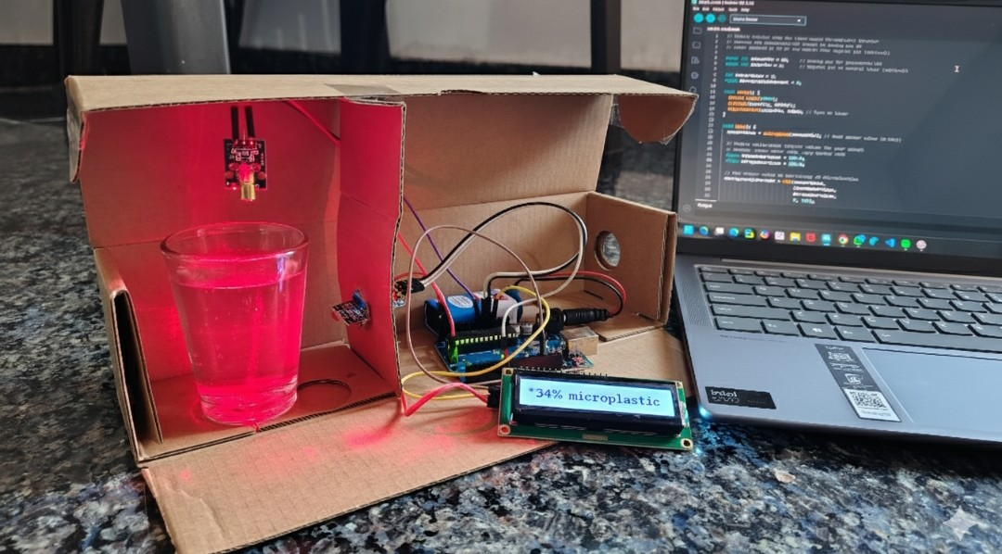
Figure 4.1: Final Prototype of Arduino-Based Microplastic Detection System

The final prototype of the Arduino-Based Microplastic Detection System is a compact, portable, and functional model capable of providing real-time indication of light intensity variation corresponding to microplastic contamination.

- The device operates as follows:
- The laser diode emits light through the sample.
- The photodiode sensor detects transmitted light and converts it into voltage.
- The Arduino processes the signal and calculates the percentage difference compared to a clean water baseline.
- The LCD display shows the measured percentage difference, e.g., “Microplastic: 3.5%”.

The final product demonstrates that light intensity decreases as the concentration of microplastics increases, validating the light scattering principle. It serves as a low-cost educational and research prototype for quick water quality assessments in labs, communities, and environmental awareness campaigns.

Chapter 5

Post Product Design and Development Activities

Design details(Data, Place ,means etc,.)

Place of Development:

The prototype was designed and developed in a home-based electronics setup with basic laboratory tools and testing facilities. Circuit assembly, sensor calibration, and code testing were conducted under controlled indoor conditions to minimize external light interference. The project was developed between August 2024 and October 2024.

Design Data:

Laser wavelength: 650 nm (Red Laser KY-008 Module)

Sensor type: LDR (Light Dependent Resistor) for light intensity measurement

Display unit: 16x2 I2C LCD module

Processing unit: Arduino Uno R3 microcontroller

Power supply: 9V dual battery system

Output type: Percentage difference in light intensity displayed on LCD

Measurement medium: Transparent water samples containing varying microplastic concentrations

Means of Fabrication:

Circuit connections were established using a breadboard and jumper wires for modular testing.

Component mounting was done on a small acrylic or cardboard platform to ensure laser and LDR alignment.

Laser and LDR positioning were manually adjusted to achieve accurate light scattering detection.

The Arduino was programmed using the Arduino IDE to calculate and display intensity variations.

Key Components Used:

Arduino Uno R3

Laser Module KY-008

LDR Sensor (3-pin module)

16x2 LCD with I2C interface

IRF520 MOSFET Module

Breadboard, jump wires, and resistors (¼W type)

9V Batteries with connectors

Feedback on delivered product

To validate the project’s effectiveness, the developed prototype was presented to the Dhruvansh NGO, an environmental non-profit organization working in the area of water pollution and conservation. The team members provided constructive feedback after observing a live demonstration of the device.

Collected Feedback Highlights:

Functionality: The device effectively demonstrated measurable differences in light intensity when water samples contained visible impurities or microplastic particles.

Ease of Use: The LCD display clearly showed the percentage variation, making it easy to interpret results without specialized training.

Practical Relevance: The NGO members appreciated the project as an educational and awareness tool to illustrate how microplastics affect water clarity and quality.

Suggestions for Improvement: They recommended enhancing sensitivity through optical calibration, adding digital data logging for comparison, and improving the physical enclosure for outdoor testing.

Overall, the feedback confirmed that the prototype achieved its objective as a proof-of-concept system and provided valuable insights for developing a more precise and field-deployable version.

Redesign

Based on feedback and testing observations, several design modifications were considered to improve the accuracy and usability of the system:

Sensor Alignment: The laser and LDR were reoriented on a fixed frame to minimize angular deviation and improve consistency of light measurements.

Signal Stabilization: The circuit was enhanced with resistors and shielding to reduce noise interference from ambient light sources.

Display Optimization: The LCD display was reprogrammed to show both the percentage of intensity difference and reference values for easier comparison.

Component Integration: Future redesigns include enclosing all modules in a single waterproof housing to prevent damage during field measurements.

These redesign considerations aim to transition the prototype from a laboratory model into a practical, portable testing device for environmental monitoring.

Chapter 6

CONCLUSION

The project “Arduino-Based Microplastic Detection in Water Using Light Scattering Principle” successfully demonstrates a low-cost, accessible, and effective approach for detecting suspended particles and microplastics in water. By integrating a laser light source, LDR sensor, and Arduino microcontroller, the system measures variations in light intensity caused by particle scattering and displays the results in percentage form on an LCD screen.

The project’s strength lies in its simplicity, affordability, and potential for adaptation in educational and field applications. Collaborating with Dhruvansh NGO provided valuable real-world insights into the environmental relevance of the system and its potential use for awareness campaigns and basic field testing.

The results validate that higher light scattering corresponds to increased microplastic presence, supporting the theoretical principle used. While the current version serves as a laboratory prototype, future work can include integrating more advanced optical sensors, automatic calibration systems, and wireless data logging features.

In conclusion, this project stands as a meaningful contribution to environmental monitoring efforts—demonstrating how simple embedded systems can be leveraged for sustainable, community-driven solutions addressing global pollution challenges.

REFERENCES
[1] Zango, Z. U., Ibnaouf, K. H., Ibrahem, M. A., Garba, A., Wadi, I. A., Ali, A. F., ... & Adamu, H. (2025). A review on dual functionality of dimensional carbon nanomaterials for adsorption and mediated degradation of MPs in wastewater. Journal of Water Process Engineering, 79, 108998.

[2] Welle, F., & Franz, R. (2018). Microplastic in bottled natural mineral water–literature review and considerations on exposure and risk assessment. Food Additives & Contaminants: Part A, 35(12), 2482-2492.

[3] Podbielska, M., Szpyrka, E., & Strojny, W. (2025). Analytical techniques for microplastics analyses. Scientific Letters, 1(Sup 1).

[4] Maharjan, K. K. (2025). Microplastic pollution in bottled water: a systematic review. International Journal of Environmental Science and Technology, 22(2), 1283-1296.

[5] Siahaan, I. A., Mutiara, G. A., & Sani, M. I. (2021, April). A low-cost water quality monitoring based on photodiode and LDR. In 2021 IEEE Asia Pacific Conference on Wireless and Mobile (APWiMob) (pp. 141-146). IEEE.

