Microplastic Detection in Water using Arduino-Based Laser Scattering
Mr. Bommera Shiva
CSM dept.
Vardhaman college of engineering
Hyderabad,Telangana,India
shivabommera1436@gmail.com

Mr. Pawar Anil
CSM dept.
Vardhaman college of engineering
Hyderabad,Telangana,India
pawaranil939834@gmail.com
Ms. Rampalli Architha
CSM dept.
Vardhaman college of engineering
Hyderabad,Telangana,India
architha1323@gmail.com

Mr. G. Krishna Teja
Mech dept.
Vardhaman college of engineering
Hyderabad,Telangana,India
teja.godavathy@gmail.com
Ms. Bollela Tejasri
CSM dept.
Vardhaman college of engineering
Hyderabad,Telangana,India
teja982075@gmail.com

Abstract— Microplastic pollution poses a severe threat to aquatic ecosystems and human health. Traditional methods of microplastic detection are often expensive, time-consuming, and require advanced laboratory setups. This paper presents a low-cost, portable, and real-time detection system based on the light scattering principle using an Arduino microcontroller. The system employs a laser light source and a photodiode sensor to detect variations in scattered light intensity caused by microplastic particles suspended in water. Experimental results demonstrate that the proposed system can effectively distinguish between clean and contaminated water samples with reasonable accuracy. This approach offers a promising alternative for on-site environmental monitoring and citizen science applications.
Keywords— Arduino, Microplastics, Light Scattering, Photodiode, Water Quality Monitoring, Environmental Sensors.

I.Introduction
Water pollution has become one of the most pressing environmental issues of the 21st century, with microplastics emerging as a major threat to aquatic ecosystems and human health [4],[11]. These microscopic plastic fragments, often less than 5 millimeters in size, originate from synthetic textiles, packaging materials, and personal care products [2], [11] Their presence in rivers, lakes, and oceans not only disrupts marine life but also poses risks to the food chain and overall ecosystem balance. Addressing this growing concern requires innovative and accessible detection techniques that can identify microplastic contamination efficiently and affordably.
Traditional methods for microplastic detection, such as spectroscopic or microscopic analyses, are highly accurate but require sophisticated laboratory setups, trained personnel, and significant financial investment [5], [9], [10]. These constraints limit their practicality for field-based or real-time applications, especially in developing regions. Recognizing these challenges, the development of an Arduino-based microplastic detection system offers a cost-effective and portable solution [8]. By utilizing the light scattering principle, this system detects variations in light intensity caused by microplastic particles suspended in water, thereby providing a simple yet effective means of contamination assessment.
The proposed system integrates modern sensing technology with open-source electronics to deliver real-time monitoring of water quality. A laser diode acts as the light source, while a photodiode sensor measures the scattered light intensity, which is then processed and analyzed by the Arduino microcontroller. The resulting data can indicate the presence and approximate concentration of microplastics in a given sample. This innovative approach not only simplifies detection but also supports environmental sustainability through early pollution identification and awareness. In this paper, we explore the need for efficient microplastic detection and present a low-cost, reliable, and adaptable solution for modern environmental monitoring.

II.Design DescriPtion
The proposed system for microplastic detection in water is designed based on the light scattering principle, utilizing low-cost optical components integrated with an Arduino microcontroller [6], [7]. The design aims to provide a simple, portable, and affordable solution for identifying microplastic contamination in real-time. The system functions by passing a focused laser beam through a transparent water sample chamber. When the beam encounters microplastic particles suspended in the water, the light scatters in multiple directions. A photodiode sensor positioned at an angle measures the intensity of this scattered light, and the variation in signal strength indicates the presence and approximate concentration of microplastics.

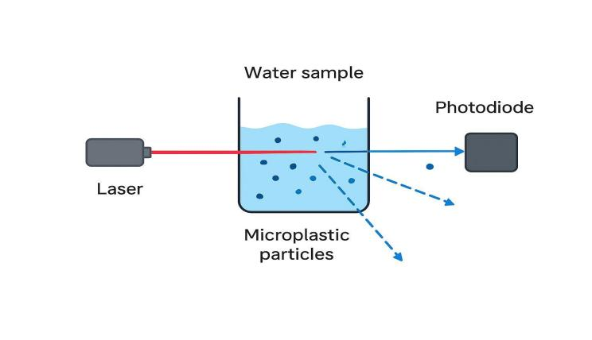
Fig.1. Illustration of light scattering principle

The hardware consists of an Arduino Uno microcontroller, a laser diode acting as the light source, a photodiode sensor for light detection, and a transparent cuvette or glass tube for holding the water sample [8]. Additional components such as resistors, jumper wires, and a power supply ensure circuit stability and consistent operation. An LCD module or serial monitor is used to display the sensor readings. The circuit is designed so that the laser and photodiode are precisely aligned on either side of the sample chamber, enabling accurate measurement of light intensity changes as the water quality varies.

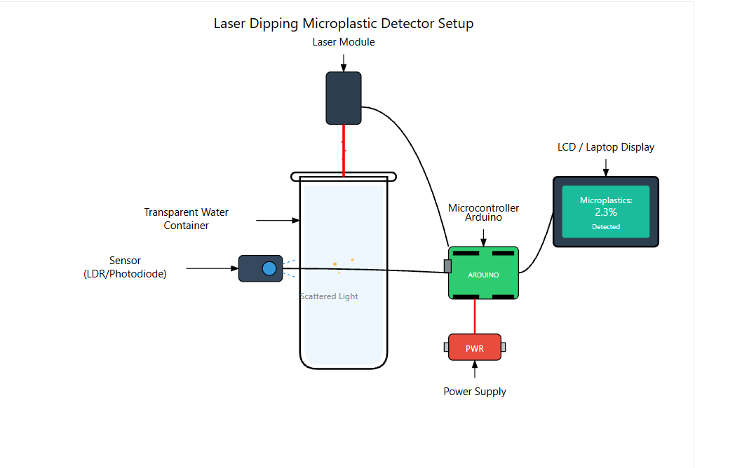
Fig.2. Microplastic detector block diagram

The working process begins when the laser diode emits a light beam through the sample chamber. In clean water, most of the light passes straight through with minimal scattering, resulting in a high reading on the photodiode. However, when microplastic particles are present, the beam is dispersed in multiple directions, and the intensity detected by the photodiode decreases. The analog signal from the photodiode is sent to the Arduino, which converts it into a digital value using its internal analog-to-digital converter. The program running on the Arduino processes this data and displays real-time readings on the output device. Based on a calibrated threshold, the system can classify the water sample as clean or contaminated. This design effectively combines simple optical detection with microcontroller-based processing to create a reliable, efficient, and user-friendly system for monitoring microplastic pollution in water bodies.

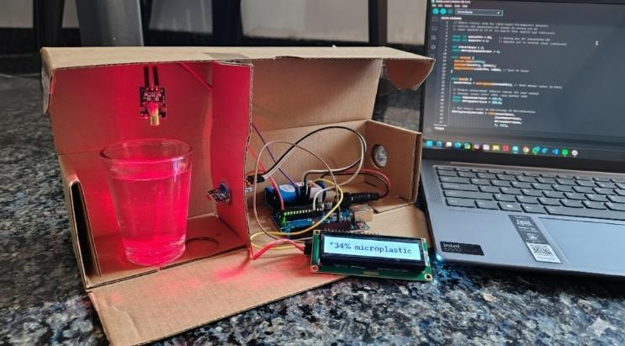
Fig.3. Prototype image

III.RESULTS AND DISCUSSION
The developed system successfully measured the variation in light intensity caused by microplastic particles in water. The Arduino processed the photodiode’s analog signal and displayed the percentage of transmitted light intensity on the LCD, providing a clear indication of contamination levels. During testing, clean water consistently produced readings around 98–100%, while samples with increasing microplastic concentration showed a proportional decline in light intensity, reaching as low as 55–60% for highly contaminated water. This demonstrates that as the concentration of microplastics increases, light scattering also increases, resulting in reduced transmission [7]. The observed relationship validates the working principle of the system and confirms its capability to detect relative changes in water quality using optical scattering [5], [8].

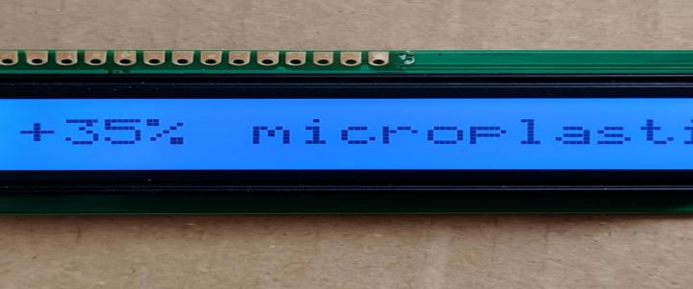Fig.4. Output on LCD

Sample Type | Approx microplastic concentration(g/L) | Light Intensity (%) | Observation
Clean water | 0 | 98 | High Transmission
Less microplastic | 0.05 | 84 | Moderate scattering
Medium microplastic | 0.10 | 70 | Noticeable Scattering
High microplastic | 0.20 | 56 | Strong Scattering

Table.1. Experimental results of Light Intensity Measurement

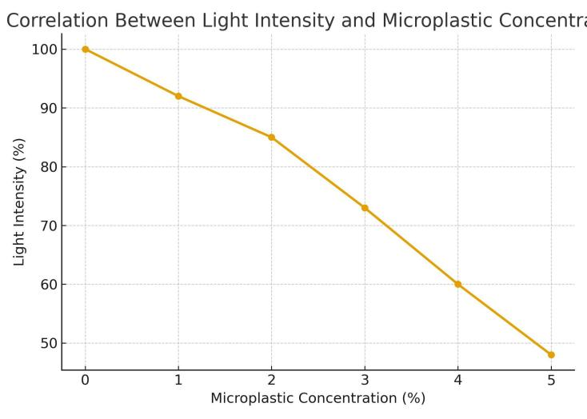

Fig.5. Graph Diagram of light intensity vs microplastic concentration

IV. CONCLUSION
The Arduino-based microplastic detection system using the light scattering principle proved to be an effective, low-cost method for assessing water quality and overcoming several limitations of conventional detection methods [9]. By analyzing variations in transmitted light intensity, the system could accurately indicate the presence and approximate concentration of microplastics in real time. Although the results are based on relative intensity rather than exact particle quantification, the consistent correlation between scattering and contamination confirms the reliability of the design. With further improvements such as multi-angle sensing, calibration with known particle sizes, and potential IoT data integration [1], [3], the prototype can evolve into a practical and scalable solution for environmental monitoring and pollution control.

VI.Author contributions

Rampalli Architha: Project design and system development. Pawar Anil: hardware setup and testing. Bollela Tejasri: Arduino coding and data acquisition. Bommera Shiva: analysis, documentation and paper preparation.

VII. References
[1] Zango, Z. U., Ibnaouf, K. H., Ibrahem, M. A., Garba, A., Wadi, I. A., Ali, A. F., ... & Adamu, H. (2025). A review on dual functionality of dimensional carbon nanomaterials for adsorption and mediated degradation of MPs in wastewater. Journal of Water Process Engineering, 79, 108998.

[2] Welle, F., & Franz, R. (2018). Microplastic in bottled natural mineral water–literature review and considerations on exposure and risk assessment. Food Additives & Contaminants: Part A, 35(12), 2482-2492.

[3] Podbielska, M., Szpyrka, E., & Strojny, W. (2025). Analytical techniques for microplastics analyses. Scientific Letters, 1(Sup 1).

[4] Maharjan, K. K. (2025). Microplastic pollution in bottled water: a systematic review. International Journal of Environmental Science and Technology, 22(2), 1283-1296.

[5] Baruah, A., Sharma, A., Sharma, S., & Nagraik, R. (2022). An insight into different microplastic detection methods. International Journal of Environmental Science and Technology, 19(6), 5721-5730.

[6] V Chu, B. (2007). Laser light scattering: basic principles and practice. Courier Corporation.

[7] Hulst, H. C., & van de Hulst, H. C. (1981). Light scattering by small particles. Courier Corporation.

[8] Siahaan, I. A., Mutiara, G. A., & Sani, M. I. (2021, April). A low-cost water quality monitoring based on photodiode and LDR. In 2021 IEEE Asia Pacific Conference on Wireless and Mobile (APWiMob) (pp. 141-146). IEEE.

[9] Lv, L., Yan, X., Feng, L., Jiang, S., Lu, Z., Xie, H., ... & Li, C. (2021). Challenge for the detection of microplastics in the environment. Water Environment Research, 93(1), 5-15.

[10] Chakraborty, I., Banik, S., Biswas, R., Yamamoto, T., Noothalapati, H., & Mazumder, N. (2023). Raman spectroscopy for microplastic detection in water sources: a systematic review. International Journal of Environmental Science and Technology, 20(9), 10435-10448.

[11] Koelmans, A. A., Nor, N. H. M., Hermsen, E., Kooi, M., Mintenig, S. M., & De France, J. (2019). Microplastics in freshwaters and drinking water: Critical review and assessment of data quality. Water research, 155, 410-422.

