INVENTION DISCLOSURE FORM

Applicant Name: Vardhaman College of Engineering
Applicant Address: Shamshabad, Hyderabad-501218

- Particulars of Inventors

Mr./Ms/Dr. | Name (Full) | Department | Designation | Mobile No. | Email | Postal Address
Ms | Rampalli Architha | CSM | Student | 9346203609 | architha1323@gmail.com | Vardhaman College of Engineering (Autonomous), Shamshabad, Hyderabad, Telangana 501218, India
Mr | Bommera Shiva | CSM | Student | 9390653053 | shivabommera0143@gmail.com | Vardhaman College of Engineering (Autonomous), Shamshabad, Hyderabad, Telangana 501218, India
Mr | Pawar Anil | CSM | Student | 9398345795 | pawaranil939834@gmail.com | Vardhaman College of Engineering (Autonomous), Shamshabad, Hyderabad, Telangana 501218, India
Ms | Bollela Tejasri | CSM | Student | 9063982075 | teja982075@gmail.com | Vardhaman College of Engineering (Autonomous), Shamshabad, Hyderabad, Telangana 501218, India
Mr | Godavarthy Krishna Teja | MECH | Assistant Professor | 9182689778 | teja.godavarthy@gmail.com | Vardhaman College of Engineering (Autonomous), Shamshabad, Hyderabad, Telangana 501218, India
Ms | A D Rani Shirisha | EEE | Assistant Professor | 9299757881 | Sirisha.adr@gmail.com | Vardhaman College of Engineering (Autonomous), Shamshabad, Hyderabad, Telangana 501218, India

- Provide a brief descriptive title of the invention:
Arduino based Microplastic Detector
- In 100 words or less, please provide an abstract or summary of the invention:
The Microplastic Detection System aims to identify and measure microplastics present in water using an Arduino-based laser scattering technique. When a laser beam passes through the water sample, microplastic particles scatter the light, which is detected by light sensors and analyzed through the Arduino for intensity variations. This real-time, low-cost, and portable system provides an efficient and eco-friendly method for monitoring water quality. Designed for research and environmental applications, it helps in understanding pollution levels and supports sustainable efforts toward cleaner water resources.
- Detail description of the invention: ( Answer to all below are required in detail)
- Problem the invention is solving
The Microplastic Detection System addresses the growing issue of microplastic contamination in water bodies, which poses serious threats to aquatic life and human health. Traditional laboratory testing methods are expensive, time-consuming, and not suitable for on-site monitoring. This invention provides a low-cost, portable, and real-time solution for detecting microplastics using Arduino-based laser scattering technology. By analyzing light scattering patterns as a laser passes through water samples, it enables early detection and quantification of microplastics, supporting pollution control and environmental protection efforts efficiently and affordably.

- General Utility/application of the invention

• Environmental Monitoring:
Enables continuous monitoring of microplastic contamination in natural water bodies like rivers, lakes, and oceans, aiding pollution tracking and data collection for environmental agencies.
• Water Treatment Plants:
Assists operators in identifying microplastic contamination during purification stages, ensuring improved filtration efficiency and water quality assurance.
• Educational and Research Institutions:
Acts as a learning and experimental tool for students and researchers studying environmental science, pollution, and sustainable technologies.
• Industrial and Municipal Waste Management:
Helps industries and municipal authorities regularly assess wastewater before discharge, ensuring compliance with environmental standards and reducing pollution.
• Aquaculture and Fisheries:
Used to monitor water quality in fish farms and marine habitats, protecting aquatic species from harmful microplastic exposure.
• Portable Field Testing Kits:
Can be integrated into mobile testing units for on-site analysis by environmental officers, NGOs, and citizen scientists conducting water surveys.
• Public Health and Awareness Programs:
Supports awareness campaigns and community-driven water testing projects to promote pollution prevention and encourage sustainable practices.
• Policy and Research Support:
Provides reliable data that can assist policymakers and researchers in developing regulations and mitigation strategies for microplastic pollution control.

- Advantages of the invention disclosing about the increased efficiency/efficacy
• Low-Cost and Affordable:
Uses easily available components such as Arduino, laser modules, and light sensors, significantly reducing overall setup and maintenance costs compared to advanced spectroscopic instruments.
• Real-Time Detection:
Provides immediate results on microplastic presence and concentration, enabling faster decision-making and quick response to pollution events.
• Portability and Compact Design:
Lightweight and battery-operable, making it ideal for on-site water quality testing in remote or outdoor locations without laboratory facilities.
• Ease of Use:
Requires minimal technical expertise, allowing students, researchers, and field workers to operate it efficiently with simple calibration.
• Increased Accuracy through Laser Scattering:
The laser-based optical method enhances sensitivity to small particle sizes, improving detection precision compared to visual or manual inspection methods.
• Automation and Digital Data Logging:
Integration with Arduino allows automated readings, digital data storage, and analysis for long-term monitoring and reporting.
• Eco-Friendly Operation:
Non-destructive testing method that does not require harmful chemicals or reagents, reducing environmental impact.
• Scalability and Customization:
Can be easily modified or upgraded with additional sensors (like turbidity or color sensors) for comprehensive water quality assessment.
• Efficient Field Monitoring:
Facilitates large-scale, real-time environmental monitoring programs at a fraction of traditional costs, improving coverage and efficiency.
• Supports Early Detection and Prevention:
Early identification of microplastic contamination helps prevent further pollution and supports timely corrective measures to protect ecosystems.

- Best way of using the invention as well as possible variants
The Microplastic Detection System is best used as a portable, real-time water monitoring device that detects and measures microplastic contamination using laser scattering and Arduino-based analysis. It is ideal for laboratories, water treatment plants, and environmental field testing to ensure accurate and efficient water quality assessment. Variants of the system can be customized for different applications — from simple educational and research models to advanced IoT-enabled or industrial versions with automated data logging, remote monitoring, and multi-parameter water analysis capabilities.

- Working of invention along with Drawing, schematics and flow diagrams if required with complete explanations

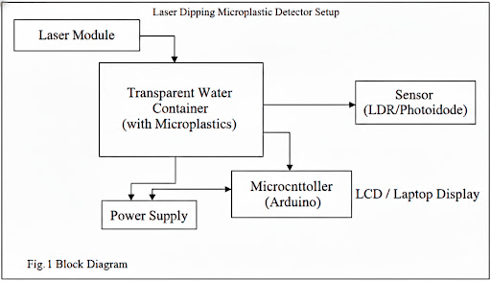

Fig.1. Block Diagram of Microplastic Detector

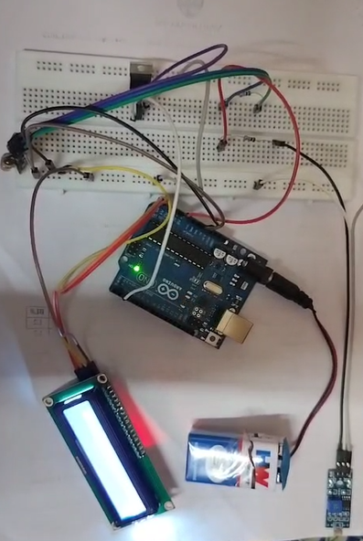

Fig.2.Integration of components to Arduino

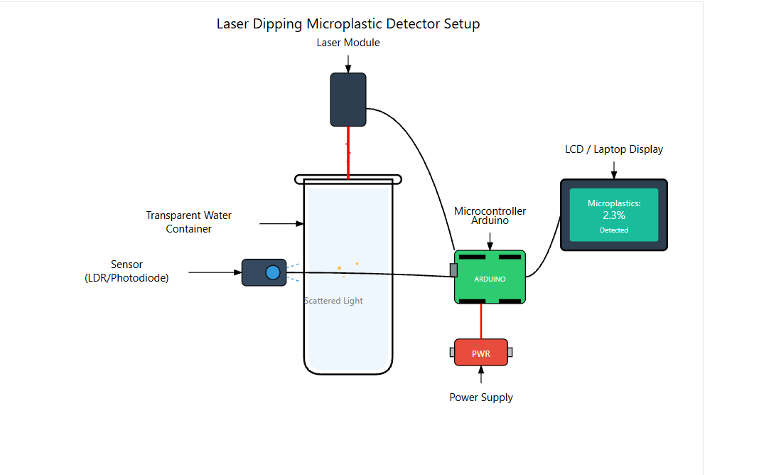
Fig.3. Side view of Prototype model

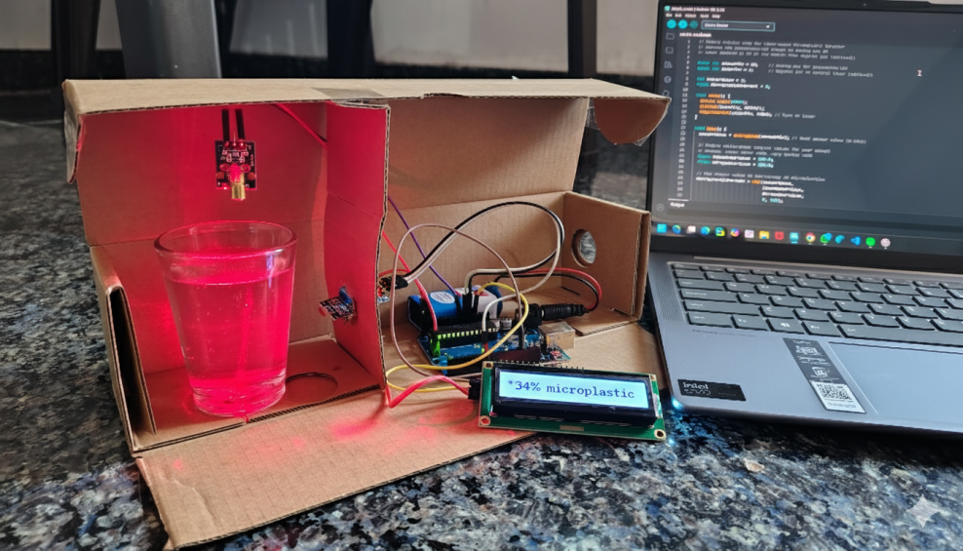

Fig.4. front View of Prototype model

- Have you conducted Primary Patent Search? Yes / No (if yes, attach the patent search report)
Yes.
- CN114998664A – Multi-Optical Platform Rapid Detection Device for Microplastics in Seawater
This patent describes a detection device using multiple optical sensors and Raman spectroscopy to rapidly identify microplastics in seawater. It combines visual and spectroscopic data to classify different plastic particles based on light response and material properties.

- EP3772663A1 – System for Detecting Plastics and Microplastics in Aquatic Environments
This patent presents a multi-wavelength detection system designed for identifying plastics in marine and river environments. It integrates sensors with optical scattering and data-processing algorithms to analyze the size and concentration of plastic particles.
- WO2021144323A1 – Detection of Plastic Microparticles by Flow Cytometry
This invention involves the use of multiple laser sources and optical detectors to measure the scattering and fluorescence of microparticles suspended in liquids. It allows accurate detection of plastic particles through laser-based optical analysis.
- US20210403346A1 – Method for Detecting and Extracting Plastic Contaminants from Water Samples
This patent focuses on separating and identifying plastic particles in water using a hydrophobic solvent extraction technique. It outlines a chemical-based detection method distinct from optical laser scattering approaches.
- EP4094063NWB1 – Luminescent Sensor for Nano and Microplastics
This patent discloses a luminescent optical sensor that detects microplastic presence based on fluorescence response. The sensor provides real-time measurements of small plastic particles suspended in liquid samples.
- Existing state-of-the-art and prior arts: (Brief background of the existing knowledge/product/process in the market)

1. Laboratory-Based Microplastic Detection Systems
Examples: Fourier Transform Infrared Spectroscopy (FTIR), Raman Spectroscopy, Scanning Electron Microscopy (SEM)
Key Features:
Provide highly accurate microplastic identification based on chemical composition.
Capable of analyzing microplastic size, shape, and polymer type.
Used in research institutions and advanced laboratories.
Limitations:
Extremely high cost and requires skilled personnel.
Not portable and unsuitable for on-site or real-time water testing.
Time-consuming sample preparation and analysis process.

2. Image and AI-Based Detection Systems
Examples: Automated image recognition systems, Fluorescence microscopy with AI classification
Key Features:
Use high-resolution cameras and deep learning algorithms to identify microplastic particles.
Provide accurate size and color differentiation.
Reduce manual intervention and improve detection speed.
Limitations:
High equipment cost and computational requirements.
Dependent on stable lab environments and controlled lighting.
Not feasible for low-cost or field-based deployment.

3. Turbidity and Water Quality Sensors
Examples: Hach 2100Q Turbidimeter, LaMotte 2020we Turbidity Meter
Key Features:
Measure light scattering caused by suspended solids in water.
Provide quick, quantitative turbidity readings for general water quality monitoring.
Portable and battery-operated for field testing.
Limitations:
Designed for overall particulate measurement, not specific to microplastics.
Cannot distinguish between microplastics and other suspended particles like silt or organic matter.
- List out the known ways about how others have tried to solve the same or similar problems? Indicate the disadvantages of these approaches. In addition, please identify any prior art documentation or other material that explains or provides examples of such prior art efforts.

S. No. | Existing State of Art | Drawbacks in Existing State of Art | How the Proposed System Overcomes the Drawbacks
1 | FTIR / Raman Spectroscopy Systems | Expensive, stationary, and complex; unsuitable for real-time or field detection. | Uses a low-cost laser diode and photodiode sensor with Arduino for portable, real-time analysis.
2 | Chemical and Dye-Based Detection (Nile Red, Solvent Extraction) | Requires chemical handling, generates waste, and may misidentify organic matter. | Eco-friendly and reagent-free; relies on optical scattering for accurate detection.
3 | Optical and Flow-Based Detectors | Depend on multiple lasers and complex calibration, increasing size and and cost. | Employs a single laser beam with simple photodiode detection to reduce both cost and complexity.

- List the Technical features and Elements of the invention along with the Description of your invention from start to end.

Water pollution caused by microplastics has become a serious environmental concern, as these microscopic plastic particles are difficult to detect with the naked eye and require expensive laboratory equipment for analysis. To address this issue, the invention proposes an Arduino-based laser scattering system for low-cost microplastic detection in water samples. This setup provides a portable, affordable, and efficient solution for identifying the presence of microplastics based on the principle of light scattering. When a laser beam passes through water containing microplastics, the light is scattered and absorbed by the particles, resulting in a measurable reduction in intensity. The system captures this variation using a light sensor and displays the results in real time.
a. LCD:
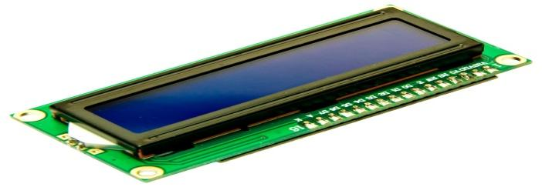

Fig.5. LCD

A liquid crystal display (LCD) is a flat-panel display technology commonly used in televisions, computer monitors, smartphones, and other digital devices. LCDs work by manipulating light through liquid crystals, which are substances that exhibit properties between those of conventional liquids and solid crystals. The display consists of several layers, including a backlight, polarizing filters, and a matrix of liquid crystals sandwiched between two glass substrates. When an electric current is applied to the liquid crystals, they align in a way that modulates the light passing through them, creating images. This technology is highly efficient, providing clear, sharp images with relatively low power consumption. LCDs are favored for their thin form factor, light weight, and

b. ARDUINO UNO:
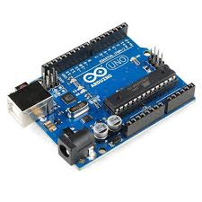

Fig.6. Arduino UNO

The UNO R3 SMD Board, an integral component in the Arduino family, is widely utilized for a plethora of applications in electronics and programming. This board, featuring a surface-mount device (SMD) version of the ATmega328 microcontroller, offers enhanced durability and a compact design, making it ideal for various embedded systems projects. It is extensively used in educational settings to teach students the fundamentals of programming and electronics, offering a user-friendly platform to build and test a wide range of projects. Hobbyists and makers often leverage the UNO R3 SMD Board for creating DIY electronics projects, such as home automation systems, interactive art installations, and robotic controls, due to its compatibility with numerous sensors, modules, and shields.
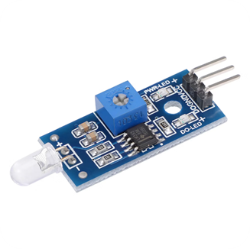
c. LIGHT SENSOR (LDR/PHOTODIODE)

Fig.7. Light Sensor

LDR (Light Dependent Resistor): The LDR is a resistive sensor whose resistance decreases as the intensity of incident light increases. In darkness, it offers very high resistance, often in the megaohm range, and in bright light, the resistance can drop to a few hundred ohms. LDRs are simple, low-cost sensors ideal for detecting ambient light levels or light interruptions in basic automation systems. Photodiode: A photodiode is a semiconductor device that generates a current or voltage proportional to the light it receives. It is more sensitive and faster in response than LDRs, making it suitable for applications that require precise and rapid light detection, such as optical encoders or security beam sensors.

d. LASER DIODE MODULE

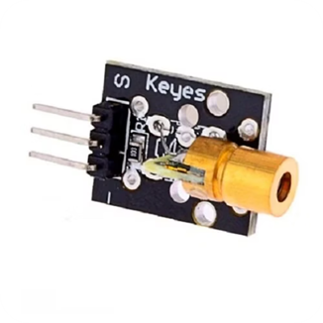

Fig.8. Lazer Diode
A Laser Diode Module is an electronic device that emits a highly focused and coherent beam of light when a low DC voltage is applied, typically 3–5V. The module often includes a built-in current-limiting resistor for safe operation. Laser diodes are used in projects for alignment, targeting, or detection purposes, as the beam can travel over long distances with minimal divergence. When combined with a light sensor such as an LDR or photodiode, the laser beam can be interrupted by an object, allowing the system to detect movement or presence. This makes laser modules especially useful in security systems, object counters, or automated delivery solutions. The emitted light is usually visible red light (~650 nm), and the module is compact, low-power, and easy to integrate with microcontrollers like Arduino.

e. POWER SOURCE (USB/9V BATTERY):


Fig.9. 9V battery
USB Power: Provides a regulated 5V DC supply directly from a computer or USB adapter. It is convenient for stationary setups or during development and programming.9V Battery: Offers portable power, allowing the system to operate without a direct connection to mains electricity. The Arduino’s onboard voltage regulator converts the battery voltage to the required 5V for the board and connected module.The choice of power source depends on the application requirements:
USB is suitable for continuous operation near a power outlet, while a battery is ideal for portable or temporary deployments. Proper power management ensures stable operation of the Arduino, sensors, laser diode, and LCD display, preventing fluctuations or resets in the system

- List out the features of your invention which are believed to be new and distinguish them over the closest technology.
- Feature | - Microplastic Detector (Your Invention) | - Closest Existing Technology | - Distinguishing Aspect
Portable Real-Time Detection Unit | Compact, low-cost sensor capable of detecting microplastics in water samples instantly | Laboratory spectroscopic analyzers (FTIR/Raman) | Enables on-site analysis without expensive lab equipment
AI-Based Particle Classification | Uses trained AI model to differentiate plastic types by size, color, and density | Manual or semi-automated analysis | Provides faster and more accurate microplastic identification
Optical and Ultrasonic Hybrid Sensing | Combines light scattering and ultrasonic resonance for enhanced sensitivity | Optical-only or chemical analysis methods | Dual-sensing increases detection accuracy even in turbid water
IoT-Enabled Monitoring Dashboard | Real-time data upload, visualization, and alert system via mobile/web app | Manual data logging or local-only display | Remote monitoring and environmental mapping through cloud connectivity
Eco-Friendly Sampling and Filtration System | Uses biodegradable filters and recyclable components | Conventional plastic-based filters | Reduces environmental footprint while collecting samples
Water Quality Parameter Integration | Simultaneous measurement of pH, turbidity, and TDS with microplastic data | Separate devices needed for each parameter | Multi-sensor integration provides comprehensive water quality profiling
Modular Design for Various Environments | Interchangeable sensors for freshwater, seawater, and wastewater testing | Fixed-use lab setups | Adaptable for diverse environmental conditions
Self-Calibrating Sensor Mechanism | Automatic baseline adjustment for consistent accuracy | Manual calibration required | Reduces maintenance and ensures reliable long-term operation
Data-Driven Pollution Mapping | AI integrates location data for hotspot detection and pollution trend analysis | Limited to sample-by-sample data | Enables large-scale environmental tracking and early intervention

10. Has the invention been built or tested or implemented? If so, please provide the particulars of the first time it was successfully built or implemented (when, where, by whom, and evidence of this event including written or on-line pointers to documentary evidence):All testing details

Yes, the microplastic detection system was successfully built and tested as part of our Technology Entrepreneurship project collaborated to construct the system using an Arduino UNO, laser diode module, LDR sensor, and supporting components. The testing involved comparing light intensity readings from clean water versus water samples containing microplastic particles. The system displayed real-time results on an LCD screen, showing percentage reductions in light intensity due to scattering effects caused by microplastics.
Evidence of this implementation is documented in our project presentation,which includes detailed schematics, code logic, and output interpretation.
The presentation was submitted to the faculty and is available in the department archives. Additional documentation, including photographs and video recordings of the working prototype.

11. Briefly state when and how you first conceived this idea?

The idea for the microplastic detector was first conceived during a classroom discussion on environmental challenges and the limitations of current water quality monitoring systems. Recognizing the growing threat of microplastic pollution and the lack of affordable detection tools, especially in developing regions, we envisioned a low-cost, DIY solution that could empower citizens and students to participate in environmental monitoring. Inspired by the accessibility of Arduino platforms and the physics of light scattering, we began prototyping the system in early September 2025.

12. Have you sold, offered for sale, publicly used or published anything related to this invention? If yes, please briefly explain the dates and circumstances. List those individuals to whom you have revealed your invention. Were non-discloser documents signed prior to discloser in each case? Please state any deadlines of which you may be aware for filing an application on this invention.

No

13. Include any reasons that your invention would not have been obvious to someone of average skill in the art.

- Unconventional Integration of Low-Cost Components:
While Arduino boards, laser diodes, and LDR sensors are commonly used in hobby electronics, their integration into a functional microplastic detection system using light scattering principles is novel. The inventive combination of these components for environmental sensing is not suggested by prior art and requires interdisciplinary insight.
- Application of Light Scattering in DIY Environmental Monitoring:
Light scattering is a well-known principle in physics and high-end laboratory equipment, but its adaptation for microplastic detection using consumer-grade electronics is unconventional. A person of ordinary skill would not typically apply this principle outside of controlled lab environments without specialized optics.
- Dual-Sensor Configuration for Enhanced Sensitivity:
The optional placement of a second sensor at a 90° angle to detect scattered light adds a layer of sophistication not commonly found in basic Arduino projects. This arrangement mimics professional turbidity meters and reflects a deeper understanding of optical physics, which is not obvious to a general electronics hobbyist.
- Real-Time Quantification via LCD Display:
Displaying microplastic concentration as a percentage reduction in light intensity on a 16x2 LCD screen bridges complex environmental data with user-friendly output. This real-time feedback mechanism is not standard in low-cost water testing kits and demonstrates inventive user-centric design.
- Calibration-Based Data Processing Algorithm:
The use of a pre-calibrated baseline for clean water to infer microplastic concentration introduces a novel algorithmic approach. This method of environmental data interpretation is more advanced than typical analog sensor readings and would not be obvious without domain-specific knowledge.
- Empowerment Through Citizen Science Design:
The system is intentionally designed for accessibility by students, hobbyists, and DIY makers. This democratization of environmental monitoring through open-source hardware and simple assembly diverges from traditional, centralized water testing methods and reflects a unique social innovation.
- Cross-Disciplinary Engineering Approach:
The invention blends principles from computer science, electronics, environmental science, and optical physics. Such a cross-disciplinary integration is not typical for someone with average skill in any one of these fields and requires inventive synthesis.
- Addressing Regulatory and Cost Barriers:
By targeting the lack of regulation and high cost of microplastic detection, the invention fills a gap that is often overlooked by conventional engineering solutions. The strategic focus on affordability and scalability is a novel response to systemic challenges in water quality management.

