EXPERIMENT 5

DATA VISUALIZATION USING MATPLOTLIB

Aim:
To create and analyze various data visualizations such as Line Charts, Bar Charts, Pie Charts, Histograms, Scatter Plots, and Box Plots using Matplotlib on a healthcare stroke dataset for effective data interpretation.

Algorithm 1 — Line chart
Step 1: Import Matplotlib and Pandas.
Step 2: Load the healthcare stroke dataset.
Step 3: Divide patients into age groups.
Step 4: Calculate average glucose level for each age group.
Step 5: Use plot() function to create the line chart.
Step 6: Add title and axis labels.
Step 7: Display the chart.

Program:
import pandas as pd
import matplotlib.pyplot as plt
df = pd.read_csv("healthcare-dataset-stroke-data(3).csv")
age_groups = pd.cut(
df["age"],
bins=[0, 20, 40, 60, 80, 100],
labels=["0-20", "21-40", "41-60", "61-80", "81-100"]
)
avg_glucose = df.groupby(
age_groups,
observed=False
)["avg_glucose_level"].mean()
plt.plot(avg_glucose.index, avg_glucose.values, marker='o')
plt.title("Average Glucose Level by Age Group")
plt.xlabel("Age Group")
plt.ylabel("Average Glucose Level")
plt.show()

Output:
Average Glucose Level by Age Group
The line chart shows the variation in average glucose level across different age groups.
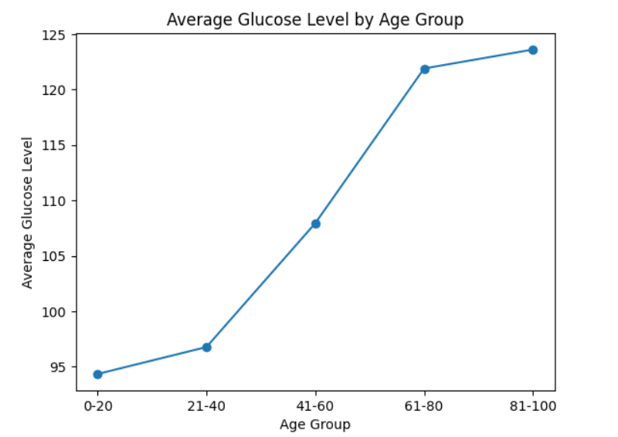

Algorithm 2 — Bar chart
Step 1: Select patients who experienced stroke.
Step 2: Group stroke cases according to gender.
Step 3: Count the number of stroke cases for each gender.
Step 4: Use bar() function to create the bar chart.
Step 5: Add chart title and labels.
Step 6: Display the chart.

Program:
stroke_gender = df[df["stroke"] == 1]["gender"].value_counts()
print(stroke_gender)
plt.bar(stroke_gender.index, stroke_gender.values)
plt.title("Stroke Cases by Gender")
plt.xlabel("Gender")
plt.ylabel("Number of Stroke Cases")
plt.show()

Output:
Stroke Cases by Gender
The bar chart compares the number of stroke cases among different genders.
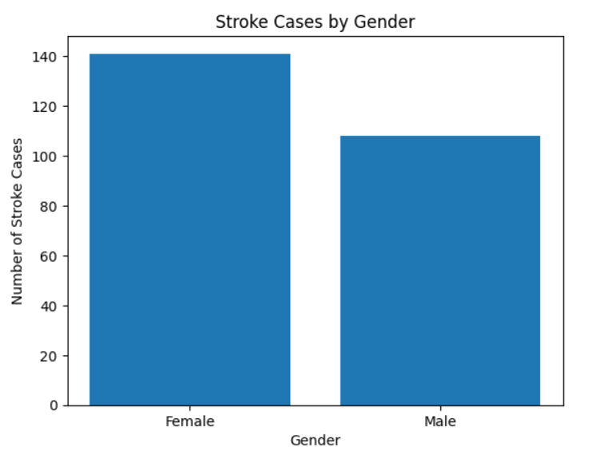

Algorithm 3 — Pie chart
Step 1: Count patients with and without stroke.
Step 2: Create labels for the categories.
Step 3: Apply pie() function.
Step 4: Add percentage labels using autopct.
Step 5: Add chart title.
Step 6: Display the chart.

Program:
stroke_counts = df["stroke"].value_counts()

labels = ["No Stroke", "Stroke"]
plt.pie(
stroke_counts,
labels=labels,
autopct='%1.1f%%'
)
plt.title("Stroke Patient Distribution")
plt.show()

Output:
Stroke Patient Distribution
The pie chart shows the percentage distribution of patients with and without stroke.
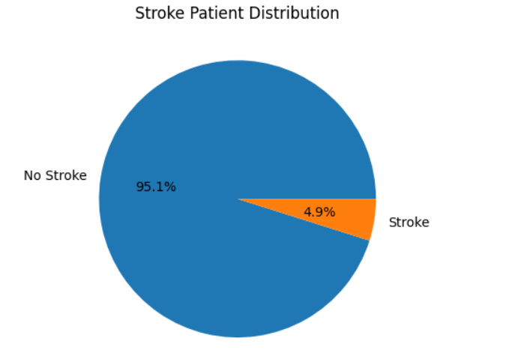

Algorithm 4 — Histogram
Step 1: Select the age column from the dataset.
Step 2: Use hist() function.
Step 3: Divide the data into suitable intervals.
Step 4: Add title and axis labels.
Step 5: Display the histogram.

Program:
plt.hist(df["age"], bins=10)

plt.title("Age Distribution of Patients")
plt.xlabel("Age")
plt.ylabel("Number of Patients")
plt.show()

Output:
Age Distribution of Patients
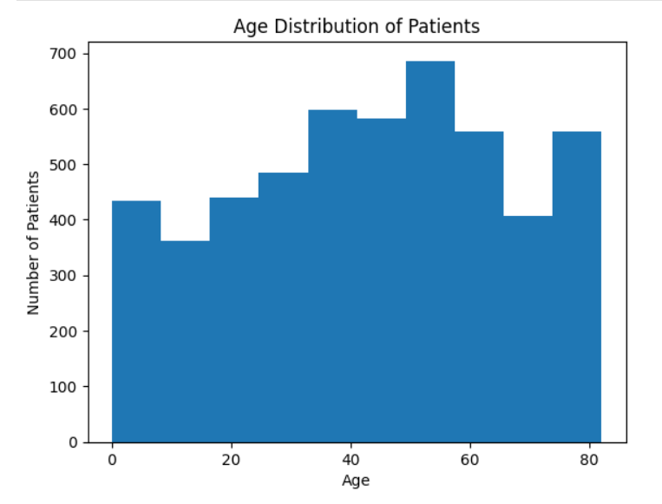

Algorithm 5 — Scatter plot
Step 1: Select age and avg_glucose_level columns.
Step 2: Use scatter() function.
Step 3: Plot age on the X-axis.
Step 4: Plot average glucose level on the Y-axis.
Step 5: Add title and axis labels.
Step 6: Display the scatter plot.

Program:
plt.scatter(
df["age"],
df["avg_glucose_level"]
)
plt.title("Age vs Average Glucose Level")
plt.xlabel("Age")
plt.ylabel("Average Glucose Level")

plt.show()

Output:
Age vs Average Glucose Level
The scatter plot shows the relationship between patient age and average glucose level.
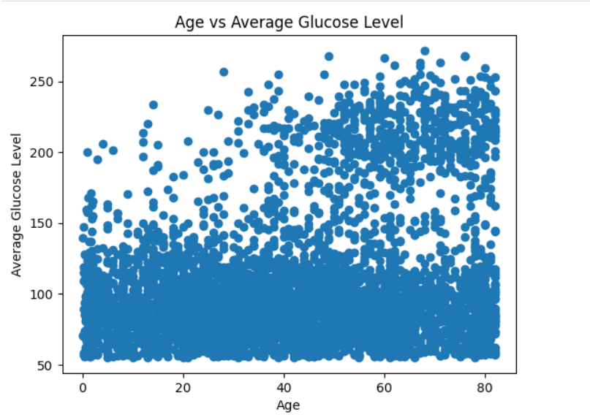

Algorithm 6 — Box plot
Step 1: Select the bmi column.
Step 2: Remove missing BMI values.
Step 3: Use boxplot() function.
Step 4: Add title and axis labels.
Step 5: Display the box plot.
Step 6: Identify possible outliers.

Program:
bmi_data = df["bmi"].dropna()
plt.boxplot(bmi_data)
plt.title("BMI Distribution")
plt.ylabel("BMI")
plt.show()

Output:
BMI Distribution
The box plot represents the distribution of BMI values and helps identify potential outliers in the healthcare dataset.
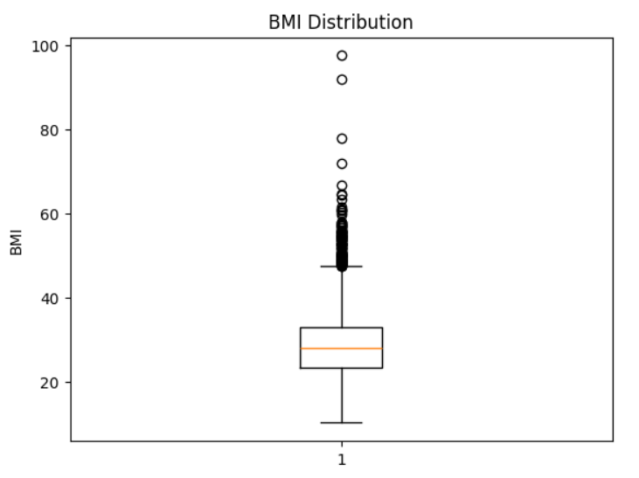

Result:
Thus, various visualization techniques such as Line Charts, Bar Charts, Pie Charts, Histograms, Scatter Plots, and Box Plots were successfully created using Matplotlib on the healthcare stroke dataset. The graphical representations helped in understanding patient distributions, stroke patterns, glucose levels, age distribution, and BMI variations.

