EXPERIMENT 1A

SETTING UP PYTHON ENVIRONMENT AND LIBRARIES – JUPYTER NOTEBOOK

Aim
To install Python, configure Jupyter Notebook, understand the notebook environment, execute Python programs, create Markdown cells, and use basic Jupyter Notebook features for Data Analytics applications.

Algorithm

Algorithm 1: Installing Python
Step 1: Download Python from python.org Step 2: Run the installer
Step 3: Select "Add Python to PATH" Step 4: Click Install Now
Step 5: Verify installation using:
python --version
Step 6: Observe installed Python version.

Algorithm 2: Installing Jupyter Notebook
Step 1: Open Command Prompt Step 2: Install Jupyter
pip install notebook
Step 3: Launch Jupyter Notebook jupyter notebook
Step 4: Browser automatically opens Notebook Dashboard.

Algorithm 3: Creating a Notebook
Step 1: Open Jupyter Dashboard Step 2: Select New → Python 3 Step 3: Create Notebook
Step 4: Rename Notebook
Step 5: Create Code and Markdown Cells

Step 6 : Execute cells using Shift + Enter

Result:
Python and Jupyter Notebook has been installed successfully.

EXPERIMENT 1B

DATA MINING FRAMEWORK

Aim
To install and import libraries, import dataset and perform data pre-preprocessing using CRISP framework.

Algorithm

Algorithm 1: Installing Python
Step 1: Import pandas to read dataset.

Step 2: Read the dataset file
Step 3: Find the first few rows and the number of features.
Step 4: Perform data pre-processing and get the total stroke output.
Step 5: Visualize the data using matplotlib library.

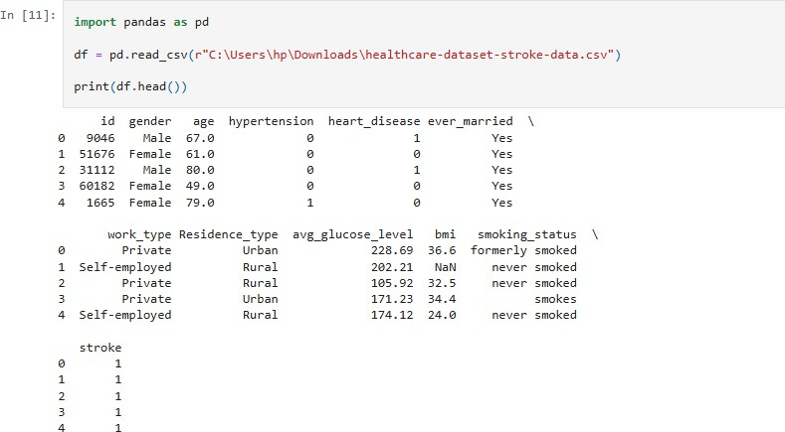
Program:

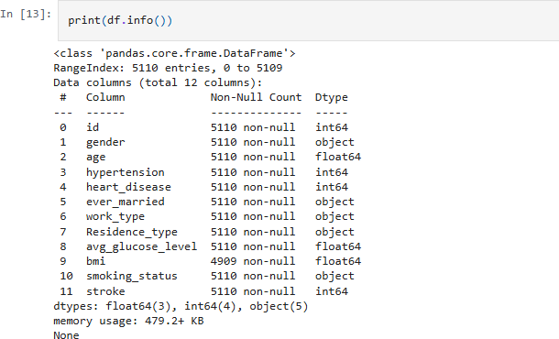

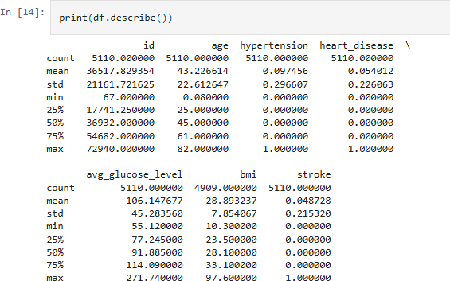

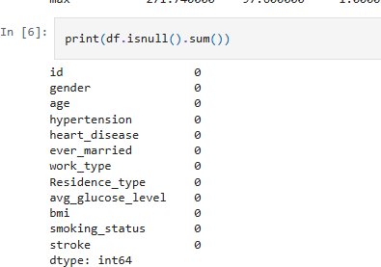
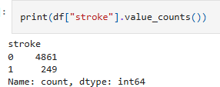
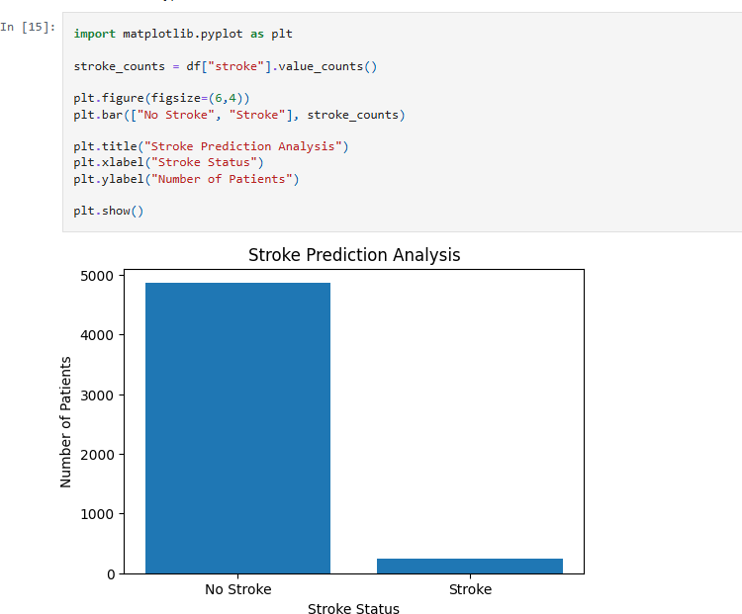

Result:
The heart_stroke dataset has been loaded, pre-processed, visualized successfully using CRISP framework.

