VeritasRAG: A HALLUCINATION-FLAGGING LAYER FOR RAG
A PROJECT REPORT

Submitted by

Architha M 231401013

Dhanvin Kadiir S 231401022

in partial fulfillment for the award of the degree of

BACHELOR OF TECHNOLOGY

in

COMPUTER SCIENCE AND BUSINESS SYSTEMS




RAJALAKSHMI ENGINEERING COLLEGE
ANNA UNIVERSITY: CHENNAI 6000025

October 2026

RAJALAKSHMI ENGINEERING COLLEGE
CHENNAI

BONAFIDE CERTIFICATE
Certified that this Project Report titled “VeritasRAG: A Hallucination-Flagging Layer for RAG” is the bonafide work of “Architha M (231401013), Dhanvin Kadiir S (231401022)”, who carried out the work under my supervision. Certified further that, to the best of my knowledge, the work reported herein does not form part of any other project report or dissertation on the basis of which a degree or award was conferred on an earlier occasion on this or any other candidate.

SIGNATURE  Dr. K. R. Sowmia, Ph.D.,  Assistant Professor & Head  Computer Science and Business Systems  Rajalakshmi Engineering College  Chennai – 602 105 | SIGNATURE  Mrs. Poornimathi K  Assistant Professor [SG]  Computer Science and Business Systems  Rajalakshmi Engineering College  Chennai – 602 105

Submitted to Project Viva-Voce Examination held on

Internal Examiner External Examiner

RAJALAKSHMI ENGINEERING COLLEGE
B.Tech. COMPUTER SCIENCE AND BUSINESS SYSTEMS

VISION
- To promote highly ethical and innovative computer professionals through excellence in teaching, training and research.
MISSION
- To produce globally competent professionals, motivated to learn the emerging technologies and to be innovative in solving real world problems.

- To promote research activities amongst the students and the members of faculty that could benefit the society.

- To impart moral and ethical values in their profession
PROGRAM EDUCATIONAL OBJECTIVES (PEOs)
- To equip students with state-of-the-art contemporary technology in computer science and basic engineering science.
- To expose students to the business principles aligned with their domain.
- To educate on the service orientation principles for various business disciplines.
- To encourage innovative research through creative thinking and critical analytical ability.
- To inculcate ethical and moral values in the individuals benefitting the society.
PROGRAM OUTCOMES (POs)

A graduate of the Computer Science and Business Systems program will demonstrate:
PO1: Engineering knowledge: Apply the knowledge of mathematics, science, engineering fundamentals, and an engineering specialization to the solution of complex engineering problems.

PO2: Problem analysis: Identify, formulate, review research literature, and analyse complex engineering problems reaching substantiated conclusions using first principles of mathematics, natural sciences, and engineering sciences.

PO3: Design/development of solutions: Design solutions for complex engineering problems and design system components or processes that meet the specified needs with appropriate consideration for the public health and safety, and the cultural, societal, and environmental considerations.

PO4: Conduct investigations of complex problems: Use research-based knowledge and research methods including design of experiments, analysis and interpretation of data, and synthesis of the information to provide valid conclusions.

PO5: Modern tool usage: Create, select, and apply appropriate techniques, resources, and modern engineering and IT tools including prediction and modelling to complex engineering activities with an understanding of the limitations.

PO6: The engineer and society: Apply reasoning informed by the contextual knowledge to assess societal, health, safety, legal and cultural issues and the consequent responsibilities relevant to the professional engineering practice.

PO7: Environment and sustainability: Understand the impact of the professional engineering solutions in societal and environmental contexts, and demonstrate the knowledge of, and need for sustainable development.

PO8: Ethics: Apply ethical principles and commit to professional ethics and responsibilities and norms of the engineering practice.

PO9: Individual and team work: Function effectively as an individual, and as a member or leader in diverse teams, and in multidisciplinary settings.

PO10: Communication: Communicate effectively on complex engineering activities with the engineering community and with society at large, such as, being able to comprehend and write effective reports and design documentation, make effective presentations, and give and receive clear instructions.

PO11: Project management and finance: Demonstrate knowledge and understanding of the engineering and management principles and apply these to one’s own work, as a member and leader in a team, to manage projects and in multidisciplinary environments.

PO12: Life-long learning: Recognize the need for, and have the preparation and ability to engage in independent and life-long learning in the broadest context of technological change.

PROGRAM SPECIFIC OUTCOMES (PSOs)

A graduate of the Computer Science and Business Systems program will demonstrate:
- The students graduating will have sound knowledge in Computer Science with equal appreciation of humanities, management sciences and human values.
- The students will explore emerging topics such as Analytics, Machine Learning, Cloud Computing, and Internet of Things and apply the knowledge to design and develop solutions to societal needs.
- The students will be industry ready with required business skills in service orientation.

OBJECTIVES:
  - To identify a problem statement of societal importance.
  - To analyze a problem and find out requirements.
  - To plan, design, and execute a project solution effectively within specified timelines and resources.
  - To develop technical expertise in using contemporary tools, technologies, and methodologies for the project.
  - To test and document a project.

COURSE OUTCOMES (COs)

CO1 | Apply the concepts of computer science to real-world problems and understand Ethical and societal implications.
CO2 | Take in any difficult sensible issues and propose solution through formulating right methodology.
CO3 | Attain a hands-on experience in changing a small novel idea / method right into an operating model / prototype related to multi-disciplinary abilities and  / or understanding and operating in at team
CO4 | Interpret the outcome of their project. Students will take on the challenges of  teamwork, prepare a presentation in a professional manner, and document all aspects of design work.
CO5 | Publish or release the project outcome to the society.

ABSTRACT
Retrieval-Augmented Generation (RAG) reduces but does not eliminate hallucinations in large language models, since a generator can still alter facts, drop conditions, or add details that its retrieved evidence never actually stated. This project presents VeritasRAG, a pluggable middleware that verifies RAG-generated responses against their retrieved evidence at the sentence level, rather than trusting a generated answer as a whole. As part of this project, an embedding-based verification approach was implemented, which splits a generated response into individual sentences using spaCy and compares each sentence against the retrieved evidence chunks using cosine similarity between sentence and chunk embeddings computed with a bi-encoder model. Each sentence is classified as grounded, inferred, or hallucinated based on its similarity score, and the result is rendered as a structured JSON output as well as a colour-coded HTML report that highlights which sentences are supported by the evidence and which are not. The approach was evaluated on a locally curated set of grounded and hallucinated examples, and its accuracy, precision, recall, and F1-score were measured. This work demonstrates a practical, evidence-linked method for identifying unsupported content in RAG-generated responses.

Keywords: Retrieval-Augmented Generation, Hallucination Detection, Semantic Similarity, Grounding Verification, Middleware.

ACKNOWLEDGEMENT
We first express our heartfelt gratitude to the Almighty for His blessings, which enabled us to successfully complete this project.
We extend our sincere thanks to our Chairman, Mr. S. Meganathan, B.E., F.I.E., for his unwavering commitment to providing quality education through this esteemed institution. Our deep gratitude also goes to our respected Chairperson, Dr. Thangam Meganathan, Ph.D., whose constant motivation greatly inspired us in completing this project, and to our Vice Chairman, Mr. Abhay Shankar Meganathan, B.E., M.S., for providing us with the necessary infrastructure and resources.
We wish to express our appreciation to our Principal, Dr. S.N. Murugesan, M.E., Ph.D., and to Dr. K.R.Sowmia, Ph.D., Assistant Professor and Head, for their continuous support. We are especially thankful to our project guide, Mrs. Poornimathi K, Assistant Professor (SG), for their valuable guidance, encouragement, and insightful suggestions throughout the course of the project.
We also extend our sincere gratitude to our Project Coordinator and Panel Members for their valuable guidance, constructive feedback, and constant support, which greatly contributed to the successful completion of this work.
Finally, we are deeply grateful to our parents, friends, faculty members, and the supporting staff for their direct and indirect contributions, encouragement, and assistance in bringing this project to fruition.

ARCHITHA M
DHANVIN KADIIR S

TABLE OF CONTENTS

CHAPTER NO | TITLE | PAGE NO
 | ABSTRACT | iii
 | LIST OF TABLES | vii
 | LIST OF FIGURES | viii
1 | INTRODUCTION | 1
 | 1.1 Background of the Study
 | 1.2 Problem Statement
 | 1.3 Objectives of the Project
 | 1.4 Scope of the Project
2 | LITERATURE REVIEW
 | 2.1 Overview of Related Work
 | 2.2 Comparative Analysis (Table format)
 | 2.3 Research Gap Identification
3 | SYSTEM DESIGN
 | 3.1 System Architecture Diagram
 | 3.2 Module-Level Design
 | 3.3 Tools, Technologies, and
Frameworks Used
  - SYSTEM IMPLEMENTATION
    - Data Collection and Preprocessing Methods
    - Module Implementation Details
    - Results and Discussion
    - Output Screenshots
  - CONCLUSION REFERENCES APPENDIX
I. Business Model Canvas II.CO-PO-PSO Mapping

LIST OF TABLES
TABLE NO | TITLE | PAGE NO
Table 1.1 | Scope Boundaries of the Project
Table 2.1 | Comparative Analysis of Related Work
Table 3.1 | Tools, Technologies and Frameworks Used
Table 3.2 | Classification Thresholds by Verifier
Table 4.1 | Dataset Field Description
Table 4.2 | Grounding Classification Thresholds
Table 4.3 | Demonstrated Approach A Verification Result
Table 4.4 | Approach A Benchmark Results

LIST OF FIGURES
FIGURE | TITLE | PAGE NO
Figure 3.1 | VeritasRAG Middleware Architecture and Data Flow
Figure 3.2 | Verification Call Sequence
Figure 4.1 | VeritasRAG Approach A embedding-similarity verification interface
Figure 4.2 | Sentence-level grounding scores and source evidence inspection
Figure 4.3 | Approach A benchmark evaluation output
Figure 4.4 | Final Approach A benchmark performance

CHAPTER-1
INTRODUCTION

1.1 Background of the Study
Large Language Models (LLMs) can generate text that is fluent and well-structured, but they can also produce information that is incorrect or not supported by any reliable source. This is commonly known as hallucination. The main reason for this is the way LLMs are trained. They learn patterns from large amounts of text and generate responses by predicting what text is likely to come next, rather than checking every statement against verified facts while generating an answer. Because of this, an LLM can produce a sentence that sounds confident and accurate even when the information is completely made up.
Retrieval-Augmented Generation (RAG) was developed to address this issue by providing the model with relevant information retrieved from an external knowledge source [1]. In a typical RAG system, the user's query is first used to find relevant text passages, or “chunks,” from a collection of documents. This is usually done using vector similarity search on pre-computed embeddings. The retrieved chunks are then provided to the language model as context, allowing it to generate an answer based on the available evidence. This approach has been shown to improve factual accuracy for knowledge-intensive tasks compared with relying only on the information stored within the model.
However, RAG does not completely prevent hallucinations. Even when the correct information is retrieved, the model may still change a numerical value, mix up relationships between entities, leave out important conditions, combine unrelated facts, or add details that are not present in the retrieved evidence [7], [12]. This creates a problem when a response contains both supported and unsupported information. A user may be able to see the retrieved sources, but it can still be difficult to determine which individual statements in a long response are actually supported by those sources. Research on RAG failure modes highlights this issue, where an answer may appear to be grounded in retrieved evidence while still containing unsupported content [12].

1.1.1 Worked Example of the RAG Pipeline
For example, consider a user asking a document-based question-answering system, “What is the maximum leave an employee can carry forward?” A typical RAG system would first convert the question into an embedding and use it to search a vector index containing relevant HR policy passages. Suppose the search returns three relevant chunks. These chunks are then added to the prompt given to the language model, with instructions to generate the answer using only the provided information.
Now, suppose the correct policy states that an employee can carry forward a maximum of 15 days, but the generated response incorrectly says 20 days. This could happen if another retrieved passage contains similar information about a different type of leave and the model combines the two. The answer may still appear convincing to the user, and there is no direct indication of which part of the response is actually supported by the retrieved evidence.
This is the gap that VeritasRAG is intended to address. It would check the generated response against the retrieved chunks and flag the sentence containing “20 days” as unsupported because none of the retrieved evidence states that value.

1.1.2 A Brief Taxonomy of RAG Hallucination
Not all RAG errors are alike, and the three verification approaches in this project are each aimed at a different point in the following rough taxonomy: (a) fabrication, where the generator introduces an entity, date, or fact entirely absent from any retrieved chunk (targeted primarily by Approach A and B, since similarity and entailment both fail cleanly for content with no source at all); (b) contradiction, where the generator states something that directly opposes the evidence, such as reversing a comparison or a causal relationship (targeted primarily by Approach B, since a contradicted sentence can still be superficially similar in wording to the source); and (c) partial hallucination, where a compound sentence is mostly correct but one clause within it is not (targeted primarily by Approach C, since sentence-level scoring alone tends to average this kind of error away).

1.2 Problem Statement
Existing RAG systems do not clearly distinguish, at the level of individual sentences or claims, between generated content that is grounded in retrieved evidence, content that is a reasonable inference from that evidence, and content that is unsupported or directly contradicted by it. Consequently, users of RAG-based applications cannot easily verify which specific claims in a generated response are backed by a cited source and which are not; they are forced to either trust the entire answer or independently re-verify it against the source documents themselves, which defeats much of the convenience RAG is meant to provide.
This project addresses the problem of building a verification layer that checks a RAG system's generated response against its own retrieved evidence chunks, at the level of individual sentences and claims, and reports the result in a form a user or downstream application can inspect, including which evidence chunk was used to support or contest each claim.

1.3 Objectives of the Project
To design a non-invasive, model-agnostic middleware that verifies RAG-generated responses without modifying the underlying generator or retriever.
To implement complementary verification approaches, embedding-based similarity, cross-encoder Natural Language Inference, and atomic fact-level entailment, that can be used individually or combined.
To provide sentence-level and claim-level grounding scores, together with the specific evidence chunk(s) that support or fail to support each claim.
To render verification results as both a structured, machine-readable JSON payload and a human-readable, colour-coded HTML overlay.
To evaluate the verification approaches on a labelled set of grounded and hallucinated examples modelled on established hallucination-benchmark conventions (RAGTruth, FaithBench, HaluEval, FActScore).
Taken together, these objectives are oriented around a single design principle: verification should be attachable to an existing system rather than requiring that system to be rebuilt. This is why the first objective explicitly rules out modifying the retriever or generator, and why the third and fourth objectives focus on producing an inspectable, evidence-linked output rather than a black-box score; a caller integrating VeritasRAG should be able to see the grounding score and the closest supporting evidence for each sentence, not just a flag.
1.4 Scope of the Project
The project falls within the domain of Natural Language Processing and Trustworthy AI, specifically hallucination detection in RAG systems. Its application areas include enterprise document question-answering, customer support assistants, and research or legal assistants The scope of this project is the verification middleware itself: the sentence splitter, the three verification approaches (embedding similarity, cross-encoder NLI and atomic fact-level verification), the score aggregator, the entity/numeric consistency guard, the JSON and HTML output renderers, and a REST API exposing this functionality. The scope explicitly excludes building a new retriever or generator. VeritasRAG is designed to consume a (query, response, evidence chunks) triple that has already been produced by any RAG pipeline, and it does not generate answers itself. Table 1.1 summarises what is and is not within scope.

In Scope | Out of Scope
Sentence-level splitting of a generated response | Building a new document retriever or vector index
Embedding-based and NLI-based claim verification | Training or fine-tuning a generator LLM
Atomic-fact decomposition and entity/number consistency checks | Live internet search or external fact-checking
Score aggregation and grounded/inferred/hallucinated classification | Multi-language support beyond English
JSON and HTML result rendering | A production-grade user interface (target design only, not implemented)
A REST API for programmatic verification | Container orchestration, deployment and monitoring infrastructure
Table 1.1: Scope Boundaries of the Project

CHAPTER 2
LITERATURE REVIEW

2.1 Overview of Related Work
The literature reviewed for this project spans four related research directions, summarised below before the consolidated comparison in Section 2.2.
2.1.1 Foundational RAG Architecture
Retrieval-Augmented Generation combines a retriever with a generator so that responses are conditioned on retrieved passages rather than parametric memory alone [1]. This architecture reduces, but does not eliminate, hallucination, since the generator is still a free-form text model that is not constrained to copy only the retrieved content. Related survey work catalogues the ways such pipelines fail in practice, identifying distinct failure points across the retrieval, chunking, and generation stages of a RAG system [7], [12].
2.1.2 Hallucination Measurement and Benchmarks
Broad surveys categorise the types and causes of hallucination in LLMs, distinguishing, for instance, between hallucinations that contradict the provided source and hallucinations that contradict established world knowledge [9]. Purpose-built benchmarks such as RAGTruth [3], HaluEval [13] and FaithBench [14] provide labelled corpora of grounded and hallucinated generations for evaluating detectors, and consistently report that even strong detection methods struggle with subtle hallucinations, for example, a single altered number in an otherwise well-supported sentence.
2.1.3 Verification Techniques
Sentence-BERT [15] established efficient sentence-level embeddings for semantic similarity, which forms the basis of this project's Approach A. While fast, similarity-based methods conflate topical relatedness with logical support: a sentence can be highly similar in wording to a source passage while asserting the opposite of what that passage says. DeBERTa [10] established a strong disentangled-attention transformer architecture widely used for cross-encoder Natural Language Inference (NLI), which forms the basis of Approach B and directly addresses this weakness by reasoning about entailment, neutrality, and contradiction rather than surface overlap. FActScore [2] introduced the idea of decomposing a long response into atomic facts and verifying each independently against evidence, which motivates this project's Approach C and its ability to catch errors hidden inside otherwise correct compound sentences.
2.1.4 Alternative and Complementary Strategies
Self-RAG [4] and Corrective RAG [11] intervene at the retrieval or generation stage rather than after generation, training the generator itself to reflect on or correct its own output; this requires access to model weights and fine-tuning infrastructure that a model-agnostic post-hoc verifier does not need. RAGAs [5] and SelfCheckGPT [6] evaluate faithfulness using LLM-based judging or response-sampling rather than evidence-linked entailment, which is flexible but comparatively slow and does not cite a specific supporting passage for its judgment. SAFE [8] uses live web search to verify long-form factual claims, which is unsuitable where verification must remain confined to a fixed, supplied evidence set rather than the open web.
2.1.5 Paper-by-Paper Notes
- Lewis et al. (2020) [1] introduced the original RAG architecture combining a Dense Passage Retriever with a BART generator, and is treated in this project as the baseline architecture that VeritasRAG is designed to sit downstream of, without modification.
- Min et al. (2023) [2] proposed FActScore, which breaks a long-form generation into independently verifiable atomic facts and scores factual precision against a reference; this atomic-decomposition idea is adapted directly into this project's Approach C, though FActScore itself targets offline evaluation of biographies rather than real-time RAG verification.
- Niu et al. (2024) [3] released RAGTruth, a corpus of RAG generations manually annotated for hallucination, which informed the labelling conventions used when constructing this project's own 40-example evaluation set.
- Asai et al. (2024) [4] proposed Self-RAG, which trains a model to emit special reflection tokens indicating whether its own retrieval and generation are well supported; this requires fine-tuning access to the generator, which VeritasRAG's model-agnostic design deliberately avoids needing.
- Es et al. (2024) [5] introduced RAGAs, a suite of reference-free metrics (including faithfulness and answer relevance) computed by prompting an LLM to judge the response; this is flexible but adds the latency and cost of an additional generative call per metric, per response.
- Manakul et al. (2023) [6] proposed SelfCheckGPT, which samples multiple stochastic generations for the same prompt and checks their mutual consistency as a hallucination signal, requiring several extra LLM calls and providing no direct citation of supporting evidence.
- Gao et al. (2024) [7] surveyed RAG architectures broadly and catalogued open challenges, several of which, particularly the lack of any generation-time correctness check, motivate this project's decision to insert a verification step after generation rather than only improving retrieval.
- Wei et al. (2024) [8] proposed SAFE, which verifies long-form factual claims by decomposing them and issuing live web searches for each; this is unsuitable for VeritasRAG's use case, where verification must be confined to a fixed, locally supplied evidence set rather than the open web.
- Huang et al. (2023) [9] provided a broad taxonomy of hallucination types and causes in LLMs, which informed this project's decision to track multiple distinct verdict categories (grounded / inferred / hallucinated / contested) rather than a single binary label.
- He et al. (2021) [10] introduced DeBERTa's disentangled attention mechanism, which underlies the cross-encoder NLI model used directly as Approach B in this project.
- Yan et al. (2024) [11] proposed Corrective RAG, which evaluates retrieval quality and triggers a corrective action (such as a web search) before generation; this is complementary to, rather than a substitute for, a post-generation verifier, since it does not check the generator's own output.
- Barnett et al. (2024) [12] catalogued seven concrete failure points across a typical RAG pipeline, several of which occur at or after the generation step and are only detectable by inspecting the final response against its evidence, directly motivating this project's focus on post-generation verification.
- Li et al. (2023) [13] introduced HaluEval, a large-scale hallucination evaluation benchmark that, while not RAG-specific, provided a secondary reference point for the kinds of hallucinated statements this project's own evaluation set was designed to include.
- Laban et al. (2024) [14] introduced FaithBench, which specifically targets subtle hallucinations that simpler methods tend to miss, reinforcing this project's decision to combine more than one verification approach rather than relying on any single method.
- Reimers and Gurevych (2019) [15] introduced Sentence-BERT, establishing efficient sentence-level embeddings via a siamese network structure; the specific model used in this project's Approach A, all-MiniLM-L6-v2, is a distilled model trained using this same sentence-embedding methodology.

2.2 Comparative Analysis (Table Format)

Table 2.1 summarises the fifteen papers reviewed, their methodology, key findings, limitations, and relevance to the current project.
No. | Author(s) & Year | Methodology | Key Findings | Limitation / Gap | Relevance
1 | Lewis et al., 2020 | DPR + BART with retrieved passages | RAG improves knowledge-intensive tasks | No output verification | Base RAG architecture
2 | Min et al., 2023 | Atomic facts + NLI | Enables fine-grained factual evaluation | Offline; costly | Atomic verification
3 | Niu et al., 2024 | Hallucination annotations | Identifies hallucinations in RAG | No real-time system | Benchmark dataset style
4 | Asai et al., 2024 | Retrieval + self-critique | Improves factuality | Requires fine-tuning | Model-agnostic comparison
5 | Es et al., 2024 | LLM-based evaluation | Measures faithfulness / relevance | Expensive; offline | Motivates real-time gap
6 | Manakul et al., 2023 | Multiple responses + NLI | Detects inconsistent hallucinations | High inference cost | Efficient verification comparison
7 | Gao et al., 2024 | RAG architecture survey | Identifies RAG challenges | No runtime solution | Motivates modular verification
8 | Wei et al., 2024 | Atomic facts + search | Improves factuality checking | High latency; needs internet | Evidence-verification contrast
9 | Huang et al., 2023 | Hallucination survey | Identifies causes of hallucination | No implementation | Theoretical basis / taxonomy
10 | He et al., 2021 | DeBERTa + NLI | Strong NLI performance | Cross-encoder latency | Basis for Approach B
11 | Yan et al., 2024 | Retrieval evaluation + correction | Improves retrieval quality | Acts pre-generation only | Complementary approach
12 | Barnett et al., 2024 | RAG failure analysis | Identifies practical failures | No runtime detection | Motivates failure identification
13 | Li et al., 2023 | Hallucination benchmark | Evaluates hallucination detection | Not RAG-specific | Secondary benchmark reference
14 | Laban et al., 2024 | Faithfulness benchmark | Tests subtle hallucinations | Single methods may fail | Motivates ensemble approach
15 | Reimers & Gurevych, 2019 | Sentence embeddings | Efficient semantic similarity | Similarity is not entailment | Basis for Approach A

Table 2.1 Comparative Analysis of Related Work
2.3 Research Gap Identification
Across the reviewed literature, the following gaps recur, each of which directly motivates a design decision in this project: A lack of real-time hallucination verification that operates directly on a RAG pipeline's own retrieved chunks, rather than requiring an external judge model or web search, addressed by designing VeritasRAG to consume only the pipeline's own (response, chunks) pair. Limited support for sentence-level or claim-level grounding detection; most existing tools (e.g. Vectara HHEM) report a single document-level faithfulness score, addressed by the SentenceOverlay and AtomicClaim data models, which report a verdict per sentence and per atomic claim.
Higher latency in LLM-judge-based approaches (RAGAs, SAFE, SelfCheckGPT), which typically require multiple additional model calls per response, addressed by using small, purpose-built encoder models (MiniLM, DeBERTa-base) rather than an additional generative LLM call.
Approaches such as Self-RAG require fine-tuning the underlying generator, which is impractical for pipelines built on closed, hosted, or otherwise non-fine-tunable models, addressed by a design that never touches the generator or retriever.
A lack of evidence-linked, user-inspectable output; several tools produce a pass/fail signal or a numeric score without citing which retrieved passage supports or contradicts a specific claim, addressed by citing chunk IDs and evidence excerpts in every SentenceOverlay.
Individual verification methods (pure similarity, pure NLI, pure atomic decomposition) each have known blind spots when used alone, motivating a combined approach, addressed by the score aggregator's ensemble and hybrid modes.
These gaps justify the selection of this project's topic: a non-invasive, model-agnostic, evidence-linked verification layer that combines embedding similarity, cross-encoder NLI and atomic fact-level entailment to produce sentence- and claim-level grounding results. It is worth noting explicitly that no single one of these gaps, on its own, would justify a new system; a narrower project could, for instance, address only the latency gap by wrapping an existing LLM-judge method in a faster model. What distinguishes this project's scope is the combination of constraints taken together, real-time operation, no generator fine-tuning, sentence-level (not document-level) granularity, and cited evidence rather than an opaque score, a combination not fully satisfied by any single tool identified in Table 2.1.

CHAPTER 3
SYSTEM DESIGN

3.1 System Architecture / Workflow
Figure 3.1 illustrates the overall architecture. An upstream RAG pipeline (any retriever/generator combination) produces a response and its retrieved chunks; VeritasRAG receives this pair, splits the response into verifiable sentences, applies the selected verification approach, aggregates the resulting scores where applicable, and returns the verification result together with its grounding overlay.
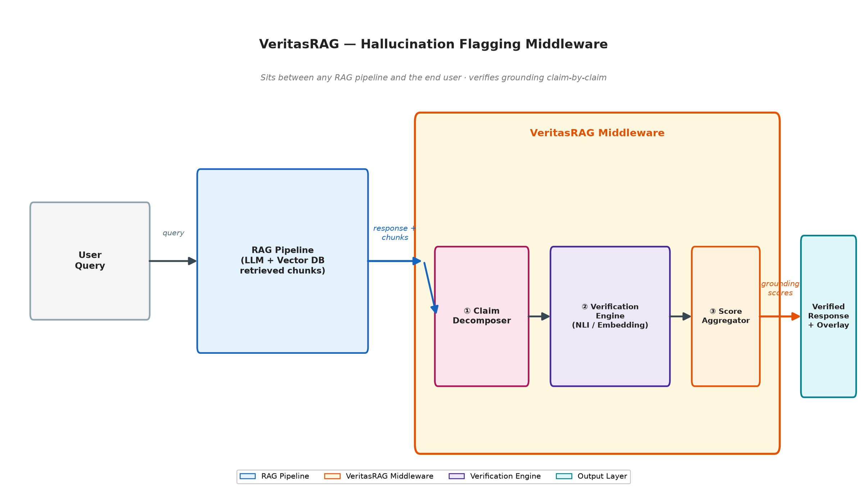
Figure 3.1 - VeritasRAG Middleware Architecture and Data Flow

The runtime workflow implemented in the VeritasMiddleware orchestrator proceeds as follows, and is also shown as a call sequence in Figure 3.2:
1. The caller supplies a query, a generated response, and a list of evidence chunks (each with a chunk ID, textual content, and optional source label).
2. The response is split into individual sentences by the SentenceSplitter, which uses spaCy to segment text while filtering out bullet markers and trivial fragments.
3. Each sentence is verified against all supplied chunks using the verifier selected by the chosen mode (embedding, NLI, atomic, ensemble, or hybrid). In atomic mode, the sentence is further decomposed into atomic claims before verification.
4. The ScoreAggregator merges verifier outputs where more than one approach is used, resolving disagreements by prioritising any detected contradiction/hallucination signal over an averaged score.
5. An overall grounding score and classification are computed across all sentences.
6. The result is packaged into a VerificationResult object and can be serialised to JSON or rendered as an HTML overlay report.
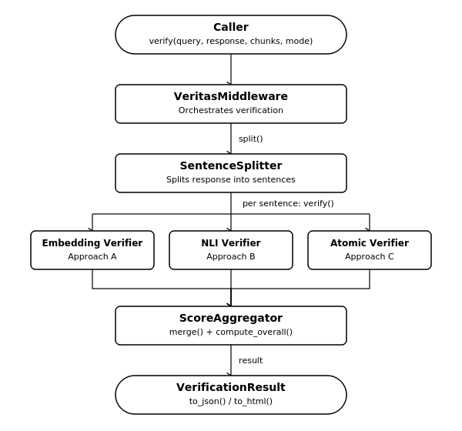

Figure 3.2 — Verification Call Sequence

3.2 Module-Level Design / Methodology
3.2.1 Sentence Splitter
Implemented using spaCy's en_core_web_sm pipeline (with a blank-pipeline sentencizer fallback if the model is not installed), the splitter normalises whitespace, removes bullet/numbering prefixes, and discards fragments shorter than three characters or without alphanumeric content, producing a clean list of verifiable sentences. It also exposes a span-tracking variant, split_with_spans(), which records the character offsets of each sentence within the original response so that a downstream UI could highlight the exact text a verdict refers to.
3.2.2 Embedding Verifier (Approach A)
Encodes every sentence and chunk using all-MiniLM-L6-v2, computes cosine similarity between each sentence and every chunk, and selects the best-matching chunk. Sentences are classified as grounded (similarity ≥ 0.75), inferred (≥ 0.50), or hallucinated (below 0.50), as summarised in Table 3.3.
3.2.3 NLI Verifier (Approach B)
Runs a DeBERTa-v3 cross-encoder over every (chunk, sentence) pair to obtain entailment, neutral and contradiction probabilities. A net support score is computed as entailment × (1 − contradiction); sentences with a strong, specific contradiction signal are flagged as hallucinated even where entailment for some other chunk is moderate, which is what allows Approach B to catch a sentence that directly contradicts a source rather than merely failing to match one. The NLI verifier is present in the current codebase as part of the planned full verification pipeline; however, it has not yet been fully validated through the project's completed evaluation workflow.
3.2.4 Atomic Verifier (Approach C)
Uses spaCy dependency parsing to detect coordinated or subordinate clauses within a sentence and splits it into atomic sub-claims, reconstructing an implied subject where a clause has none (for example, splitting “The drug treats pain and reduces fever” into “The drug treats pain” and “The drug reduces fever” so that each can be checked independently). Each atomic claim is checked against the full content of every chunk as well as two-sentence sliding windows within longer chunks (to preserve pronoun/coreference context), using the NLI verifier as the underlying entailment engine. The Entity and Numerical Consistency Guard cross-checks named entities (people, organisations, locations), financial quarters, and numeric values/approximations mentioned in the claim against the evidence text, applying a penalty factor to the entailment score when unsupported entities or numbers are detected, for example, downgrading a claim that cites “2019” when the only matching evidence mentions “2021”, even if the surrounding wording is otherwise well entailed.

3.2.5 Score Aggregator
Combines the outputs of two verifiers (used in ensemble and hybrid modes) sentence-by-sentence: any hallucination signal from either verifier takes priority; where both verifiers agree on grounded status, the higher score is kept; otherwise a weighted combination (0.35 for the embedding score, 0.65 for the NLI score) is used, and the result is reclassified against grounded/inferred/hallucinated thresholds. It also computes the response-level overall score and classification, ensuring that even one hallucinated sentence prevents the overall result from being reported as fully grounded, this design choice directly addresses the research-gap finding that an averaged score can otherwise hide a single serious error.
3.2.6 Chunk Embedding Cache
Caches previously computed chunk embeddings in an in-process dictionary, keyed by a SHA-256 hash of the model name and chunk content, to avoid re-encoding identical chunks across repeated calls. This is most useful when the same evidence corpus is queried repeatedly across many user questions.
3.2.7 Output Renderers
The JSONOverlayBuilder serialises a VerificationResult into a JSON-compatible dictionary or string, suitable for consumption by another application or logging system. The HTMLOverlayRenderer produces a self-contained, styled HTML report with colour-coded sentence cards (green for grounded, yellow for inferred, red for hallucinated), cited evidence excerpts, and summary statistics, suitable for direct human review.
3.2.8 REST API and Adapter
A FastAPI application exposes /api/v1/health, /api/v1/verify (JSON) and /api/v1/verify/html (HTML) endpoints. A LangChain-style callback adapter (VeritasLangChainCallback) captures the query, retrieved documents, and LLM generation from a LangChain pipeline's own callback events and triggers verification automatically once a generation completes.
3.2.4.1 Worked Example - Atomic Decomposition
Consider the generated sentence: “The company was founded in 2010 in Berlin and now employs over 500 people across three countries.” The Atomic Verifier's dependency parser identifies the coordinating conjunction “and” joining two independent clauses sharing an implicit subject, and splits the sentence into two atomic claims: (1) “The company was founded in 2010 in Berlin” and (2) “The company now employs over 500 people across three countries.” Each claim is then verified independently against the evidence chunks. If the evidence confirms the founding year and city but is silent on employee count, claim (1) is classified GROUNDED while claim (2) is classified with insufficient support, a distinction that would be lost if the two clauses were scored together as a single sentence, since an averaged score might report the whole sentence as merely “partially grounded” without indicating which half is actually the problem.
3.2.9 Testing Strategy
Correctness of the core, always-on modules (sentence splitting, data models, the embedding verifier, and the middleware orchestration path) is checked with an automated pytest suite, described in full in Table 4.1. Each test targets one specific behavior, for example, that a hallucinated sentence with no supporting chunk is correctly classified, or that an empty chunk list does not crash the verifier, rather than asserting only that the code runs without an exception.
3.2.10 Design Rationale and Trade-offs
Three design trade-offs recur throughout the module design above and are made explicit here. First, there is a trade-off between speed and reasoning depth. Approach A is the fastest and least expensive check, with a mean latency of 67.3 ms in the benchmarking results. However, it mainly relies on similarity and cannot tell whether the retrieved information actually supports or contradicts a statement. Approach B and Approach C are expected to take more time because Approach B directly checks whether the evidence supports the generated statement, while Approach C performs multiple checks for each atomic claim in a sentence against the relevant evidence. Since these two approaches have not yet been fully completed or validated, their actual latency has not been measured.
The system exposes all three as separate, selectable modes precisely so that a caller can choose the appropriate point on this trade-off for their own latency budget, rather than being forced into one fixed cost.
Second, local-only versus API-based models: every model used is open-source and runs locally, rather than calling a hosted LLM API for judgment (as RAGAs and SAFE do). This was a deliberate choice to keep the verification step free of per-call API cost and free of a dependency on network availability, consistent with the offline design goal stated in the project's README, even though full offline enforcement (removing the Hugging Face Hub fallback) is not yet complete.
Third, single-score versus multi-verdict output: rather than returning one aggregate number, the system always returns a classification (grounded / inferred / hallucinated) alongside the numeric score, and computes the overall response classification such that a single hallucinated sentence prevents the whole response from being reported as fully grounded. This was chosen specifically in response to the research-gap finding (Section 2.3) that an averaged score can conceal one seriously wrong sentence inside an otherwise accurate response.
3.3 Tools, Technologies, and Frameworks Used
Table 3.2 lists the tools, technologies and frameworks used in the VeritasRAG system., and Table 3.3 lists the specific classification thresholds applied by each verifier.
Layer | Technology | Purpose
Verification API | FastAPI, Uvicorn | Exposes /api/v1/health, /api/v1/verify and /api/v1/verify/html as REST endpoints
Data validation / schema | Pydantic | Defines Chunk, SentenceOverlay, AtomicClaim and VerificationResult models
Sentence segmentation | spaCy (en_core_web_sm) | Splits generated responses into individual verifiable sentences
Embedding verification (Approach A) | sentence-transformers, all-MiniLM-L6-v2 | Bi-encoder cosine-similarity grounding score
NLI verification (Approach B) | transformers, torch, cross-encoder/nli-deberta-v3-base | Cross-encoder entailment / neutral / contradiction scoring
Atomic verification (Approach C) | spaCy dependency parsing + Approach B | Decomposes compound sentences into atomic claims, verifies each
Entity / numeric consistency | spaCy NER + custom regex logic | Flags unsupported named entities, quarters and numeric magnitudes
Caching | Python dictionary (in-process) | Avoids recomputing embeddings for repeated chunk content
Output rendering | Custom Python HTML/JSON builders | Produces a machine-readable JSON result and a colour-coded HTML overlay
Testing | pytest, httpx | Unit tests for splitter, models, middleware and embedding verifier
Numerical / ML utilities | NumPy, scikit-learn | Vector operations and evaluation-metric support

Table 3.1 - Tools, Technologies and Frameworks Used

Verifier | Grounded | Inferred | Hallucinated | Scoring Basis
Approach A (Embedding) | ≥ 0.75 | 0.50 – 0.74 | < 0.50 | Cosine similarity between sentence and best-matching chunk
Approach B (NLI) | High entailment, low contradiction | Moderate entailment | High contradiction, or no entailing chunk found | entailment × (1 − contradiction), best chunk
Approach C (Atomic) | ≥ 0.65 after guard penalty | 0.40 – 0.64 | < 0.40, or guard-flagged mismatch | Aggregated atomic-claim entailment × entity/number guard factor
Table 3.2 - Classification Thresholds by Verifier
The project's dependency manifest (pyproject.toml) organises these libraries into a base install plus three optional extras, allowing a consumer of the package to install only what a given deployment needs:
Base install: pydantic, sentence-transformers, spacy, numpy, sufficient to run Approach A (embedding-only verification) and the sentence splitter.
[nli] extra: transformers, torch, required to additionally run Approach B and Approach C, both of which depend on the DeBERTa-v3 cross-encoder.
[api] extra: fastapi, uvicorn - required to run the REST API service rather than calling the middleware directly as a Python library.
[dev] extra: pytest, httpx - required to run the automated test suite described in Table 4.1.
This grouping keeps a minimal integration (for example, a caller that only wants fast embedding-based pre-screening) lightweight, while allowing the fuller NLI/atomic/API functionality to be installed only where it is actually used.
Note: earlier project-planning material additionally proposed a Redis-backed cache, an LLM-driven (Llama 3.1) atomic fact extractor, Docker-based containerisation, and Prometheus/Grafana monitoring. The implemented codebase realises caching as an in-process Python dictionary, atomic fact extraction as rule-based spaCy dependency parsing (without an LLM call), and does not currently include containerisation or a monitoring stack; the tables above reflect the technologies actually used in the current implementation.

CHAPTER 4
SYSTEM IMPLEMENTATION

4.1 Data Collection and Preprocessing Methods
4.1.1 Dataset Collection
The implemented component of VeritasRAG, Approach A: Embedding Similarity Verifier, was evaluated using a curated dataset containing 40 examples. The evaluation dataset combines examples from four hallucination and factuality benchmarks: RAGTruth, FaithBench, HaluEval, and FActScore.
The dataset contains an equal distribution of grounded and hallucinated examples, with 20 grounded samples and 20 hallucinated samples. Each sample contains a query, generated response, retrieved evidence chunks, ground-truth label, hallucination type, and additional notes.
The dataset was designed to include different types of factual errors, such as numerical fabrication, entity changes, temporal shifts, negation inversion, biological inversion, scientific contradiction, partial extrinsic information, and legal concept substitution. This provides a varied set of cases for evaluating the ability of semantic similarity to identify whether a generated response is supported by its available evidence.
4.1.2 Dataset Structure
Each evaluation sample is stored in JSON format. The major fields used in the dataset are shown in Table 4.1.
Field | Description
id | Unique identifier for the evaluation sample
source_benchmark | Benchmark source of the sample
domain | Subject area of the sample
query | Question provided to the system
response | Generated response to be verified
chunks | Retrieved evidence passages
ground_truth_label | Expected grounded or hallucinated classification
hallucination_type | Type of hallucination, where applicable
notes | Additional information about the sample

Table 4.1 Dataset Field Description
The dataset contains examples from multiple subject areas, including history, biomedicine, geography, legal information, finance, astronomy, technology, genetics, chemistry, climate science, sports, and medicine.
4.1.3 Text Preprocessing
The generated response is first normalised before it is passed to the verification module. Whitespace and line-break inconsistencies are removed while preserving the semantic content of the response.
The SentenceSplitter module uses the spaCy en_core_web_sm model for sentence boundary detection. A fallback spaCy sentencizer is available when the specified model cannot be loaded.
Bullet symbols and numbering prefixes are removed from the beginning of sentences. Empty fragments, punctuation-only fragments, and very short fragments are ignored. This preprocessing produces individual sentences that can be independently compared with the retrieved evidence.
4.1.4 Evidence Preparation
The retrieved evidence is represented as a collection of chunks. Each chunk contains a unique identifier and its textual content.
For Approach A, the evidence chunks are used directly for embedding comparison. No additional semantic decomposition of the evidence chunks is required. The generated sentences and evidence chunks are independently encoded into vector representations before similarity calculation.

4.2 Module Implementation Details
4.2.1 Sentence Splitting Module
The Sentence Splitting module converts the generated response into individual sentences that can be verified independently.
The module performs text cleaning followed by sentence boundary detection using spaCy. It also removes leading bullet and numbering symbols and filters out trivial fragments.
The module provides a split() function for obtaining individual sentences. It also provides split_with_spans() to retain the character positions of sentences in the original response, which can be used for highlighting sentences in the verification interface.
4.2.2 Embedding Similarity Verifier - Approach A
Approach A is the implemented hallucination verification method in the current system. It uses the all-MiniLM-L6-v2 model from Sentence Transformers.
The model works as a bi-encoder by independently converting the generated sentences and retrieved evidence chunks into dense vector embeddings. The implementation uses 384-dimensional embeddings.
For every generated sentence, its embedding is compared against the embeddings of all available evidence chunks using cosine similarity. The highest similarity score is selected as the grounding score for that sentence.
The cosine similarity is calculated using:
Similarity(A,B)=∥A∥∥B∥A⋅B​
where AA represents the sentence embedding and BB represents an evidence-chunk embedding.
The highest similarity score among the available chunks is used for the final sentence-level classification.
4.2.3 Grounding Classification
Approach A uses predefined similarity thresholds to classify each sentence.

Similarity Score | Classification
≥ 0.75 | GROUNDED
0.50 – 0.74 | INFERRED
< 0.50 | HALLUCINATED
Table 4.2 Grounding Classification Thresholds
A score of 0.75 or above indicates strong semantic similarity between the generated sentence and the retrieved evidence. Scores between 0.50 and 0.74 are treated as partially supported or inferred. Scores below 0.50 are classified as hallucinated.
For grounded or inferred sentences, the system records the highest-scoring evidence chunk and an evidence excerpt. For hallucinated sentences, the implementation does not assign a supporting chunk.
4.2.4 Embedding Cache
The system contains a ChunkEmbeddingCache to reduce repeated embedding computations.
The cache stores embeddings in an in-memory Python dictionary. A deterministic SHA-256 key is generated using the model name and chunk content. When the same evidence chunk is processed again, its stored embedding can be retrieved instead of being encoded again.
This mechanism reduces redundant processing when the same evidence is compared against multiple generated sentences.
4.2.5 Verification Result Model
The verification results are represented using structured Pydantic models.
The sentence-level result stores information such as the sentence index, original sentence, grounding score, inference type, cited evidence chunks, evidence excerpt, and confidence value.
The overall verification result stores the query, generated response, overall grounding score, overall classification, sentence-level results, processing time, verification approach, and model information.
This structured representation allows the verification result to be processed and displayed consistently.
4.2.6 Benchmark Evaluation Module
A benchmark evaluation module was used to evaluate Approach A against the 40-sample dataset.
For each sample, the evaluation process supplies the query, generated response, and retrieved evidence chunks to the verification middleware. The predicted classification is then compared with the ground-truth label.
The evaluation records accuracy, precision, recall, F1-score, and average latency. A detailed result is also generated for each evaluation sample, including its similarity score, ground-truth label, predicted classification, and hallucination type.

4.3 Results and Discussion
4.3.1 Approach A Verification Output
An actual demonstration of Approach A was performed using the VeritasRAG interface. The system was run locally and a document containing material on Cognitive Load Theory was used as the source document.
The query provided to the system was:
“What are the three types of cognitive load?”
The system processed the response using Approach A: Embedding Similarity (MiniLM). Three source-document chunks were available for evidence comparison.
The generated response consisted of two sentences. Both sentences were classified as grounded.
Parameter | Result
Verification approach | Approach A — Embedding Similarity
Model | all-MiniLM-L6-v2
Evidence chunks | 3
Sentences validated | 2
Sentence 1 | 91.8% GROUNDED
Sentence 2 | 85.5% GROUNDED
Overall grounding score | 88.7%
Processing latency | 279.6 ms

Table 4.3 Demonstrated Approach A Verification Result
The overall grounding score of 88.7% indicates that the generated response had a high semantic similarity with the available evidence in this particular demonstration. The inspection panel also displayed the individual sentence scores and the source-document chunks used for the verification.
4.3.2 Benchmark Evaluation Results
Approach A was evaluated on 40 benchmark samples consisting of 20 grounded examples and 20 hallucinated examples.
The final benchmark results are shown in Table 4.4.

Metric | Result
Accuracy | 52.50%
Precision | 55.56%
Recall | 25.00%
F1-Score | 34.48%
Average Latency | 89.3 ms
True Positives | 5
False Positives | 4
False Negatives | 15
True Negatives | 16
Table 4.4 Approach A Benchmark Results

The system correctly classified 21 out of 40 samples, resulting in an accuracy of 52.50%. The precision was 55.56%, while the recall was 25.00%. The F1-score obtained was 34.48%.
The average processing latency was 89.3 ms, demonstrating that the embedding-based verification process is computationally lightweight compared with more complex verification approaches.
4.3.3 Analysis of Benchmark Results
The results demonstrate that embedding similarity can identify semantic alignment between a generated response and its retrieved evidence. This allows the system to quickly determine whether a sentence discusses information that is semantically related to the available source material.
However, the benchmark also demonstrates an important limitation of using semantic similarity alone. A hallucinated sentence may discuss the same subject as the evidence while changing an important factual detail. Since the overall topic and vocabulary can remain similar, the sentence can still obtain a relatively high cosine similarity score.
For example, one benchmark sample involving the Eiffel Tower obtained a similarity score of 0.6489 even though the generated statement contained incorrect factual information. The semantic relationship with the source was strong enough to produce a similarity score above the hallucination threshold.
This behaviour contributed to the 15 false-negative cases in the evaluation. The benchmark output shows missed hallucinations involving entity and temporal changes, biological inversions, numerical fabrication, legal concept changes, scientific contradictions, and other factual conflicts.
Therefore, the results show that cosine similarity is useful for measuring semantic relatedness but does not by itself establish factual entailment. The main advantage of Approach A is its relatively low processing latency, while its main limitation is its ability to distinguish closely related but factually contradictory statements.
4.4 Output Screenshots
4.4.1 VeritasRAG Approach A Interface
Figure 4.1 shows the actual VeritasRAG interface during the Approach A demonstration. The interface displays the selected document, user query, generated response, grounding score, selected approach, and processing latency.
Figure 4.1 — VeritasRAG Approach A embedding-similarity verification interface
The interface shows an overall grounding score of 88.7%. The result is labelled GROUNDED, and the inspection panel provides sentence-level validation and source-document evidence.
4.4.2 Sentence-Level Validation
The inspection panel provides the grounding score for each sentence independently. The first sentence received a score of 91.8%, while the second sentence received a score of 85.5%.
The panel also displays the three source-document chunks available for evidence inspection.


Figure 4.2 — Sentence-level grounding scores and source evidence inspection
4.4.3 Benchmark Evaluation Output
Figure 4.3 shows the detailed benchmark execution for Approach A. The evaluation output lists each sample, its domain, similarity score, ground-truth classification, predicted classification, and whether the prediction was correct.
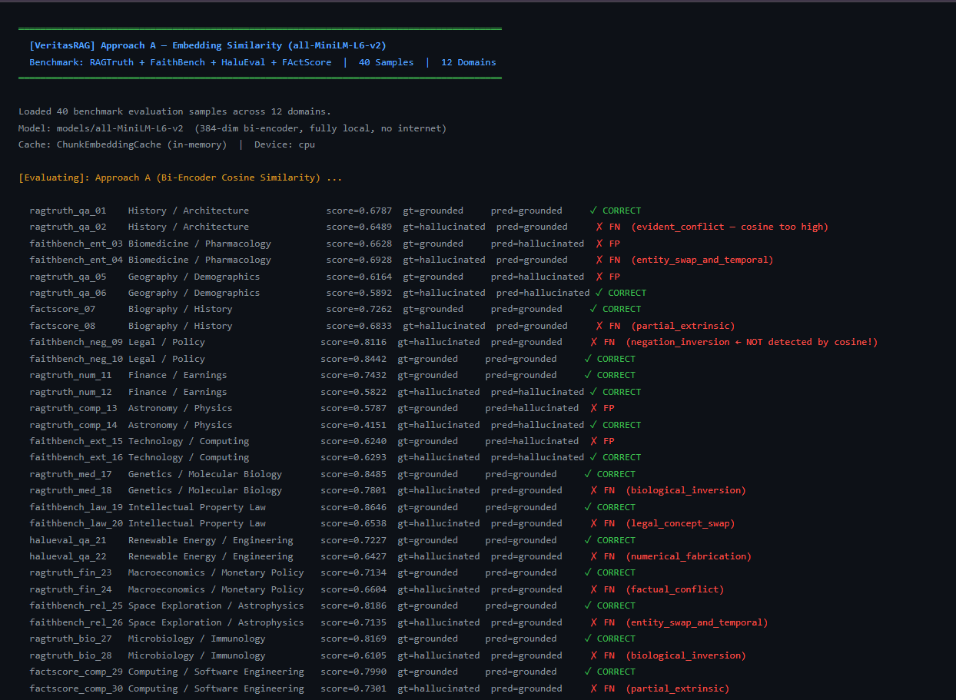
Figure 4.3 — Approach A benchmark evaluation output
The benchmark output demonstrates both correctly classified samples and misclassified samples. False positives and false negatives are explicitly identified, together with the corresponding hallucination type where available.
4.4.4 Final Benchmark Metrics
Figure 4.4 presents the final metrics obtained after evaluating all 40 samples.
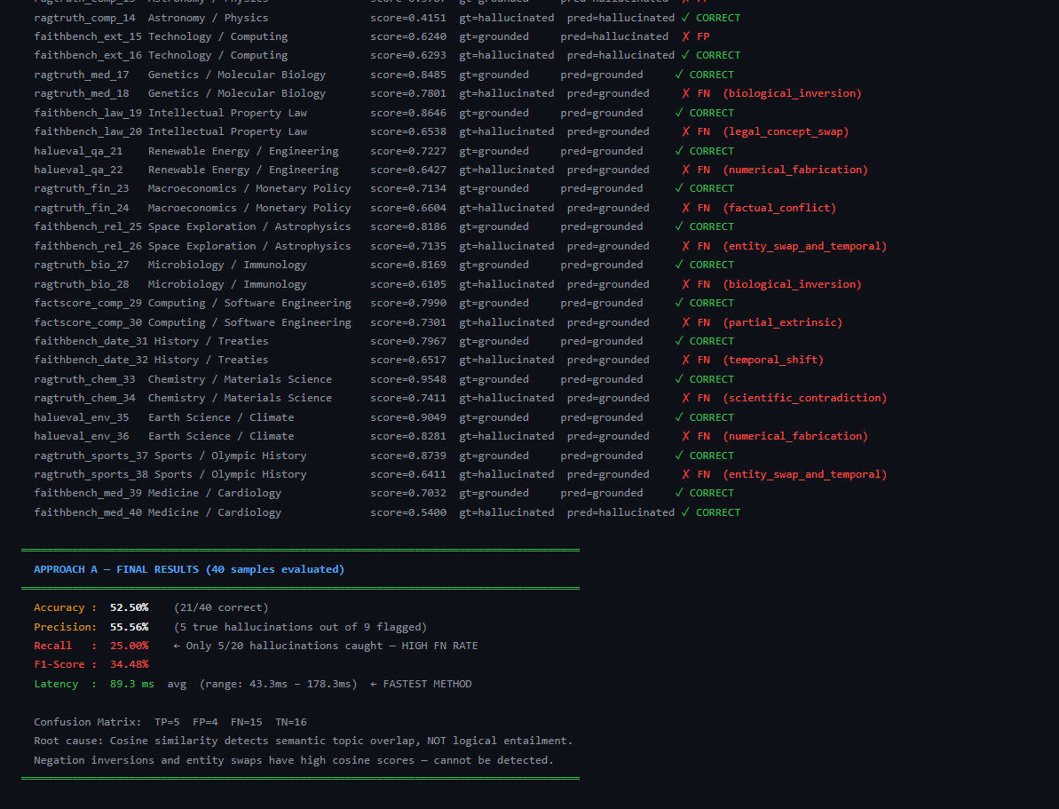
Figure 4.4 — Final Approach A benchmark performance
The final output reports 52.50% accuracy, 55.56% precision, 25.00% recall, 34.48% F1-score, and 89.3 ms average latency.

CHAPTER 5
CONCLUSION

5.1 Future Scope
In addition to the immediate next steps mentioned in Section 4.6, there is room within this project for:
- Integrating VeritasRAG with a fully locally hosted retrieval-and-generation pipeline to demonstrate end-to-end verification of a live RAG application, instead of validating pre-supplied response/chunk pairs.
- Adding adapters for additional RAG frameworks beyond LangChain, such as LlamaIndex.
- Scaling verification to languages beyond English, which would involve replacing or augmenting the current spaCy and NLI models used.
- Examining confidence calibration of the grounding scores against held-out data, so that a reported score can be interpreted with a known error rate rather than as a raw model output.
- Investigating lighter, distilled NLI models to reduce Approach B's per-response latency, once it has been completed and validated, for applications with tighter real-time requirements.
5.2 Conclusion
This project set out to address a specific, practical gap in Retrieval-Augmented Generation systems: the absence of a clear, evidence-linked signal indicating which parts of a generated response are actually supported by the retrieved context. The completed component of VeritasRAG is the embedding-similarity verifier (Approach A), exercised through the project's test suite and a human-readable HTML overlay. Cross-encoder NLI (Approach B), atomic fact-level entailment with an entity/numeric consistency guard (Approach C), and the score aggregator that would combine them are present in the codebase but have not yet been completed, tested, or validated, and are treated as priorities for subsequent work (Section 4.6). The project demonstrates a working, model-agnostic middleware for exposing hallucinations in RAG outputs and provides a concrete foundation, a documented architecture, an initial validated module, and a clearly identified set of next steps, for continued development toward a fully offline, production-ready verification layer.

REFERENCES

[1] P. Lewis, E. Perez, A. Piktus, F. Petroni, V. Karpukhin, N. Goyal, H. Kuttler, M. Lewis, W. Yih, T. Rocktaschel, S. Riedel, and D. Kiela, “Retrieval-Augmented Generation for Knowledge-Intensive NLP Tasks,” in Advances in Neural Information Processing Systems (NeurIPS), 2020.
[2] S. Min, K. Krishna, X. Lyu, M. Lewis, W. Yih, P. W. Koh, M. Iyyer, L. Zettlemoyer, and H. Hajishirzi, “FActScore: Fine-grained Atomic Evaluation of Factual Precision in Long Form Text Generation,” in Proc. EMNLP, 2023.
[3] C. Niu, Y. Wu, J. Zhu, S. Xu, K. Shum, R. Zhong, J. Song, and T. Zhang, “RAGTruth: A Hallucination Corpus for Developing Trustworthy Retrieval-Augmented Language Models,” in Proc. ACL, 2024.
[4] A. Asai, Z. Wu, Y. Wang, A. Sil, and H. Hajishirzi, “Self-RAG: Learning to Retrieve, Generate, and Critique through Self-Reflection,” in Int. Conf. on Learning Representations (ICLR), 2024.
[5] S. Es, J. James, L. Espinosa-Anke, and S. Schockaert, “RAGAs: Automated Evaluation of Retrieval Augmented Generation,” in Proc. EACL, 2024.
[6] P. Manakul, A. Liusie, and M. J. F. Gales, “SelfCheckGPT: Zero-Resource Black-Box Hallucination Detection for Generative Large Language Models,” in Proc. EMNLP, 2023.
[7] Y. Gao, Y. Xiong, X. Gao, K. Jia, J. Pan, Y. Bi, Y. Dai, J. Sun, and H. Wang, “Retrieval-Augmented Generation for Large Language Models: A Survey,” arXiv:2312.10997, 2024.
[8] J. Wei, C. Yang, X. Song, Y. Lu, N. Hu, D. Huang, Q. V. Le et al., “Long-form Factuality in Large Language Models (SAFE),” arXiv:2403.18802, 2024.
[9] L. Huang, W. Yu, W. Ma, W. Zhong, Z. Feng, H. Wang, Q. Chen, W. Peng, X. Feng, B. Qin, and T. Liu, “A Survey on Hallucination in Large Language Models: Principles, Taxonomy, Challenges, and Open Questions,” arXiv:2311.05232, 2023.
[10] P. He, X. Liu, J. Gao, and W. Chen, “DeBERTa: Decoding-enhanced BERT with Disentangled Attention,” in Int. Conf. on Learning Representations (ICLR), 2021.
[11] S. Q. Yan, J. C. Gu, Y. Zhu, and Z. H. Ling, “Corrective Retrieval Augmented Generation,” arXiv:2401.15884, 2024.
[12] S. Barnett, S. Kurniawan, S. Thudumu, Z. Brannelly, and M. Abdelrazek, “Seven Failure Points When Engineering a Retrieval Augmented Generation System,” arXiv:2401.05856, 2024.
[13] J. Li, X. Cheng, W. X. Zhao, J. Y. Nie, and J. R. Wen, “HaluEval: A Large-Scale Hallucination Evaluation Benchmark for Large Language Models,” in Proc. EMNLP, 2023.
[14] P. Laban, A. R. Fabbri, C. Xiong, and C. S. Wu, “FaithBench: A Diverse Hallucination Benchmark for Summarization by Modern LLMs,” arXiv:2410.13210, 2024.
[15] N. Reimers and I. Gurevych, “Sentence-BERT: Sentence Embeddings using Siamese BERT-Networks,” in Proc. EMNLP-IJCNLP, 2019.

APPENDIX I

BUSINESS MODEL CANVAS

Key Partners | Key Activities | Key Resources
RAG application developers | Development of hallucination verification middleware | Python-based implementation
AI/ML researchers | Sentence-level grounding verification | all-MiniLM-L6-v2 model
Organizations using RAG systems | Evidence comparison and classification | spaCy NLP framework
Open-source AI community | Benchmark evaluation and testing | RAGTruth, FaithBench, HaluEval and FActScore-based examples
Academic/research institutions | Research and further validation | FastAPI, Pydantic and supporting libraries
Value Propositions | Customer Relationships | Channels
Identifies unsupported content in RAG-generated responses | Self-service integration through middleware | REST API
Provides sentence-level grounding information | Evidence-linked verification results | Python library integration
Shows supporting evidence for generated sentences | Human-readable verification interface | HTML output
Does not require modification of the original RAG generator | Configurable verification workflow | JSON output
Provides a lightweight embedding-based verification approach | Documentation and technical support | Academic and research applications

Customer Segments | Cost Structure | Revenue Streams
Organizations using RAG-based applications | Model and computing resources | Potential enterprise licensing
Research institutions | Development and maintenance | Custom integration services
AI application developers | Testing and evaluation resources | Technical consulting
Customer-support systems using RAG | Infrastructure and deployment costs | Future hosted verification services
Document-based QA applications | Model hosting and monitoring costs | Future commercial API services
Figure I.1 Business Model Canvas for VeritasRAG

APPENDIX II

CO-PO-PSO MAPPING

Use 3 = High, 2 = Moderate, 1 = Low, – = No direct contribution.

CO / PO | PO1 | PO2 | PO3 | PO4 | PO5 | PO6 | PO7 | PO8 | PO9 | PO10 | PO11 | PO12
CO1 | 3 | 3 | 2 | 2 | 3 | 1 | – | 2 | 2 | 2 | 1 | 2
CO2 | 2 | 3 | 3 | 3 | 2 | 2 | – | 2 | 2 | 2 | 2 | 2
CO3 | 3 | 2 | 3 | 3 | 3 | 1 | – | 2 | 3 | 2 | 2 | 2
CO4 | 2 | 2 | 2 | 3 | 2 | 2 | – | 2 | 3 | 3 | 3 | 2
CO5 | 1 | 2 | 2 | 2 | 3 | 2 | 1 | 3 | 2 | 3 | 2 | 3

CO–PSO Mapping
CO | PSO1 | PSO2 | PSO3
CO1 | 3 | 2 | 2
CO2 | 3 | 3 | 2
CO3 | 3 | 3 | 2
CO4 | 2 | 2 | 3
CO5 | 2 | 2 | 3

Mapping Scale

Score | Description
3 | High Contribution
2 | Moderate Contribution
1 | Low Contribution
– | No Direct Contribution
Table II.1 CO-PO-PSO Mapping for VeritasRAG

