**PCA Based Mushroom Species Recognition**

About the project:

The project uses the PCA algorithm to extract the pca features of the images and using those features the test set is prepared. After the test set is prepared the KNN algorithm is used to predict the species type of the mushroom['agaricus','amantia','entoloma','suillus'].

Algorithm :

1. In the main() function the data for the training is loaded into a list.
2. Then the image data which has been read from the directory is flattened for efficient extraction of the information.
3. PCA Algorithm:
   * 1. The mean of the image files are calculated.
     2. Then the mean corrected matrix is calculated and stored in a list.
     3. The covariance value of the mean corrected matrix is calculated using the formula.

Cov=np.dot(arr.T,arr)/len(data)

* + 1. The eigen value and vector pairs are found using the inbuilt numpy eigen value function.

e,u=np.linalg.eigh(Cov)

* + 1. Now the corresponding eigen values are paired with the corresponding eigen vectors and sorted.
    2. From the sorted eigen value pairs a specific number of eigen value pairs are selected and stored in a new list called feature set for preparing the test set.
    3. The fit line is calculated by multiplying the mean corrected training set and feature set.
    4. Now the test set data is loaded into a new list.
    5. The test set data mean is calculated and mean corrected test set is prepared.
    6. The mean corrected test set is multiplied with the feature list so that KNN can use the data for prediction.

1. KNN algorithm:
2. The Cartesian distance between the test set data and project list are calculated.
3. The list of Cartesian distances are sorted and the number of specific neighbors are stored in the list.
4. The class to which the test set belong is predicted using the classmajority function().
5. After the class is predicted for all the test set the accuracy is calculated.

**Sample Input Images:**

**Class Agaricus:**

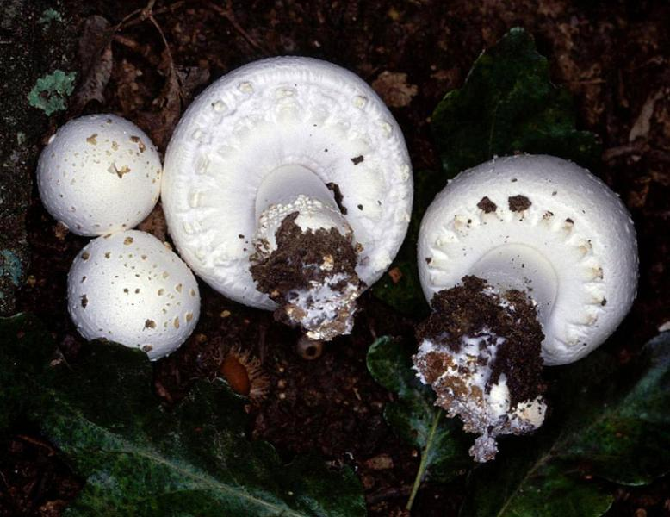

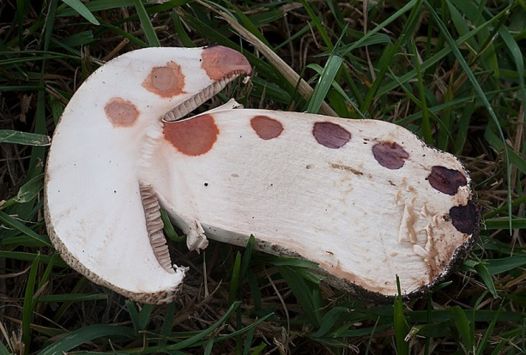

**Class Amantia:**

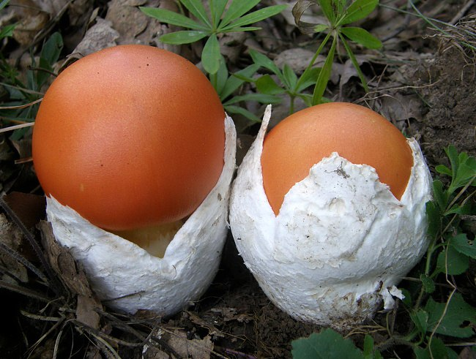

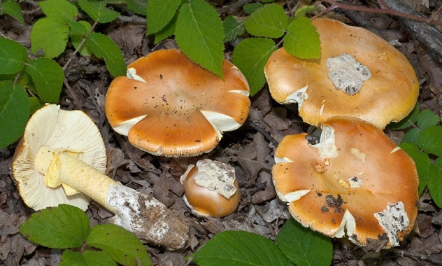

**Class Entoloma:**

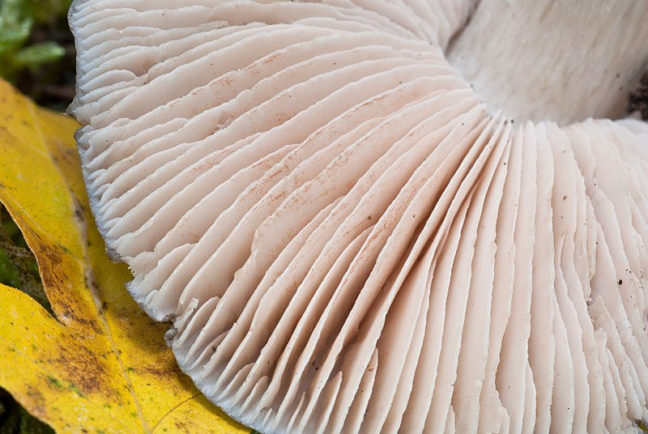

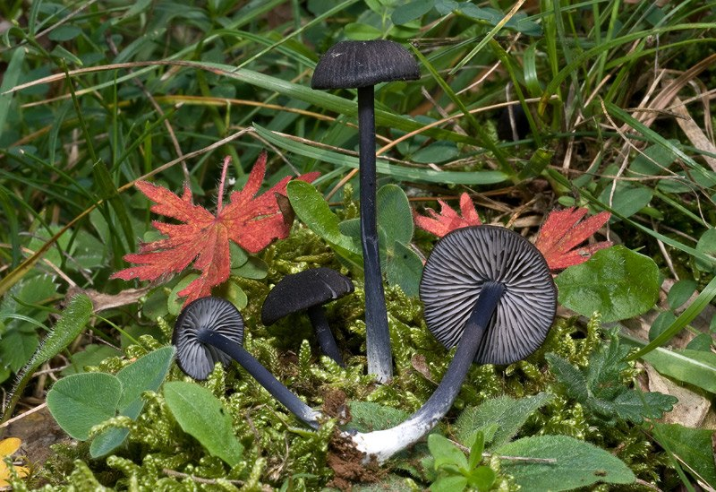

**Class Suillus:**

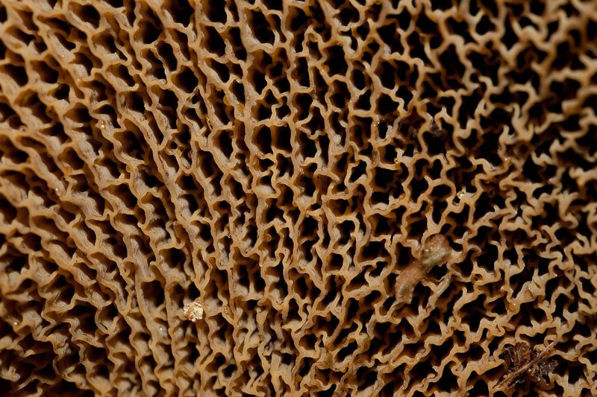

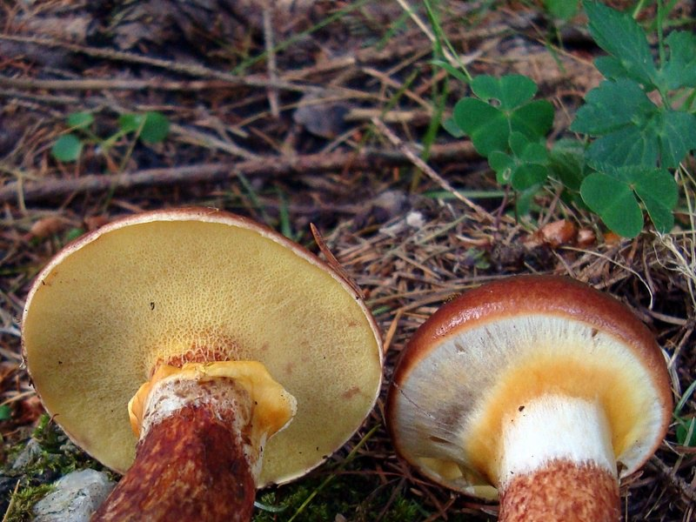

**Output:**

