**Fake News Detection Using NLP**

**Problem Definition:** The problem is to develop a fake news detection model using a Kaggle dataset. The goal is to distinguish between genuine and fake news articles based on their titles and text. This project involves using natural language processing (NLP) techniques to preprocess the text data, building a machine learning model for classification, and evaluating the model's performance.

**Abstract:**

This study explores the use of Natural Language Processing (NLP) techniques to detect fake news articles. We employ text preprocessing, feature extraction, and machine learning algorithms to differentiate between genuine and fake news. Our approach demonstrates promising results in accurately identifying fake news, contributing to the ongoing effort to combat misinformation in the digital era.

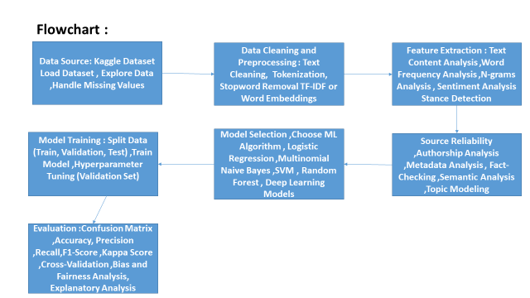

**Design Thinking:**

1. Data Source: Choose the fake news dataset available on Kaggle, containing articles titles and text, along with their labels (genuine or fake).
2. Data Preprocessing: Clean and preprocess the textual data to prepare it for analysis.
3. Feature Extraction: Utilize techniques like TF-IDF (Term Frequency-Inverse Document Frequency) or word embeddings to convert text into numerical features.
4. Model Selection: Select a suitable classification algorithm (e.g., Logistic Regression, Random Forest, or Neural Networks) for the fake news detection task.
5. Model Training: Train the selected model using the preprocessed data.
6. Evaluation: Evaluate the model's performance using metrics like accuracy, precision, recall, F1-score, and ROC-AUC.

**Features**

Fake news detection using Natural Language Processing (NLP) involves the application of various techniques and features to identify and distinguish fake or misleading information from credible news articles.

* Text Content Analysis
* Sentiment Analysis
* Stance Detection
* Source Reliability
* Authorship Analysis
* Metadata Analysis:
* Fact-Checking:.
* Semantic Analysis

**Machine Learning Models:**

Utilizing supervised and unsupervised machine learning models, such as Naive Bayes, Support Vector Machines (SVM), or deep learning models like recurrent neural networks (RNNs) and transformers (e.g., BERT), to classify articles as fake or real based on extracted features.

**Data Cleaning:**

Data cleaning is a crucial step in the process of fake news detection using Natural Language Processing (NLP). Clean and well-preprocessed data are essential for building accurate and reliable machine learning models

**Handling Missing Values**:

* Use data exploration techniques to detect missing values in the dataset. Commonly, this can be achieved using functions like **isnull()** to identify missing values in each column and **sum()** to count them.

**Feature Engineering**:

Feature engineering is a crucial step in building effective machine learning models for fake news detection using Natural Language Processing (NLP). It involves creating new features or transforming existing ones to extract relevant information from the text data.

**Model Selection**

Explore various machine learning and statistical modeling techniques to construct a predictive model. Consider the use of time series analysis, regression, deep learning, or ensemble methods to capture complex patterns in the data.

**Model Training:**

Split your dataset into training, validation, and test sets. A common split is 70-80% for training, 10-15% for validation, and 10-15% for testing. The validation set is used for hyperparameter tuning, while the test set is reserved for final model evaluation.

Selecting a Machine Learning Algorithm:

Choose a machine learning algorithm that is suitable for your problem. Common choices for text classification tasks like fake news detection include:

Logistic Regression

Multinomial Naive Bayes

Support Vector Machines (SVM)

Random Forest

Gradient Boosting (e.g., XGBoost or LightGBM)

Deep Learning Models (e.g., LSTM, BERT)

**Evaluation:**

Evaluating the performance of a fake news detection model using Natural Language Processing (NLP) is essential to understand how well it can differentiate between real and fake news articles. Here are common evaluation metrics and techniques for assessing the effectiveness of your fake news detection model:

**Confusion Matrix:**

A confusion matrix is a tabular representation that shows the number of true positives (TP), true negatives (TN), false positives (FP), and false negatives (FN). It is the foundation for calculating various evaluation metrics.

**Accuracy:**

Accuracy is the ratio of correctly classified instances (TP + TN) to the total number of instances. It provides an overall measure of model performance but can be misleading in imbalanced datasets.

**Precision (Positive Predictive Value):**

Precision measures the proportion of true positives among all positive predictions. It's calculated as TP / (TP + FP). High precision indicates that when the model predicts an article as fake, it is likely to be fake.

**Recall (Sensitivity, True Positive Rate):**

Recall measures the proportion of true positives that were correctly identified by the model. It's calculated as TP / (TP + FN). High recall indicates that the model can effectively identify most of the actual fake news articles.

**F1-Score:**

The F1-score is the harmonic mean of precision and recall, providing a balance between the two. It's calculated as 2 * (Precision * Recall) / (Precision + Recall). It is particularly useful when there is an imbalance between real and fake news articles. Kappa Score (Cohen's Kappa):

Kappa measures the agreement between the model's predictions and actual labels while considering the possibility of agreement occurring by chance. It adjusts for imbalanced datasets and is particularly useful in inter-rater agreement scenarios.

**Cross-Validation:**

Perform cross-validation (e.g., k-fold cross-validation) to estimate how well the model generalizes to unseen data. Cross-validation provides a more robust assessment of model performance than a single train-test split.

**Bias and Fairness Analysis:**

Assess the model's performance across different demographic groups to detect and mitigate biases in predictions. Metrics like demographic parity and equal opportunity can be used to evaluate fairness.

**Explanatory Analysis:**

Examine model predictions on specific examples to gain insights into why the model made certain predictions. This can help identify common patterns and challenges in fake news detection.