Bryan Guner 10/25

**Matlab code:**

L = pi;

xInc = 0.01;

T = 3;

Tinc = 0.01;

Tset = [0.0,0.5, 1.0,1.5,2.0,3.0];

h = 1;

a = 1;

x = 0:xInc:L;

t = 0:Tinc:T;

N = 100;

U = zeros(length(t),length(x));

for n=1:N

sn = ((8*h)/(n*pi)^2*cos(n*t')*sin(n*pi/2)*sin(n*x));

U = U + sn;

if(n == 5)

s5 = sn;

end

end

hold on;

for i=1:length(Tset)

ind = Tset(i)/Tinc;

plot(x,s5(ind+1,:))

end

xlabel('x')

ylabel('u_5(x,t)')

title('Fifth Standing Wave')

legend('t=0.0','t=0.5','t=1.0','t=1.5','t=2.0','t=3.0')

figure

for i=1:length(Tset)

ind = Tset(i)/Tinc;

subplot(2,3,i);

plot(x,U(ind+1,:));

xlabel('x')

ylabel('u(x,t)')

title(['t = ' num2str(Tset(i))])

end

**Figures:**

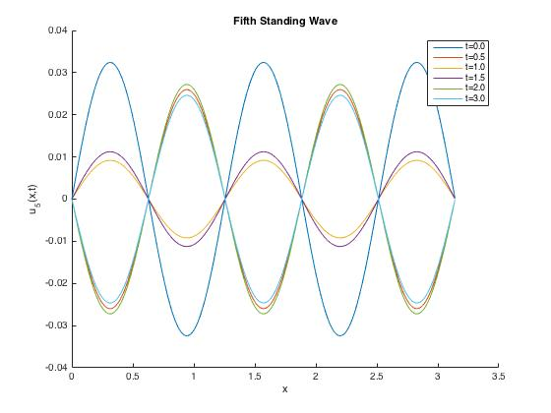

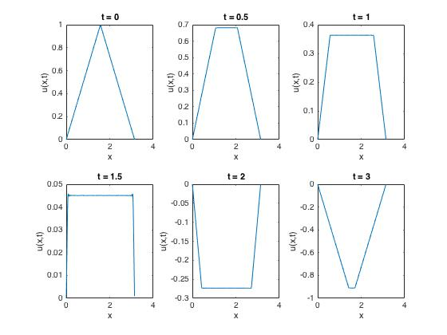

Failed attempt Matlab code:

L = pi;

T= pi;

Tset=[0.0,0.5,1.0,1.5,2.0,3.0];

h=1;

a=1;

x=0:0.01:2*pi;

t=0:0.01:6;

N=1000;

U=zeros(length(t),length(x));

for n=1:N

b=((8*h/(n^2*pi^2))*cos(n*t'*a)*sin(n*pi/2)*sin(n*x)); % b represents the nth standing wave

U=U+b;

if(n==5)

s5=b;

end

end

figure

hold on;

for i=1:length(Tset)

ind=Tset(i)/0.01;

plot(x,s5(ind+1,i));

end

xlabel('x')

ylabel('U(x,t)when n=5')

title('fifth standing wave')

legend('t=0.0','t=0.5','t=1.0','t=1.5','t=2.0','t=3.0')

figure

for i=1:length(Tset)

ind=Tset(i)/0.01;

subplot(2,3,i);

plot(x,U(ind+1,i));

xlabel('x')

ylabel('U(x,t)')

title('at t=0.0','at t=0.5','at t=1.0','at t=1.5','at t=2.0','at t=3.0')

end