Training: Discovery, Part 2 - 3D Models
Step-by-step guide to the 3D viewer, augmented reality, hotspots, model settings, IIIF 3D manifests and 3D administration
Dr Johan Pieterse
Document control
Field | Value
Document title | Training: Discovery, Part 2 - 3D Models
Author | Dr Johan Pieterse
Owner | The Archive and Heritage Group (Pty) Ltd
Version | 1.0
Status | Released
Date | 15 October 2026
Prepared for | Curators, archivists and digitisation staff using the AHG extensions
Classification | Public
Reference | AHG-TRN-DIS-02
Contents
Right-click and choose Update Field to build this list.
List of Tables
Right-click and choose Update Field to build this list.
This guide goes with part 2 of the discovery training videos. It covers how 3D models of objects are shown and annotated: the viewer on a record, the model page and augmented reality, hotspots, each model’s settings, the IIIF 3D manifest and the administration pages. Allow about 15 minutes.

Before you start
What you need before you start
What | Notes
Viewing | Anyone, for published records.
Hotspots and settings | An editor or administrator.
Formats | GLB and glTF are recommended for the web; OBJ, STL and USDZ are also handled.
Example | A 3D scan of the Rosetta Stone.

1. On the record
A record whose digital object is a 3D model shows it in a 3D viewer on its page. Drag to turn it, scroll to zoom; it turns slowly by itself until you take hold of it. Models are served through an access-controlled route (/3d/file/<id>), so visitors who are not signed in can view them while the master file stays protected.
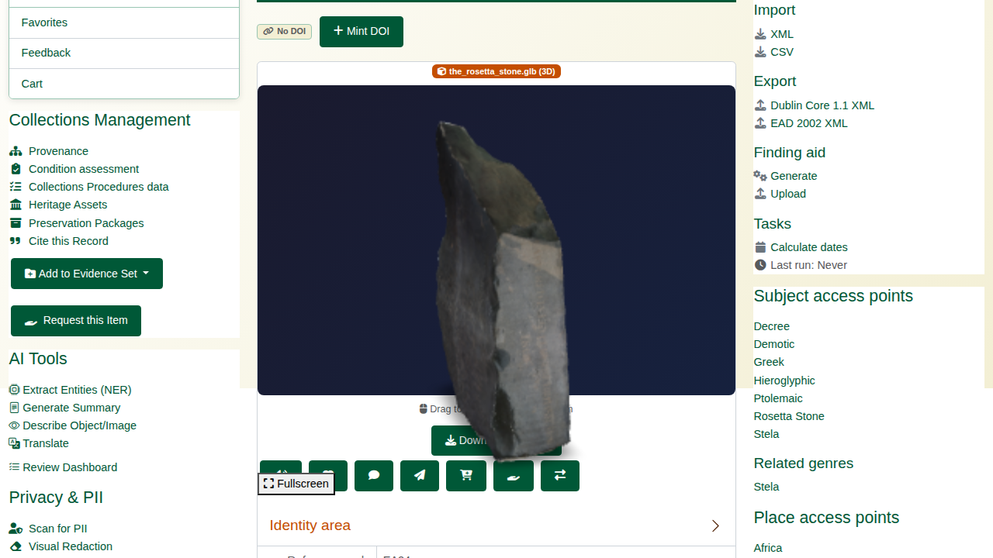
A 3D model on its record.

2. The model page and augmented reality
The model page (/ahg3DModel/view/<model id>) gives the viewer more room, with full-screen, rotation and reset controls, the format and size, and an AR Ready badge when augmented reality is on. On a phone or tablet (iOS Safari, Chrome on Android, WebXR browsers), the AR button places the object in the room in front of you, at its real size.
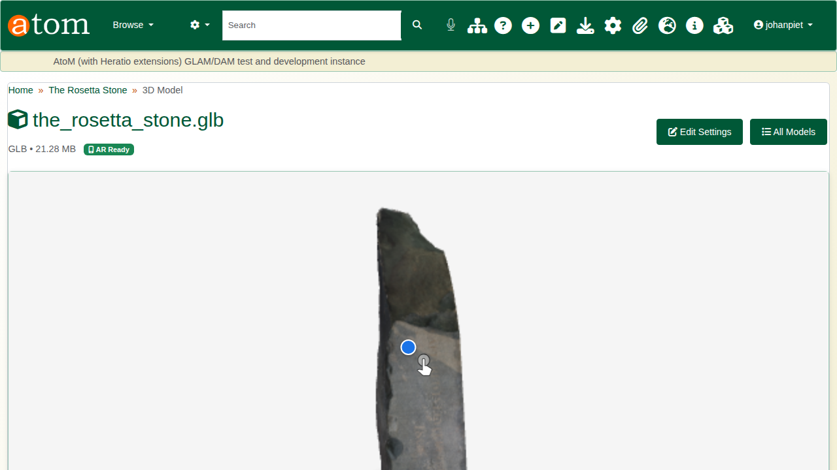
The model page.

3. Hotspots
Hotspots mark details on the model. In the model’s settings (Edit Settings), click the point on the model in the preview. The Add Hotspot form opens with that position filled in; a drag that turns the model is not taken as a click.
Hotspot fields
Field | Notes
Type | Annotation, information, link, damage or detail; each has its own colour
Title and description | Shown when a visitor points at or clicks the hotspot
Position | Filled in from the click; X, Y and Z can also be typed
A damage hotspot links to the object’s condition assessment automatically.
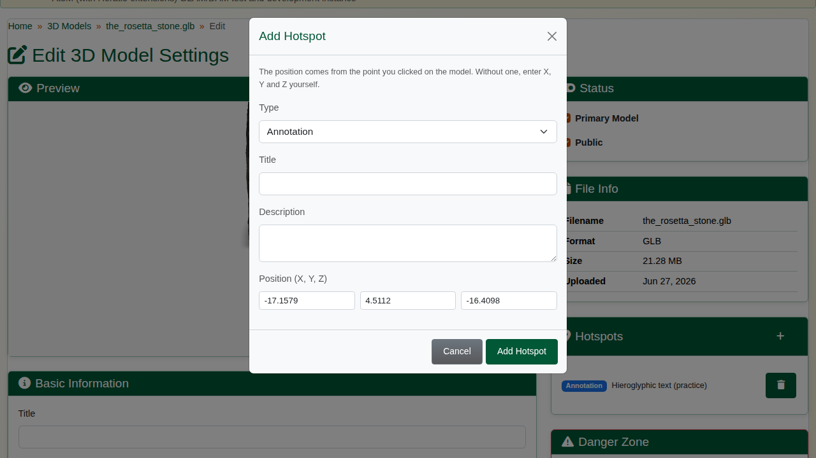
Adding a hotspot.
The hotspots then sit on the model for every visitor and are listed beside it.
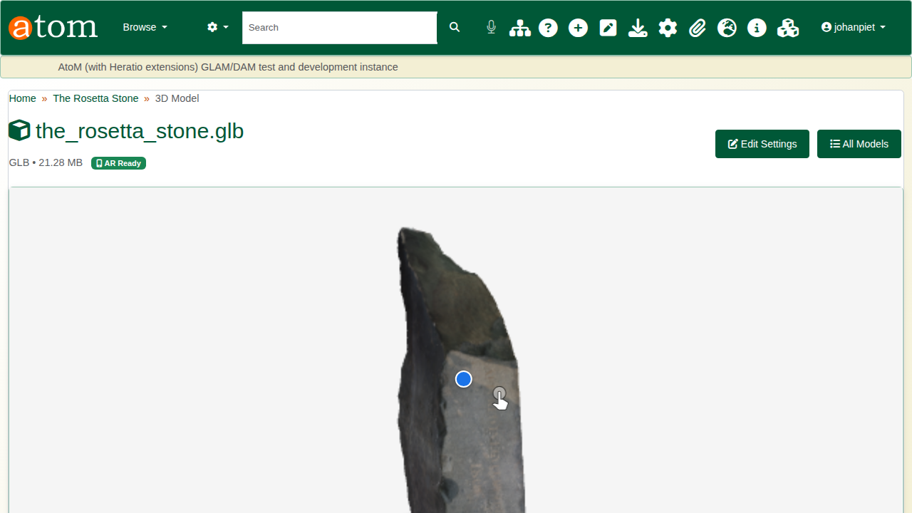
Hotspots on the model.

4. Model settings
Each model has its own settings:
Model settings
Section | Settings
Viewer | Camera orbit, field of view, exposure, shadow intensity, rotation speed, background colour, auto-rotate
Augmented reality | On or off, scale (auto or fixed), placement (floor or wall)
Status | Primary model, public
Capture, provenance and rights | How and when it was captured, with what, by whom; processing; licence and attribution
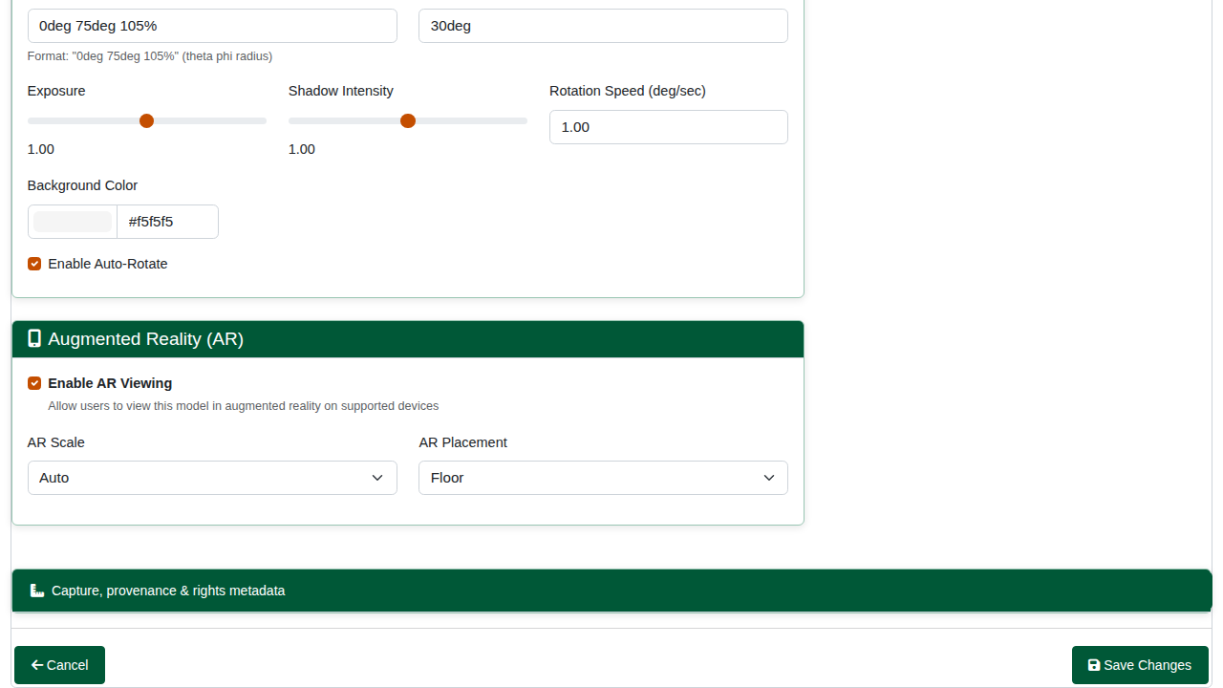
Model settings.
Delete Model removes the model’s 3D settings and hotspots. For a model registered from a record’s digital object, the master file itself is kept.

5. IIIF 3D
Every model has a IIIF 3D manifest at /iiif/3d/<model id>/manifest.json, with its hotspots as annotations, so systems that follow the IIIF 3D work can show it. The model page has the link, with Copy and View.
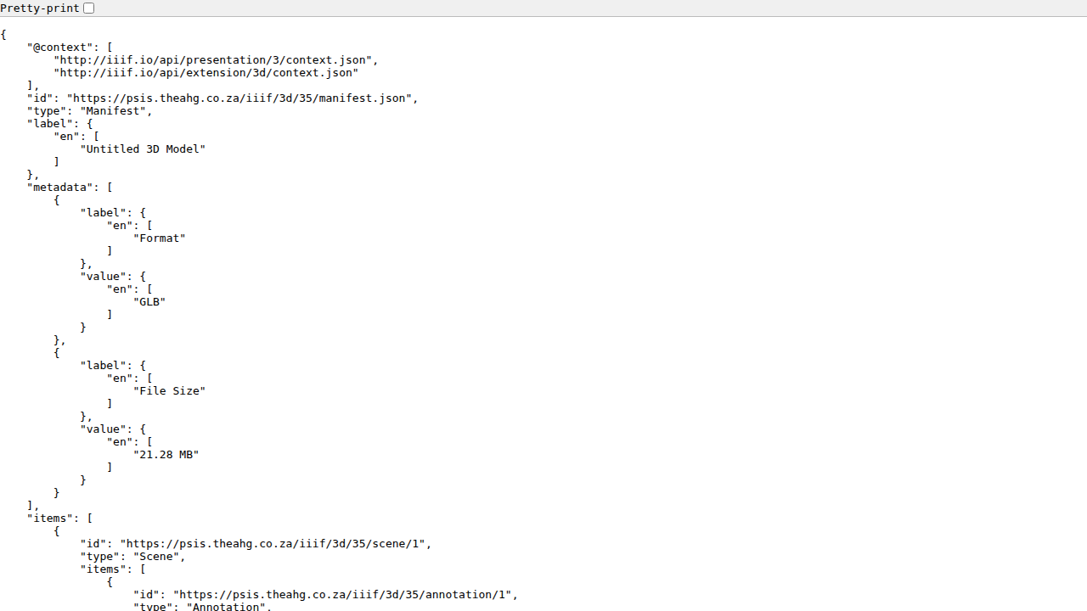
A IIIF 3D manifest.

6. Managing models
3D Models (/ahg3DModel/index) lists every model with its object, format, size and status. 3D Viewer Settings (/ahg3DSettings/index) set the defaults for all models: the viewer, background, exposure, auto-rotate and full screen; augmented reality; the formats and file size allowed for upload, and downloads; hotspots; and watermarking. Usage figures are at the top.
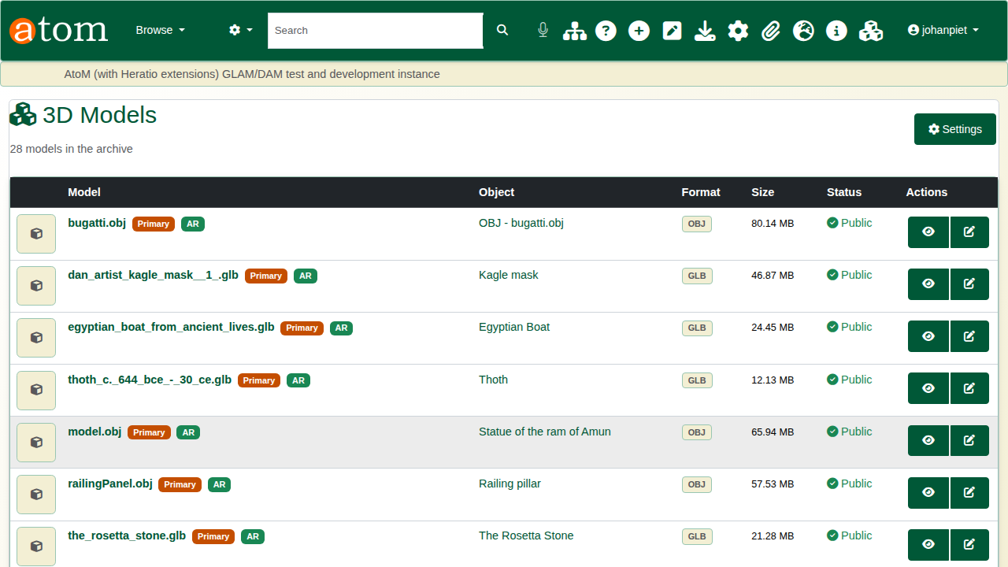
All models.
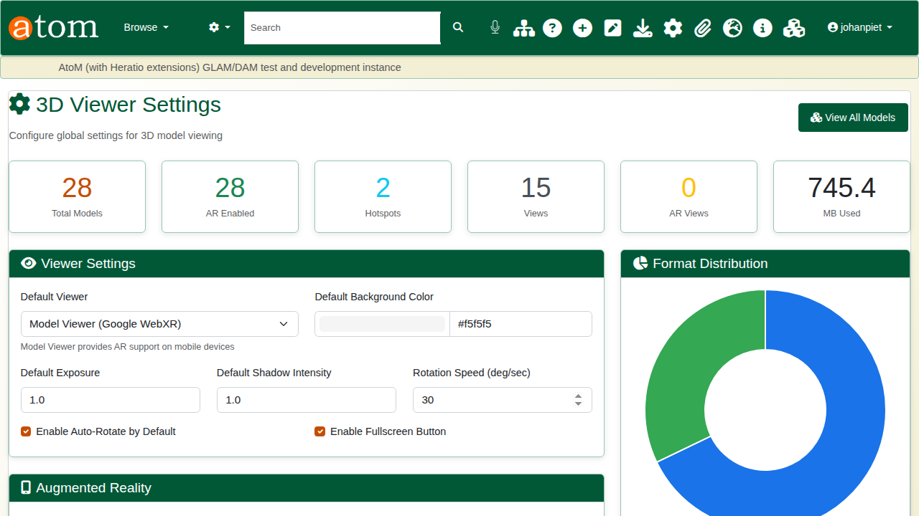
Global 3D settings.

Recap
- 3D models open in the viewer on the record.
- They can be seen in augmented reality on a phone or tablet.
- Hotspots mark details, added by a click on the model.
- Each model is published as IIIF 3D.
Part 3 covers discovery search.

