Training: Museum, Part 3 - Condition Checking
Step-by-step guide to recording a condition check, photographing and marking damage, and producing the condition report
Dr Johan Pieterse
Document control
Field | Value
Document title | Training: Museum, Part 3 - Condition Checking
Author | Dr Johan Pieterse
Owner | The Archive and Heritage Group (Pty) Ltd
Version | 1.0
Status | Released
Date | 12 October 2026
Prepared for | Conservators, registrars and collections staff using the AHG extensions
Classification | Public
Reference | AHG-TRN-MUS-03
Contents
Right-click and choose Update Field to build this list.
List of Tables
Right-click and choose Update Field to build this list.
This guide goes with part 3 of the museum training videos. The painting from part 1 has a tear. You record a condition check with the full assessment, photograph the damage, mark it on the photograph, and export the condition report. Allow about 15 minutes.

Before you start
What you need before you start
What | Notes
An editor or administrator account | Condition checking is a staff function.
A museum object | The painting from part 1.
A photograph of the object | The practice photograph landscape-painting-practice.jpg is in docs/training-files/ of the AHG extensions catalogue: a fictitious landscape with a tear in the lower left.

1. A new condition check
On the object, open Condition assessment (under Collections Management). Condition Reports shows the object’s condition history.
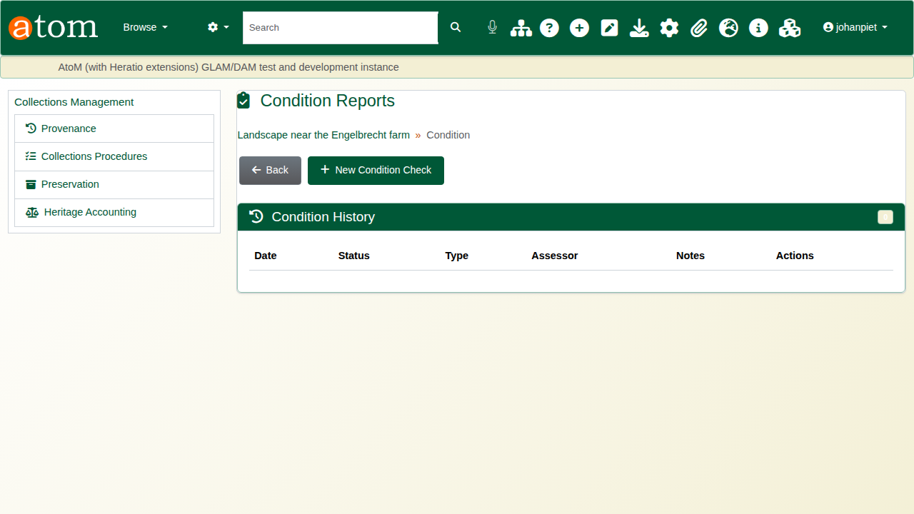
The condition reports page.
Click New Condition Check. The check date and the person checking are filled in; the check is created only when the form is saved.
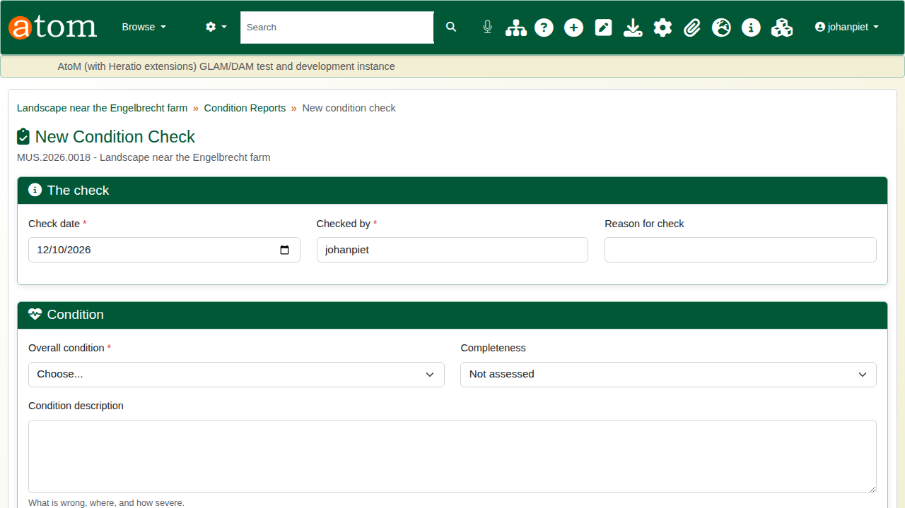
A new condition check.

2. The assessment
The form has four parts:
The condition check form
Part | Fields
The check | Check date (required), checked by (required), reason for check
Condition | Overall condition (required), completeness, condition description, hazards noted, technical assessment
Treatment | Treatment recommendations, treatment priority, next check
Care recommendations | Environment, handling, display, storage, packing and transport, additional notes
The deliberate mistake: save without rating the overall condition. The check is refused, the missing field is marked, and everything typed is kept.
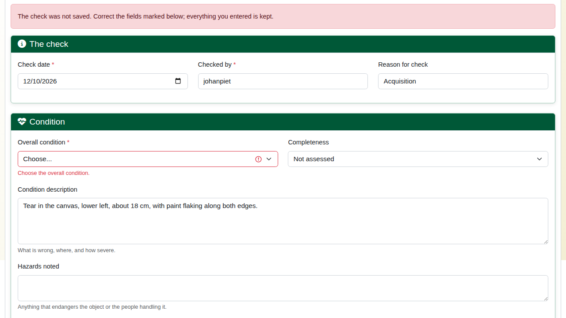
The check refused.
Rate the overall condition (Excellent, Good, Fair, Poor or Critical), then complete the assessment: completeness, hazards, the recommended treatment, its priority (Low, Medium, High or Urgent), the next check date, and care advice. The next check cannot be before this one. Click Record condition check.
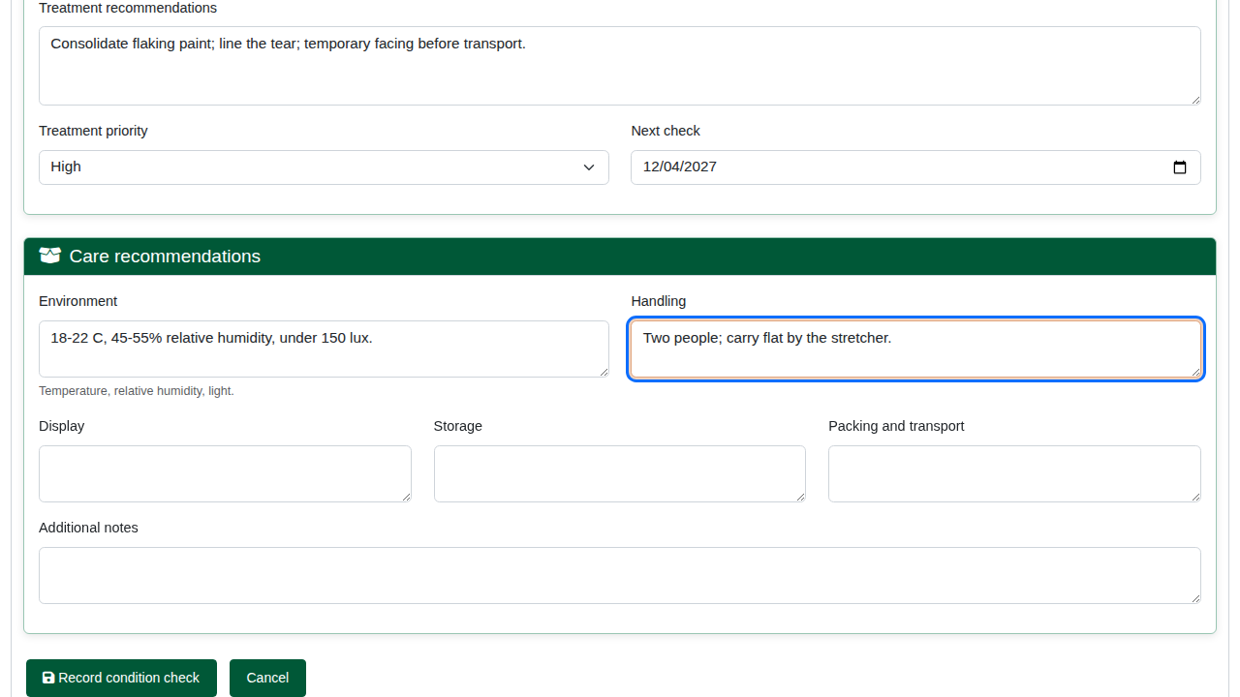
The assessment.
The check gets its own reference (for example CC-20261012-913375) and shows the rating, priority, next check, and the notes and recommendations. Edit Condition Check corrects it later.
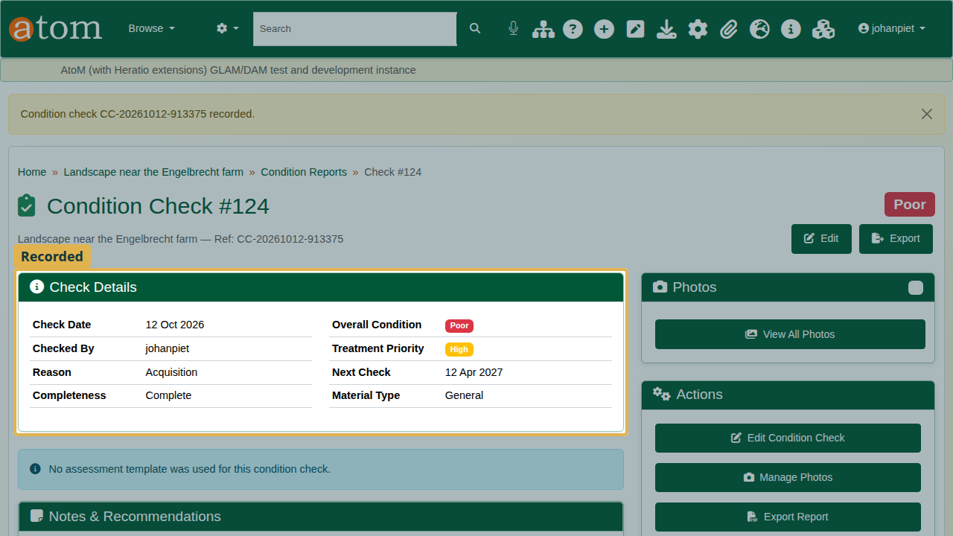
The recorded check.

3. Photographs
Click Manage Photos. Choose the kind of photograph (Overall View, Detail, Damage, Before Treatment, After Treatment or Other), give it a caption, choose the file and click Upload Photo.
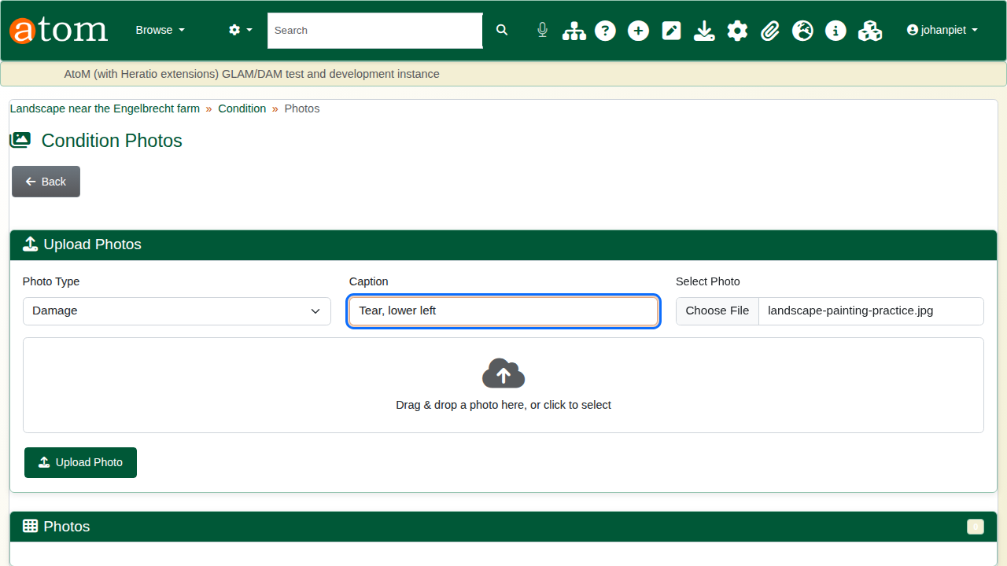
Uploading a damage photograph.
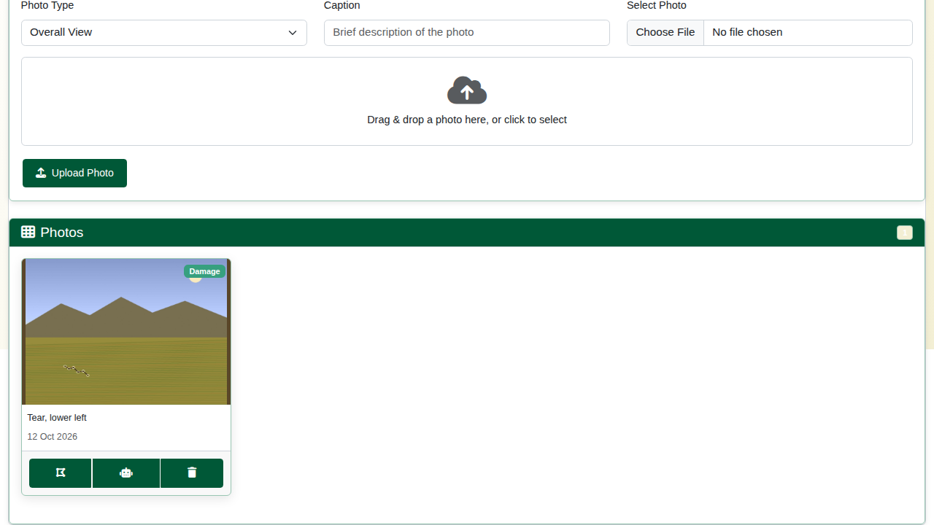
The uploaded photograph.

4. Marking the damage
On the photograph, click the annotate button. Choose the Category (here Tear; others include Crack, Stain, Loss/Missing, Mould/Fungus, Pest Damage, Water Damage, Abrasion/Wear and Corrosion), take the Rectangle tool and draw around the damage. Circle, arrow, freehand, text and marker tools are also available. Click Save Annotations.
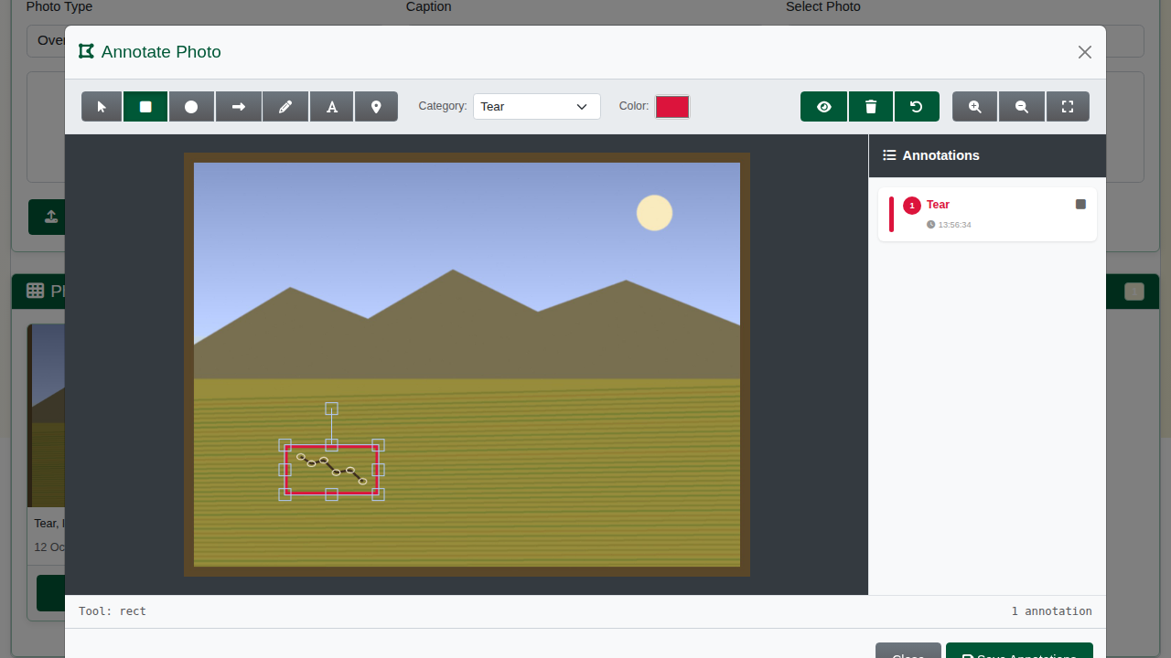
The damage marked on the photograph.
The photograph now shows how many marked areas it carries.
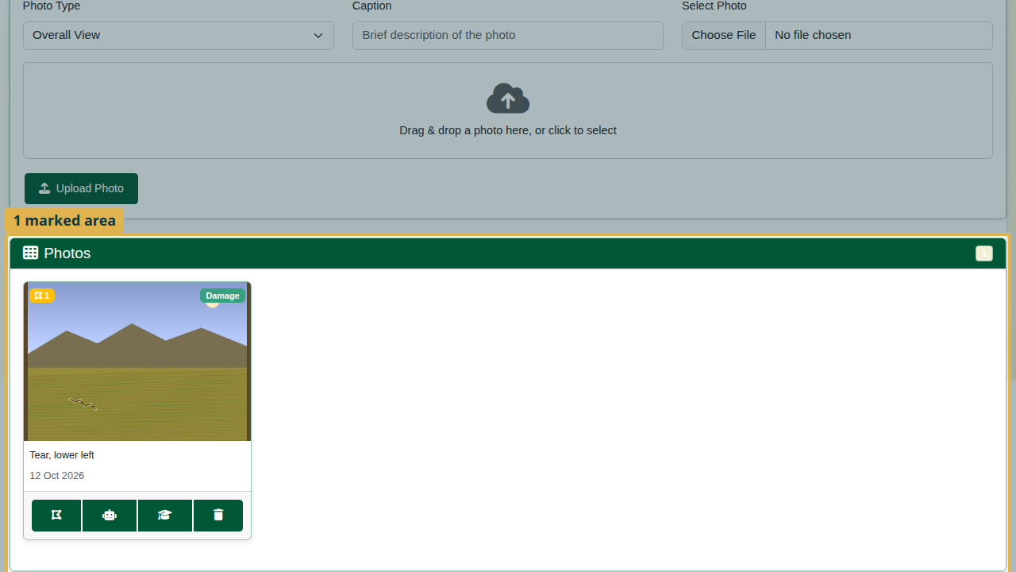
The annotation count on the photograph.

5. The report
Export Report gives a printable condition report: reference, date, who checked it, overall condition, completeness, treatment priority, next check, the condition description, hazards, recommended treatment, care recommendations, and the photographs.
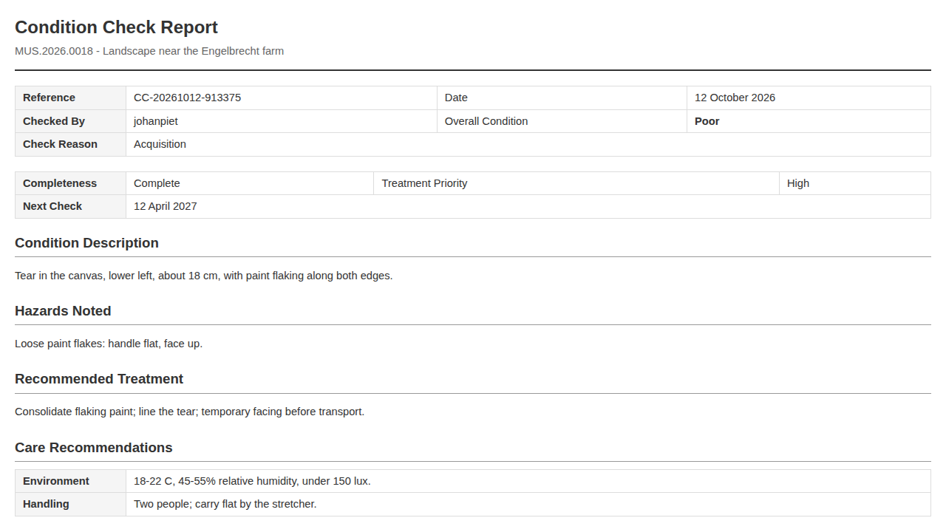
The condition report.
Back on the object, Condition History lists the check with its date, rating, assessor and a summary of the description.
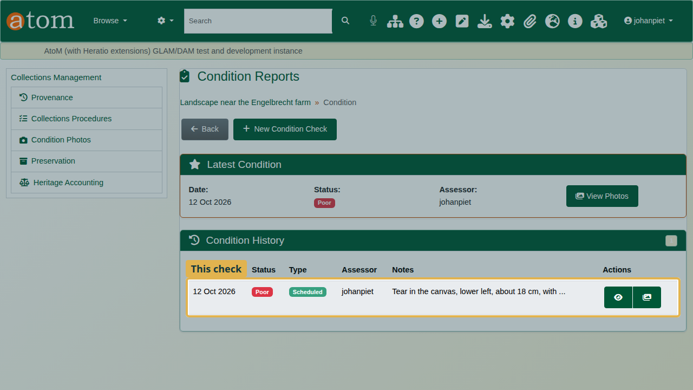
The condition history.

Recap
- Start a condition check from the object.
- Rate the overall condition; the check will not save without it.
- Record the assessment, treatment and care advice.
- Photograph the damage and mark it.
- Export the report.
Part 4 covers provenance and the chain of custody.

