Walkthrough: Library Services
Step-by-step guide to cataloguing a book from its ISBN, registering a reader, lending and returning it, and the public catalogue
Dr Johan Pieterse
Document control
Field | Value
Document title | Walkthrough: Library Services
Author | Dr Johan Pieterse
Owner | The Archive and Heritage Group (Pty) Ltd
Version | 1.0
Status | Released
Date | 13 October 2026
Prepared for | Librarians and circulation staff using the AHG extensions
Classification | Public
Reference | AHG-TRN-LIB-01
Contents
Right-click and choose Update Field to build this list.
List of Tables
Right-click and choose Update Field to build this list.
This guide goes with the Library Services walkthrough video. The library runs on the same platform as the archive: a book is a catalogue record like any other description, with library details, copies and loans added. You catalogue a book from its ISBN, register a reader, lend the book and take it back, and see the public catalogue follow. Allow about 15 minutes.

Before you start
What you need before you start
What | Notes
A librarian or administrator account | Cataloguing, patrons and circulation are staff pages.
A barcode label for the copy | Any unique code; the example uses PRAC-0001.
Loan rules | Set under Circulation > Loan rules. The installed rules lend a monograph for 21 days.
The reader, the barcodes and the card number in the examples are fictitious.

1. Catalogue from an ISBN
Open Library > Add new item (/library/add). In ISBN / DOI / ISSN, type the ISBN and click Resolve. The lookup asks Open Library and the other configured providers, and after you confirm, fills in the title, author, publisher, date, pagination and subjects.
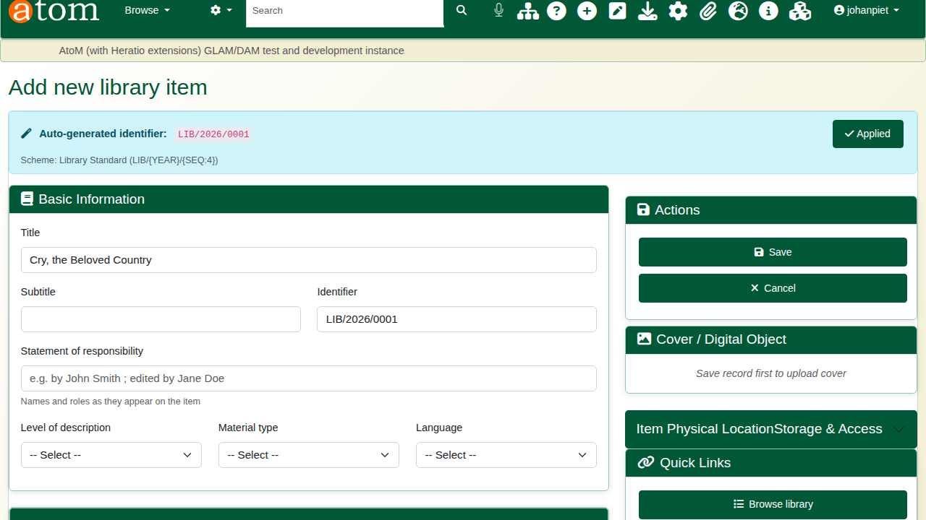
The record filled from the ISBN.
Then add the local details:
Local details for the book
Field | Example | Notes
Level of description | Book | Required
Classification scheme | Dewey Decimal (DDC)
Dewey Decimal | 823.912
Call number | 823.912 PAT | What goes on the spine label
Barcode | PRAC-0001 | The copy’s barcode; circulation scans this
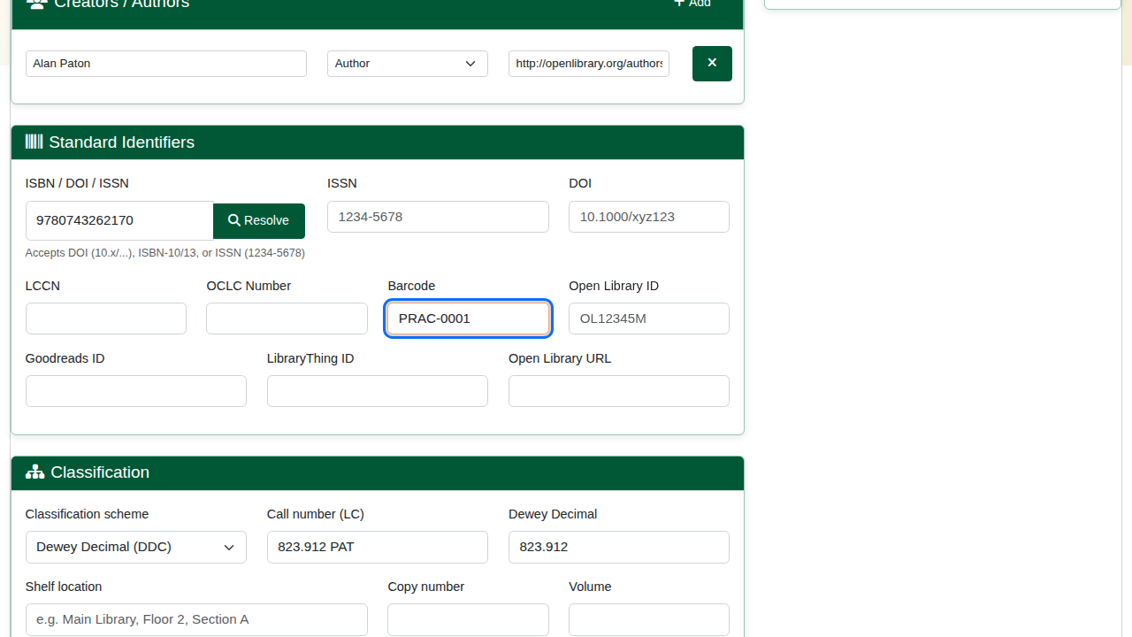
Shelf details and the copy barcode.
Click Save. Saving with a barcode creates the item’s first copy, ready to lend. Further copies come from acquisitions (receiving an order or batch capture).

2. Publish
New records start as drafts, which the public catalogue does not show. Open the book, and under More choose Update publication status, set Published and click Update.
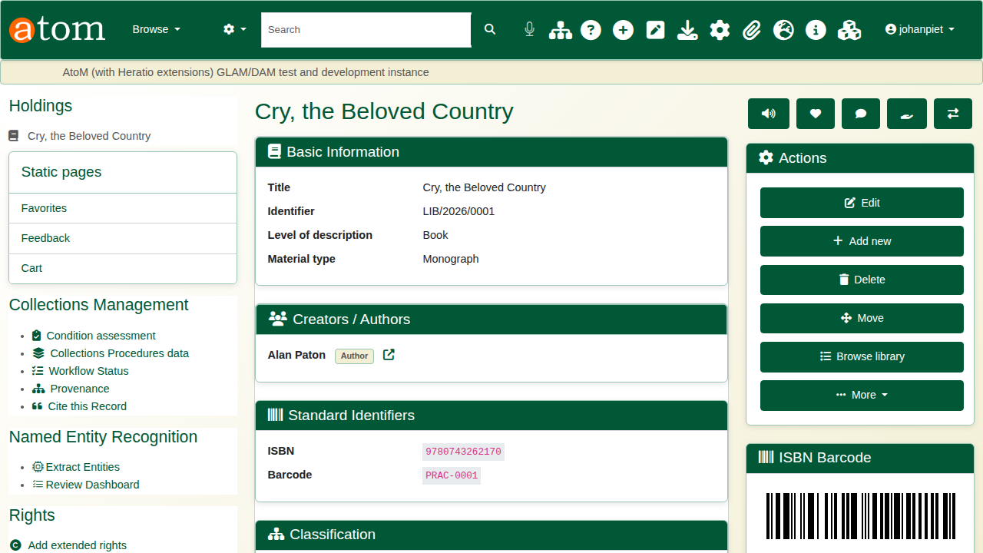
The catalogued book.

3. Register a reader
Under Patrons (/patron), click Add Patron. Enter the first and last name, the email address and the patron type (Student, Staff, Faculty, Public, Researcher and others). Maximum loans and holds can be set per reader. Save: the system issues a library card number, shown on the patron’s page.
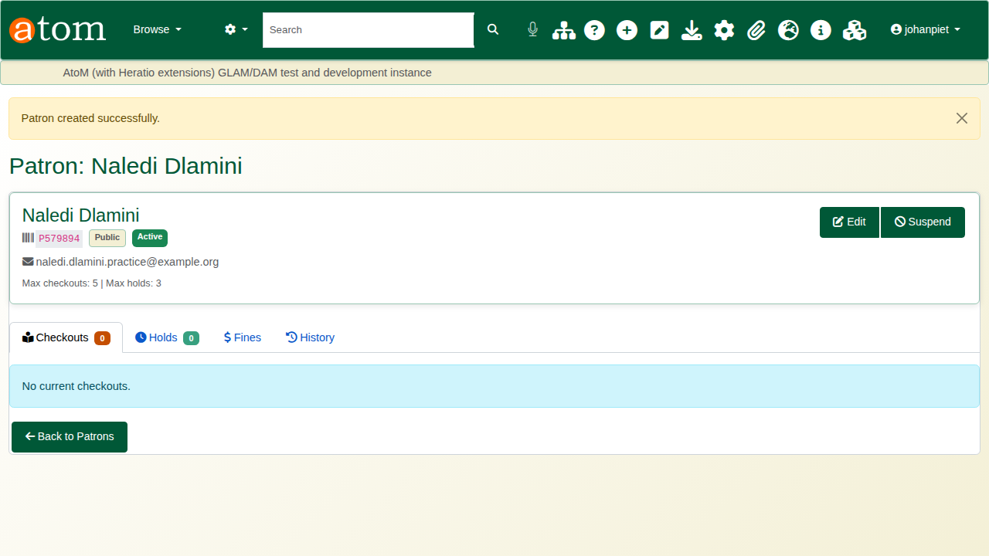
The new patron and card number.

4. Lend and return
Open the circulation desk (/circulation). Under Check Out Item, scan or type the reader’s card number and the book’s barcode, and click Checkout. The loan rule for the material type and reader type sets the due date. The reader’s details, current loans and overdue count appear beside the form.
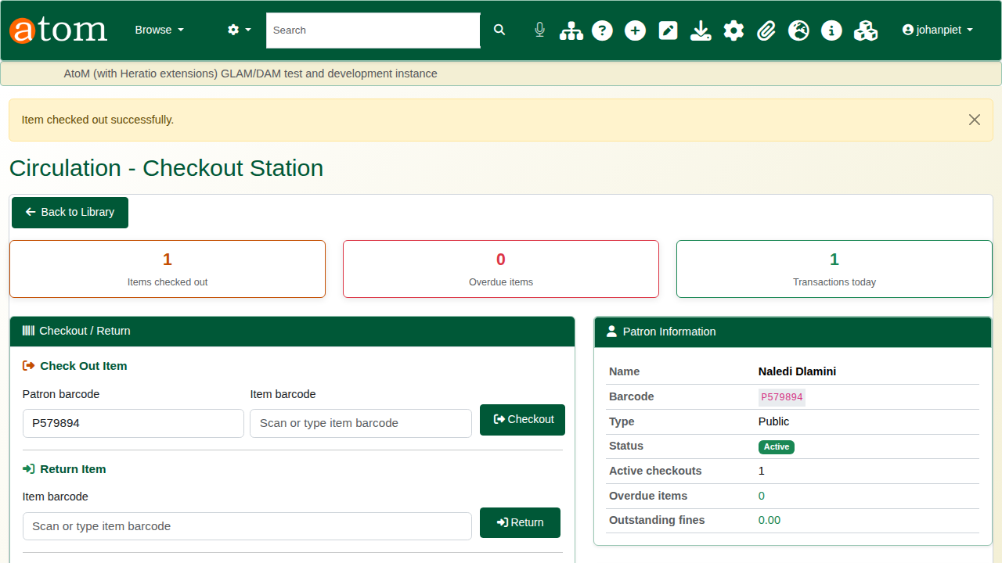
The checkout.
When the book comes back, scan its barcode under Return Item and click Return. The loan closes, the copy is available again, and a late return raises an overdue fine when automatic fines are on. Renew Item extends a loan in the same way.
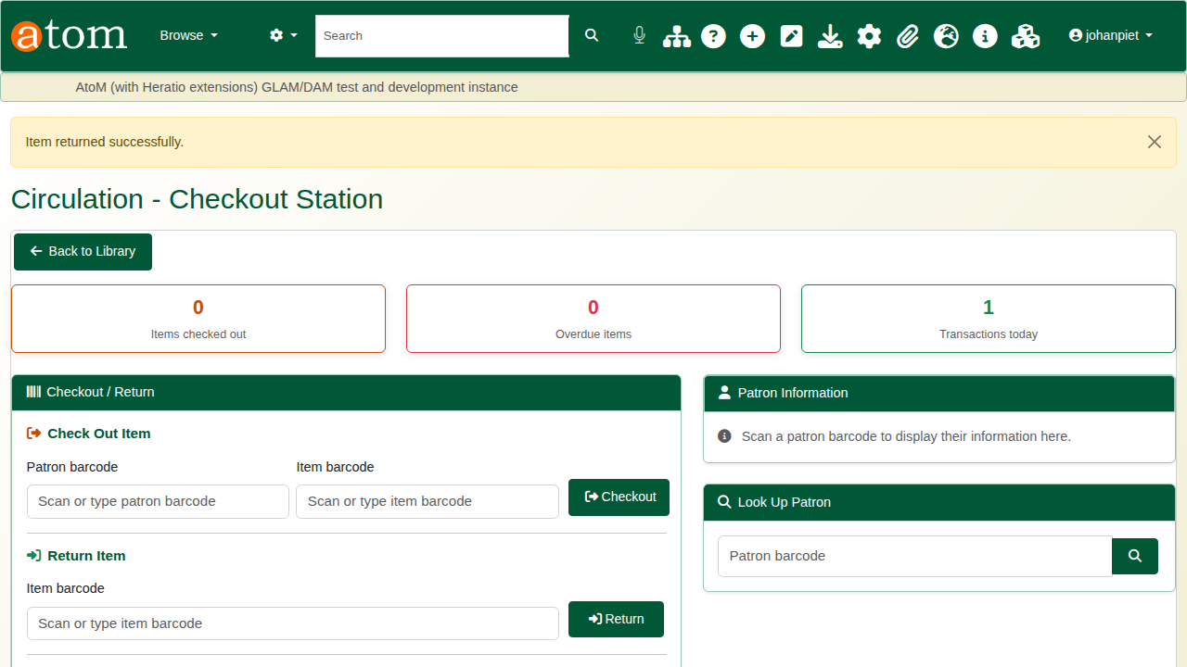
The return.

5. The public catalogue
Readers search the public catalogue (/opac) by keyword, title, author, subject or ISBN, and refine by material type and publication year. Editions of the same work can be grouped together. Each result shows how many copies are available.
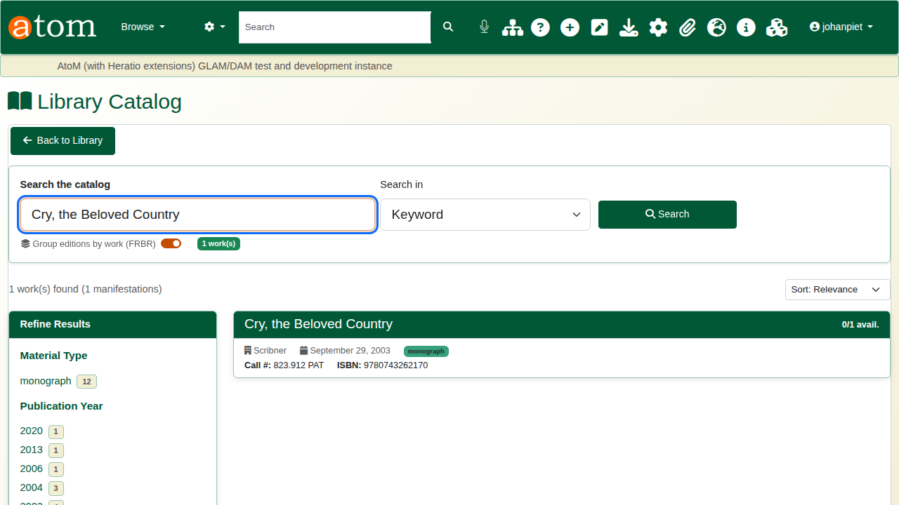
Search results.
The record shows the bibliographic details and, under Availability, each copy with its barcode and status, so a reader can see whether the book is on the shelf.
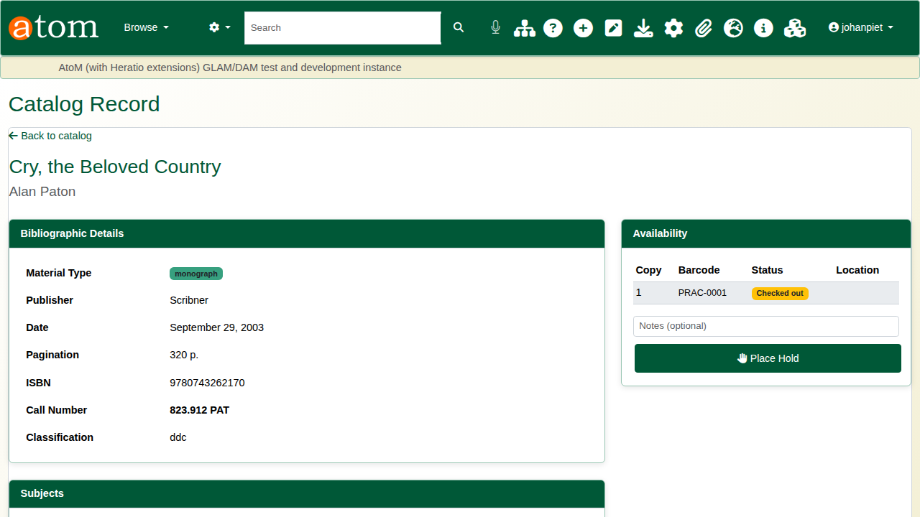
The public record with the copy checked out.

Also in the library module
Other library functions
Area | What it covers
Circulation | Renewals, overdue lists, loan rules per material and reader type
Acquisitions | Orders, receiving, budgets, batch capture from ISBNs
Serials | Subscriptions, issue check-in, claims, bindery
Interlibrary loans | Requests and their status history
Copy cataloguing | Import records from other libraries over Z39.50 (targets configured by an administrator)
Export | MARC and other bibliographic exports

Recap
- Catalogue from the ISBN; add the shelf details and barcode.
- Publish the record.
- Register the reader.
- Lend and return at the circulation desk.
- The public catalogue shows what is on the shelf.

