Training: Museum, Part 5 - Exhibitions and Loans
Step-by-step guide to planning an exhibition, lending an object to another institution, moving the loan through approval and the agreement, and recording its return
Dr Johan Pieterse
Document control
Field | Value
Document title | Training: Museum, Part 5 - Exhibitions and Loans
Author | Dr Johan Pieterse
Owner | The Archive and Heritage Group (Pty) Ltd
Version | 1.0
Status | Released
Date | 13 October 2026
Prepared for | Curators and registrars using the AHG extensions
Classification | Public
Reference | AHG-TRN-MUS-05
Contents
Right-click and choose Update Field to build this list.
List of Tables
Right-click and choose Update Field to build this list.
This guide goes with part 5 of the museum training videos. You plan an exhibition and add the painting to it, then lend the painting to another gallery, take the loan through approval and the signed agreement, and record its return. Allow about 20 minutes.

Before you start
What you need before you start
What | Notes
An editor or administrator account | Exhibitions and loans are staff pages.
A museum object | The painting from part 1.
Fictitious details | The exhibition, the borrowing gallery and the people named are made up for this practice.

1. Plan an exhibition
Under Exhibitions, choose Add (/exhibition/add). Enter a title, the exhibition type (permanent, temporary, travelling, online, pop-up and others), the opening and closing dates and the curator. Venue, organiser, budget and a project code are optional. Save: the exhibition starts at the Concept stage, and its page shows the dates, the duration and how long until it opens.
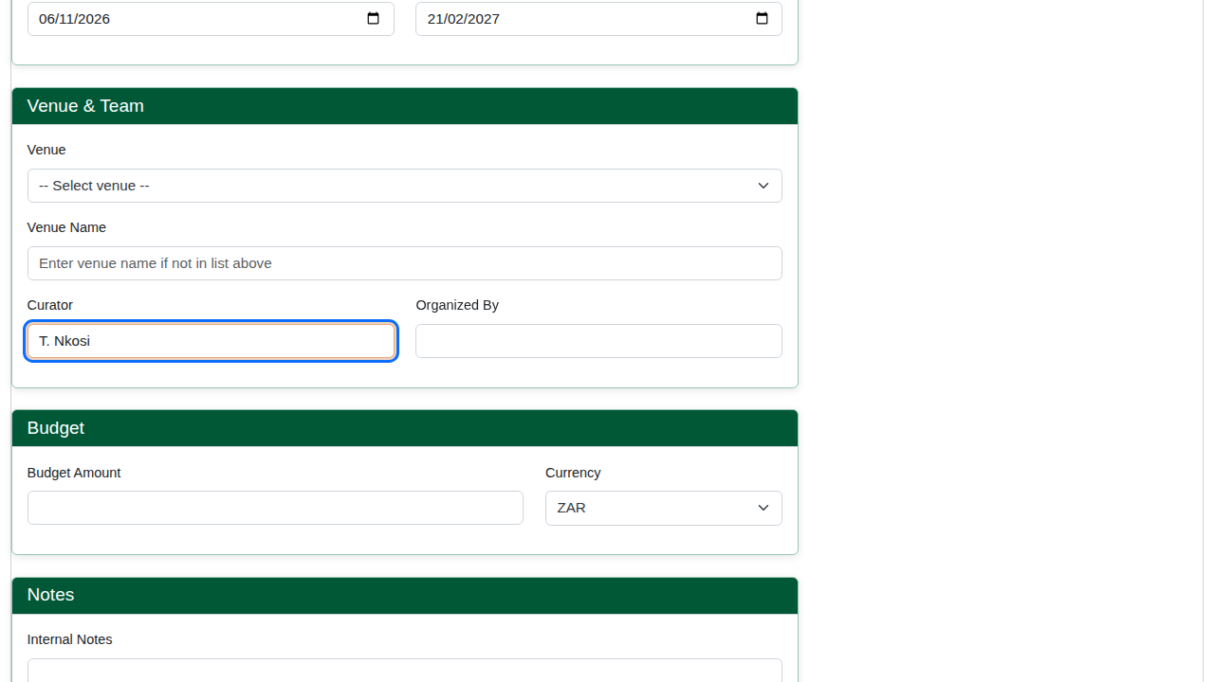
The exhibition form.
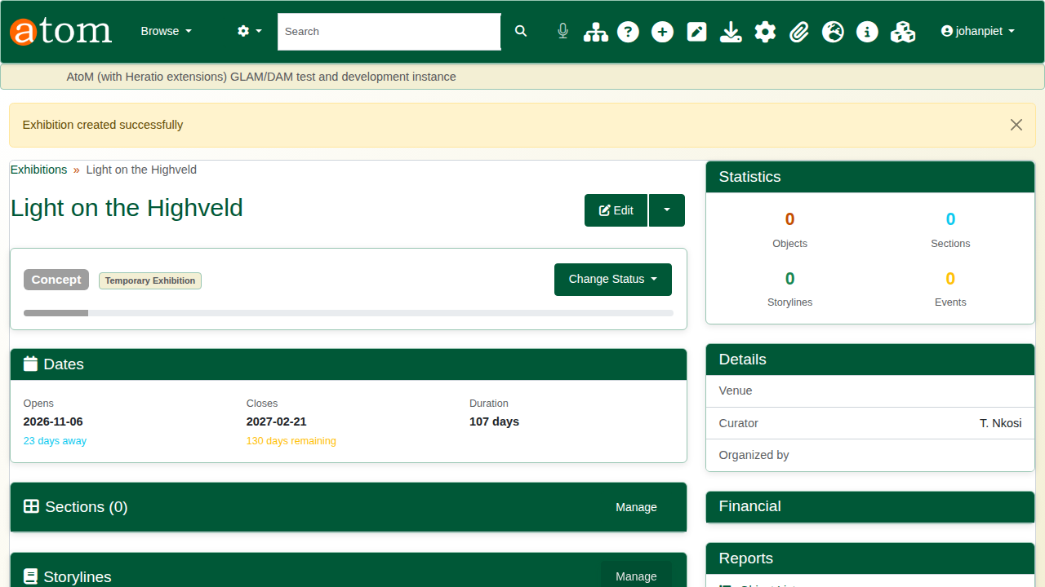
The new exhibition.

2. Add objects
On the exhibition, open Manage Objects and click Add Object. Search by title or object number, choose the object, and say where it will be displayed (here, Gallery A, east wall). Objects can also be placed in sections and storylines, and flagged when they need to be borrowed from another institution.
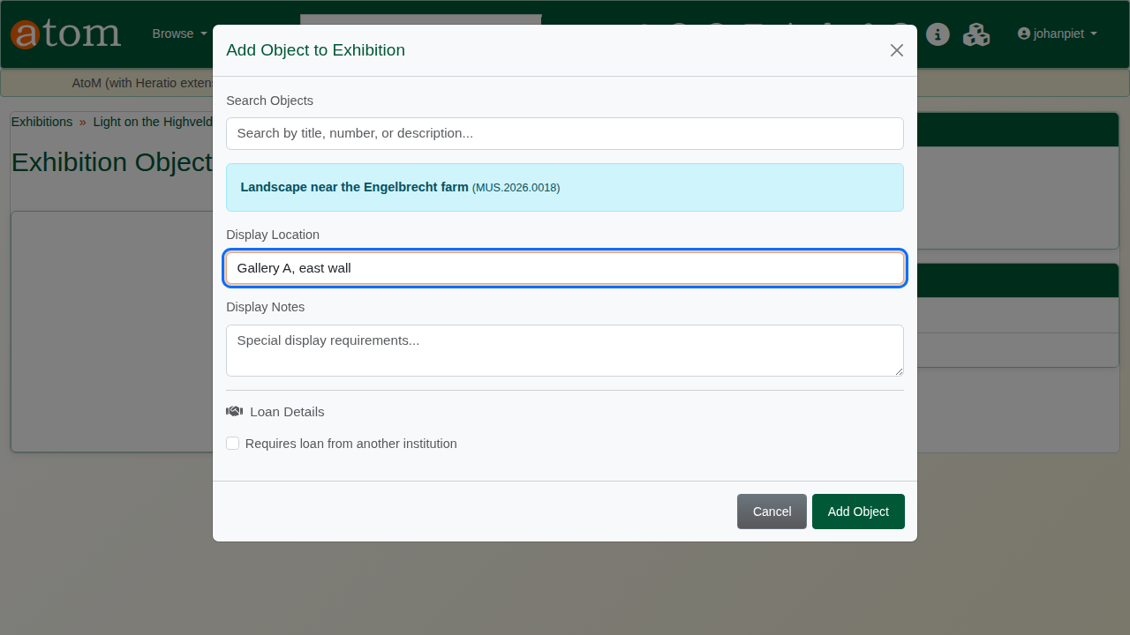
Adding the painting.
The exhibition page counts its objects, sections, storylines and events. Under Reports, Object List prints the list for installers and Export Objects (CSV) exports it as a spreadsheet.
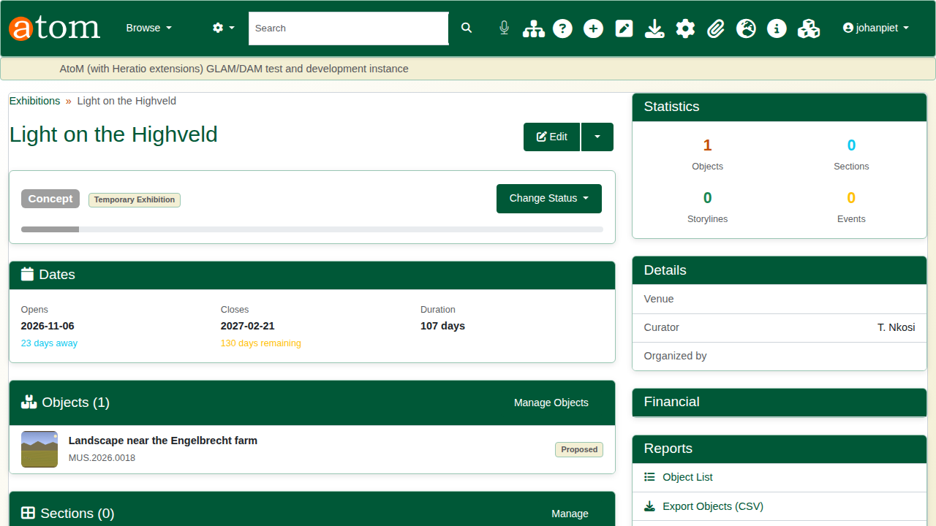
The exhibition with its object.

3. Record a loan out
Under Loans, add a museum loan (/loan/museum/add). Record:
The loan out
Field | Example
Title | Light on the Highveld - travelling
Purpose | Exhibition (also research, conservation, photography, education, touring exhibition)
Borrowing institution and contact | Highveld Regional Gallery; P. Mahlangu
Loan dates | 1 March 2027 to 30 June 2027
Insurance | Borrower covers; ZAR 85,000
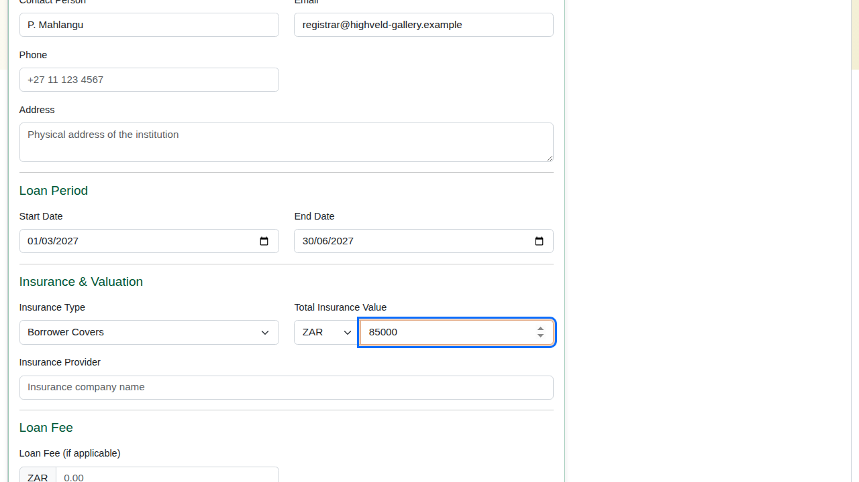
The loan form.
Save. The loan gets its own number (for example MUS-LO-2026-0004) and starts at Request Received.
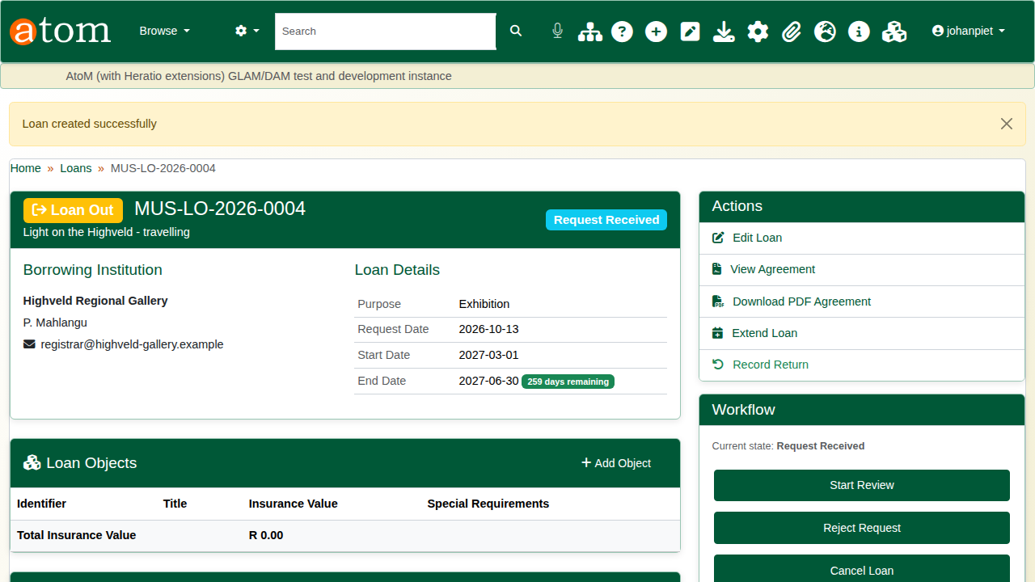
The new loan.

4. Add the object
Under Loan Objects, click Add Object, search for the painting and give its insurance value. A loan can carry several objects; the page totals their insurance value, and that total is what the agreement shows.
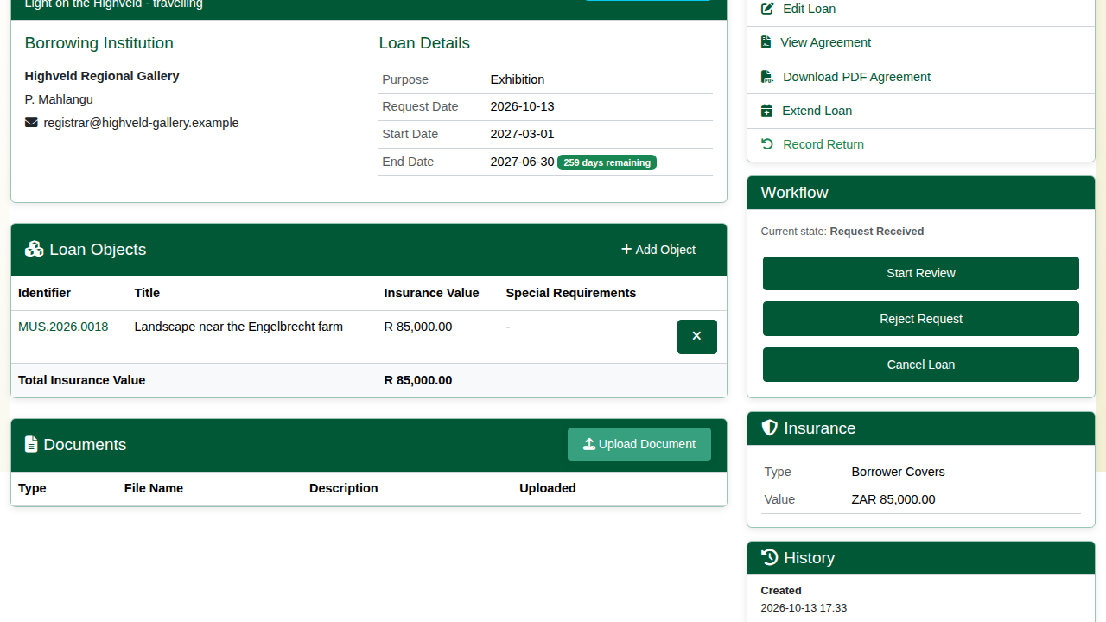
The painting on the loan.

5. Approval and the agreement
A loan out follows a workflow, and the Workflow panel offers only the steps that make sense from where the loan stands. The first steps are:
The first workflow steps for a loan out
Step | From | To
Start Review | Request Received | Under Review
Approve | Under Review | Approved
Send Agreement | Approved | Agreement Pending
Agreement Received | Agreement Pending | Agreement Signed
Later steps cover insurance, condition checks, packing, courier and dispatch, display at the borrower, and the return. Each change is recorded in the loan’s status history with the user and time, and the badge at the top shows the current state.
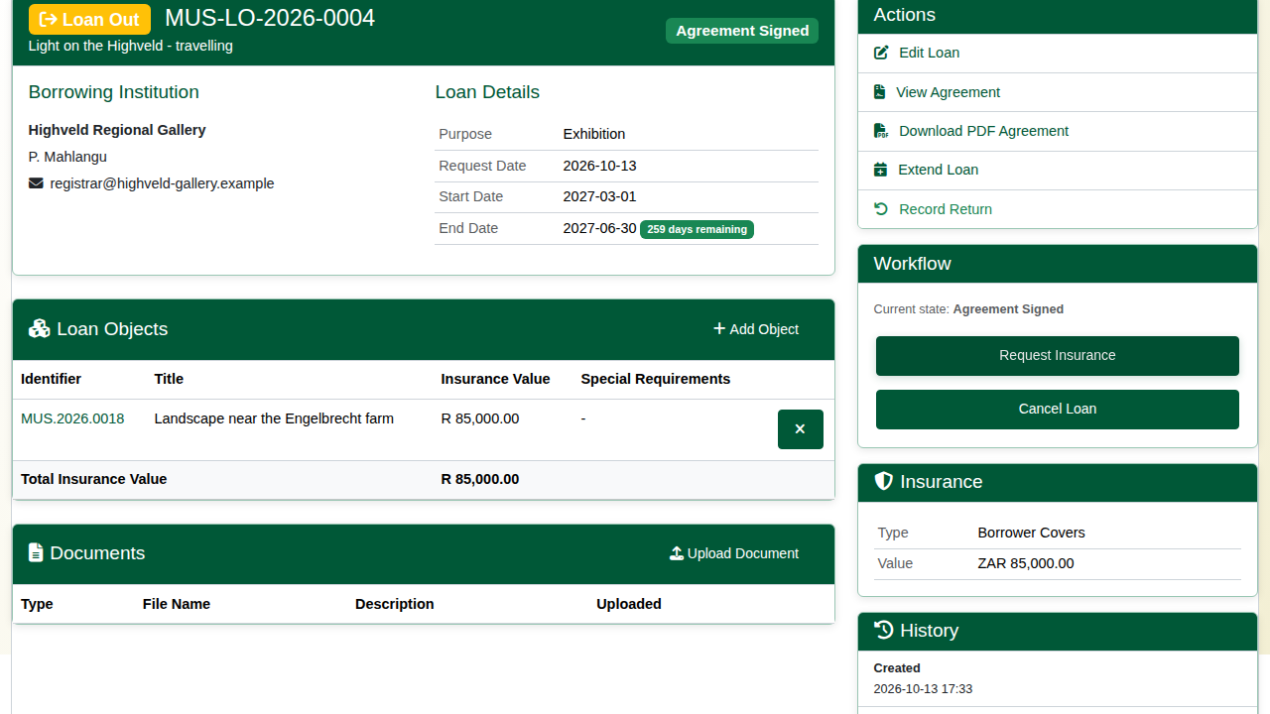
The loan with its agreement signed.
View Agreement generates the loan agreement from the record: lender and borrower, purpose, loan period, insurance, the objects with their values, standard terms and signature blocks. Download PDF Agreement gives the same as a PDF. The lender is the repository that holds the objects.
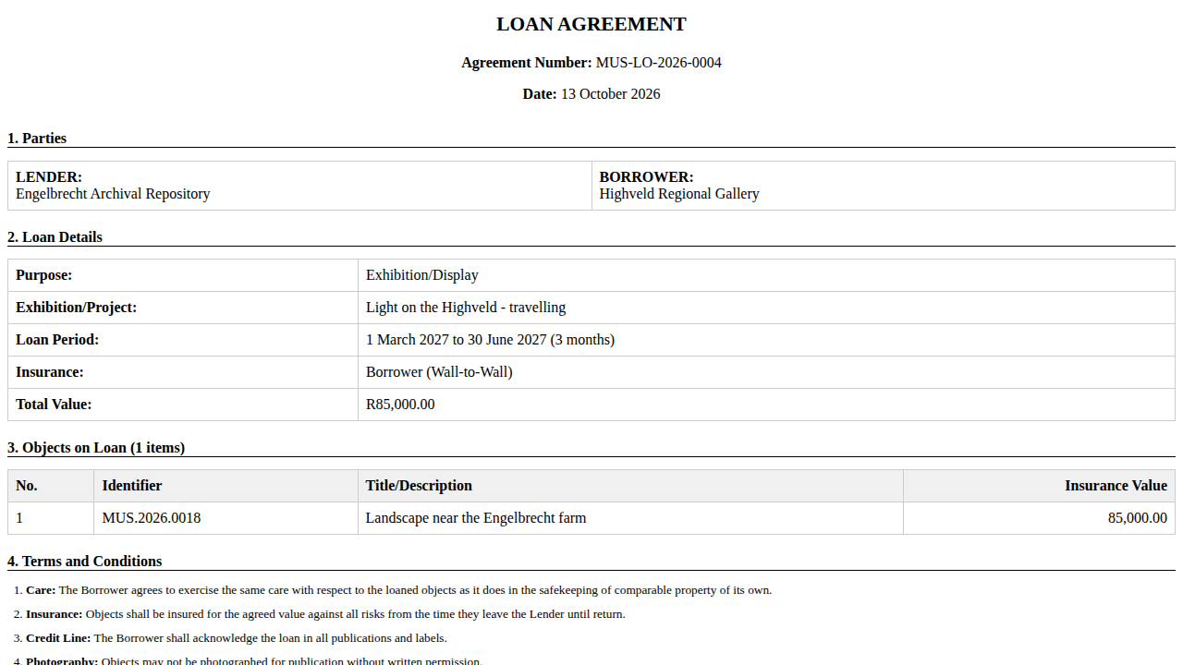
The loan agreement.

6. Record the return
When the object comes back, choose Record Return under Actions, give the return date and a note on its condition, and click Record Return. The loan is marked Returned, the return is added to its history, and the workflow offers the next step, Verify Return Condition. Extend Loan changes the end date if the borrower asks for longer.
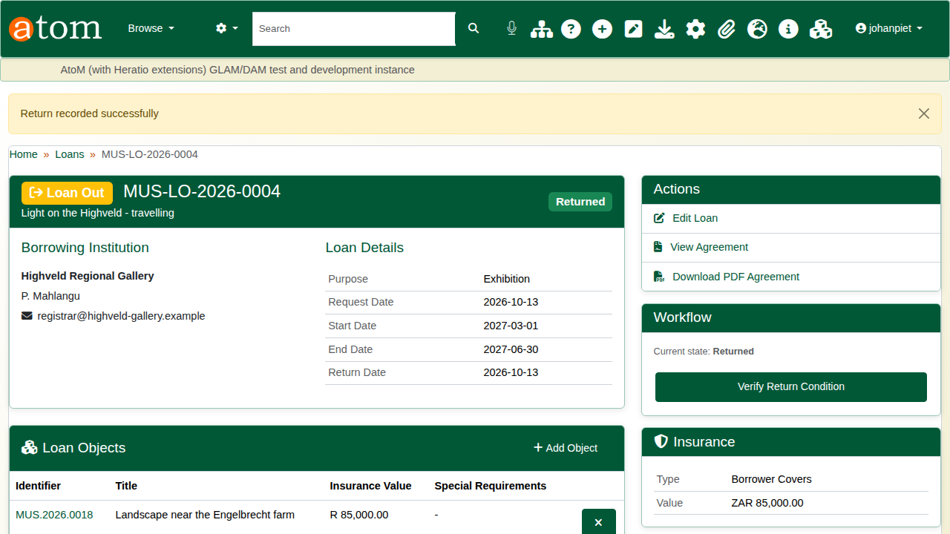
The returned loan.

Recap
- Plan the exhibition and add its objects.
- Record the loan with its borrower, dates and insurance.
- Move it through approval and the agreement, step by step.
- Record the return.
Part 6 covers heritage accounting.

