Walkthrough: Records in Contexts and Graph Discovery
Step-by-step guide to searching the catalogue in plain words and following its records, creators, holders and custody as a graph
Dr Johan Pieterse
Document control
Field | Value
Document title | Walkthrough: Records in Contexts and Graph Discovery
Author | Dr Johan Pieterse
Owner | The Archive and Heritage Group (Pty) Ltd
Version | 1.0
Status | Released
Date | 13 October 2026
Prepared for | Archivists, researchers and administrators using the AHG extensions
Classification | Public
Reference | AHG-TRN-RIC-01
Contents
Right-click and choose Update Field to build this list.
List of Tables
Right-click and choose Update Field to build this list.
This guide goes with the Records in Contexts walkthrough video. You search the catalogue in plain words, open a record’s knowledge graph, follow a painting’s chain of custody in the provenance graph, and check the dashboard that keeps the graph in step with the catalogue. Allow about 10 minutes.

Before you start
What you need before you start
What | Notes
An administrator account | The graph pages and the RiC dashboard are staff pages.
Records with creators and a holder | The example uses the Engelbrecht Family Fonds.
An object with provenance recorded | The painting from part 4 of the museum series. Every owner and date in its history is fictitious.

What Records in Contexts is
Records in Contexts (RiC) is the International Council on Archives’ model for describing records as a network rather than a tree. The AHG extensions publish every description, creator and repository as linked data to a graph store, using the RiC ontology (RiC-O), so a connection can be followed in any direction: from a record to its creators, from a creator to everything they made, from a holder to everything it holds.

1. Semantic search
Open Semantic Search (/ricSemanticSearch/index). Type a question in plain words and click Search.
What semantic search understands
Ask for | What comes back
A name, such as Engelbrecht | Records and authority records that match, across the whole collection
all fonds, all series, all collections | Descriptions at that level only
records between 1930-1960 | Descriptions whose own dates overlap that period
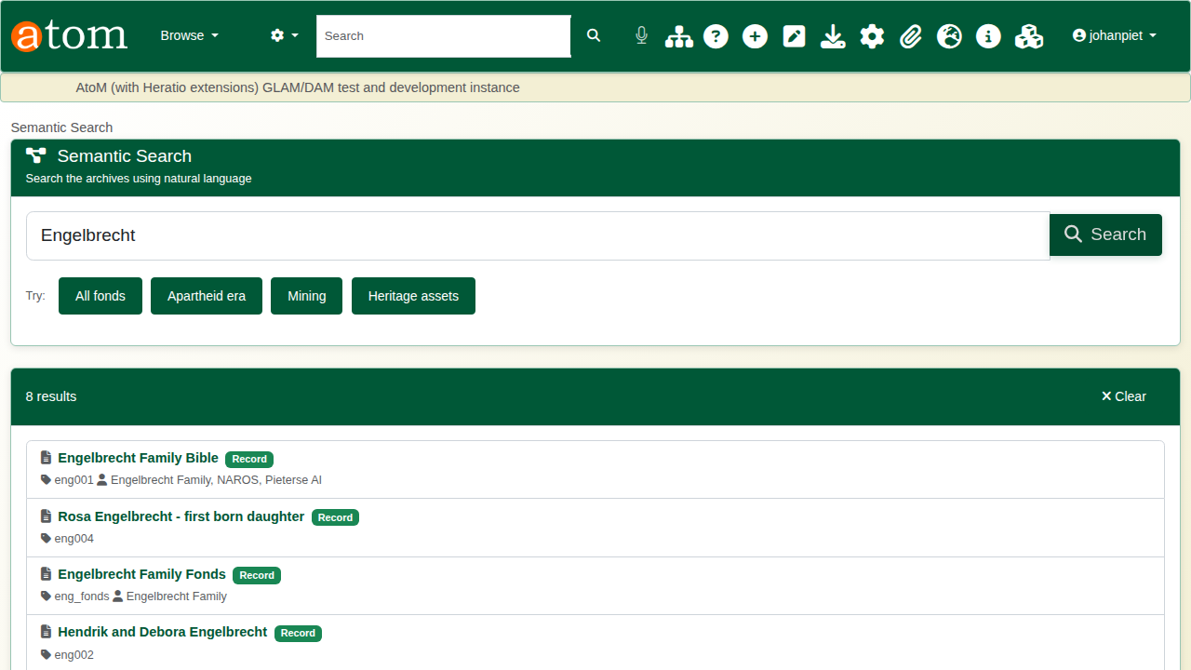
Searching for Engelbrecht.

2. The knowledge graph
Open the knowledge graph for a record (/ricExplorer/knowledge-graph/<record id>). The record sits in the centre. Around it:
Knowledge graph colours
Colour | Node
Dark | The record itself
Orange | Creators and accumulators
Blue | The repository that holds it
Teal | Subjects
Green | Related records
Every line is labelled with its relationship: creation, accumulation, held by. Nodes can be dragged to make room.
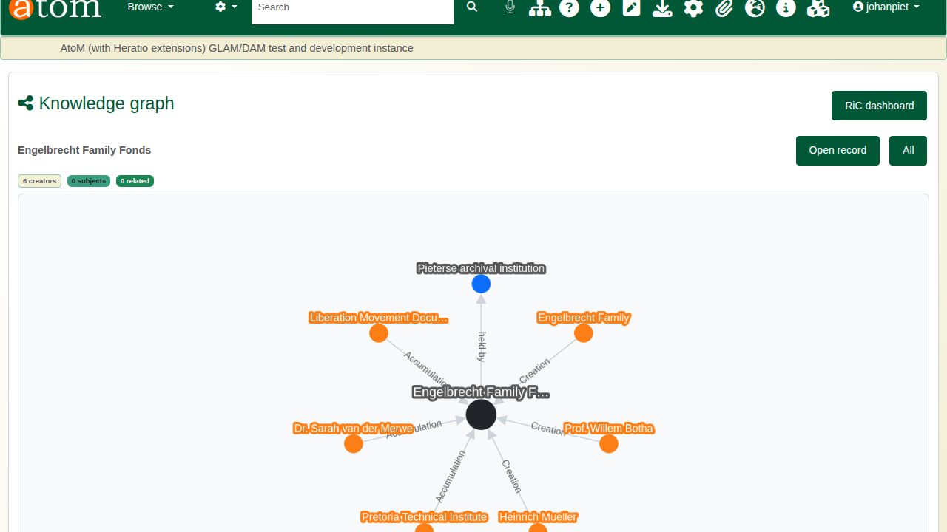
The knowledge graph of the Engelbrecht Family Fonds.
Open record returns to the description. All lists every record that has a graph, each with a Graph button.
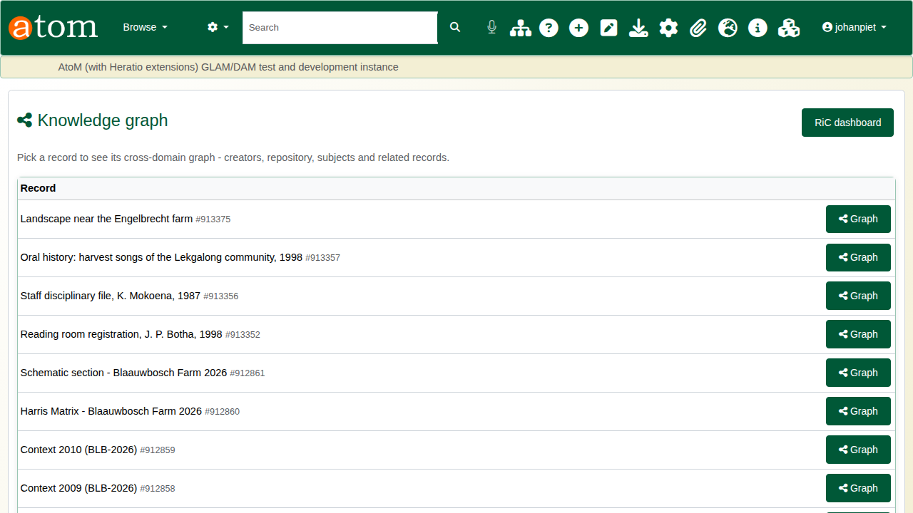
Every record with a graph.

3. The provenance graph
Open the provenance graph for an object (/ricExplorer/provenance/<record id>). It draws the chain of custody recorded on the object’s Provenance page, top to bottom in date order, with each transfer labelled by its type and date. The archive’s current custody is the dashed blue line back to the object.
Where an event has no recorded seller, the graph shows an Unknown holder with a dashed outline, joined to the previous holder by a dashed not recorded line. For the painting, that is the gap between the artist in 1934 and the purchase by J. P. Botha around 1952.
Beside the graph, Custody & acquisition summarises the record and Authenticity & due diligence shows the gaps as they were recorded, the Nazi-era provenance check and the cultural property status.
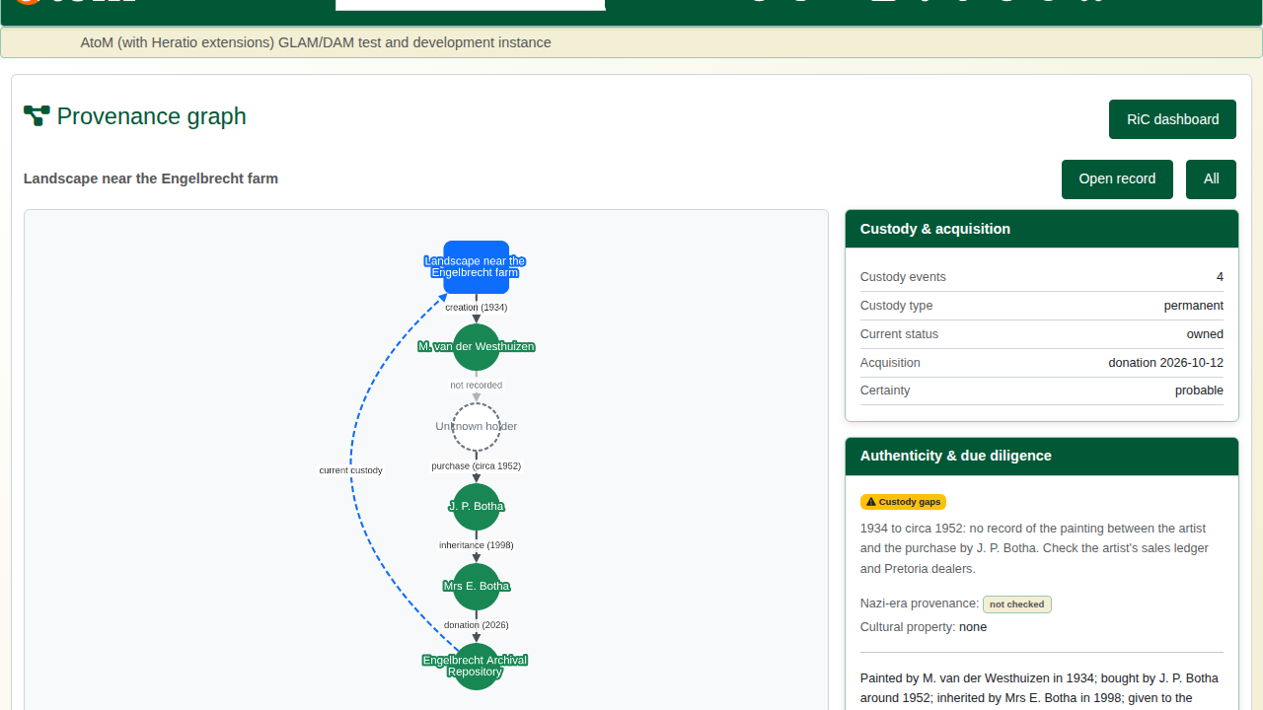
The painting’s provenance graph.

4. Keeping the graph in step
Administrators open RiC Tools > Dashboard (/admin/ric).
RiC dashboard panels
Panel | Shows
Fuseki Status | Whether the graph store is online and holds data
Queue | Changes waiting to be sent to the graph
Orphaned Triples | Graph entries whose record no longer exists in the catalogue
Record Activity | Records created and updated over the last seven days
Quick Actions | Sync to Fuseki, Run Integrity Check, Preview Cleanup
Run Integrity Check compares the graph with the catalogue and reports anything out of step; Preview Cleanup shows what would be removed before anything is.
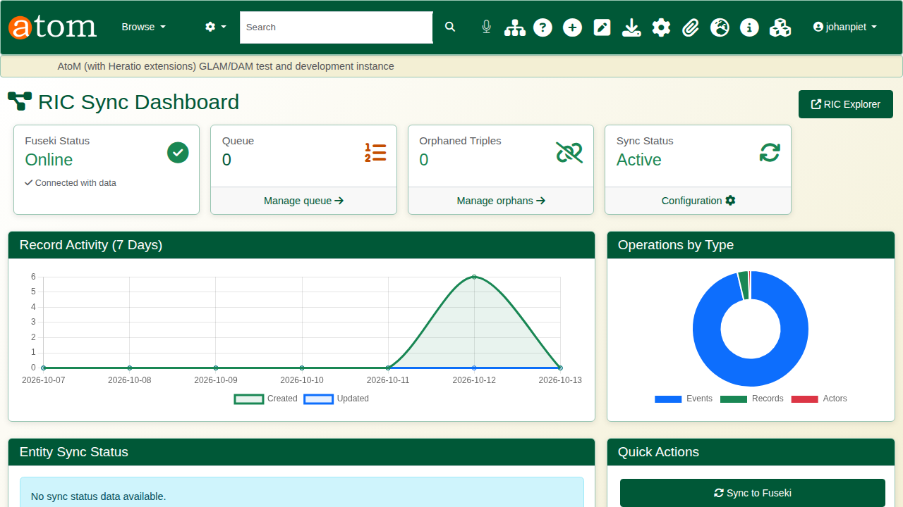
The RiC dashboard.

Recap
- Search in plain words.
- Open a record’s knowledge graph to see who made and holds it.
- Follow an object’s custody in the provenance graph, gaps included.
- Watch the dashboard to keep the graph and the catalogue in step.

