Training: Discovery, Part 3 - Discovery Search
Step-by-step guide to plain-language search with Discover, search modes, why results were found, saved searches, history and search templates
Dr Johan Pieterse
Document control
Field | Value
Document title | Training: Discovery, Part 3 - Discovery Search
Author | Dr Johan Pieterse
Owner | The Archive and Heritage Group (Pty) Ltd
Version | 1.0
Status | Released
Date | 15 October 2026
Prepared for | Researchers, reading-room staff and archivists using the AHG extensions
Classification | Public
Reference | AHG-TRN-DIS-03
Contents
Right-click and choose Update Field to build this list.
List of Tables
Right-click and choose Update Field to build this list.
This guide goes with part 3 of the discovery training videos. It covers Discover, the plain-language search: asking a question, reading why each result was found, using names in the question with Semantic mode, switching views, and keeping searches with saved searches, history and templates. Allow about 15 minutes.

Before you start
What you need before you start
What | Notes
Searching | Anyone, for published records.
Saved searches and history | A signed-in user.
Search templates | An administrator.

1. Discover
Open Discover (/discovery) and type a question in your own words, for example photographs of the Engelbrecht family. Results are grouped by the collection (fonds) they belong to, each with a score and the reasons it was found:
Why a result was found
Reason | Meaning
keyword | The words of the question appear in the record’s title or description
A name or place | The record’s description mentions a name, place or date the question contains (Semantic mode)
sibling or child | The record sits beside, or below, a record that matched
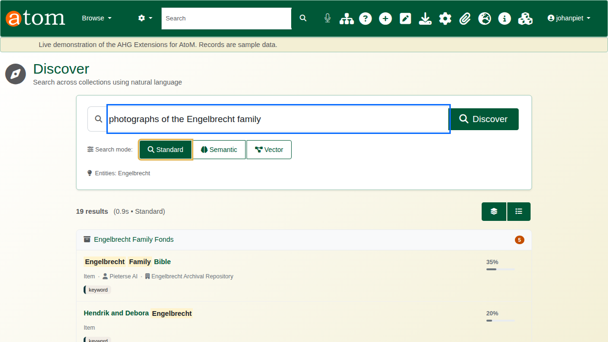
Results grouped by collection.

2. Names in the question and the search modes
Discover reads the question for names, places and dates, and shows what it recognised under the search box (Entities). The search modes decide how much it does with them:
Search modes
Mode | What it searches
Standard | The words of the question, plus related records in the hierarchy
Semantic | Standard, plus the names, places, organisations and dates extracted from the records’ descriptions (the entity index built by the AI tools)
Vector | Semantic, plus meaning-based similarity, where a vector index is configured
For stories from the Great Karoo, Standard mode matches the words and finds books with great and stories in their titles. Semantic mode also searches the entity index and puts first a documentary filmed in the Great Karoo, whose description names the place.
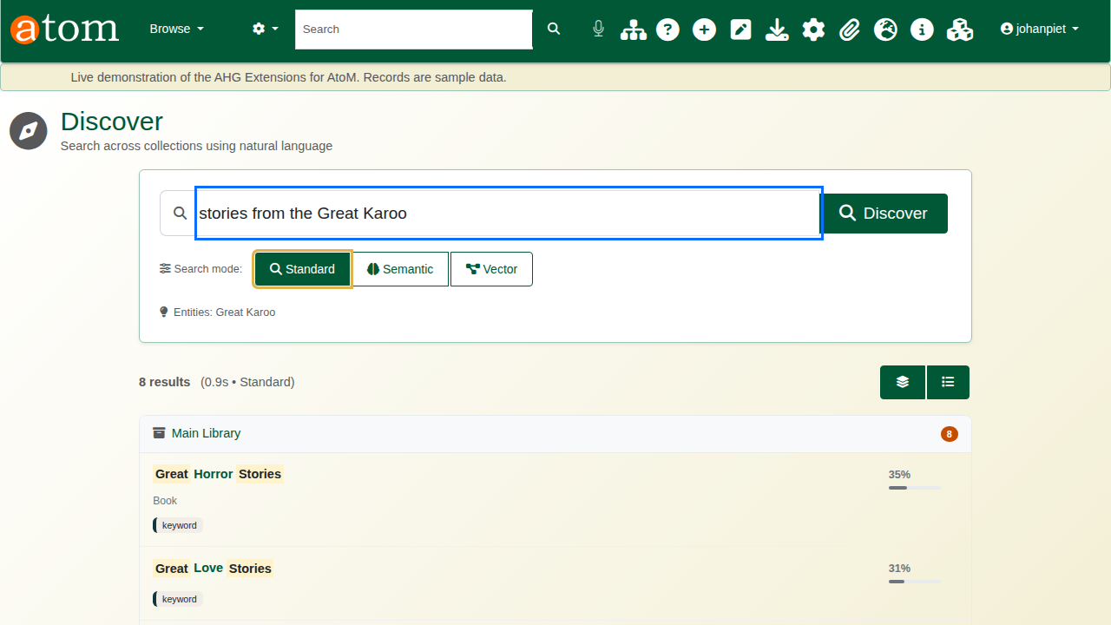
Standard mode.
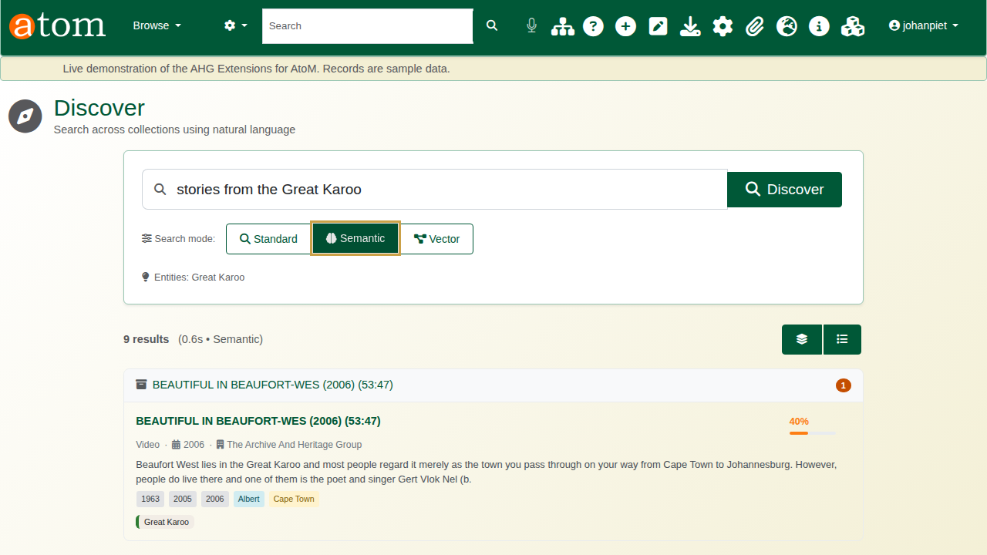
Semantic mode.

3. Views and popular searches
The buttons above the results switch between the grouped view and a single list. Before you search, the most popular searches are offered as a starting point. Clicking a result opens the record.
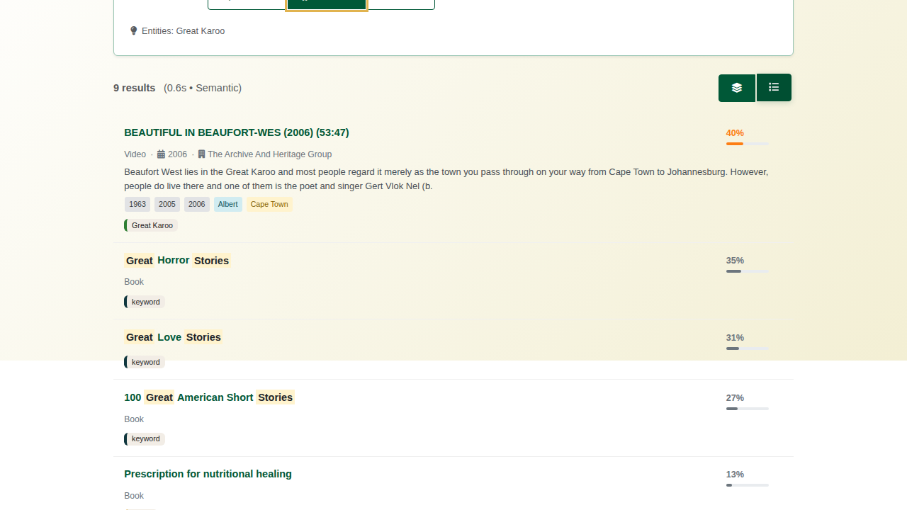
The list view.

4. Saved searches, history and templates
A search you run often can be saved, with an optional notification when new records match. My Saved Searches (/search/enhancement/saved) lists them with their notifications and use, ready to run again; Search History (/search/enhancement/history) keeps your recent searches.
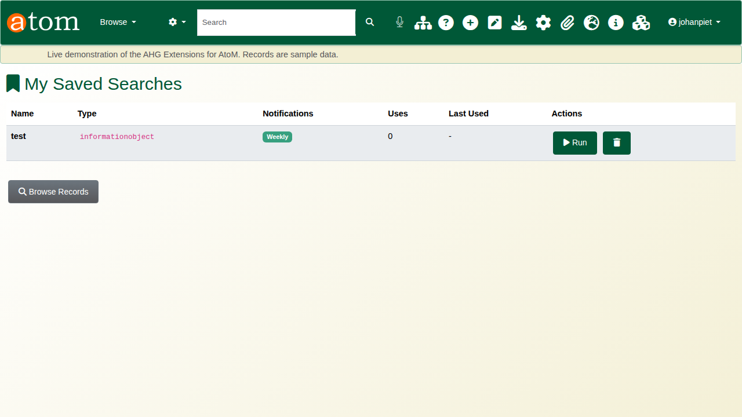
Saved searches.
Search Templates (/admin/search-templates) are ready-made searches set up by an administrator, such as photographs, maps and plans, audio and video, or recent additions, offered to every user as a quick start.
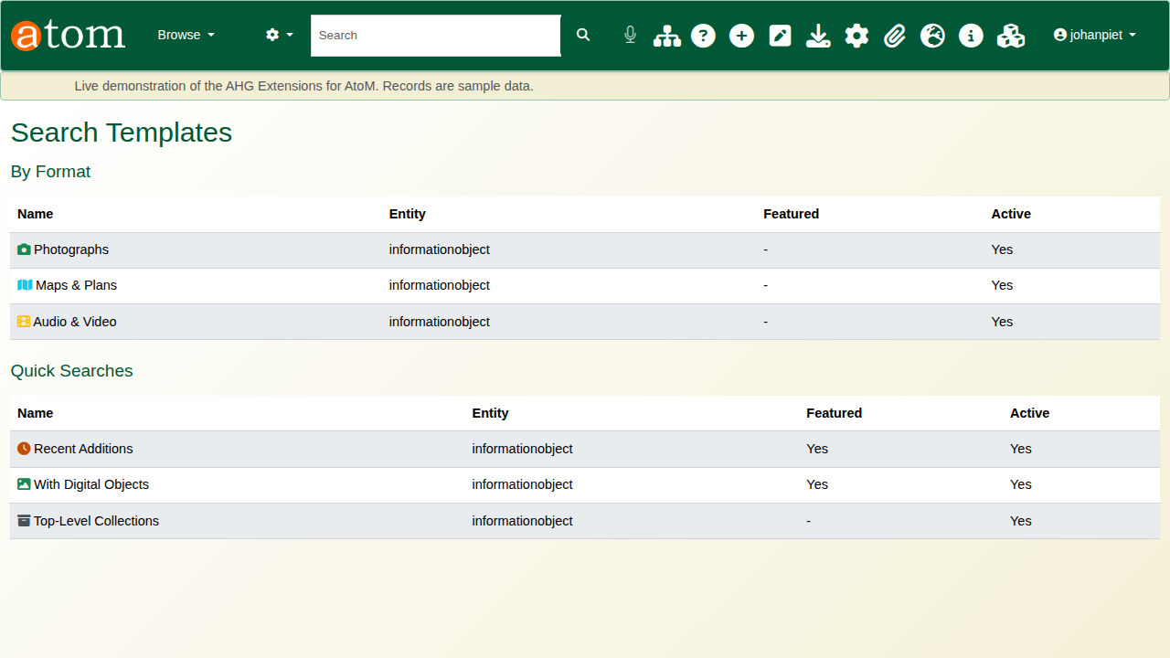
Search templates.

Recap
- Ask in plain language.
- Read why each result was found.
- Let the names in your question narrow it, with Semantic mode.
- Save the searches you need again.
Part 4 covers landing pages.

