Training: Batch Edit
Step-by-step guide to changing many descriptions at once from the clipboard, with a preview before anything is saved
Dr Johan Pieterse
Document control
Field | Value
Document title | Training: Batch Edit
Author | Dr Johan Pieterse
Owner | The Archive and Heritage Group (Pty) Ltd
Version | 1.0
Status | Released
Date | 9 October 2026
Prepared for | AtoM users of the AHG extensions
Classification | Public
Reference | AHG-TRN-DESC-01
Contents
Right-click and choose Update Field to build this list.
List of Tables
Right-click and choose Update Field to build this list.
This guide goes with the training video of the same name. Batch edit applies one set of changes to every description on the clipboard: level of description, repository, publication status, access and reproduction conditions, languages, access points and creators, a date, and title renaming. A preview shows every change before anything is saved.
You will put four draft letters on the clipboard, set their level, publish them, add a place, rename their titles, and fix one deliberate mistake. Allow about 15 minutes.

Before you start
What you need before you start
What | Notes
An editor or administrator account | Batch edit is open to editors and administrators.
Up to 500 descriptions at a time | Larger selections are refused; split them.
The practice file | mission-station-letters-practice.csv in docs/training-files/ of the AHG extensions catalogue: a fonds with four draft letters whose titles say “Ltr”. Import it with Data Ingest, choosing “Use hierarchy from CSV” (see the hierarchical CSV training).

1. Put the descriptions on the clipboard
- Open the Browse menu and choose Archival descriptions. The newest are listed first; open Mission Station Letters (training).
- Click Browse as list. The fonds and its four letters are listed.
- Click the paperclip button on each letter. The count on the Clipboard menu (paperclip icon in the top bar) goes up with each one.
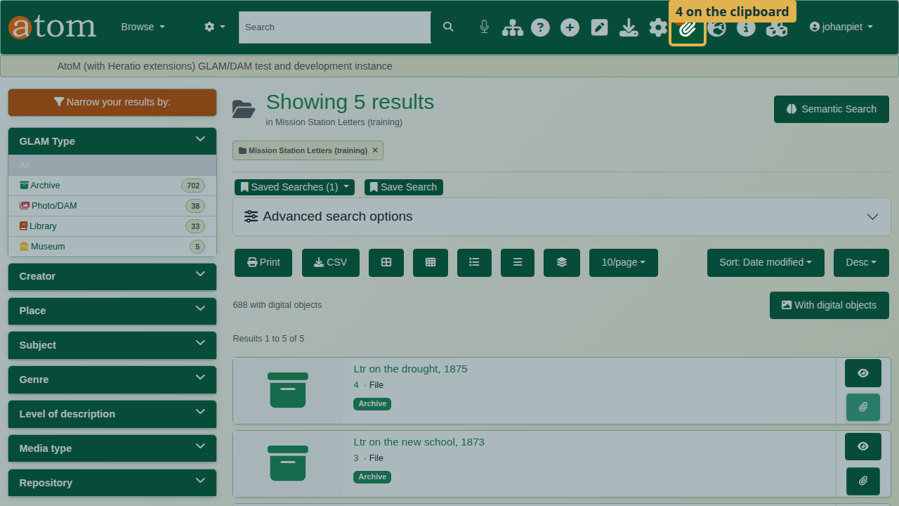
The Clipboard menu shows four descriptions.
- Open the Clipboard menu and choose Go to clipboard. Check that exactly the descriptions you want are listed, and nothing else; batch edit changes everything on the clipboard.
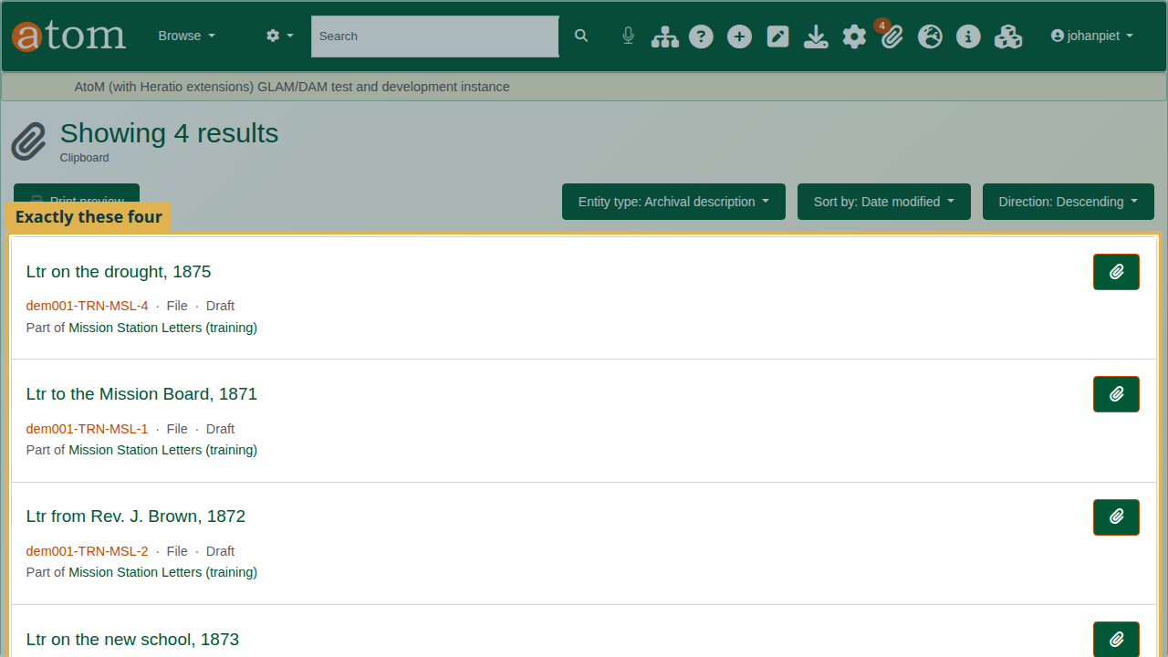
The clipboard with the four letters.

2. Fill in the batch form
Click Batch edit. One form applies to every description on the clipboard. The rule at the top of the form:
Fill in only what should change. Empty fields are left alone. Access points, dates and creators are added; existing ones are never removed. Nothing is saved until you have seen the preview.
- Level of description: Item. Publication status: Published.
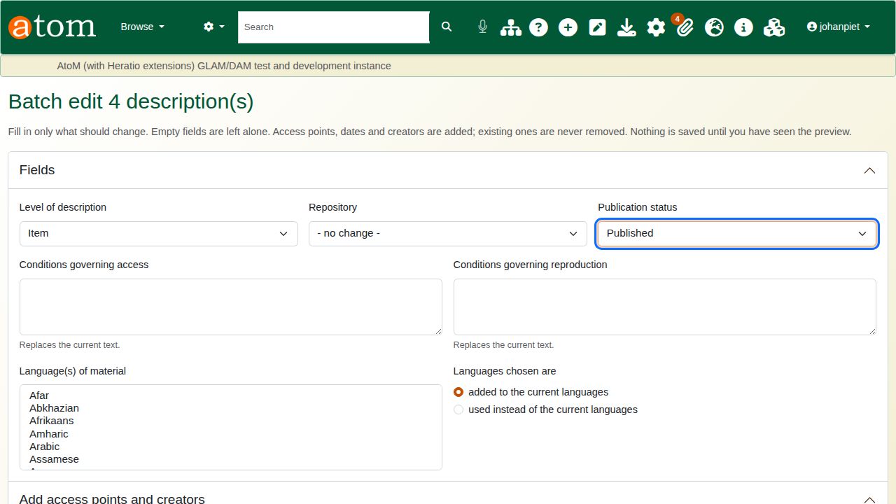
Level of description and publication status set.
- Add access points and creators, Place access points: type the place exactly as it appears in the places taxonomy, one per line. The deliberate mistake: type Capetown as one word.
- Rename titles: Find Ltr, Replace with Letter.
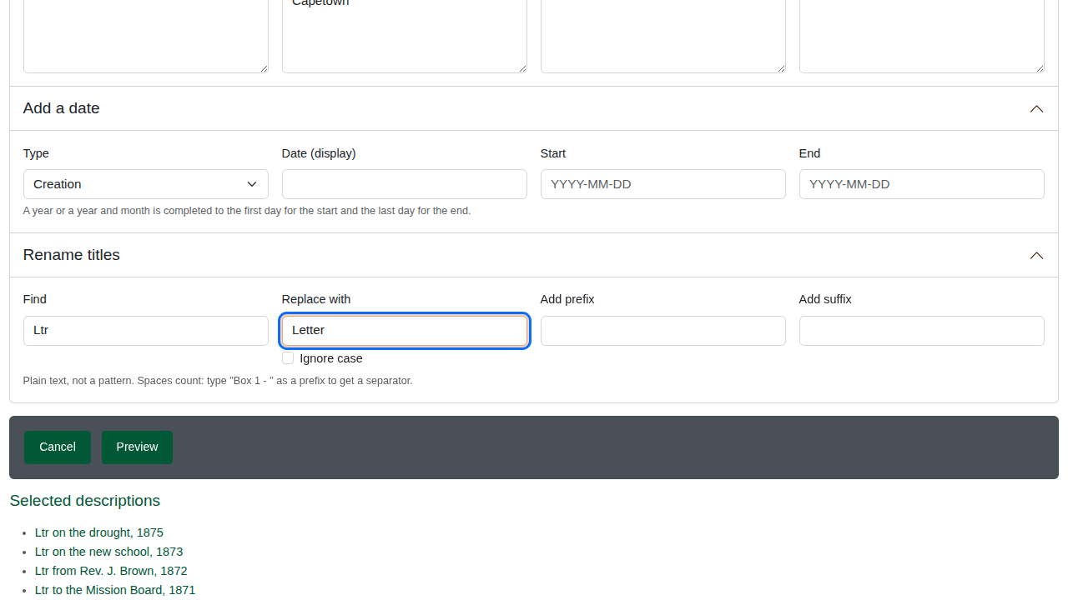
Rename titles: Ltr replaced with Letter.
Find and replace is plain text, never a pattern. It matches case unless you tick Ignore case. Add prefix and Add suffix put text before or after every title.

3. Preview and fix
Click Preview. Nothing is saved yet. Batch edit stops with “No single place term named”Capetown”“: no place has that exact name, and batch edit never creates a new term by accident.
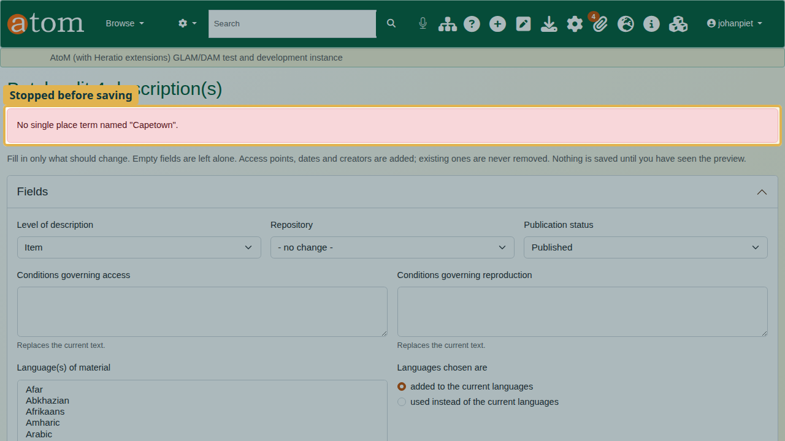
The preview stops on the misspelt place.
Correct the place to Cape Town, two words, as it is in the taxonomy, and click Preview again.
The preview lists every description and every field that will change, with what it has now (Before) and what it will have (After). Descriptions that already have the new values are skipped. Read it before you apply.
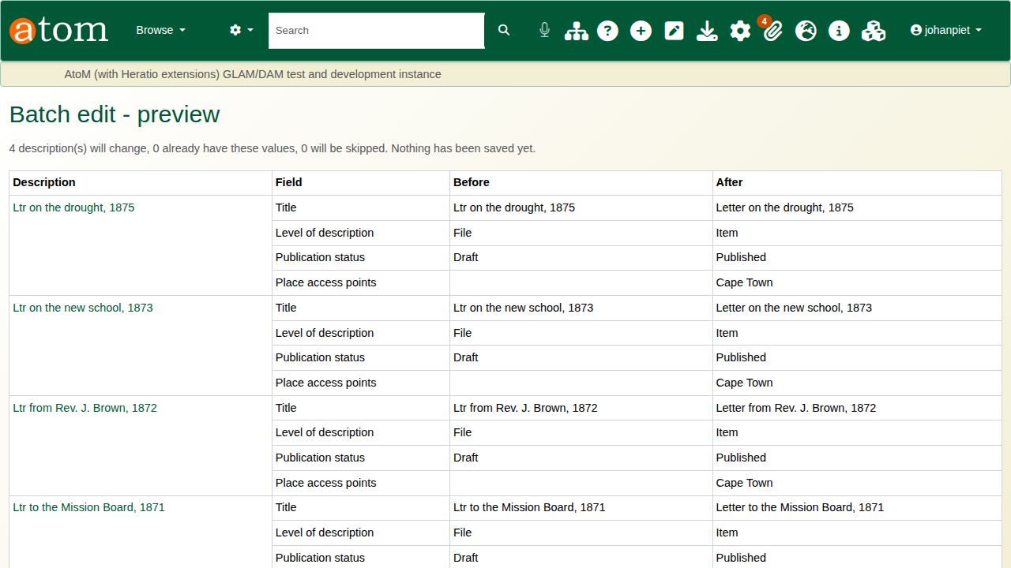
The preview: before and after, description by description.
Use Back to change the form; your entries are kept.

4. Apply
Click Apply to 4 description(s). Each description is saved exactly as the edit form would save it, so the search index and the audit trail stay in step. The result lists each description as Updated, Skipped or Error, with the fields changed.
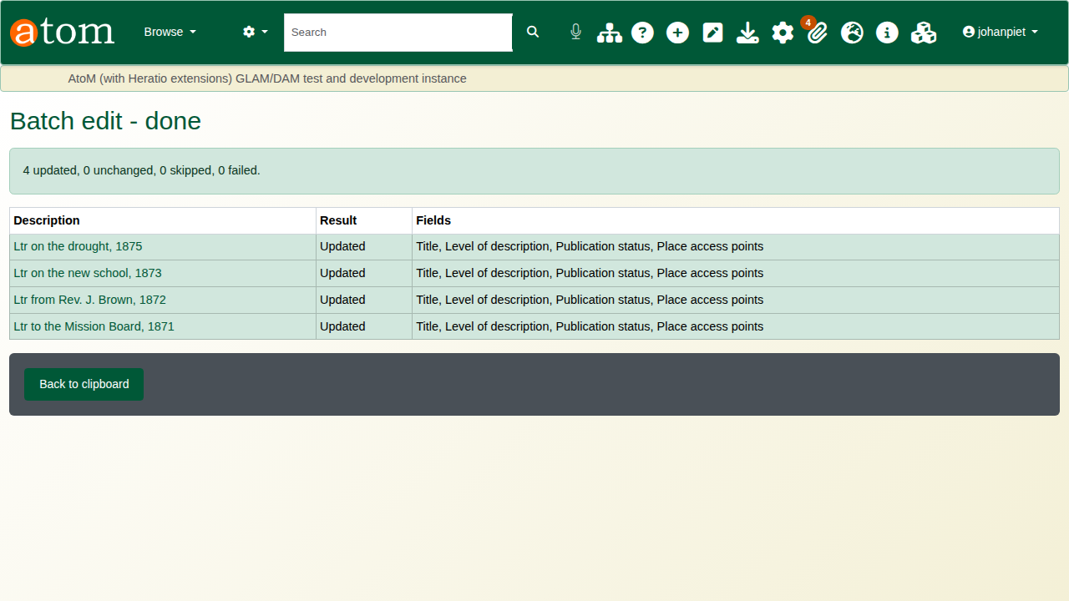
Batch edit - done: four descriptions updated.

5. Check the result
Open one of the letters. It has its full title, the level Item, the place Cape Town, and it is published.
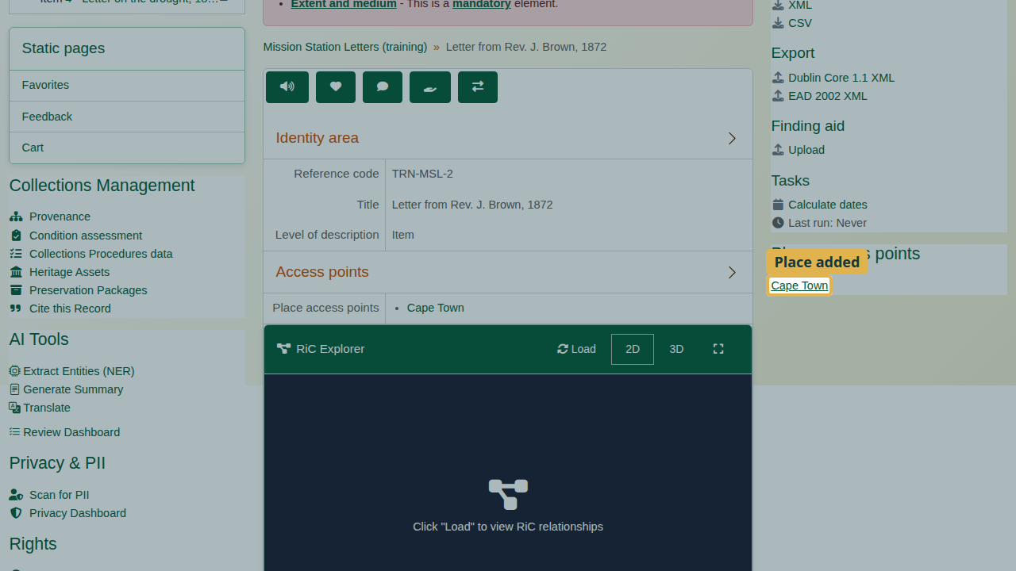
A letter after the batch edit.

What each field does
Batch edit fields
Field | Effect
Level of description, Repository, Publication status | Set to the value chosen
Conditions governing access, reproduction | Replace the current text
Language(s) of material | Added to, or used instead of, the current languages
Subject, place, genre access points; creators | Added; names must match exactly one existing term or authority record
Add a date | Adds a date of the chosen type; a year or year and month is completed to the first or last day
Rename titles | Plain-text find and replace, with optional prefix and suffix

Recap
- Put the descriptions on the clipboard, and check it.
- Batch edit: fill in only what should change.
- Access points and creators: exact names from the taxonomy or authority records.
- Preview, and fix what it reports.
- Apply, then check a record.

Cleaning up
To remove the practice records, open the fonds and choose Delete. AtoM deletes the letters under it as well. Clear the clipboard from the Clipboard menu.

