Training: Custom Fields
Step-by-step guide to defining your own fields for descriptions, filling them in, and seeing them on the record and in exports
Dr Johan Pieterse
Document control
Field | Value
Document title | Training: Custom Fields
Author | Dr Johan Pieterse
Owner | The Archive and Heritage Group (Pty) Ltd
Version | 1.0
Status | Released
Date | 9 October 2026
Prepared for | AtoM users of the AHG extensions
Classification | Public
Reference | AHG-TRN-CF-01
Contents
Right-click and choose Update Field to build this list.
List of Tables
Right-click and choose Update Field to build this list.
This guide goes with the training video of the same name. Every institution records something the descriptive standards leave out. Custom fields add it without any code: an administrator defines the field once, editors fill it in on the edit form, and the field appears on the record and in every export.
You will define two fields, one public and one for staff only, fill them in on a fonds, and meet the warning AtoM gives when a required field is left empty. Allow about 15 minutes.

Before you start
What you need before you start
What | Notes
An administrator account | Administrators define custom fields. Editors fill them in.
The practice file | vermaak-family-papers-practice.csv in docs/training-files/ of the AHG extensions catalogue: one published fonds. Import it with Data Ingest, choosing “Use hierarchy from CSV” (see the hierarchical CSV training).

1. Define the fields
Open the Manage menu and choose Custom Fields (under Extensions). The list shows every custom field by the kind of record it belongs to. Click Add Field.
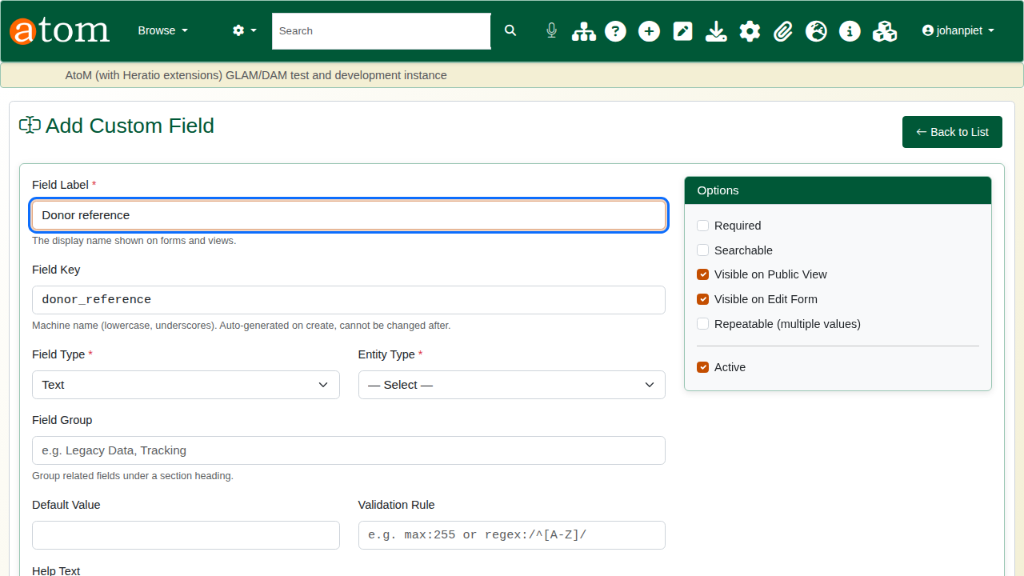
Add Custom Field: the label, with the key generated from it.
Field settings
Setting | What it does
Field Label | What people read on the form and the record
Field Key | The field’s fixed name in exports and the API: lower case, digits and underscores. It cannot be changed later.
Field Type | Text, long text, date, number, yes/no, dropdown (from a dropdown list) or URL
Entity Type | The kind of record: archival description, authority record, accession, repository, donor or function
Field Group | A heading that groups related fields on the form and the record
Required | The record cannot be saved with this field empty
Visible on Public View | Visitors see it; when unticked, only staff see it
Repeatable | More than one value per record
Validation Rule | Optional, for example max:255
The first field:
- Donor reference: key donor_ref, type Text, entity Information Object (archival descriptions), group Acquisition, Visible on Public View ticked. Save.
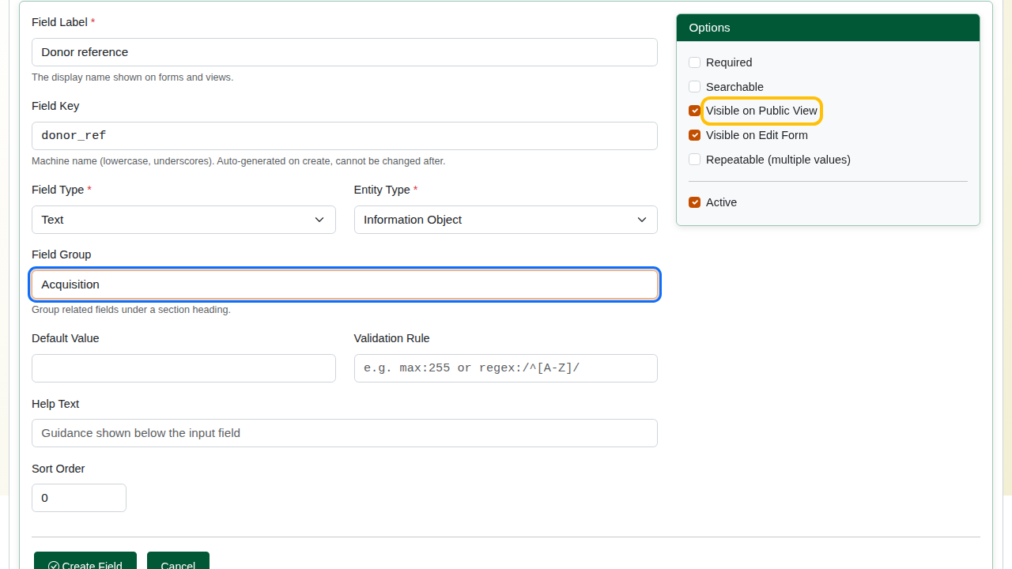
The Donor reference field.
The second field:
- Date received: key date_received, type Date, same group, Required ticked, Visible on Public View unticked (staff only). Save.
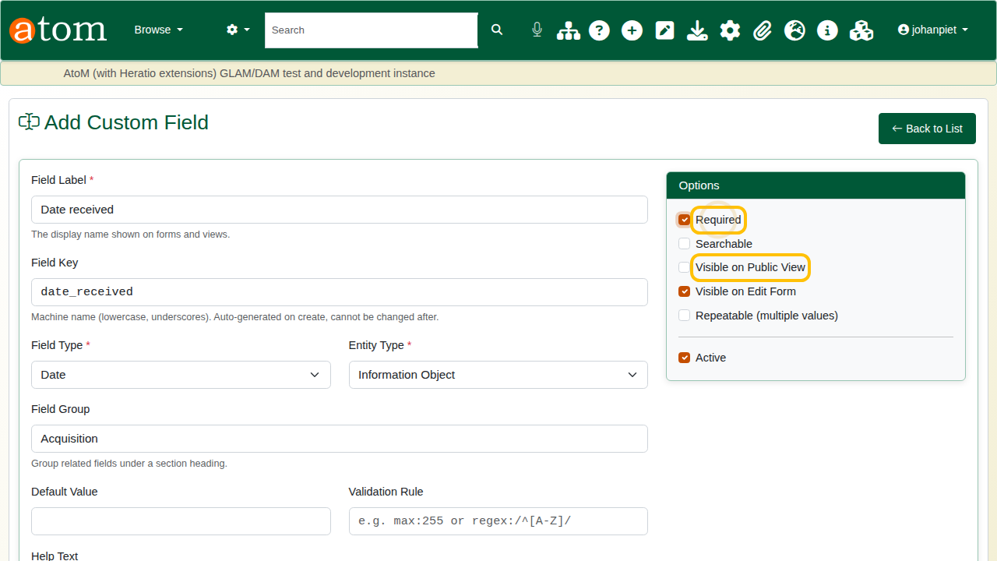
The Date received field: required, staff only.
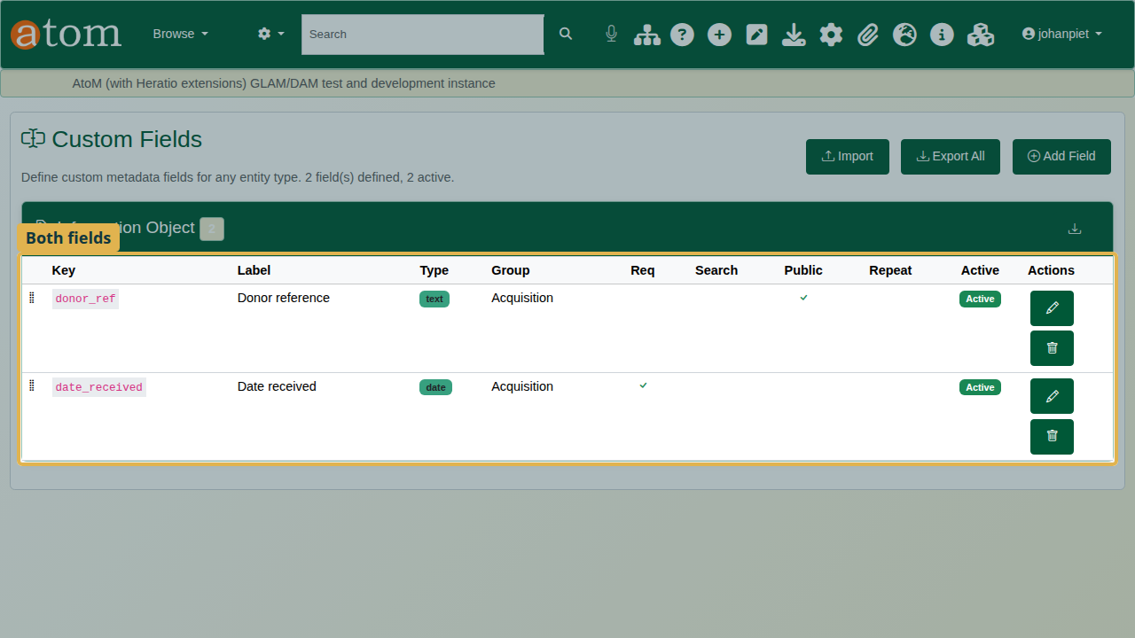
The custom fields list with both fields.

2. Fill them in
Open the practice fonds and click Edit. The custom fields appear near the end of the form, under Additional Fields, grouped under Acquisition.
Type the donor reference DR-1987-044. The deliberate mistake: leave Date received empty.
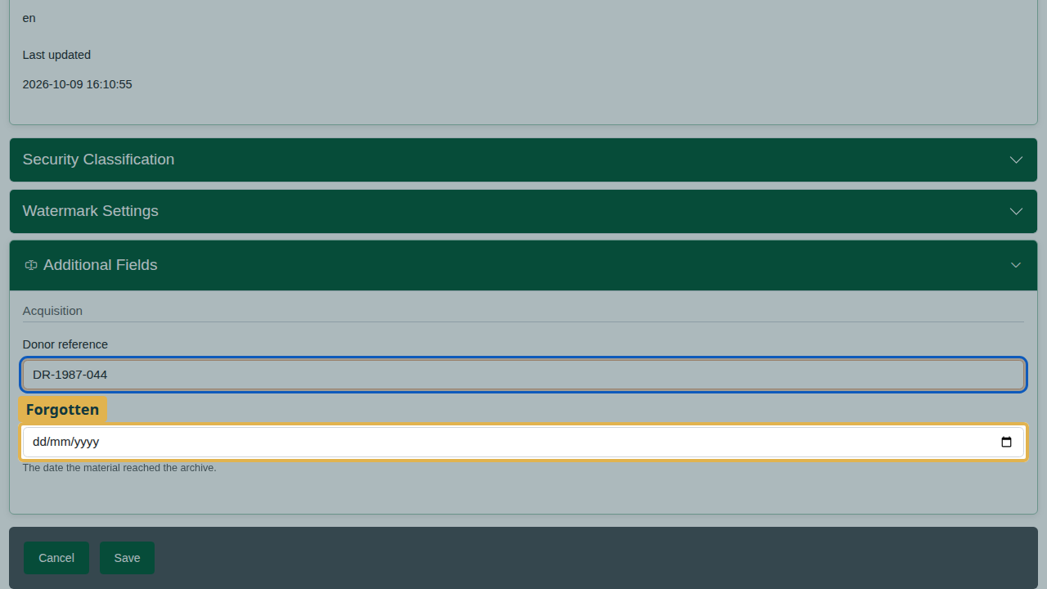
The donor reference filled in; the date received forgotten.
Click Save. Nothing is saved: Date received is required, so the form opens the custom fields and points at the empty field.
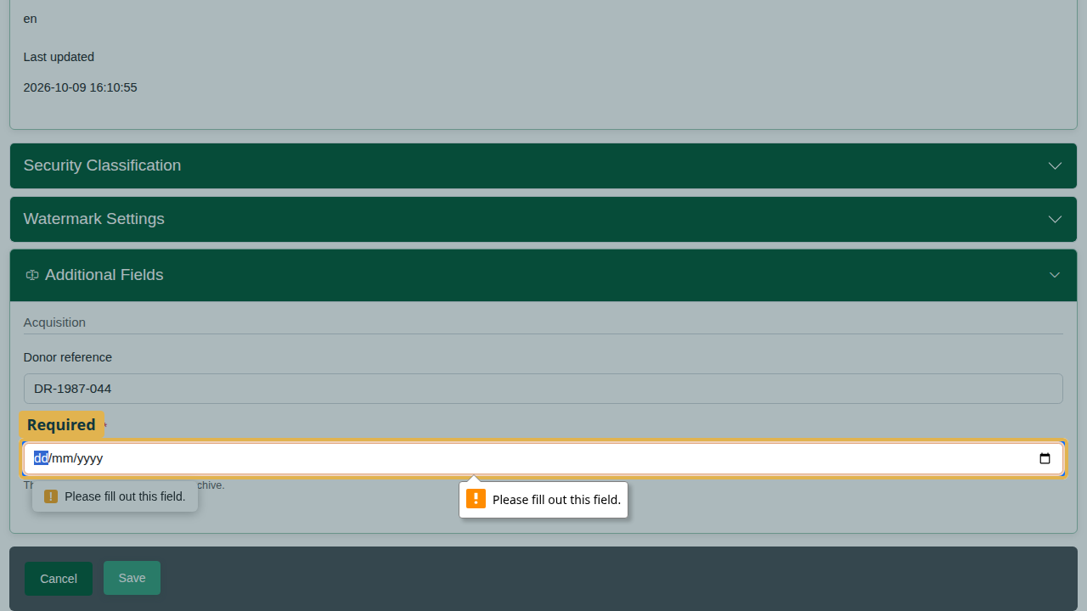
The form stops and points at the required field.
Choose the date received with the date picker (12 March 1987) and save again. The description saves, with both fields.
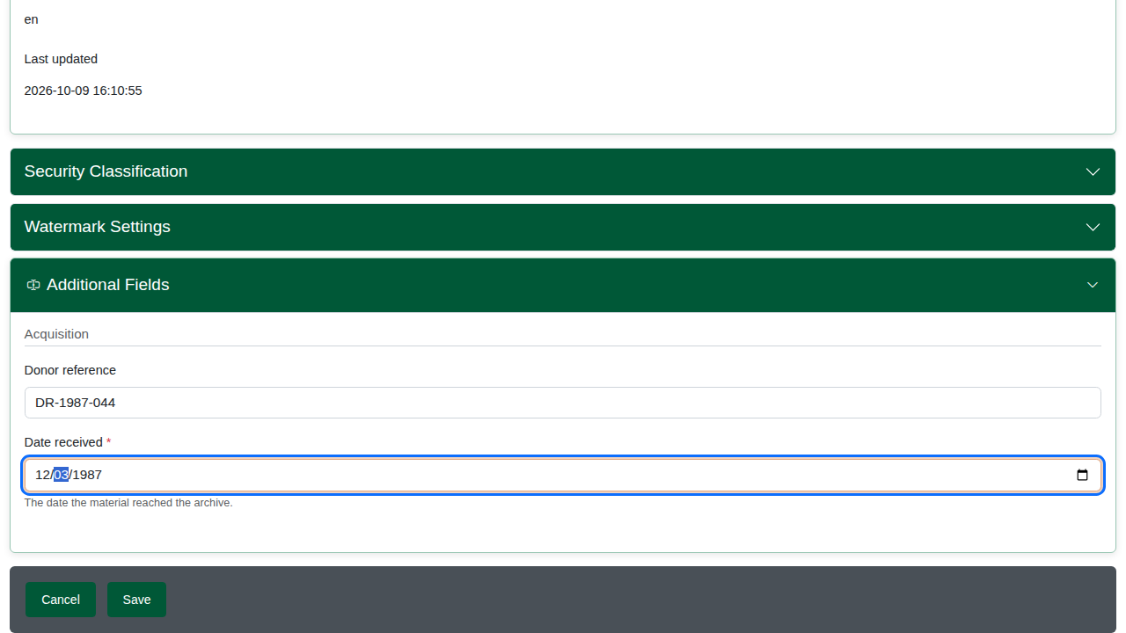
The date chosen.

3. Where the fields appear
On the description, staff see the Acquisition group with both fields.
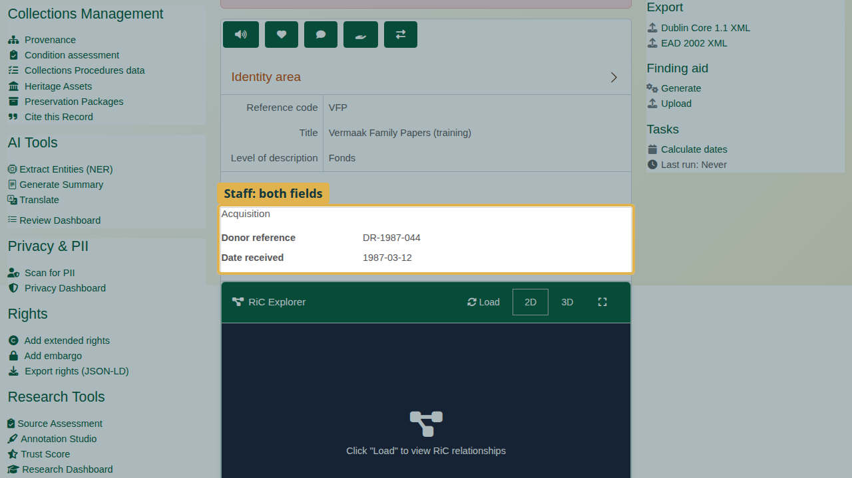
Staff: both fields on the record.
Visitors (signed out) see only the donor reference, because the date received is not visible on the public view.
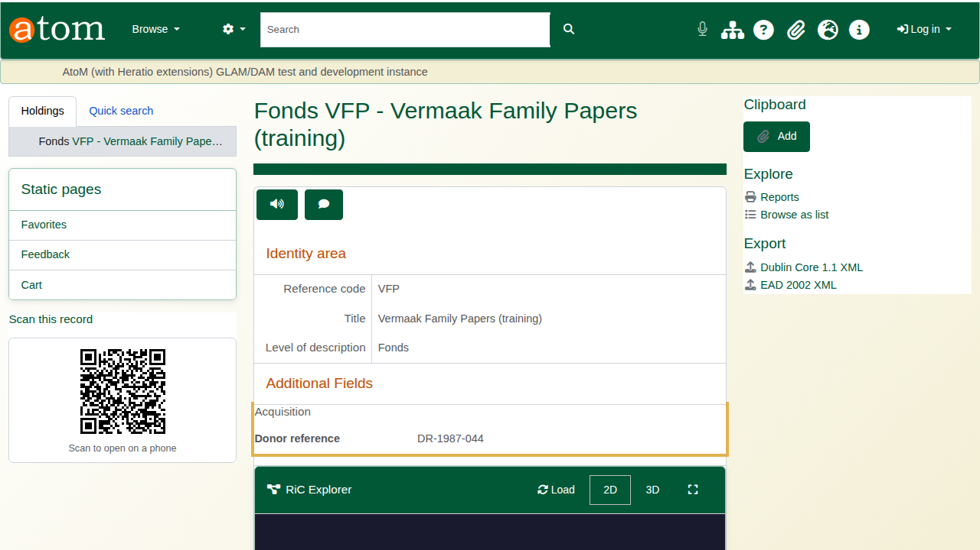
Visitors: only the public field.
Custom fields travel with the record. The EAD export carries them in a note labelled “Custom fields”, and so do the PDF finding aid, the clipboard CSV export (one column per field), the REST API and GraphQL. Every export follows the same rule: visitors get public fields only, staff get them all.
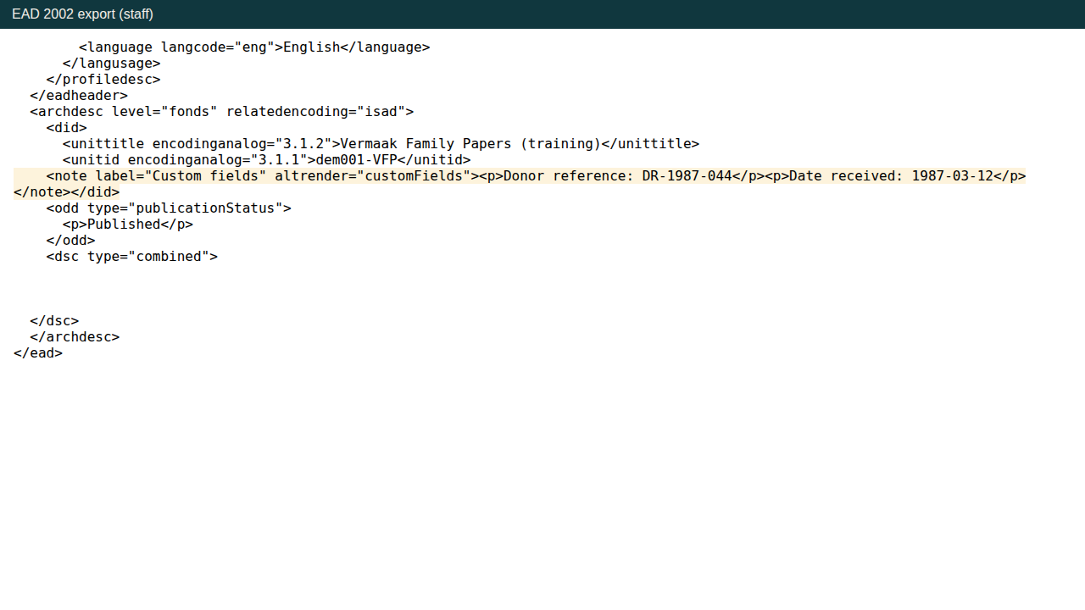
The EAD export (staff) with the custom fields note.

Recap
- Manage > Custom Fields > Add Field.
- Set the label, key, type, group, and who may see it.
- Fill it in on the edit form.
- Read any warning when you save, and correct the value.
- The field appears on the record and in every export.

Cleaning up
Open the fonds and choose Delete. To remove the practice fields, open Manage > Custom Fields and delete them, or untick Active to hide a field while keeping its values.

