Training: Preservation Triage
Step-by-step guide to finding which records need conservation and digital preservation attention first
Dr Johan Pieterse
Document control
Field | Value
Document title | Training: Preservation Triage
Author | Dr Johan Pieterse
Owner | The Archive and Heritage Group (Pty) Ltd
Version | 1.0
Status | Released
Date | 9 October 2026
Prepared for | AtoM users of the AHG extensions
Classification | Public
Reference | AHG-TRN-PRES-01
Contents
Right-click and choose Update Field to build this list.
List of Tables
Right-click and choose Update Field to build this list.
This guide goes with the training video of the same name. Preservation triage ranks every record that has condition data or digital files by how much conservation and digital-preservation attention it needs. It works from data AtoM already holds: condition assessments, fixity checks, format risk, virus scans and the age of the last assessment or check. It only reads; it changes nothing.
You will read the summary and the ranked list, narrow it, meet one deliberate mistake (a filter that returns nothing) and export the list. Allow about 10 minutes.

Before you start
What you need before you start
What | Notes
An editor or administrator account | Triage is a staff tool: it lists drafts and conservation findings.
Your own data | Triage reads your condition reports and preservation data; no practice file is needed.

1. Open triage
Open the Manage menu and, under Extensions, choose Preservation triage.

2. Read the summary
The tiles at the top show where the risk lies: records in scope and scoring above zero, records in poor condition or worse, assessments overdue, records in high- or critical-risk formats, files with no checksum, failed fixity checks and infected files.
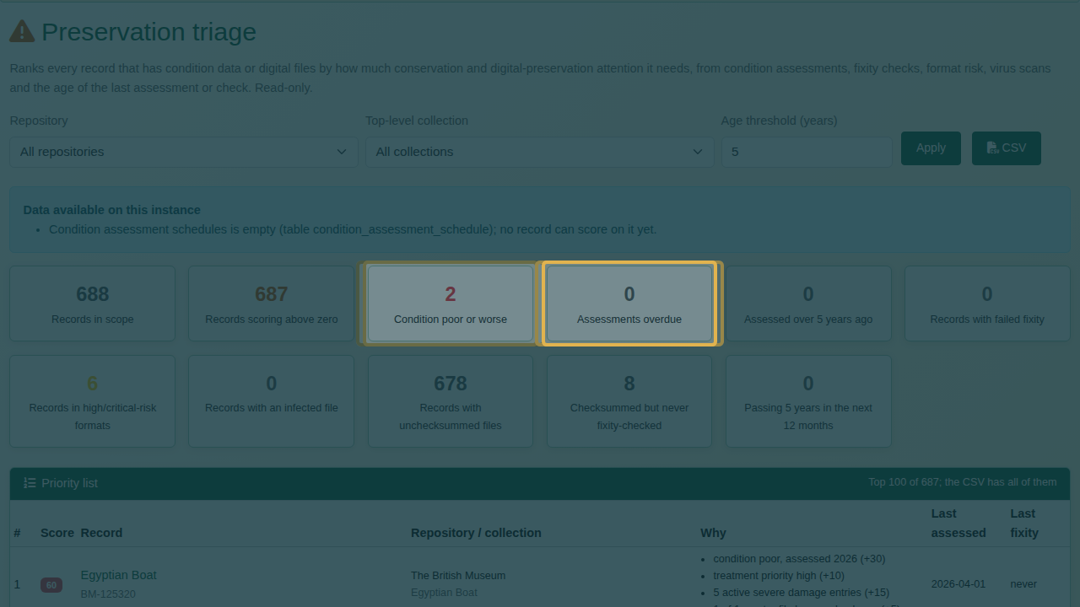
The summary tiles.
Data available on this instance says which sources triage could read. A source that is empty or not installed cannot add to any score.

3. Read the priority list
Below the summary, every record is ranked by score, highest first. These need attention before anything else.
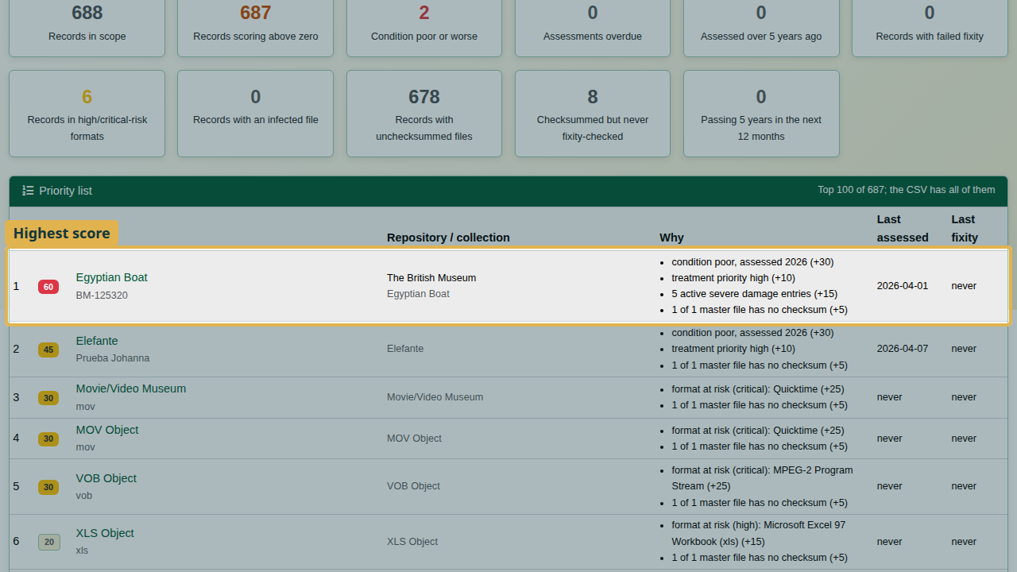
The priority list, highest score first.
Each score is explained beside the record under Why, finding by finding, with the points each adds. Nobody has to trust a number they cannot check.
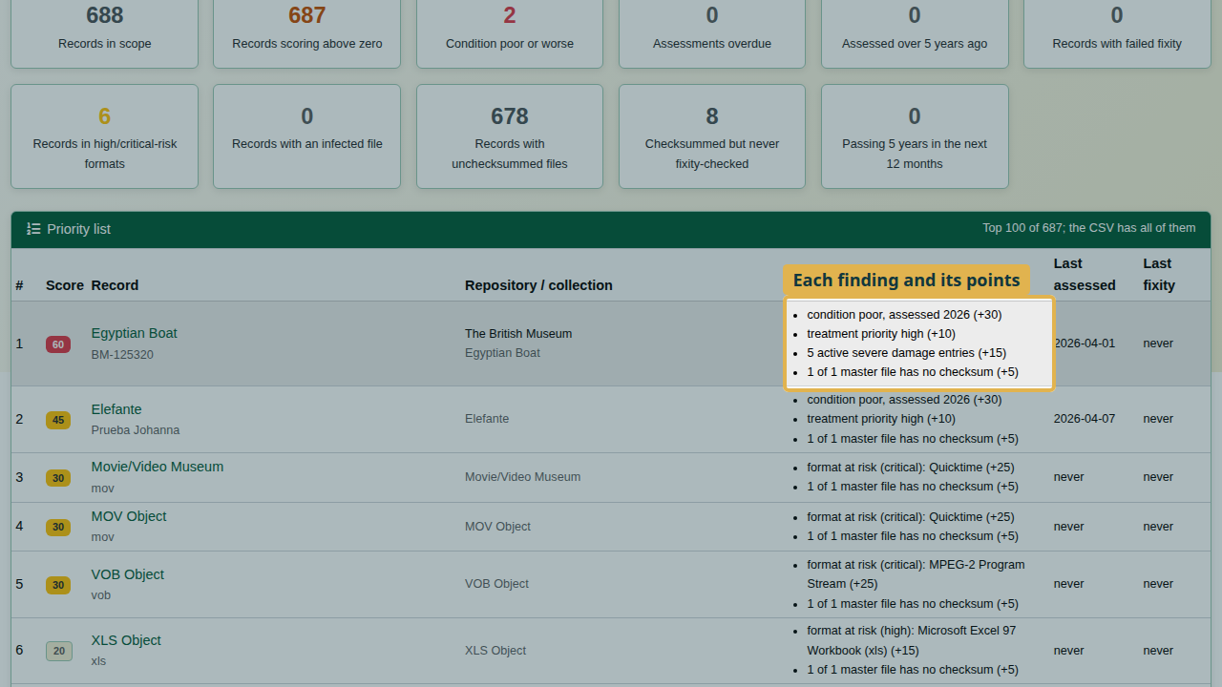
Why: each finding and its points.
How the score is worked out lists the weight behind every finding.
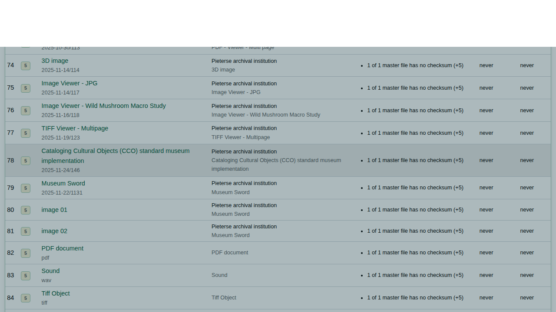
The weights behind the score.
Triage weights (as shown on the page)
Finding | Points
Latest condition: unacceptable or critical / poor / fair | 40 / 30 / 15
Treatment priority on the latest assessment: urgent / high | 15 / 10
Active severe or critical damage entry (each) | 5, max 15
Next check date or schedule due date has passed | 10
Latest assessment older than the age threshold | 10
Failed or missing-file fixity check (each) | 20, max 60
Fixity check could not complete | 5
Latest virus scan: threat found / scan error | 50 / 5
Worst format risk among the files: critical / high / medium | 25 / 15 / 5
A master file has no stored checksum | 5
Checksummed but never fixity-checked, or last checked over the threshold | 5

4. Narrow it down
Use Repository, Top-level collection and Age threshold (years) above the summary, then click Apply.
The deliberate mistake: choose a repository whose holdings have no condition reports or preserved files, and apply. The list is empty: “No record scores above zero with the current filters.”
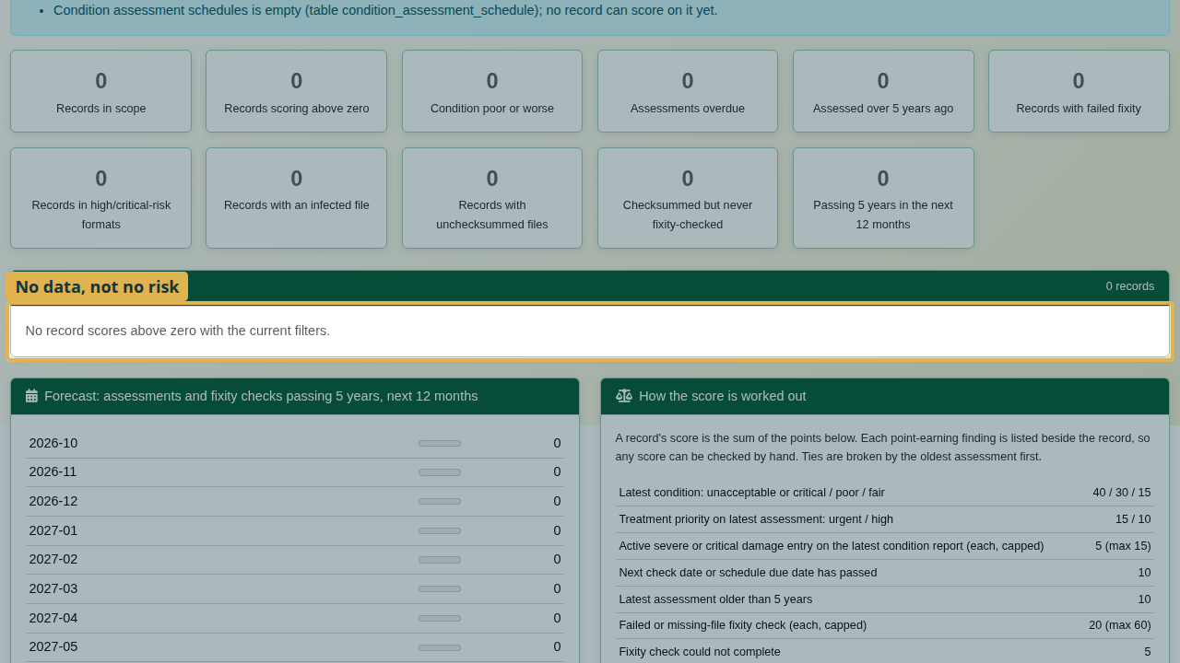
An empty list: no data, not no risk.
An empty list does not mean those holdings are safe. It means triage has nothing to read for them. An empty list means no data, not no risk.
Choose the repository whose holdings you manage and apply again; its own records are ranked.
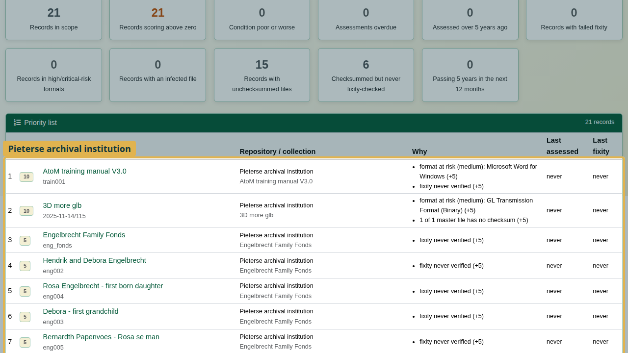
The list narrowed to one repository.
The age threshold sets how many years may pass before an assessment counts as overdue. It defaults to the AHG setting preservation_triage_age_years, else 5 years; changing it here affects this view only.
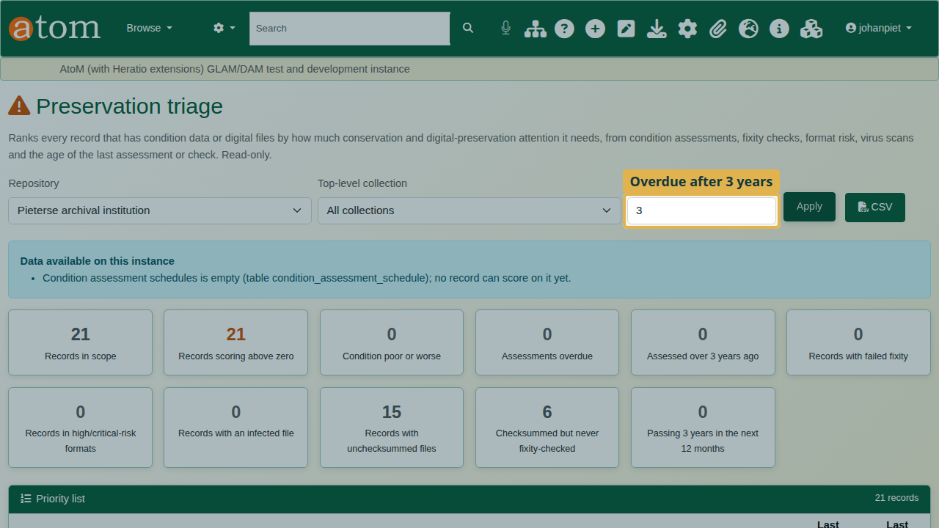
The age threshold set to 3 years.

5. Export
CSV downloads the ranked list with the current filters, for planning the work or reporting to management. The page shows the top 100; the CSV holds every record.
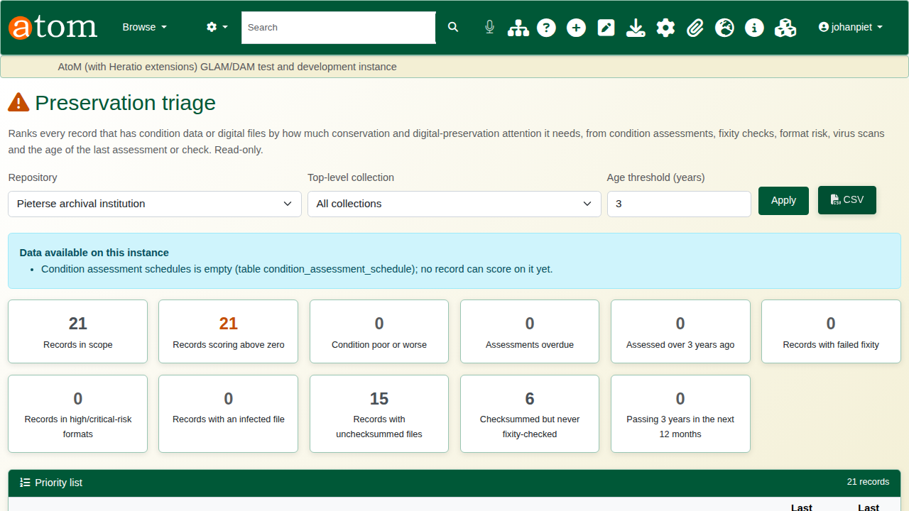
The CSV export button.
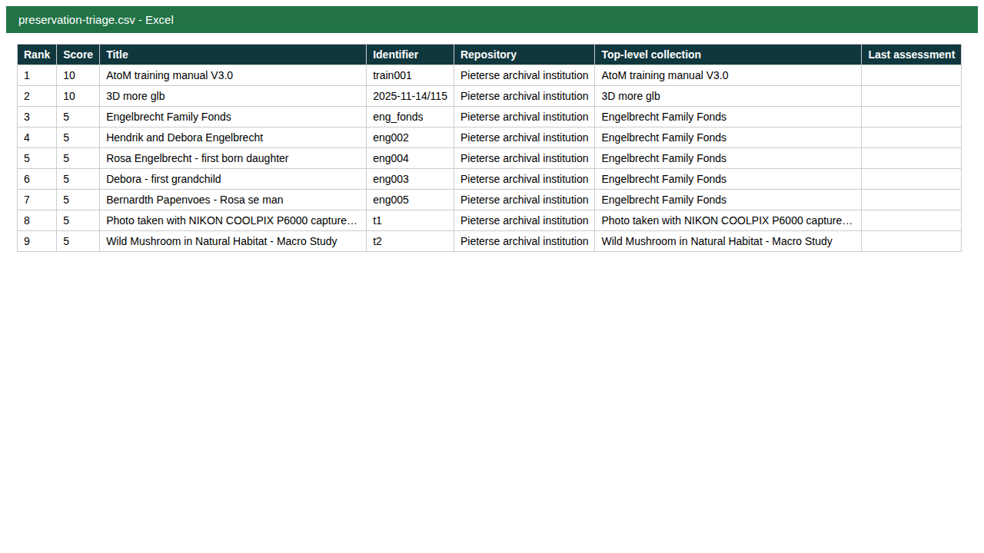
The exported list.

Recap
- Manage > Extensions > Preservation triage.
- Read the summary, then the ranked list.
- Check why each record scores.
- Narrow by repository or collection; an empty list means no data, not no risk.
- Export as CSV.

