Training: Report Builder
Step-by-step guide to building a report from scratch: data source, columns, filters, checking the count, sorting, saving and exporting
Dr Johan Pieterse
Document control
Field | Value
Document title | Training: Report Builder
Author | Dr Johan Pieterse
Owner | The Archive and Heritage Group (Pty) Ltd
Version | 1.0
Status | Released
Date | 9 October 2026
Prepared for | AtoM users of the AHG extensions
Classification | Public
Reference | AHG-TRN-REP-01
Contents
Right-click and choose Update Field to build this list.
List of Tables
Right-click and choose Update Field to build this list.
This guide goes with the training video of the same name. You will build one practical report from scratch: published descriptions that have no digital object yet, a ready-made digitisation list. On the way you add a filter that answers only half of the question, notice it from the count, and add the missing half. Allow about 15 minutes.

Before you start
What you need before you start
What | Notes
An administrator account | The report builder is open to administrators.
Your own catalogue | The report runs on live data; no practice file is needed. Your counts will differ from the ones in this guide.

1. Create the report
- Open the Manage menu and choose Central Dashboards. On the reports dashboard, choose Report Builder. (Report Builder is also listed under Extensions in the Manage menu.)
- The report builder lists every saved report. Click Create New Report.
- Enter a Report Name and a short Description, so others know what it is for.
- Under Data Source, choose Archival Descriptions.
- Click Continue to Designer.
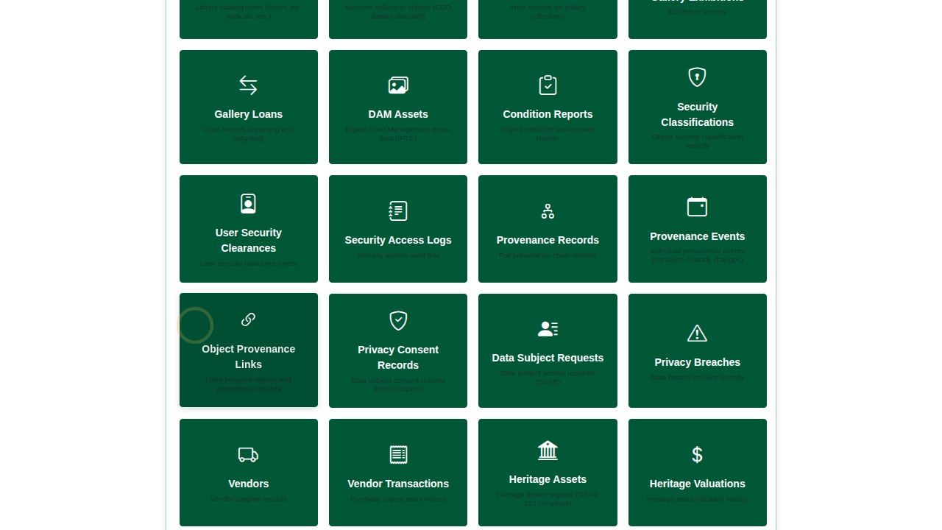
Create New Report: name, description and data source.

2. Choose the columns
The designer opens. Available Columns on the left lists every column the data source offers, grouped as core, descriptive, system and computed fields. Tick the ones the report should show:
Columns for the digitisation list
Column | Group | Notes
Identifier | Core fields
Title | Descriptive fields
Level of Description | Core fields | Empty for descriptions that have no level
Publication Status | Computed fields | Draft or Published
Has Digital Object | Computed fields | 1 (yes) or 0 (no) when filtering; shown as Yes or No
Untick ID, which only the database needs. Columns appear in the order you tick them; drag them in Column Order to change it.
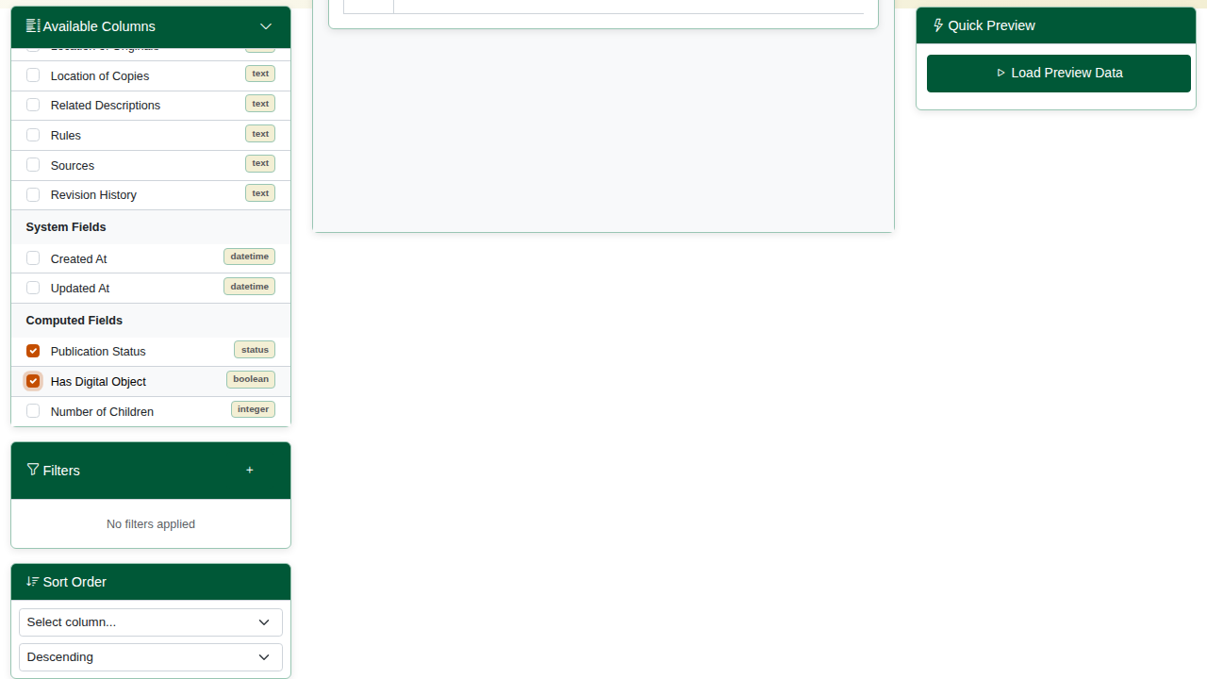
Columns ticked, with the column order on the right.

3. Filter, and check the count
- Under Filters, click + and set: Publication Status, equals, Published.
- Click Load Preview Data under Quick Preview. Quick Preview runs what is on screen against the live catalogue, before you save.
Check the count. In the video it is 723: every published description, digitised or not. The report answers only half of the question.
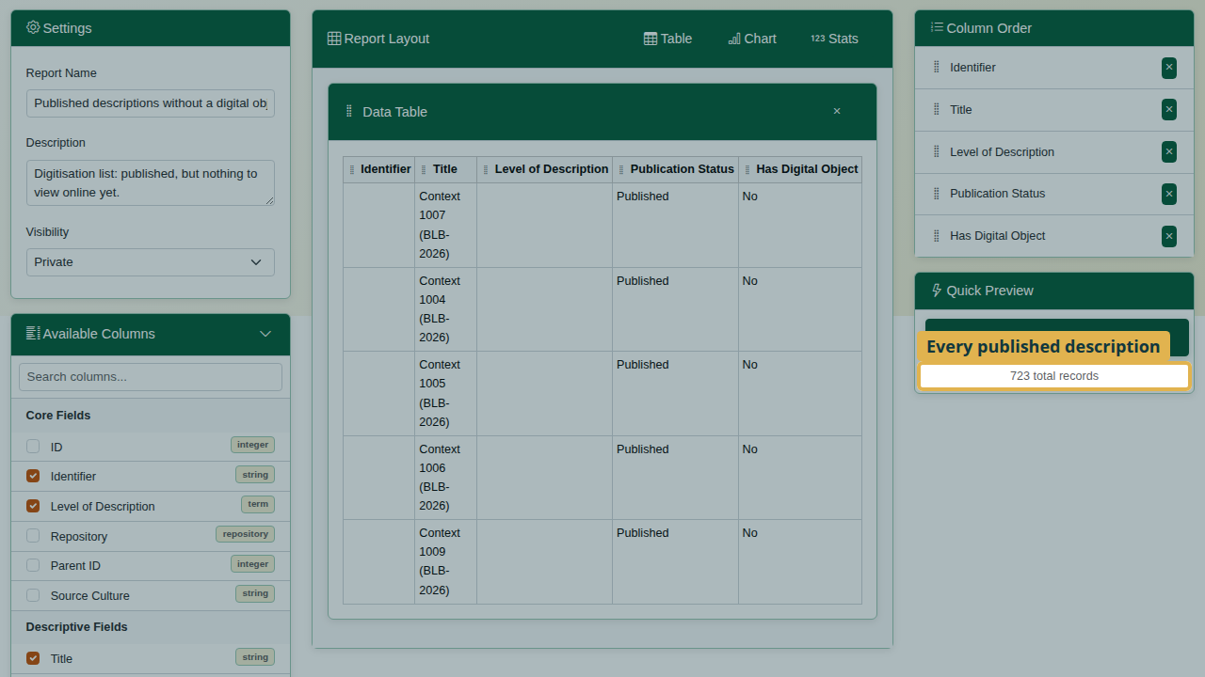
Quick Preview: every published description.
- Add a second filter: Has Digital Object, equals, 0 (0 means no, 1 means yes). Every filter must match, so this keeps only published descriptions with no digital object.
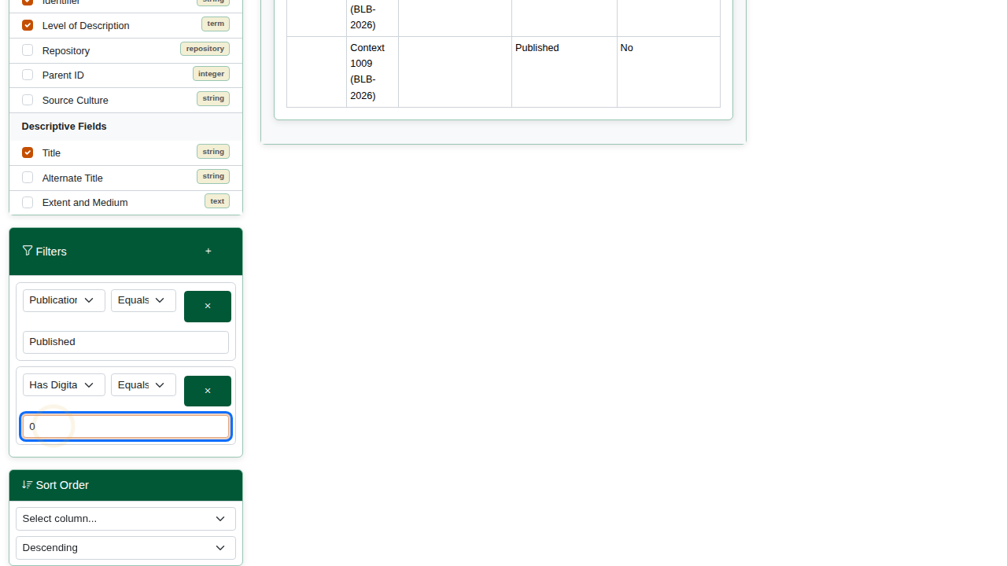
Two filters: published, and no digital object.
- Run Quick Preview again. In the video the count drops to 74: the list we want.
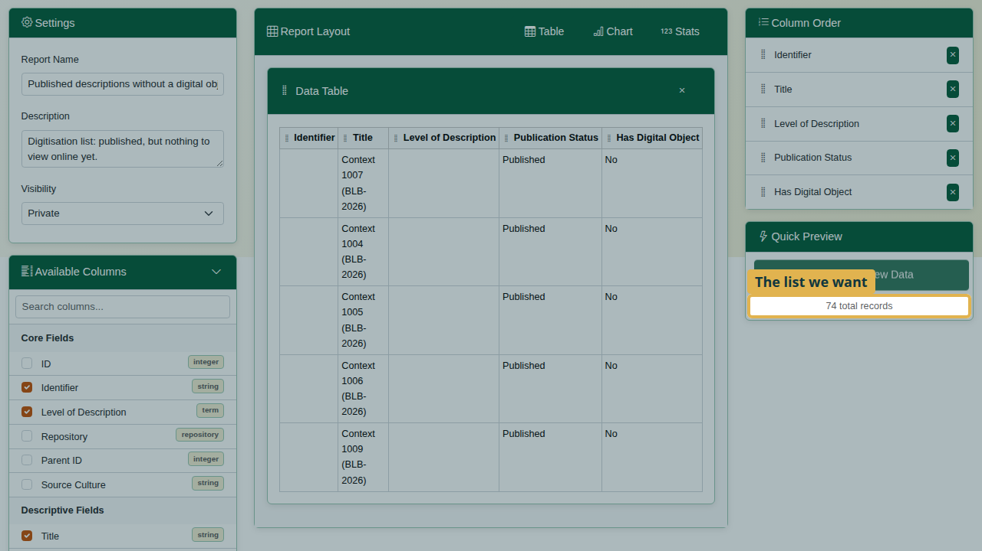
Quick Preview: the digitisation list.
Always check the count against what you expect before you save or send a report.

4. Sort, save and export
- Under Sort Order, choose Identifier, Ascending, so the list follows the arrangement.
- Click Save. Nothing in the designer is kept until you save; leaving with unsaved changes asks for confirmation.
- Click Preview. The report opens in a new tab and runs the saved report with every row, with its total.
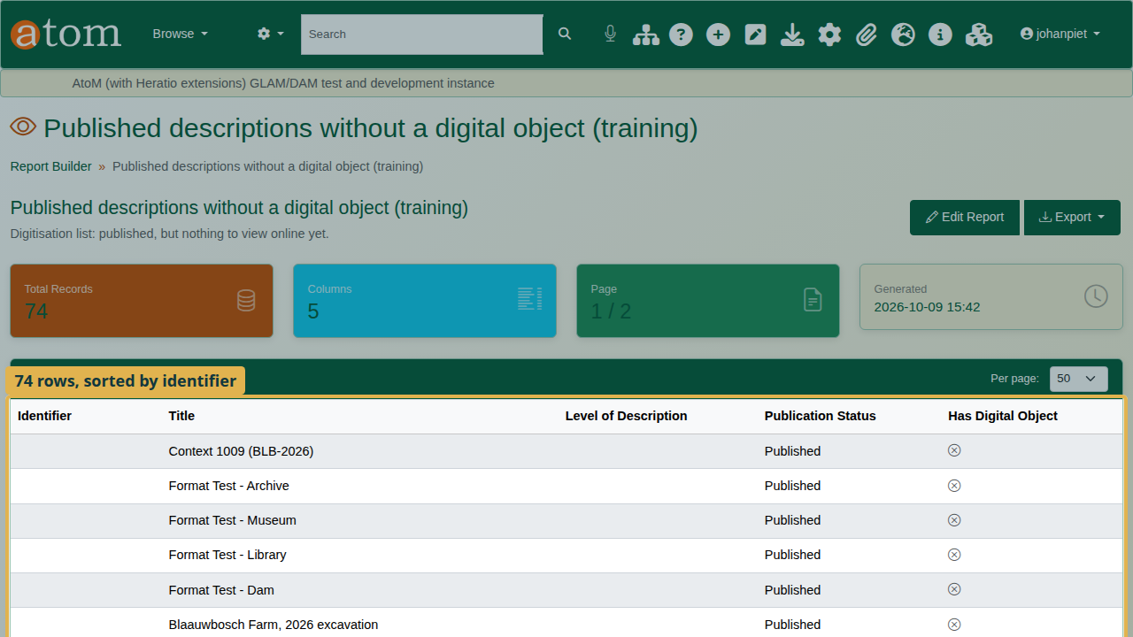
The saved report: 74 records, sorted by identifier.
- Export offers PDF, Word (DOCX), Excel (XLSX) and CSV.
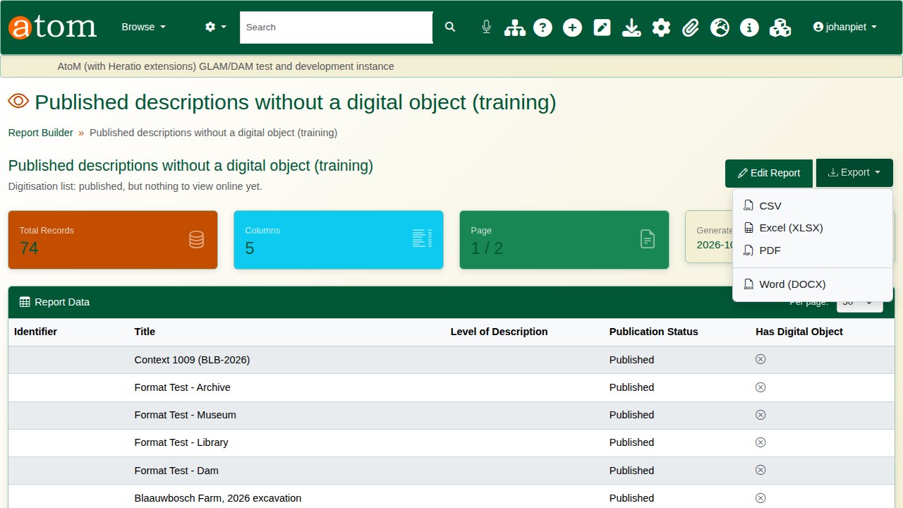
The Export menu.
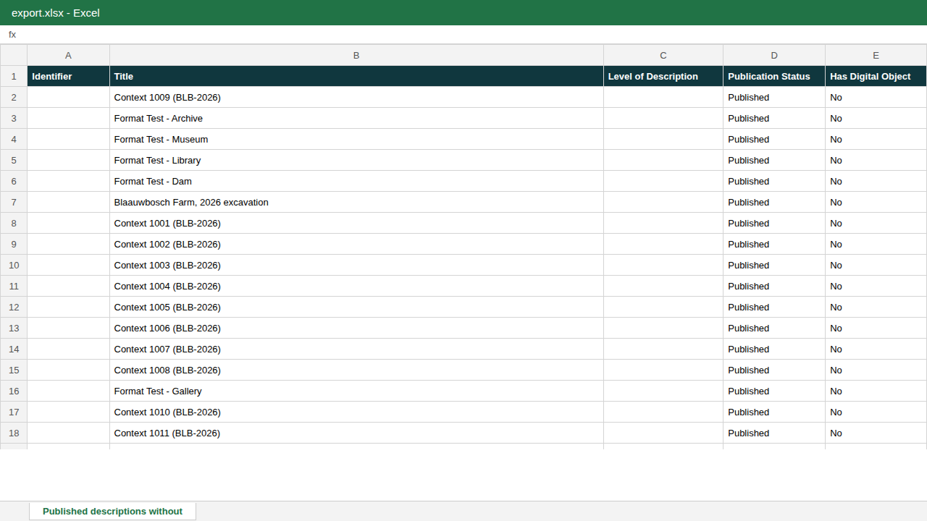
The Excel export.

5. Share and schedule
In the designer’s Settings, Visibility keeps a report Private, Shared with colleagues, or Public. Schedule runs the report on a timetable. History keeps earlier versions of the report’s design.

Recap
- Manage > Central Dashboards > Report Builder.
- Create New Report; choose the data source.
- Tick the columns.
- Add filters; check the count with Quick Preview.
- Sort, Save, then Preview and Export.

Cleaning up
To remove the practice report, open the report list and choose Delete on its row.

