Training: REST API and GraphQL
Step-by-step guide for developers: API keys and scopes, reading and changing records, GraphQL, and revoking keys
Dr Johan Pieterse
Document control
Field | Value
Document title | Training: REST API and GraphQL
Author | Dr Johan Pieterse
Owner | The Archive and Heritage Group (Pty) Ltd
Version | 1.0
Status | Released
Date | 10 October 2026
Prepared for | Developers integrating with AtoM and the AHG extensions
Classification | Public
Reference | AHG-TRN-API-01
Contents
Right-click and choose Update Field to build this list.
List of Tables
Right-click and choose Update Field to build this list.
This guide goes with the training video of the same name. It is for developers. You will issue an API key, read records, try a write with a read-only key and see it refused, issue a second key with the right scopes, create, update and delete a record, run a GraphQL query, and revoke both keys. Allow about 20 minutes.

Before you start
What you need before you start
What | Notes
An AtoM account | A key belongs to you and can do no more than you can: it sees what you may see, and only within its scopes.
An HTTP client | curl, Postman, or your own code. The examples use curl.
The documentation | /api/v2/docs on your own site: every endpoint, with its parameters and responses.

1. Get a key
Open /api/v2/docs on your site. The bar at the top links to Get or manage your API keys (/api/keys).
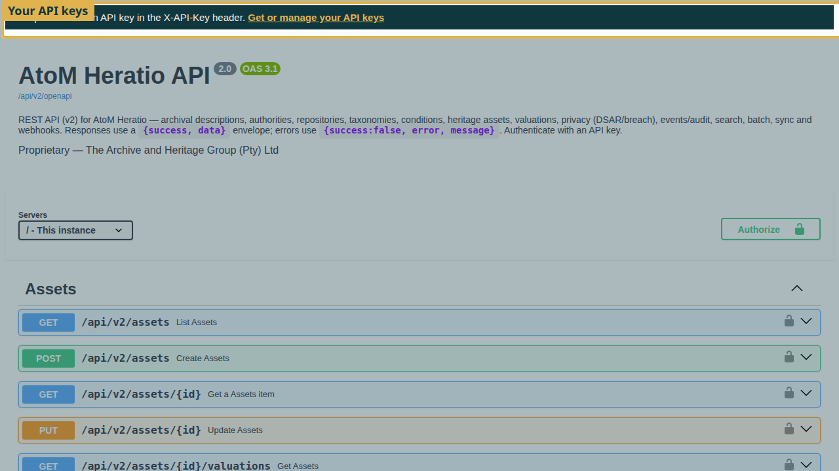
The API documentation, with the link to your keys.
On the API keys page, under Create a key, give the key a Name that says what it is for and tick only the Scopes it needs:
API key scopes
Scope | Allows
read | Listing and reading records (GET)
write | Creating and updating records (POST, PUT)
delete | Deleting records (DELETE)
batch | Batch operations
Click Create key. The key is shown once: copy it now and store it safely. The site keeps only a fingerprint of it; if you lose it, revoke it and create another.
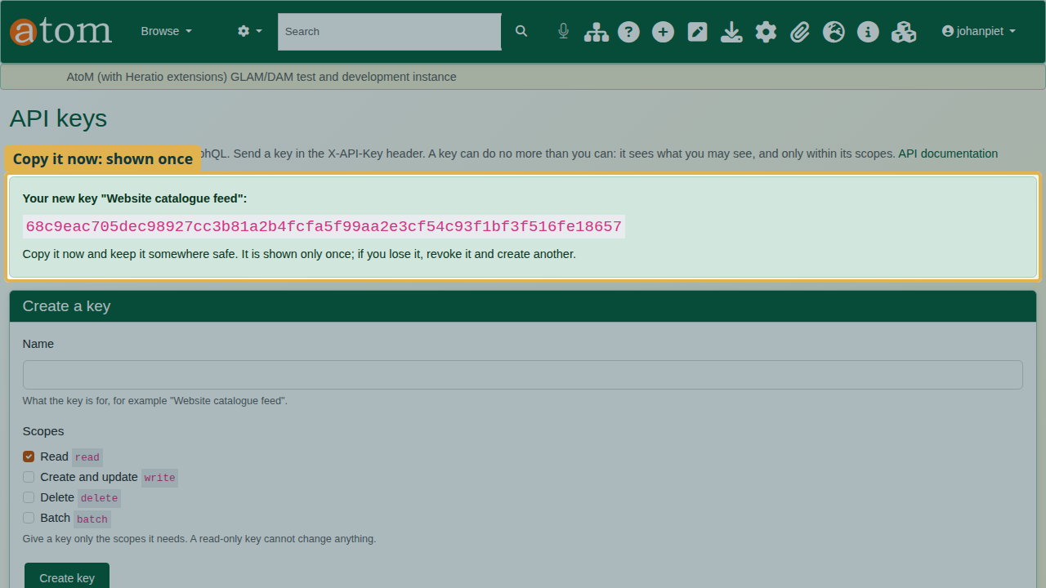
The new key, shown once.

2. Read records
Send the key in the X-API-Key header with every request.
curl -H "X-API-Key: YOUR_KEY" https://your-site/api/v2/descriptions?limit=2
The response is JSON, with total, limit and skip for paging.
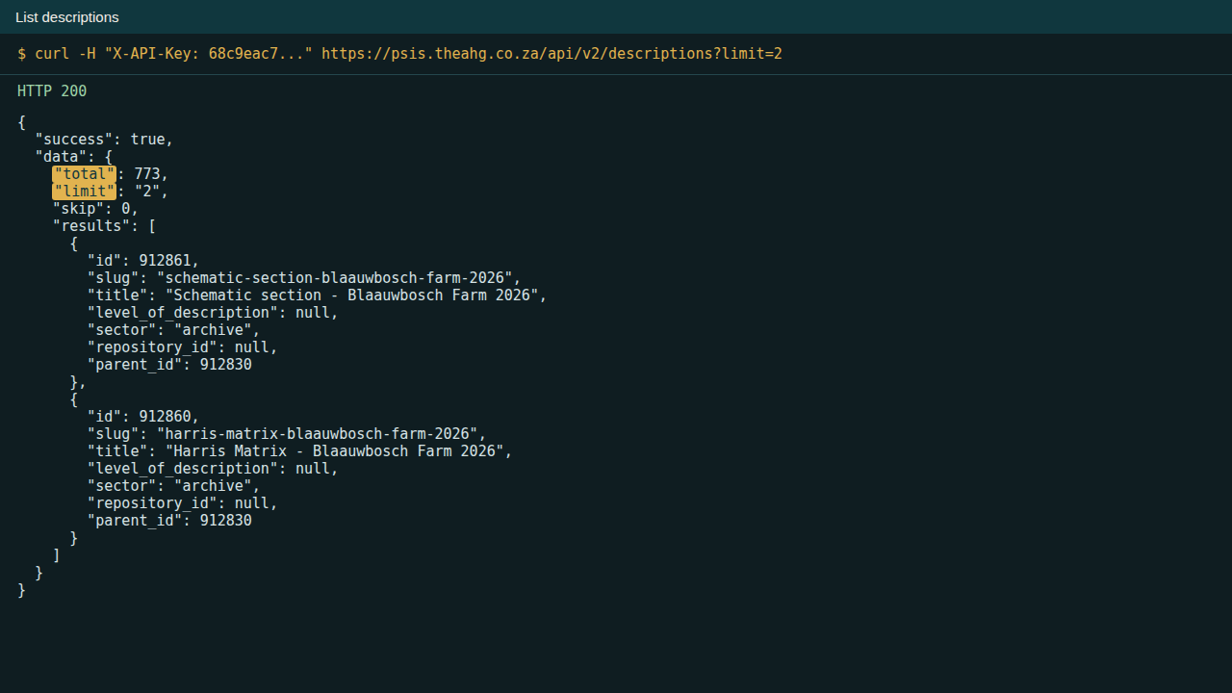
Listing descriptions.
Read one description by its slug, including dates, access points and custom_fields:
curl -H "X-API-Key: YOUR_KEY" https://your-site/api/v2/descriptions/SLUG

3. Write, and the right scope
The deliberate mistake: try to create a description with the read-only key.
curl -X POST -H "X-API-Key: READ_KEY" -H "Content-Type: application/json" \
-d '{"title":"API training record","identifier":"API-TRN-1"}' https://your-site/api/v2/descriptions
The API answers 403, Write scope required. A read-only key cannot change anything; that is the point of scopes.
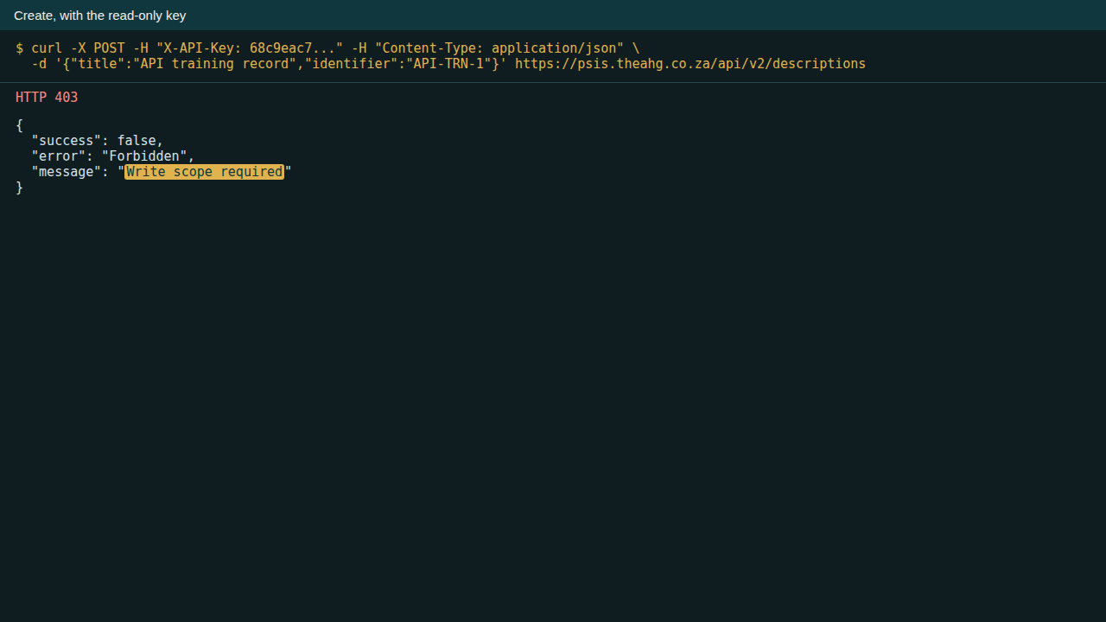
The write refused for a read-only key.
Create a second key for the job that needs it, with read, write and delete. Use one key per job, so each can be revoked on its own.
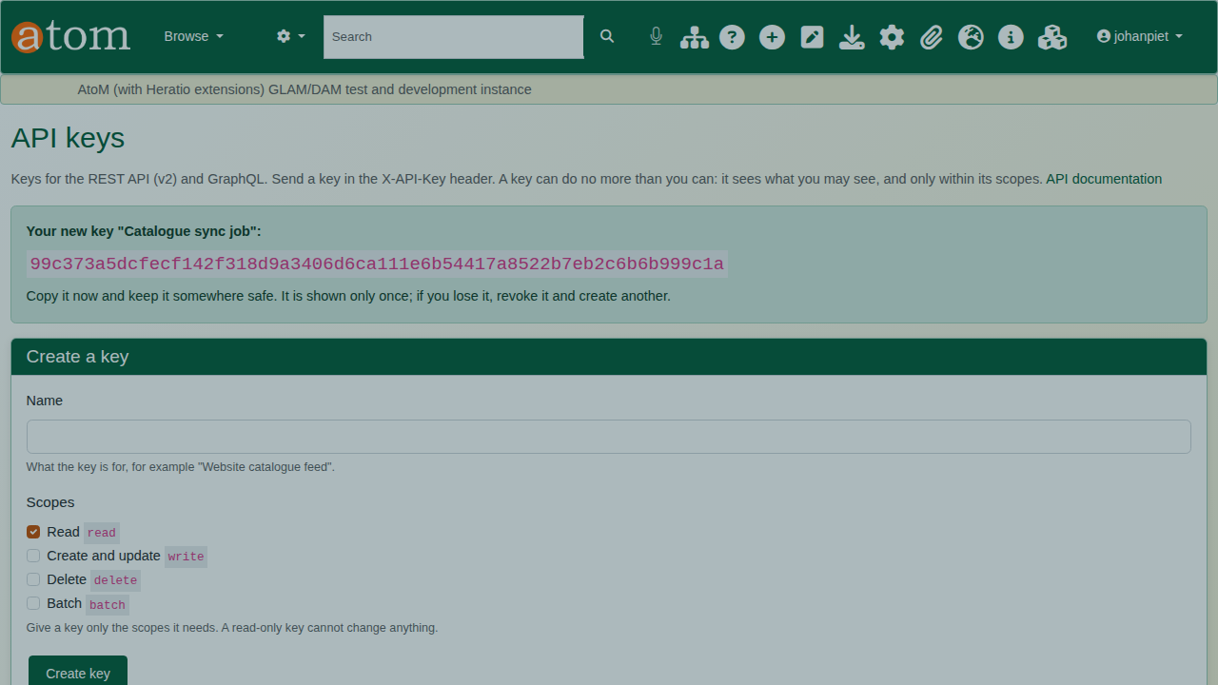
Two keys, two jobs.
With the write key, the same request answers 201 Created with the new record’s id and slug. New records are drafts unless "publication_status": "published" is sent; parent_slug places the record under an existing description.
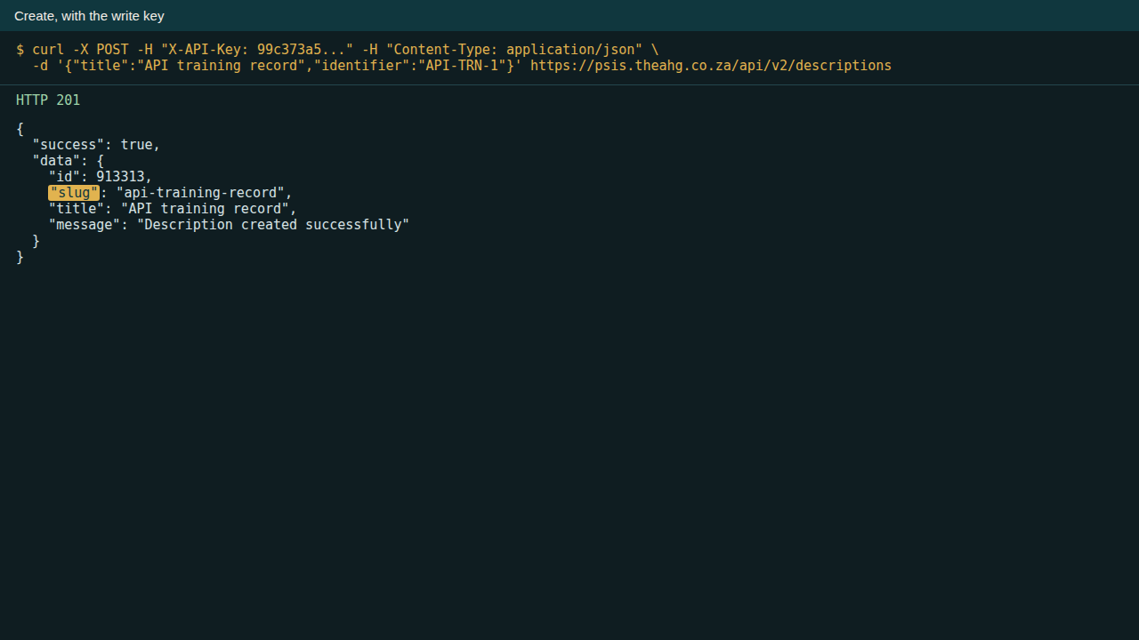
Created: 201 with the new slug.
PUT to /api/v2/descriptions/SLUG changes fields; DELETE to the same address removes the record and needs the delete scope.
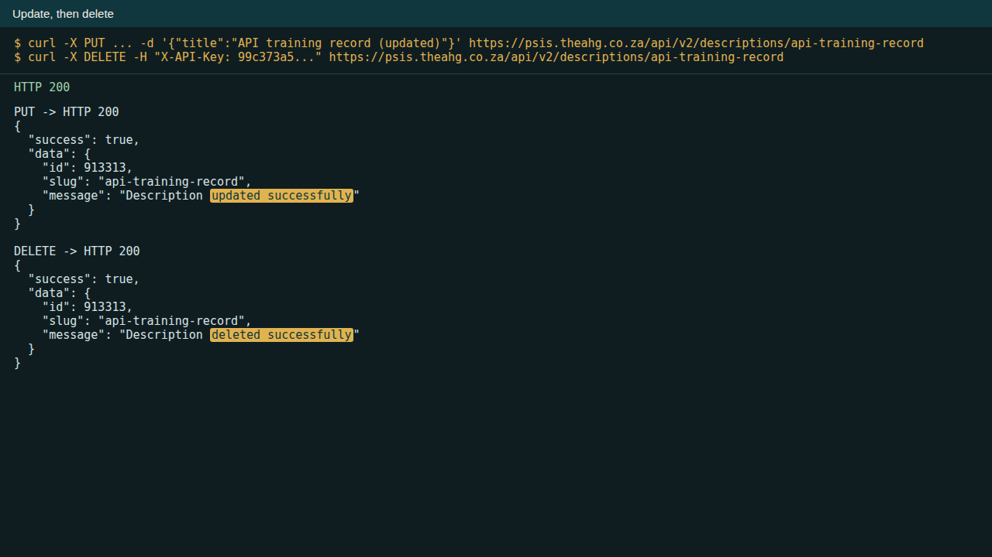
Update, then delete.

4. GraphQL
GraphQL, at /api/graphql, asks for exactly the fields you need, nested, in one request, with the same key:
curl -X POST -H "X-API-Key: YOUR_KEY" -H "Content-Type: application/json" \
-d '{"query":"{ item(slug: \"SLUG\") { title levelOfDescription { name } repository { name } childrenCount children(first: 3) { edges { node { title } } } } }"}' \
https://your-site/api/graphql
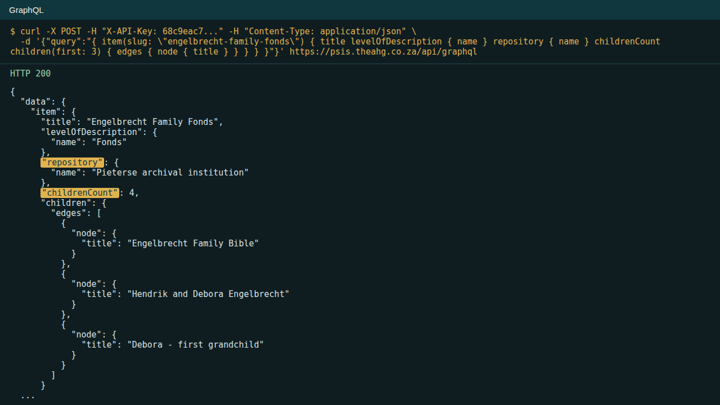
A GraphQL query and its answer.

5. Revoke
When a key is no longer needed, or may have leaked, click Revoke beside it on the API keys page. It stops working at once.
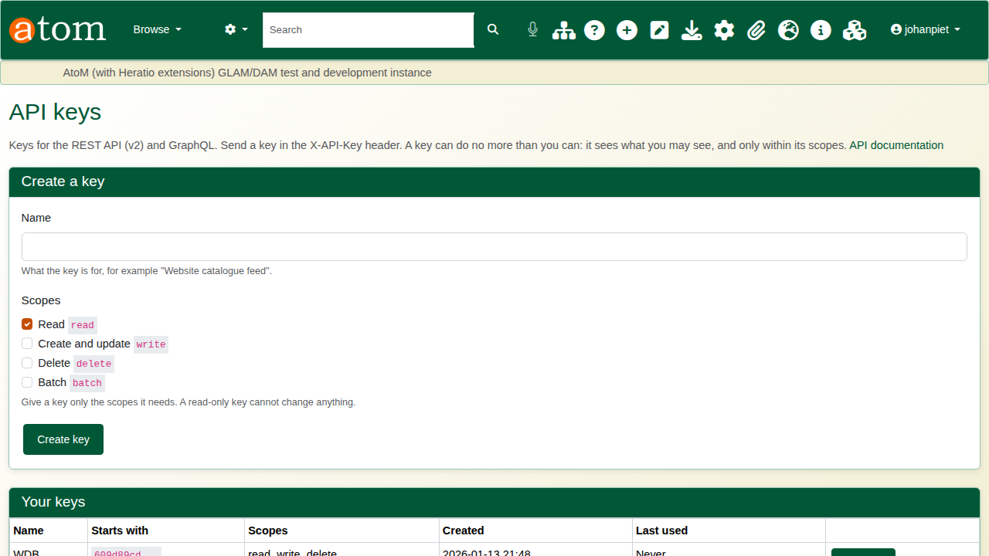
The API keys page with both keys before revoking.

Recap
- Create a key on the API keys page, with only the scopes it needs; copy it once.
- Send it in the X-API-Key header with every request.
- Read with read, change with write, delete with delete.
- Use GraphQL for exactly the fields you want.
- Revoke keys you no longer use.

