Training: Sort the Records Below
Step-by-step guide to putting the records below a description into order, all at once, with a preview before anything moves
Dr Johan Pieterse
Document control
Field | Value
Document title | Training: Sort the Records Below
Author | Dr Johan Pieterse
Owner | The Archive and Heritage Group (Pty) Ltd
Version | 1.0
Status | Released
Date | 9 October 2026
Prepared for | AtoM users of the AHG extensions
Classification | Public
Reference | AHG-TRN-DESC-02
Contents
Right-click and choose Update Field to build this list.
List of Tables
Right-click and choose Update Field to build this list.
This guide goes with the training video of the same name. AtoM keeps the records below a description in the order they were entered, until someone moves each one by hand. Sort the records below puts every level below a description into order in one step: by identifier, title or earliest date. A preview shows the new order before anything moves.
You will sort six farm diaries that were entered out of order, catch one deliberate mistake in the preview, and check the result. Allow about 10 minutes.

Before you start
What you need before you start
What | Notes
An editor or administrator account | The More menu entry appears only for editors and administrators, and only on a description that has records below it.
The practice file | smit-farm-diaries-practice.csv in docs/training-files/ of the AHG extensions catalogue: a fonds with six diary volumes entered as 10, 2, 1, 20, 3, 11. Import it with Data Ingest, choosing “Use hierarchy from CSV” (see the hierarchical CSV training).

1. See the problem
Open one of the diaries. The tree on the left shows the volumes in the order they were entered: 10, 2, 1, 20, 3, 11.
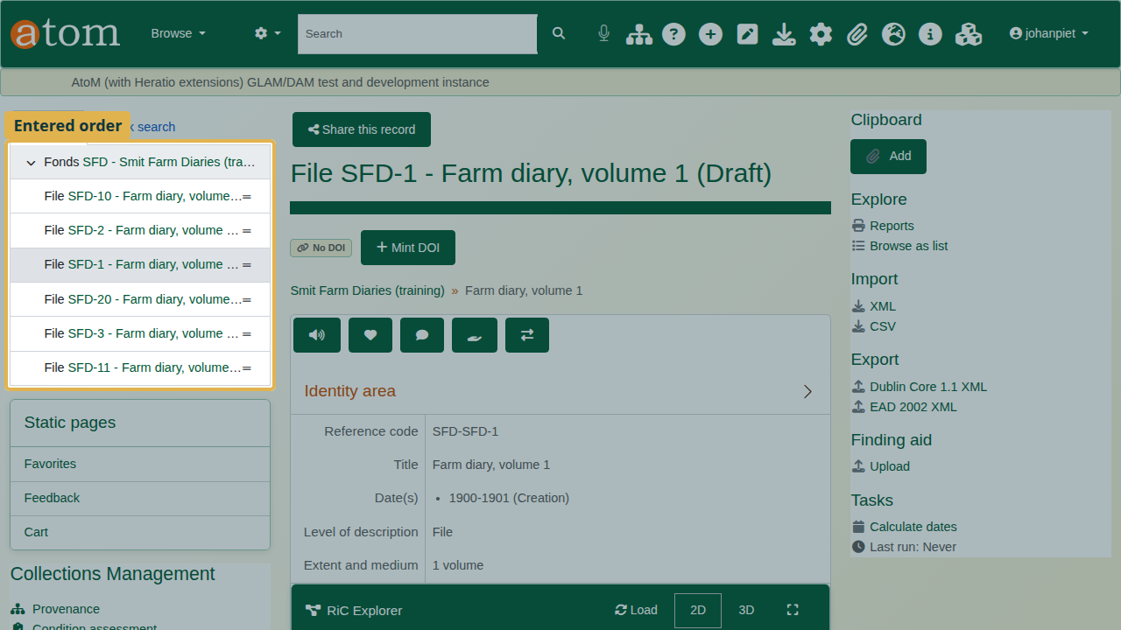
The tree in entered order.

2. Sort the records below
- Open the fonds (click it in the tree).
- In the More menu at the foot of the page, choose Sort the records below.
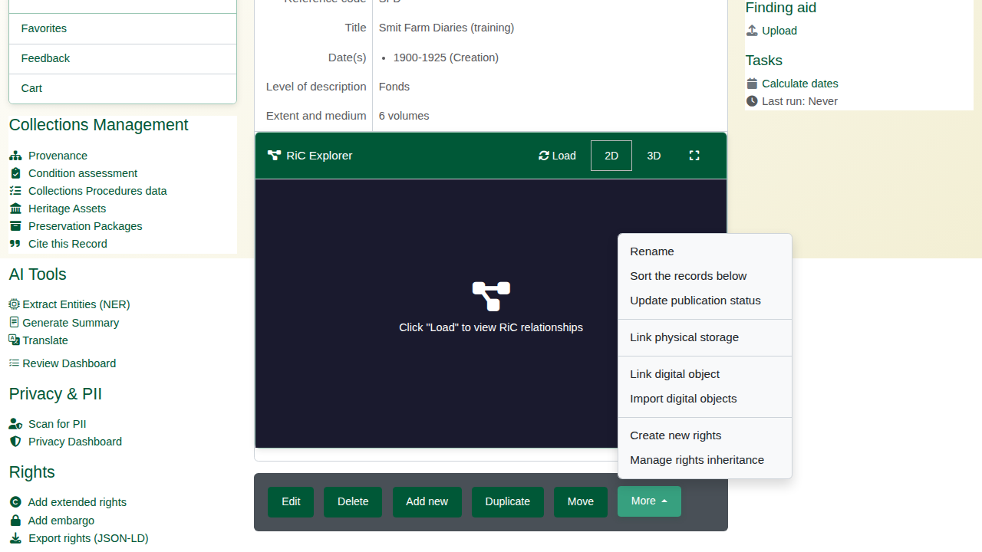
More > Sort the records below.
- Under Sort by, choose the key:
Sort keys
Key | Order
Identifier (2 before 10) | Identifiers compared as people read numbers: 2 comes before 10
Title | Titles, also with numbers in natural order
Earliest date | The earliest date of each record; records without a date go last
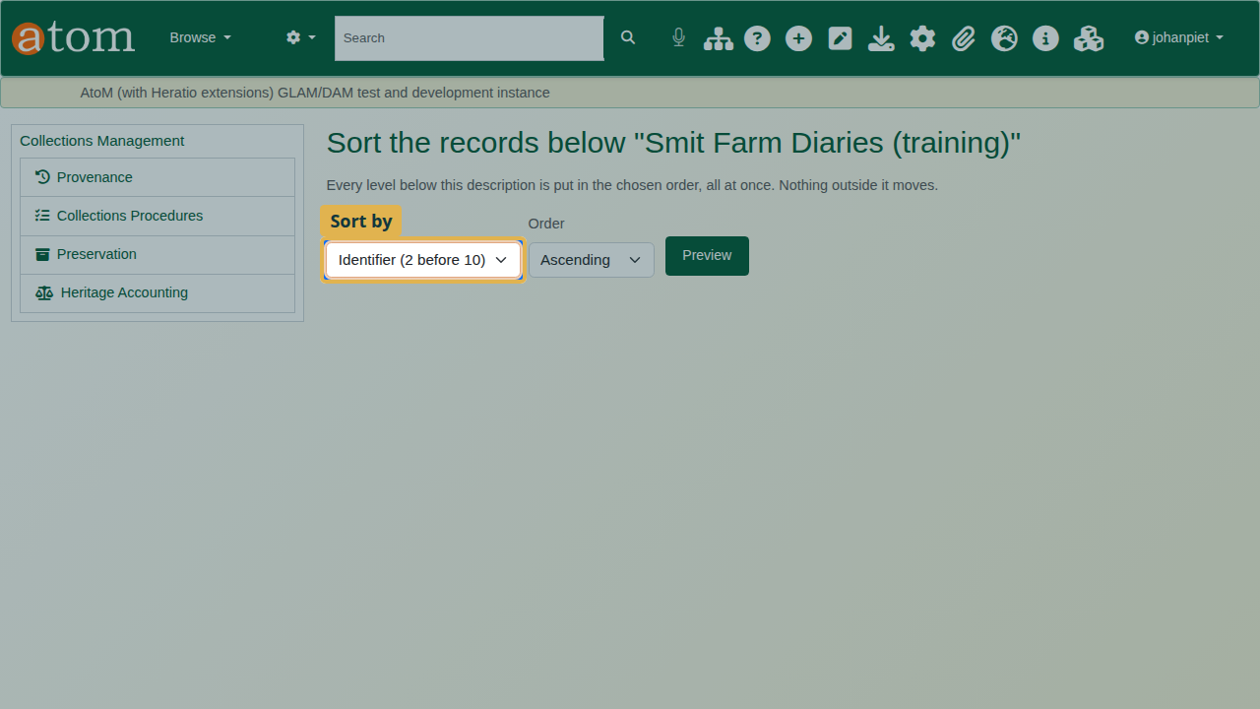
Sort by Identifier (2 before 10).
Every level below the description is sorted, and nothing outside it moves. Branches move with their parent: a sorted series keeps its files.

3. Read the preview
The deliberate mistake: choose Descending under Order and click Preview. The preview lists the new order (New) and each record’s current place (Was). Volume 20 comes first. Nothing has changed yet.
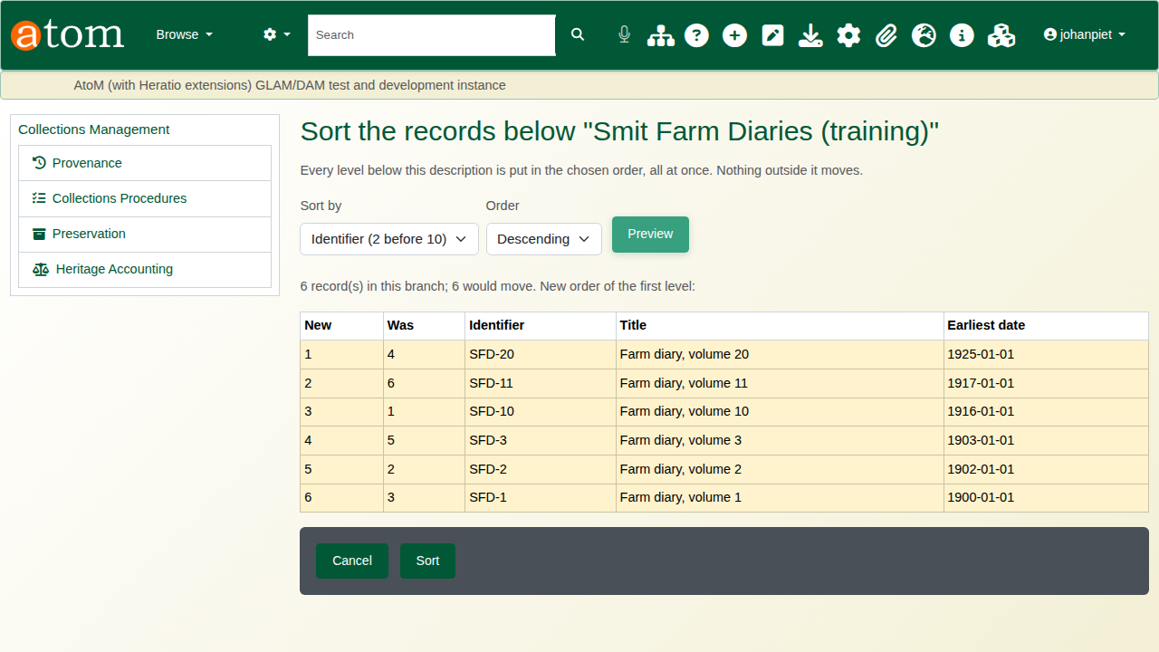
The preview with Descending: volume 20 first.
The choices stay above the preview. Change Order to Ascending and click Preview again. Now the volumes run 1, 2, 3, 10, 11, 20.
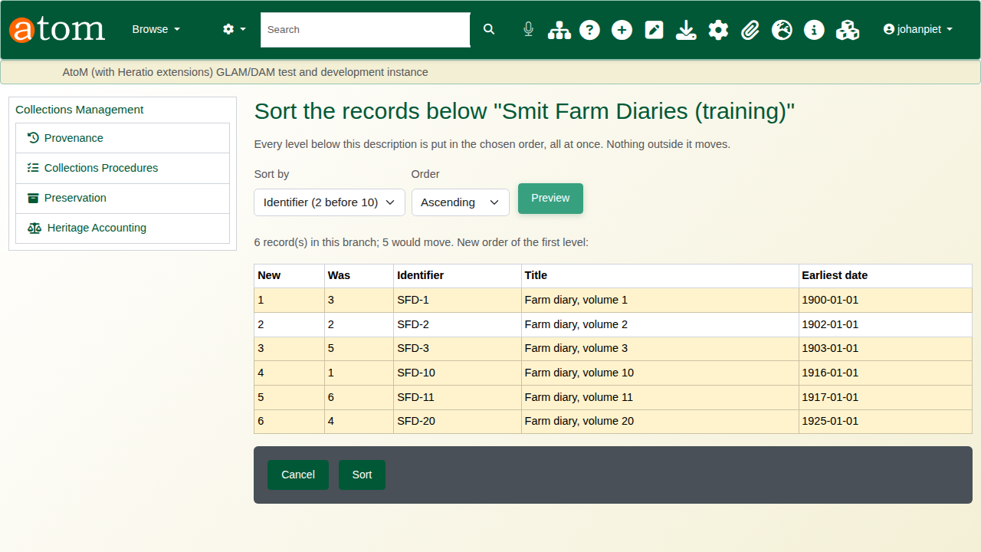
The preview with Ascending: 1, 2, 3, 10, 11, 20.
If the records are already in the chosen order, the page says so and there is nothing to sort.

4. Sort
Click Sort. Only the records whose place changes are moved, in one step, and the search index is updated. Cancel returns to the description without changing anything.
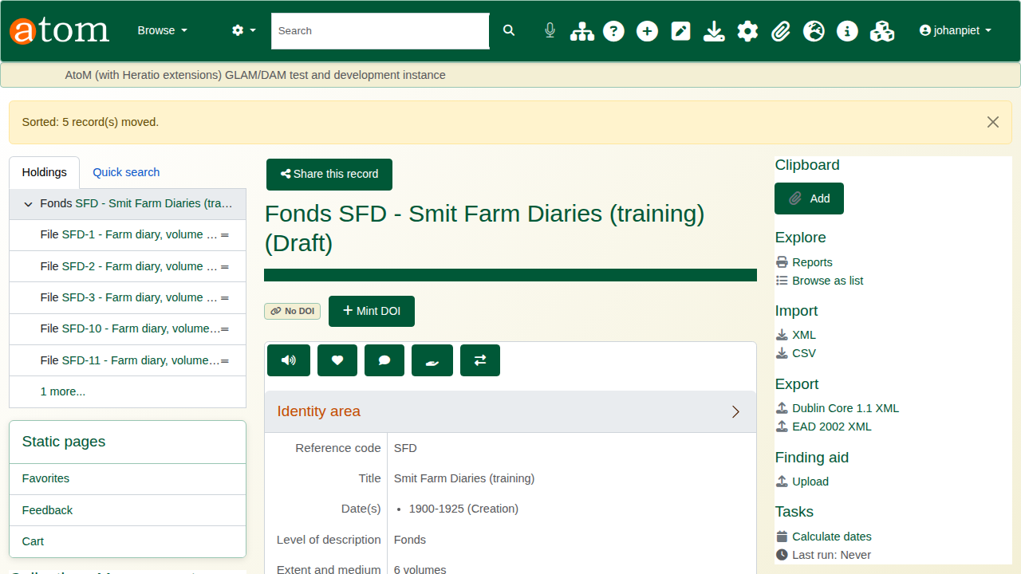
Sorted: the confirmation on the fonds.

5. Check the result
Open a diary again. The tree shows the volumes in number order.
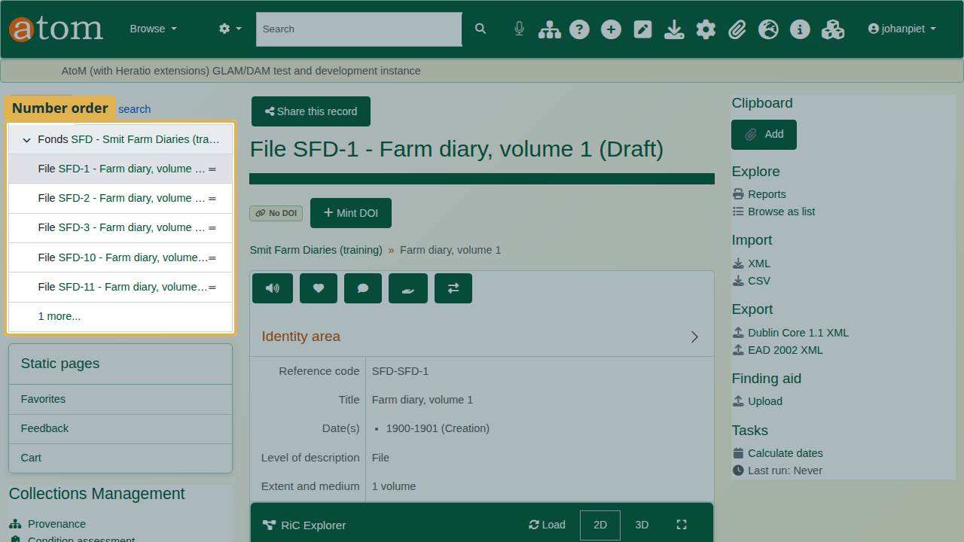
The tree in number order.

Recap
- Open the description whose records you want in order.
- More > Sort the records below.
- Choose the key and the order.
- Read the preview.
- Sort, then check the tree.

Cleaning up
To remove the practice records, open the fonds and choose Delete. AtoM deletes the diaries under it as well.

