Training: Move a Term to Another Taxonomy
Step-by-step guide to moving a term, for example a place catalogued as a subject, without re-linking any description
Dr Johan Pieterse
Document control
Field | Value
Document title | Training: Move a Term to Another Taxonomy
Author | Dr Johan Pieterse
Owner | The Archive and Heritage Group (Pty) Ltd
Version | 1.0
Status | Released
Date | 9 October 2026
Prepared for | AtoM users of the AHG extensions
Classification | Public
Reference | AHG-TRN-TERM-01
Contents
Right-click and choose Update Field to build this list.
List of Tables
Right-click and choose Update Field to build this list.
This guide goes with the training video of the same name. A term catalogued in the wrong taxonomy, such as a farm entered as a subject, used to mean creating the right term and re-linking every description by hand. Move to another taxonomy moves the term itself, with any terms below it. Every description keeps its link.
You will move a farm from Subjects to Places, by way of one deliberate wrong choice. Allow about 10 minutes.

Before you start
What you need before you start
What | Notes
An administrator account | Moving a term is for administrators: only they see the Move to another taxonomy button.
The practice file | groenkloof-estate-practice.csv in docs/training-files/ of the AHG extensions catalogue: three descriptions that list “Groenkloof (farm)” as a subject. Import it with Data Ingest, choosing “Use hierarchy from CSV” (see the hierarchical CSV training).

1. Find the term
Open one of the descriptions, for example “Photographs of the homestead”. Groenkloof is a farm, a place, but it is listed under Subject access points. Click the term to open its page.
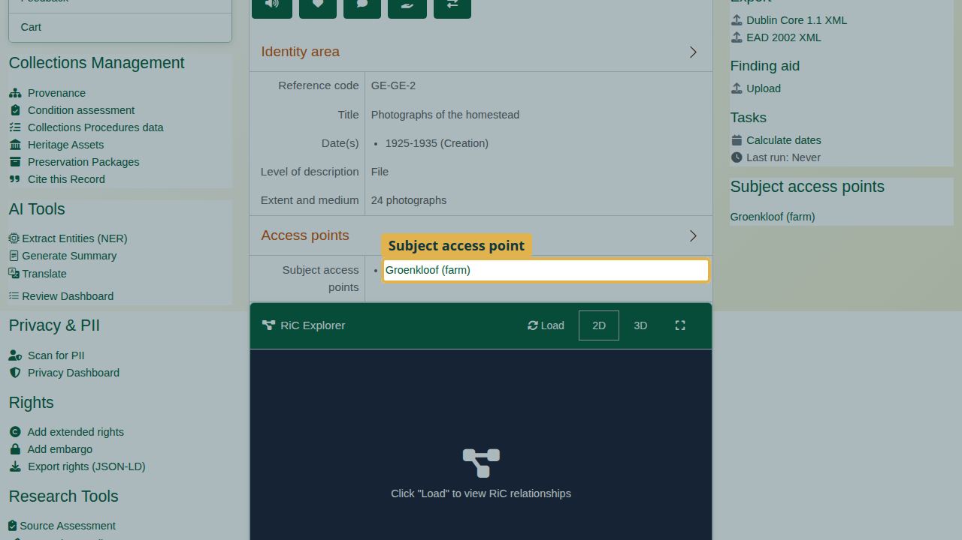
Groenkloof (farm) under Subject access points.

2. Move the term
On the term’s page, click Move to another taxonomy.
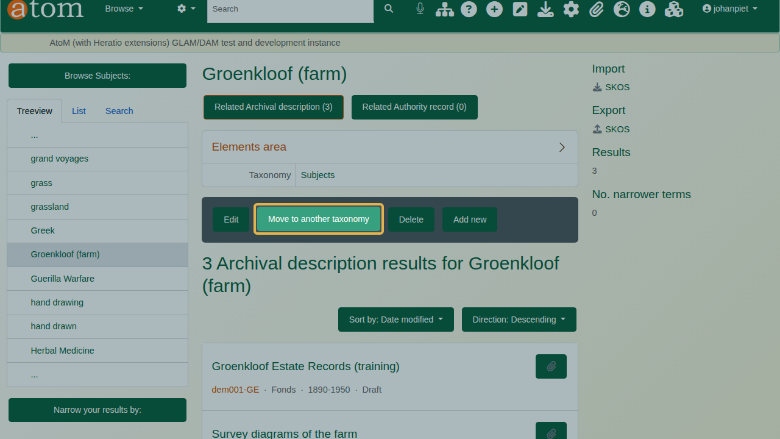
The term page with Move to another taxonomy.
The page says what will move: this term, every term below it, and how many descriptions use them. Those descriptions keep their links. The term goes to the top level of the chosen taxonomy.
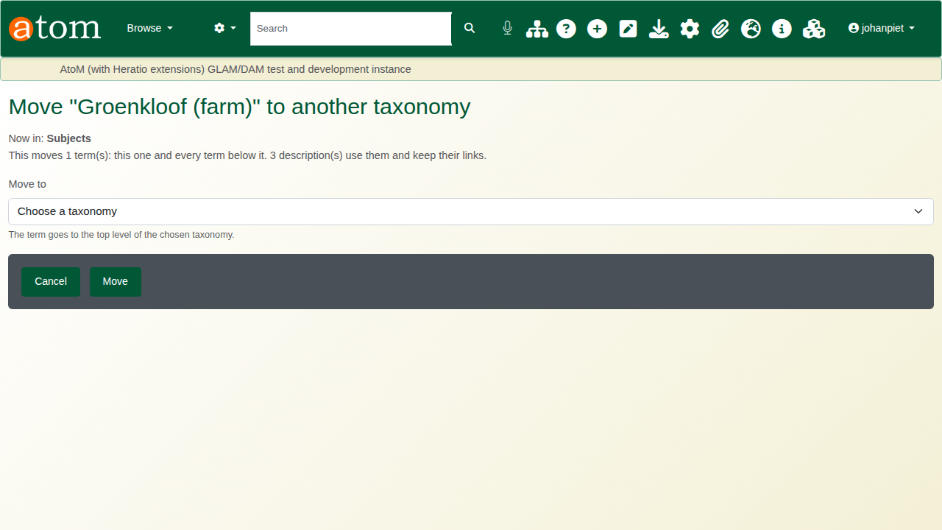
The move page: what will move, and the Move to list.
The deliberate mistake: choose Genres under Move to and click Move.

3. Check, and fix a wrong choice
Open the description again. Groenkloof is now listed under Genre access points. The move worked; the choice was wrong.
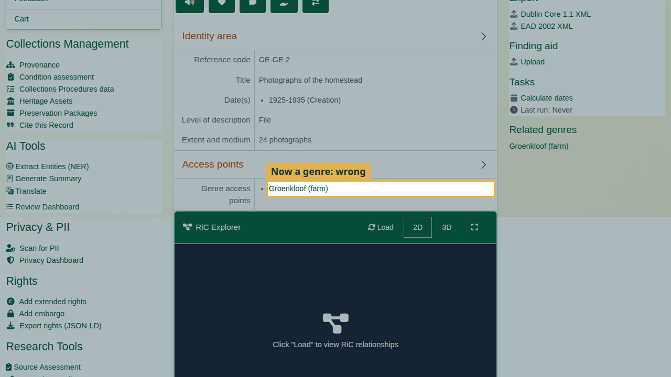
Groenkloof now listed as a genre.
Moves can always be repeated. Open the term again, click Move to another taxonomy, choose Places and click Move.
Back on the description, Groenkloof is listed under Place access points. Nothing had to be re-linked, and search follows the move.
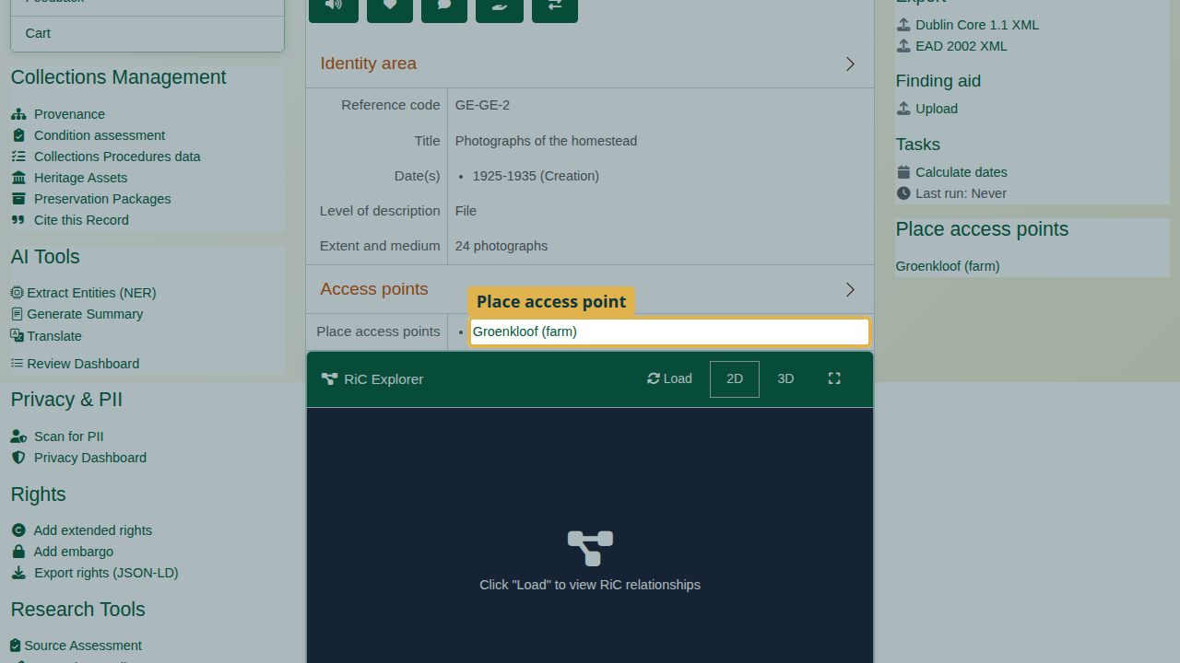
Groenkloof under Place access points.
Some terms cannot be moved because AtoM relies on them or on their taxonomy (for example levels of description). Their page says so instead of offering the move.

Recap
- Open the term from any description that uses it.
- Click Move to another taxonomy and read what will move.
- Choose the taxonomy and click Move.
- Check a description.
- Wrong choice? Move it again.

Cleaning up
To remove the practice records, open the fonds and choose Delete. Then open the term and delete it.

