Training: Wikidata Links
Step-by-step guide to linking an authority record to Wikidata, and correcting a wrong link
Dr Johan Pieterse
Document control
Field | Value
Document title | Training: Wikidata Links
Author | Dr Johan Pieterse
Owner | The Archive and Heritage Group (Pty) Ltd
Version | 1.0
Status | Released
Date | 9 October 2026
Prepared for | AtoM users of the AHG extensions
Classification | Public
Reference | AHG-TRN-AUTH-01
Contents
Right-click and choose Update Field to build this list.
List of Tables
Right-click and choose Update Field to build this list.
This guide goes with the training video of the same name. Wikidata is the open, linked database of people, places and organisations. Linking an authority record to its Wikidata item shows visitors the outside world’s description of the same person, on the authority record and on every description that names them. VIAF, the Getty Union List of Artist Names (ULAN) and the Library of Congress Name Authority File (LCNAF) are linked the same way.
You will link Nelson Mandela’s authority record to Wikidata, by way of one deliberate wrong link that you delete. Allow about 10 minutes.

Before you start
What you need before you start
What | Notes
An editor or administrator account | Editors and administrators manage external identifiers.
The practice file | robben-island-letters-practice.csv in docs/training-files/ of the AHG extensions catalogue: a collection with Nelson Mandela as a name access point. Import it with Data Ingest, choosing “Use hierarchy from CSV” (see the hierarchical CSV training).
Internet access from the server | The search asks Wikidata directly.

1. Open the authority record
Open the collection “Letters from Robben Island (training)”. Nelson Mandela is listed as a name access point. Click his name to open his authority record.
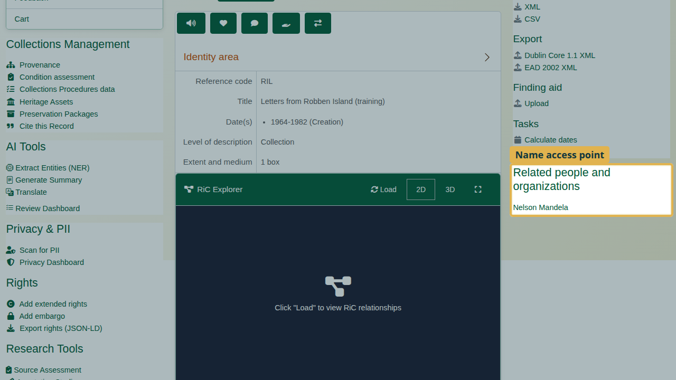
The name access point on the collection.
On the authority record, click Add Wikidata, VIAF and other identifiers (staff only). The External Identifiers page opens.
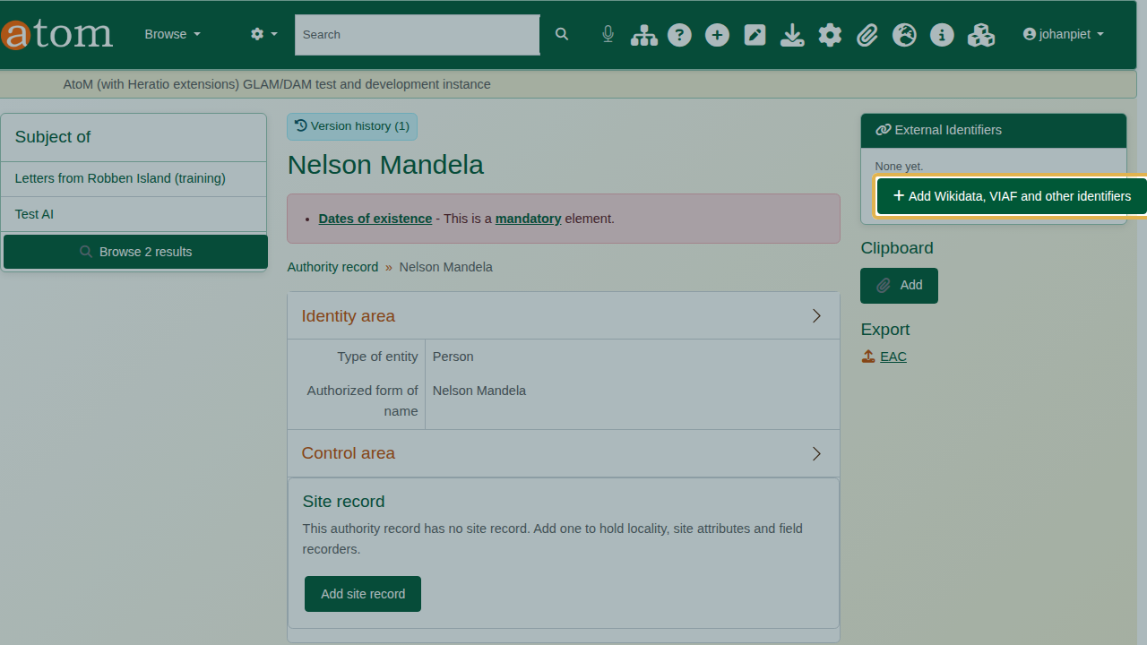
The link to manage external identifiers.

2. Search Wikidata
Under Search External Authorities, type the name and click Wikidata. Each match is listed with its ID, label and a short description. Several items share this name: the man, songs, statues and a painting. Read the descriptions.
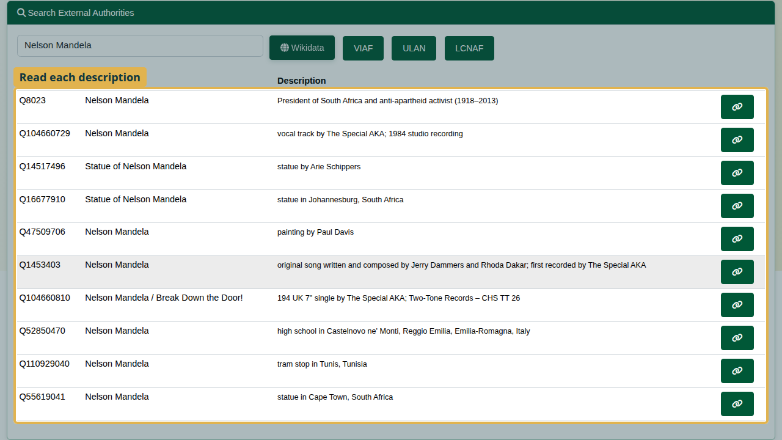
Wikidata matches for “Nelson Mandela”, each with its description.
The deliberate mistake: click the link button on the second result. The record is now linked to Q104660729, whose description reads “vocal track by The Special AKA; 1984 studio recording”: a song, not the man.
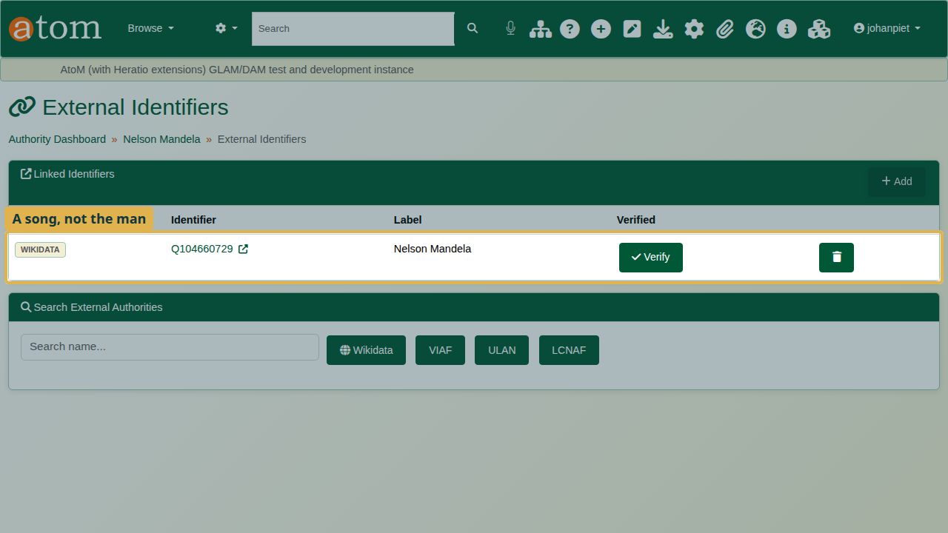
The wrong item linked: Q104660729, a song.
Always read the description before you link.

3. Fix the link
- Under Linked Identifiers, click the delete button on the wrong row and confirm.
- Search again and link the first result: Q8023, “President of South Africa and anti-apartheid activist (1918-2013)”.
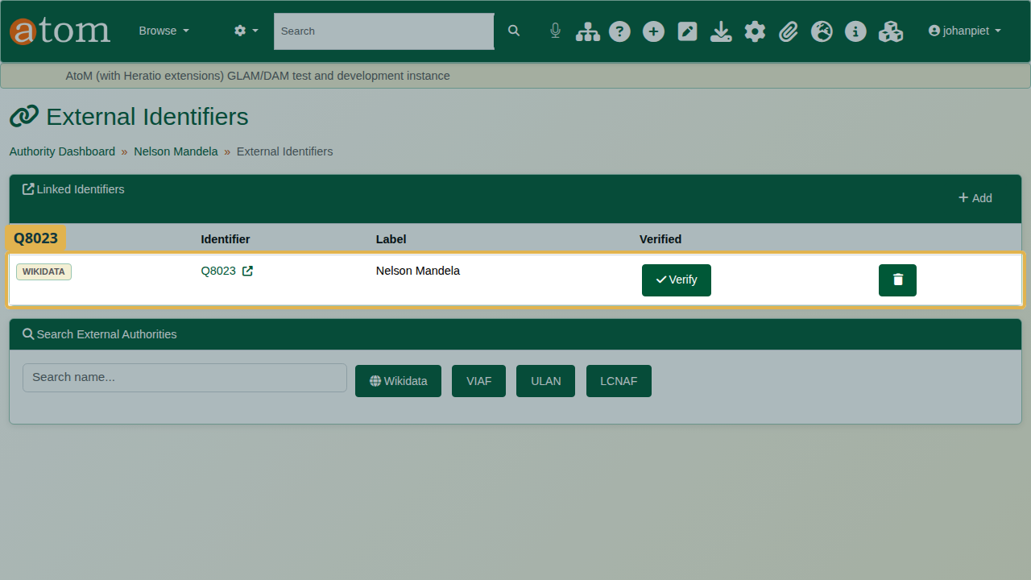
The right item linked: Q8023.
Verify marks a link as checked by a person, for your own quality control.

4. Where the link appears
The authority record shows the Wikidata link to every visitor.
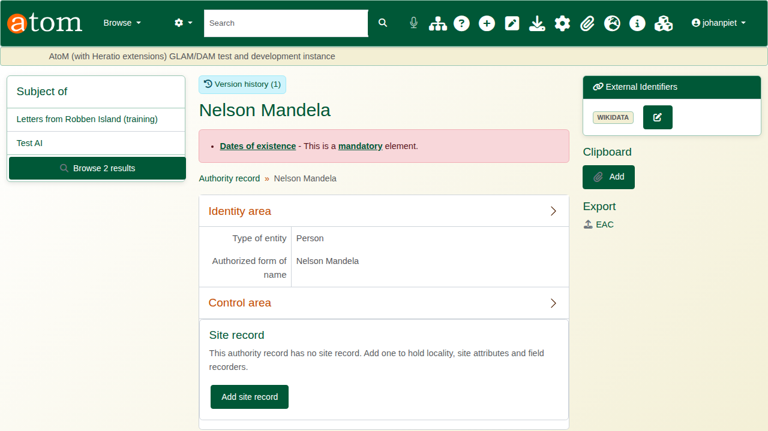
The Wikidata link on the authority record.
Every description that names him, as creator or as name access point, carries a Wikidata panel.
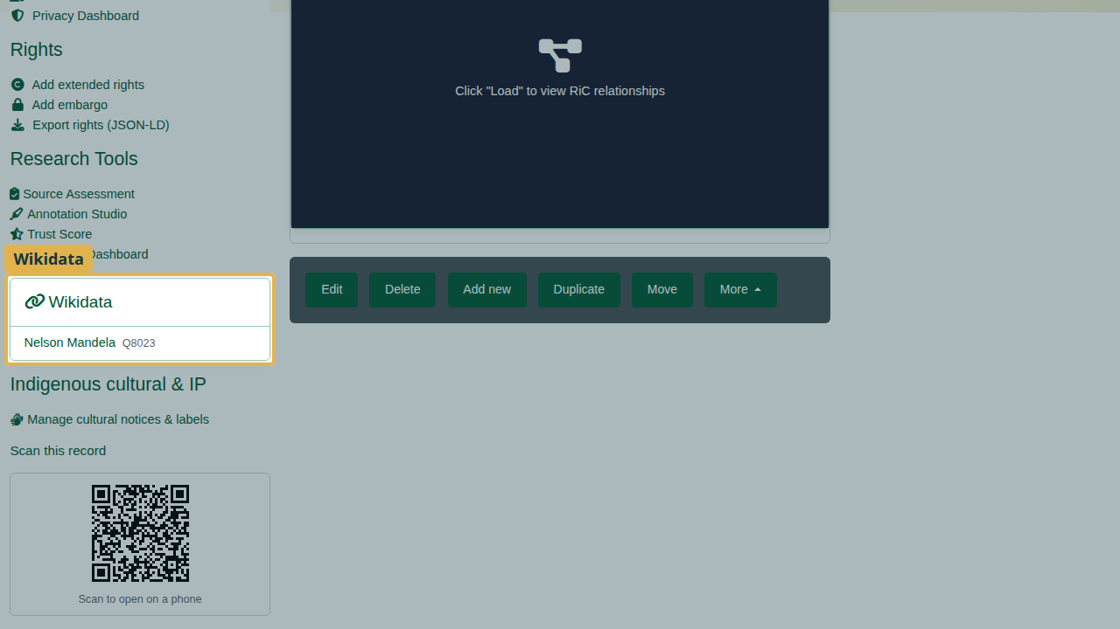
The Wikidata panel on the collection.

Recap
- Open the authority record and choose Add Wikidata, VIAF and other identifiers.
- Search Wikidata by name; read each description.
- Link the right item.
- If a link is wrong, delete it and link again.

Cleaning up
Open the collection and choose Delete. To remove the link, open the authority record’s external identifiers and delete it.

