Training: Museum, Part 1 - Cataloguing a Museum Object
Step-by-step guide to describing a museum object to the CCO standard, with Getty vocabulary terms and an authority-linked creator
Dr Johan Pieterse
Document control
Field | Value
Document title | Training: Museum, Part 1 - Cataloguing a Museum Object
Author | Dr Johan Pieterse
Owner | The Archive and Heritage Group (Pty) Ltd
Version | 1.0
Status | Released
Date | 12 October 2026
Prepared for | Museum cataloguers and registrars using the AHG extensions
Classification | Public
Reference | AHG-TRN-MUS-01
Contents
Right-click and choose Update Field to build this list.
List of Tables
Right-click and choose Update Field to build this list.
This guide goes with part 1 of the museum training videos. It describes a painting to the CCO standard (Cataloging Cultural Objects), using a Getty Art & Architecture Thesaurus term for the work type and linking the artist to an authority record. Allow about 15 minutes.

Before you start
What you need before you start
What | Notes
An editor or administrator account | Museum cataloguing needs create rights.
The artist as an authority record | The video uses a fictitious painter, “Westhuizen, M. van der”. Create the authority record first (Add > Authority record).
A repository | The institution that holds the object.

1. Choose a template
Go to Add museum object (/museum/add). The Object Template panel offers fourteen templates: Painting, Sculpture, Photograph, Print, Drawing, Textile, Ceramic, Furniture, Decorative Art, Archival Object, Book/Manuscript, Numismatic, Natural Specimen and Generic Object. Each sets which fields are required, recommended or hidden for that kind of object.
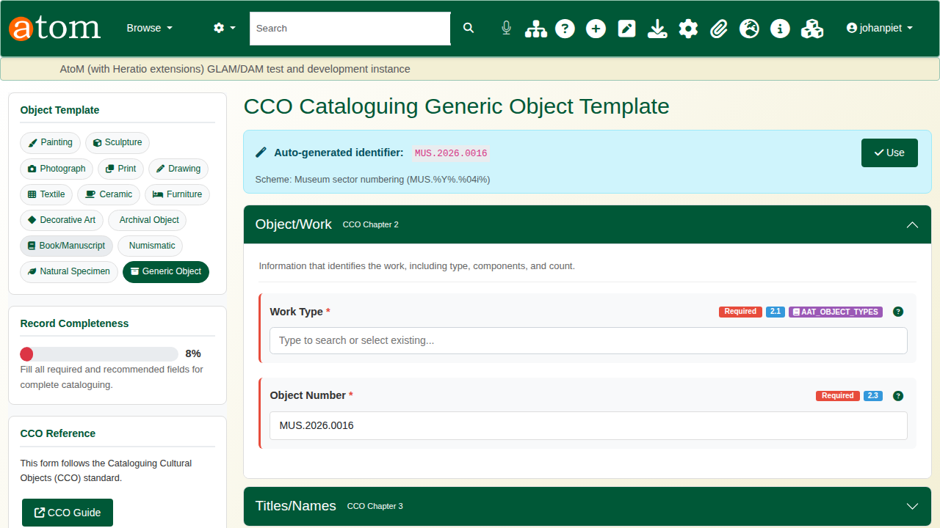
The add form.
Choose Painting. The object number is generated from the museum numbering scheme (for example MUS.2026.0016); Use accepts it.
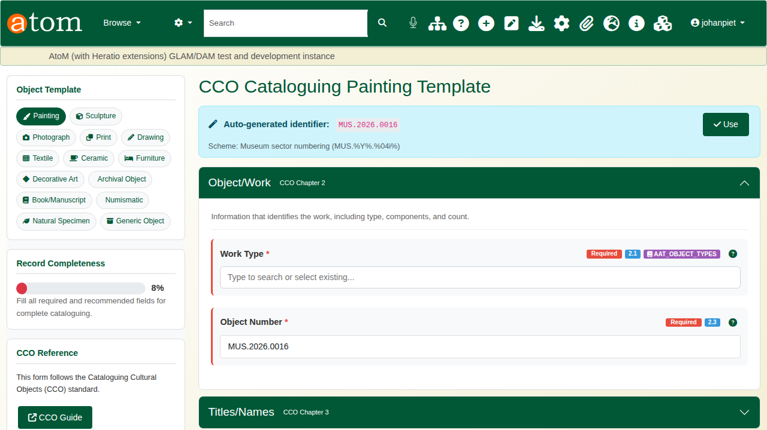
The Painting template.
The form follows the CCO chapters: Object/Work, Titles/Names, Creation, Styles/Periods, Measurements, Materials/Techniques, Subject Matter, Inscriptions, Description, Condition, Current Location, Related Works and Rights. Record Completeness shows how much of the template is filled.

2. Required fields
The deliberate mistake: save with only a title. The record is refused. Validation Errors lists every field the template requires that is still empty, Recommended Fields Missing lists what is worth adding, and everything typed is kept.
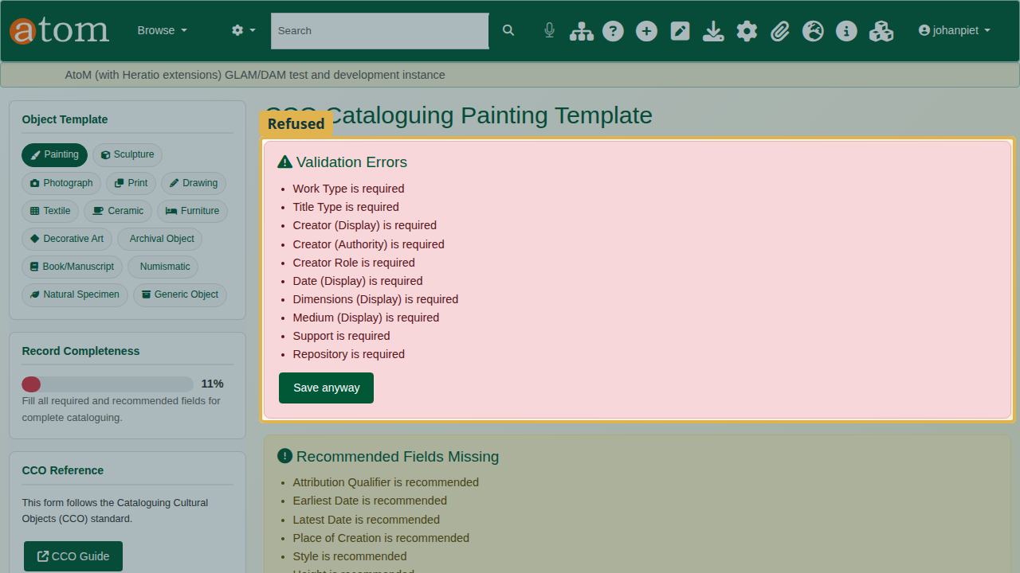
The save refused.
For the Painting template the required fields are:
Required fields in the Painting template
Section | Required fields
Object/Work | Work Type, Object Number
Titles/Names | Title, Title Type
Creation | Creator (Display), Creator (Authority), Creator Role, Date (Display)
Measurements | Dimensions (Display)
Materials/Techniques | Medium (Display), Support
Current Location | Repository
Save anyway saves an incomplete record on purpose, for example when the information is not yet known.

3. Describe the painting
Work Type uses the Getty Art & Architecture Thesaurus: start typing and choose a term, here paintings (visual works). Title Type records where the title comes from; here, Creator (given by artist).
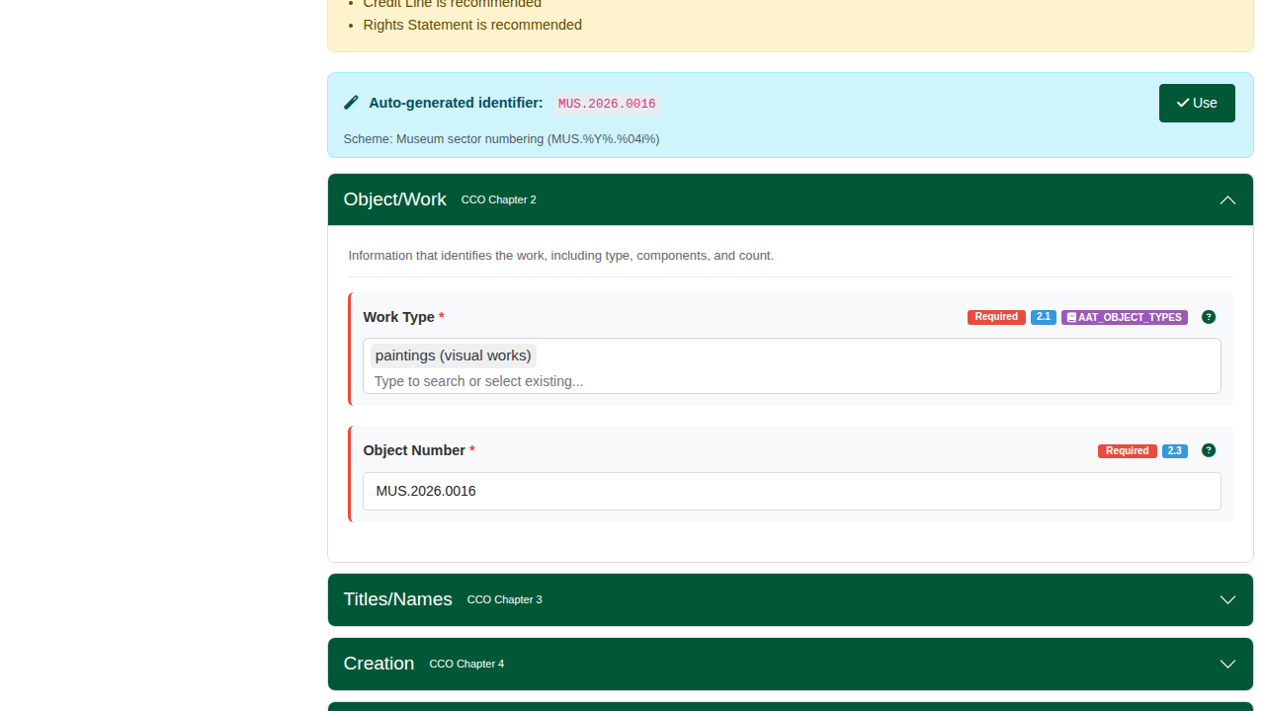
A Getty term for the work type.
Under Creation, give the creator’s name as it should be displayed, choose the authority record it links to, the role (painter) and the date as it should be displayed (1934). Earliest and latest dates are recommended for searching by date.
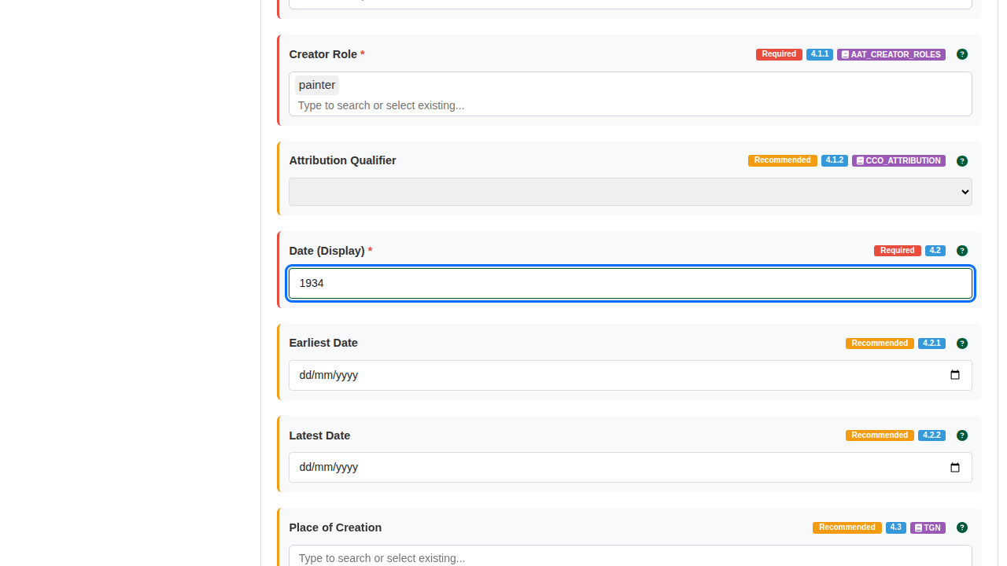
Creation.
Under Measurements and Materials/Techniques, write the dimensions and medium as they would appear on a label (45 x 60 cm, Oil on canvas) and index the Support (canvas). A term that is not yet in the local list is added when you choose it. Under Current Location, choose the Repository.
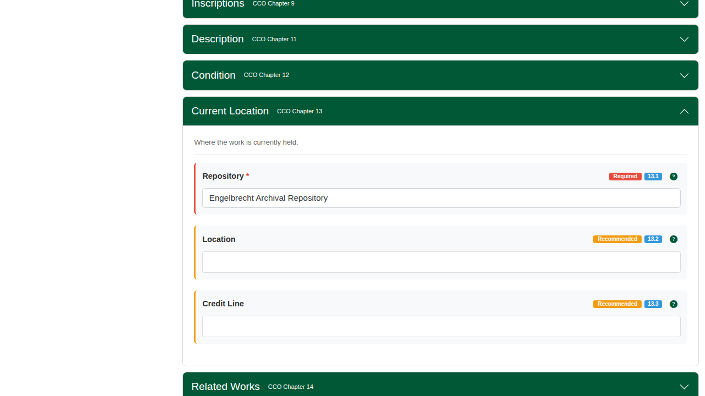
Current location.

4. The catalogue record
Click Save. The record’s Museum object information shows the object number, the work type with its Getty term, the creator linked to the authority record, the date, the dimensions, the medium and the repository.
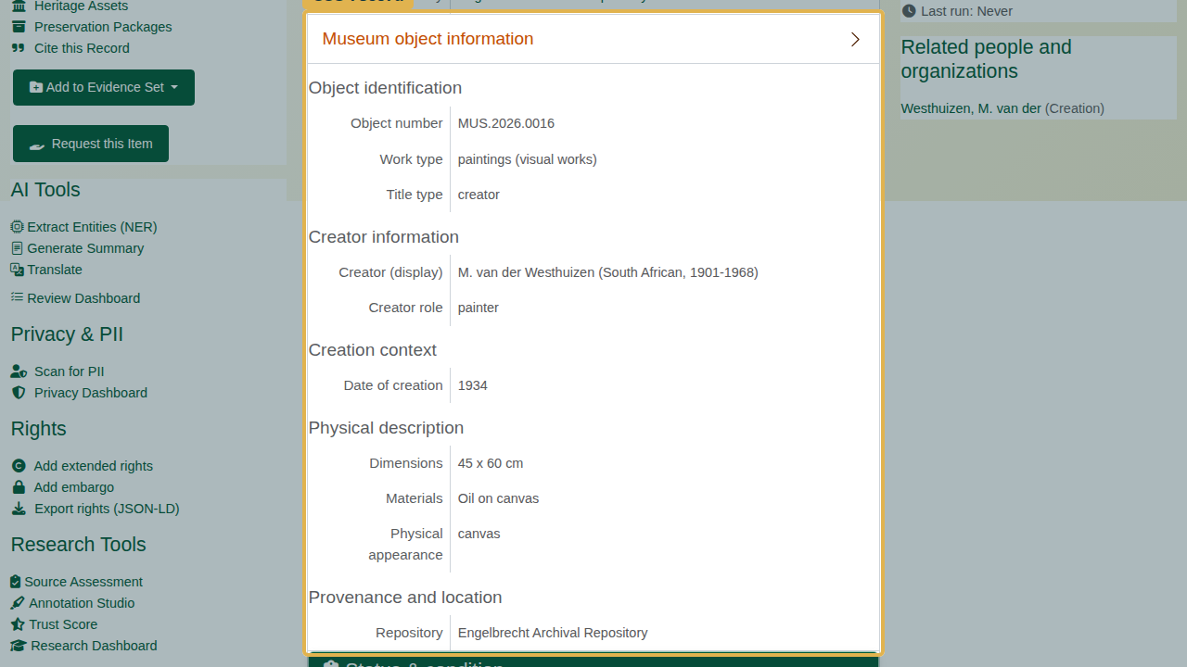
The catalogue record.

Recap
- Choose the template that fits the object.
- Fill the required fields; the record will not save without them unless you choose Save anyway.
- Use the Getty term for the work type.
- Link the creator to an authority record.
Part 2 covers the Spectrum collections procedures.

