Training: Excel Import and Grid Entry
Step-by-step guide to adding many records at once, from an Excel workbook or by typing and pasting into the grid
Dr Johan Pieterse
Document control
Field | Value
Document title | Training: Excel Import and Grid Entry
Author | Dr Johan Pieterse
Owner | The Archive and Heritage Group (Pty) Ltd
Version | 1.0
Status | Released
Date | 9 October 2026
Prepared for | AtoM users of the AHG extensions
Classification | Public
Reference | AHG-TRN-INGEST-02
Contents
Right-click and choose Update Field to build this list.
List of Tables
Right-click and choose Update Field to build this list.
This guide goes with the training video of the same name (watch on YouTube). It covers two ways to add many descriptions at once. Part one imports an Excel workbook under a new fonds. Part two adds more records to that fonds through Grid entry, by typing, pasting from Excel, and duplicating rows. On the way you meet one deliberate mistake, a date typed day first, and fix it.
Allow about 20 minutes with the practice files.

Before you start
What you need before you start
What | Where to check
An administrator account | The AHG Plugins menu (stacked cubes icon in the top bar) only appears for administrators. Grid entry itself is open to editors, but its menu entry is in the AHG Plugins menu.
Data Ingest enabled | AHG Plugins menu > Data Ingest. If the section is missing, ask your system administrator to enable ahgIngestPlugin.
The practice workbooks | rosch-family-papers-practice.xlsx and rosch-grid-rows-practice.xlsx, in docs/training-files/ of the AHG extensions catalogue.
Use a test or training instance if you have one; see “Cleaning up” at the end.

1. The workbook
Open rosch-family-papers-practice.xlsx. Each row is one record. The heading row uses AtoM’s own field names, which is how Data Ingest recognises the columns without any mapping work.
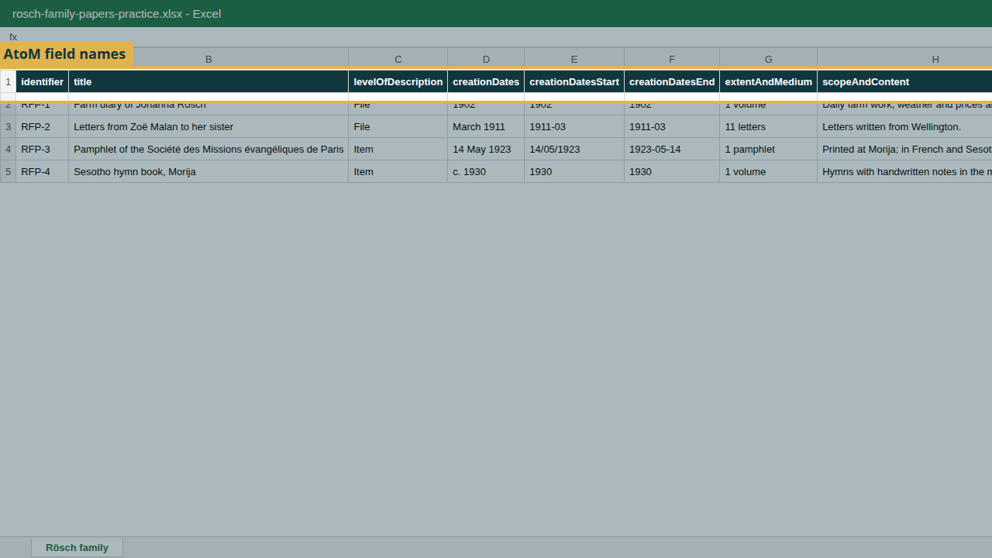
The practice workbook: one row per record, AtoM field names as headings.
Columns in the practice workbook
Column | What it holds | Required
identifier | The reference code segment | Recommended
title | Title of the description | Yes
levelOfDescription | Fonds, Series, File, Item and so on | Yes
creationDates | The date as people should read it, any wording (“March 1911”, “c. 1930”) | No
creationDatesStart | Start date for sorting and searching: YYYY, YYYY-MM or YYYY-MM-DD | No
creationDatesEnd | End date, same formats | No
extentAndMedium | Extent and medium | No
scopeAndContent | Scope and content | No
Two points worth knowing:
- Accents are safe in a workbook. Rösch, Zoë and Société arrive exactly as typed. There is no need to save as CSV first; upload the .xlsx itself.
- Start and end dates are always year first. A year (1902) becomes the whole year, a year and month (1911-03) the whole month. On import, 1902 is stored as 1 January to 31 December 1902.
The deliberate mistake: on the pamphlet row (RFP-3), the start date was typed day first, 14/05/1923. AtoM cannot be sure what that means, so it warns you.
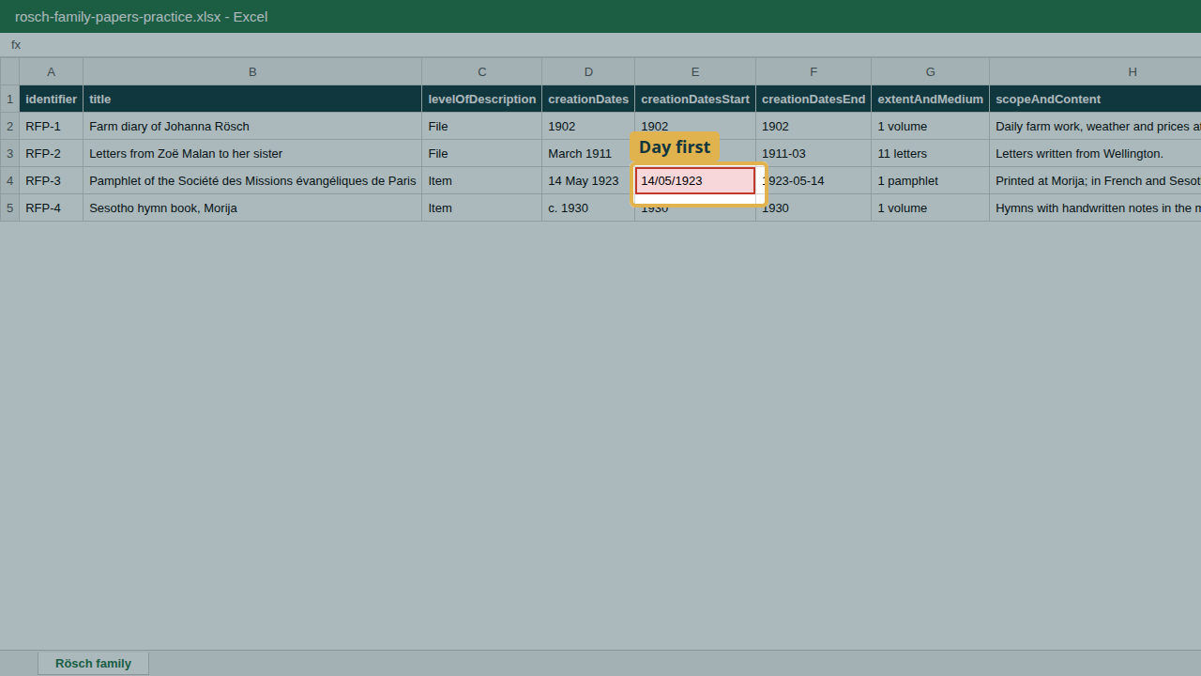
The pamphlet row: its start date was typed day first.

2. Import the workbook
- Open the AHG Plugins menu and, under Data Ingest, choose New Ingest.
- Enter a Session Title, choose the Sector (Archive), the Descriptive Standard (ISAD(G)) and the Repository.
- Under Hierarchy Placement, choose Create a new parent record. Enter the New parent title (“Rösch Family Papers (training)”) and the Level of description (Fonds). Every row in the workbook is placed under this new fonds.
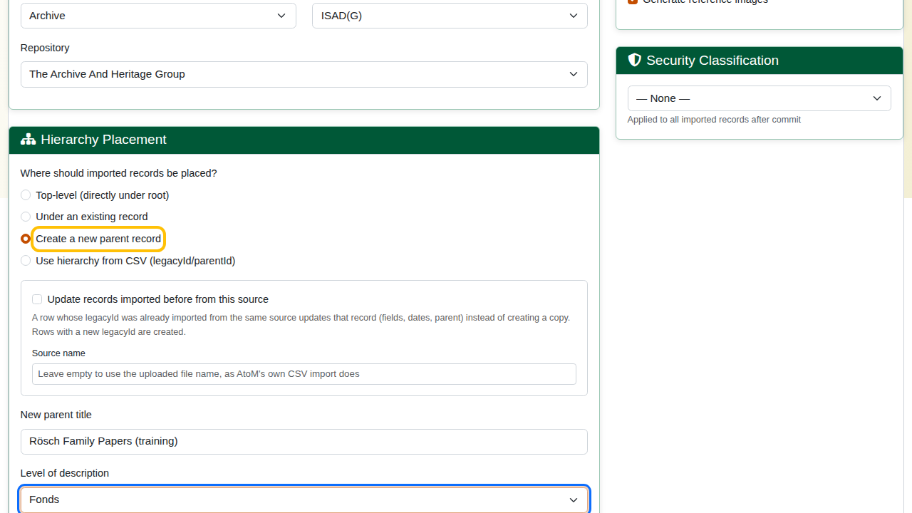
Create a new parent record, with its title and level.
If the records belong under a description that already exists, choose Under an existing record instead and search for it.
- Click Next: Upload Files, choose the workbook and click Upload.
- Check the Column Mapping: every column maps itself. Click Save Mappings & Validate.
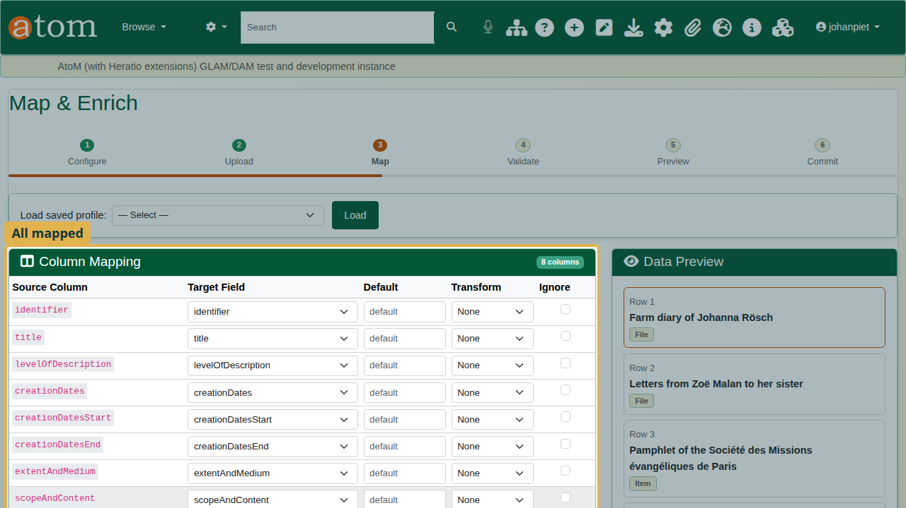
Every column mapped to its AtoM field.

3. Validate and fix the warning
Validation reports 4 rows, 4 valid, and 1 warning on row 3, field creationDatesStart: “Date ‘14/05/1923’ may not be in a recognized format (YYYY-MM-DD preferred)”.
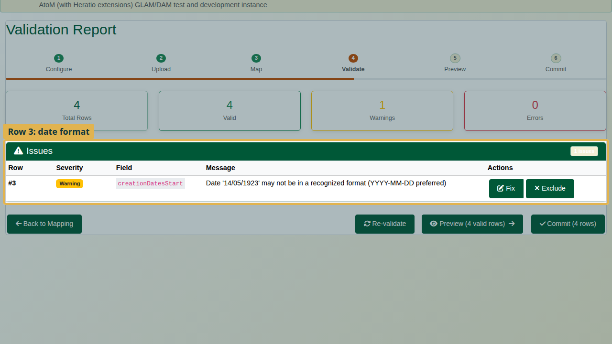
Validation: four valid rows and one warning on row 3.
A warning does not stop the import, but always read it. Imported unchanged, an ambiguous date can be stored wrongly, or not at all.
- Click Fix on the row.
- Type the date year first: 1923-05-14.
- Click Apply Fix. The warning is gone.
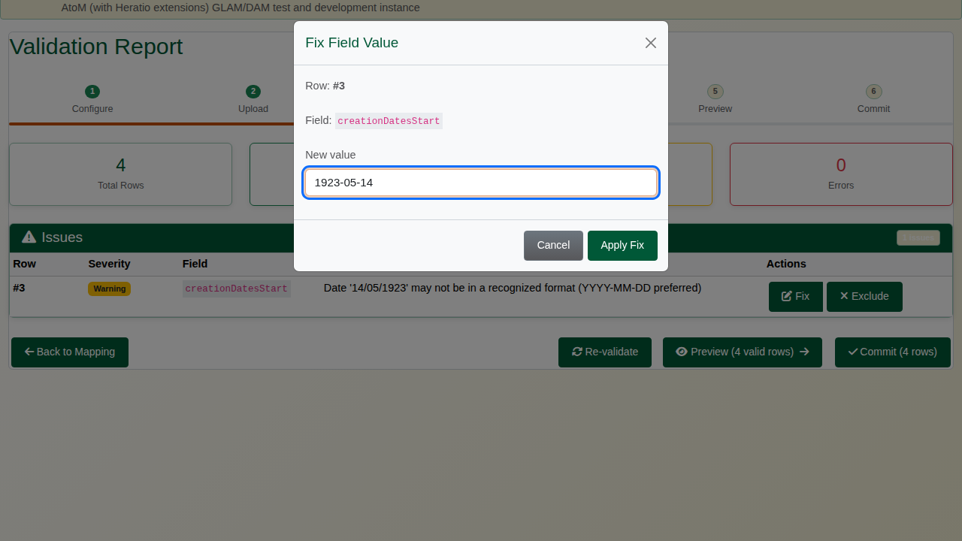
The Fix Field Value dialog with 1923-05-14.
Correct the workbook as well, so that the next import is clean.

4. Preview and commit
Click Preview and Expand All. The new fonds holds the four records; check the titles and their accents.
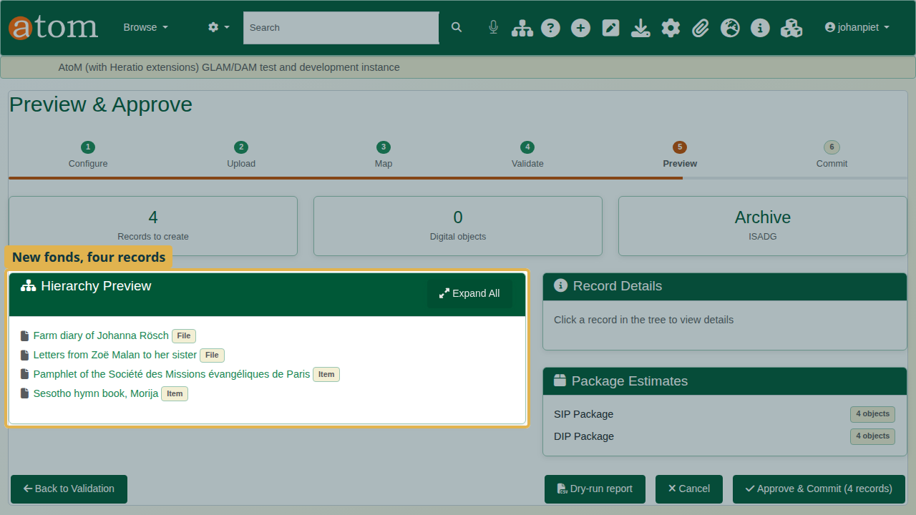
Preview: the four records under the new fonds.
Click Approve & Commit, then Start Commit. The completion report shows the records created.
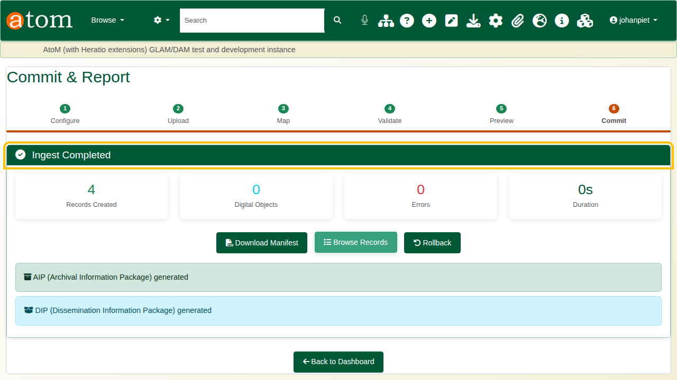
Ingest Completed.

5. Grid entry
For a handful of records, Grid entry is quicker than preparing a file.
- Open the AHG Plugins menu and, under Data Ingest, choose Grid entry.
- Choose the parent. Type at least two letters of its title and pick the fonds you have just imported. Its existing records are listed under “Existing descriptions under this parent”, so you can see what is already there.
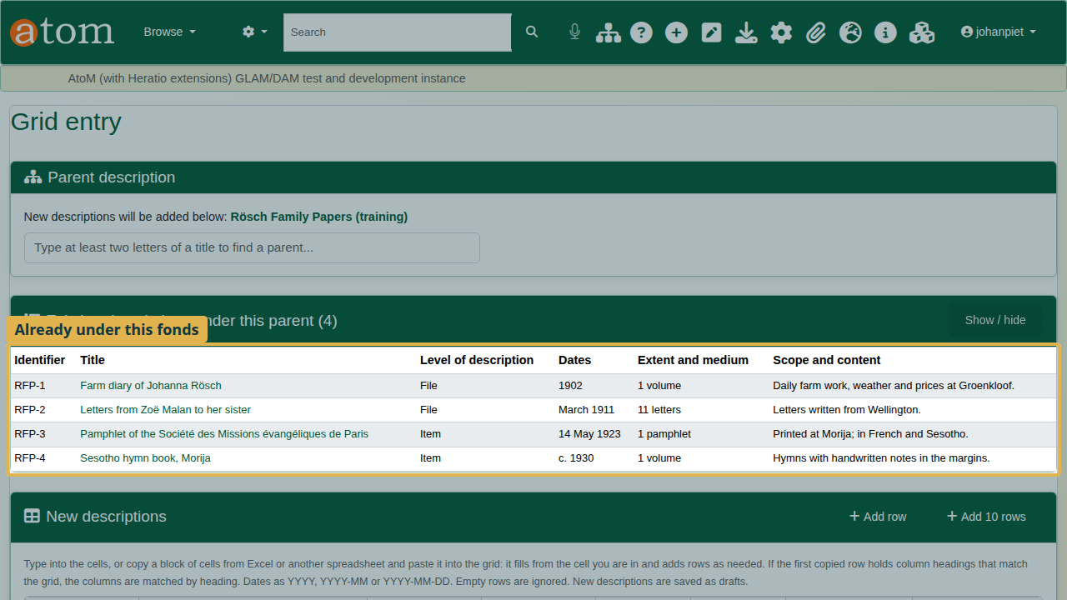
Grid entry with the fonds chosen and its existing records listed.
- Type a row. Each grid row is one new record. Click a cell and type; press Tab to move to the next cell.
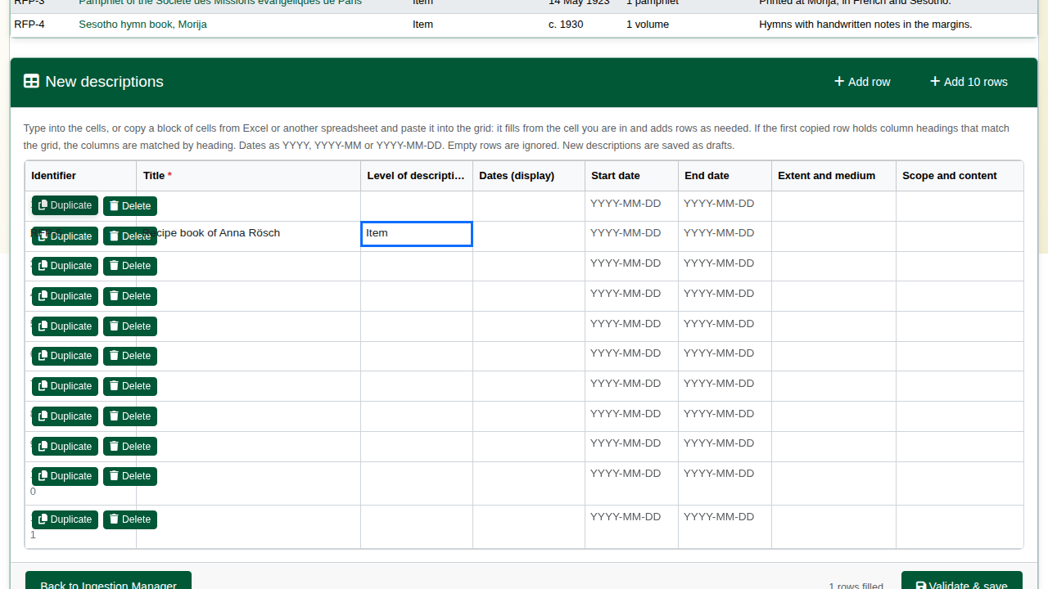
A row typed into the grid.
- Paste from Excel. Open rosch-grid-rows-practice.xlsx, select the cells including the heading row, and copy. In the grid, click the first cell of an empty row and paste (Ctrl+V). Each column lands in its own field, because the heading row tells the grid which column is which.
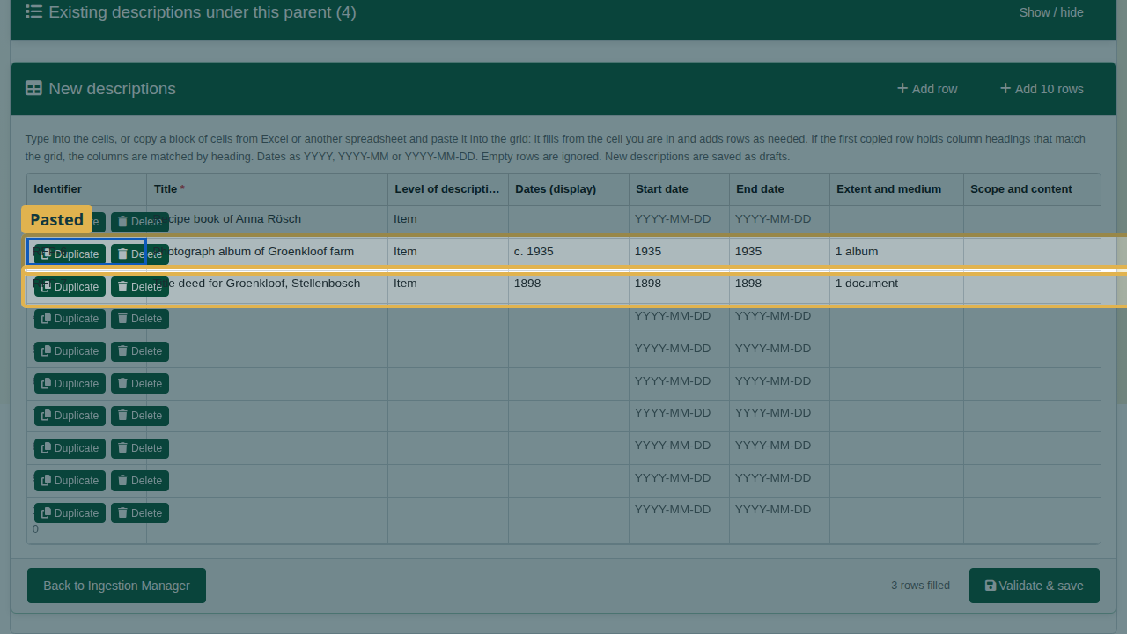
Two rows pasted from Excel.
- Duplicate copies a row below itself, which saves typing when records are alike. Change what differs; in the video, the identifier (RFP-8) and the title.
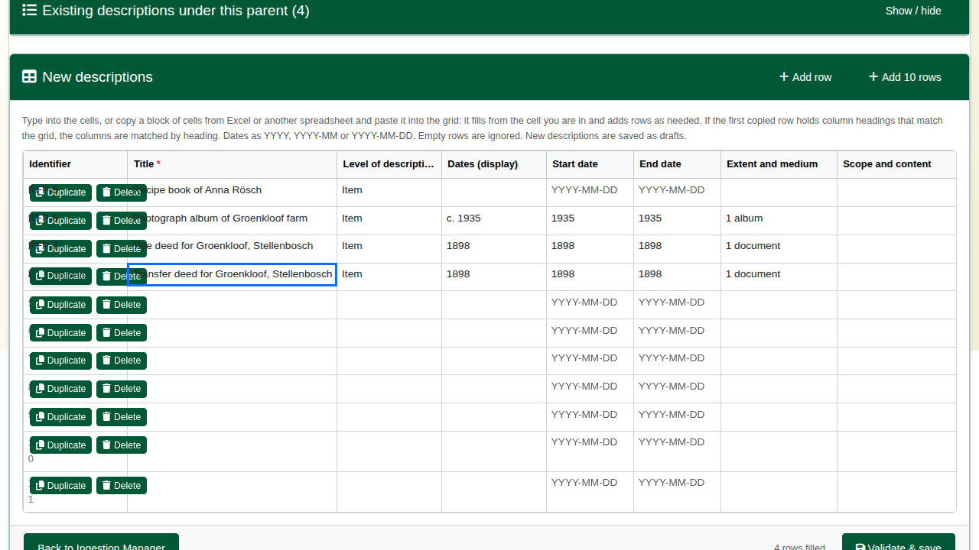
A duplicated row, with the identifier and title changed.
- Delete removes a row you do not need. Empty rows are ignored anyway.
- Click Validate & save. Nothing is saved before this. The rows go through the same checks and the same commit as an import.

6. Check the result
On the completion page, click Browse Records. Descriptions are listed newest first, so the fonds is at the top. Open it: the tree shows the four imported records and the four added in the grid.
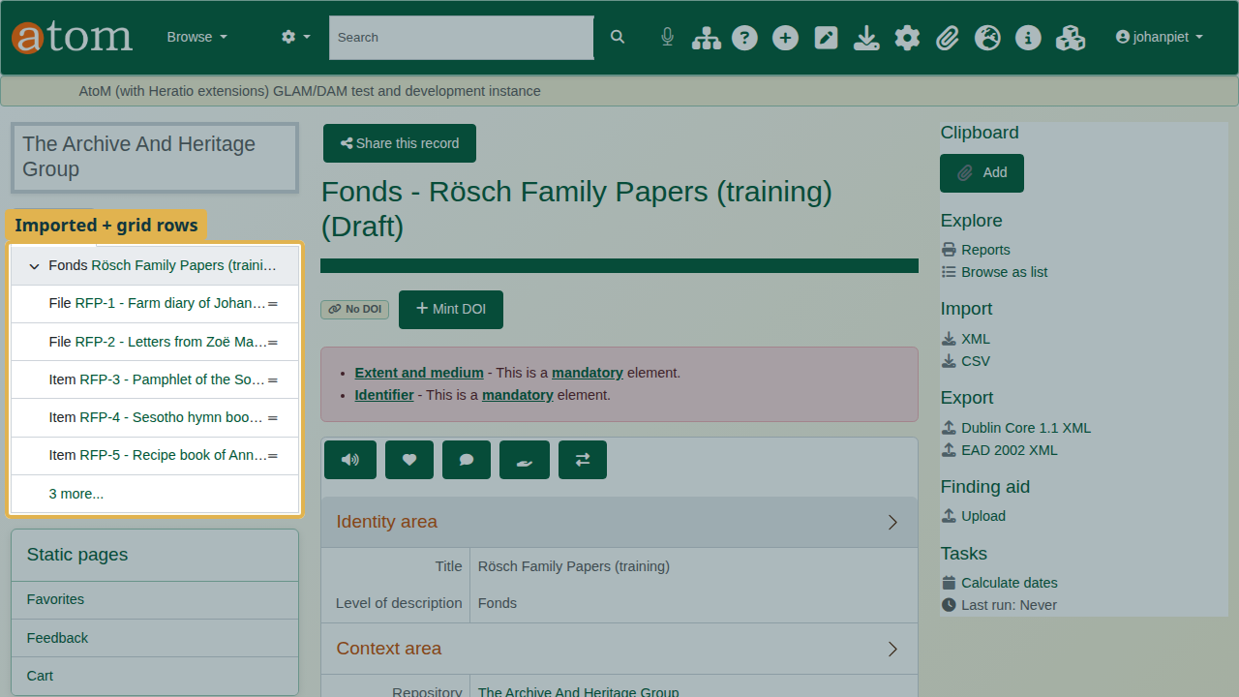
The fonds with the imported and grid records in the tree.
Like every import, the records are drafts until you publish them: on the fonds, choose More > Update publication status and apply it to the descendants as well.

Common warnings
Common validation warnings
Message | Cause | What to do
Date ‘…’ may not be in a recognized format | A date not written year first | Fix it as YYYY, YYYY-MM or YYYY-MM-DD
Level of description ‘…’ may not be recognized | A typo, or a level your site does not use | Fix it; otherwise the record is saved with no level of description
Required field ‘title’ is empty | A row with no title | Fix it, or Exclude the row

Recap
- Headings are AtoM field names; start and end dates are written year first.
- Import the workbook with New Ingest, under a new or an existing parent.
- Read every warning; fix it at validation and in your file.
- For a few records, use Grid entry: choose the parent, then type or paste.
- Duplicate and Delete rows as needed, then Validate & save.

Cleaning up
To remove the practice records, open the fonds and choose Delete. AtoM deletes the records under it as well.

