Training: Research Portal, Part 5 - Reproduction Requests
Step-by-step guide to requesting copies of records, and to triaging and completing requests as staff
Dr Johan Pieterse
Document control
Field | Value
Document title | Training: Research Portal, Part 5 - Reproduction Requests
Author | Dr Johan Pieterse
Owner | The Archive and Heritage Group (Pty) Ltd
Version | 1.0
Status | Released
Date | 10 October 2026
Prepared for | Researchers and reading-room staff using the AHG extensions
Classification | Public
Reference | AHG-TRN-RES-05
Contents
Right-click and choose Update Field to build this list.
List of Tables
Right-click and choose Update Field to build this list.
This guide goes with part 5 of the research portal training videos. A researcher asks for copies of two records. Staff then triage the request from the Requests Dashboard, keep the correspondence with it, and close it once it is fulfilled. Allow about 15 minutes.

Before you start
What you need before you start
What | Notes
An approved researcher account | See part 1.
A staff account | An administrator or editor processes requests. Researchers see only their own requests; only staff see everyone’s.

1. Make a request (researcher)
From the research sidebar, open Reproduction Requests and click New Request.
Request details
Field | Choices
Purpose of Reproduction | Academic research, publication, exhibition, documentary/film, personal use, commercial use, other
Intended Use | How the copies will be used
Publication Details | Title, publisher and date, for publication or commercial use
Delivery Method | Digital download, email, physical copy (post), collect in person
Urgency | Normal (10-15 working days), high (5-7), rush (2-3, additional fee)
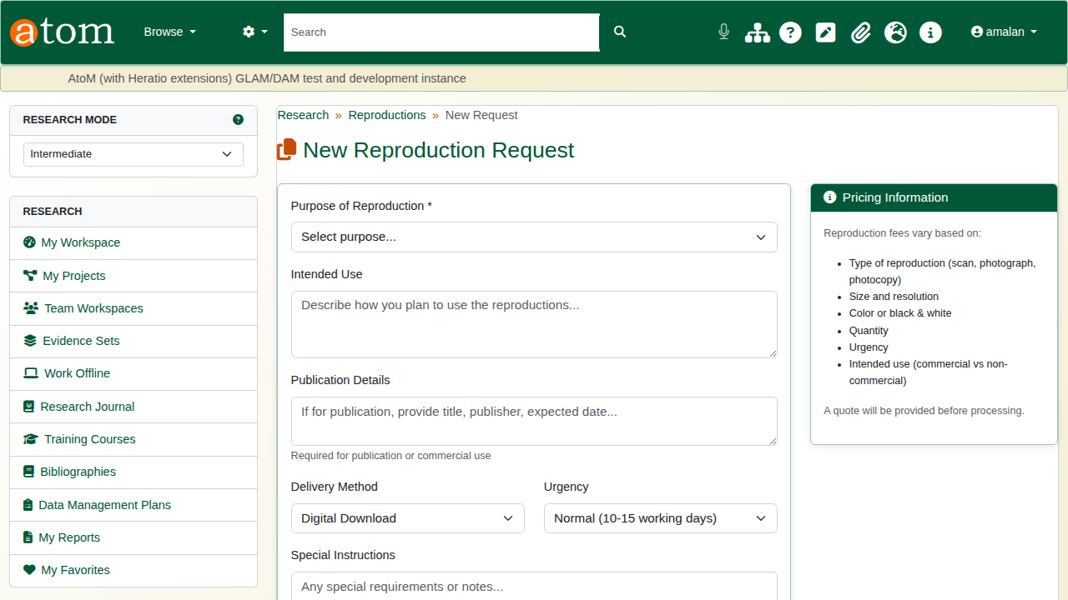
A new reproduction request.
Under Optional: Add First Item, search the archive for the first record, and choose the type of copy, the format and any specifications.
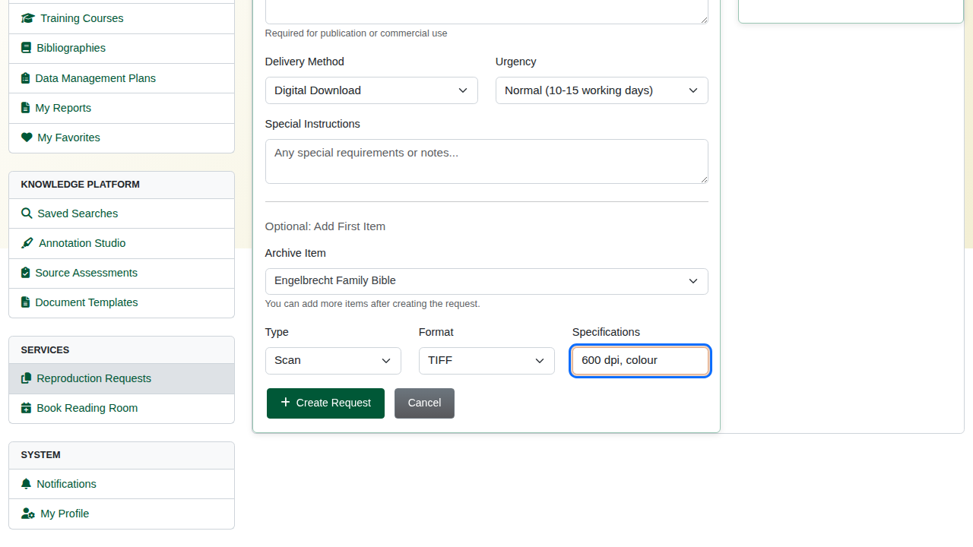
The first item: a 600 dpi TIFF scan.
Click Create Request. The request is saved as a draft with its own reference number, so more items can be added before it is sent.
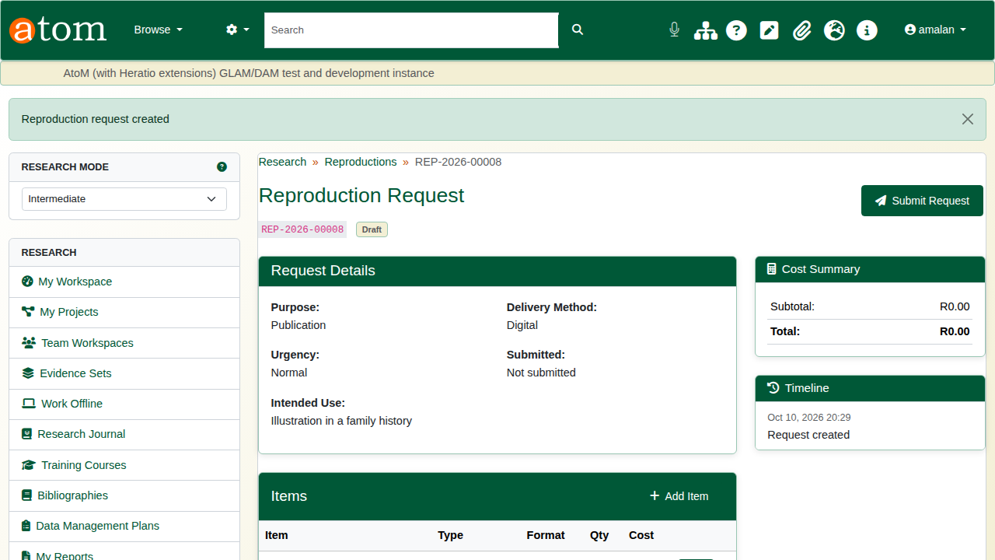
The draft request.
The deliberate mistake: click Add Item and add it without choosing a record. The form refuses an item that is not in the archive.
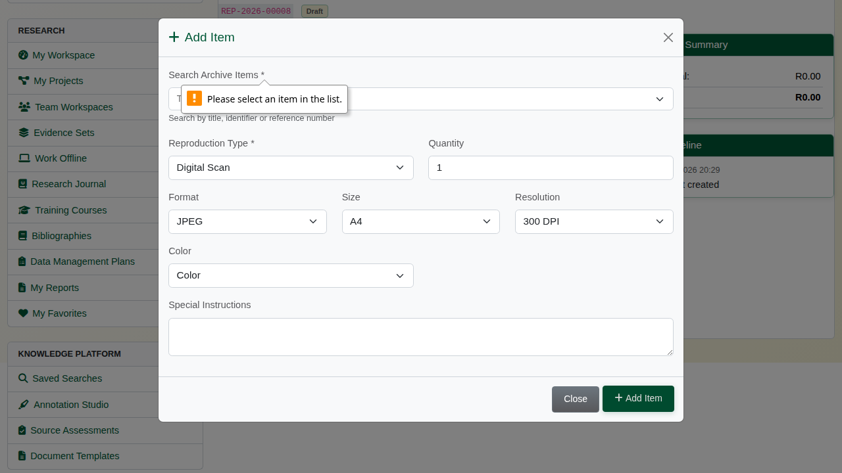
An item must be a record in the archive.
Search for the record, choose the reproduction type (digital scan, photograph, photocopy, microfilm, certified copy), format, size, resolution and colour, and click Add Item.
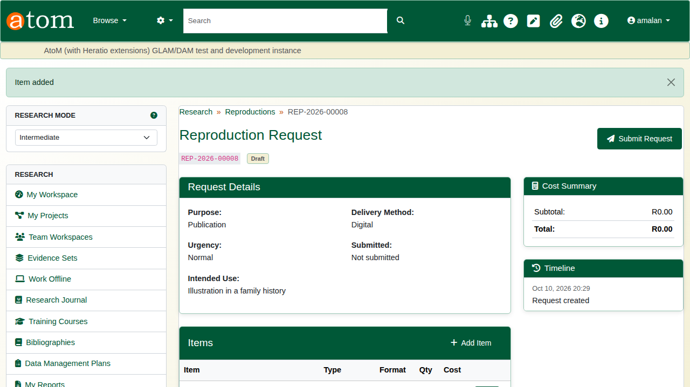
Two items.
Click Submit Request. The status changes to submitted, the date is recorded, and the archive is notified by email.
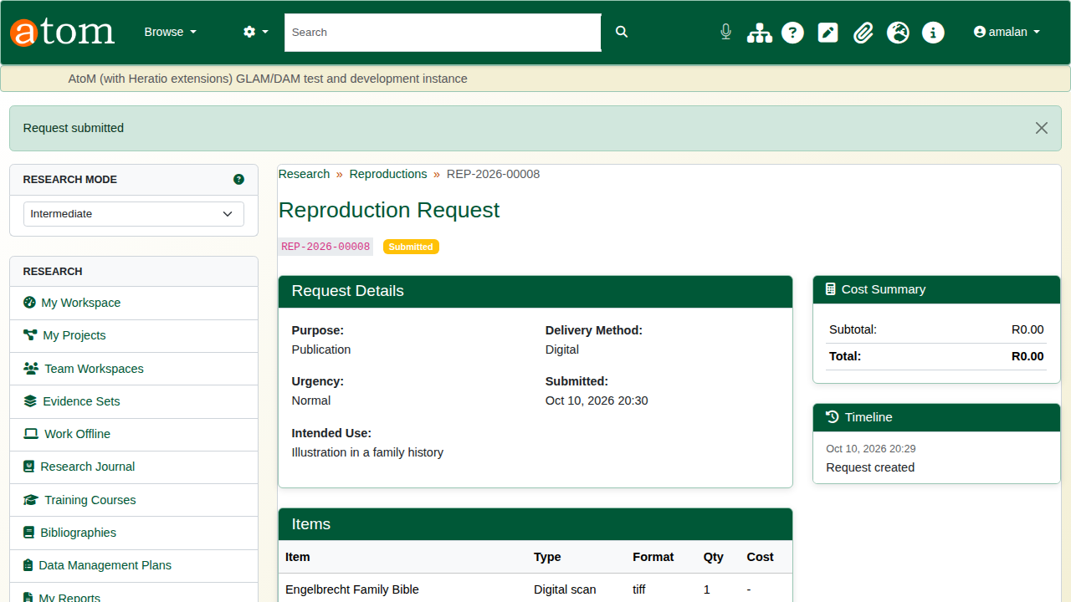
Submitted.

2. Review and complete (staff)
Open the Requests Dashboard (/research/requests-dashboard). Material requests and reproduction requests are listed side by side, each with its status, triage state and service-level clock.
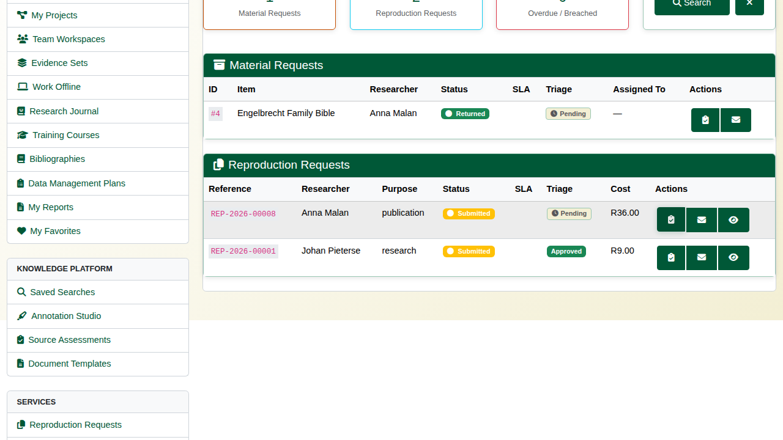
The Requests Dashboard.
Click Triage on the request. It shows who is asking, why, and for what. Choose Approve, Deny or Needs Information, add a note, and click Submit Decision.
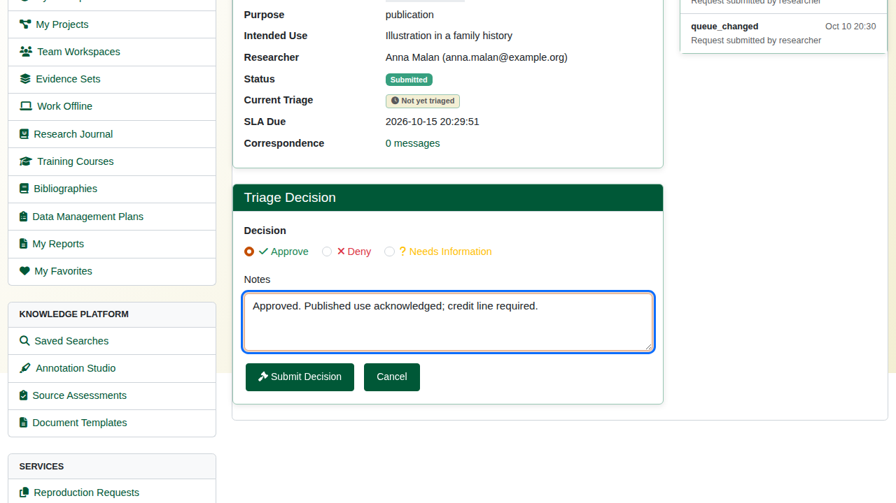
Triage: approve with a note.
Click Correspondence to keep a record of what was said about the request. Tick Internal note for notes meant only for staff. The correspondence is kept with the request; it is not emailed to the researcher.
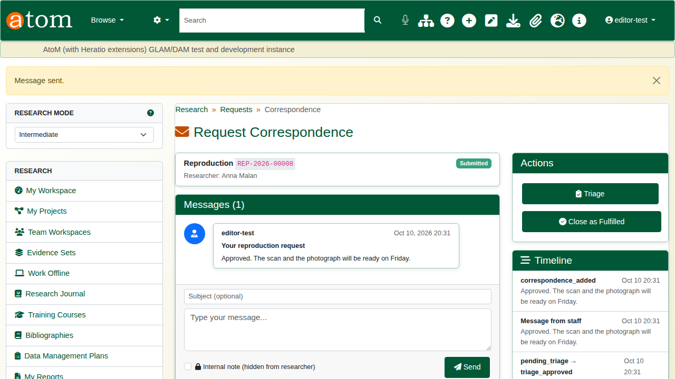
Correspondence on the request.
When the copies have been delivered, click Close as Fulfilled. The request becomes completed.
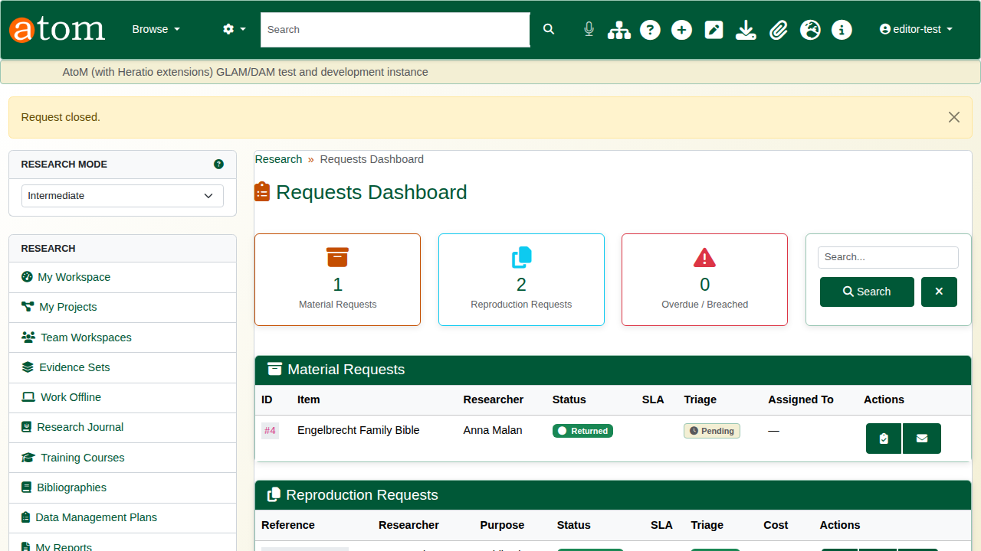
Closed.

3. The researcher’s view
The researcher’s request now shows Completed, with each step in its timeline.
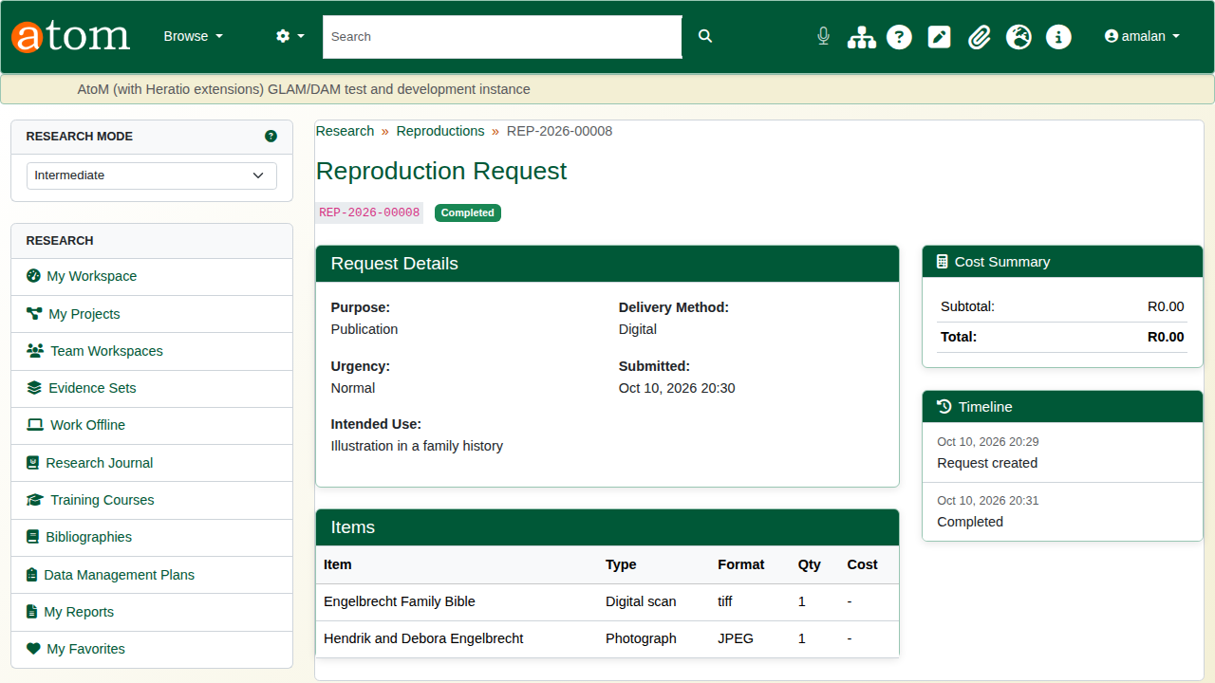
The completed request.

Recap
- Create a request and say why the copies are needed.
- Add each record and the kind of copy wanted.
- Submit it.
- Staff triage it from the Requests Dashboard.
- Keep the correspondence with it, and close it when fulfilled.
Part 6 covers researcher submissions.

