Training: Research Portal, Part 6 - Researcher Submissions
Step-by-step guide to offering records to the archive: building a submission, the two-step review, and publishing into the catalogue
Dr Johan Pieterse
Document control
Field | Value
Document title | Training: Research Portal, Part 6 - Researcher Submissions
Author | Dr Johan Pieterse
Owner | The Archive and Heritage Group (Pty) Ltd
Version | 1.0
Status | Released
Date | 11 October 2026
Prepared for | Researchers and archivists using the AHG extensions
Classification | Public
Reference | AHG-TRN-RES-06
Contents
Right-click and choose Update Field to build this list.
List of Tables
Right-click and choose Update Field to build this list.
This guide goes with part 6, the last of the research portal training videos. A researcher who holds records of her own, family letters for instance, describes them and offers them to the archive. The archive reviews the submission in two workflow steps, then an administrator publishes it as archival descriptions with the files attached. Allow about 20 minutes.

Before you start
What you need before you start
What | Notes
An approved researcher account | See part 1. Researchers see only their own submissions.
A reviewer and an administrator | Staff claim and approve the review steps; only an administrator can publish.
The practice file | engelbrecht-letter-1912-practice.jpg in docs/training-files/ of the AHG extensions catalogue: a practice image of a letter.

1. Build a submission (researcher)
From the user menu, choose My Submissions, then New Submission. Give it a title and a description, and choose the Target Repository that should keep the records. A submission can also be linked to a research project or placed under an existing record. Click Create Submission.
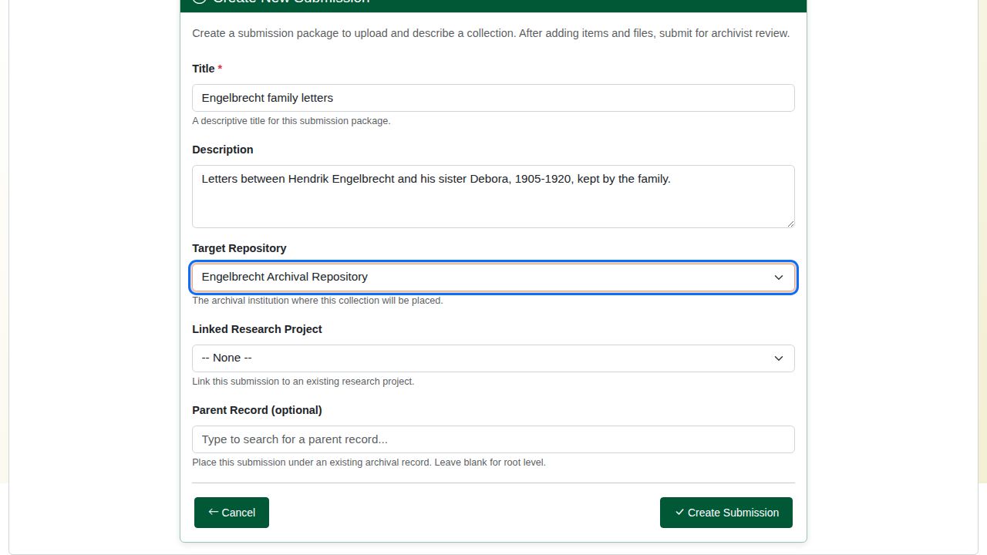
A new submission.
The submission is a draft. Submit for Review stays disabled until it holds at least one description.
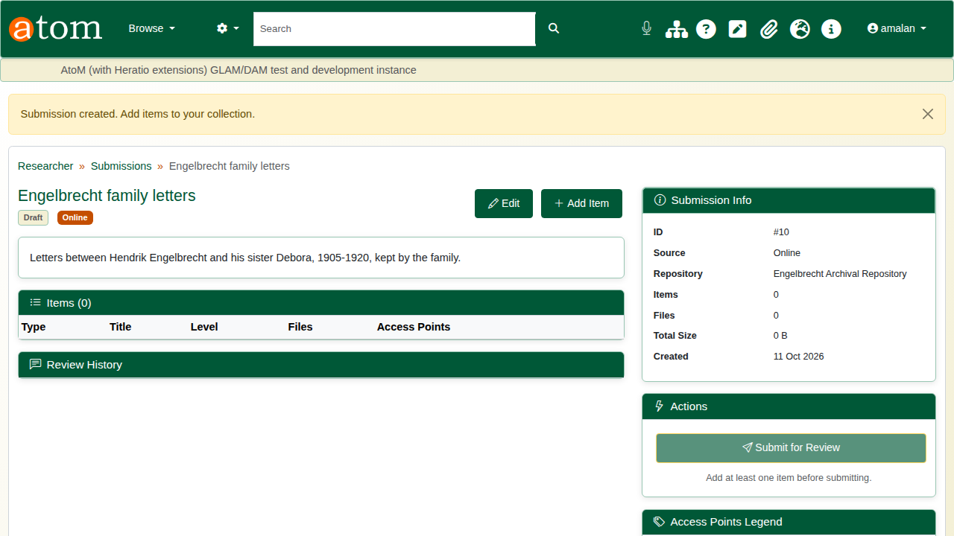
The draft submission.
Click Add Item. The item form follows ISAD(G): type, parent item (for a hierarchy), title, identifier, level of description, dates, extent and medium, scope and content, creators, subjects, places, genres, access and reproduction conditions, and notes.
The deliberate mistake: an end date before the start date. On Save the form comes back with “The end date is before the start date”. Everything typed is kept, so correct the date and save again.
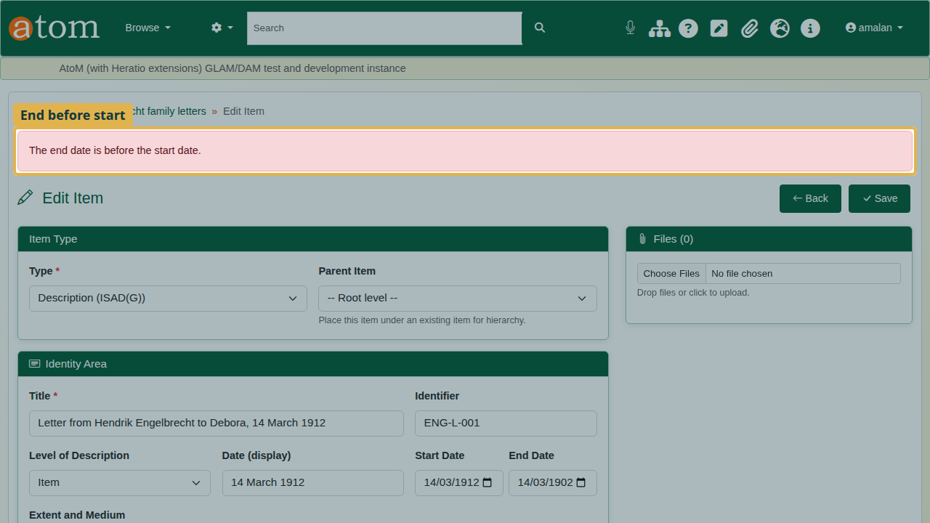
The dates refused, everything kept.
Once the item is saved, Files accepts uploads. Each file is stored with a SHA-256 checksum, so the archive can show it has not changed.
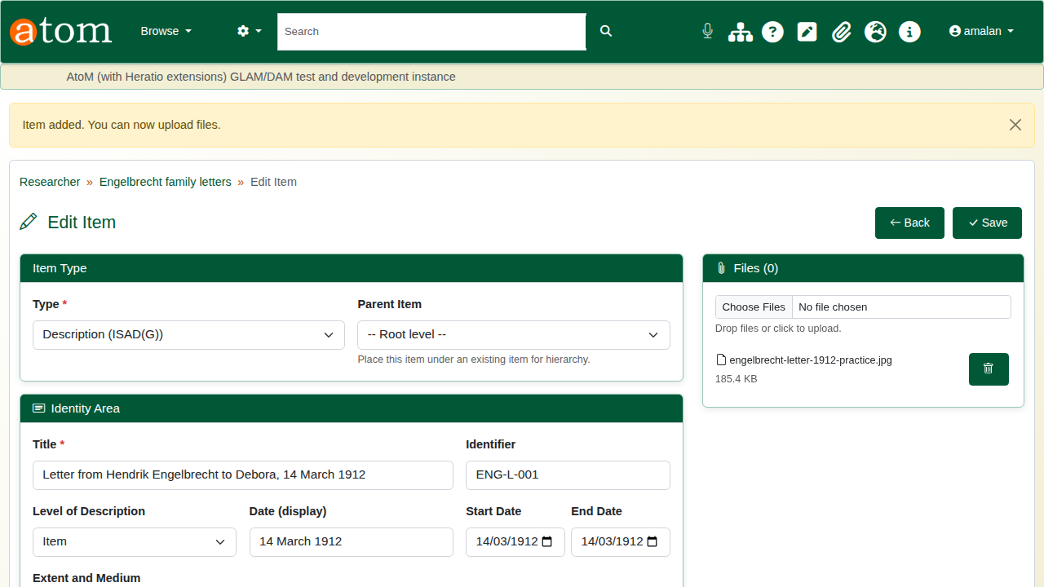
The scan attached.
Back on the submission, click Submit for Review. The submission is locked while it is reviewed.
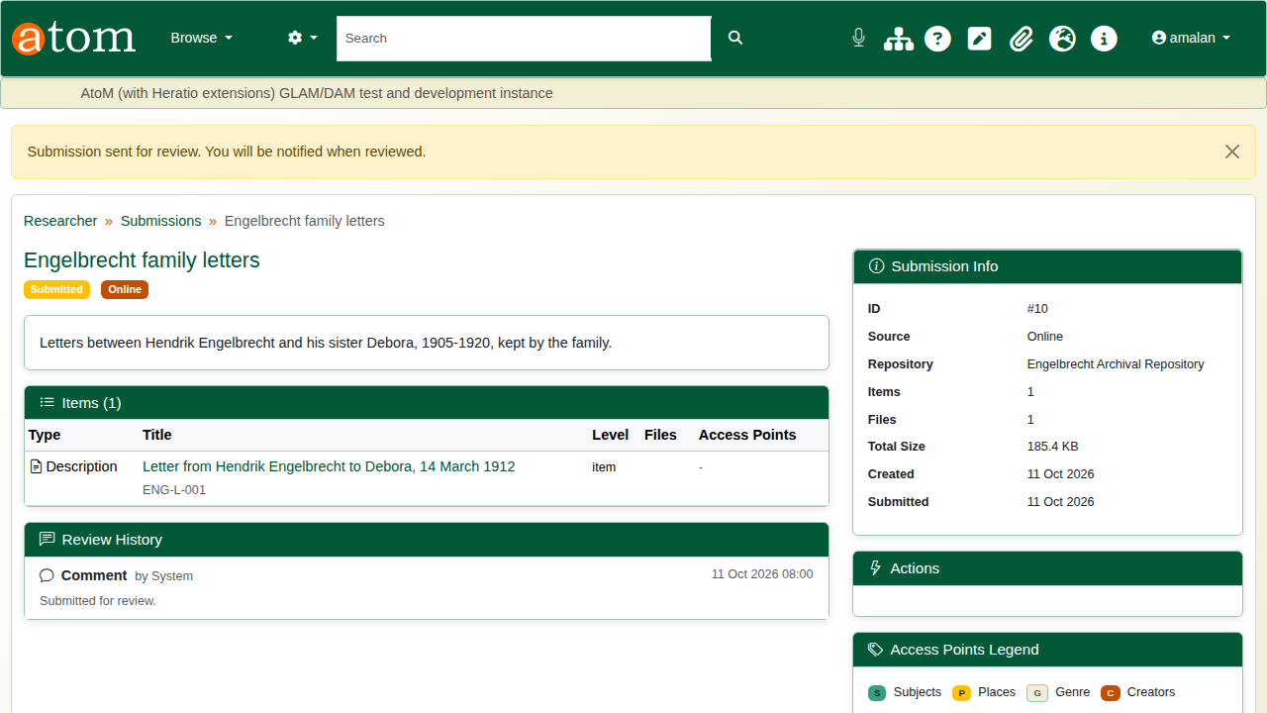
Submitted for review.

2. Review and approve (staff)
Submissions go through the Researcher Submission Review workflow, which has two steps: Content Review and Publication Approval. Open the workflow Task Pool (/workflow/pool) and click Claim Task on the submission.
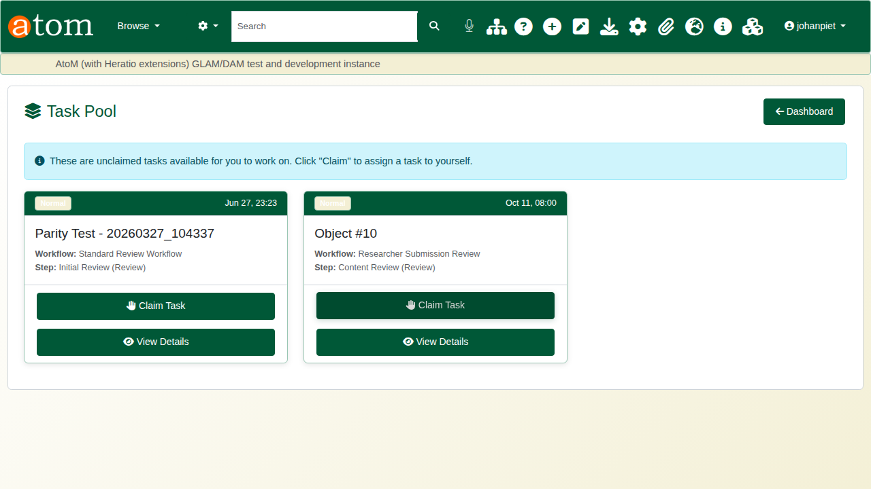
The task pool.
Read the instructions, check the description, write a comment and click Approve. Reject returns the submission to the researcher, who can correct and resubmit it.
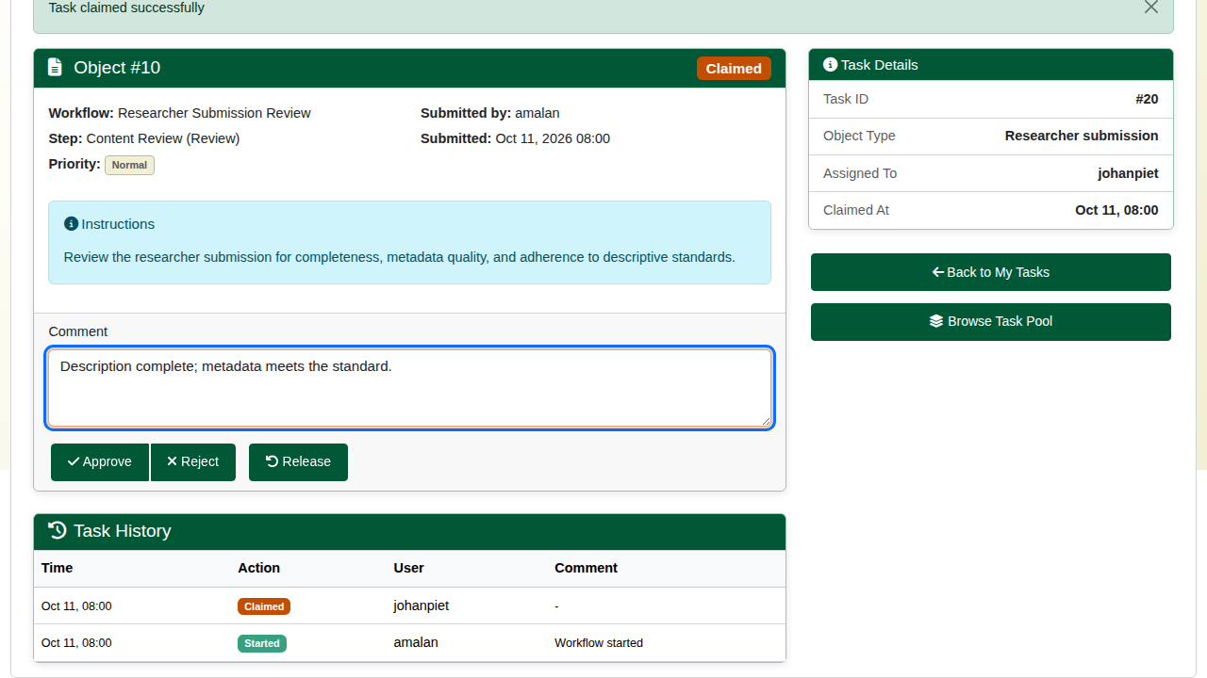
Content review.
The second step, Publication Approval, appears in the pool. Claim and approve it the same way.
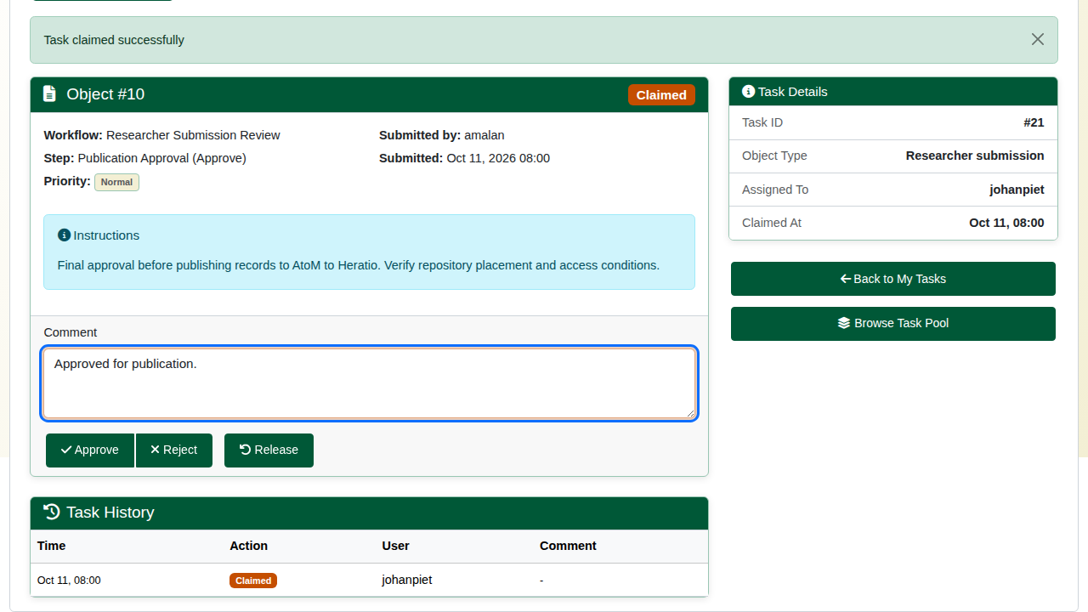
Publication approval.

3. Publish (administrator)
The submission is now approved. On the submission, click Publish to AtoM. The confirmation page summarises what will be created, because publishing makes permanent records. Click Publish Now.
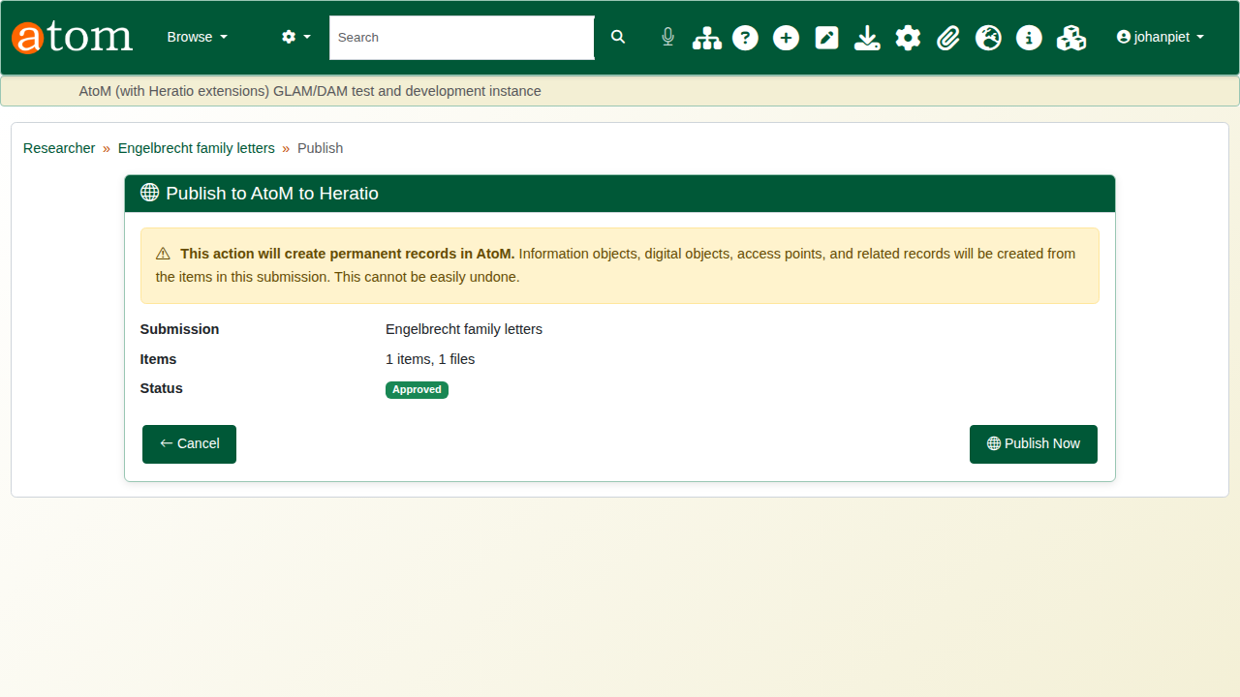
Publish to AtoM.
Publishing creates the archival descriptions in the chosen repository, with their dates and access points. Each attached file becomes a digital object with a reference image and a thumbnail. The new records are published and searchable straight away. Each item is created whole or not at all: if one fails, nothing half-made is left behind, and the error is listed.
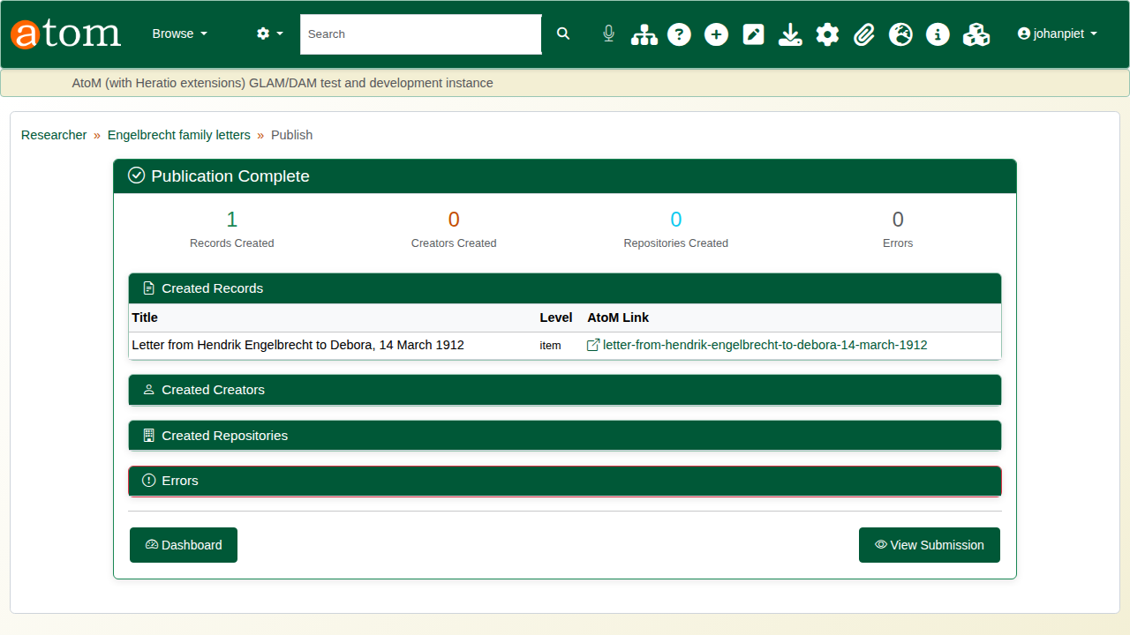
Publication complete.
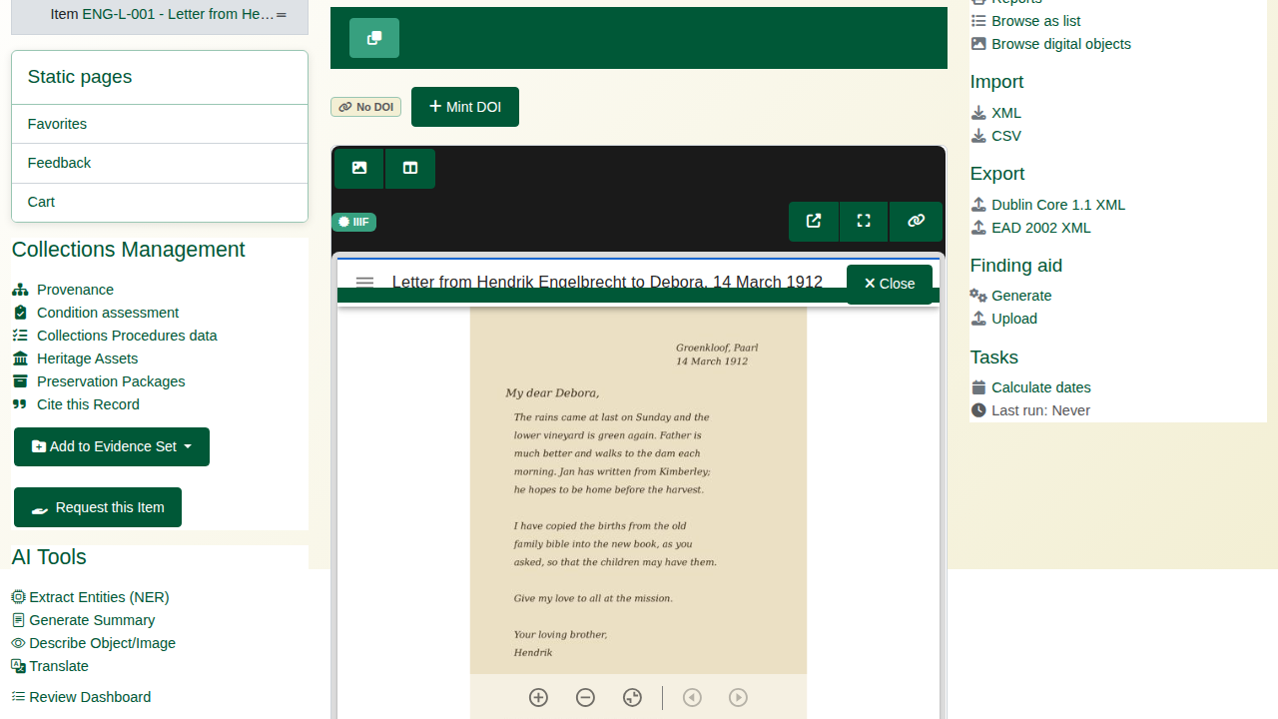
The new record with the letter attached.
The researcher sees the submission as published, with its review history.
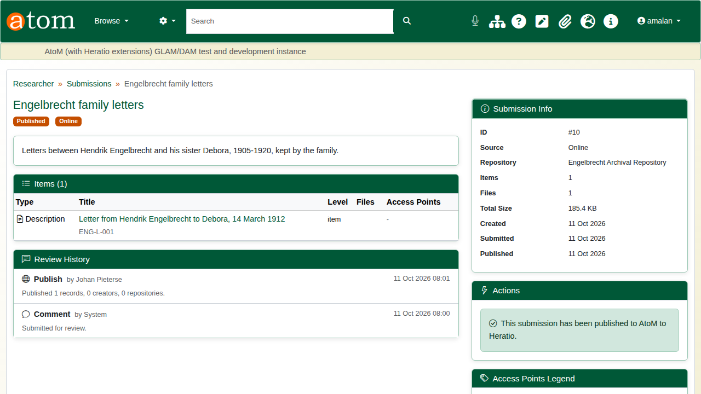
The researcher’s view.

Recap
- Create a submission and choose the repository.
- Describe each item; the dates are checked.
- Attach the files.
- Submit; staff approve it in two workflow steps.
- An administrator publishes it into the catalogue.
This completes the research portal series.

