Training: Museum, Part 6 - Heritage Accounting
Step-by-step guide to recognising a heritage asset under GRAP 103, recording revaluations and impairments, checking compliance, and producing the asset register and National Treasury report
Dr Johan Pieterse
Document control
Field | Value
Document title | Training: Museum, Part 6 - Heritage Accounting
Author | Dr Johan Pieterse
Owner | The Archive and Heritage Group (Pty) Ltd
Version | 1.0
Status | Released
Date | 14 October 2026
Prepared for | Finance officers, registrars and curators using the AHG extensions
Classification | Public
Reference | AHG-TRN-MUS-06
Contents
Right-click and choose Update Field to build this list.
List of Tables
Right-click and choose Update Field to build this list.
This guide goes with part 6, the last part of the museum training videos. You recognise the painting from part 1 as a heritage asset under GRAP 103, revalue it, record an impairment, check the record against the standard, and produce the reports that auditors and National Treasury ask for. Allow about 20 minutes.

Before you start
What you need before you start
What | Notes
An administrator account | Heritage accounting is a staff function.
A museum object | The painting from part 1.
Fictitious figures | The values, the valuer and the damage in this guide are made up for the practice.

1. Recognise the asset
On the object, under Collections Management, open Heritage Accounting and click Create Heritage Asset Record. The form opens already linked to the object.
Recognising the painting
Field | Example | Notes
Accounting standard | GRAP 103 Heritage Assets | IPSAS 45, IAS 16, FRS 102, GASB 34 and others are available
Asset class | Works of Art
Recognition status and date | Recognised, 12 October 2026
Measurement basis | Fair value | Cost, fair value, nominal, or not practicable
Acquisition method and date | Donation, 12 October 2026
Fair value at acquisition | 85,000
Initial and current carrying amount | 85,000
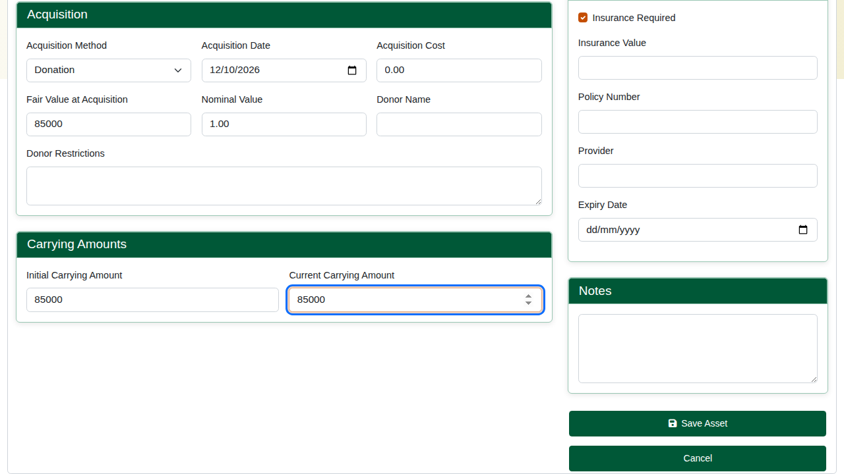
The asset record.
Save. The asset page shows the carrying amount, status, standard and class, with tabs for Valuations, Impairments, Movements and Journal Entries.
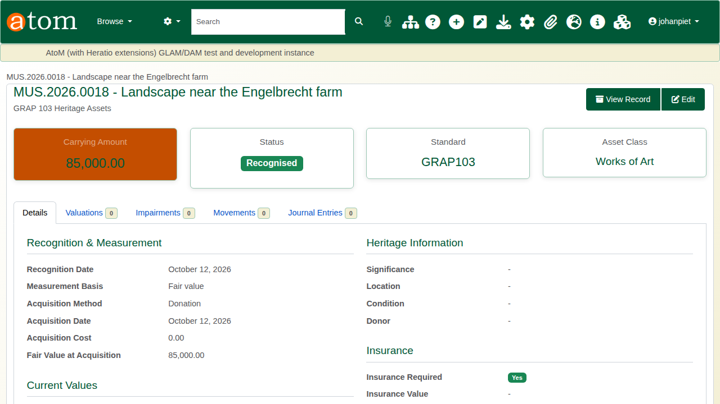
The new heritage asset.

2. Revaluation
On the Valuations tab, add a valuation: the date, the new value, the method (market value, cost approach, income approach, expert opinion, insurance valuation) and the valuer. Under the revaluation model an increase is credited to the revaluation surplus; a decrease is charged against the surplus first.
The example revaluation
Before | Valuation | After
Carrying amount 85,000 | 95,000, expert opinion | Carrying amount 95,000; revaluation surplus 10,000
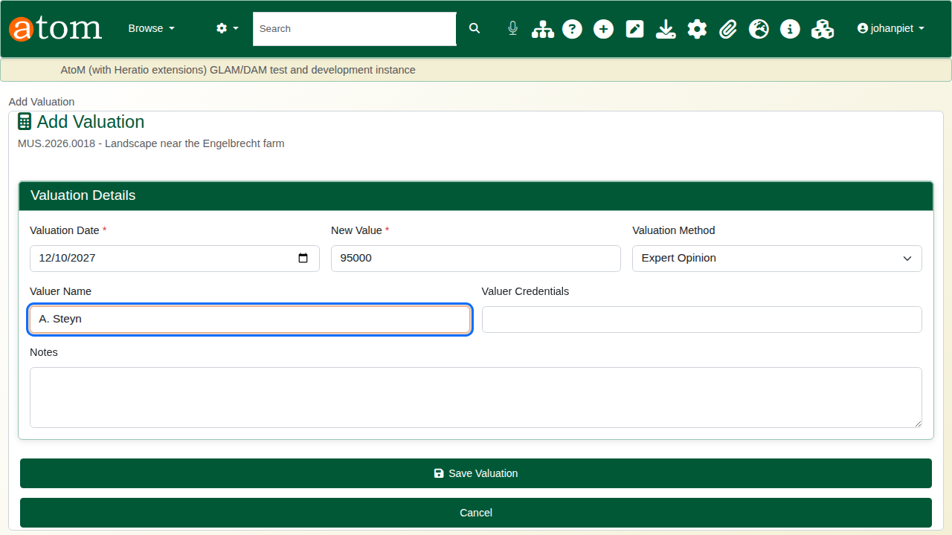
Recording the valuation.
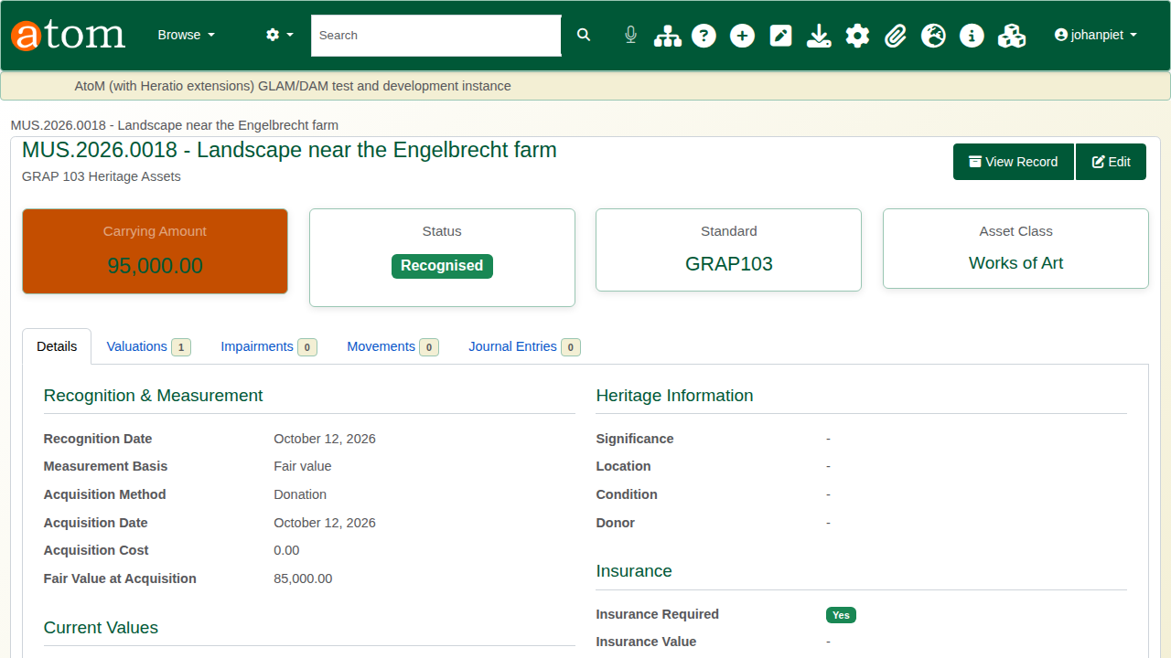
After the revaluation.

3. Impairment
On the Impairments tab, add an assessment. Tick the indicators that apply (physical damage, obsolescence, change in use, external factors) and describe them, mark Impairment identified, and give the recoverable service amount and who assessed it. If the loss is left blank it is worked out as the carrying amount less the recoverable amount, and the carrying amount is reduced to match.
The example impairment
Before | Assessment | After
Carrying amount 95,000 | Physical damage; recoverable amount 91,000 | Impairment loss 4,000; carrying amount 91,000
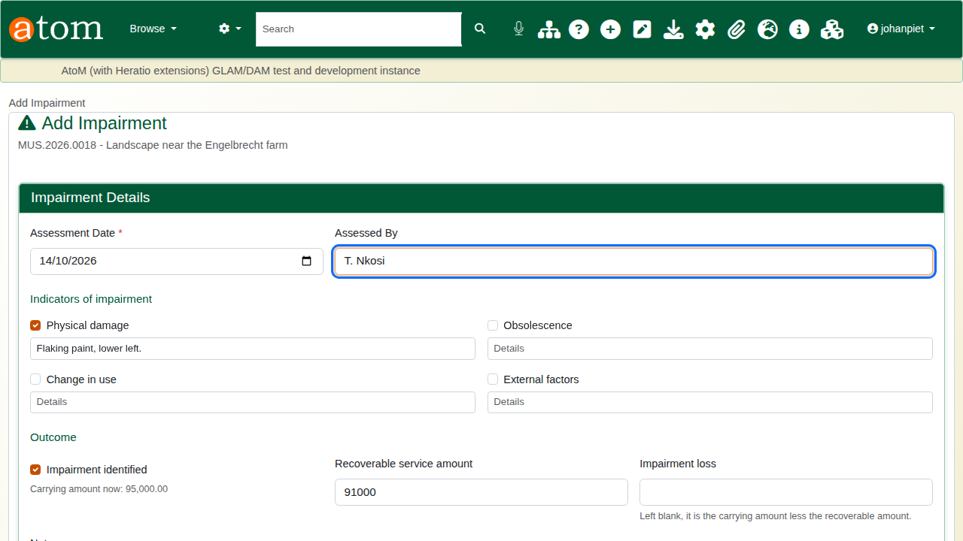
The impairment assessment.
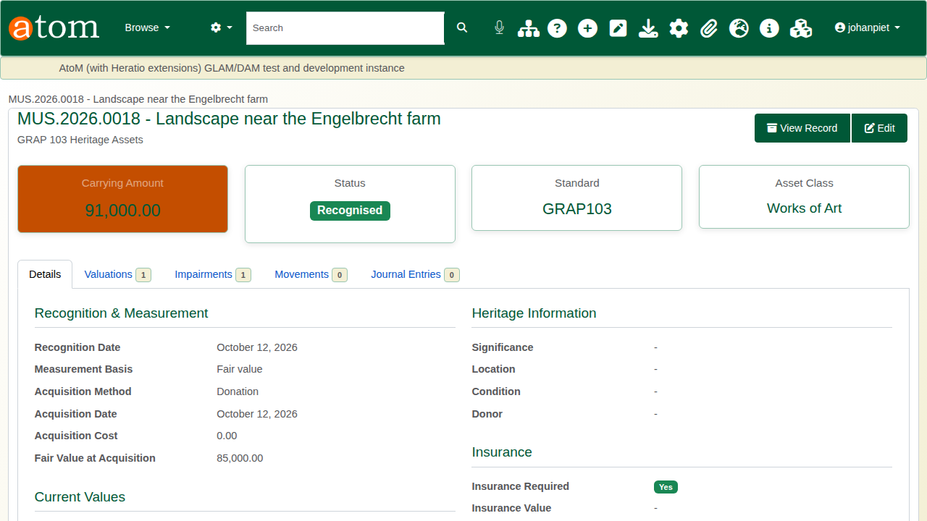
After the impairment.

4. Checking against GRAP 103
Open the asset’s Compliance Check (/grap/check/<asset id>). Each requirement is listed with its GRAP 103 paragraph, category and status, and the page gives a compliance score. For the painting, recognition and measurement pass, with warnings for the significance statement, the insurance details and the location.
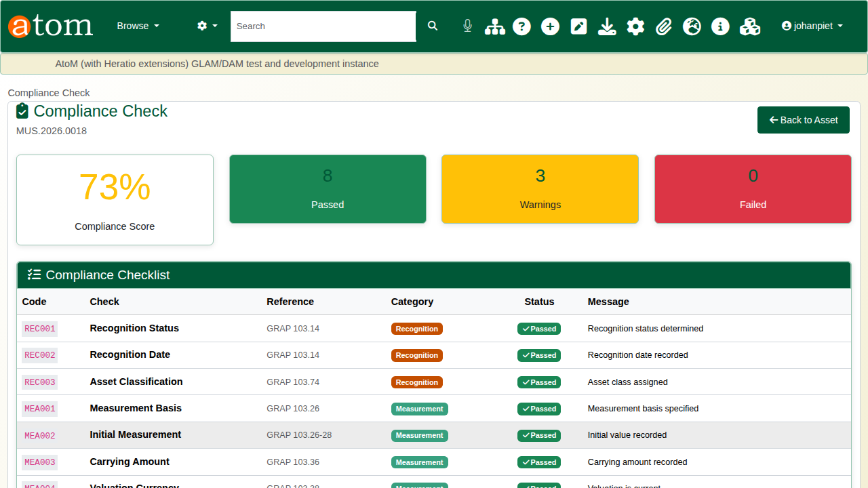
The first compliance check.
Edit the asset to deal with them: heritage significance and a statement, the current location, and the insured value with the policy number. Check again: every requirement passes.
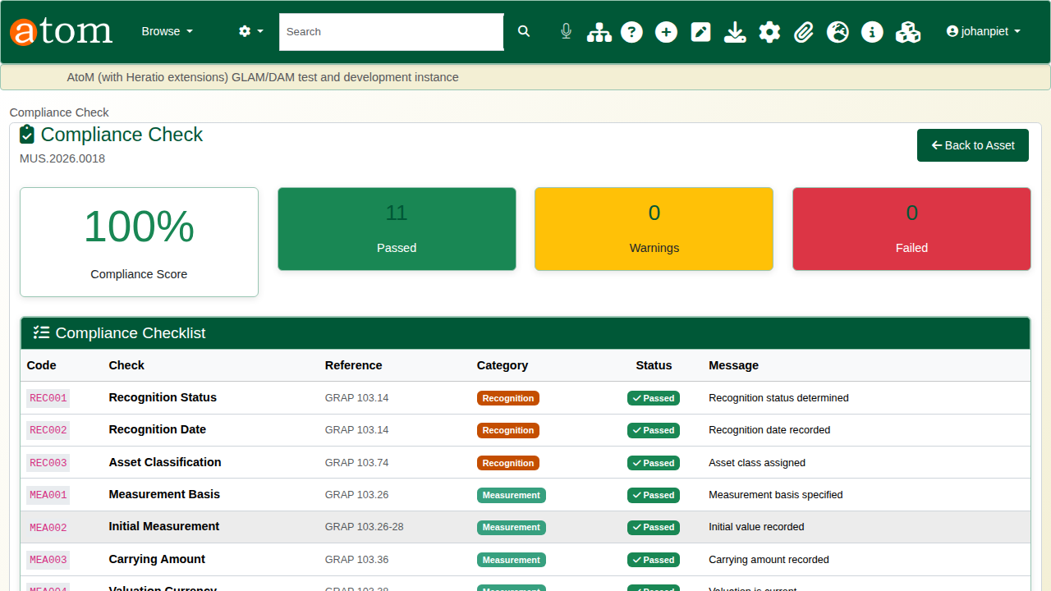
The check after the fixes.
The GRAP Dashboard (/grap/dashboard) shows the same picture across all assets and can run a batch check.

5. Reports
Heritage accounting reports
Report | Shows
Asset register | Every heritage asset with its class, status, basis, cost and carrying amount, filterable by standard, class and status
National Treasury report | Totals by asset class with impairments and revaluation surplus, and the full register, for the annual financial statements
Valuation and movement reports | Valuation history and revaluation surplus; loans, transfers, exhibitions and storage changes
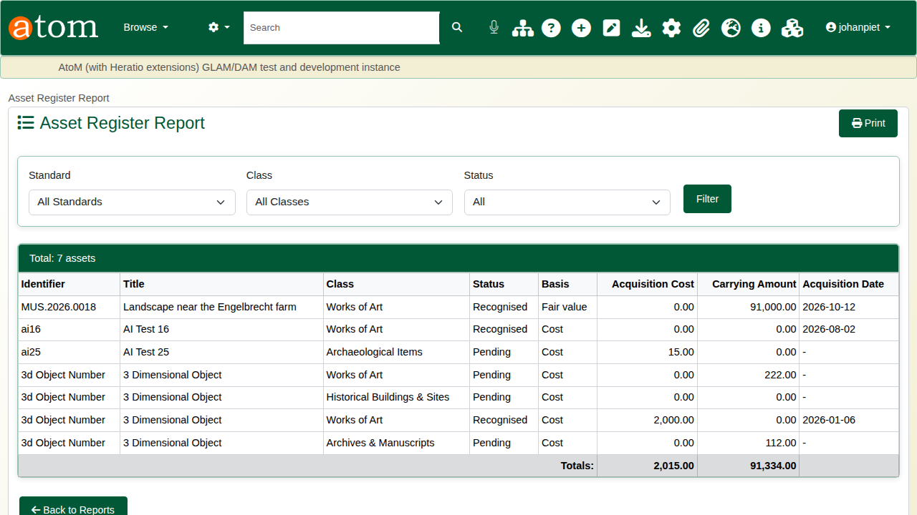
The asset register.
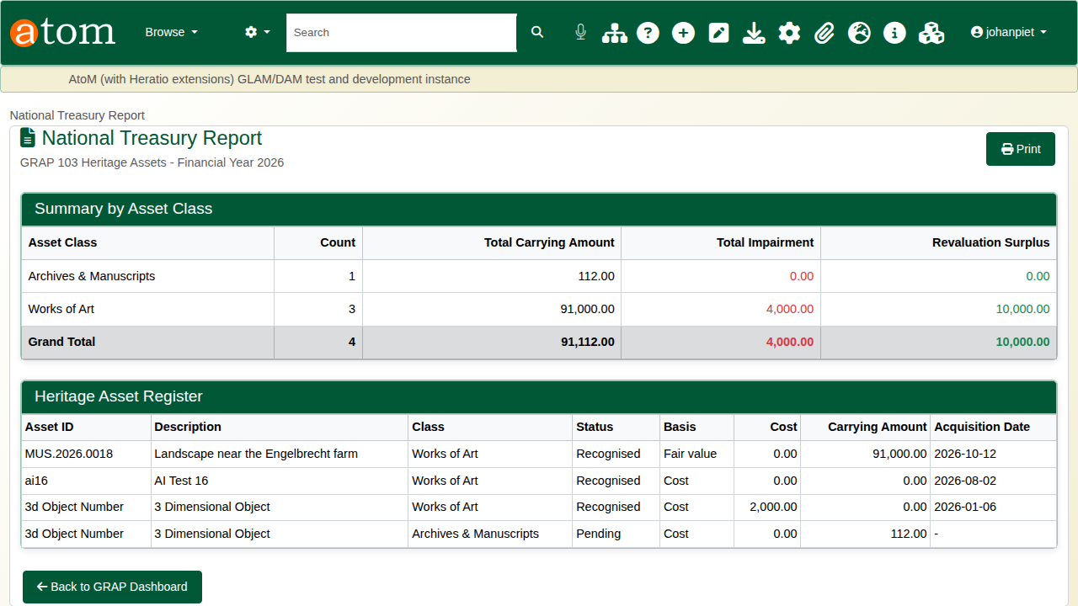
The National Treasury report.

6. Other standards
GRAP 103 is one of several accounting standards built in, each with its own compliance rules: IPSAS 45 and IPSAS 17, IAS 16, FRS 102, GASB 34, FASB 958, PSAS 3150, AASB 116 and a custom local standard. Administrators manage them under Accounting Standards.
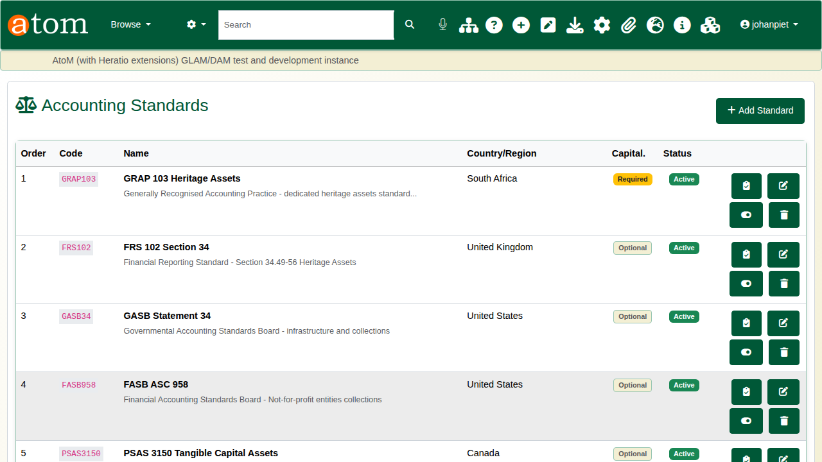
The accounting standards.

Recap
- Recognise the object as a heritage asset under the right standard.
- Record valuations and impairments as they happen.
- Check the record against the standard and fix what it flags.
- Produce the asset register and the treasury report from the same data.
That completes the museum training series.

