Training: Preservation, Part 1 - The Ingest Wizard
Step-by-step guide to bringing records and digital objects into the archive through the six-step OAIS ingest wizard, with SIP, AIP and DIP packages
The Archive and Heritage Group (Pty) Ltd
Document control
Field | Value
Document title | Training: Preservation, Part 1 - The Ingest Wizard
Author | Dr Johan Pieterse
Owner | The Archive and Heritage Group (Pty) Ltd
Version | 1.0
Status | Released
Date | 14 October 2026
Prepared for | Archivists and digitisation staff using the AHG extensions
Classification | Public
Reference | AHG-TRN-PRS-01
This guide goes with part 1 of the preservation training videos. You bring three digitised farm diaries into the archive through the ingest wizard: a ZIP file holding a CSV that describes them and the three scanned pages. The wizard maps and checks the data, shows you the result before anything is written, and then creates the records and writes the OAIS packages. Allow about 20 minutes.

Before you start
What you need before you start
What | Notes
An administrator account | The Ingestion Manager is a staff function.
The practice ZIP | harts-river-diaries.zip: harts-river-diaries.csv and diary-vol1.jpg to diary-vol3.jpg.
Fictitious records | The diaries, their writer and their contents are made up for the practice.
The CSV uses AtoM’s own import column names, so it maps without any work:
The practice CSV
Column | Example
legacyId | HRD-001
identifier | HRD/1
title | Farm diary, volume 1, 1934
levelOfDescription | Item
extentAndMedium | 1 volume
scopeAndContent | Daily entries on rainfall, livestock and labour
eventDates, eventStartDates, eventEndDates | 1934; 1934-01-01; 1934-12-31
eventActors, eventTypes | Pretorius, A. J.; Creation
digitalObjectPath | diary-vol1.jpg

1. Configure
Open Admin > Ingestion Manager (/ingest) and click New Ingest.
Configuring the session
Setting | Example | Notes
Session title | Harts River farm diaries (practice) | Names the session on the dashboard
Record type | Archival descriptions | Accessions can be ingested too
Sector and standard | Archive, ISAD(G) | Library, museum, gallery and DAM sectors offer their own standards
Repository | Engelbrecht Archival Repository | Holds the new records
Hierarchy placement | Create a new parent record | Or top level, under an existing record, or the hierarchy in the CSV (legacyId and parentId)
New parent title and level | Harts River farm diaries (practice), Fonds | Created at commit; the rows are filed under it
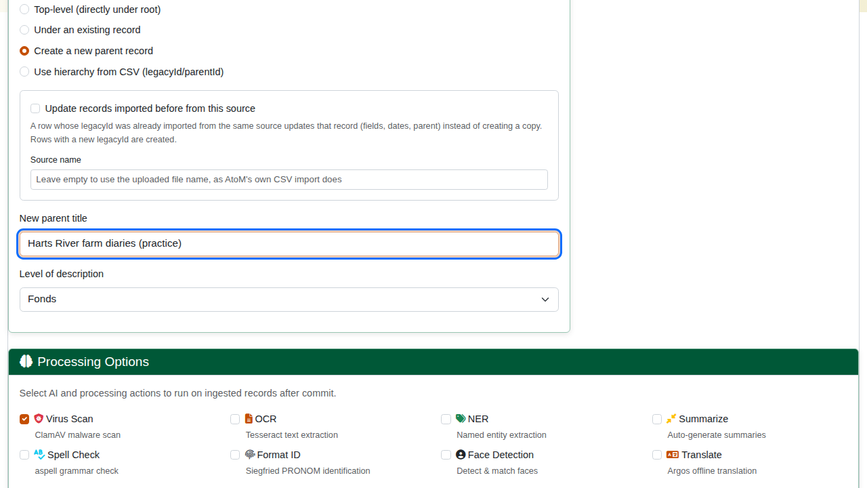
Configuring the session.
On the right, Output Options set what the commit produces: the AtoM records, the SIP, AIP and DIP packages, and thumbnails and reference images. An optional Security Classification is applied to every record after commit. Below, Processing Options run on the ingested records: virus scan (on by default), OCR, named entity extraction, summaries, spell check, format identification, face detection and translation. The defaults for all of these are set under Admin > AHG Settings > Data Ingest Defaults.
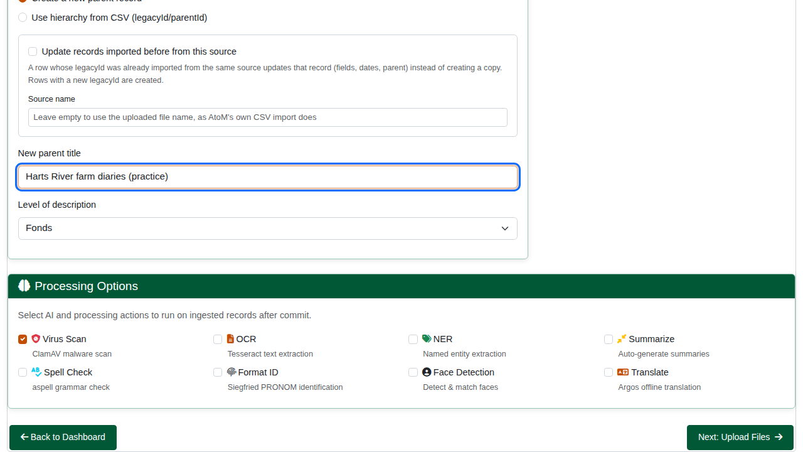
Outputs and processing options.

2. Upload
Choose the file and click Upload & Continue. A CSV on its own is accepted, as is a ZIP holding the CSV with the digital objects beside it, or EAD. The wizard unpacks a ZIP, finds the CSV and counts its rows.
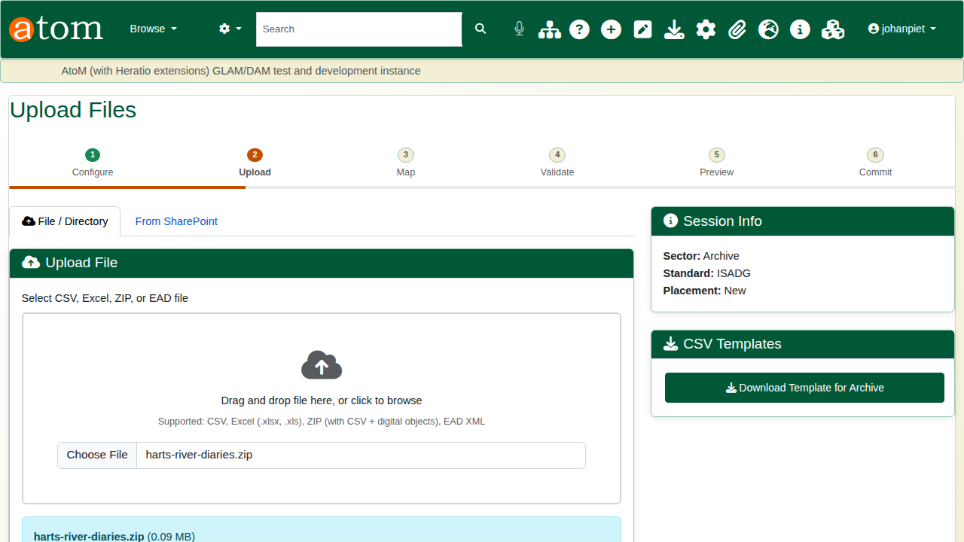
Uploading the ZIP.

3. Map and enrich
Each source column is matched to a target field. Columns with AtoM’s import names map themselves; any other column is flagged as unmapped for you to choose its field, give it a default or a transform, or ignore it. The Data Preview shows the rows as they will be read, and Digital Object Matching pairs the files in the ZIP with rows by file name. A mapping can be saved as a profile and loaded for the next batch. Click Save Mappings & Validate.
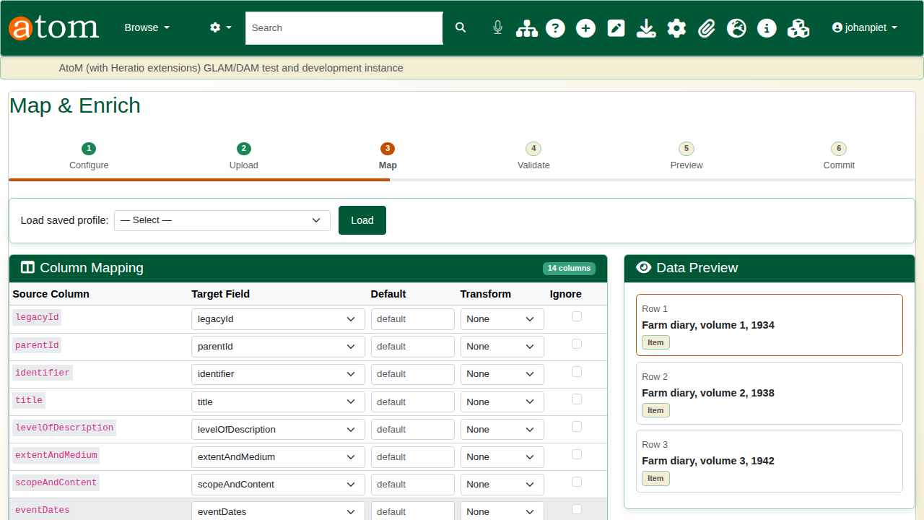
Mapping the columns.

4. Validate
Validation checks required fields, dates, the hierarchy, duplicates and checksums before anything is written. Each failing row is listed with the reason: fix the file and upload it again, or exclude the row. All three practice rows pass.
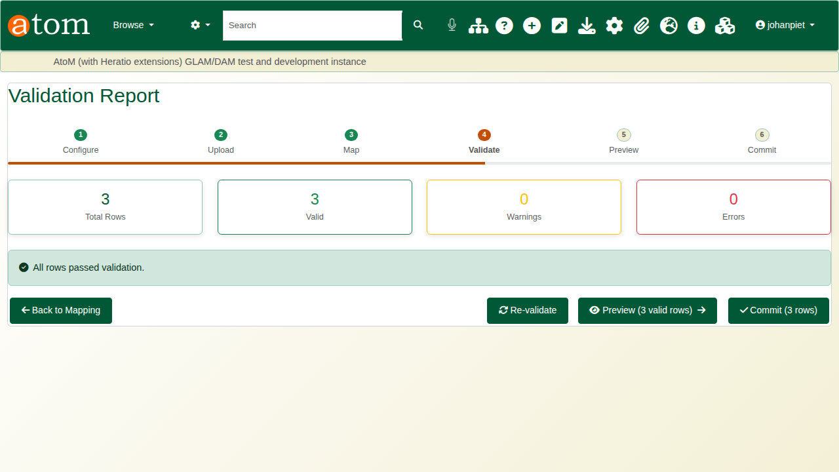
The validation report.

5. Preview
The preview shows the tree as it will be built: the new fonds marked (new), with the three diaries under it, each with its digital object. Package Estimates lists the packages to be written. Dry-run report downloads the same plan as a CSV, row by row (what is created or updated, and where it is placed), without writing anything.
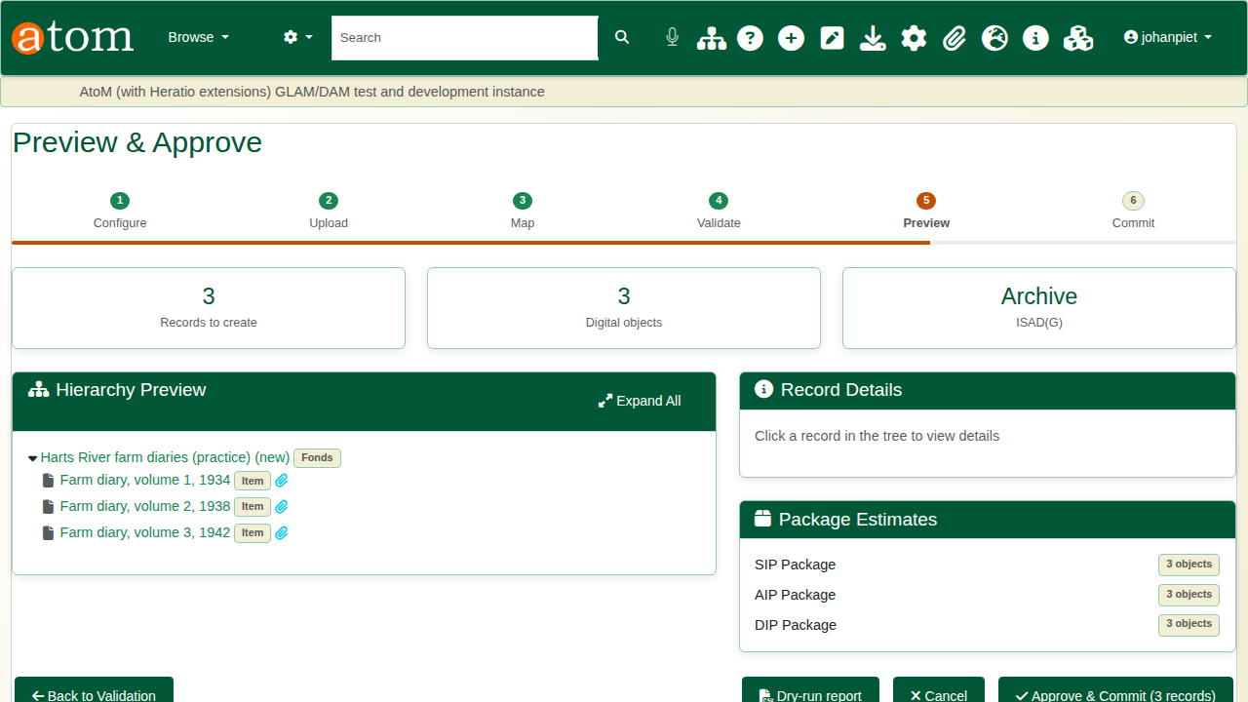
Previewing the tree.

6. Commit
Click Approve & Commit, then Start Commit. The commit runs as a background job (php symfony ingest:commit), so a large batch does not tie up the browser; the page follows its progress and post-processing. The report gives the records and digital objects created, the errors and the time taken, and confirms each package.
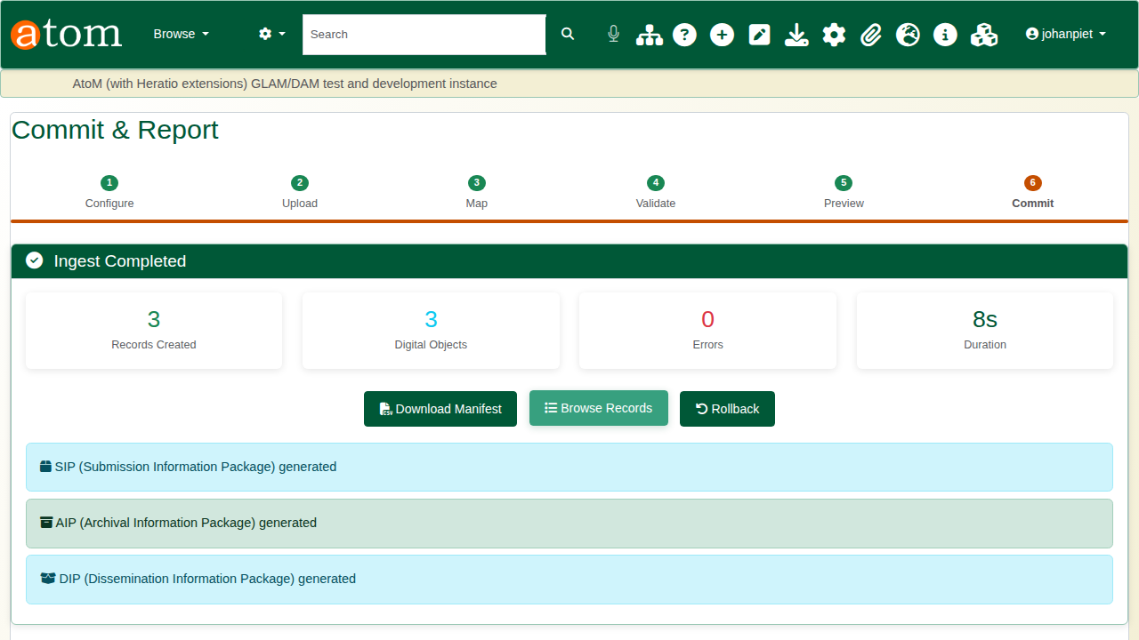
The commit report.
The OAIS packages
Package | Written to | Holds
SIP (submission) | sip/ in the ingest work folder | A JSON manifest of what was submitted, with checksums
AIP (archival) | aip/ in the ingest work folder | A folder: objects/, metadata/ (per-record metadata and premis.json) and manifest.json
DIP (dissemination) | dip/ in the ingest work folder | Access URLs and slugs for the new records
The ingest work folder is /var/lib/ahg-ingest/<instance> unless an administrator sets ingest_work_dir. It sits outside the web root, so packages, uploaded files and job logs cannot be downloaded from the site. A session with its own output paths, set on the Configure step, writes there instead.

7. The new records
Browse Records opens the record the batch went under, here the new fonds with the three diaries. The wizard creates the fonds with its title only, so AtoM flags its identifier and extent as missing until you add them: edit the fonds and complete it.
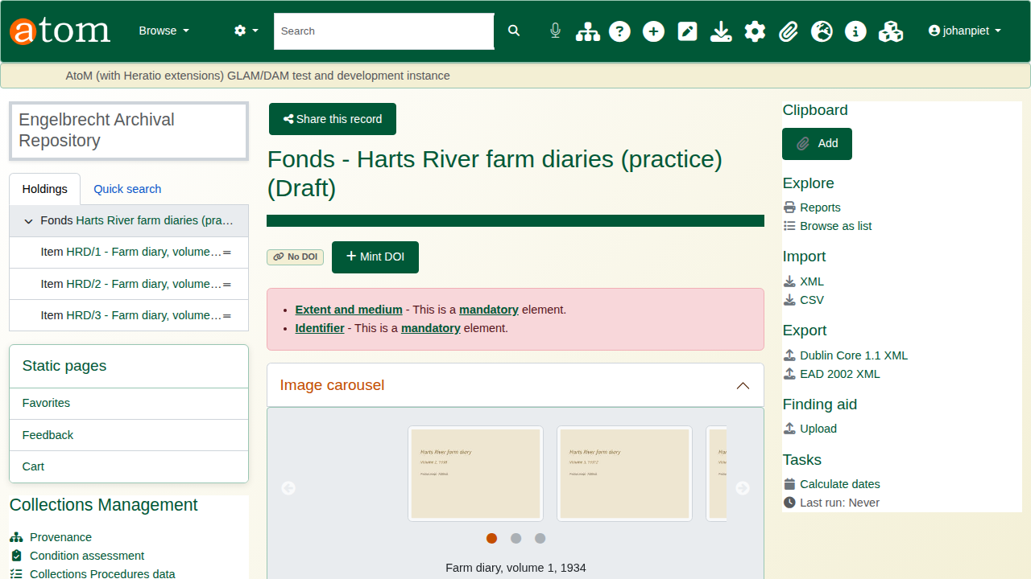
The new fonds.
Each diary carries its description and its scan in the IIIF viewer.
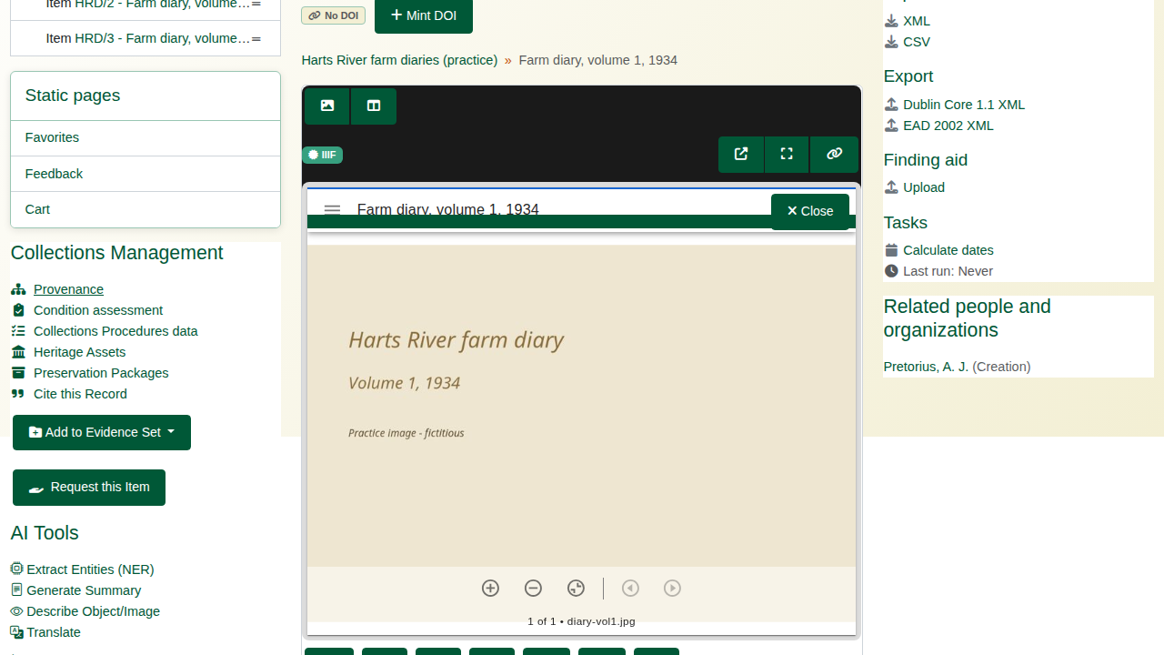
A diary with its digital object.
The CSV’s event columns (eventTypes, eventActors, eventDates, eventStartDates, eventEndDates, pipe-separated and aligned by position) become the record’s dates and creator. A creator not yet in the archive becomes a new authority record, shared by every row that names it; a missing event type is Creation.
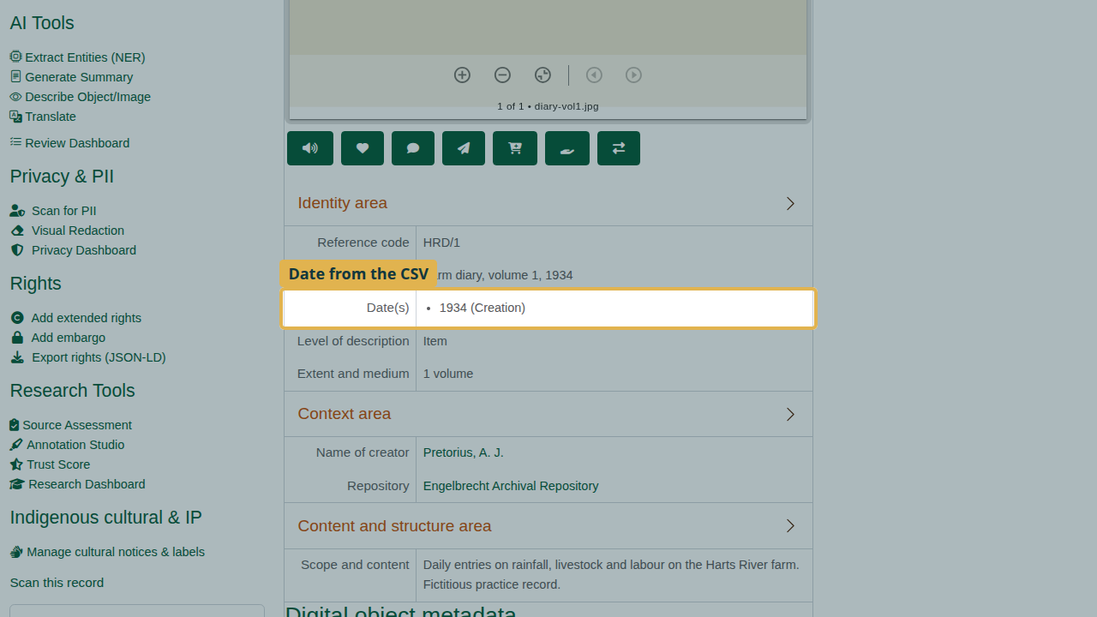
The date and creator from the CSV.

Rolling back
If a batch turns out to be wrong, Rollback on the commit report (or on the dashboard) deletes everything the ingest created: the digital objects, the records and a parent record it created, provided nothing else has since been filed under that parent. Keep the practice diaries for part 2.

Recap
- Configure the session, its standard and where the records go.
- Upload a CSV, or a ZIP with the digital objects.
- Map the columns and check the validation.
- Preview the tree, then commit: the records and the SIP, AIP and DIP are written.
Part 2 covers fixity checks, format identification, virus scanning and PREMIS events.

