Training: Museum, Part 2 - Collections Procedures
Step-by-step guide to recording an object entry and taking an acquisition through review and approval as a workflow
Dr Johan Pieterse
Document control
Field | Value
Document title | Training: Museum, Part 2 - Collections Procedures
Author | Dr Johan Pieterse
Owner | The Archive and Heritage Group (Pty) Ltd
Version | 1.0
Status | Released
Date | 12 October 2026
Prepared for | Registrars, curators and collections staff using the AHG extensions
Classification | Public
Reference | AHG-TRN-MUS-02
Contents
Right-click and choose Update Field to build this list.
List of Tables
Right-click and choose Update Field to build this list.
This guide goes with part 2 of the museum training videos. The painting catalogued in part 1 enters the museum as an offered gift: its object entry is recorded, and its acquisition is taken through review and approval as a workflow, with the review step assigned to a colleague. Allow about 15 minutes.

Before you start
What you need before you start
What | Notes
A registrar account | Administrator rights; starts the procedures and assigns tasks.
A reviewer account | Editor rights; receives and acts on the assigned task.
A museum object | The painting from part 1. The painting, the people and the gift are fictitious.

1. The procedures
On the object, under Collections Management, open Collections Procedures data. It lists the 21 collections procedures, from Object Entry and Acquisition through Location & Movement, Condition Checking, Valuation, Loans In and Out, Audit and Disposal, to Retrospective Documentation. Manage opens each one.
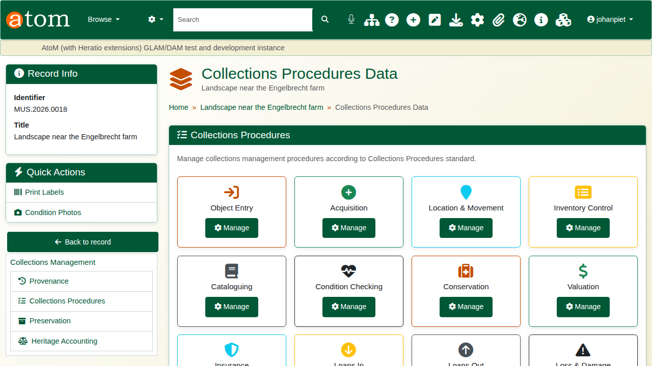
The Collections Procedures page.

2. Object entry
Open Object Entry. Record the entry date, how the object came in, the reason for entry, the depositor, the current owner and who received it. Packing notes and a return date are there for loans and deposits.
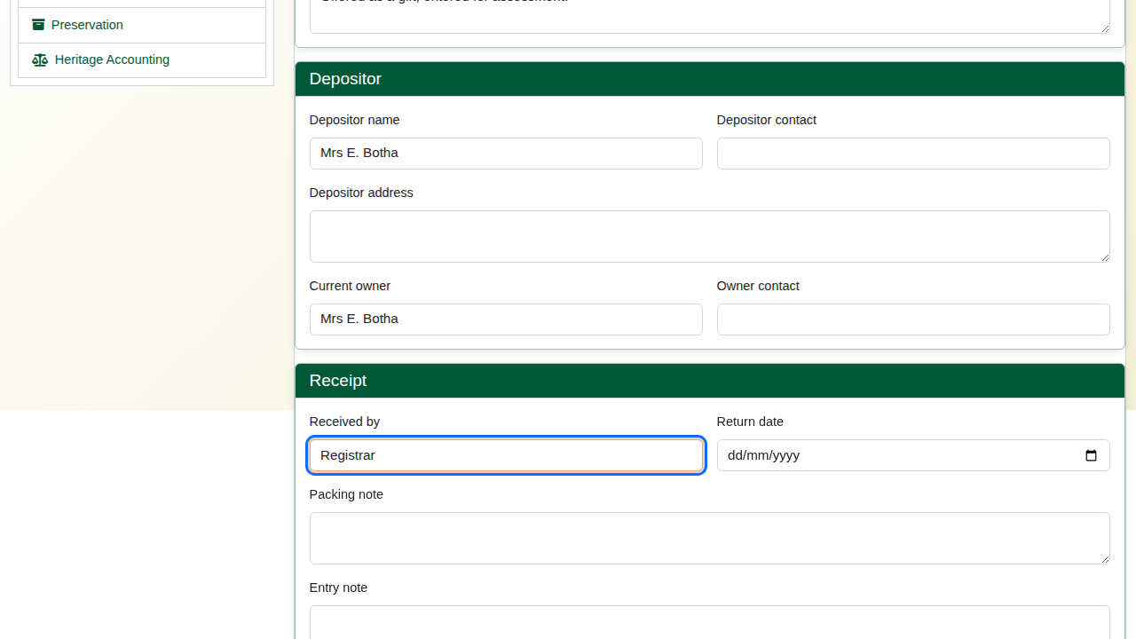
The object entry form.
Click Record object entry. The entry gets its own number (for example OE-20261012-913375).
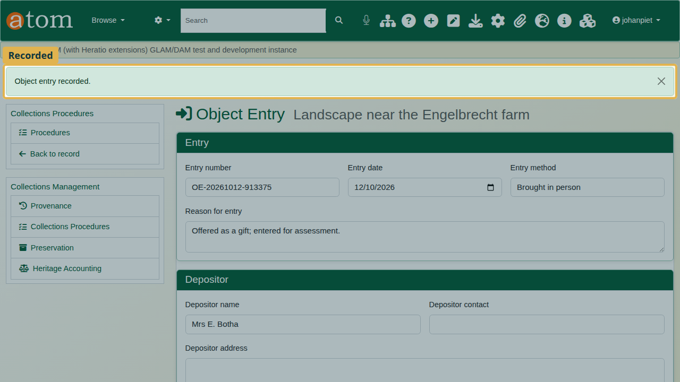
Object entry recorded.

3. The acquisition workflow
Open Acquisition. The progress bar shows the workflow’s states: Proposed, Under Review, Approved, Accessioned, Catalogued, Completed, and Rejected. Under Procedure steps, tick each step as it is done (Acquisition Proposal, Committee Review, Formal Approval, Accessioning, Cataloguing, Completion) and click Save steps. Evidence can be attached to a step.
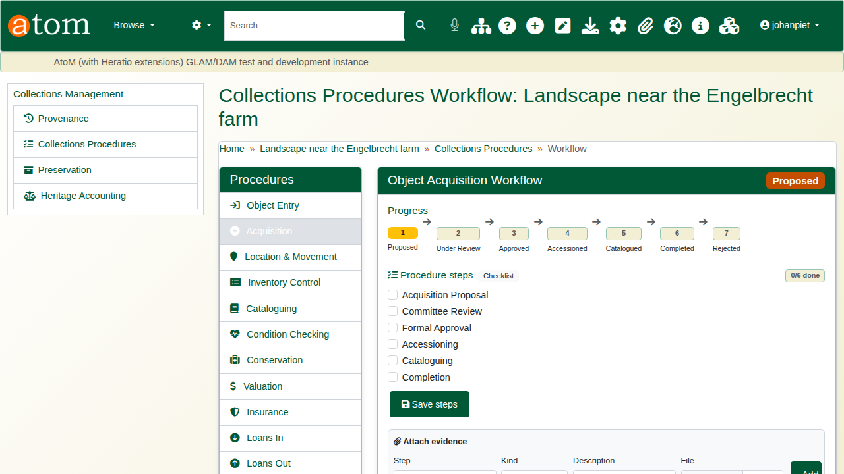
The acquisition workflow.
Under Available Actions, choose the action (Submit For Review), who it is assigned to, and a note saying what is needed. Click Execute Action.
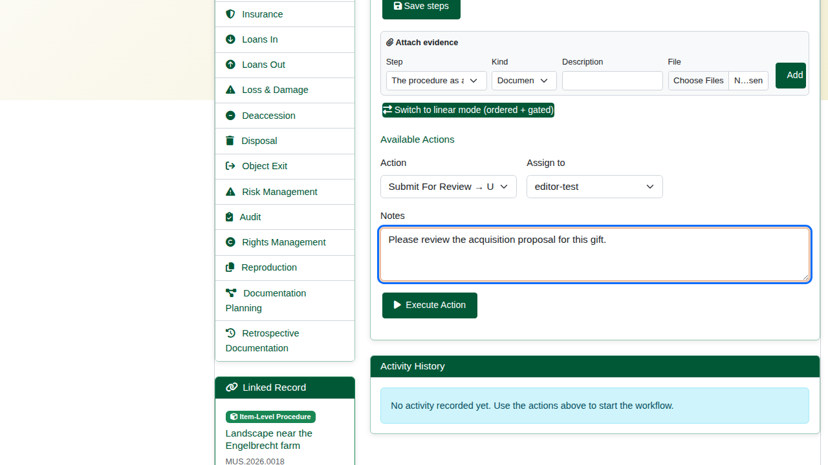
Submitting for review and assigning it.
The workflow moves from Proposed to Under Review.
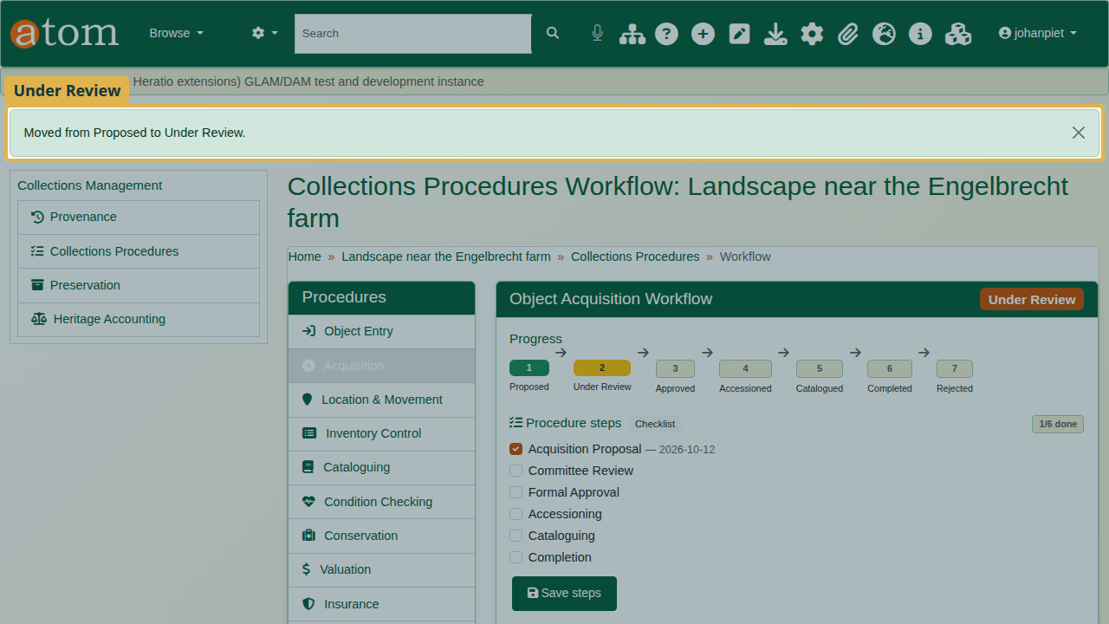
Under review.

4. The reviewer
When the reviewer signs in, a notice says a task is waiting. My Tasks (from the notice, or from the Collections Procedures dashboard’s quick links) lists it with the object, the procedure, its state, and who assigned it and when.
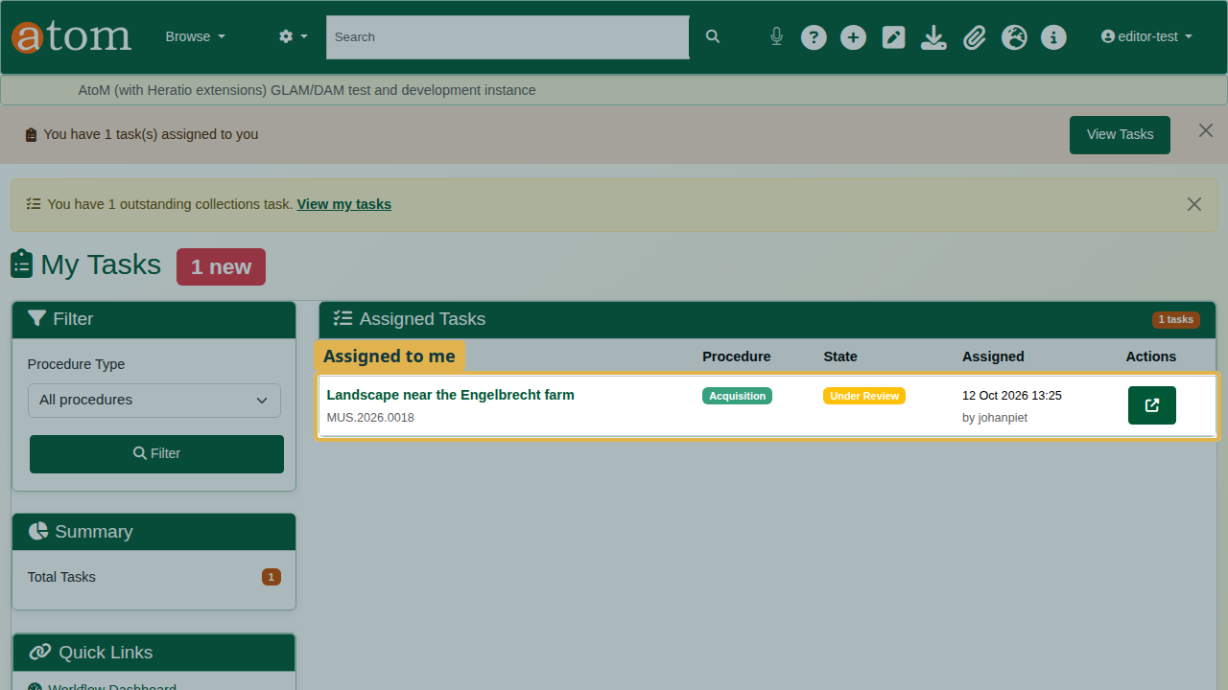
My Tasks.
The reviewer opens the workflow. The actions on offer depend on the state: here, Approve or Reject. Choose Approve, give the reason, and click Execute Action. The acquisition moves to Approved.
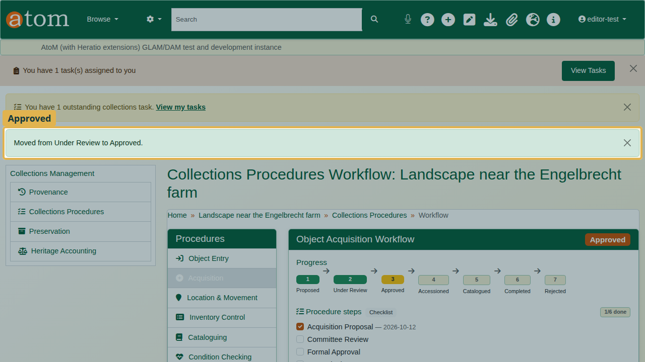
Approved.

5. The record of it
Activity History keeps every move: the date, the action, the states it moved from and to, and the note.
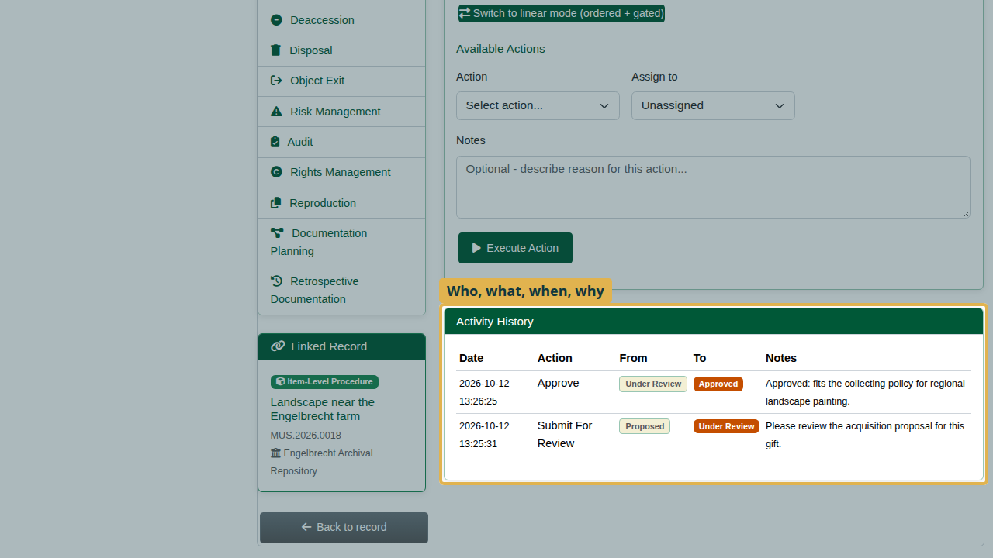
The activity history.
The Collections Procedures Workflow Dashboard shows every procedure across the collection: pending, in progress and completed.
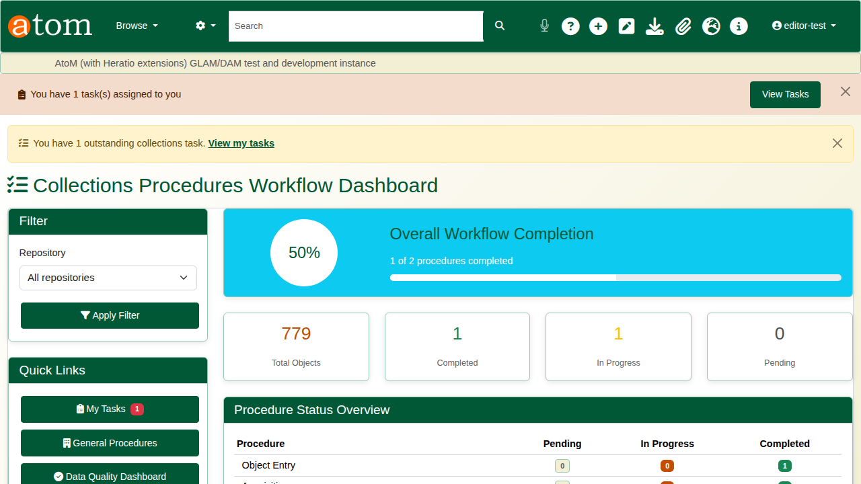
The workflow dashboard.

Recap
- Record every object entry.
- Run acquisition as a workflow and tick the steps as they are done.
- Assign the next step to a colleague; it arrives in their tasks.
- Every move is recorded with who, when and why.
Part 3 covers condition checking.

