Training: Research Portal, Part 2 - The Reading Room
Step-by-step guide to reading rooms, bookings, material requests, the retrieval queue, check-in and walk-in visitors
Dr Johan Pieterse
Document control
Field | Value
Document title | Training: Research Portal, Part 2 - The Reading Room
Author | Dr Johan Pieterse
Owner | The Archive and Heritage Group (Pty) Ltd
Version | 1.0
Status | Released
Date | 10 October 2026
Prepared for | Researchers and reading-room staff using the AHG extensions
Classification | Public
Reference | AHG-TRN-RES-02
Contents
Right-click and choose Update Field to build this list.
List of Tables
Right-click and choose Update Field to build this list.
This guide goes with part 2 of the research portal training videos. Staff set up a reading room. A researcher books a visit and requests records. Staff then confirm the booking, fetch the material and check the researcher in and out, and register a walk-in visitor. Allow about 15 minutes.

Before you start
What you need before you start
What | Notes
An approved researcher | See part 1.
A staff account | An administrator or editor. Only staff see bookings and the retrieval queue, and check visitors in and out; a researcher who opens those pages is refused.

1. Set up a reading room (staff)
Open the AHG Plugins menu and, under Research, choose Rooms. The existing rooms are listed. Click Add Reading Room.
Give the room a name, a code, its location and its capacity.
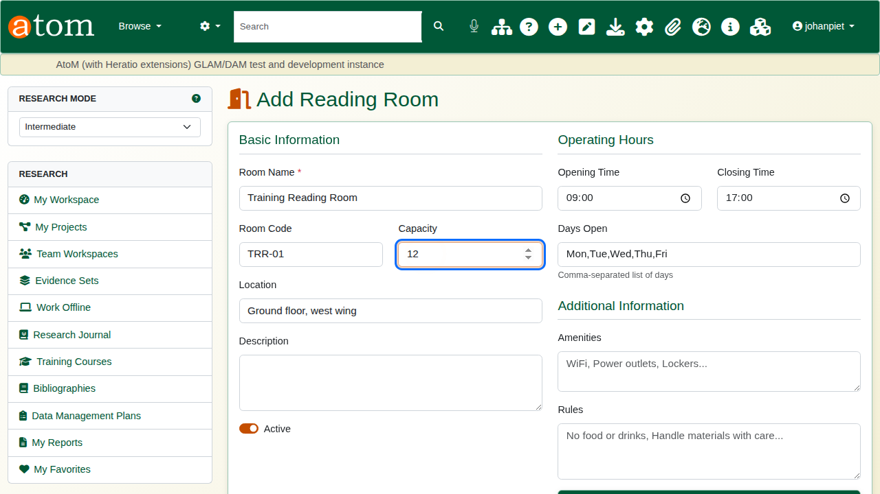
A new reading room.
The hours and limits matter, because every booking is checked against them:
Reading room hours and limits
Field | Example | Effect
Opening / Closing Time | 09:00 / 16:00 | A booking must start and end within these hours.
Days Open | Mon,Tue,Wed,Thu,Fri | A booking on any other day is refused.
Advance Booking (days) | 30 | How far ahead a visit may be booked.
Max Hours per Booking | 4 | The longest single booking.
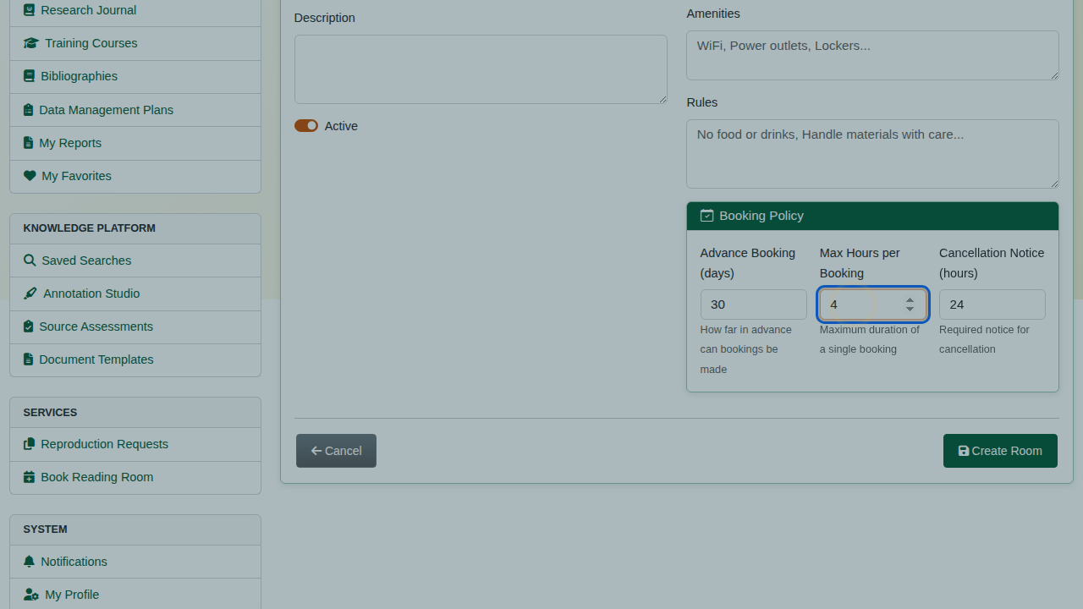
Hours, days and booking policy.
Click Create Room. It appears in the list and is open for bookings.
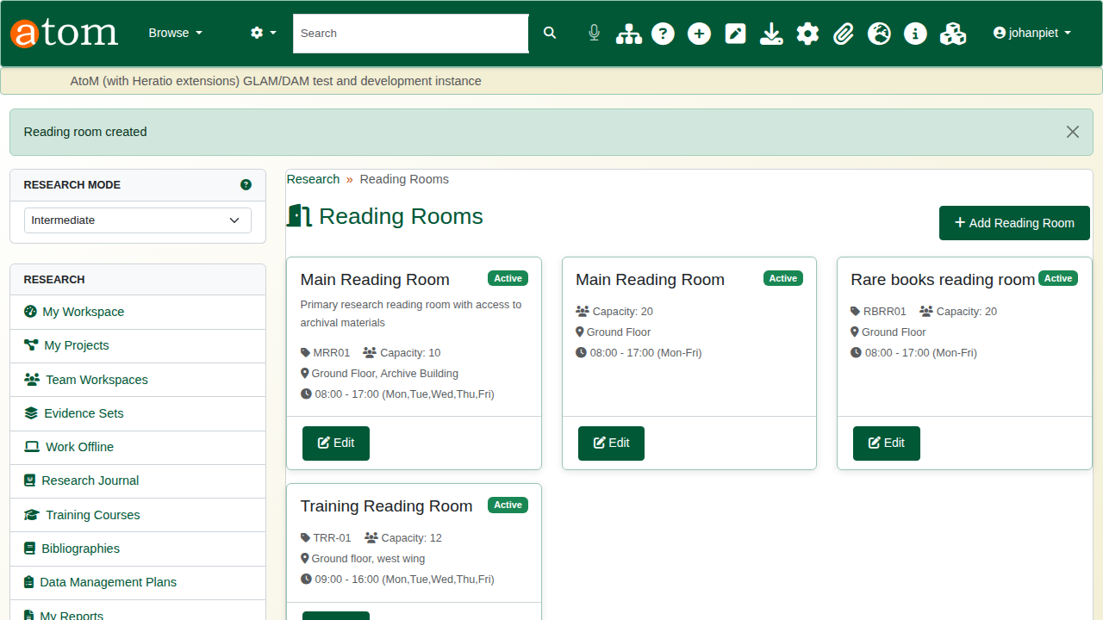
The rooms list.

2. Book a visit (researcher)
On a record she wants to see, the researcher clicks Request this Item in the left-hand column. Without a booking, the answer is: no active booking found, please book a reading room visit first. Material is fetched for a visit, not on its own.
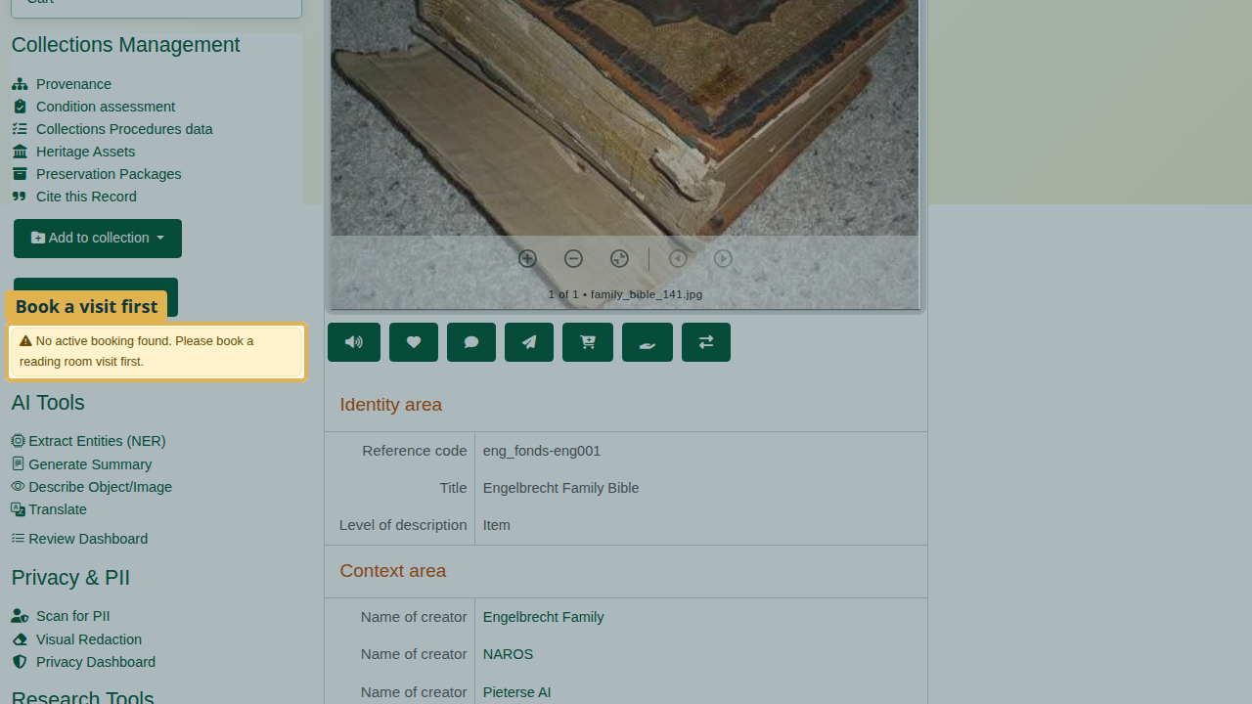
Request this Item needs a booking first.
From the research sidebar, choose Book Reading Room. Choose the room, the date, the start and end times, and the purpose of the visit.
The deliberate mistake: a Saturday. On submit, the booking is refused - the room is closed on Saturdays and open Monday to Friday - and everything typed is kept.
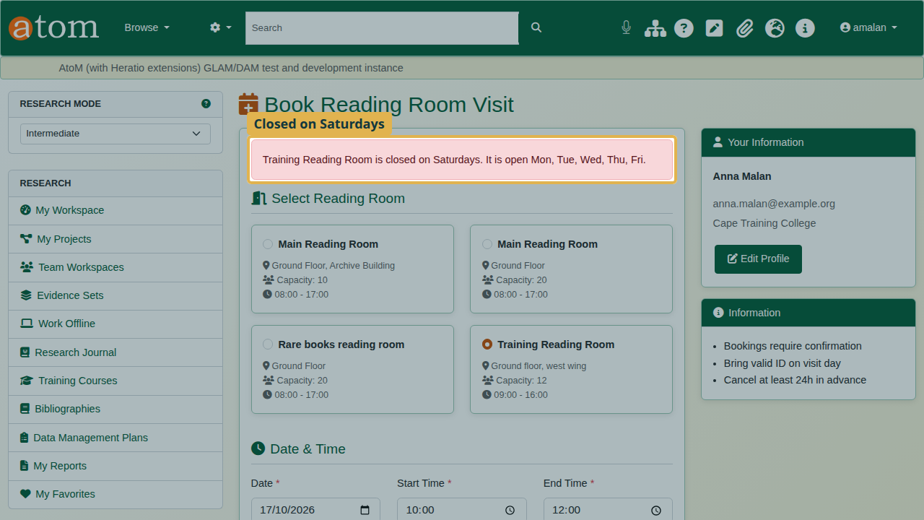
Refused: the room is closed on Saturdays.
Change the date to a weekday and submit again. The booking is pending until the archive confirms it.
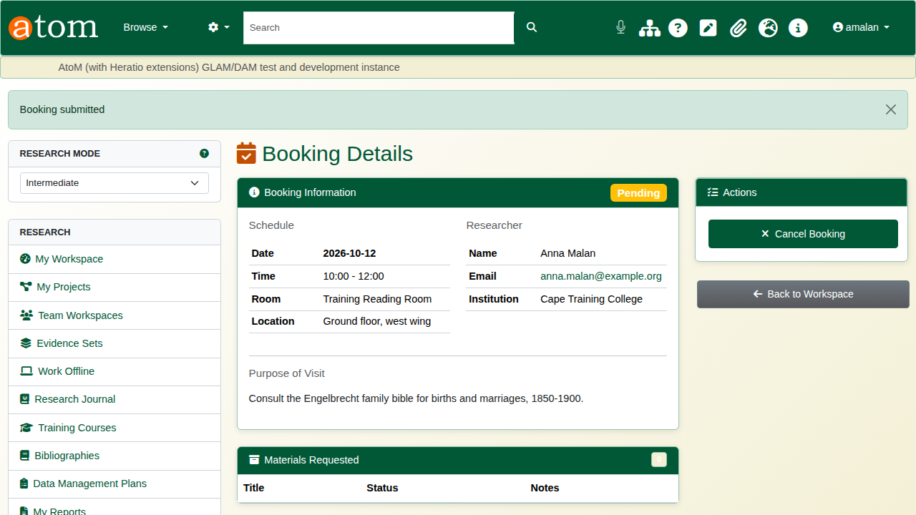
The booking, pending.
Back on the record, Request this Item now works, and the request is attached to the booking.
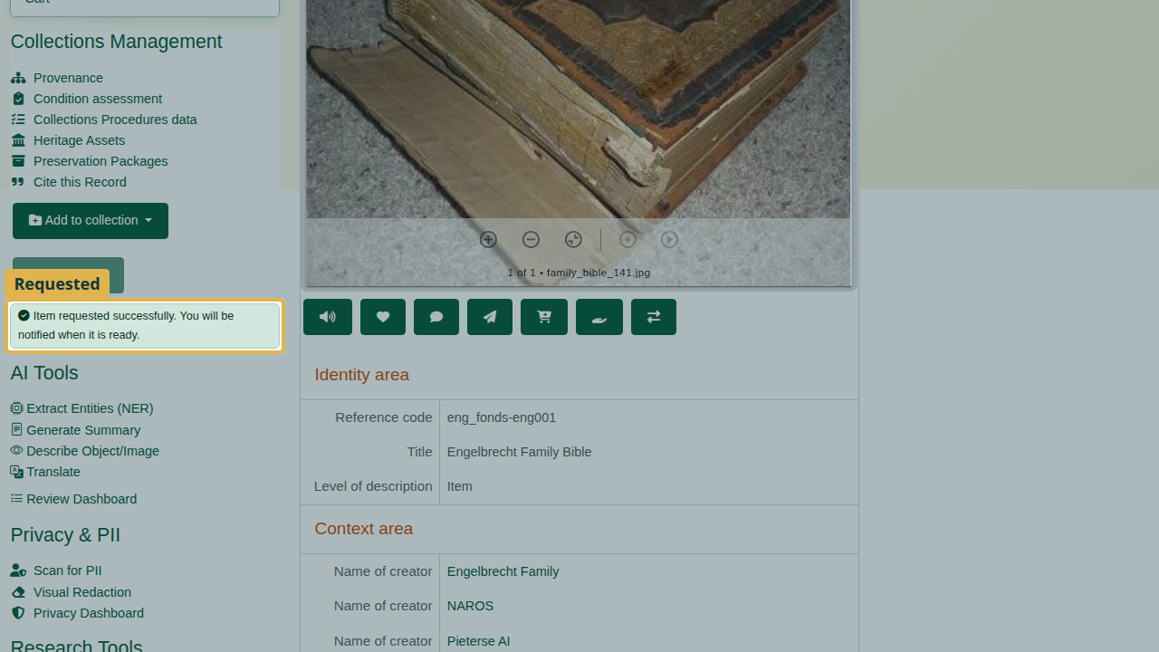
The item requested.

3. Confirm and fetch (staff)
Open AHG Plugins > Bookings. New bookings wait under Pending Confirmation.
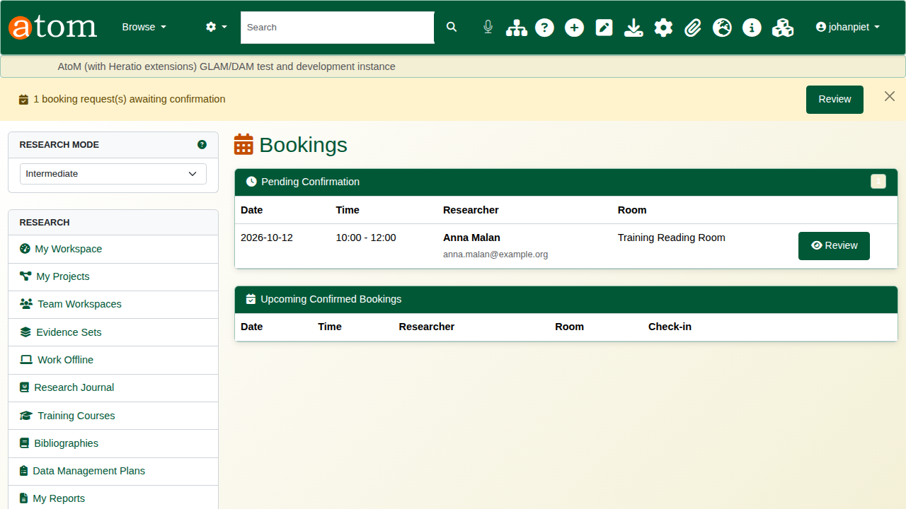
Bookings awaiting confirmation.
Open the booking, check it, and click Confirm. The researcher is emailed that the visit is confirmed.
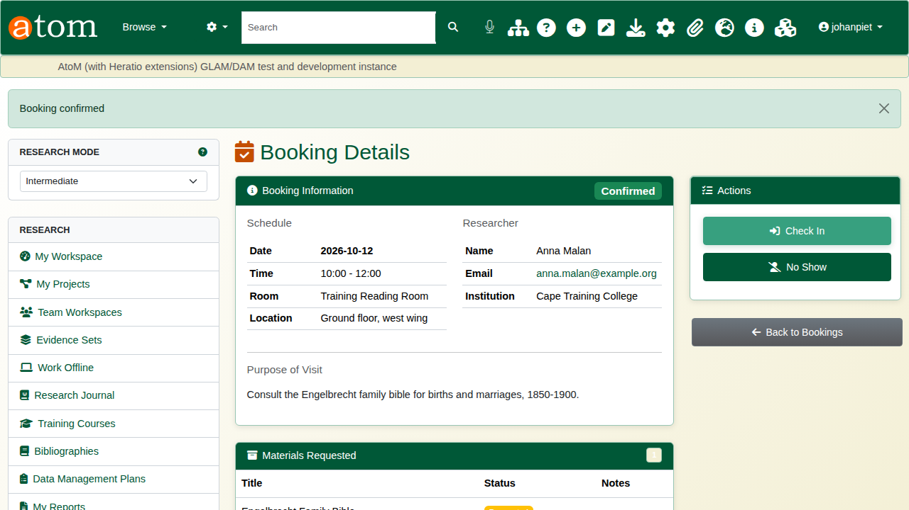
The booking confirmed.
The retrieval queue lists every requested item. Print Call Slip produces the slip for the staff who fetch the material from the stores.
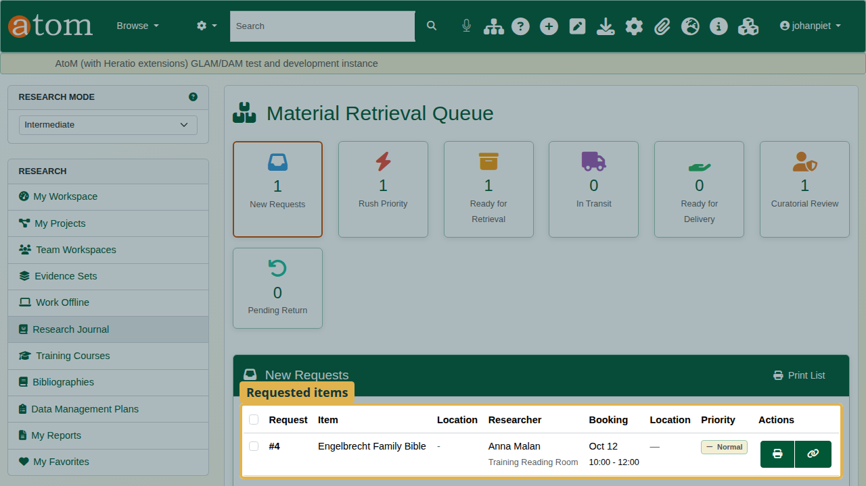
The retrieval queue.
When an item is fetched, tick it, set Update Status to Retrieved, and click Update Selected. Each item moves through requested, retrieved, delivered, in use and returned, and the queue shows where it is.
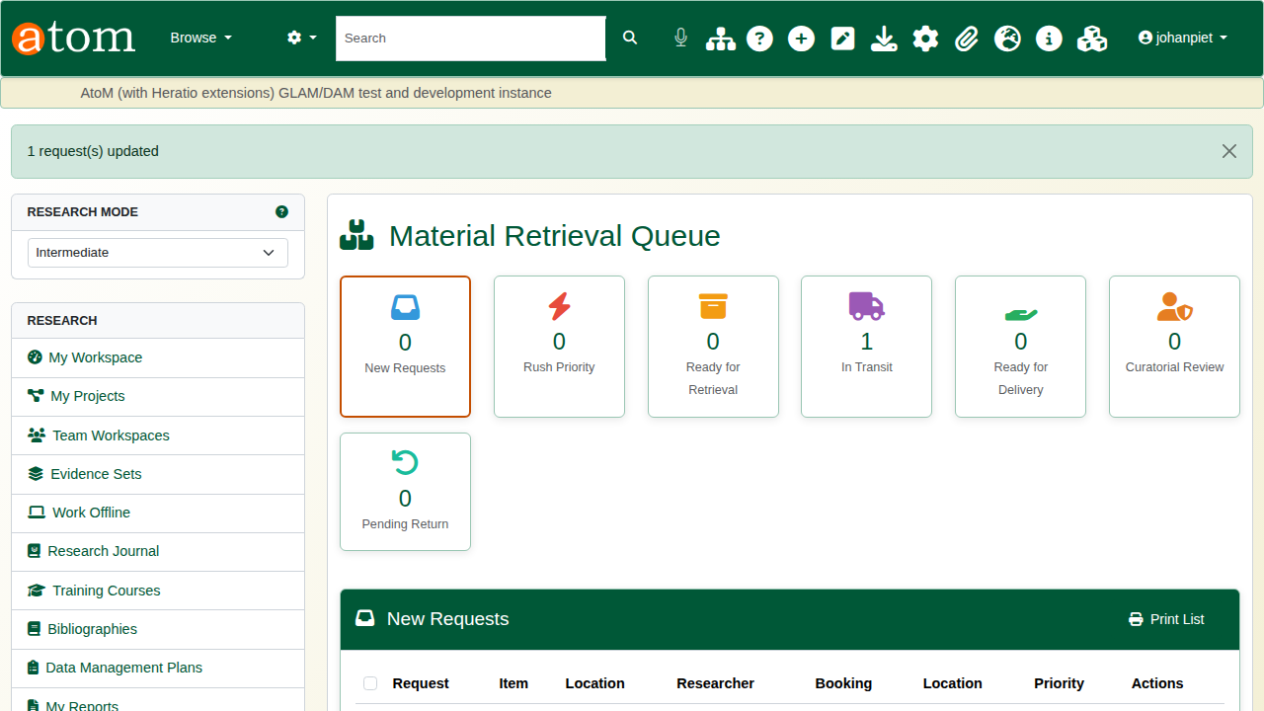
The item retrieved, now in transit.

4. On the day
From the booking, click Check In when the researcher arrives.
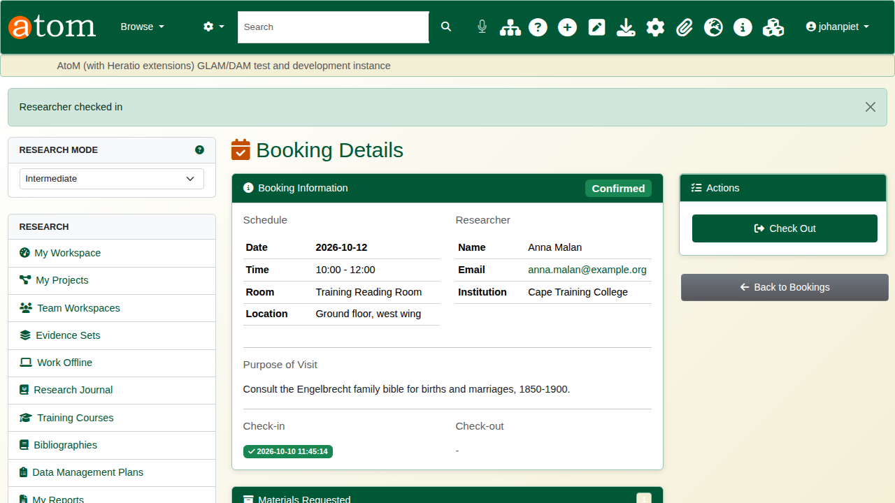
Checked in.
When the researcher leaves, click Check Out. Any material still out on that booking is marked returned, so nothing is left unaccounted for.
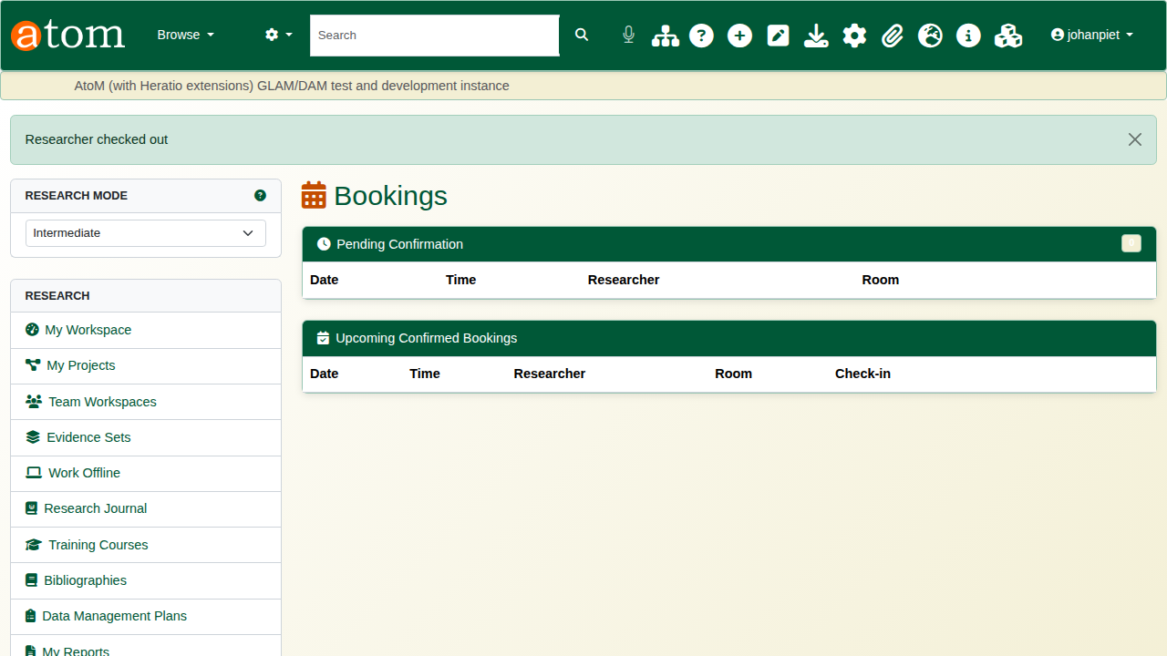
Checked out.

5. Walk-in visitors
A visitor without a booking is registered under Walk-In: choose the room, then enter their name, ID and purpose. They must accept the reading room rules. Walk-ins see open-access material only, cannot request material in advance, and can later be converted to registered researchers.
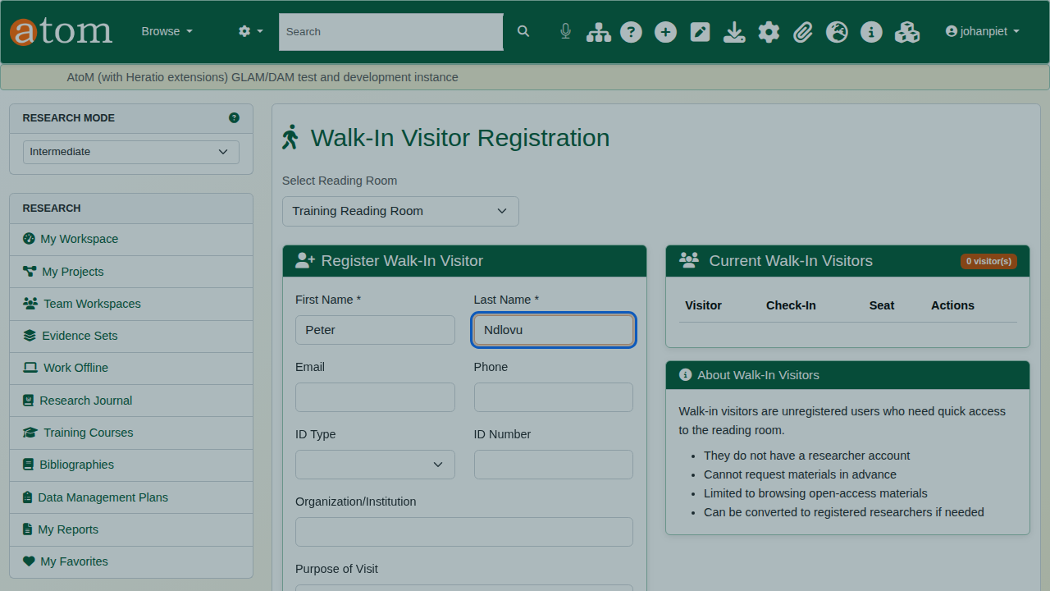
Registering a walk-in visitor.

Recap
- Staff set up a room with its hours, days and limits.
- The researcher books a visit, then requests records from the record pages.
- Staff confirm the booking and fetch the material through the retrieval queue.
- Check the researcher in and out on the day.
- Register walk-ins on the spot.
Part 3 covers the research workspace.

