Training: Research Portal, Part 3 - Workspace, Evidence Sets and Citing
Step-by-step guide to evidence sets, research notes, citing a record and building a bibliography
Dr Johan Pieterse
Document control
Field | Value
Document title | Training: Research Portal, Part 3 - Workspace, Evidence Sets and Citing
Author | Dr Johan Pieterse
Owner | The Archive and Heritage Group (Pty) Ltd
Version | 1.0
Status | Released
Date | 10 October 2026
Prepared for | Researchers using the AHG extensions
Classification | Public
Reference | AHG-TRN-RES-03
Contents
Right-click and choose Update Field to build this list.
List of Tables
Right-click and choose Update Field to build this list.
This guide goes with part 3 of the research portal training videos. The researcher gathers records into an evidence set and adds notes to them. Then she cites a record correctly and builds a bibliography she can take to a reference manager. Allow about 15 minutes.

Before you start
What you need before you start
What | Notes
An approved researcher account | See part 1.
Privacy | Evidence sets, notes and bibliographies belong to the researcher. Other researchers cannot see them unless she shares them.

1. My Workspace
Sign in and choose My Workspace from the user menu. It is the researcher’s starting point: booking a visit, her profile, journal entries and notes, and the research tools in the sidebar.
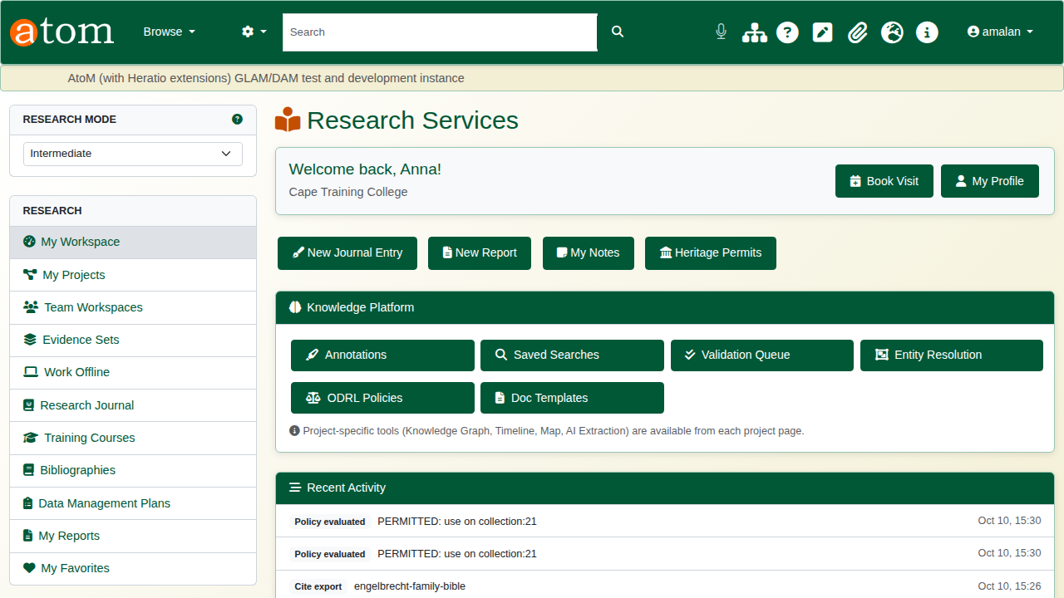
My Workspace.

2. Evidence sets
An evidence set gathers the records that support one question.
On a record, open Add to Evidence Set in the left-hand column and choose New Evidence Set…. Give it a name and a short description, and click Create and add. The record is in the new set straight away.
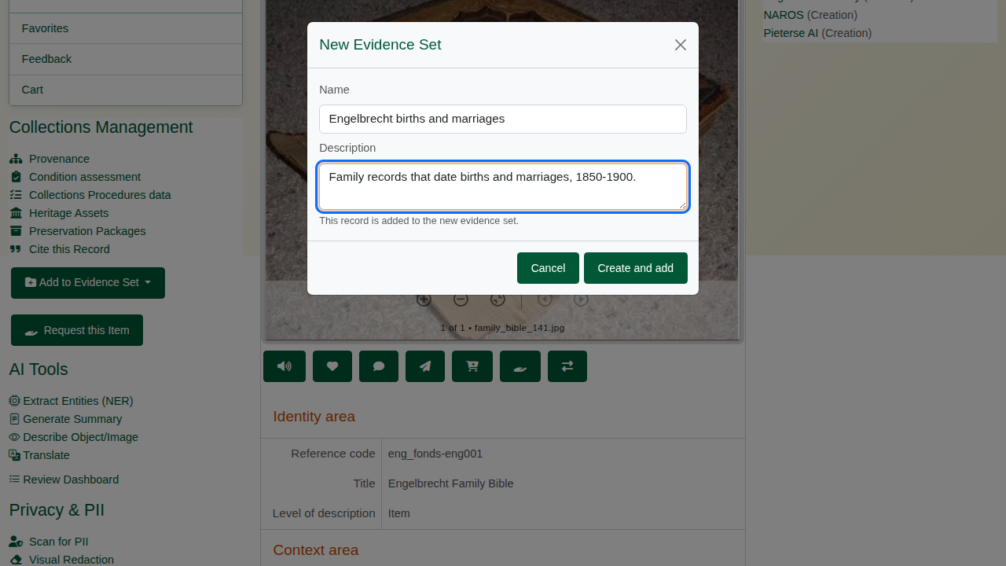
A new evidence set, from the record page.
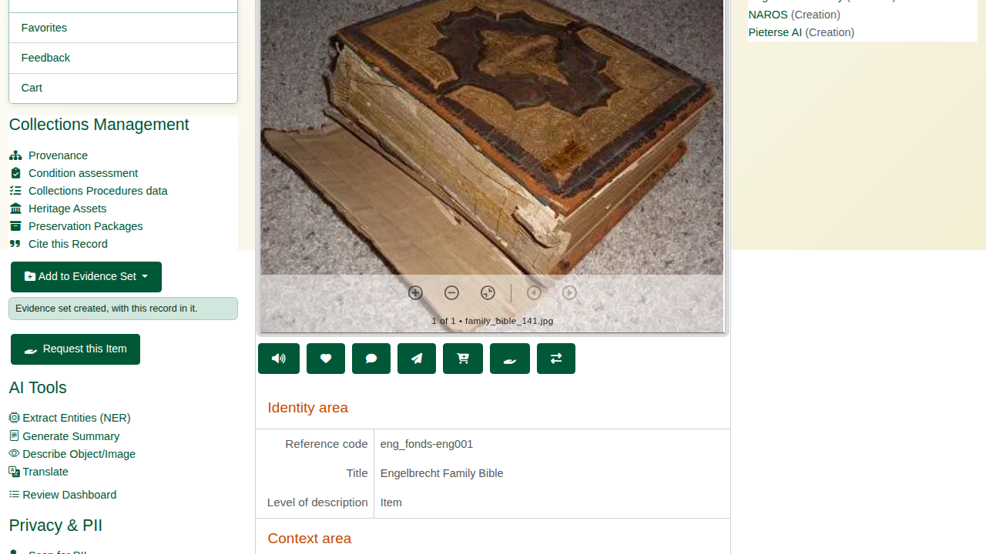
Created, with this record in it.
On the next record, the same button lists the set. One click adds the record.
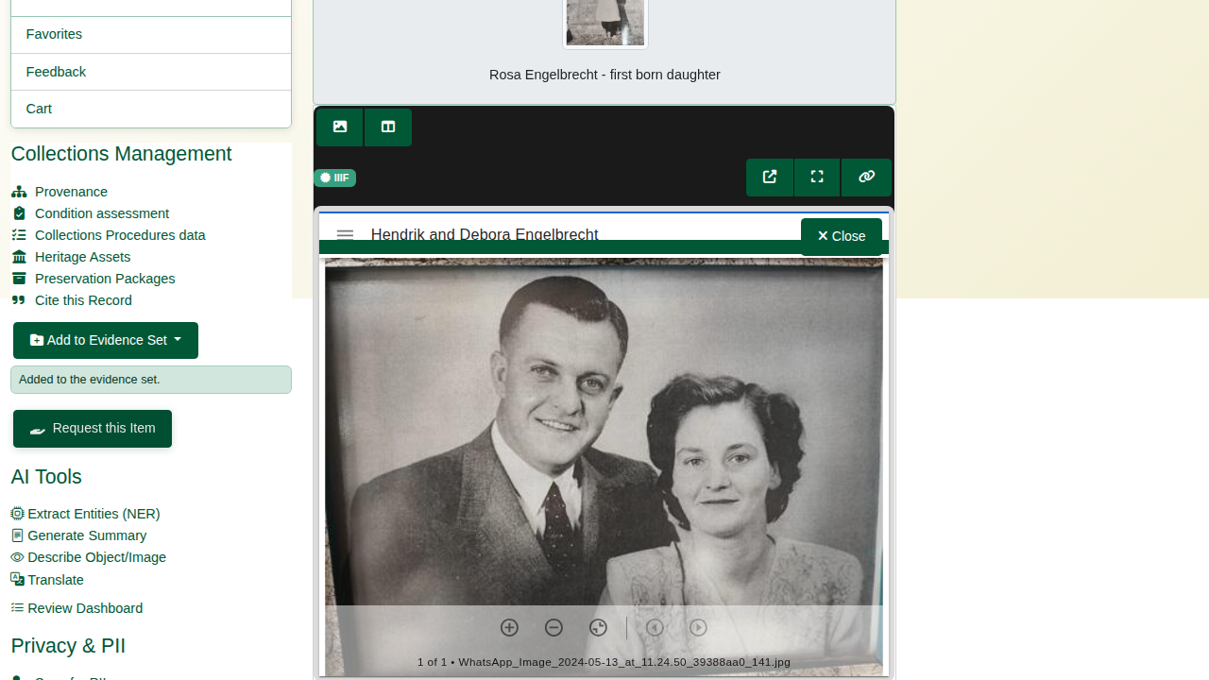
Added to the evidence set.
The deliberate mistake: add the first record to the same set again. The portal answers that the record is already in that evidence set. Nothing is duplicated.
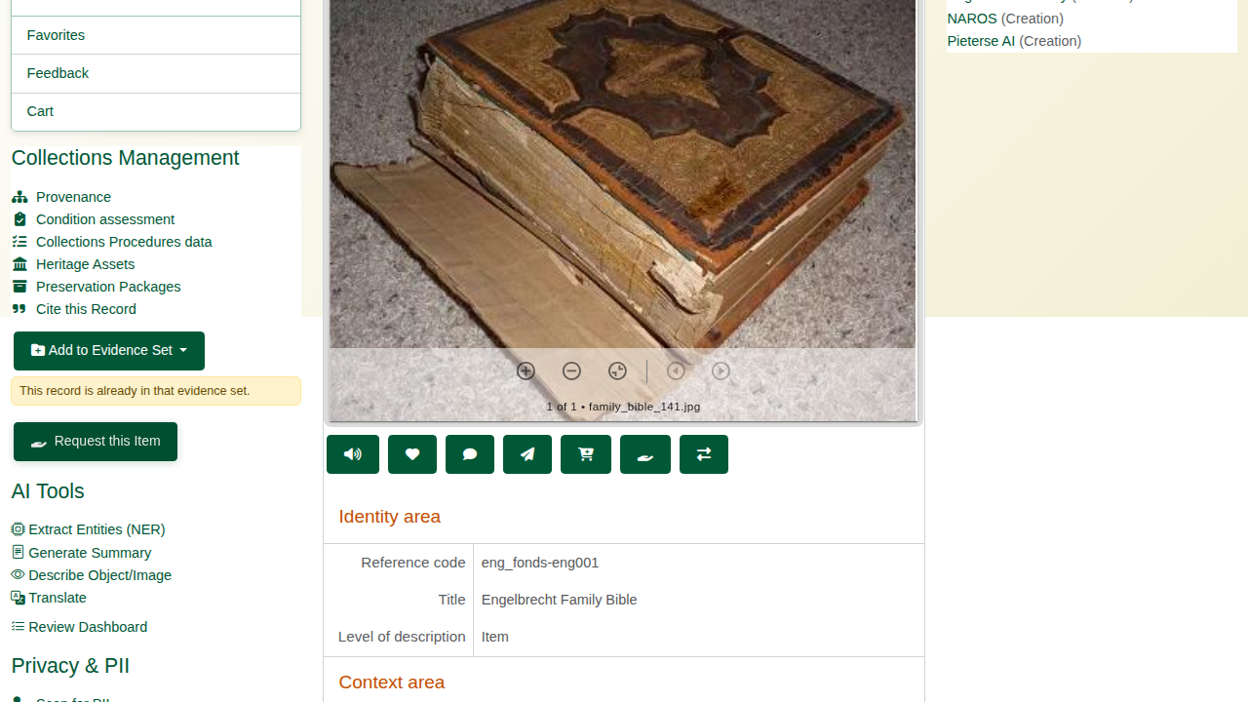
Already in that evidence set.
Open Evidence Sets from the research sidebar and choose View Evidence Set. The records are listed with their level of description and the date they were added. Records can also be added here, by searching, with Include children to bring in a whole branch of the hierarchy.
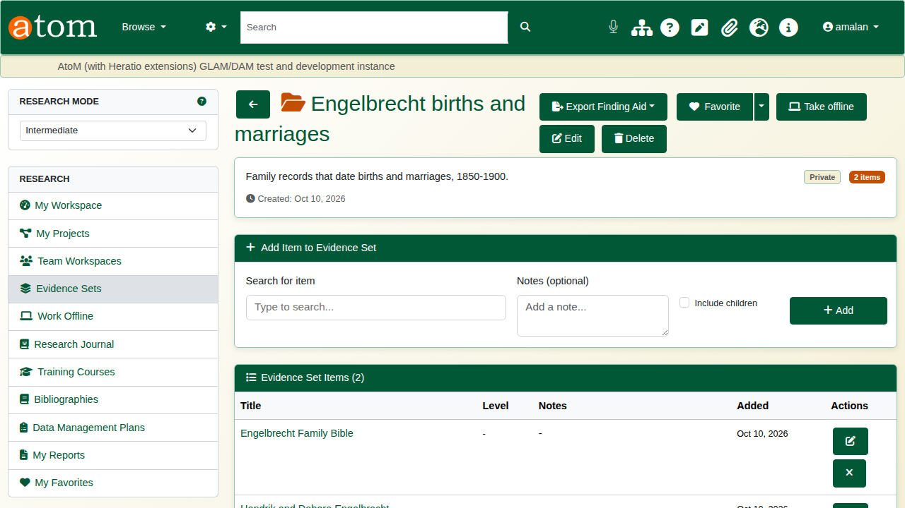
The evidence set.
The edit button beside a record opens its note. Write what you found and save.
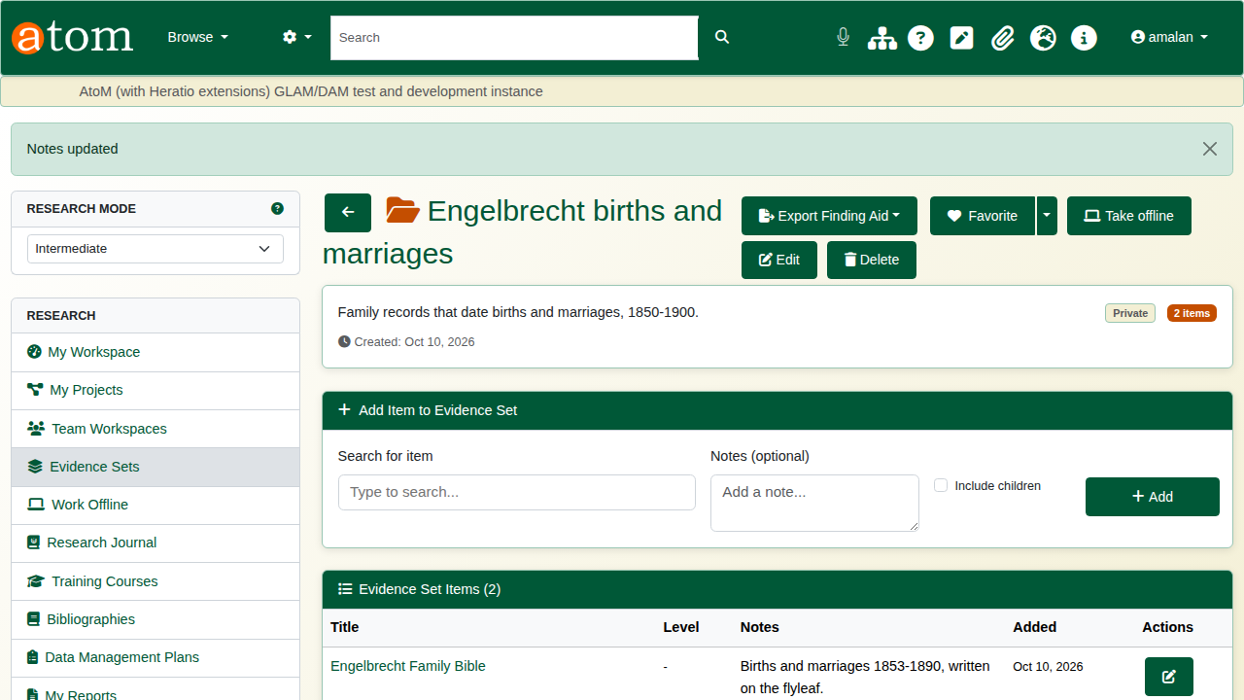
A note on a record.
Export Finding Aid produces the set as PDF, Word (DOCX) or HTML, with the notes included. It is ready to share with a supervisor or colleague.
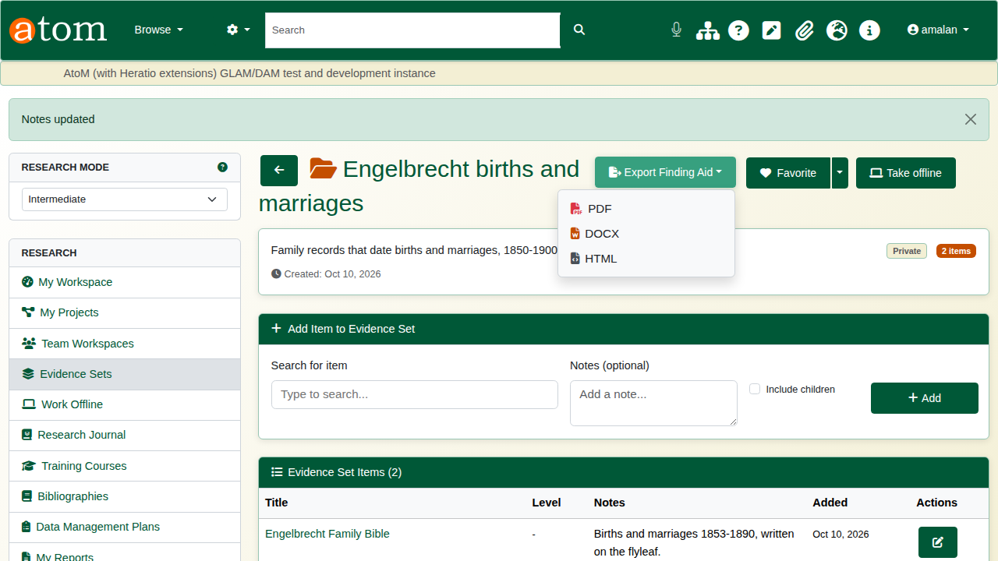
Export Finding Aid.

3. Cite a record
On a record, choose Cite this Record. The citation generator shows the record in six styles - Chicago, MLA, Turabian, APA, Harvard and UNISA Harvard - each with a Copy button.
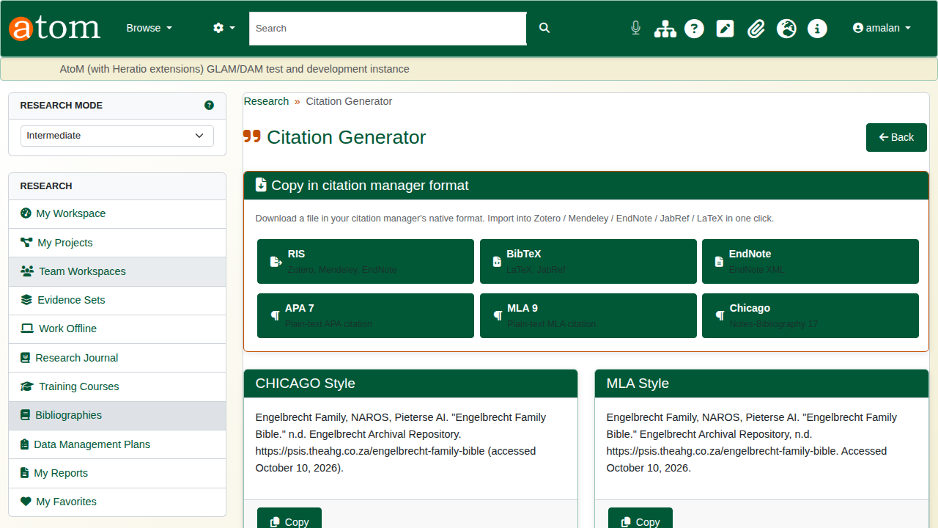
The citation generator.
Names are handled with care. A creator recorded as a person is cited surname first, with initials. A family or an organisation is cited as written.
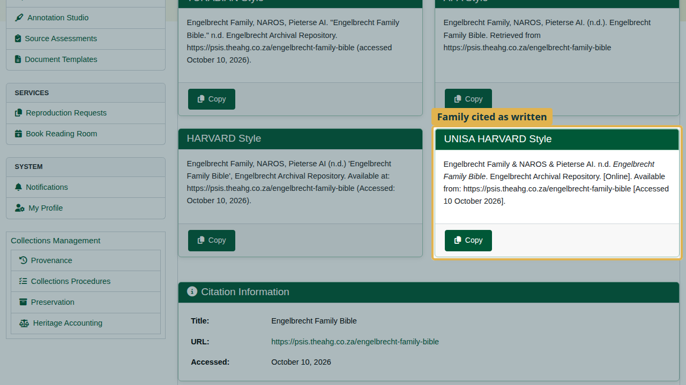
UNISA Harvard: the family is cited as written.
For a reference manager, download the citation in its own format:
Citation downloads
Button | For
RIS | Zotero, Mendeley, EndNote
BibTeX | LaTeX, JabRef
EndNote | EndNote XML
APA 7, MLA 9, Chicago | Plain-text citations
Every creator of the record is included: RIS gives one author line each, and BibTeX joins them with “and”.
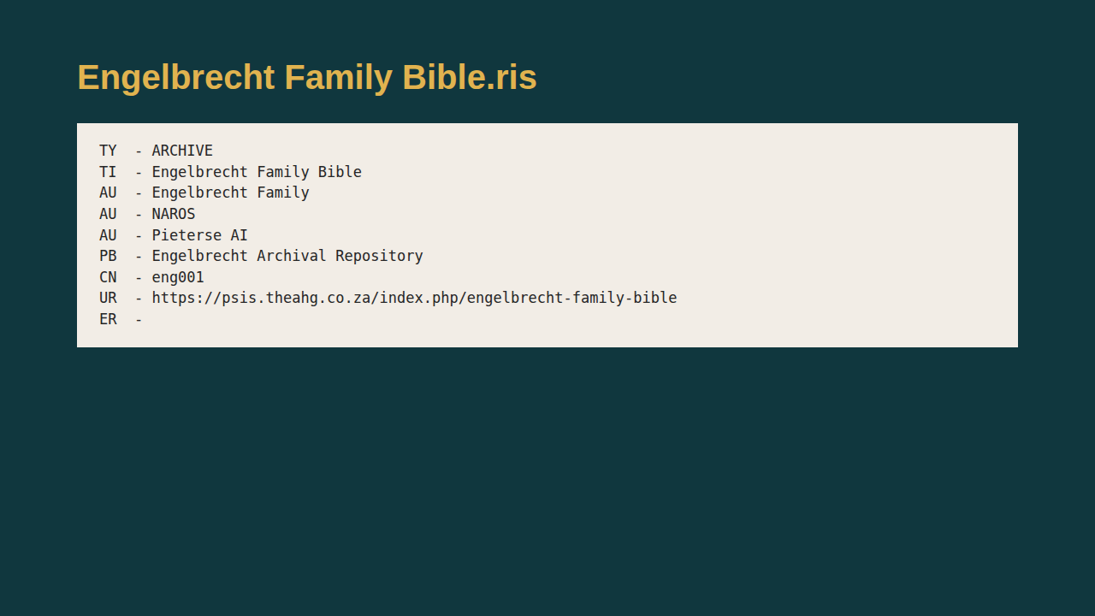
The RIS file.

4. Bibliographies
A bibliography collects citations for a chapter or an article. Open Bibliographies from the research sidebar and click New Bibliography. Name it, choose the citation style, and click Create.
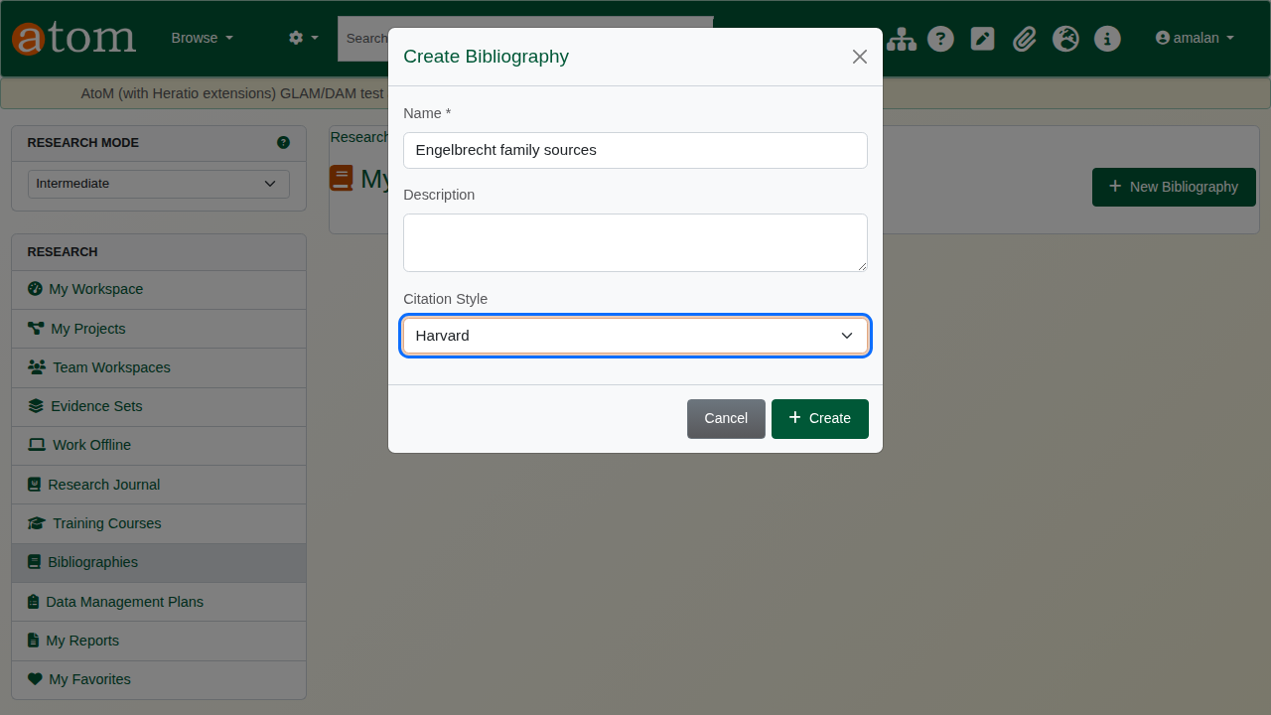
A new bibliography.
Click Add Entry and type part of a title or a reference code; matching archive records are offered as you type. Choose one and click Add Entry.
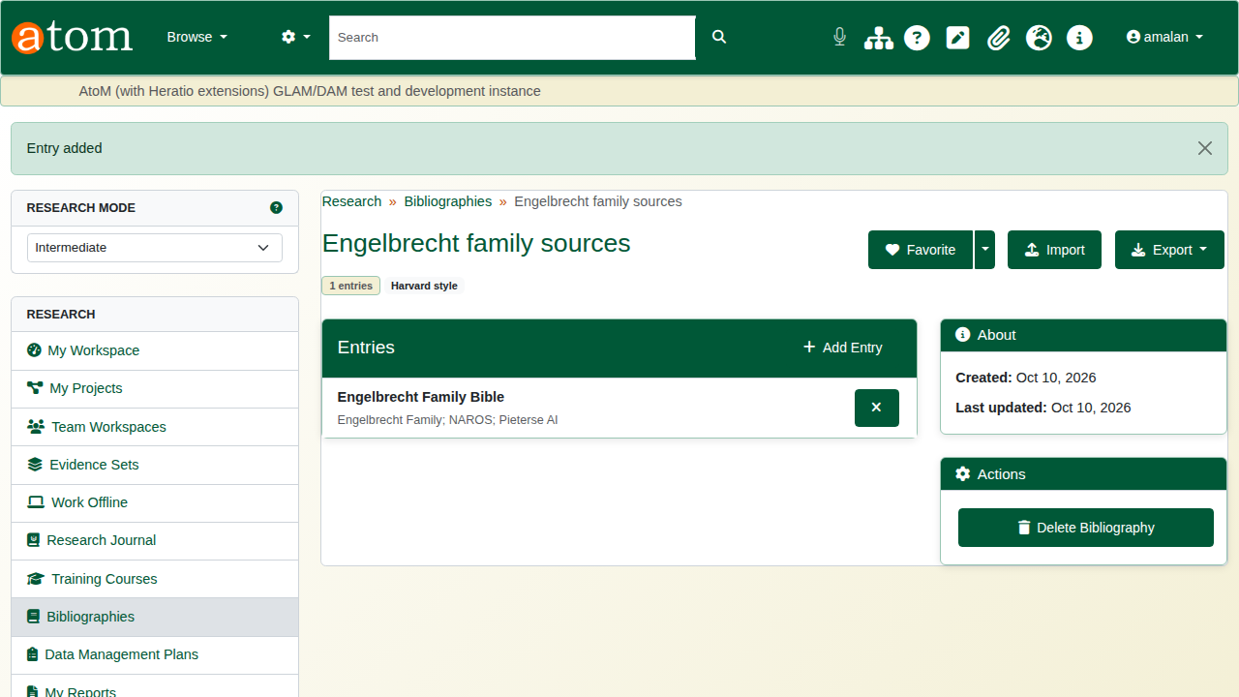
The entry added.
Export downloads the whole bibliography as RIS, BibTeX, Zotero RDF, Mendeley JSON or CSL-JSON. Import brings in citations from elsewhere, as a BibTeX or RIS file or pasted text; duplicate titles are skipped.
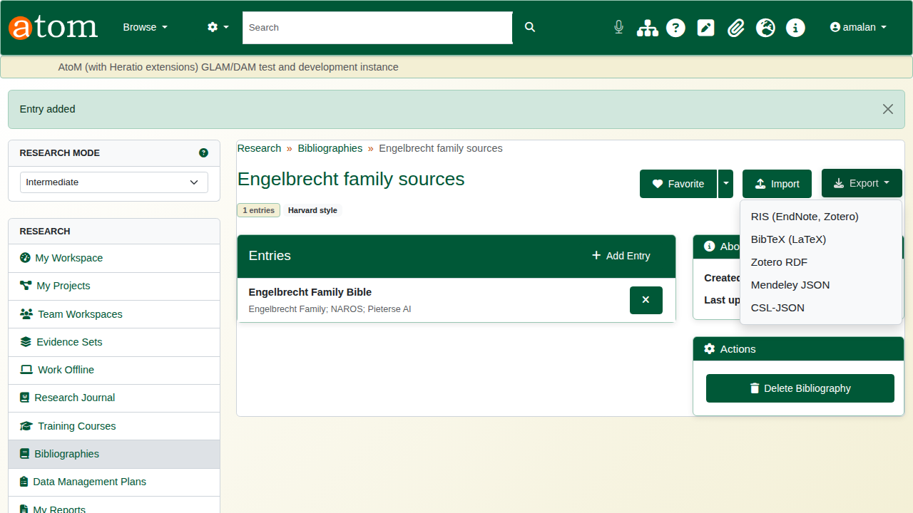
Export formats.

Recap
- My Workspace is the starting point.
- Gather records into evidence sets from any record page.
- Add a note to each record, and export the set as a finding aid.
- Cite a record in the style you need, or download it for a reference manager.
- Build a bibliography, and export it.
Part 4 covers research projects and writing.

