Training: Research Portal, Part 4 - Projects and Writing
Step-by-step guide to research projects, milestones, the research journal and reports
Dr Johan Pieterse
Document control
Field | Value
Document title | Training: Research Portal, Part 4 - Projects and Writing
Author | Dr Johan Pieterse
Owner | The Archive and Heritage Group (Pty) Ltd
Version | 1.0
Status | Released
Date | 10 October 2026
Prepared for | Researchers using the AHG extensions
Classification | Public
Reference | AHG-TRN-RES-04
Contents
Right-click and choose Update Field to build this list.
List of Tables
Right-click and choose Update Field to build this list.
This guide goes with part 4 of the research portal training videos. The researcher sets up a research project, plans it with milestones and attaches the records she works from. She keeps a research journal along the way, then drafts a report from a template and exports it. Allow about 20 minutes.

Before you start
What you need before you start
What | Notes
An approved researcher account | See part 1.
Privacy | Projects, journal entries and reports belong to the researcher and stay private until she shares them.

1. Create a project
Open My Projects from the research sidebar and click New Project.
New project fields
Field | Example
Project Title | The Engelbrecht family, 1850-1950
Description | Births, marriages and land of the Engelbrecht family in the Cape.
Project Type | Genealogy (also thesis, dissertation, publication, exhibition, documentary, institutional, personal, other)
Institution | Cape Training College
Start Date / Expected End Date | 1 November to 31 October the following year
The deliberate mistake: an expected end date before the start date.
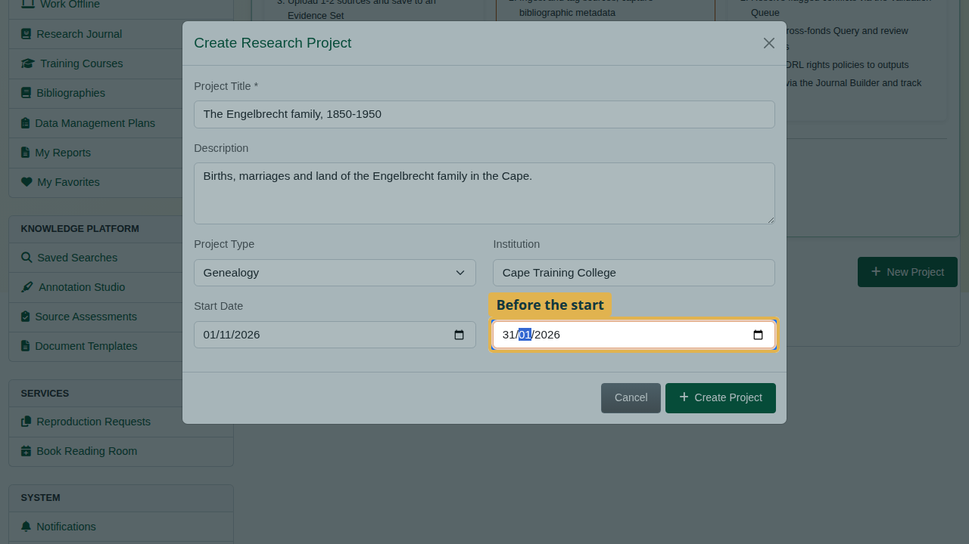
The end date before the start.
On Create Project the dialog stays open with the message “The expected end date is before the start date”. Everything typed is kept. Correct the end date and create the project.
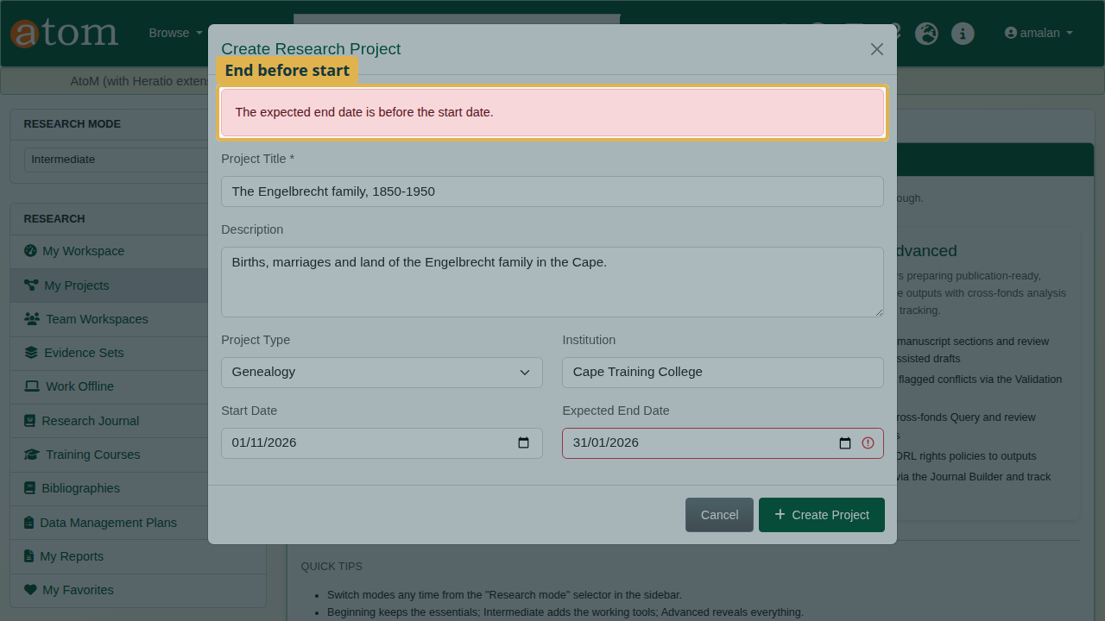
The dates refused, everything kept.

2. The project page
The project page brings the work together: description and timeline, milestones, linked resources, external sources and documents, collaborators, and analysis tools such as the knowledge graph and timeline builder.
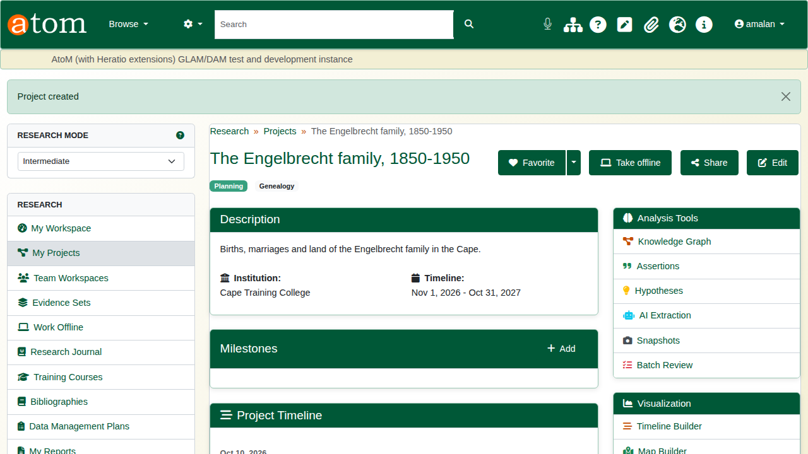
The new project.
Under Milestones, click Add, give the step a title and a due date, and click Save Milestone. It also appears on the project timeline.
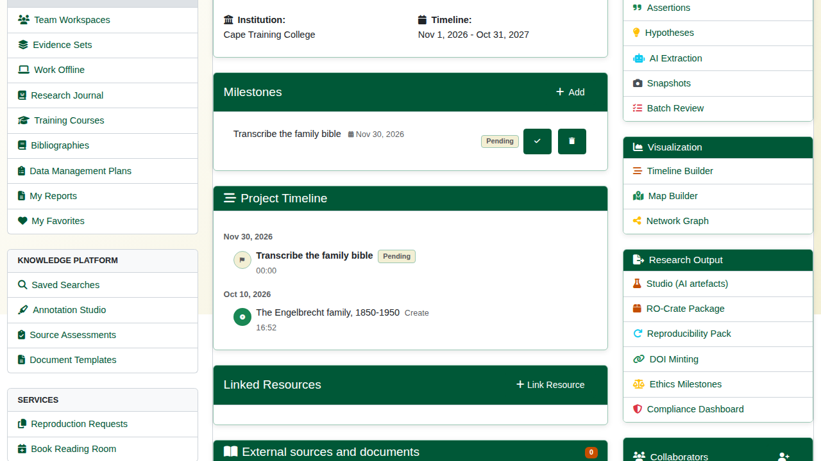
A milestone.
Under Add Items to Project, type part of a title. Choose the record, add an optional note, and click Add to Project.
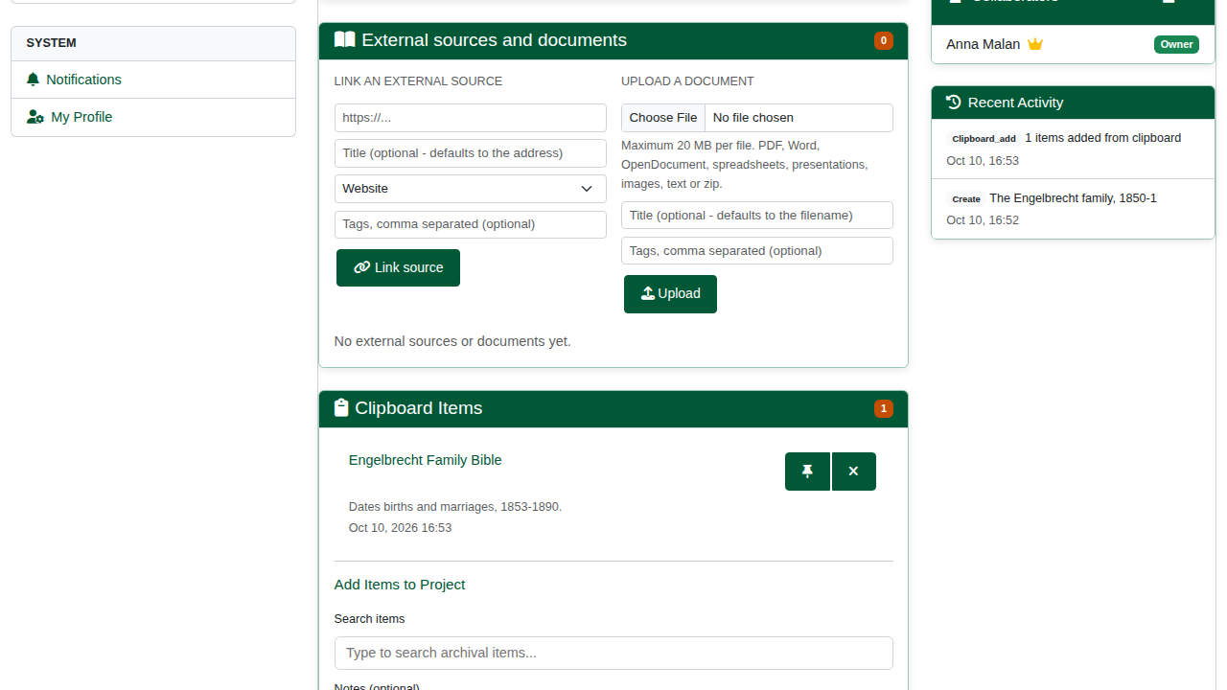
A record added to the project.

3. The research journal
Open Research Journal. It keeps a dated record of the work. Some entries are written automatically, such as reading room bookings.
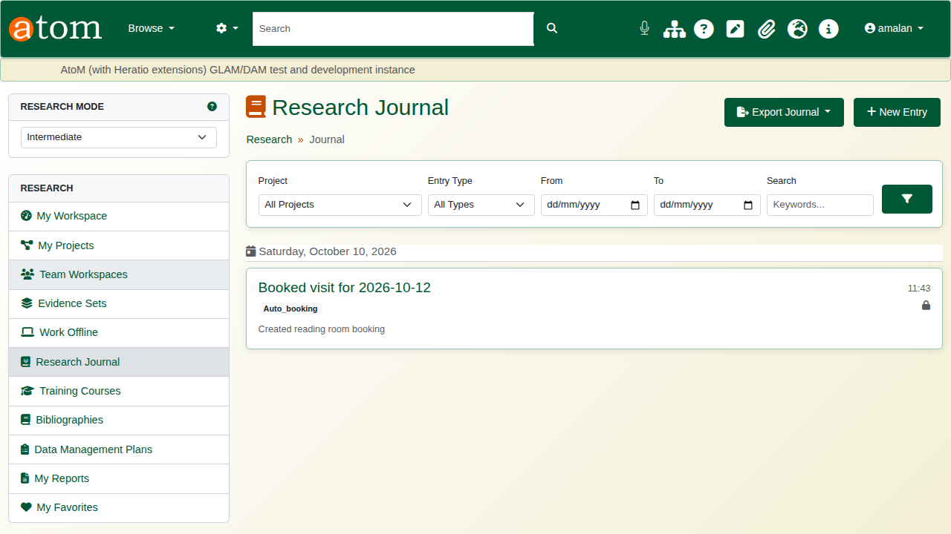
The research journal.
Click New Entry. Give it a title and write the entry, then choose the project and the entry type (note, observation, finding, question). You can also log the time spent and add tags. Private keeps the entry to yourself.
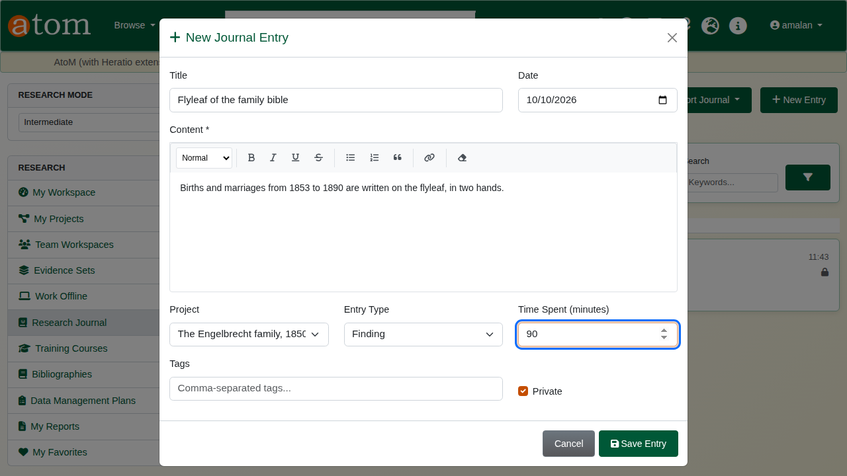
A new journal entry.
Click Save Entry. The entry is listed under its date with its project, type and time. Export Journal downloads the journal as PDF or Word (DOCX). The filters narrow it by project, type and dates.
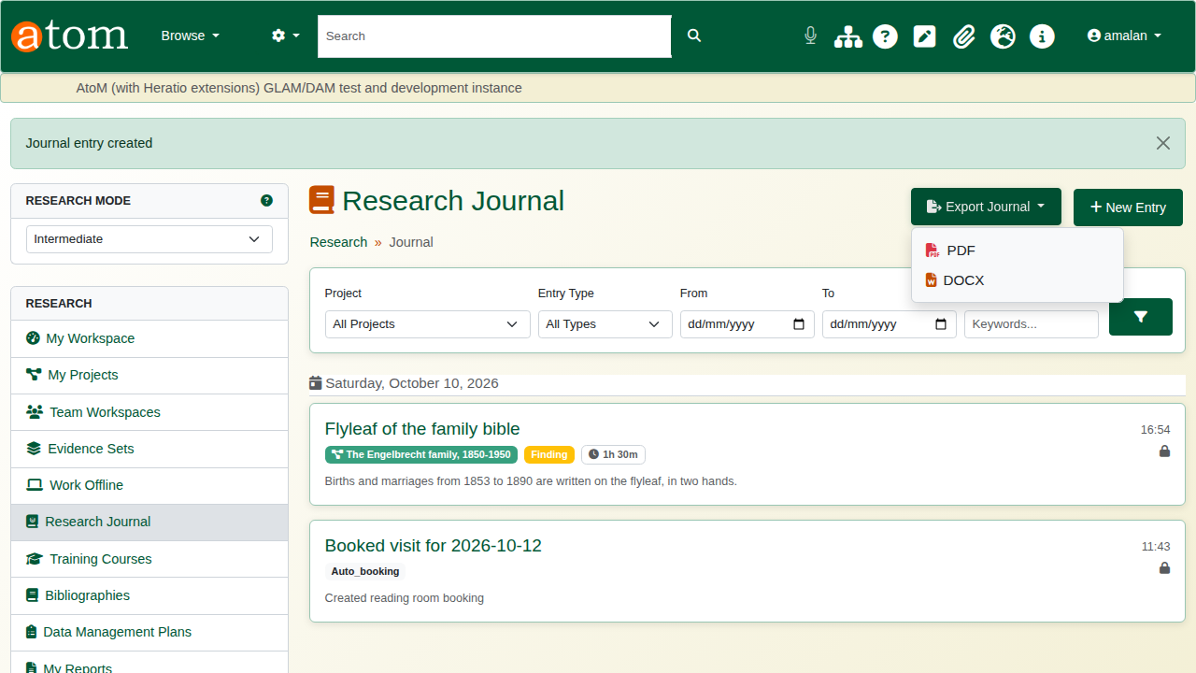
The saved entry and the export menu.

4. Reports
Open My Reports and click New Report. Choose a template, give the report a title, and link it to the project.
Report templates
Template | Sections
Research Summary | Introduction, methodology, findings, conclusions
Genealogical Report | Title page, contents, family overview, origins, timeline, notable members, records consulted, bibliography
Historical Analysis | Context, primary sources, chronological narrative
Source Analysis | Provenance, reliability, interpretation
Finding Aid | Scope, arrangement, access conditions, container list
Custom Report | Blank: add your own sections
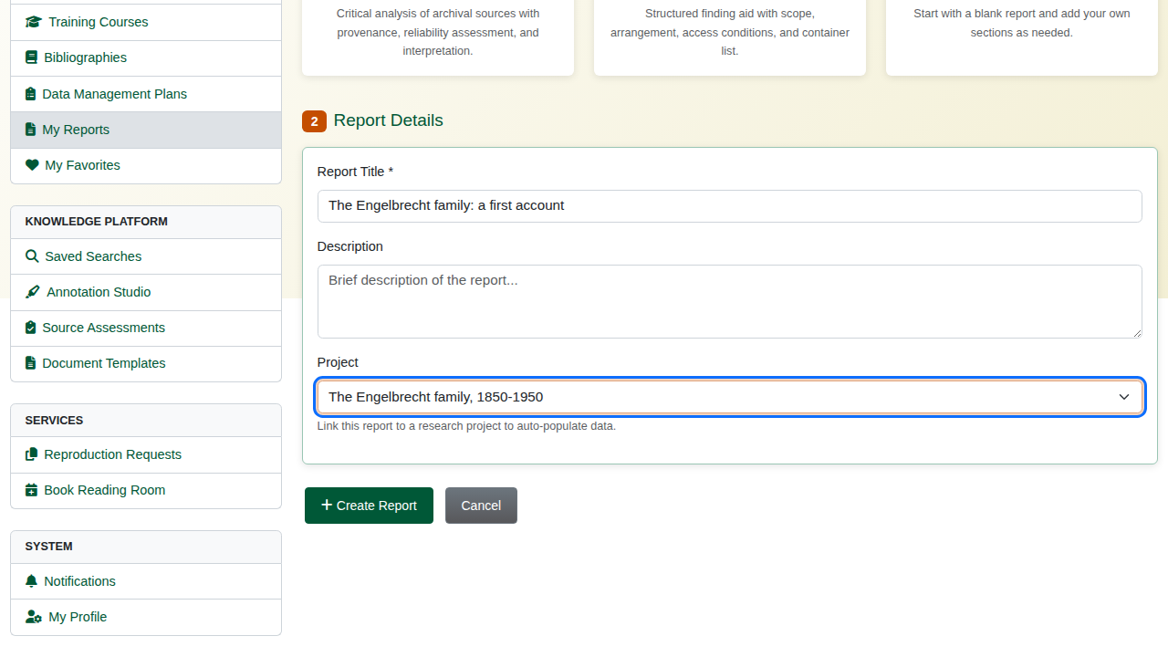
A new report from the Genealogical template.
The template lays out the sections. Each can be moved up or down, edited or removed, and new sections are added at the foot of the page.
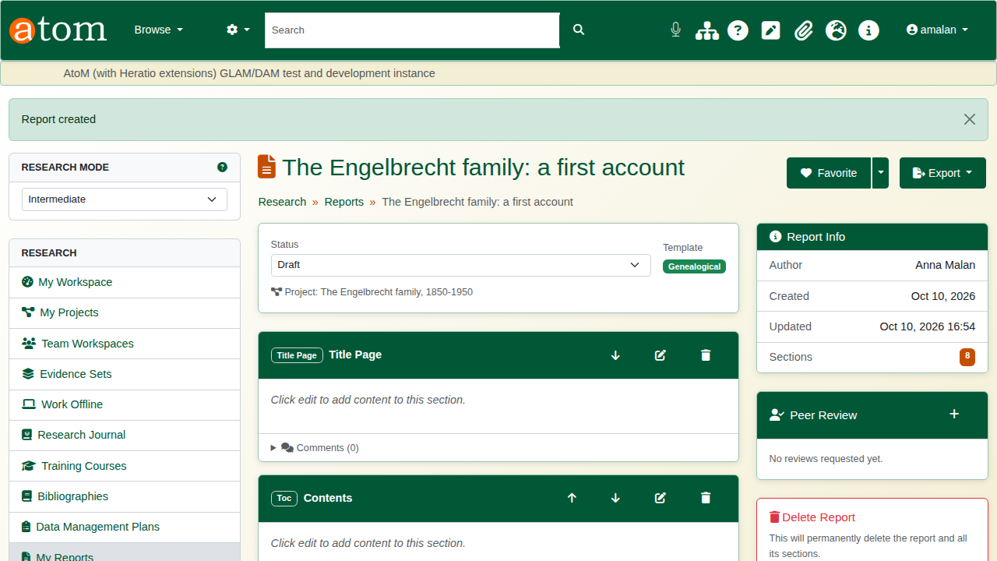
The report’s sections.
Click the edit button on a section, write in the editor, and click Save.
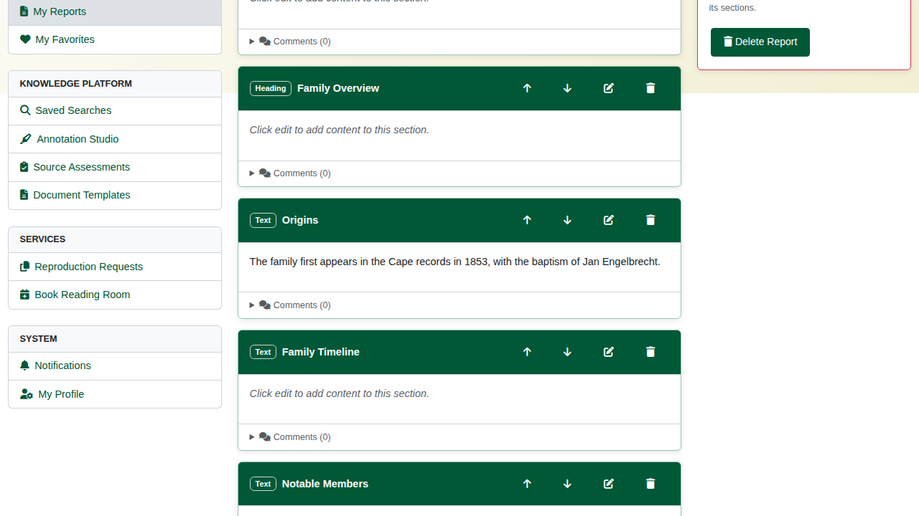
The Origins section written.
Export produces the report as PDF or Word (DOCX).
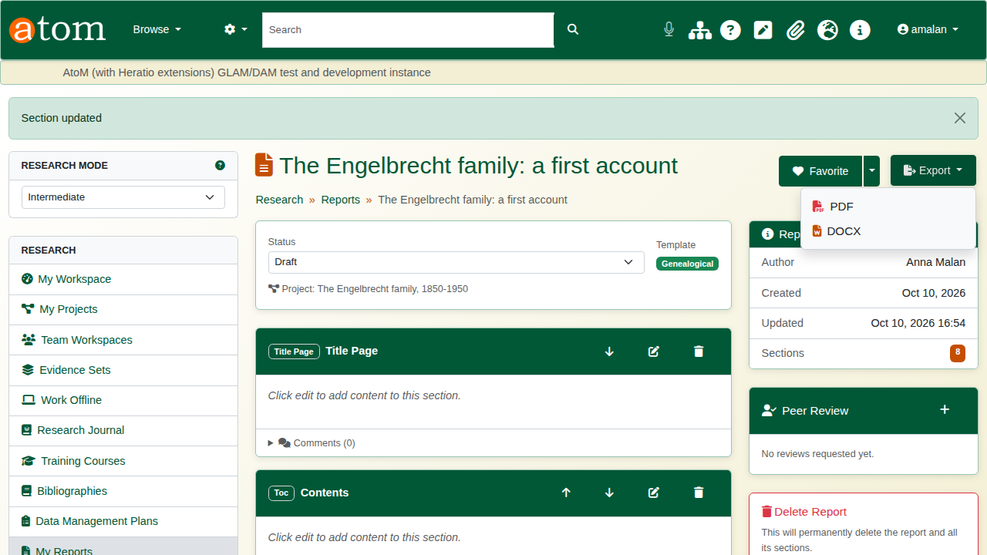
Export.

Recap
- Create a project; the portal checks the dates.
- Plan milestones and attach the records you work from.
- Keep a research journal as you go.
- Draft a report from a template and write it section by section.
- Export it as PDF or Word.
Part 5 covers reproduction requests.

