Training: Preservation, Part 2 - Fixity, Formats and PREMIS
Step-by-step guide to checksums and fixity checks, PRONOM format identification and risk, virus scanning, PREMIS events and the preservation scheduler
Dr Johan Pieterse
Document control
Field | Value
Document title | Training: Preservation, Part 2 - Fixity, Formats and PREMIS
Author | Dr Johan Pieterse
Owner | The Archive and Heritage Group (Pty) Ltd
Version | 1.0
Status | Released
Date | 14 October 2026
Prepared for | Archivists and digital preservation staff using the AHG extensions
Classification | Public
Reference | AHG-TRN-PRS-02
Contents
Right-click and choose Update Field to build this list.
List of Tables
Right-click and choose Update Field to build this list.
This guide goes with part 2 of the preservation training videos. Using the farm diaries ingested in part 1, you look at how the archive proves a file is unchanged, says what format it is and how much at risk, scans it for viruses, and records every one of those actions as a PREMIS event. Allow about 20 minutes.

Before you start
What you need before you start
What | Notes
An administrator account | The preservation pages are under Admin > Preservation.
The farm diaries from part 1 | Fictitious practice records with three scanned pages.

1. One file’s preservation record
Every digital object has a preservation page (/admin/preservation/object/<digital object id>), reached from the file name on any preservation list. It shows the file’s details, its format and risk, its checksums, its fixity history and its PREMIS events.
At ingest the wizard already calculated a SHA-256 checksum, identified the format and scanned the file, so the diary’s page starts with those events.
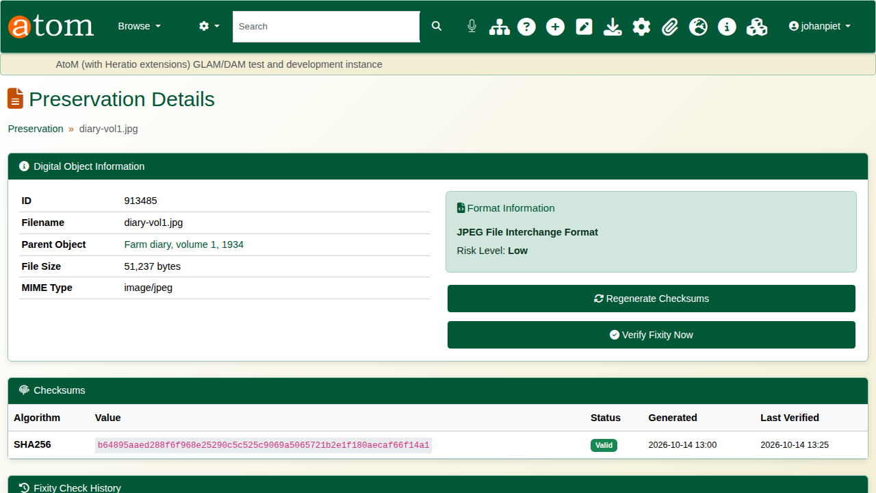
The diary’s preservation page.

2. Fixity
A checksum is a fingerprint of the file’s exact bytes. Verify Fixity Now reads the file again and compares it with the stored checksum: a match passes, and any change (disk fault, corruption, tampering) fails and flags the file. Each check is added to the fixity history and logged as a fixity check event. Regenerate Checksums makes new ones, for instance after a deliberate, recorded change to the file.
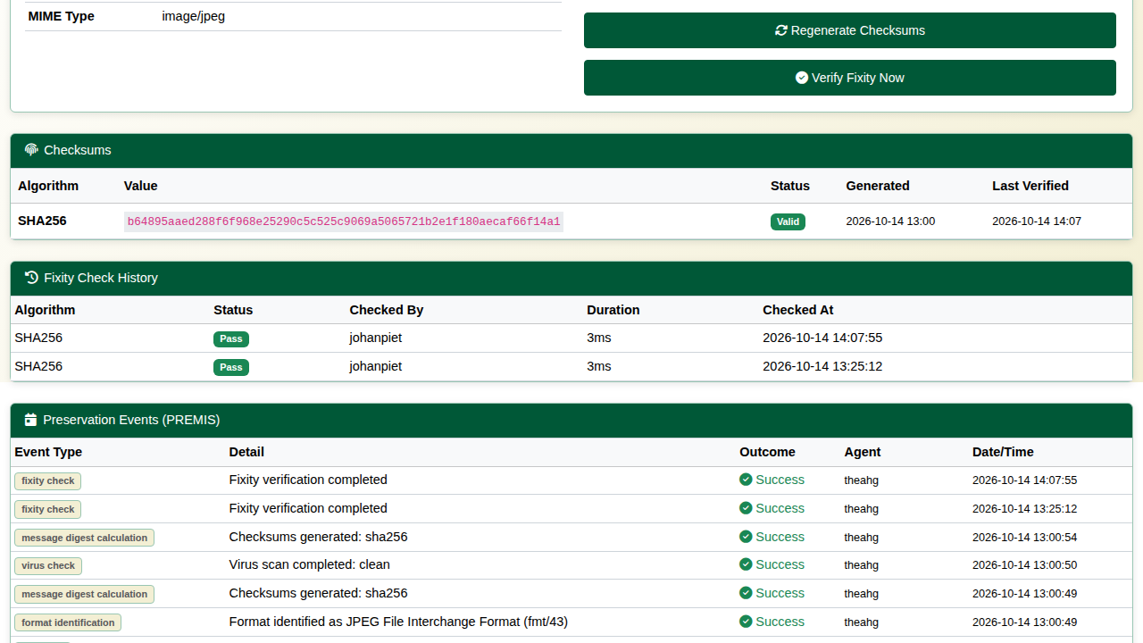
The fixity check passed.
The Fixity Log (/admin/preservation/fixity-log) lists every check across the archive with its result, who or which job ran it, and when; it can be filtered to failures.
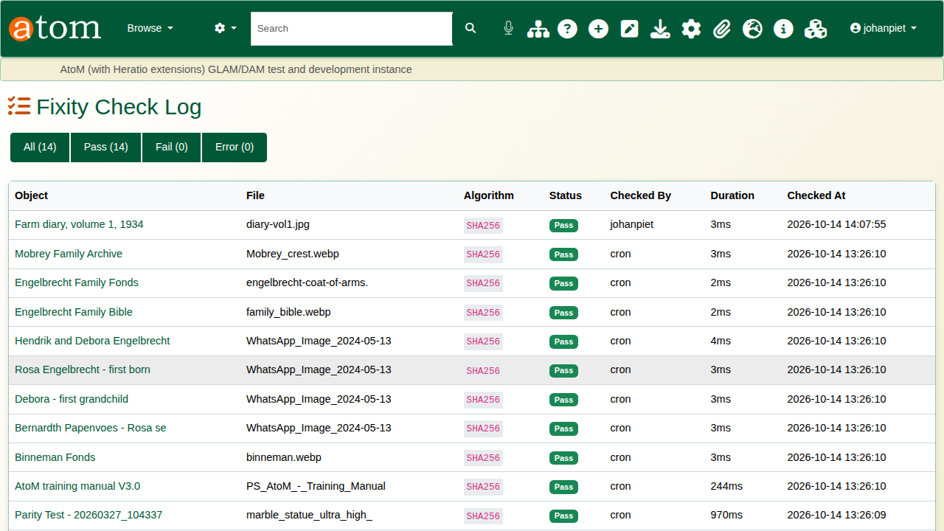
The fixity log.

3. Format identification
Format Identification (/admin/preservation/identification) uses Siegfried against PRONOM, the format registry of The National Archives (UK). It shows the coverage of the collection, the confidence of each match, the formats with warnings, the most used formats and the latest identifications. A file Siegfried cannot match is logged as a warning (“no PRONOM match”) for follow-up.
Identification confidence
Confidence | Meaning
Certain / High | Matched on the file’s internal signature (and usually its extension)
Medium | Matched with a warning
Low | Matched on extension only, or a weak signature
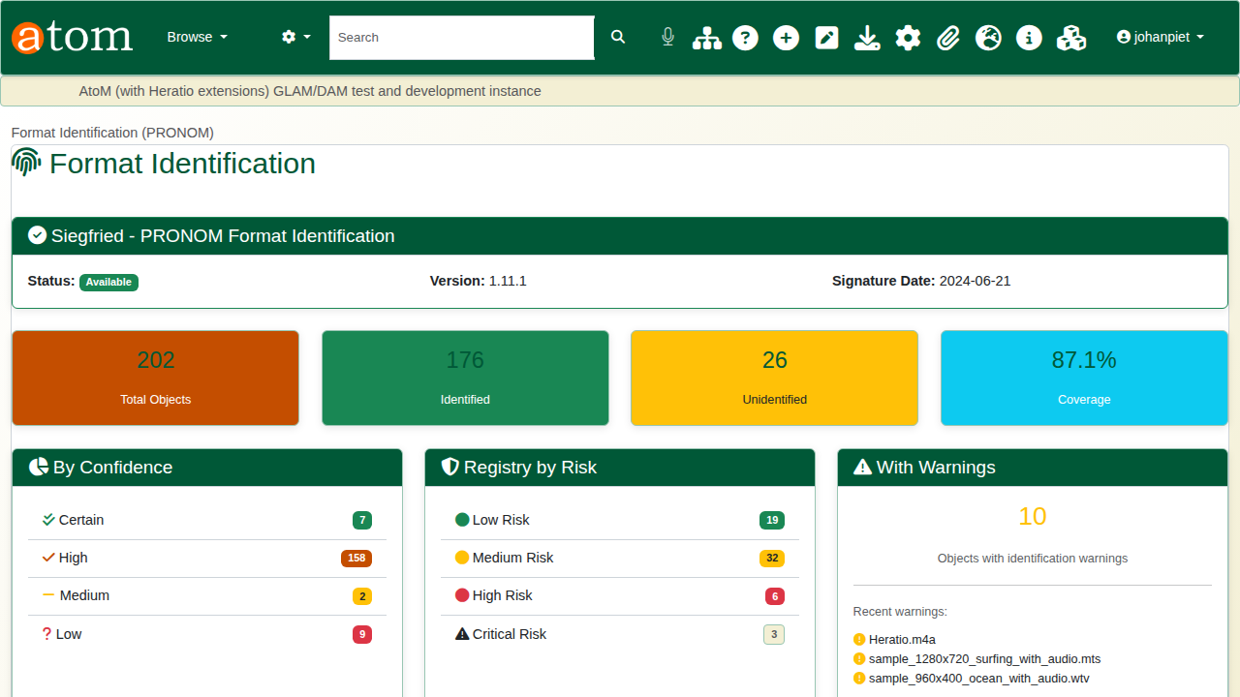
Format identification.
The Format Registry (/admin/preservation/formats) rates each format’s preservation risk and the action it needs, most at risk first. Preservation formats (TIFF, PDF/A, plain text, WAV, FLAC and others) are marked as such.
Format risk levels
Risk | Typical formats | Action
Critical, High | Old Office binaries (.doc, .xls, .ppt), Windows Media, AVI, PICT | Migrate
Medium | Proprietary or less documented formats | Monitor
Low | TIFF, PDF/A, PNG, JPEG, plain text | None
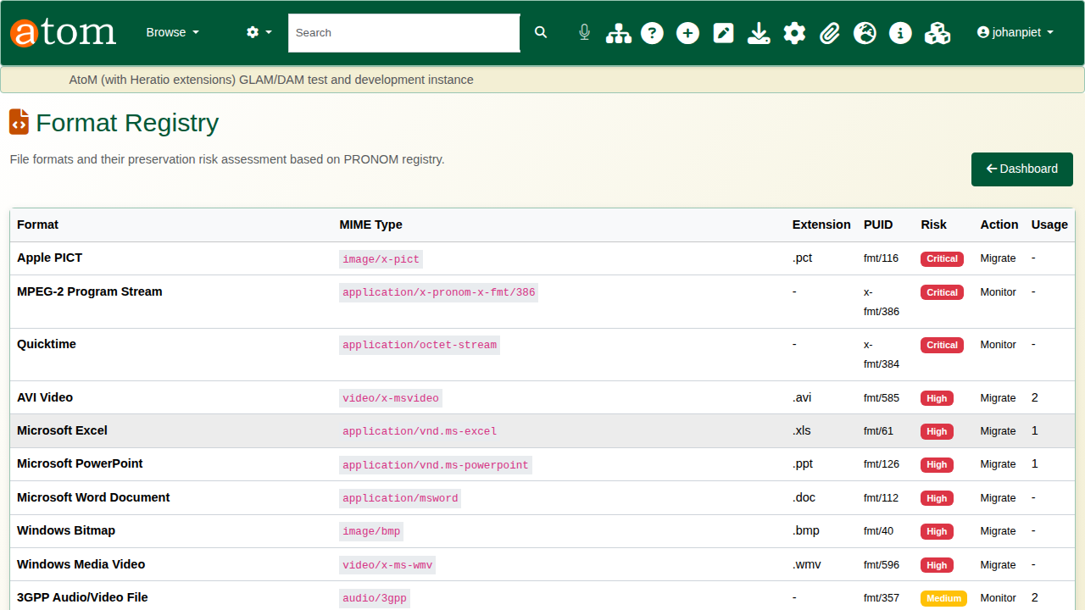
The format registry.

4. Virus scanning
Virus Scanning (/admin/preservation/virus-scan) uses ClamAV. The header shows the scanner (daemon or command line), the engine version and the signature version with its date; keep the signatures current (the clamav-freshclam service). The counts show clean, infected, error and not-yet-scanned files. An infected file is moved to quarantine and logged as a failed virus check event.
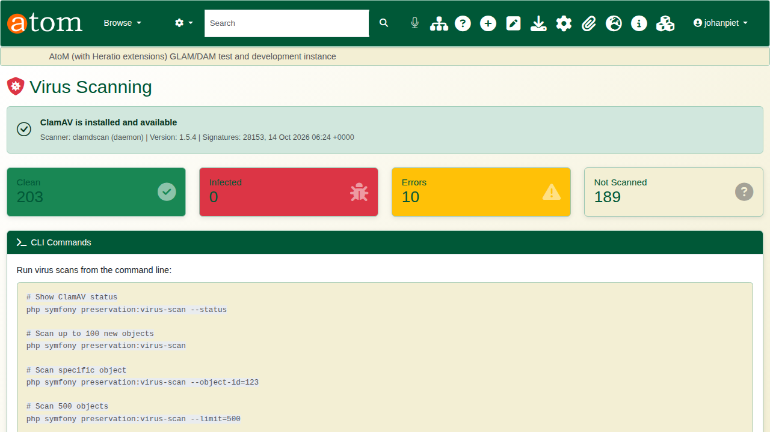
Virus scanning.

5. PREMIS events
Preservation Events (/admin/preservation/events) is the audit trail, in PREMIS terms. Filter by type to see one kind.
PREMIS event types
Event type | Recorded when
Ingestion | A file enters through the ingest wizard
Message digest calculation | A checksum is made
Fixity check | A file is verified against its checksum
Format identification | A file is identified (or not) against PRONOM
Virus check | A file is scanned
Information package creation | A SIP, AIP or DIP is written
Normalization | A file is converted to a preservation format
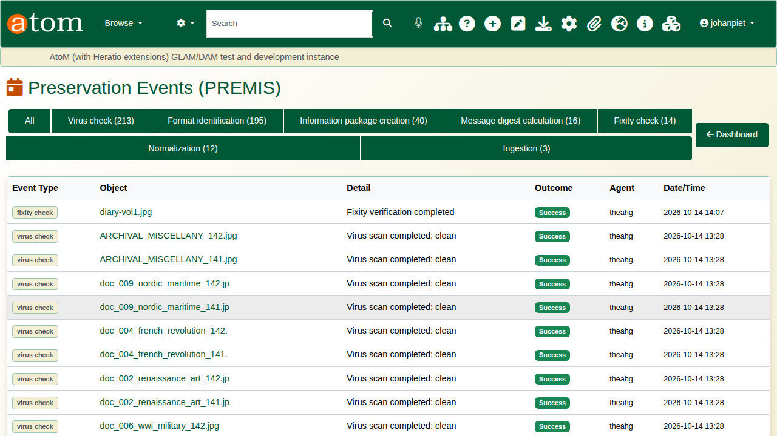
The PREMIS event log.
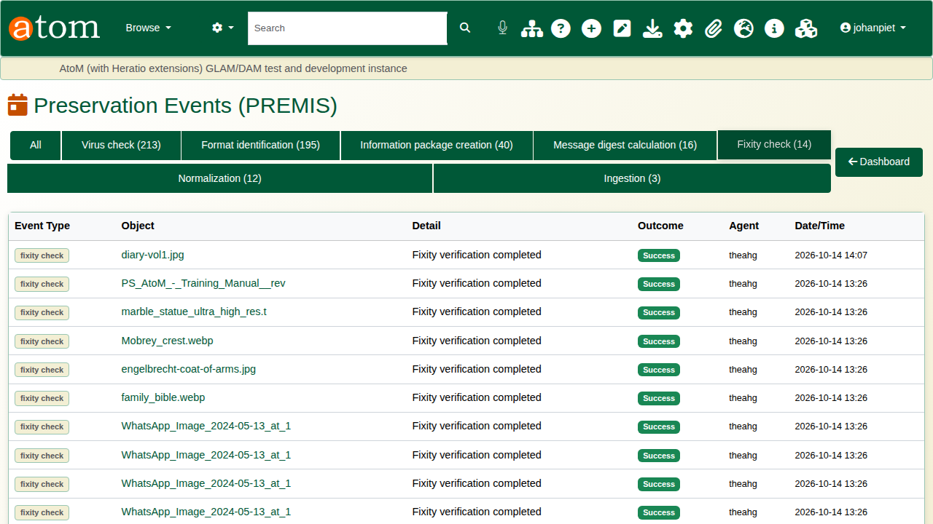
Filtered to fixity checks.

6. Scheduling
The Workflow Scheduler (/admin/preservation/scheduler) runs the work on a timetable: daily format identification, fixity checks and virus scans, and weekly backup verification, each over a set number of objects. It shows each schedule’s last run and result, the next run, and the upcoming runs; the play button starts a schedule at once. The scheduler itself is started every minute by cron:
* * * * * www-data cd /usr/share/nginx/archive && php symfony preservation:scheduler
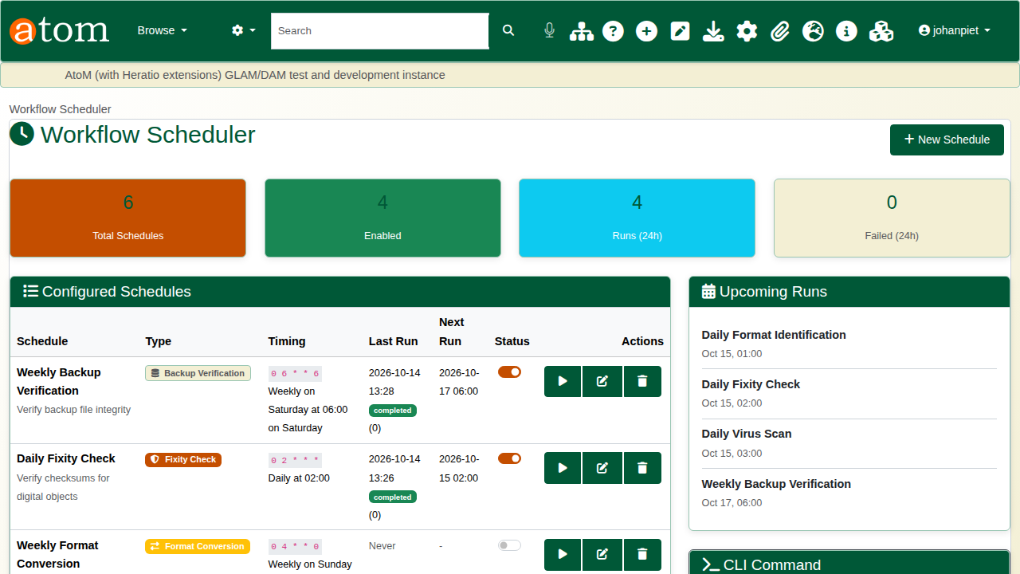
The workflow scheduler.

Recap
- Checksums are made at ingest and verified again over time.
- Formats are identified against PRONOM and rated for risk.
- Files are scanned for viruses, and infected files are quarantined.
- Every action is a PREMIS event; the scheduler keeps it all running.
Part 3 covers backup and restore.

