Training: Research Portal, Part 7 - From Research to a Manuscript
Step-by-step guide to choosing a target journal, drafting a manuscript, the submission checklist, and downloading it for submission
Dr Johan Pieterse
Document control
Field | Value
Document title | Training: Research Portal, Part 7 - From Research to a Manuscript
Author | Dr Johan Pieterse
Owner | The Archive and Heritage Group (Pty) Ltd
Version | 1.0
Status | Released
Date | 12 October 2026
Prepared for | Researchers using the AHG extensions
Classification | Public
Reference | AHG-TRN-RES-07
Contents
Right-click and choose Update Field to build this list.
List of Tables
Right-click and choose Update Field to build this list.
This guide goes with part 7, the last of the research portal training videos. The researcher chooses a journal to publish in and drafts her article in the manuscript workspace. She checks it against the journal’s requirements, then downloads it as a Word document ready to submit. Allow about 15 minutes.

Before you start
What you need before you start
What | Notes
An approved researcher account | See part 1. Manuscripts are private to their author.
The journal directory | Kept by the archive’s administrators; researchers browse it and choose from it.

1. Choose a journal
Open Where to Publish (/research/target-journals). The directory lists each journal’s scope, where it is indexed or accredited, and the reference style it expects. Search by title, scope, publisher or indexing, or filter by market.
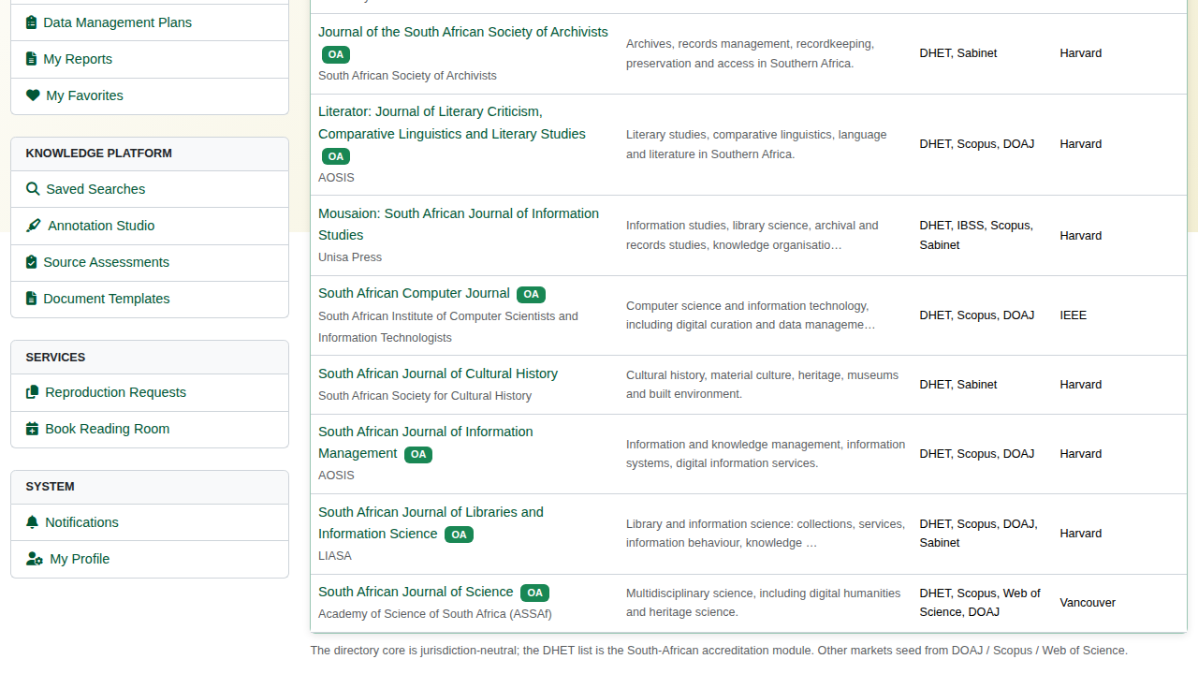
The target-journal directory.
Open a journal to read its submission rules: article types, accreditation, reference style, peer review and languages.
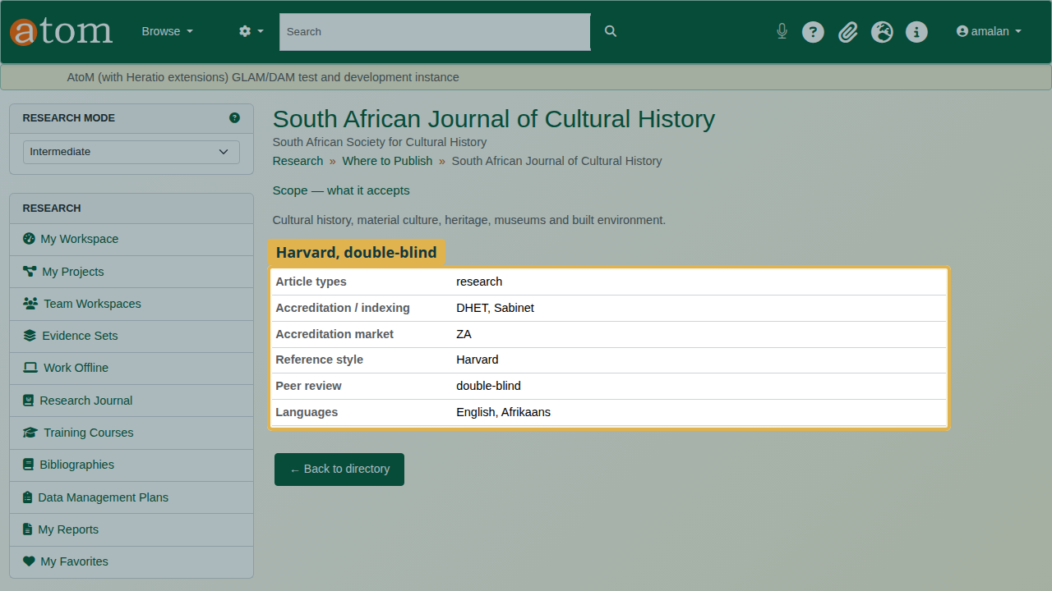
A journal’s submission rules.

2. Draft the manuscript
Open the Journal Builder (/research/journal-builder) and click New manuscript. Give it a title and choose its Target journal, then save.
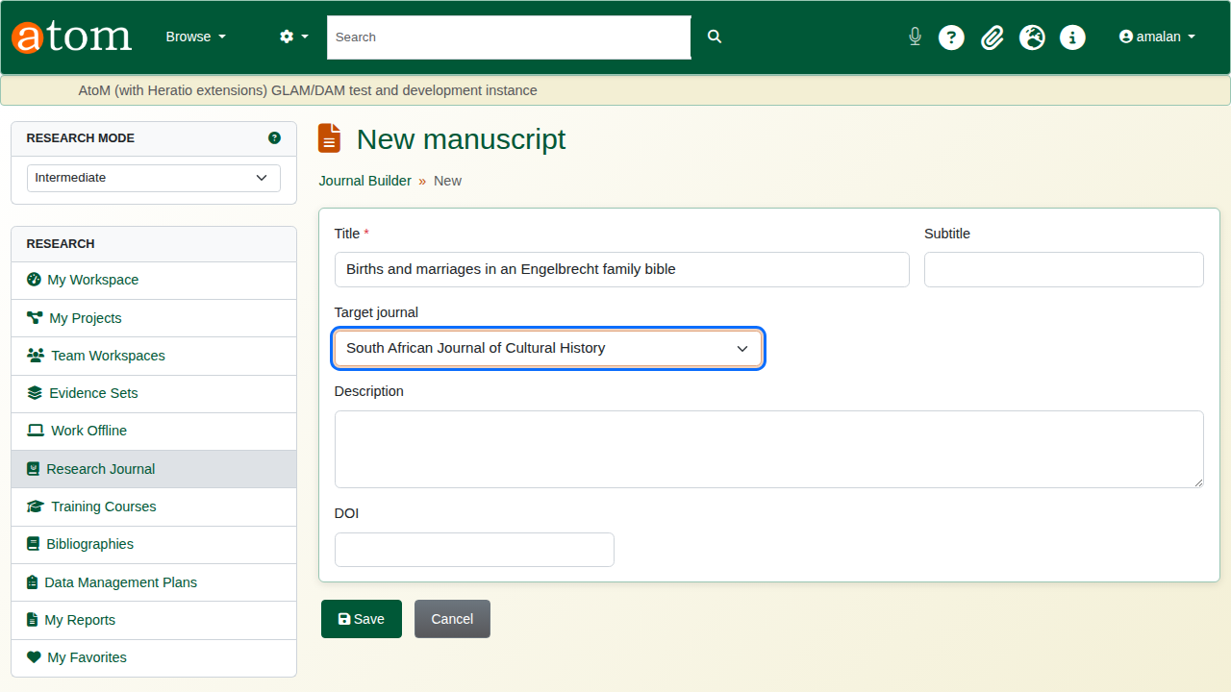
A new manuscript aimed at a journal.
On the manuscript, click New manuscript article. Enter the title, the authors, an abstract and keywords, then write the body in Markdown: ## for headings, - for list items, a blank line between paragraphs.
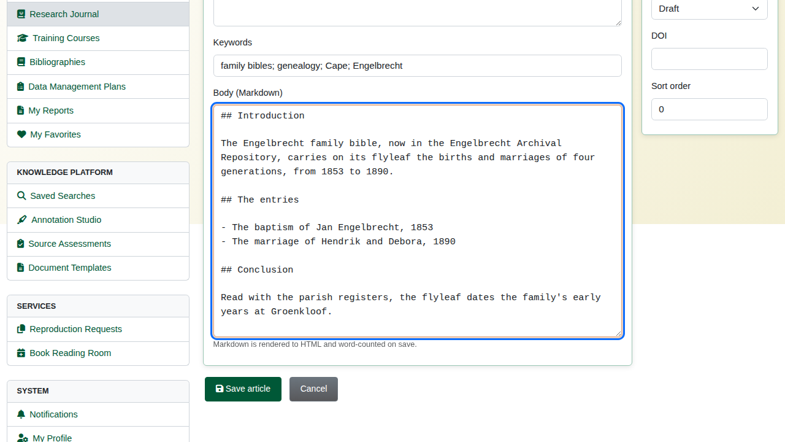
The article, written in Markdown.

3. The submission checklist
The deliberate mistake: leave the abstract empty and set the reference style to APA. On Save article the Submission checklist lists what stands between the manuscript and submission:
What the checklist checks
Check | Example message
Completeness | An abstract is required for submission. (Also title, at least one author, and a body.)
Reference style | Reference style should be Harvard for this journal.
Word limit | Manuscript exceeds the journal’s word limit, when the journal sets one.
The article is checked against its own target journal or, if it has none, against the manuscript’s. Below the form, a preview shows the article as rendered.
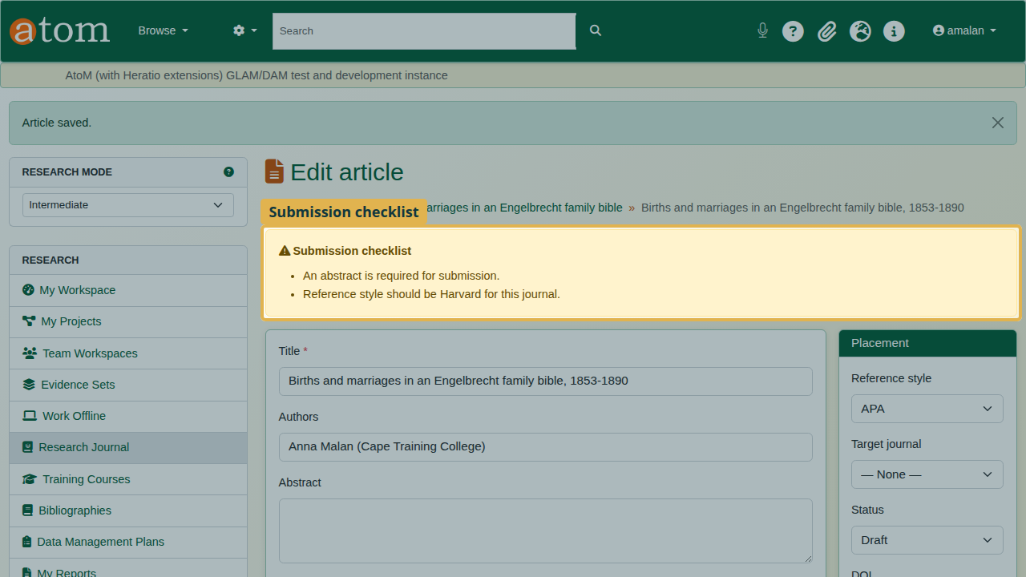
The checklist finds two problems.
Write the abstract, choose Harvard, and save again. The manuscript passes every check.
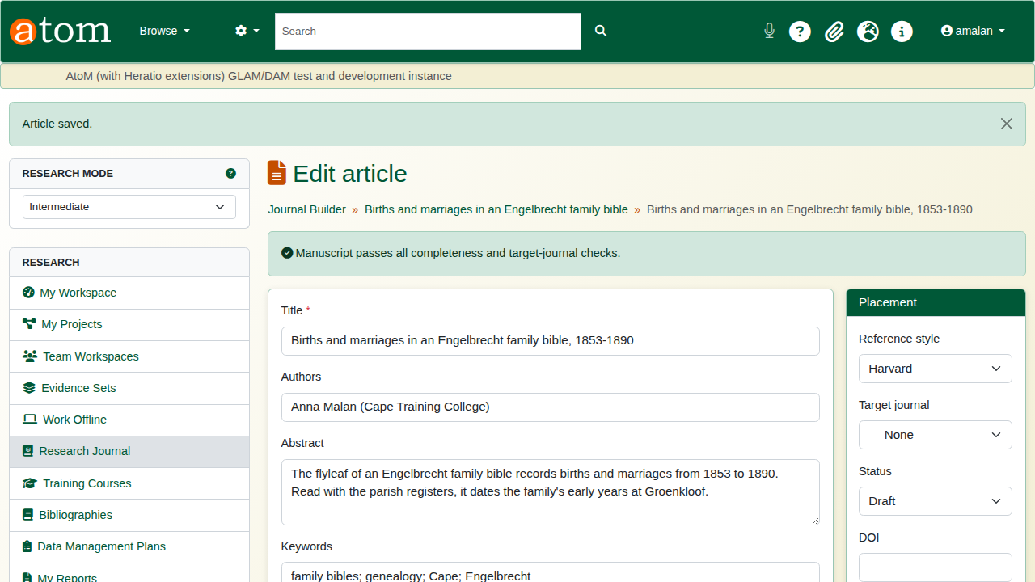
The manuscript passes.

4. Download for submission
Click Download for submission (Word). The document carries the title, the authors, the target journal, the abstract, the keywords and the article body with its headings and lists.
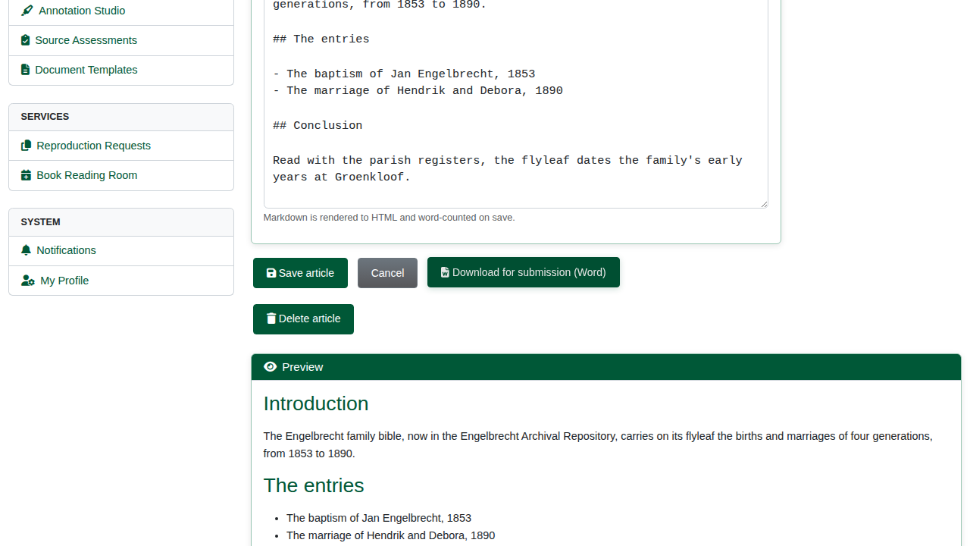
Download for submission.
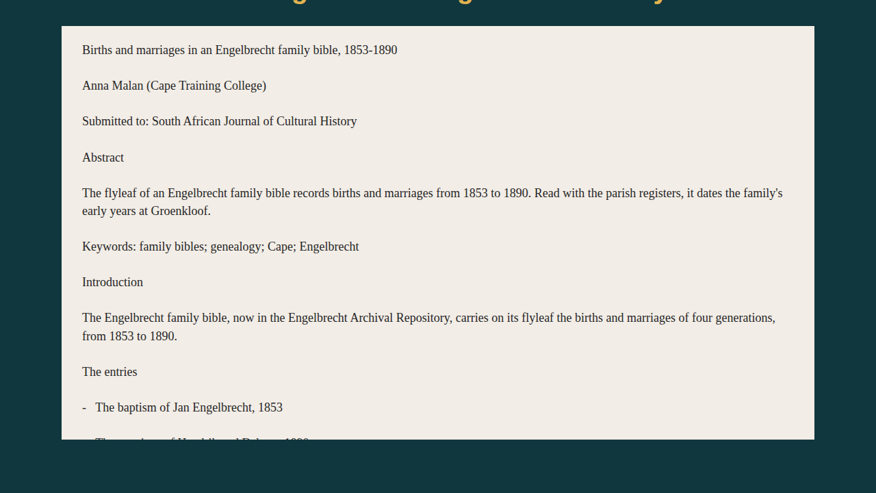
The Word document, as text.

Recap
- Choose a journal from Where to Publish and note what it expects.
- Create a manuscript aimed at it, and add the article.
- Write the body in Markdown.
- Fix what the submission checklist finds.
- Download it for submission.
This completes the research portal series.

