Training: Museum, Part 4 - Provenance and the Chain of Custody
Step-by-step guide to recording an object’s ownership history, finding gaps in the chain, and recording them
Dr Johan Pieterse
Document control
Field | Value
Document title | Training: Museum, Part 4 - Provenance and the Chain of Custody
Author | Dr Johan Pieterse
Owner | The Archive and Heritage Group (Pty) Ltd
Version | 1.0
Status | Released
Date | 12 October 2026
Prepared for | Curators, registrars and provenance researchers using the AHG extensions
Classification | Public
Reference | AHG-TRN-MUS-04
Contents
Right-click and choose Update Field to build this list.
List of Tables
Right-click and choose Update Field to build this list.
This guide goes with part 4 of the museum training videos. You record who has owned the painting since it was made, see the system find a break in the chain, and record that gap so the next researcher knows where to look. Allow about 15 minutes.

Before you start
What you need before you start
What | Notes
An editor or administrator account | Provenance is edited by staff; the summary can be shown publicly.
A museum object | The painting from part 1. Every owner and date in its history is fictitious.

1. Open the provenance
On the object, under Collections Management, open Provenance. With nothing recorded yet, click Add provenance information.
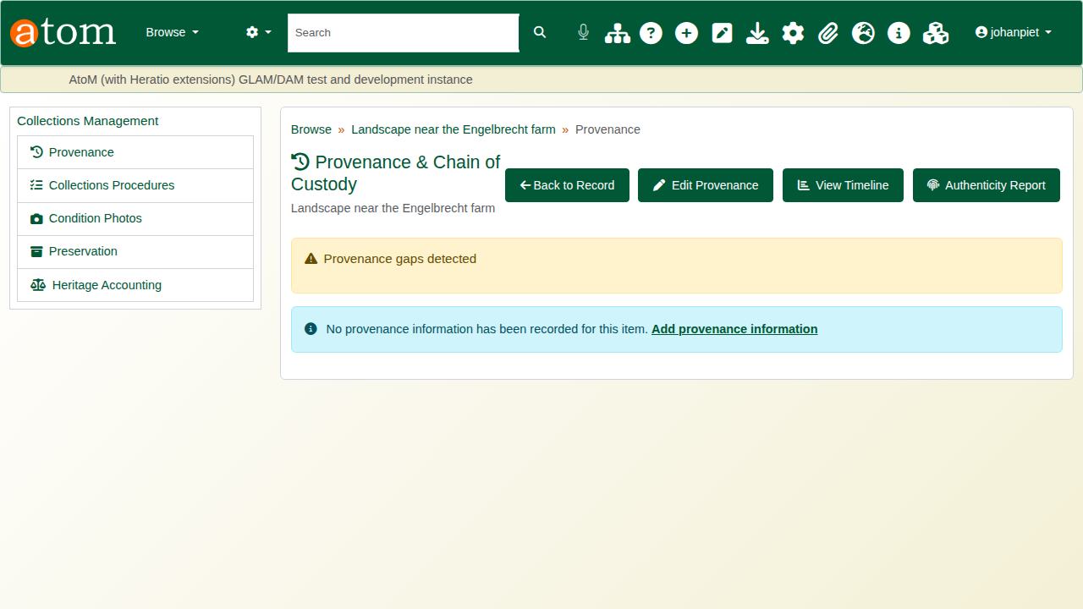
No provenance recorded yet.

2. Summary and acquisition
Write a Provenance Statement in plain words; it is shown publicly when Display provenance publicly is ticked. Under Acquisition Details, record how the institution acquired the object (here Donation), the date, and any price, currency and notes.
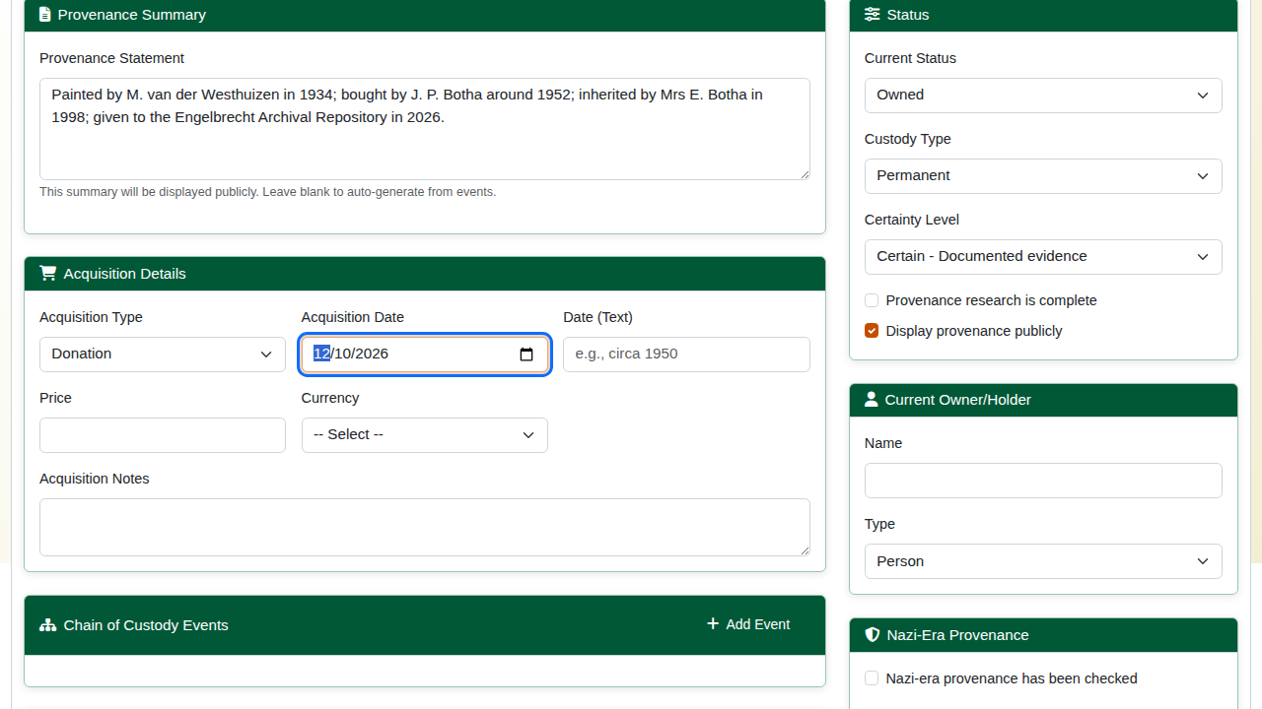
The summary and acquisition.

3. The chain of custody
Under Chain of Custody Events, click Add Event for each change of custody. Each event has:
Chain of custody event fields
Field | Meaning
Type | Creation, sale, purchase, auction, gift, donation, bequest, inheritance, transfer, loan, deposit, theft, recovery and more
Date / Date (text) | An exact date, or an approximate one such as “circa 1952”
Certainty | Certain, probable, possible or uncertain
From / To | Who the object passed from and to
Location, Notes | Where it happened and the evidence for it
The example chain:
The example chain of custody
Event | Date | From | To | Certainty
Creation | 1934 | - | M. van der Westhuizen | Certain
Purchase | circa 1952 | (unknown) | J. P. Botha | Probable
Inheritance | 1998 | J. P. Botha | Mrs E. Botha | Certain
Donation | 2026 | Mrs E. Botha | Engelbrecht Archival Repository | Certain
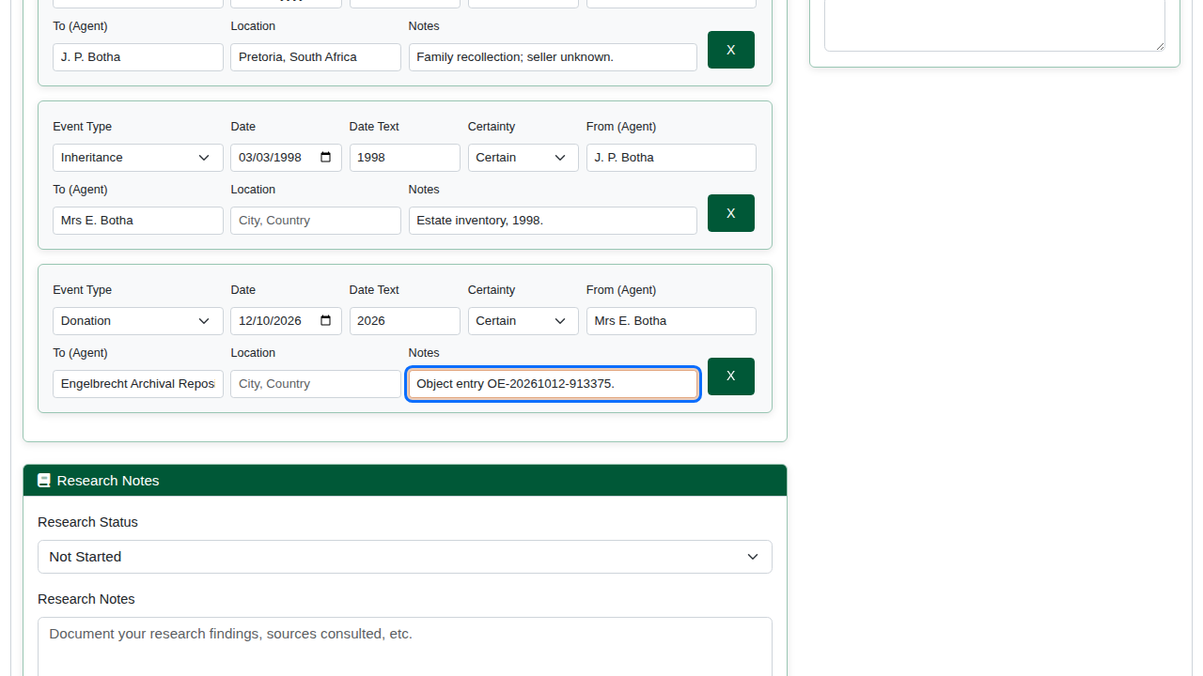
The chain of custody.
Set the Research Status, the overall Certainty Level and the Current Owner/Holder, then click Save Provenance.
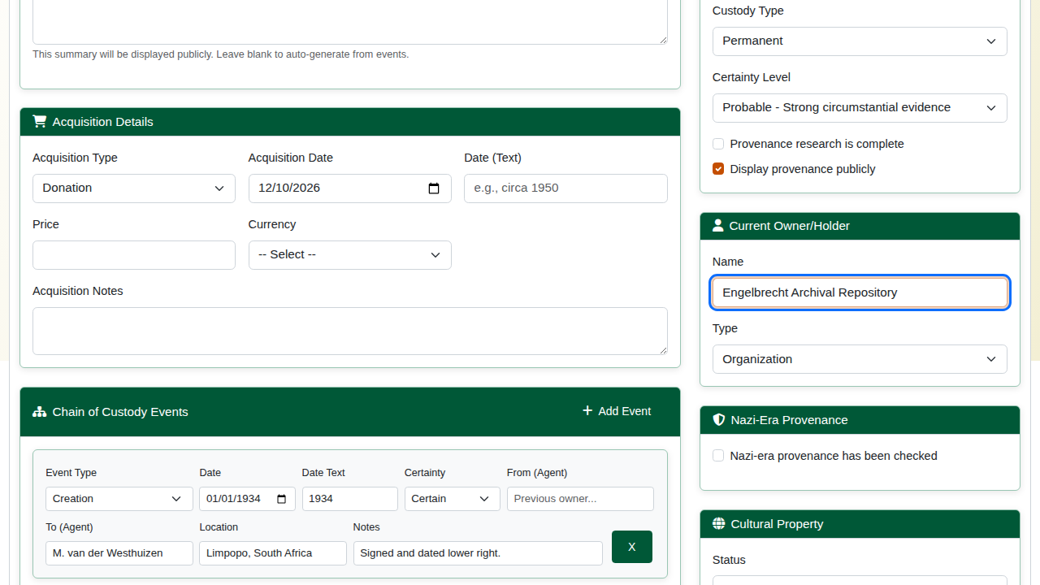
Status and current holder.

4. A gap in the chain
The system reads the chain link by link: each event’s “from” should be the previous event’s “to”. Where it is missing, or names someone else, Provenance gaps detected reports the break, with the years it covers when they are known. Here the purchase has no recorded seller, so the 18 years from 1934 to 1952 are unaccounted for.
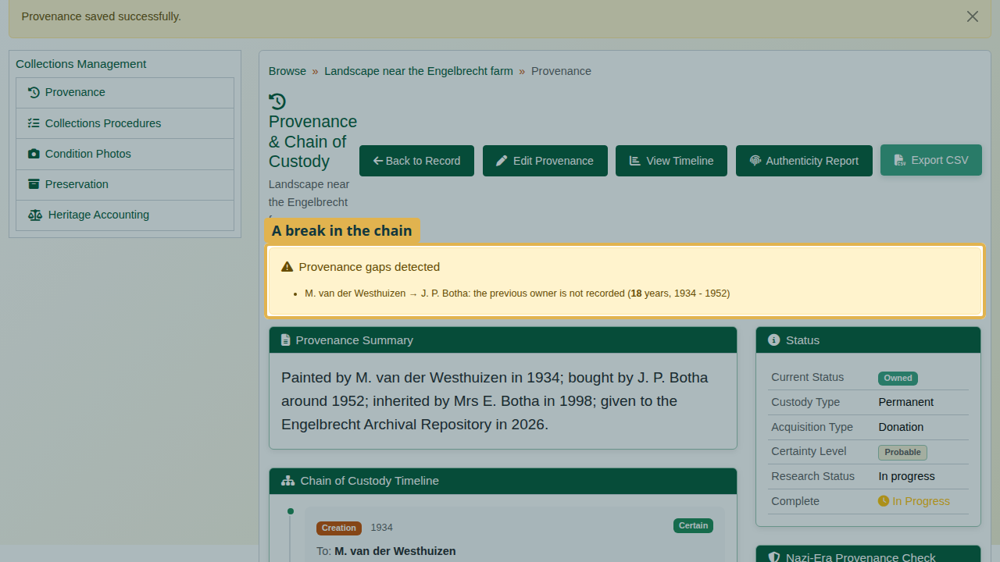
The gap detected.
Record the gap rather than hide it: Edit Provenance, tick There are gaps in the provenance chain and describe what is missing and where to look. Save.
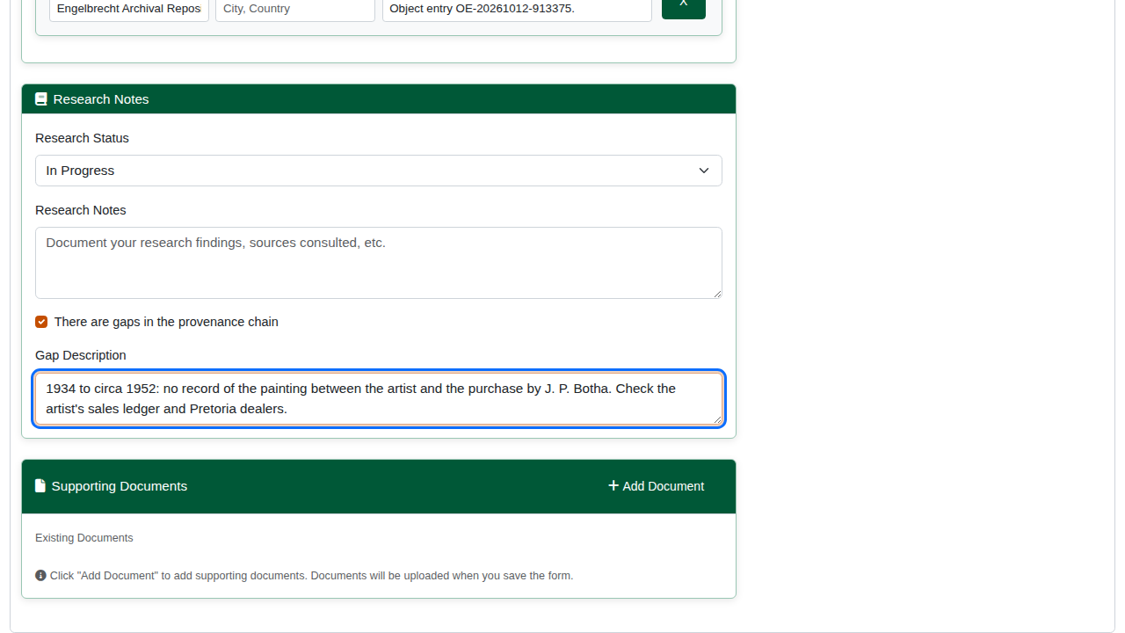
The gap recorded.

5. Timeline and export
View Timeline lays the chain out in order on a timeline, with approximate dates placed by their year, and lists the events in a table. Export CSV exports the chain for a loan or a due-diligence check; Authenticity Report summarises the evidence.
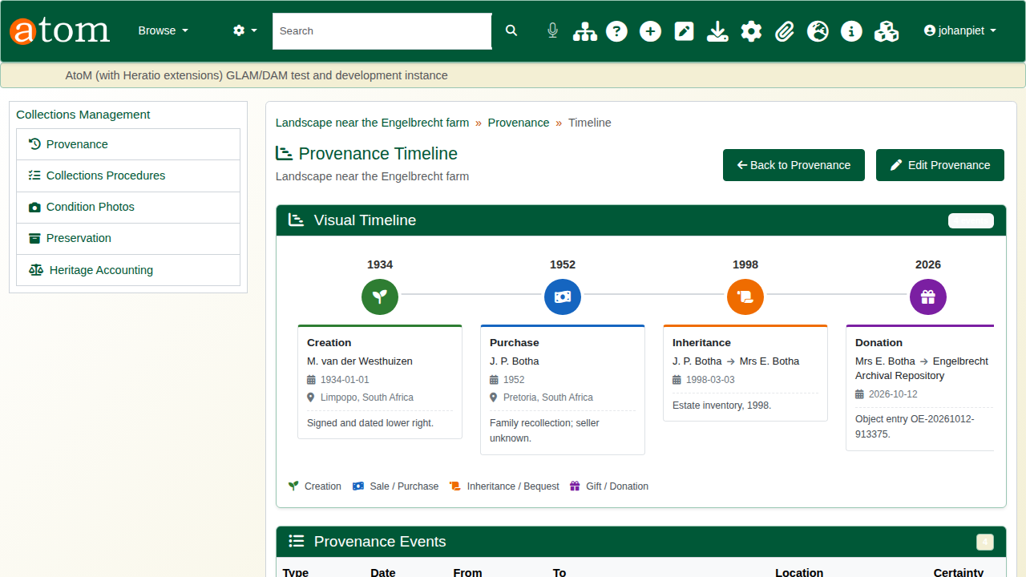
The provenance timeline.
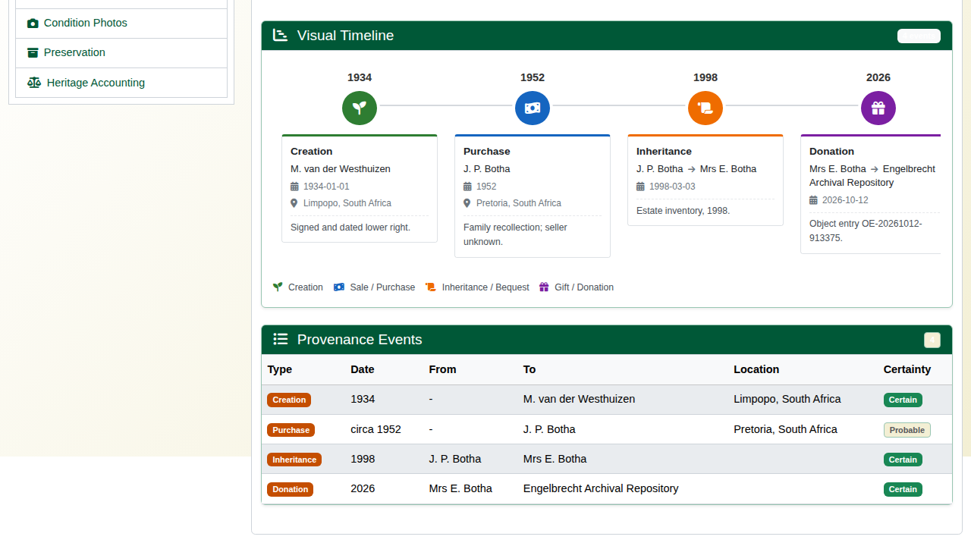
The events table.
The edit form also records a Nazi-era provenance check (1933-1945), cultural property status and claims, and supporting documents.

Recap
- Write a public summary and record the acquisition.
- Enter the chain of custody event by event, with a certainty for each.
- Let the system find the gaps.
- Record gaps rather than hide them.
Part 5 covers loans and exhibitions.

