Training: Compliance, Part 5 - The Audit Trail
Step-by-step guide to searching the audit log, reading an entry and a record’s history, checking logins, verifying the log’s integrity, and exporting it
Dr Johan Pieterse
Document control
Field | Value
Document title | Training: Compliance, Part 5 - The Audit Trail
Author | Dr Johan Pieterse
Owner | The Archive and Heritage Group (Pty) Ltd
Version | 1.0
Status | Released
Date | 12 October 2026
Prepared for | Administrators, information officers and auditors using the AHG extensions
Classification | Public
Reference | AHG-TRN-CMP-05
Contents
Right-click and choose Update Field to build this list.
List of Tables
Right-click and choose Update Field to build this list.
This guide goes with part 5, the last of the compliance training videos. It shows how to find who did what and when, read a single entry, see a record’s history, check logins and activity, prove that the log has not been altered, and export it for an auditor. Allow about 15 minutes.

Before you start
What you need before you start
What | Notes
An administrator account | The audit trail is administrator-only, at Admin > Audit trail (/admin/audit).
Entries to look at | The video uses entries recorded while making parts 1 to 4.

1. The audit log
Every action is logged: the user, the action, the record, the time and the address it came from. Filter by Action Type, Entity Type, Username or a date range, then Apply Filters.
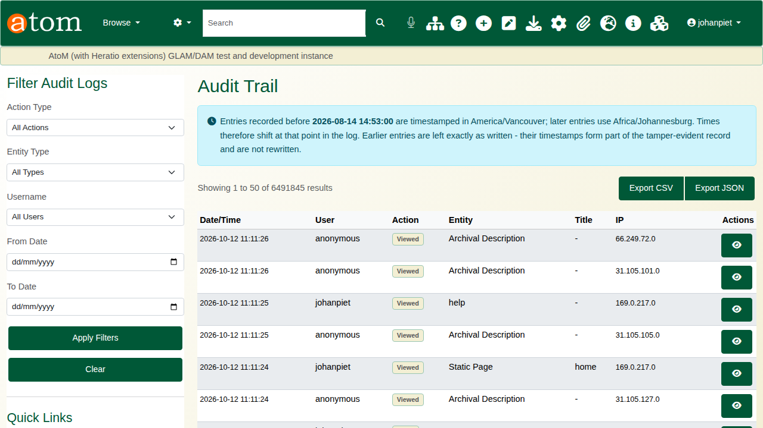
The audit log.
Filtered to one user, the log shows everything that person did.
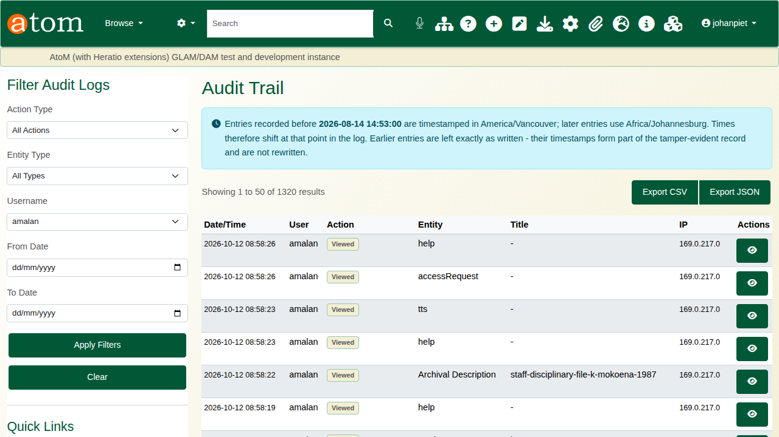
Everything one researcher did.

2. A single entry
The eye button opens an entry: date and time, action, record type and id, the user, the address, the request method and the entry’s unique identifier. Addresses are stored with their last part removed.
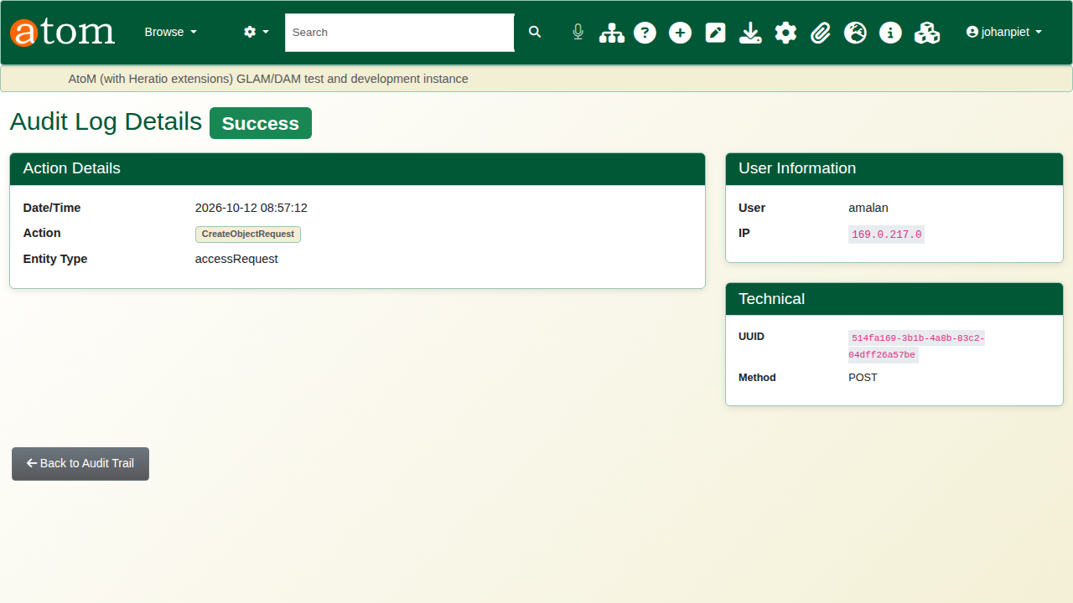
An audit entry.

3. A record’s history
/admin/audit/entity/QubitInformationObject/<id> gathers everything done to one archival description: edits, rights, TK labels and cultural notices added from the record’s own pages, and views, each with who did it and when. Details opens the entry.
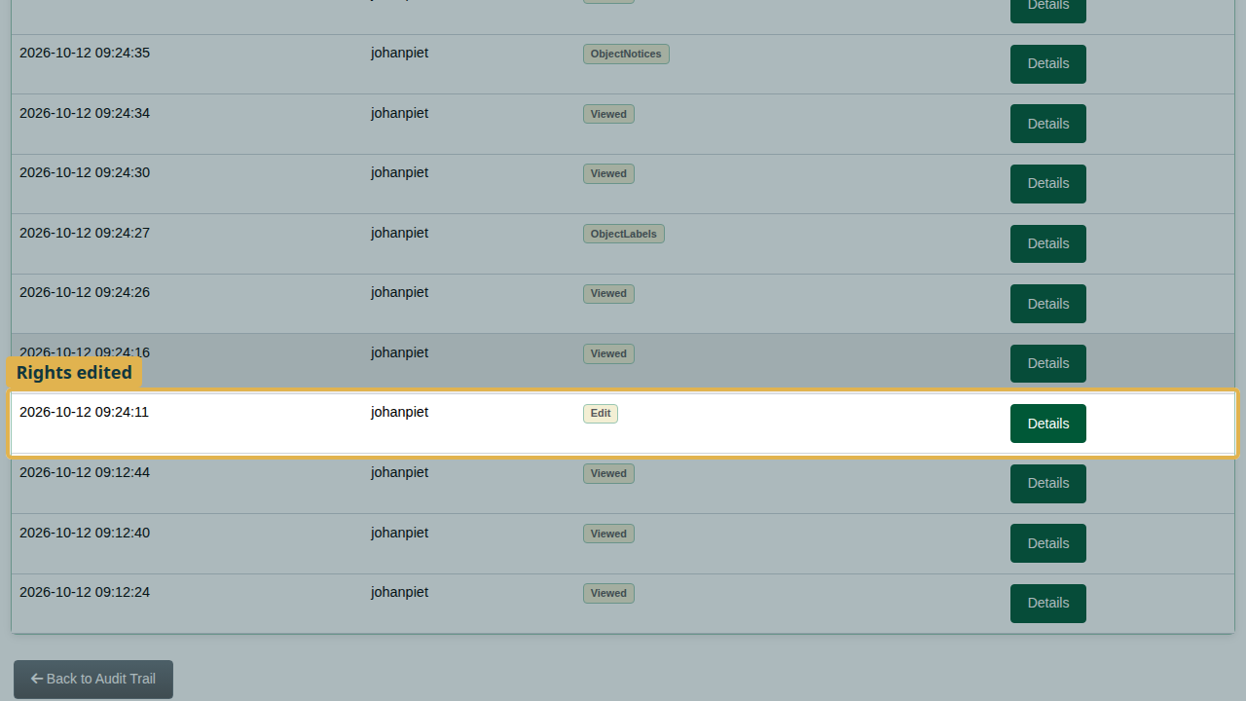
A record’s history.
Embargoes are logged against the embargo rather than the record, so search for them under the action type Add or Lift with entity type Embargo.

4. Logins and statistics
Authentication Log lists sign-ins and sign-outs, and Suspicious Activity lists failed logins: the first sign of someone guessing passwords.
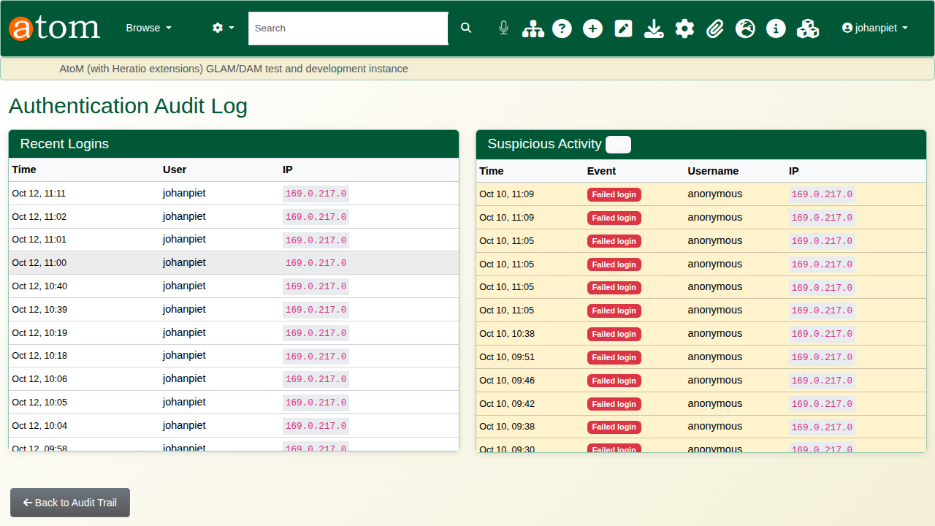
The authentication log.
Statistics Dashboard shows the volume of activity and the most active users over the last 7, 30 or 90 days. It opens on 7 days; longer periods take longer on a large log.
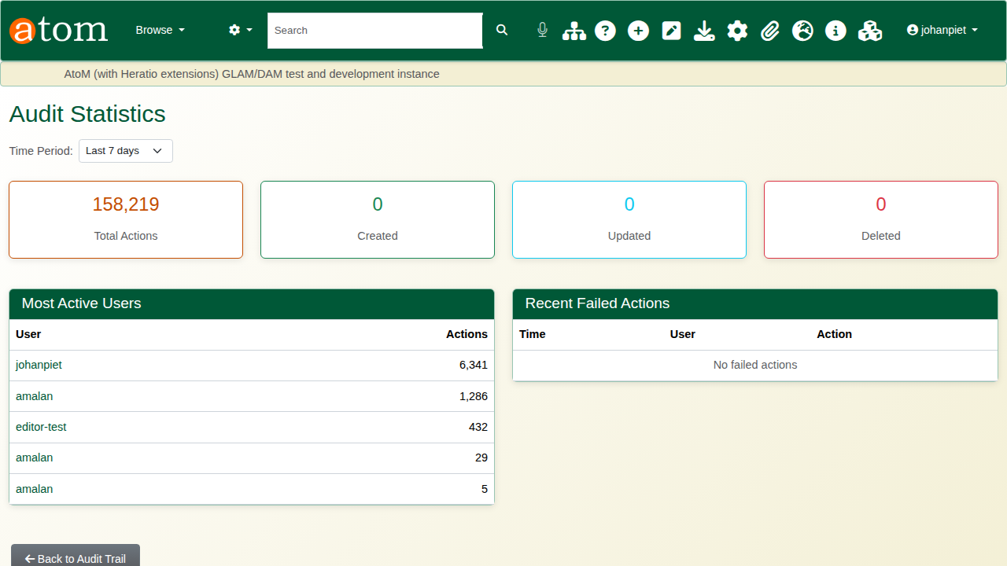
Audit statistics.

5. Proving nothing was changed
Each entry is linked to the one before it by a SHA-256 hash. Changing, deleting or inserting an entry breaks the chain at that point. Integrity check (/admin/audit/integrity) recomputes the most recent 50,000 entries and the end of the chain in a few seconds, and reports either Chain intact or where the chain breaks and why.
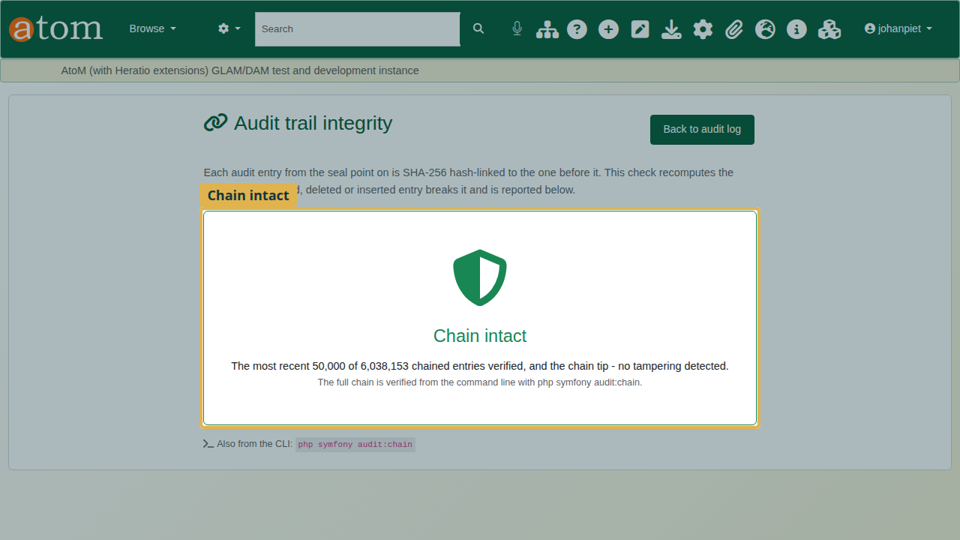
The integrity check.
The full chain is verified from the command line, and can be scheduled nightly:
cd /usr/share/nginx/archive && sudo -u www-data php symfony audit:chain
Entries cannot be edited or deleted through the database either: the log is append-only.

6. Export
Export CSV and Export JSON download the log with the current filters applied, for an auditor or a POPIA request. An export holds at most the 10,000 most recent matching entries, so narrow the dates or the user for longer periods.
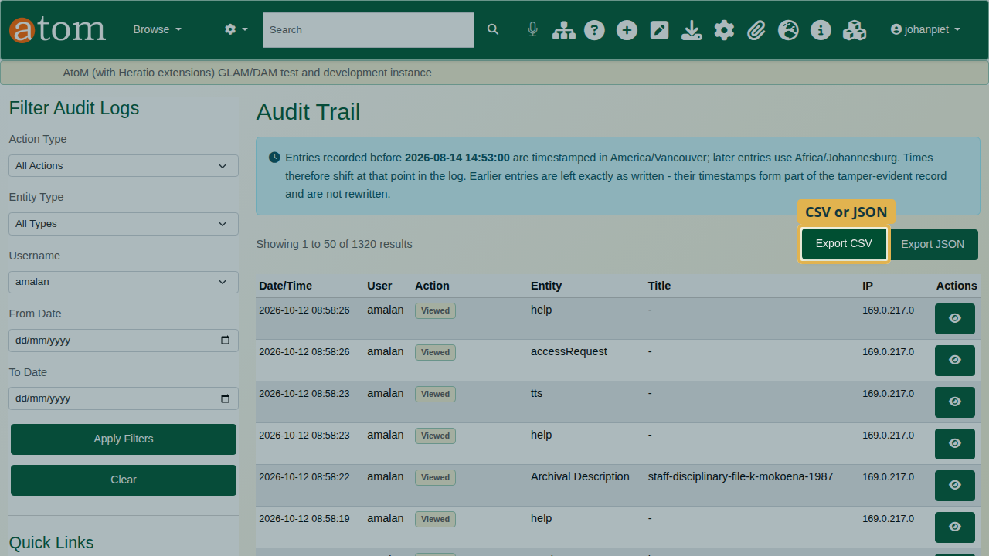
Exporting the filtered log.

7. Settings
Settings decide whether auditing is on, what is logged (views, searches, downloads, API requests, authentication events, classified access) and how personal details in the log are protected (masking sensitive data, anonymising addresses).
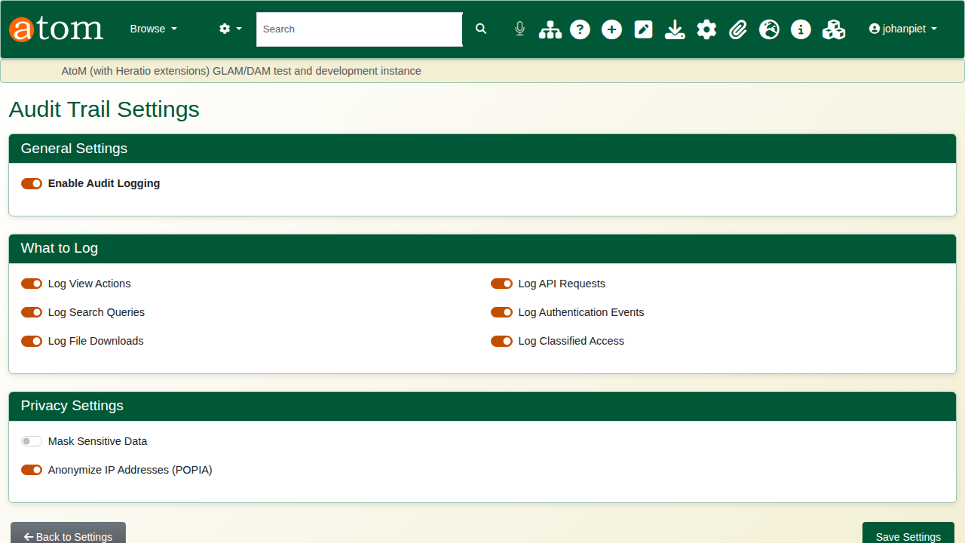
Audit trail settings.
Logging views records every page a visitor opens. On a busy public site that is most of the log; turn it off if views are not needed for compliance.

Recap
- Filter the log to find who did what.
- Open an entry for the detail.
- Use a record’s history and the authentication log.
- Check the chain’s integrity, and schedule the full check.
- Export what an auditor needs.
This completes the compliance series.

