Training: Compliance, Part 1 - Running a POPIA Programme
Step-by-step guide to the privacy settings, the processing register, data subject requests and breach reporting
Dr Johan Pieterse
Document control
Field | Value
Document title | Training: Compliance, Part 1 - Running a POPIA Programme
Author | Dr Johan Pieterse
Owner | The Archive and Heritage Group (Pty) Ltd
Version | 1.0
Status | Released
Date | 12 October 2026
Prepared for | Information officers and administrators using the AHG extensions
Classification | Public
Reference | AHG-TRN-CMP-01
Contents
Right-click and choose Update Field to build this list.
List of Tables
Right-click and choose Update Field to build this list.
This guide goes with part 1 of the compliance training videos. It walks through a POPIA programme in Access to Memory: setting the privacy settings, recording a processing activity, taking a data subject’s request from receipt to completion, and reporting a breach. Allow about 15 minutes.

Before you start
What you need before you start
What | Notes
An administrator account | The privacy module sits under Admin > Privacy.
A jurisdiction | Six laws are supported: POPIA, NDPA, the Kenya DPA, the GDPR, PIPEDA and the CCPA. This guide uses POPIA.

1. The compliance dashboard
Open Admin > Privacy (/admin/privacy). The dashboard shows the programme at a glance: open requests, breaches, processing activities and a compliance score.
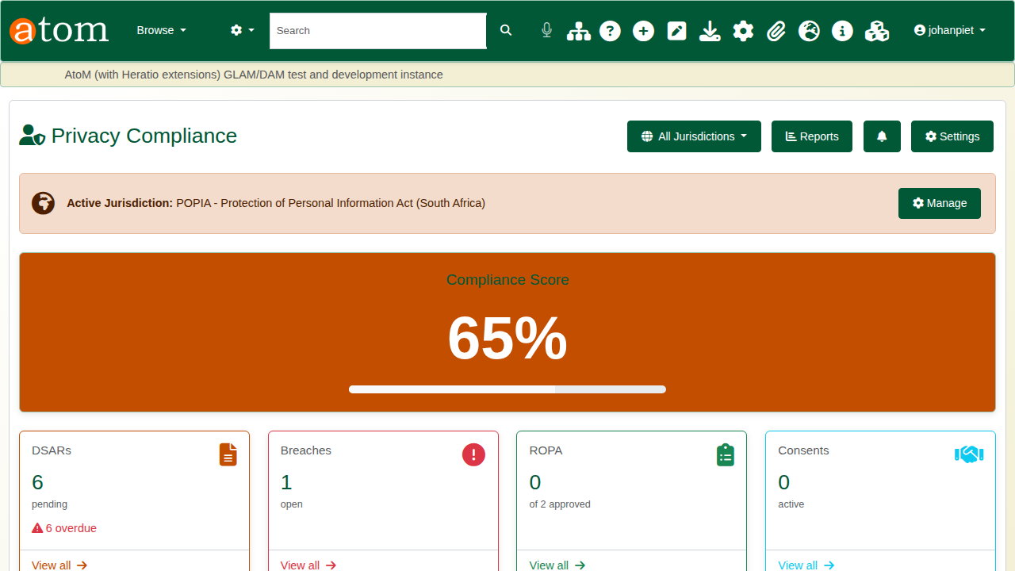
The compliance dashboard.

2. Settings and the legal clocks
Click Settings. Each jurisdiction has its own tab. On POPIA, record the organisation name, registration number and data protection email, and set the clocks: the days allowed to answer a data subject (30 by default) and the hours within which a breach must be reported (72 by default). The default retention period sits here too. Add the information officer under Privacy Officers, then Save Configuration.
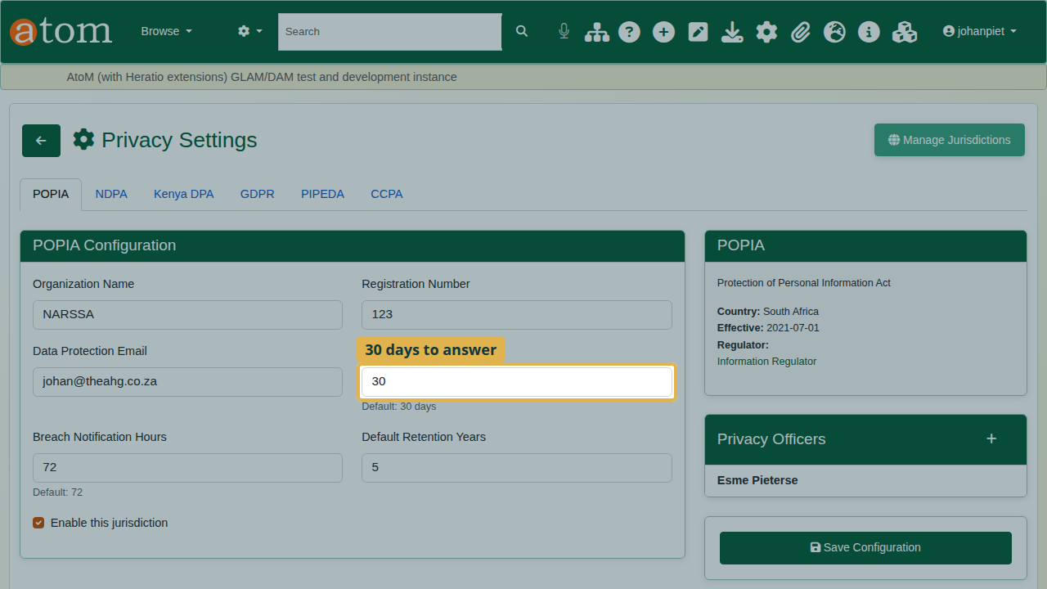
POPIA settings.

3. The processing register
POPIA expects a record of every processing activity. Click Add Activity and describe what is processed, why, and on what lawful basis. The example is registering researchers for the reading room, by a public body.
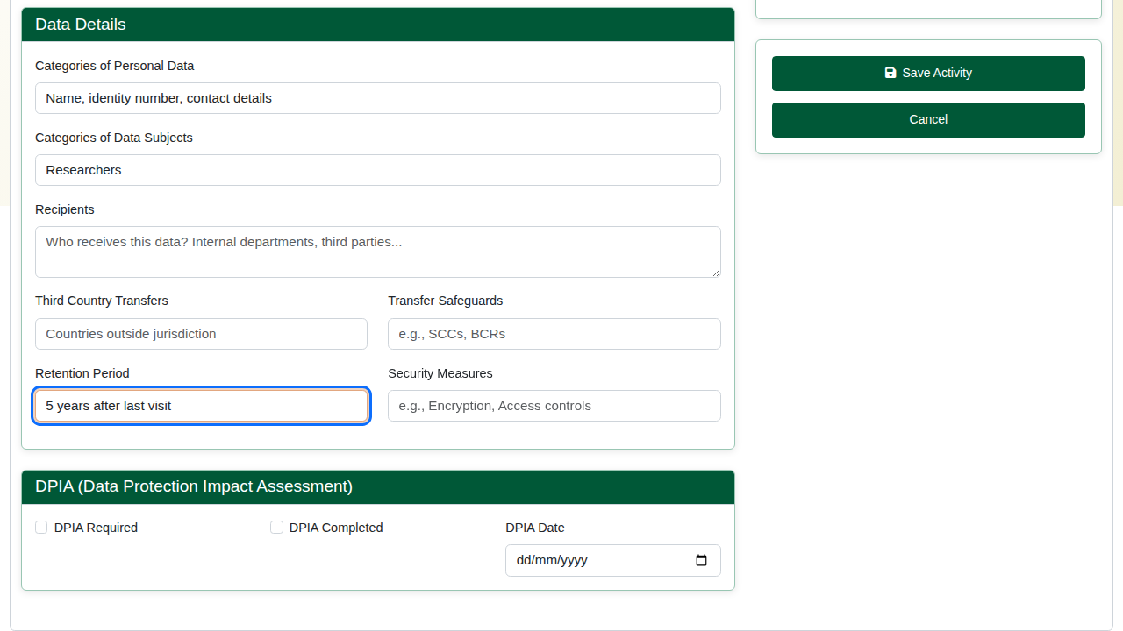
A new processing activity.
Under Data Details, add the categories of personal data and of data subjects, the recipients, any transfers outside the jurisdiction, and the retention period. Tick DPIA Required if the activity needs an impact assessment. Click Save Activity. The activity can then be submitted to the information officer for review.
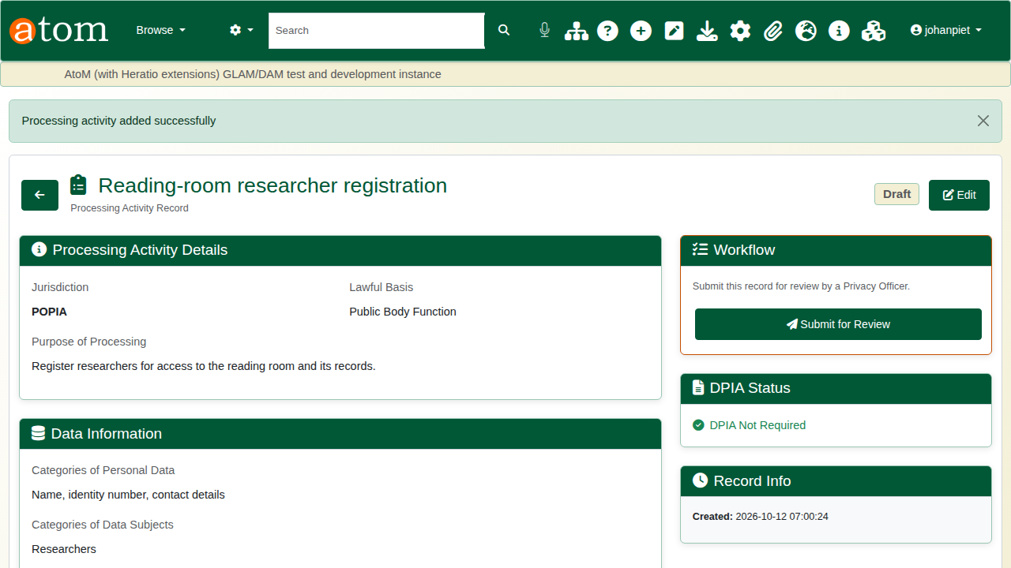
The activity saved.

4. A data subject request
A former researcher asks for a copy of her personal information. Click New DSAR.
The deliberate mistake: create it without the requester’s name. The form refuses it and keeps everything typed. Add the name, choose the request type (here, Right of Access) and describe the request, then create it.
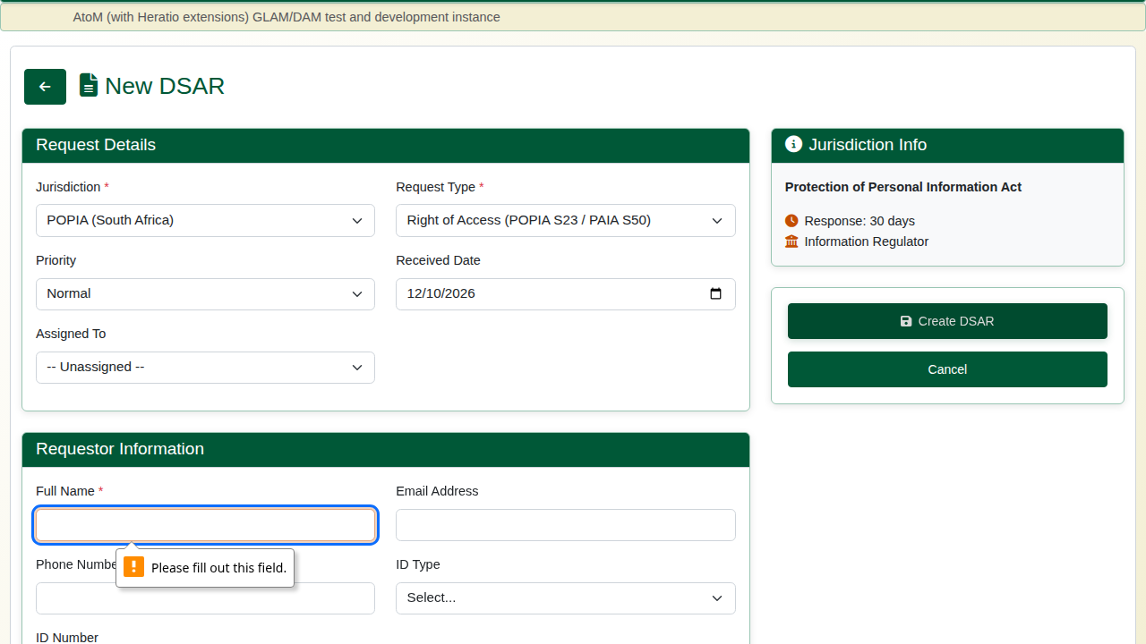
The request refused without a name.
The request gets a reference (for example DSAR-PO-202610-0007) and a due date 30 days after receipt, with the days remaining counted down.
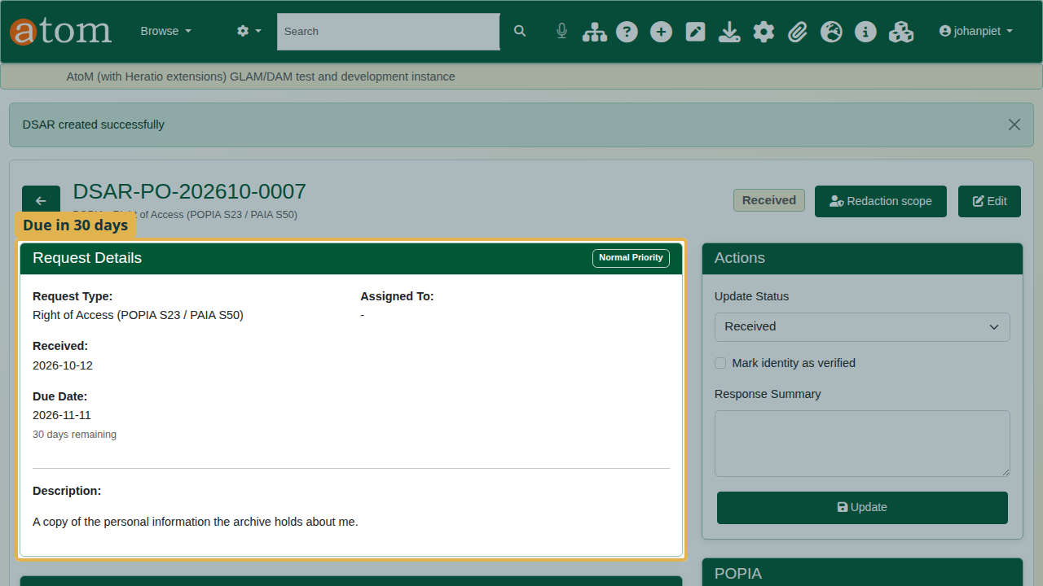
The new request and its due date.
Work it through under Actions: tick Mark identity as verified, set the status to In progress, and once the information has been sent, set it to Completed with a summary of the response. Click Update after each step. Every step is written to the Activity Log with who did it and when. On a completed request the countdown is no longer shown.
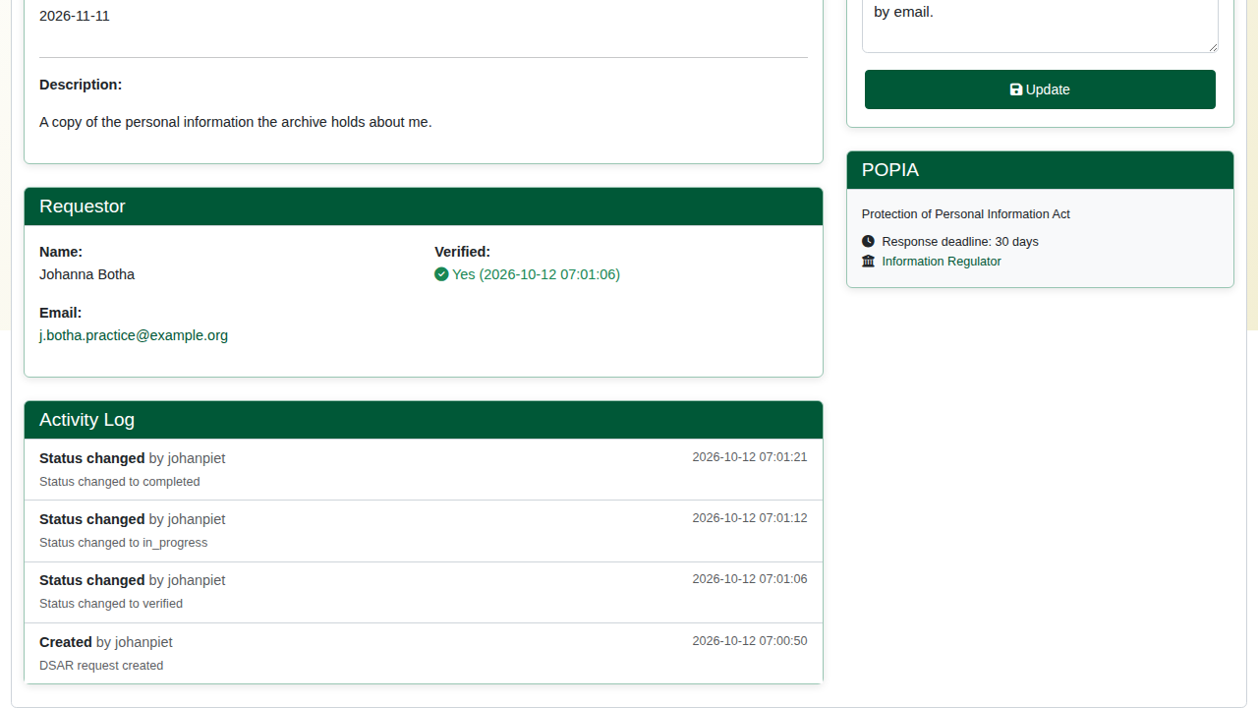
The request completed, with its activity log.

5. Reporting a breach
A researcher register was emailed to the wrong person. Click Report Breach and record the jurisdiction, the breach type (a confidentiality breach), the severity, the records affected, when it was detected, the cause and what happened. Notification Deadlines shows how long you have to report it.
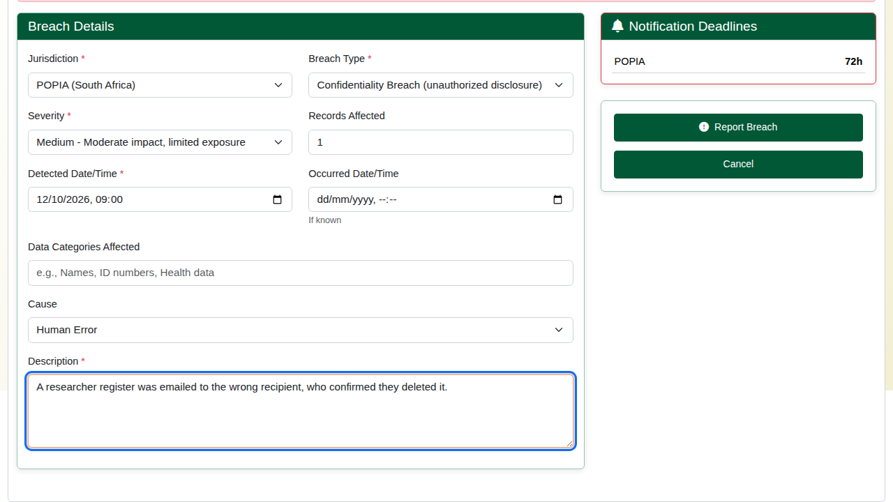
Reporting a breach.
The breach is recorded with a reference. As it is handled, use Update Breach to record when the regulator and the people affected were notified.
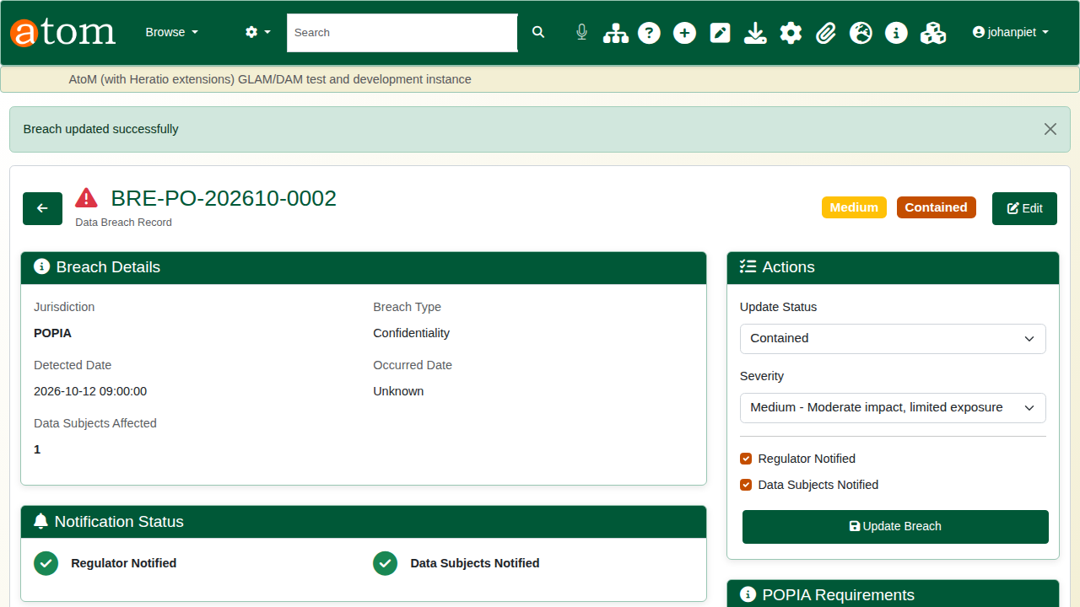
The breach record.

Recap
- Set the privacy settings and the legal clocks.
- Keep the processing register.
- Log every data subject request and answer it within the deadline.
- Record and report breaches.
Part 2 covers personal information inside records: scanning, review and redaction.

