Training: Compliance, Part 2 - Personal Information in Records
Step-by-step guide to scanning a record for personal information, reviewing each finding, and redacting it for the public
Dr Johan Pieterse
Document control
Field | Value
Document title | Training: Compliance, Part 2 - Personal Information in Records
Author | Dr Johan Pieterse
Owner | The Archive and Heritage Group (Pty) Ltd
Version | 1.0
Status | Released
Date | 12 October 2026
Prepared for | Archivists and information officers using the AHG extensions
Classification | Public
Reference | AHG-TRN-CMP-02
Contents
Right-click and choose Update Field to build this list.
List of Tables
Right-click and choose Update Field to build this list.
This guide goes with part 2 of the compliance training videos. A cataloguer typed a researcher’s details into a description, and the scanned form attached to the record shows them too. You find them, decide what each one is, and redact them so visitors cannot see them. Allow about 15 minutes.

Before you start
What you need before you start
What | Notes
An administrator account | Scanning, review and redaction are staff tasks.
The practice file | reading-room-registration-1998-practice.pdf in docs/training-files/ of the AHG extensions catalogue: a reading room registration form from 1998. Every detail on it is fictitious.
A practice record | Create a record whose scope and content repeat the form’s identity number, cell number and email, and attach the PDF.

1. The problem
On the record, the scope and content gives the researcher’s identity number, cell number and email address. Anyone visiting the catalogue can read them.
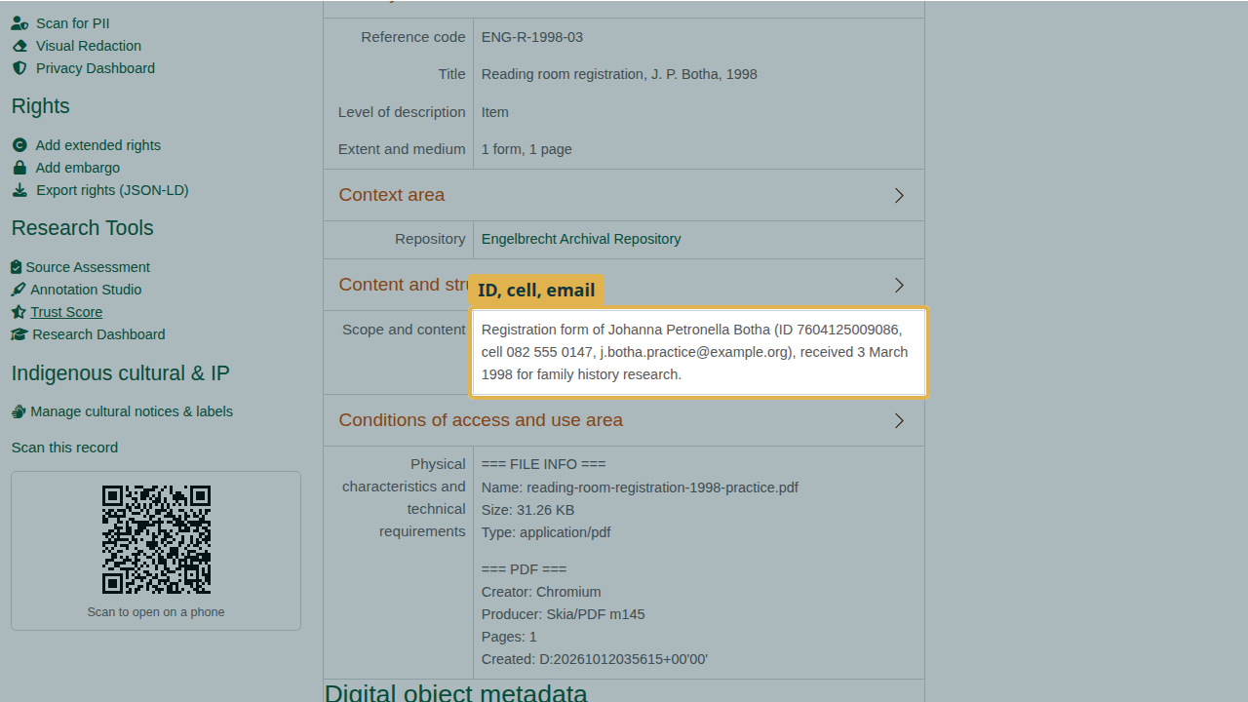
Personal information in the description.

2. Scan the record
Open the PII scanner for the record (/privacyAdmin/piiScanObject/id/<id>). It reads the description fields and the text inside an attached PDF. It finds the South African identity number (rated high risk), the cell number and the email, as well as names and dates found by the named-entity service. Values are shown masked, so the scan result does not itself spread the data.
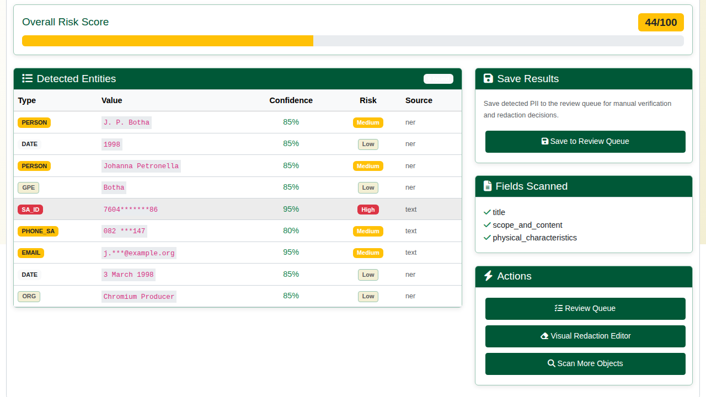
The scan results.
The deliberate mistake: open the Review Queue straight away. This record’s findings are not there, because a scan only reaches the queue once it is saved. Go back to the scan and click Save to Review Queue.
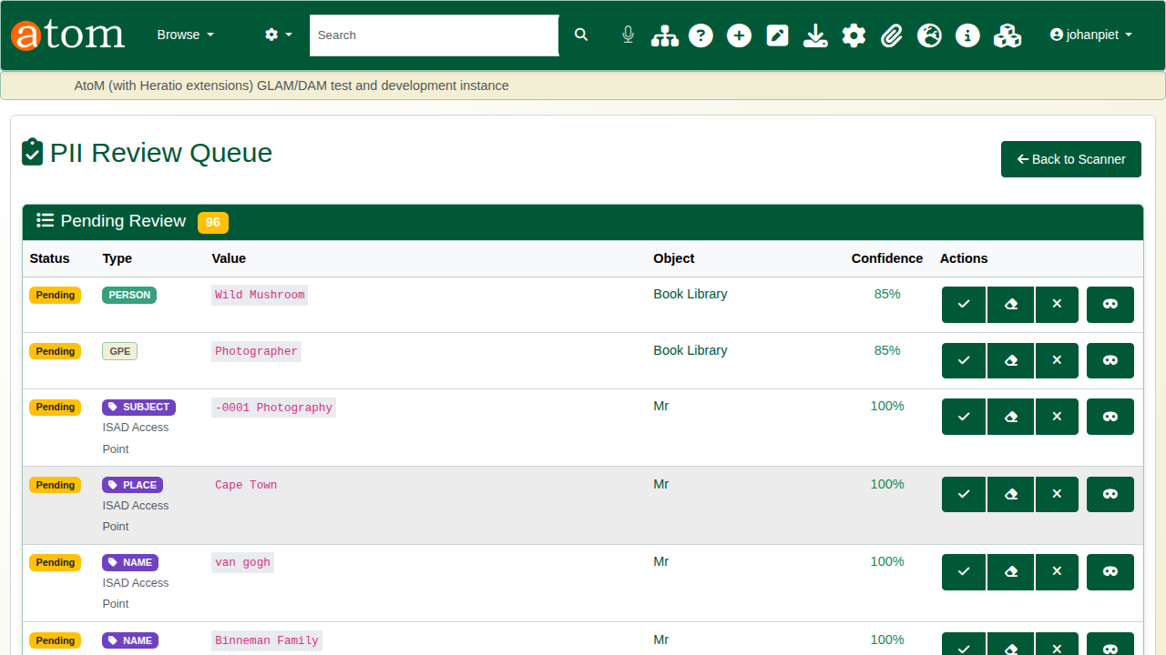
The findings are not in the queue yet.

3. Review each finding
The PII Review Queue (/privacyAdmin/piiReview) lists each finding with its type, masked value, record and confidence. Flagged findings are listed first.
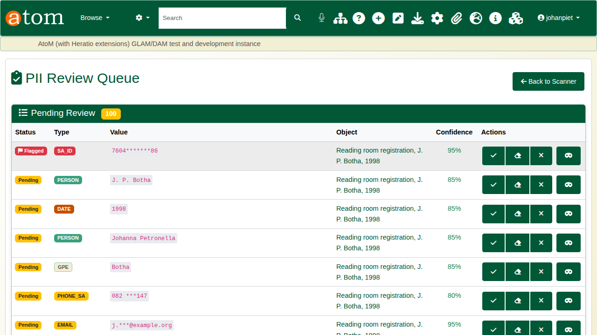
The review queue.
Each finding takes one of three decisions:
The three review decisions
Decision | Meaning
Approve | It may stay visible.
Redact | It is personal information and is hidden from visitors.
Reject | It is not personal information at all (a false positive).
In the example the identity number, cell number and email are redacted, and the date is approved. “Chromium Producer” is rejected: it comes from the PDF’s own file details, not from the record. Every decision is recorded with who made it.
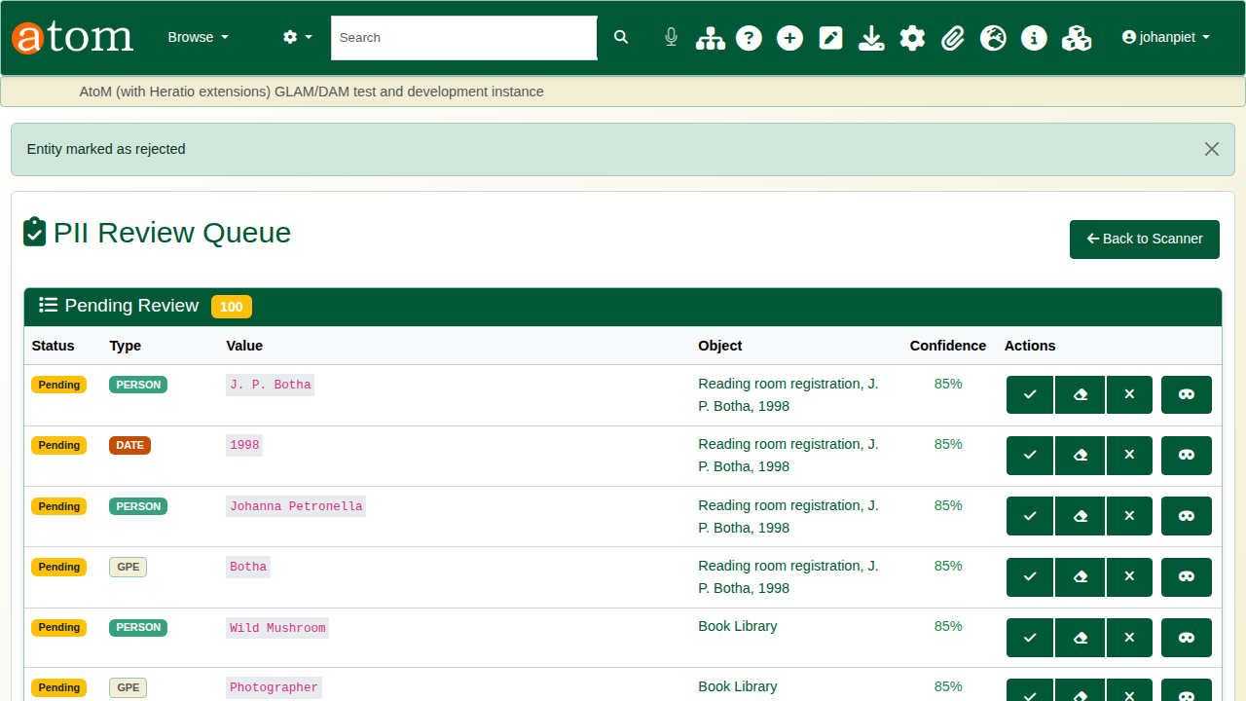
The decisions made.
Redacted values are replaced with [REDACTED] wherever visitors see the description. The fields themselves are not changed, so staff still see the full text.

4. Redact the scanned document
Open Visual Redaction for the record (/admin/privacy/redaction/<id>). It shows the scanned form, where the identity number is still readable.
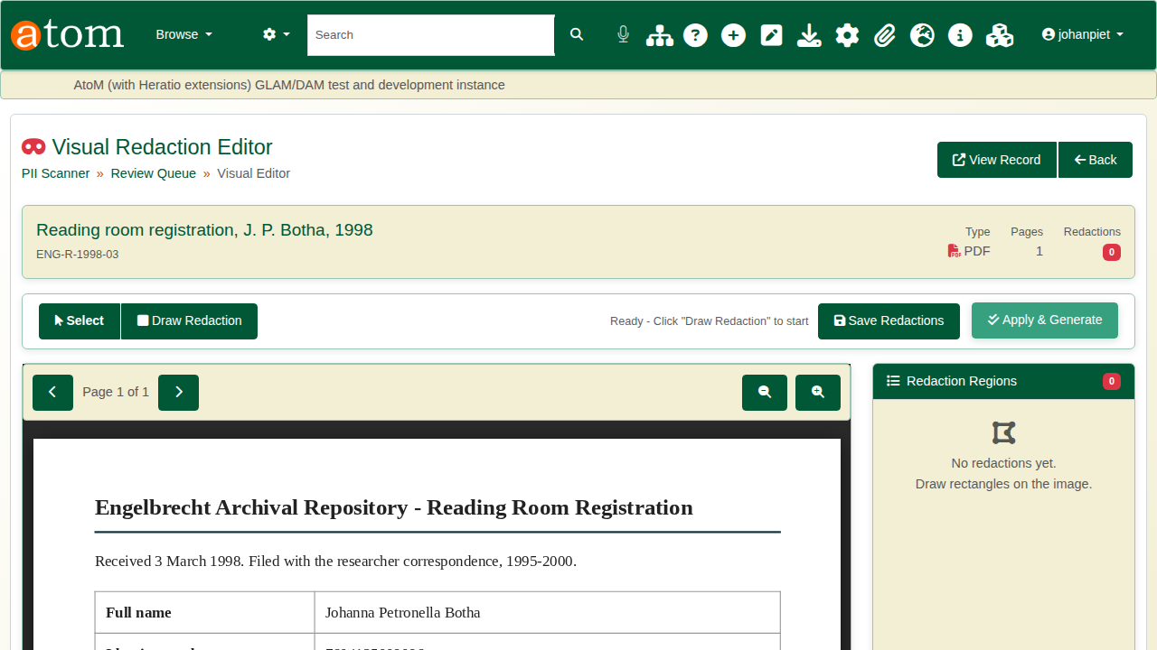
The visual redaction editor.
Click Draw Redaction and drag a box over the identity number. Click Save Redactions, then Apply & Generate. The original file is kept. Visitors get a redacted copy of the PDF, and the record’s reference image and thumbnail are re-rendered from it.
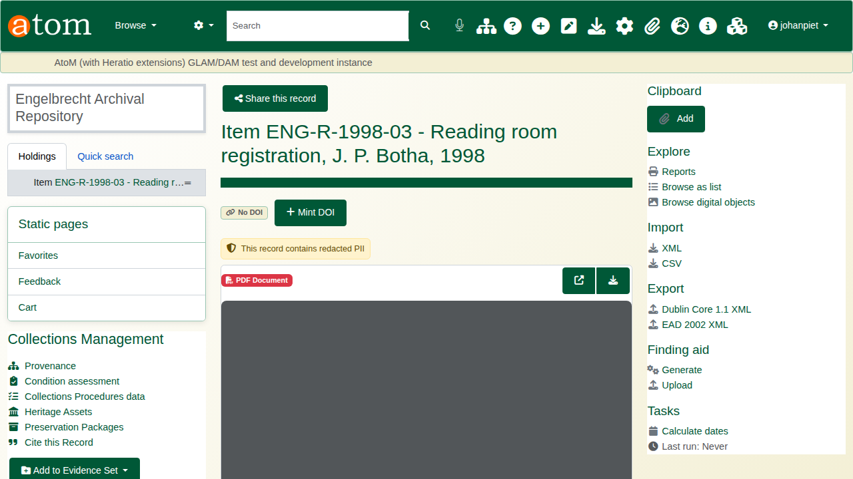
Redaction applied.

5. Check what visitors see
Sign out and open the record. In the description, the identity number, cell number and email read [REDACTED], and the record shows the note “This record contains redacted PII”.
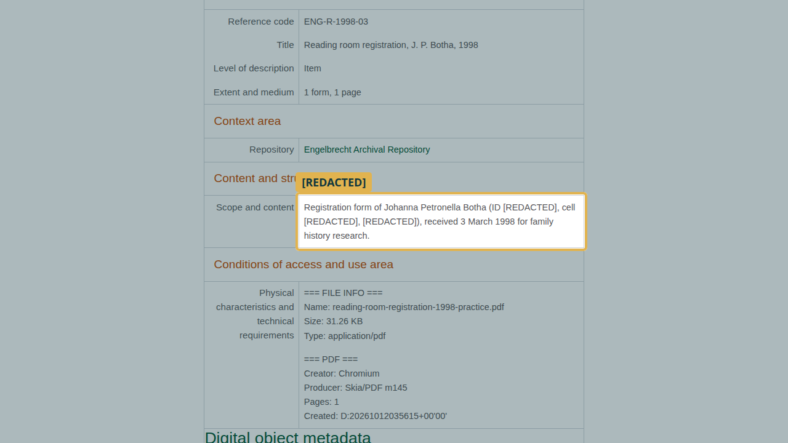
The description, as a visitor sees it.
The visitor’s copy of the form has the identity number blacked out by the drawn box, and the redacted values from the review are blacked out as well.
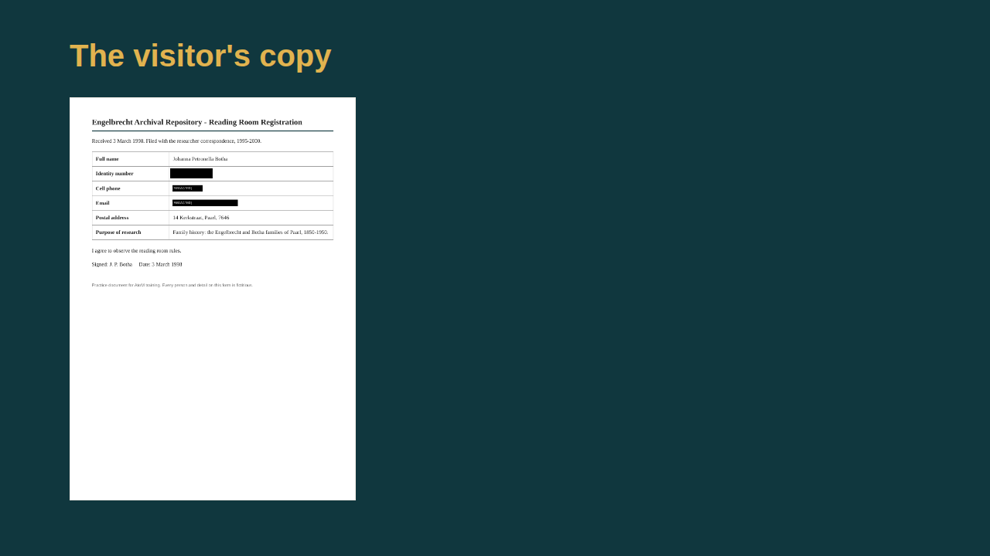
The visitor’s copy of the form.

Field redaction
The privacy module can also redact a whole field for visitors rather than individual values. A full redaction shows [REDACTED - personal data removed] in place of the field. A partial redaction such as last four digits masks the field except its last four characters. As with value redaction, staff still see the original.

Recap
- Scan the record.
- Save the scan to the review queue.
- Review each finding: approve, redact or reject.
- Draw redactions on scanned documents and apply them.
- Check the record as a visitor would see it.
Part 3 covers security classification and access requests.

