Training: Compliance, Part 3 - Security Classification and Access Requests
Step-by-step guide to clearance levels, classifying a record, and taking a researcher’s access request from submission to approval
Dr Johan Pieterse
Document control
Field | Value
Document title | Training: Compliance, Part 3 - Security Classification and Access Requests
Author | Dr Johan Pieterse
Owner | The Archive and Heritage Group (Pty) Ltd
Version | 1.0
Status | Released
Date | 12 October 2026
Prepared for | Archivists, information officers and administrators using the AHG extensions
Classification | Public
Reference | AHG-TRN-CMP-03
Contents
Right-click and choose Update Field to build this list.
List of Tables
Right-click and choose Update Field to build this list.
This guide goes with part 3 of the compliance training videos. You classify a record as Confidential, see what a researcher without clearance gets, and take her request for access from submission to approval. Allow about 15 minutes.

Before you start
What you need before you start
What | Notes
An administrator account | Classifying records and approving requests are administrator tasks.
A researcher account | The guide uses Anna, a researcher with no clearance.
A practice record | The video uses “Staff disciplinary file, K. Mokoena, 1987”. Every name and detail in it is fictitious.

1. Clearance levels
Every user has a clearance level. A record classified above a user’s level is closed to them.
Classification levels
Level | Classification
0 | Public
1 | Internal
2 | Restricted
3 | Confidential
4 | Secret
5 | Top Secret
A user’s clearance is set on their clearance page (/security/clearance/user/<username>): the level, an optional expiry date and notes. Give staff the clearance their work needs. A user with no clearance sees only public material. Researchers usually need one record rather than a standing clearance, and section 3 covers that.
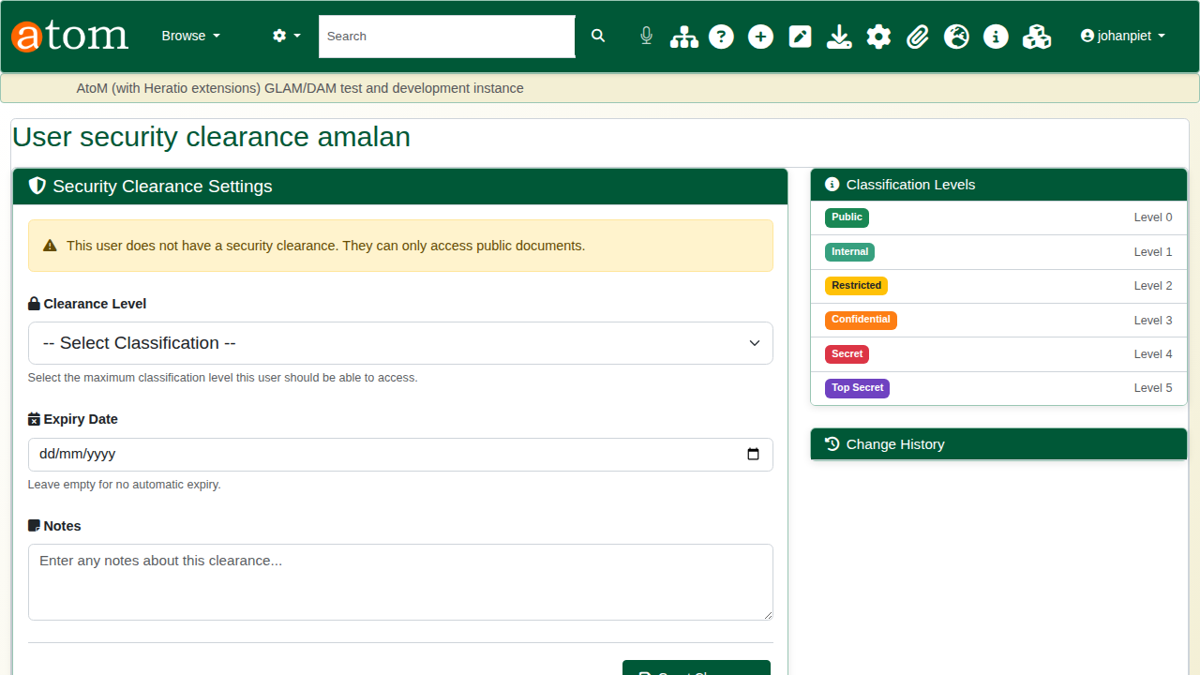
A user without clearance.

2. Classify a record
Edit the record and open Security Classification. Choose the level (here Confidential), give the reason, and set a review date. Apply to child records passes the classification down the hierarchy. Save.
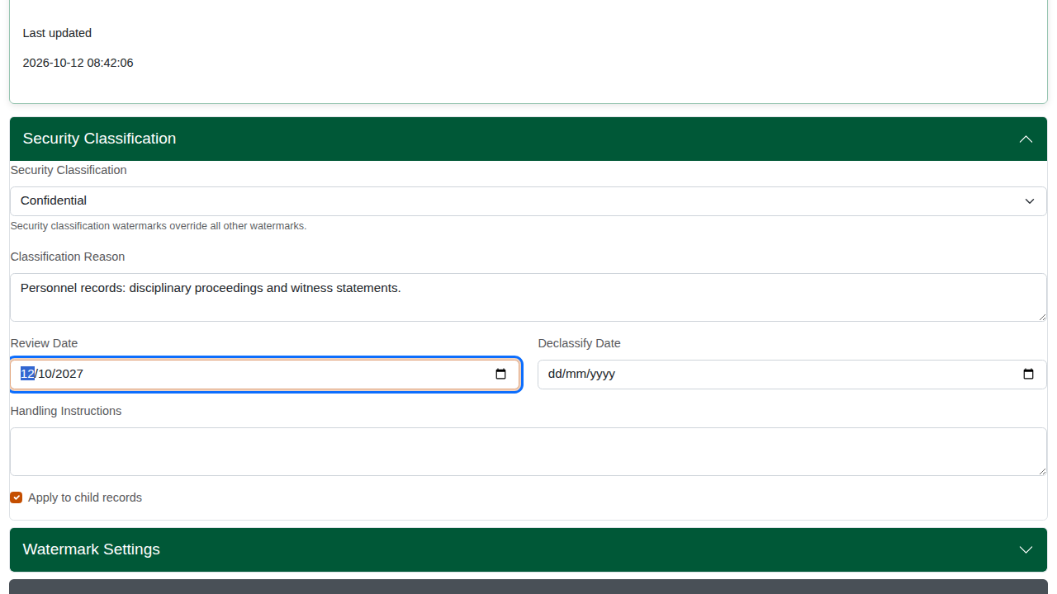
Classifying the record.
The record now shows its classification. Staff with enough clearance see it as before.
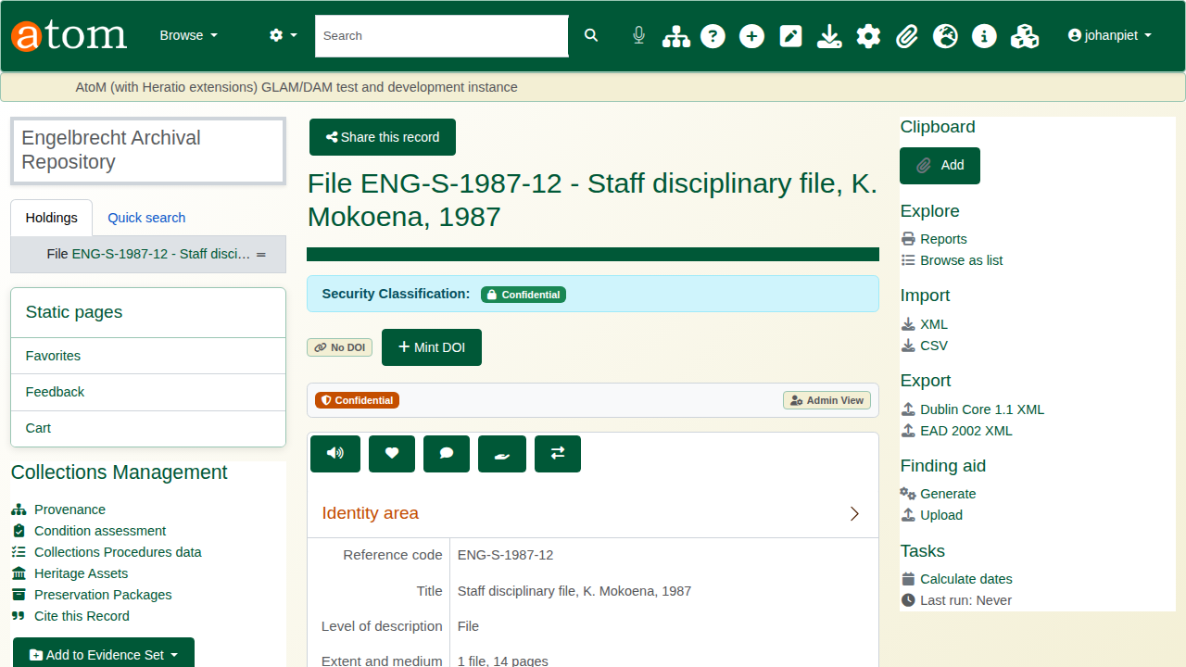
The classified record.
To remove a classification, choose Public (No Classification) and save. A child record cannot be classified lower than its parent; if the classification cannot be saved, the edit page says so.

3. The researcher’s view
Signed in as Anna, the record is closed. The page says the material is classified Confidential and that her clearance does not permit access. It does not show the title, which can itself be sensitive.
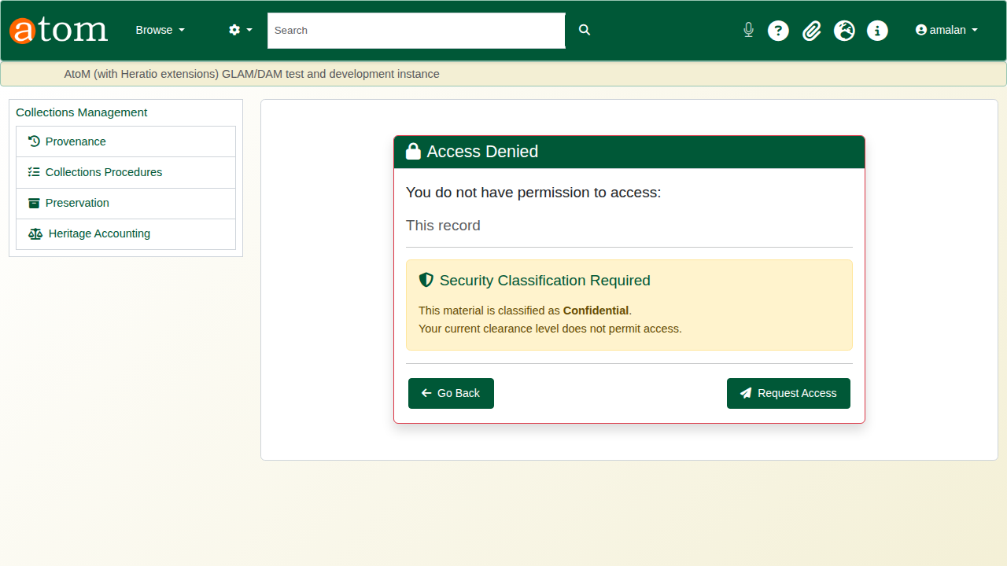
Access denied.
Request Access opens a request for this one record. Choose the access level (view only here), the urgency, and give a reason, which is required. Additional justification is optional. Click Submit Request.
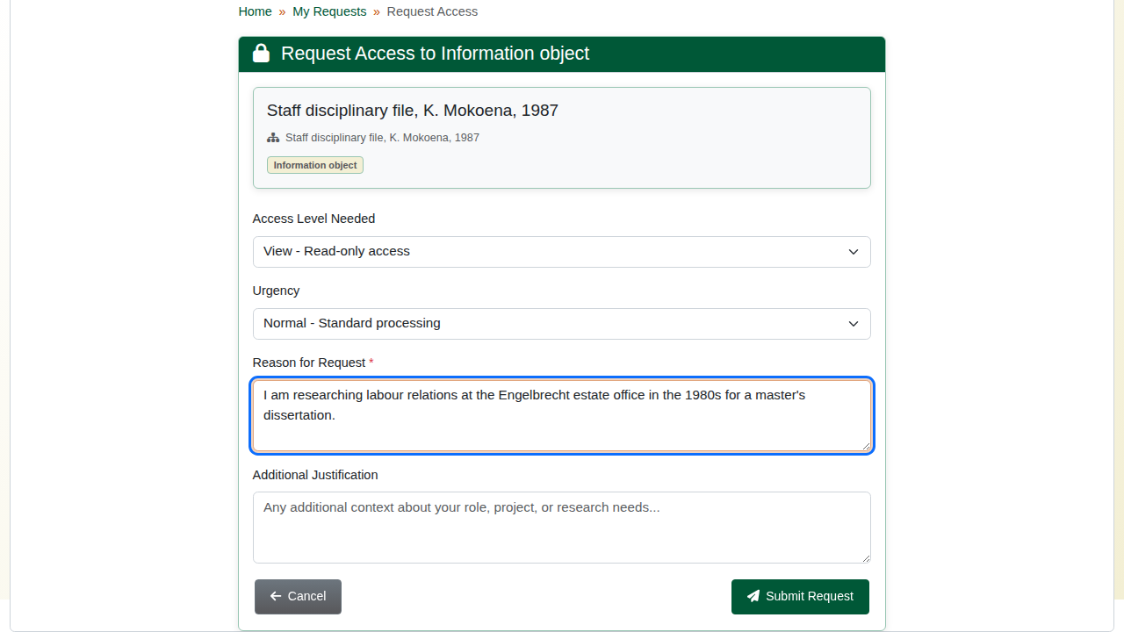
The access request.
The request appears in My Access Requests (/security/my-requests) as Pending. A pending request can be cancelled from there.
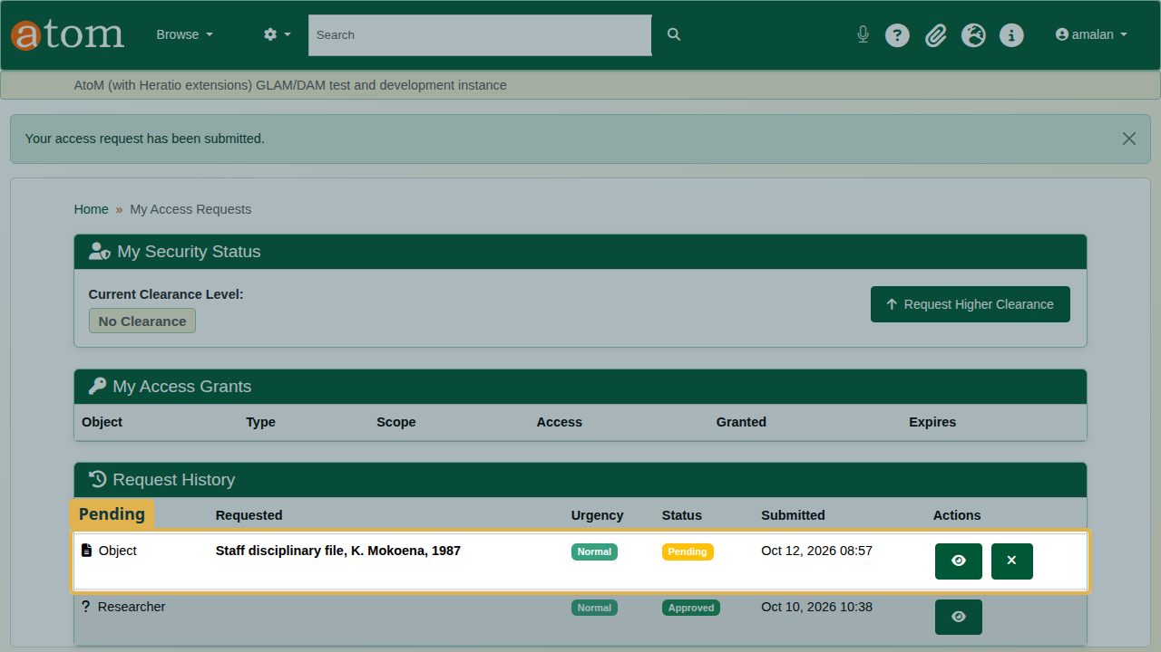
The pending request.

4. Review and approve
The Security Dashboard (/security/dashboard) lists pending access requests. The full queue is at Access Requests (/security/access-requests).
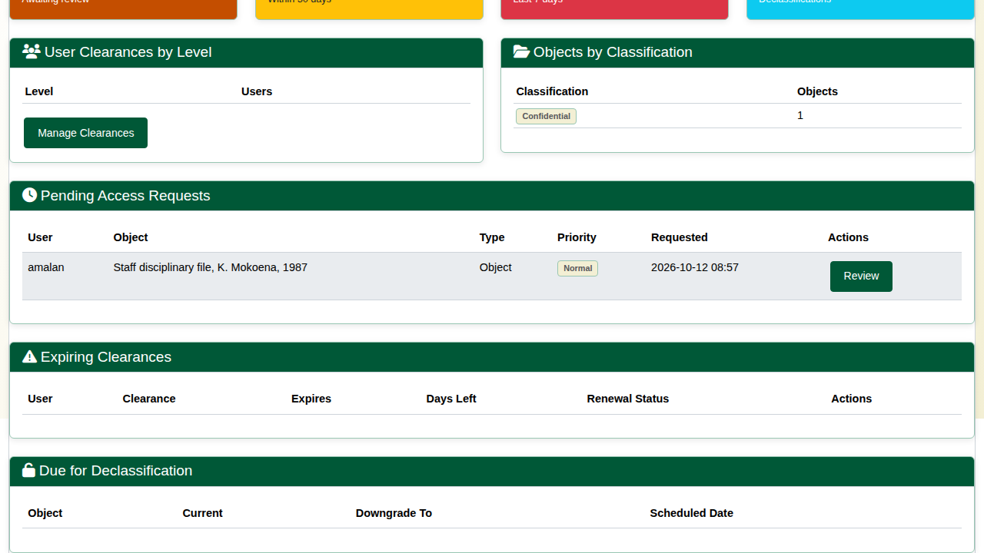
The pending request on the dashboard.
Review opens the request: who is asking, for which record, how urgently, and why.
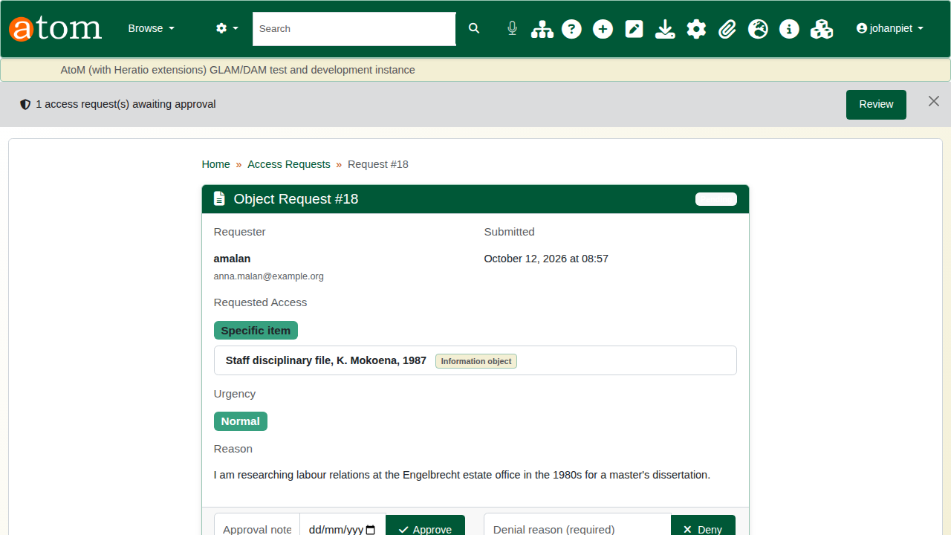
Reviewing the request.
To approve, add a note and an end date, then click Approve. The access lapses by itself on that date. To deny, give a reason and click Deny.
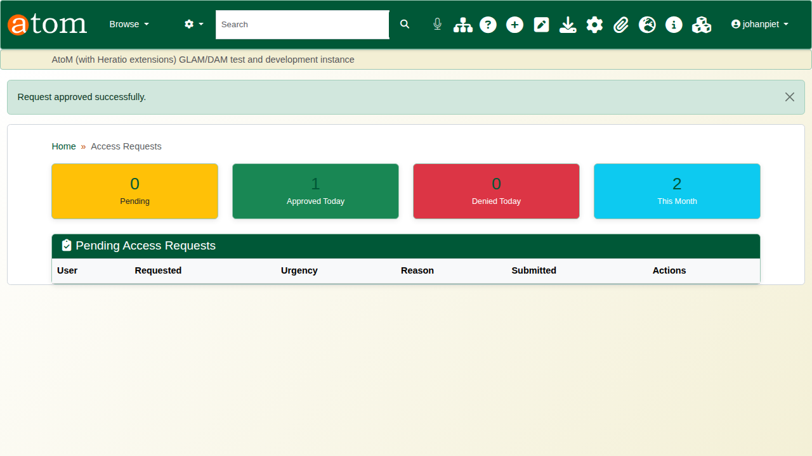
The request approved.

5. Access granted
Anna can now open the record, and only this record: her clearance has not changed.
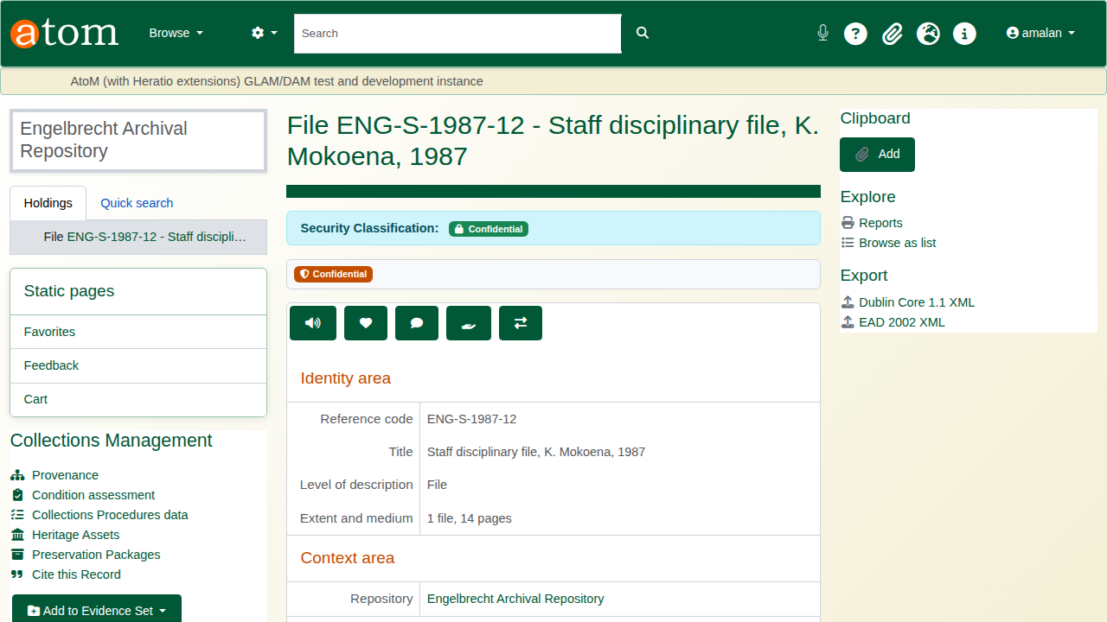
The record opens for Anna.
My Access Grants lists the grant with its scope, access level and expiry date.
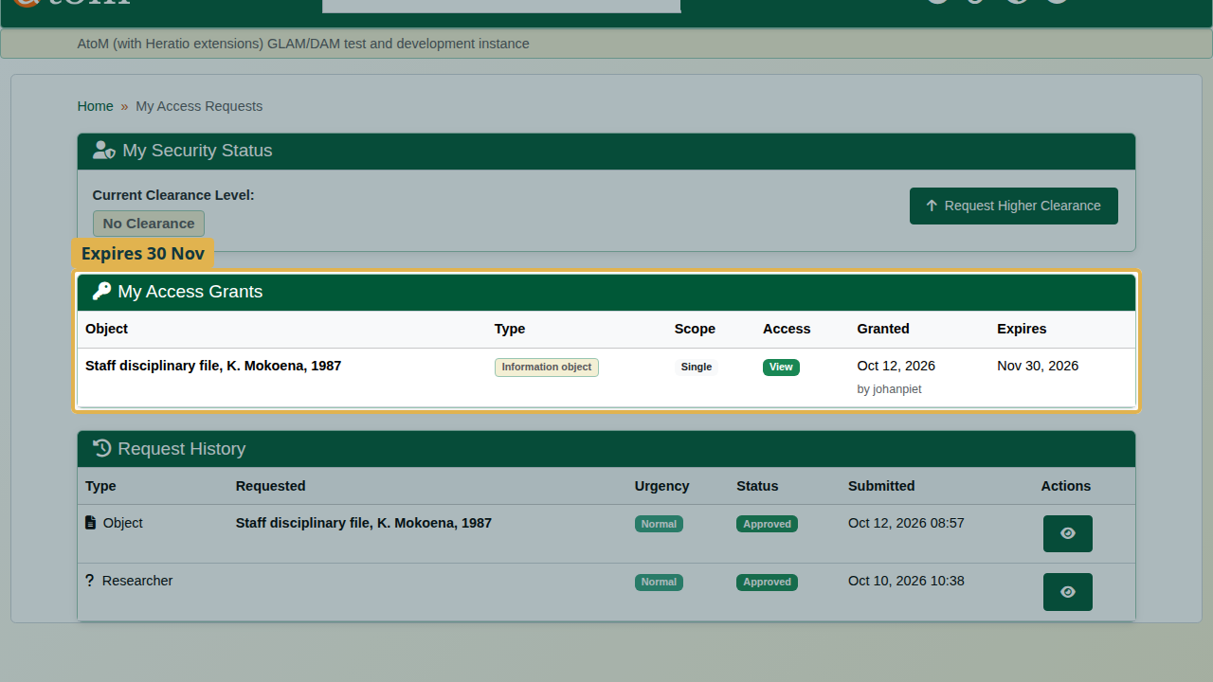
Her access grants.
An approved request lifts only the security classification. A donor closure or an embargo on the same record still applies.

Recap
- Give staff the clearance their work needs.
- Classify sensitive records, with a reason and a review date.
- Researchers request access to a single record, with a reason.
- Approve with an end date, and the grant lapses by itself.
Part 4 covers rights, embargoes and traditional knowledge labels.

