Training: CAAIS Accessions
Step-by-step guide to recording an accession to CAAIS 1.0 in AtoM, checking it against the mandatory elements, and exporting it
Dr Johan Pieterse
Document control
Field | Value
Document title | Training: CAAIS Accessions
Author | Dr Johan Pieterse
Owner | The Archive and Heritage Group (Pty) Ltd
Version | 1.0
Status | Released
Date | 9 October 2026
Prepared for | AtoM users of the AHG extensions
Classification | Public
Reference | AHG-TRN-ACC-01
Contents
Right-click and choose Update Field to build this list.
List of Tables
Right-click and choose Update Field to build this list.
This guide goes with the training video of the same name. CAAIS, the Canadian Archival Accession Information Standard, version 1.0, defines what an accession record should hold. With the CAAIS profile switched on, AtoM’s accession form gains a CAAIS section, the accession page checks the mandatory elements, and each record exports as CAAIS in JSON, CSV or XML.
You will switch CAAIS on, record an accession, find and fix a missing mandatory element, and export the result. Allow about 15 minutes.

Before you start
What you need before you start
What | Notes
An editor or administrator account | Needed to add and edit accessions.
CAAIS switched on | Done once, for the whole site, by an administrator (step 1).
Use a test or training instance if you have one; see “Cleaning up” at the end.

1. Switch CAAIS on (administrator, once)
- Open the AHG Plugins menu (stacked cubes icon) and choose AHG Settings.
- Open the Accession Management section.
- Turn on CAAIS 1.0 accession profile and click Save Settings.
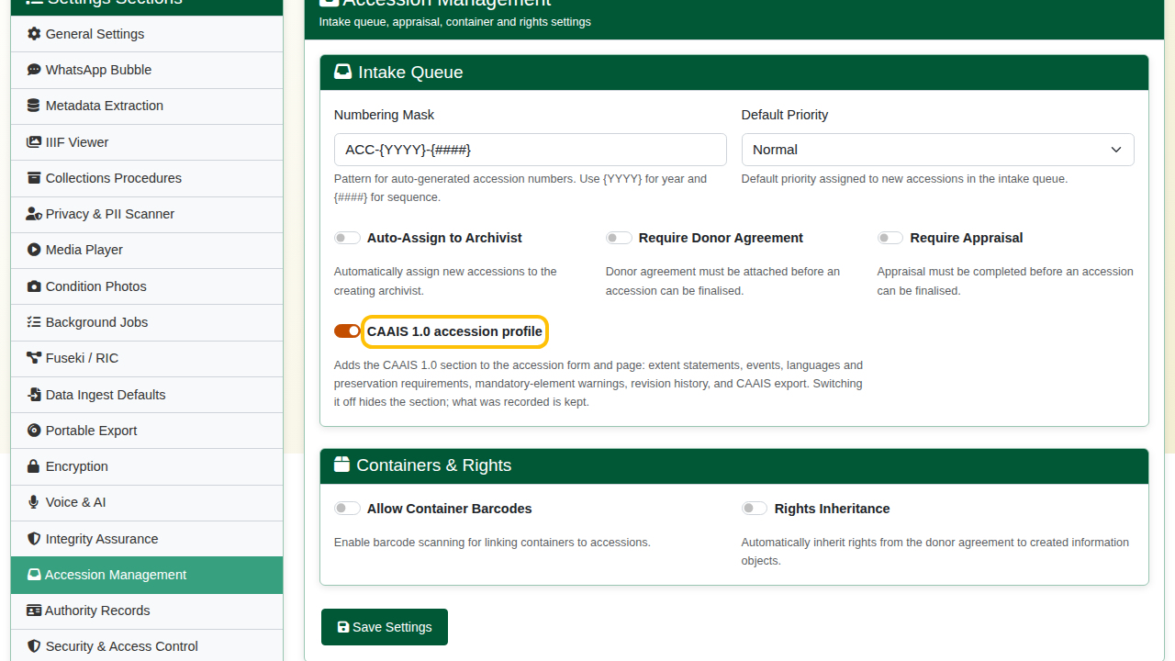
AHG Settings > Accession Management, with the CAAIS 1.0 accession profile switched on.
Switching it off later hides the CAAIS section again; everything already recorded is kept.

2. Record the accession
Open the Add menu (plus icon) and choose Accession records.
Basic info. The accession number is suggested for you and the acquisition date defaults to today. Fill in:
- Immediate source of acquisition: where the material came from (“Donated by Anna Malan, Wellington”).
- Location information: where it is now stored (“Strongroom 2, bay 4”).
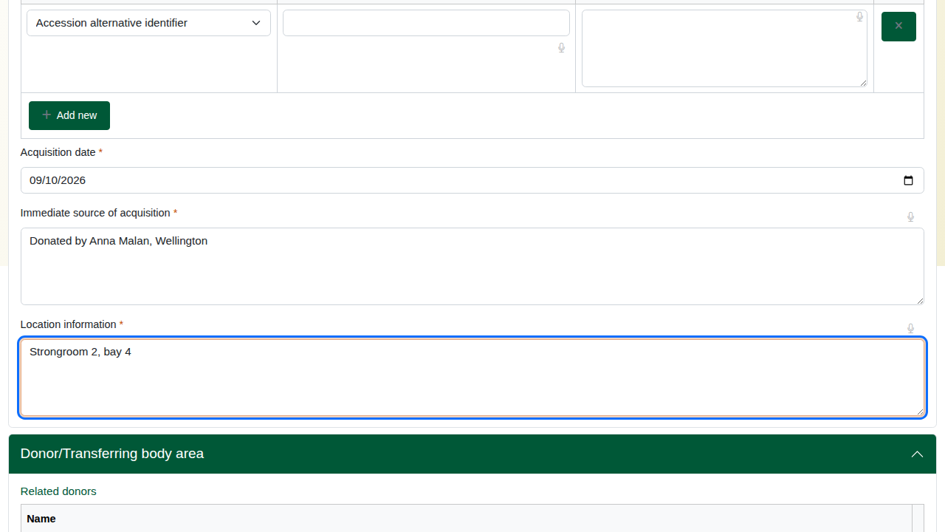
Basic info: accession number, acquisition date, source and location.
Administrative area. Choose the Acquisition type (Gift) and enter the Title.
Date(s). The date of the material itself. Enter the display date (“1890-1925”) and the start and end dates as full dates, year first (1890-01-01 and 1925-12-31).
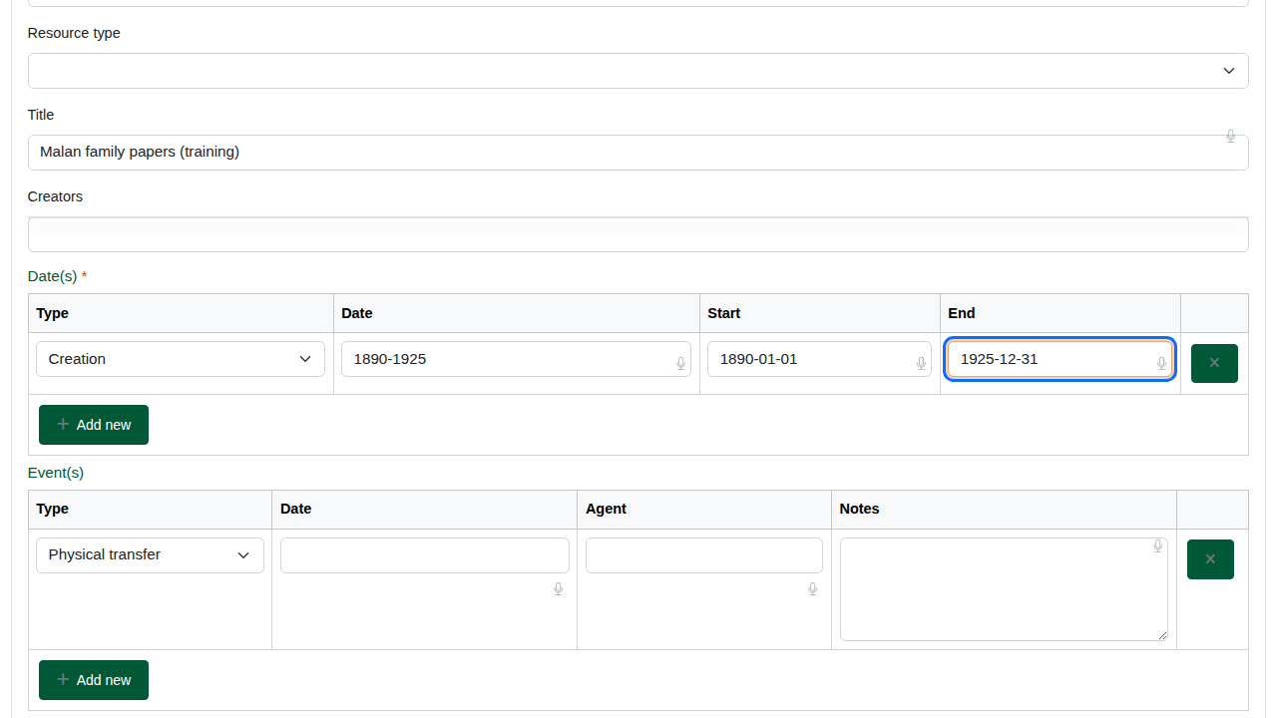
Date(s): display date, start and end.
Repository and CAAIS profile. Open this section and choose:
- Repository: the institution that holds the accession (CAAIS 1.1).
- Rules or conventions: CAAIS 1.0 (CAAIS 7.1).
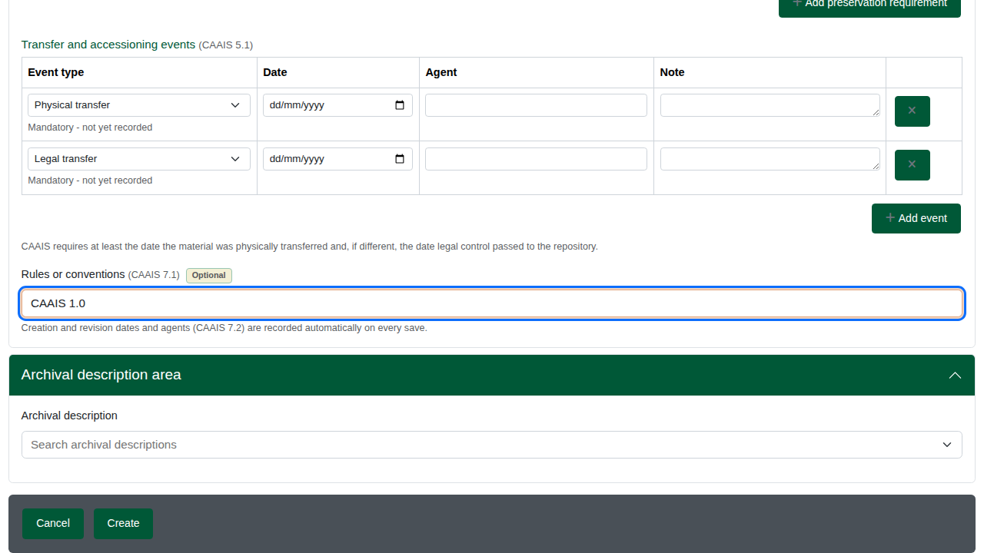
The CAAIS section opened, with the repository and rules.
Extent statements (CAAIS 3.2). One row per type of extent: extent received, quantity 2, unit Boxes, content type textual records, carrier Paper. Add a row per material type if the accession mixes them.
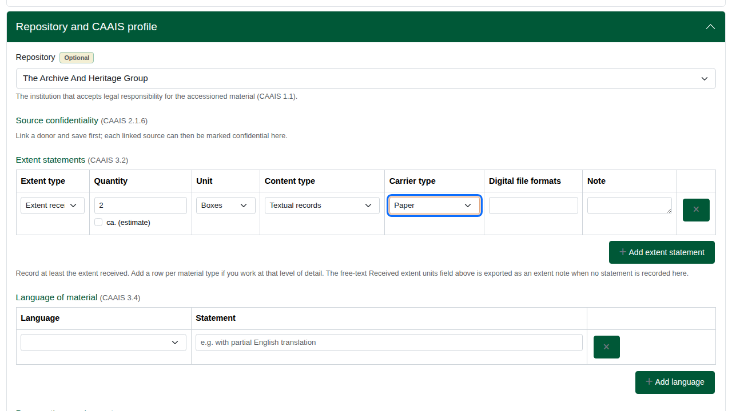
An extent statement: two boxes of textual records on paper.
Language of material (CAAIS 3.4). Choose English. Add a row for each further language.
Transfer and accessioning events (CAAIS 5.1). CAAIS requires two events:
- Physical transfer: when the material arrived.
- Legal transfer: when ownership passed to the institution.
The form suggests both rows. A suggested row left empty is not saved.
This is the table CAAIS reads. The Event(s) table higher up, in the Administrative area, is AtoM’s own and is not part of the CAAIS check.
The deliberate mistake: fill in the legal transfer (date and agent) and leave the physical transfer empty.
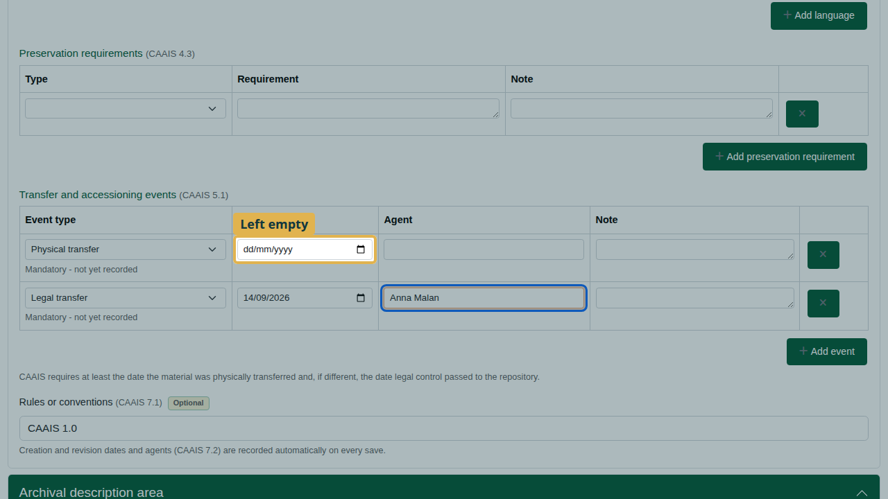
The legal transfer filled in; the physical transfer left empty on purpose.
Click Create. The accession page opens.

3. Check and fix
Scroll to the CAAIS area of the accession page. It lists the CAAIS elements recorded and, in a yellow box, any mandatory element still missing: “5.1 - Event: physical transfer”.
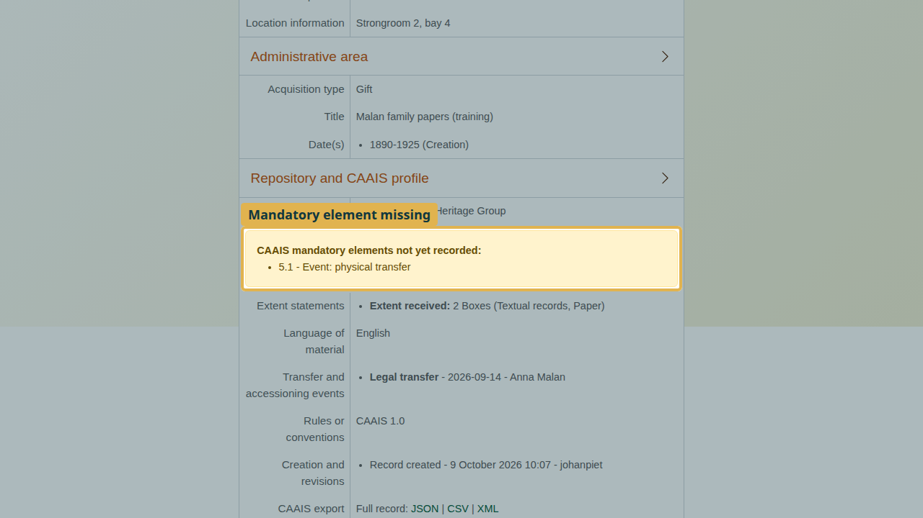
CAAIS mandatory elements not yet recorded: 5.1 - Event: physical transfer.
To fix it:
- Click Edit and open the CAAIS section.
- Give the Physical transfer row its date and agent.
- Click Save.
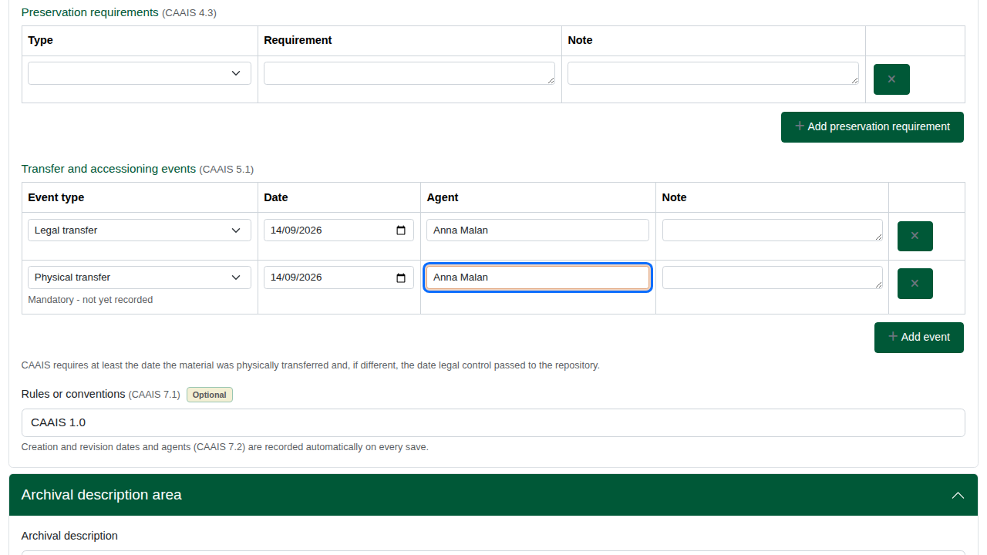
The physical transfer row completed on the edit form.
The warning is gone: the accession meets CAAIS at the mandatory level. Every save is kept as a dated revision under “Creation and revisions” (CAAIS 7.2).
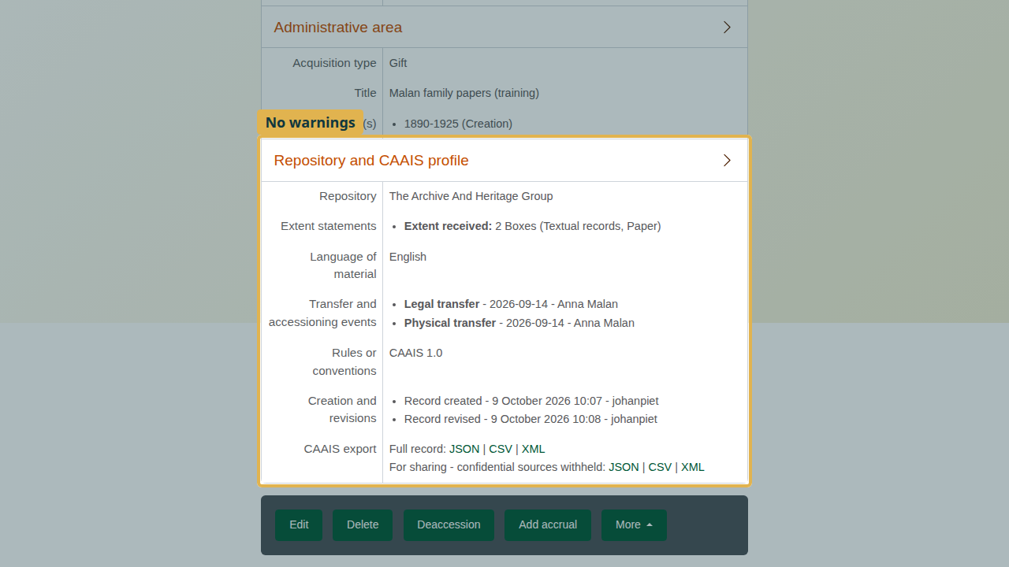
The CAAIS area with no warnings, both events and the revision history.
The mandatory elements the page checks:
CAAIS mandatory elements checked on the accession page
Element | Name | Where it comes from
1.2 | Identifiers | Accession number
2.1 | Source of material | Related donor, or Immediate source of acquisition
3.1 | Date of material | Date(s)
3.2 | Extent statement | Extent statements, or Received extent units
5.1 | Event: physical transfer | Transfer and accessioning events
7.2 | Date of creation | Recorded automatically on the first save

4. Export
The CAAIS area offers the record in JSON, CSV or XML:
- Full record includes everything.
- For sharing withholds sources marked confidential (CAAIS 2.1.6).
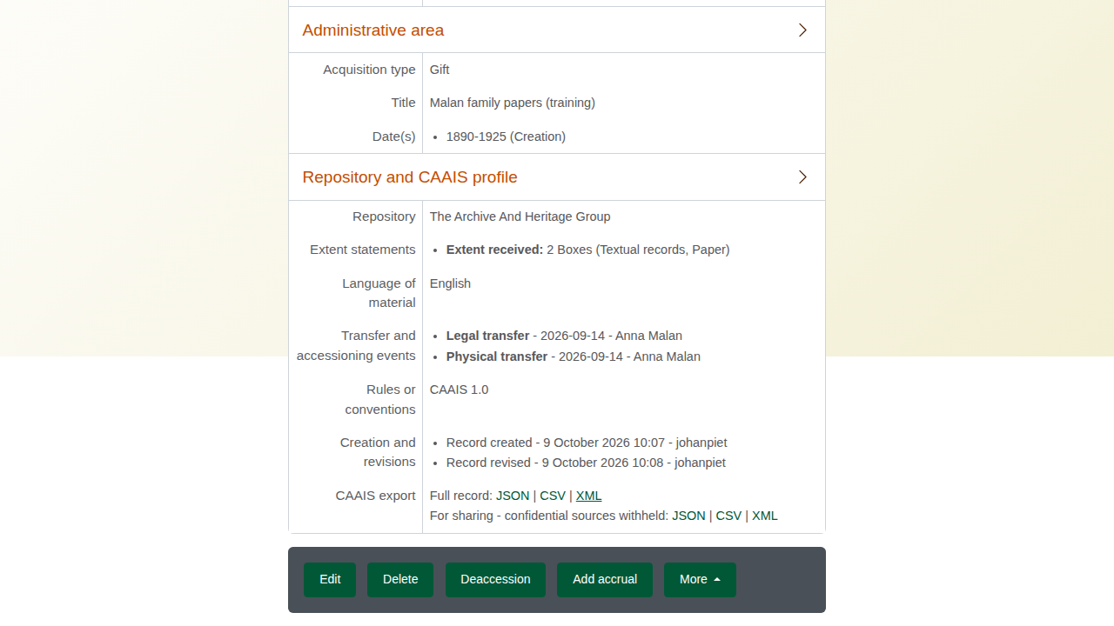
The CAAIS export links on the accession page.
Each export carries a crosswalk naming the CAAIS element behind each field, so a receiving archive can map it without AtoM.
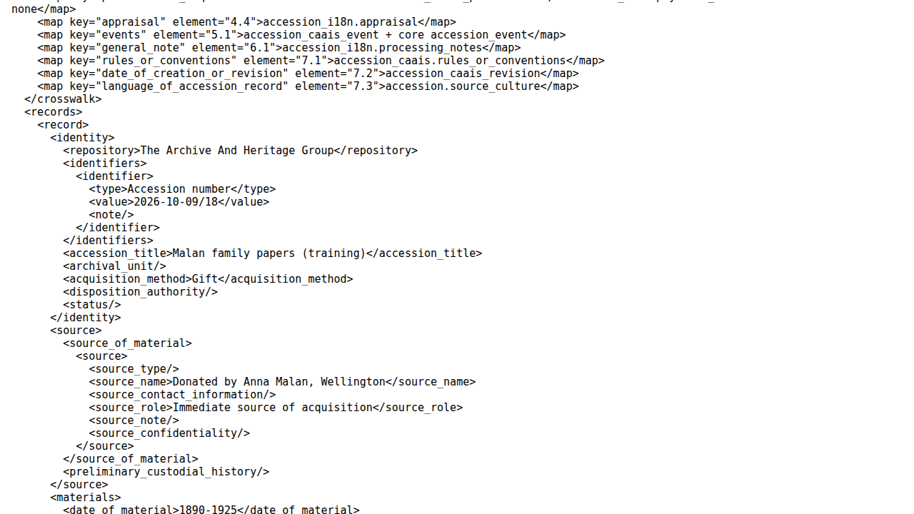
The XML export, with its crosswalk.
To export several accessions at once, open Manage > Accessions (the accession list), tick the accessions, and choose JSON, CSV or XML under the list. Tick “For sharing - withhold confidential sources” for the sharing version.
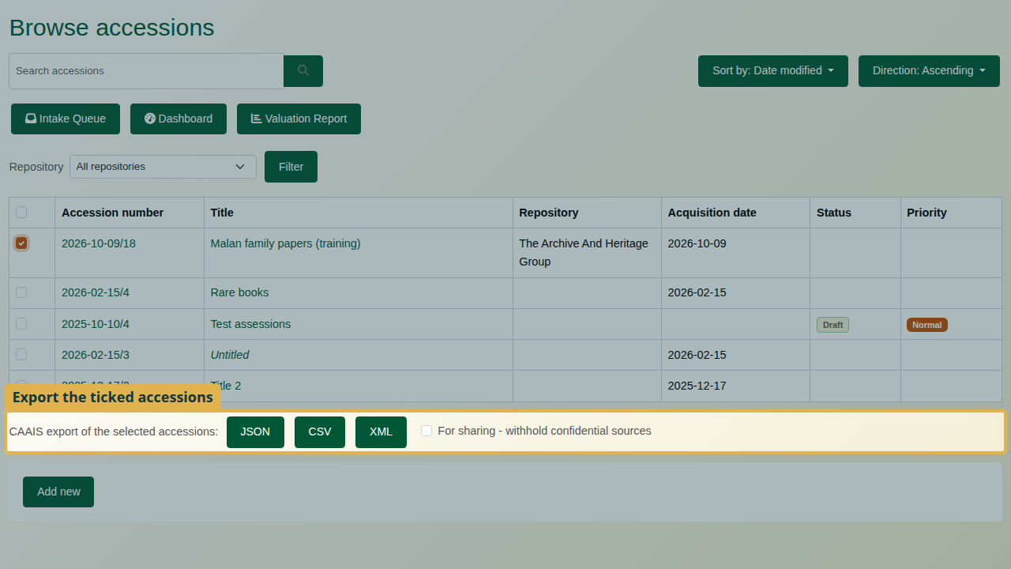
Bulk export from the accession list.

Recap
- An administrator switches CAAIS on: AHG Settings > Accession Management.
- Record the accession as usual.
- Complete the CAAIS section: repository, rules, extent, language.
- Record both transfer events: physical and legal.
- After saving, read the CAAIS warnings and edit until there are none.
- Export as JSON, CSV or XML, full or for sharing.

Cleaning up
To remove the practice accession, open it and choose Delete.

